Table 5. All data of counted Median, 1st, and 3rd quartiles and results. Mann–Whitney’s test (plasma) 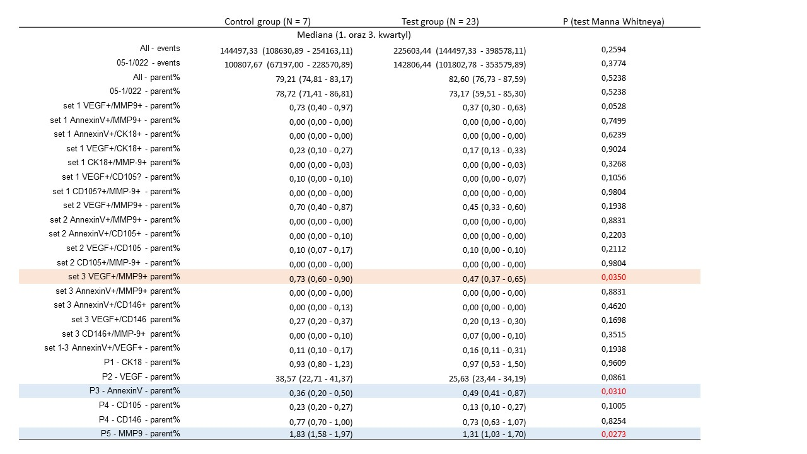All events: all events detected; 05-1/022 –number of events bigger in size than 220nm; All – parent%; 05-1/022 - parent%- parent category of events bigger in size than 220nm; set 1 VEGF+/MMP9+ - parent%: objects VEGF and MMP9 positive in set 1; set 1 AnnexinV+/MMP9+ - parent%: objects Annexine V and MMP9 positive in set 1; set 1 AnnexinV+/CK18+ - parent% : objects Annexin V and cytokeratin 18 positive in set 1; set 1 VEGF+/CK18+ - parent %: objects VEGF and cytokeratin 18 positive in set1; set 1 CK18+/MMP-9+ - parent%: objects cytokeratine 18 and MMP9 positive in set 1; set 1 VEGF+/CD105? - parent%: objects VEGF and CD105 positive in set 1; set 1 CD105?+/MMP-9+ - parent: objects CD105 and MMP9 positive in set 1; set 2 VEGF+/MMP9+ - parent%: objects VEGF and MMP9 positive in set 2; set 2 AnnexinV+/MMP9+ - parent%: objects Annexine V and MMP9 positive in set 2; set 2 AnnexinV+/CD105+ - parent% : objects Annexin V and CD105 positive in set 2; set 2 VEGF+/CD105 - parent %: objects VEGF and CD105 positive in set2; set 2 CD105+/MMP-9+ - parent%: objects CD105 and MMP9 positive in set 2; set 3 VEGF+/MMP9+ - parent%: objects VEGF and MMP9 positive in set 3; set 3 AnnexinV+/MMP9+ - parent%: objects Annexine V and MMP9 positive in set 3; set 2 AnnexinV+/CD146+ - parent%: objects Annexin V and CD146 positive in set 3; set 3 VEGF+/CD146 - parent %: objects VEGF and CD146 positive in set3; 3 CD146+/MMP-9+ parent%: objects CD146 and MMP9 positive in set 3; set 1-3 AnnexinV+/VEGF+ - parent% : objects Annexin V and VEGF positive in set1 to 3; P1 - CK18 - parent%: objects cytokeratin 18 positive; P2 - VEGF - parent%: objects VEGF positive; P3 - AnnexinV - parent%: objects Annexin V positive; P4 - CD105 - parent%: objects CD105 positive; P4 - CD146 - parent%: objects CD146 positive; P5 - MMP9 - parent%: objects MMP9 positive.

Table 6.All data of counted Median, 1st, and 3rd quartiles and results. Mann–Whitney’s test (peritoneal fluid)
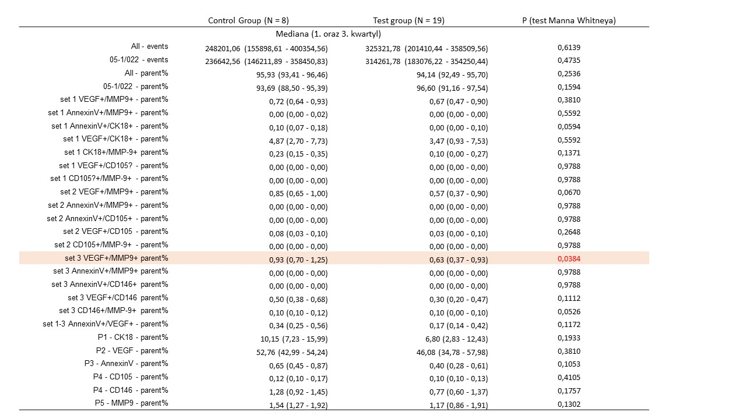

All events: all events detected; 05-1/022 –number of events bigger in size than 220nm; All – parent%; 05-1/022 - parent%- parent category of events bigger in size than 220nm; set 1 VEGF+/MMP9+ - parent%: objects VEGF and MMP9 positive in set 1; set 1 AnnexinV+/MMP9+ - parent%: objects Annexine V and MMP9 positive in set 1; set 1 AnnexinV+/CK18+ - parent% : objects Annexin V and cytokeratin 18 positive in set 1; set 1 VEGF+/CK18+ - parent %: objects VEGF and cytokeratin 18 positive in set1; set 1 CK18+/MMP-9+ - parent%: objects cytokeratine 18 and MMP9 positive in set 1; set 1 VEGF+/CD105? - parent%: objects VEGF and CD105 positive in set 1; set 1 CD105?+/MMP-9+ - parent: objects CD105 and MMP9 positive in set 1; set 2 VEGF+/MMP9+ - parent%: objects VEGF and MMP9 positive in set 2; set 2 AnnexinV+/MMP9+ - parent%: objects Annexine V and MMP9 positive in set 2; set 2 AnnexinV+/CD105+ - parent% : objects Annexin V and CD105 positive in set 2; set 2 VEGF+/CD105 - parent %: objects VEGF and CD105 positive in set2; set 2 CD105+/MMP-9+ - parent%: objects CD105 and MMP9 positive in set 2; set 3 VEGF+/MMP9+ - parent%: objects VEGF and MMP9 positive in set 3; set 3 AnnexinV+/MMP9+ - parent%: objects Annexine V and MMP9 positive in set 3; set 2 AnnexinV+/CD146+ - parent%: objects Annexin V and CD146 positive in set 3; set 3 VEGF+/CD146 - parent %: objects VEGF and CD146 positive in set3; 3 CD146+/MMP-9+ parent%: objects CD146 and MMP9 positive in set 3; set 1-3 AnnexinV+/VEGF+ - parent% : objects Annexin V and VEGF positive in set1 to 3; P1 - CK18 - parent%: objects cytokeratin 18 positive; P2 - VEGF - parent%: objects VEGF positive; P3 - AnnexinV - parent%: objects Annexin V positive; P4 - CD105 - parent%: objects CD105 positive; P4 - CD146 - parent%: objects CD146 positive; P5 - MMP9 - parent%: objects MMP9 positive.

