Title of the Manuscript: Assessing garden pea germplasm for powdery mildew resistance through disease phenotyping and genotyping using molecular markers
Journal Name: Euphytica
Name of Authors: Priyambada Sharada and Ragiba Makandar

Supplementary figures

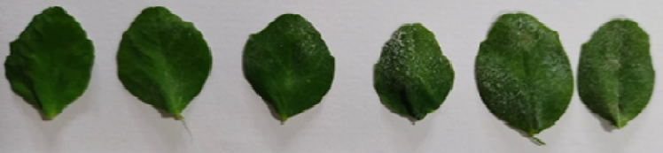
0–8
9–15
16–35
36–48
49–55
>56

Fig. S1 Disease scoring for powdery mildew infection on pea leaves according to Gawande and Patil (2003) with modifications. The disease phenotypes categorized into six groups; 0–8: highly resistant, 9–15: resistant, 16–35: moderately resistant, 36-48: moderately susceptible, 49–55: susceptible and >56: highly susceptible

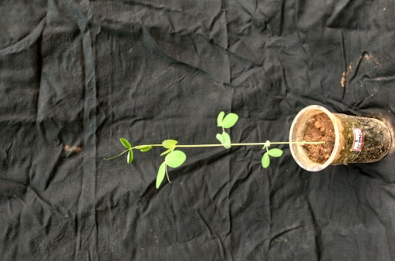
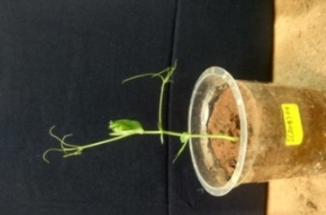
EC398611
Thin and erect stem, short internode length, normal round green leaves, normal stipules, short tendrils present
IC208364
Normal stem, short internode length, fewer leaves, wide stipules, dense tendrils present

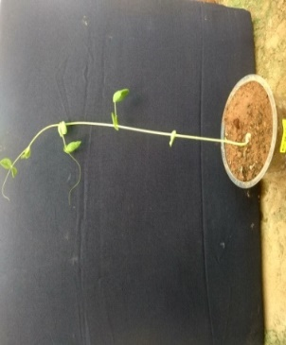
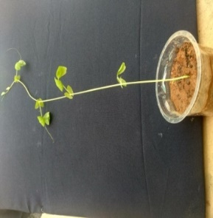
EC6620
Normal stem, long internode length, normal green leaves, small stipules, tendrils present
IC424592
Slender stem, long internode length, normal round green leaves, small stipules, tendrils present

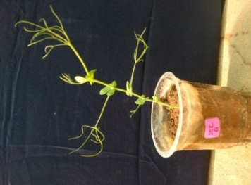
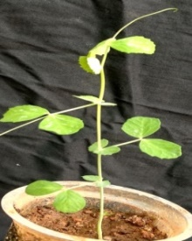
DDR-61
Normal stem, short internode length, fewer leaves, broad green stipules, branched tendrils present
IC424888
Normal stem, normal internode length, thin serrated green leaves, small stipules, tendrils present

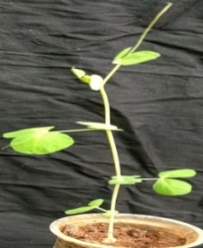
EC398602
Thick stem, short internode length, broad round green leaves, small stipules, tendrils present
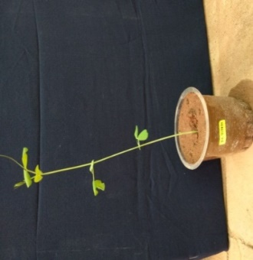
IC417837
Thick stem, short internode length, small green serrated leaves, small stipules, tendrils present

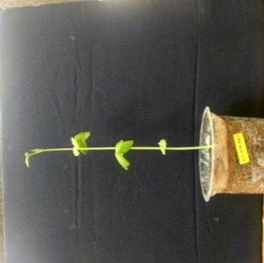
EC414485
Thick waxy stem, long internode length, normal green leaves, small stipules, small tendrils present
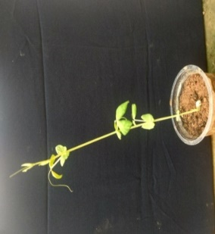
IC267181
Thick stem, long internode length, normal leaf size, small stipules, tendrils present

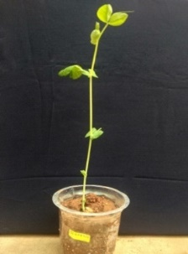
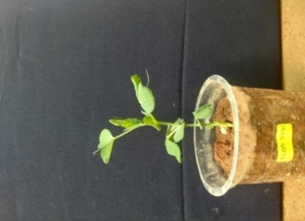
IC208368
Thick stem, long internode length, broad green leaves, small stipules, tendrils present
EC507771
Thick and short stem, very short internode length, broad green leaves, small stipules, tendrils present

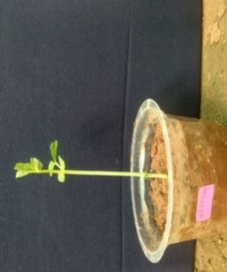
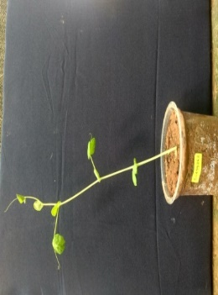
IC267169
Thick waxy stem, elongated small green leaves, small stipules, tendrils present
EC499762
Normal stem, long internode length, normal green leaves, small stipules, tendrils present

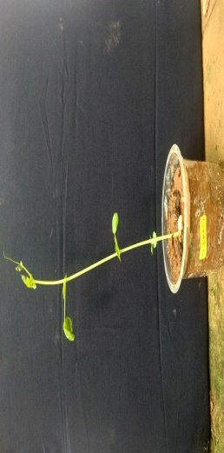
IC398604
Thick stem, long internode length, normal leaves, stipules, tendrils present
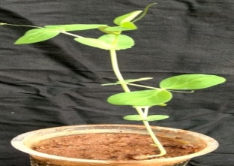
IC424892
Normal stem, long internode length, normal green leaves, small stipules, small tendrils present

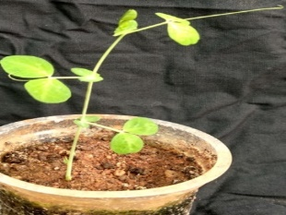
IC424887
Thin stem, small round green leaves, small stipules, tendrils present
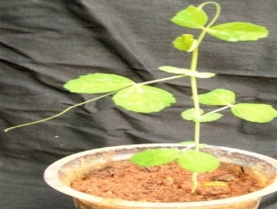
IC424588
Thin stem, small leaves serrated, small stipules, tendrils present

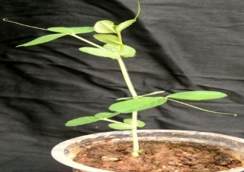
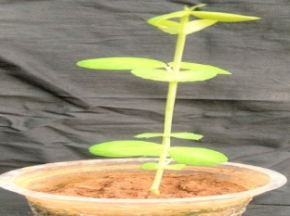
EC499976
Thick waxy stem, long internode length, green leaves, stipules, tendrils present
IC417586
Normal stem, long internode length, small leaves, small stipules, no tendrils

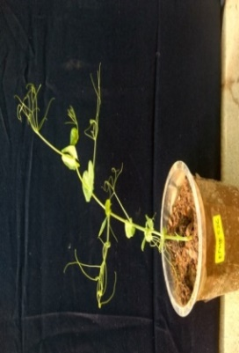
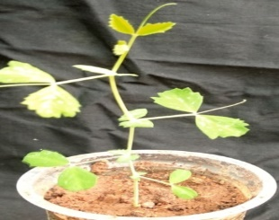
KPMR-526
Thick stem very short internode length, small green leaves, wide stipules, dense tendrils present
IC424591
Thin stem, small green serrated leaves, small stipules, tendrils present

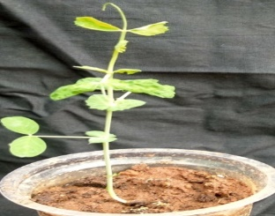
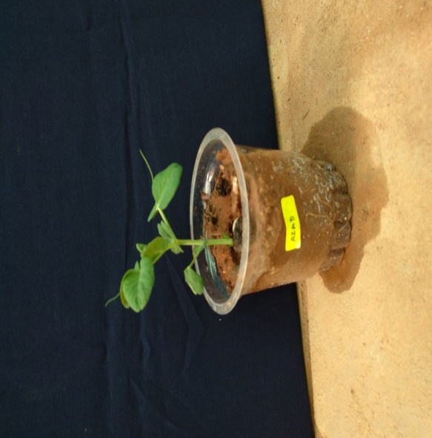
VKG-30162
Normal stem, long internode length, green serrated leaves normal size, small stipules, short tendrils
Azad
Thick stem, short internode length, broad green leaves, small stipules, short tendrils present

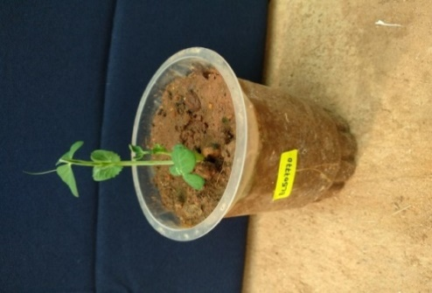
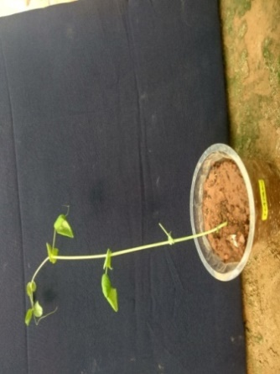
EC507770
Thick stem, short internode length, broad green leaves, small stipules
IC417880
Thin stem, long internode length, wide leaves, small stipules, tendrils present

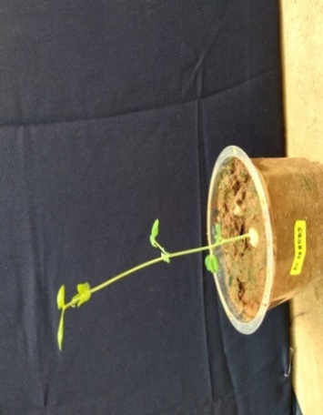
EC398589
Normal stem, long internode length small green leaves, small stipules, short tendrils present
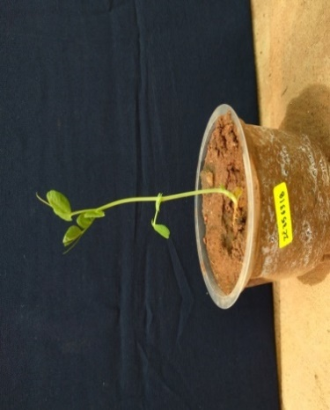
IC356318
Thick stem, normal internode length, normal green leaves, small stipules, short tendrils present

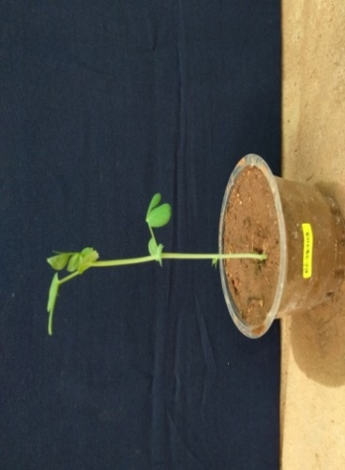
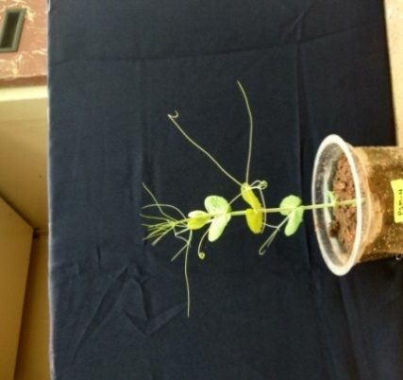
EC387113
Thick stem, long internode length, normal green leaves, small stipules, tendrils are not present
PSM-4
Thick stem, short internode length, normal-sized green stipules, branched-tendrils present

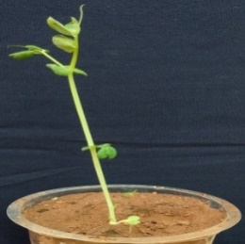
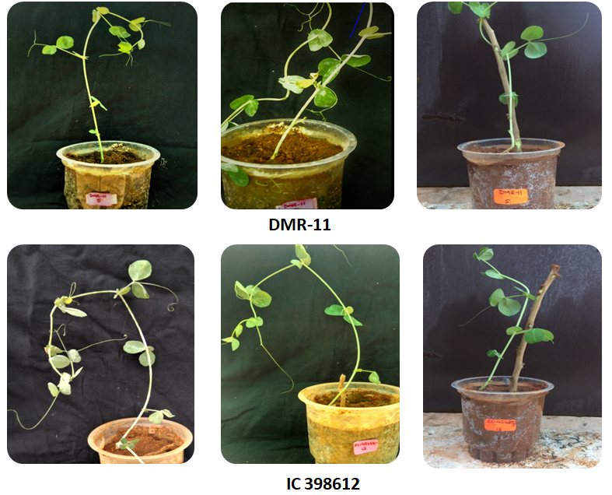
IC356304
Thick stem, long internode length, small green leaves, small stipules, tendrils present
DMR-11
Normal stem, short internode length, small green leaves, small stipules, short branched wild type tendrils present

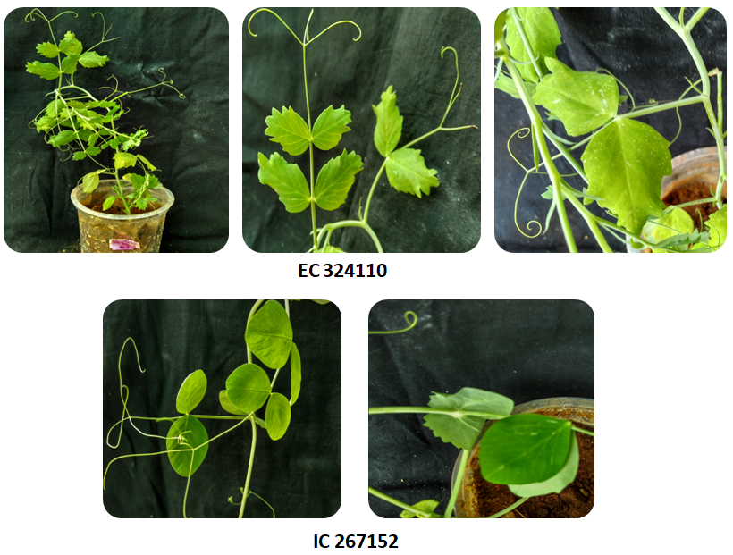
EC398612
Normal stem, long internode length, small round green leaves, small stipules, tendrils present
IC267152
Normal stem, wide round green leaves, branched tendrils present

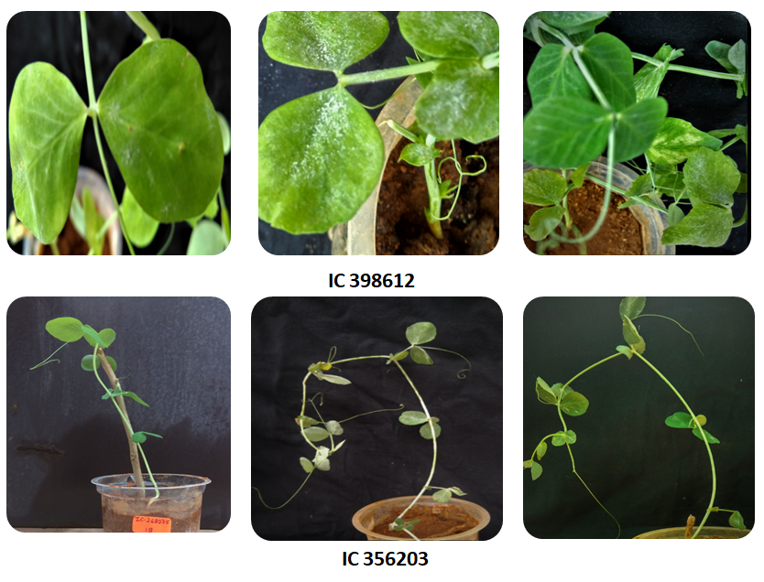
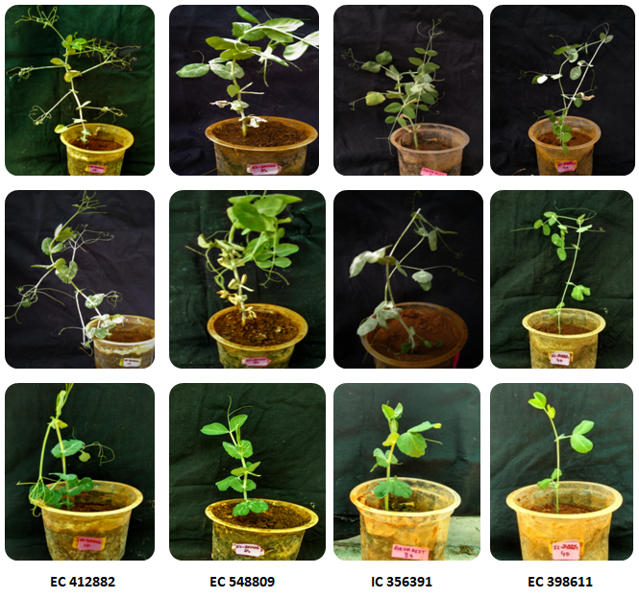
IC356203
Normal stem, long internode length, small green leaves, small stipules, tendrils present
IC356391
Thick stem, short internode space, broad green leaves, small stipules, short tendrils present

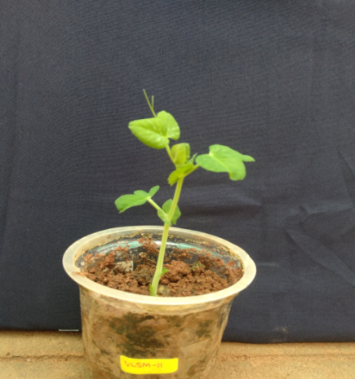
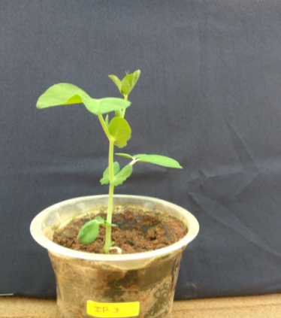
VLSM-11
Thick stem, short internode length, broad green leaves, small stipules, tendrils present
IP-3
Thick stem, short internode length, broad leaves, small stipules, tendrils present

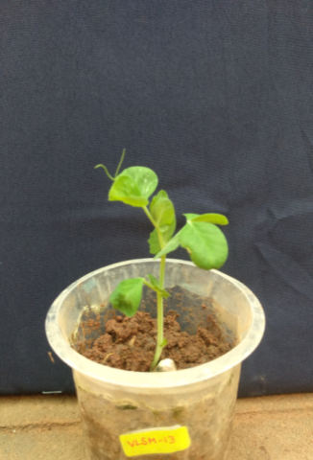
VLSM-13
Thick stem, short internode length, green round broad leaves, small stipules, tendrils present
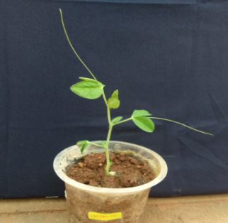
VLSM-12
Normal stem, short internode length, normal green leaves, small stipules, long tendrils present

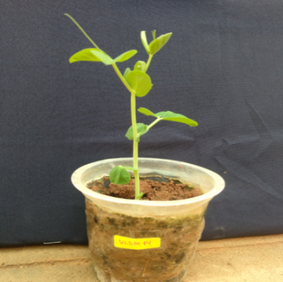
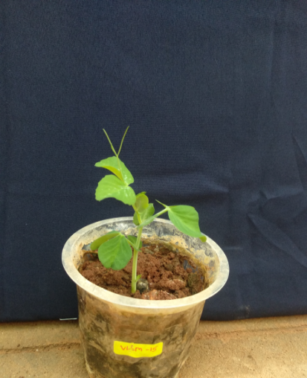
VLSM-14
The thick erect stem, short internode length, broad green leaves, small stipules, tendrils present
VLSM-15
Thick stem, short internode length, green round broad leaves, small stipules, tendrils present

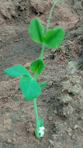
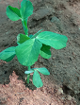
JI2480
Normal stem, normal internode length, green thin leaves, stipules are present, wild type tendrils present
JI2302
Thick stem, short internode length, green wide leaves, broad stipules, wild type tendrils present

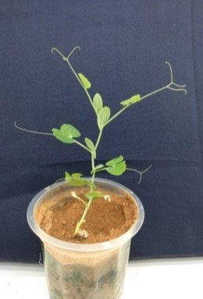
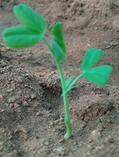
Arkel
Thick stem, short internode length, broad green leaves, normal-sized stipules, branched tendrils present
P660-4
Thin stems, normal internode length, small green leaves, stipules are present, tendrils present

Fig. S2 Morphological characterization of pea germplasm to assess their phenotypes

