Table 1 Images of Women ' s Close-Crotch Pants Unearthed from the Tombs in the Jiangnan Area in the Ming Dynasty of China Unit： cm
Tomb name | Identity of tomb owner | Pants name | Quantity | Basic characteristics | Fabric | length | Waist width | Bottom of a pant leg width | Entity | Line drawing（The author draws）
Wangluo Family Tomb in Changzhou, Jiangsu Province | Sheng | Plain silk clamp cotton-padded pants | 1 | Crotch, cotton-padded. | Plain silk | 80 | - | 25 | 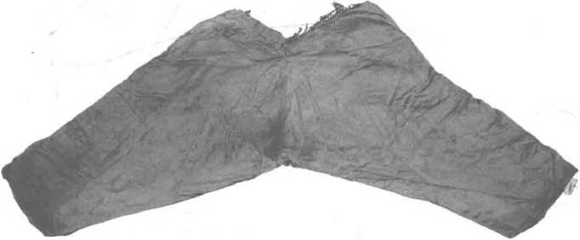 | 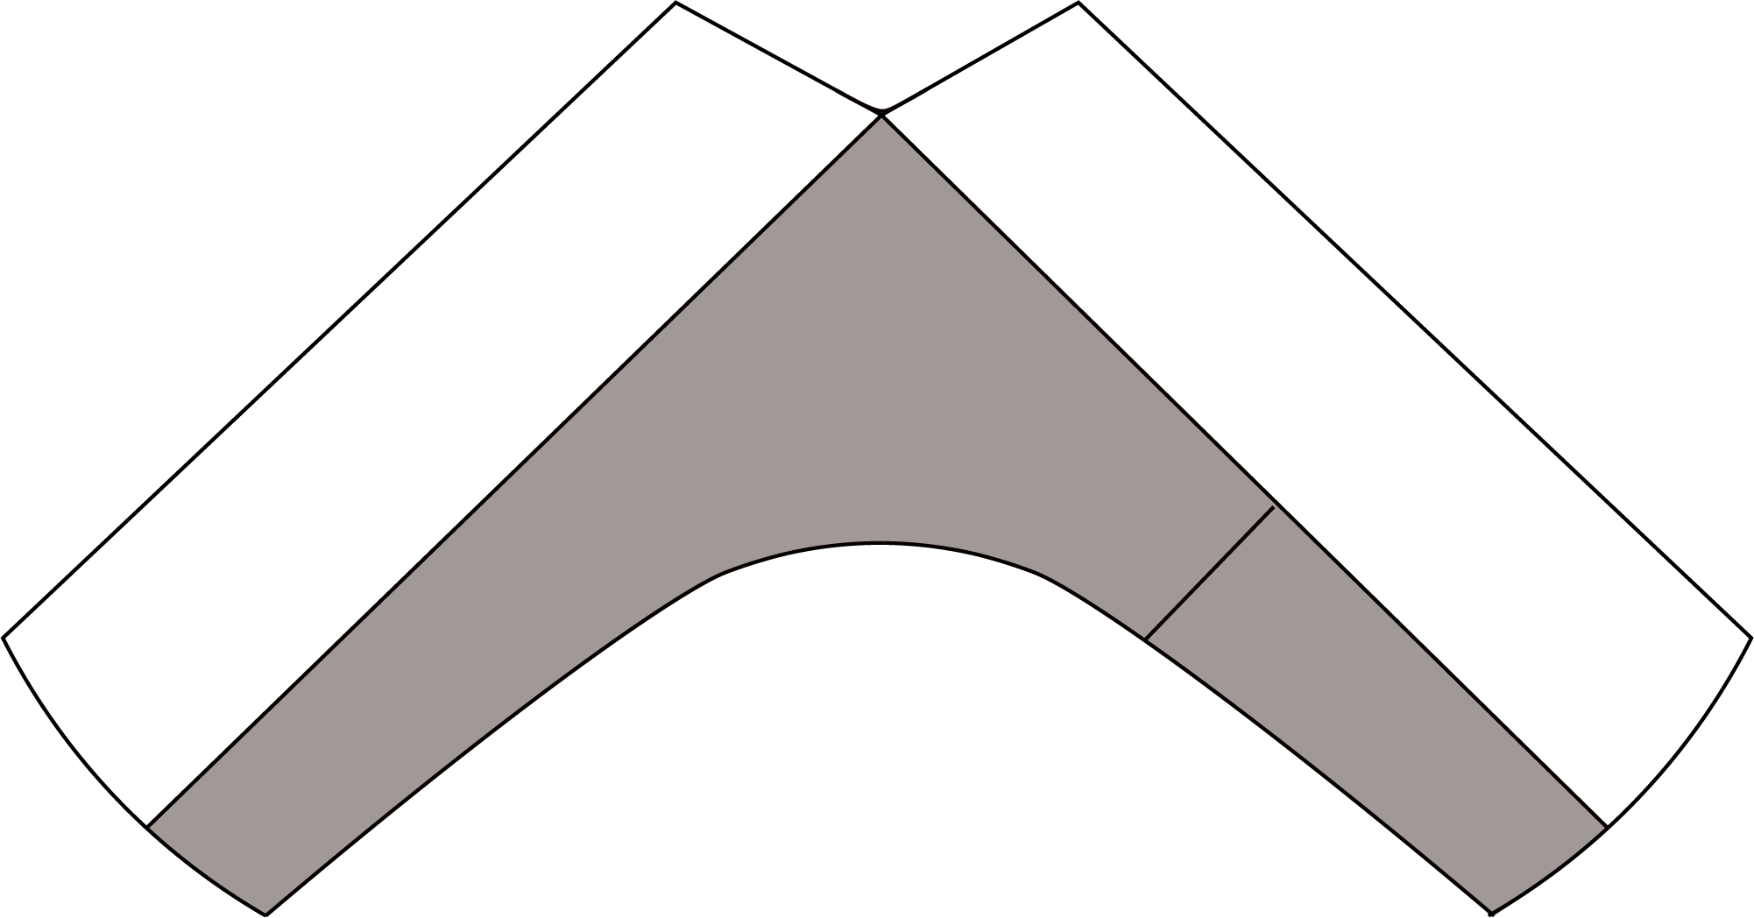
Wangluo Family Tomb in Changzhou, Jiangsu Province | Xu | Satin clamp cotton-padded pants | 1 | Shallow bean yellow silk lining, inner cotton, miscellaneous treasure patterns. | Satin | 80 | 84 | 33 | 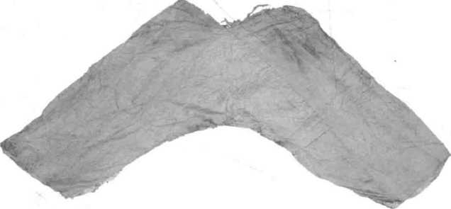
Tombs of Xu Fan Couples in Taizhou, Jiangsu Province | Zhang Panlong | Plain silk clamp cotton-padded pants | 1 | There is a slit on the right side of the waist, and a pair of waistband are sewn on both sides. | Plain silk | 80 | 70 | 36 | 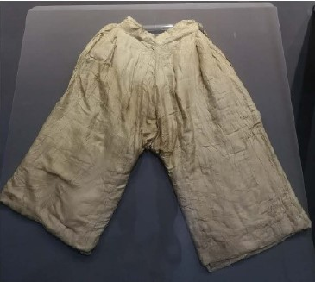 | 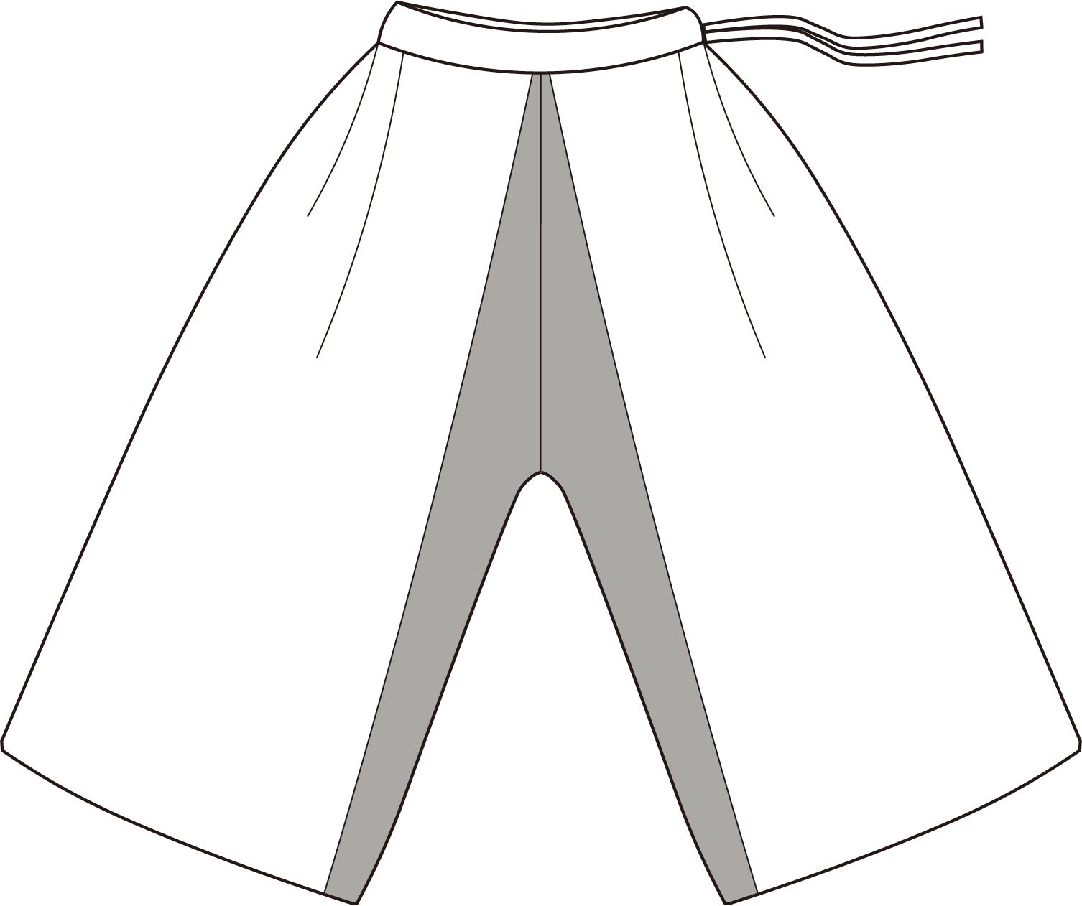
Tombs of Xu Fan Couples in Taizhou, Jiangsu Province | Zhang Panlong | Cotton-padded pants | 1 | A pair of white cloth pants. A 37 cm-long opening slit on the right side of the waist, and a white cloth waistband with a length of 57 cm and a width of 0.8 cm are sewn on both sides. | cotton | 82 | 56 | 36 | 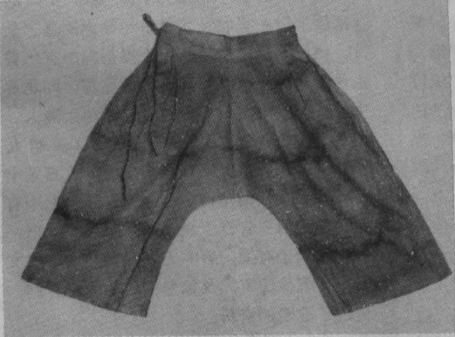 | 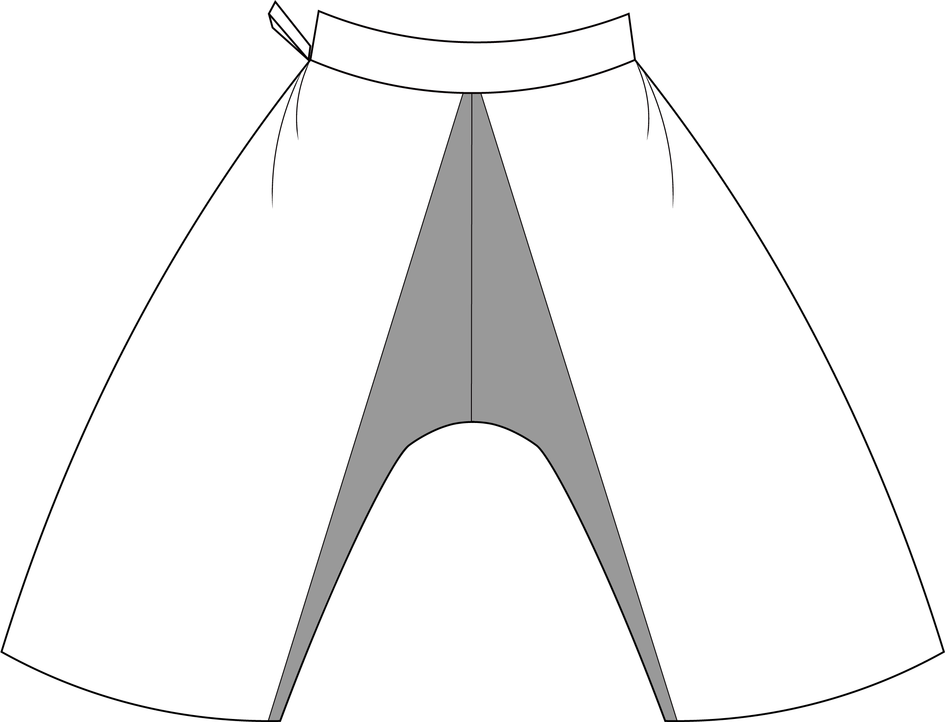
Xue Family Tombs in Wuxi, Jiangsu Province | Chen | Small close-crotch lined pants | 1 | Small in size. The left and right trouser legs are stitched with a piece of fabric. A small square piece of fabric is used to fold the front and the back triangles to form the crotch. | Cotton | 30 | 25 | 15 | 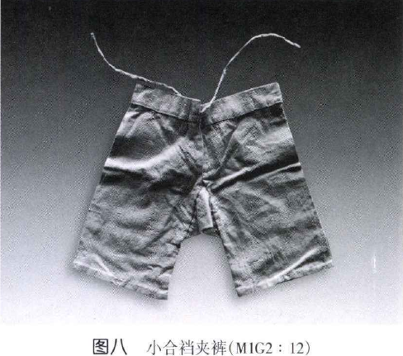 | 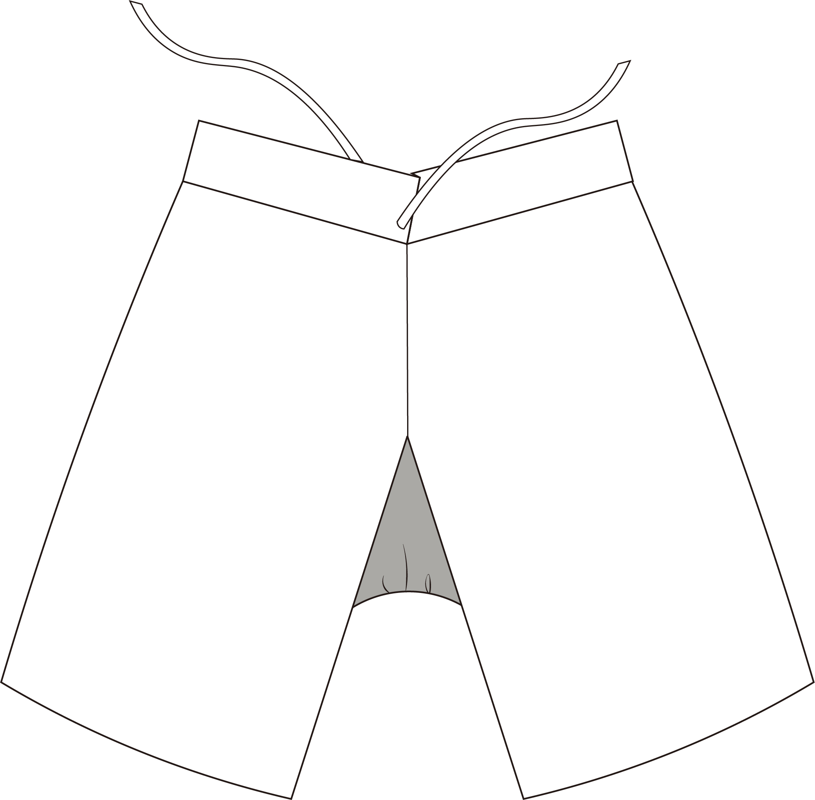
Xue Family Tombs in Wuxi, Jiangsu Province | Chen | Close-crotch lined pants | 1 | The right trouser leg is stitched two pieces of fabric at the front and back, and the fabric extends to the left to join two small triangular pieces of fabric, which is stitched with one piece of fabric on the left trouser leg. The left trouser leg is 26 cm upwards, and the waist is tied. | cotton | 80 | 47 | 13 | 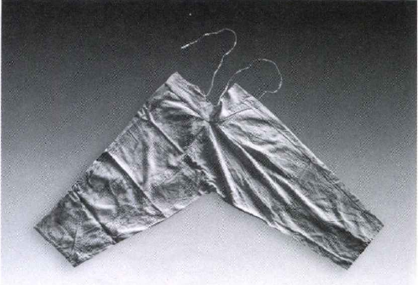 | 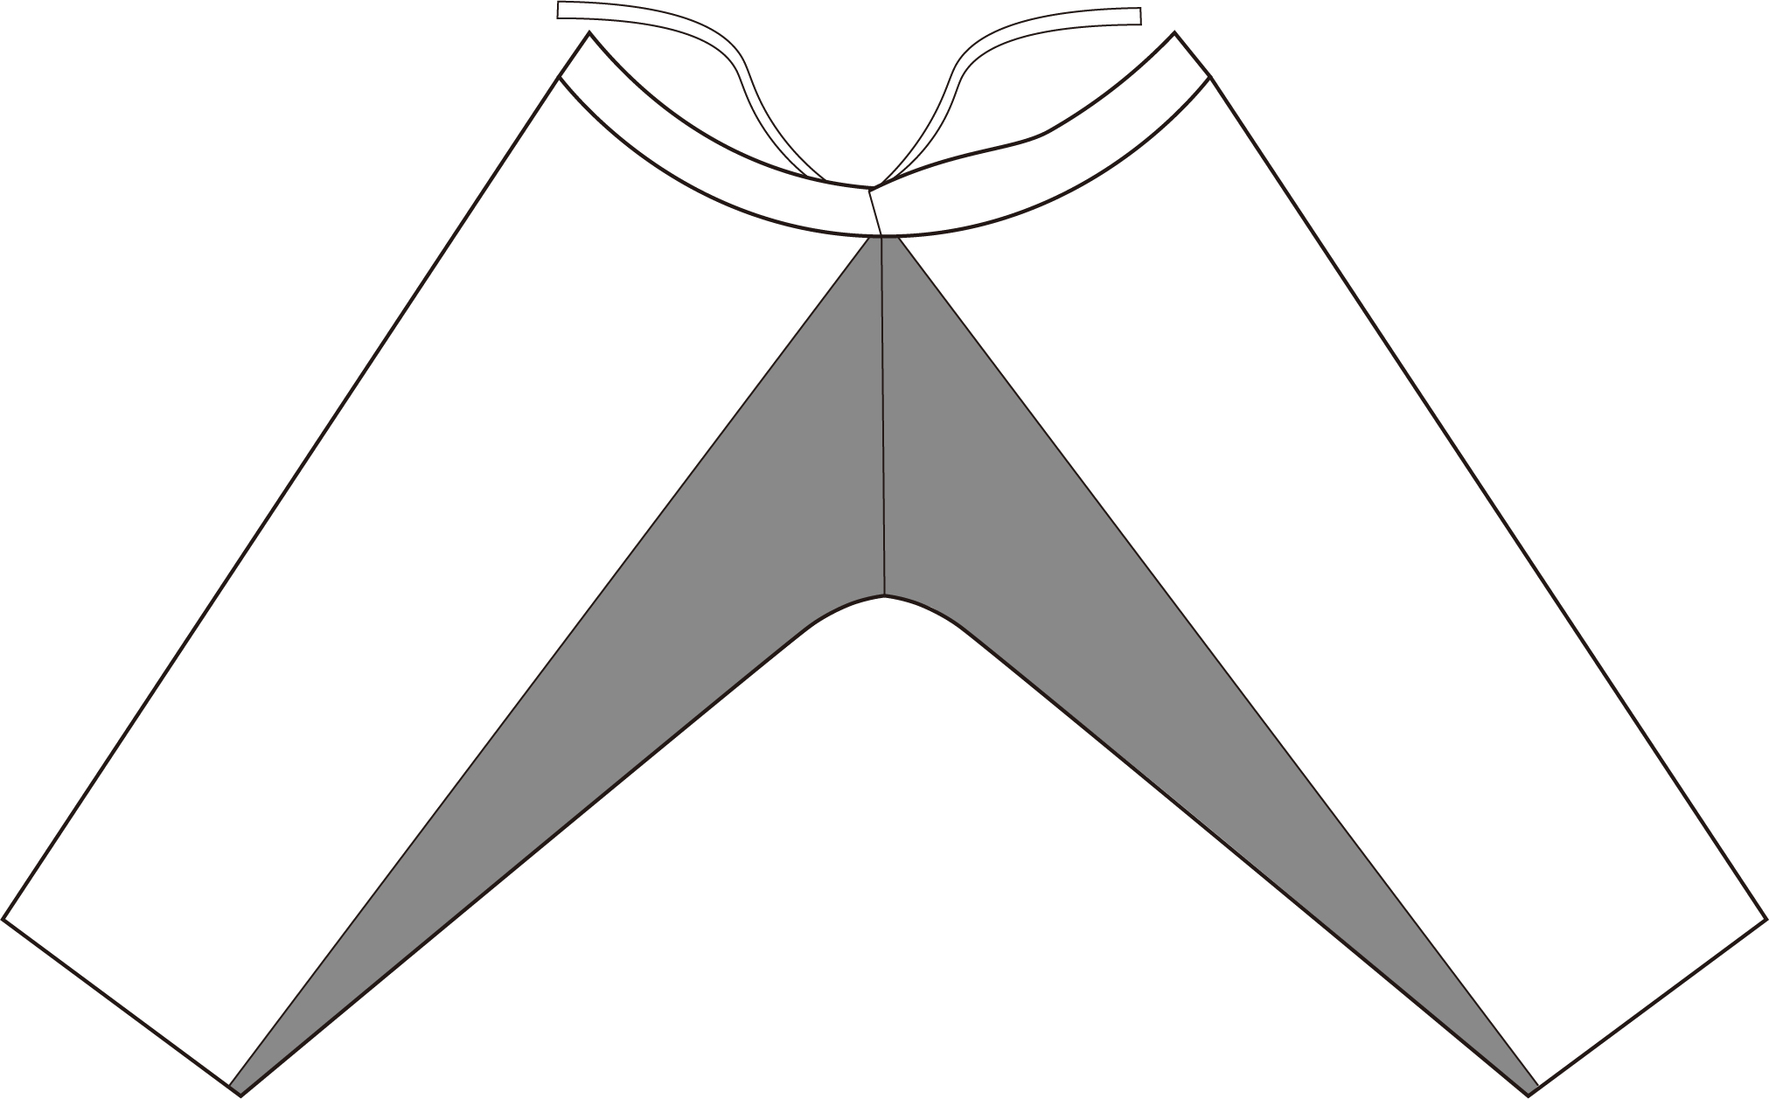
Xue Family Tombs in Wuxi, Jiangsu Province | Chen | Close-crotch lined pants | 1 | The two trousers are folded with a piece of cotton fabric, and then stitched with a large piece of cotton crotch fabric on the front and the back, and the upper is horizontally connected to the waist. Tie a belt at the waist 30 cm from the front of the right leg. | Cotton | 80 | 50 | 32 | 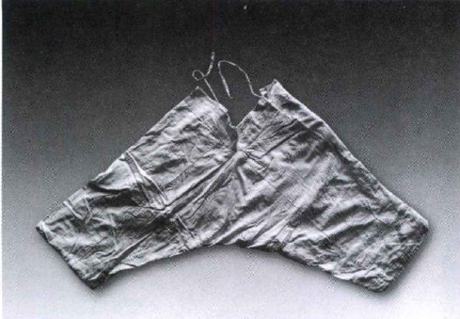 | 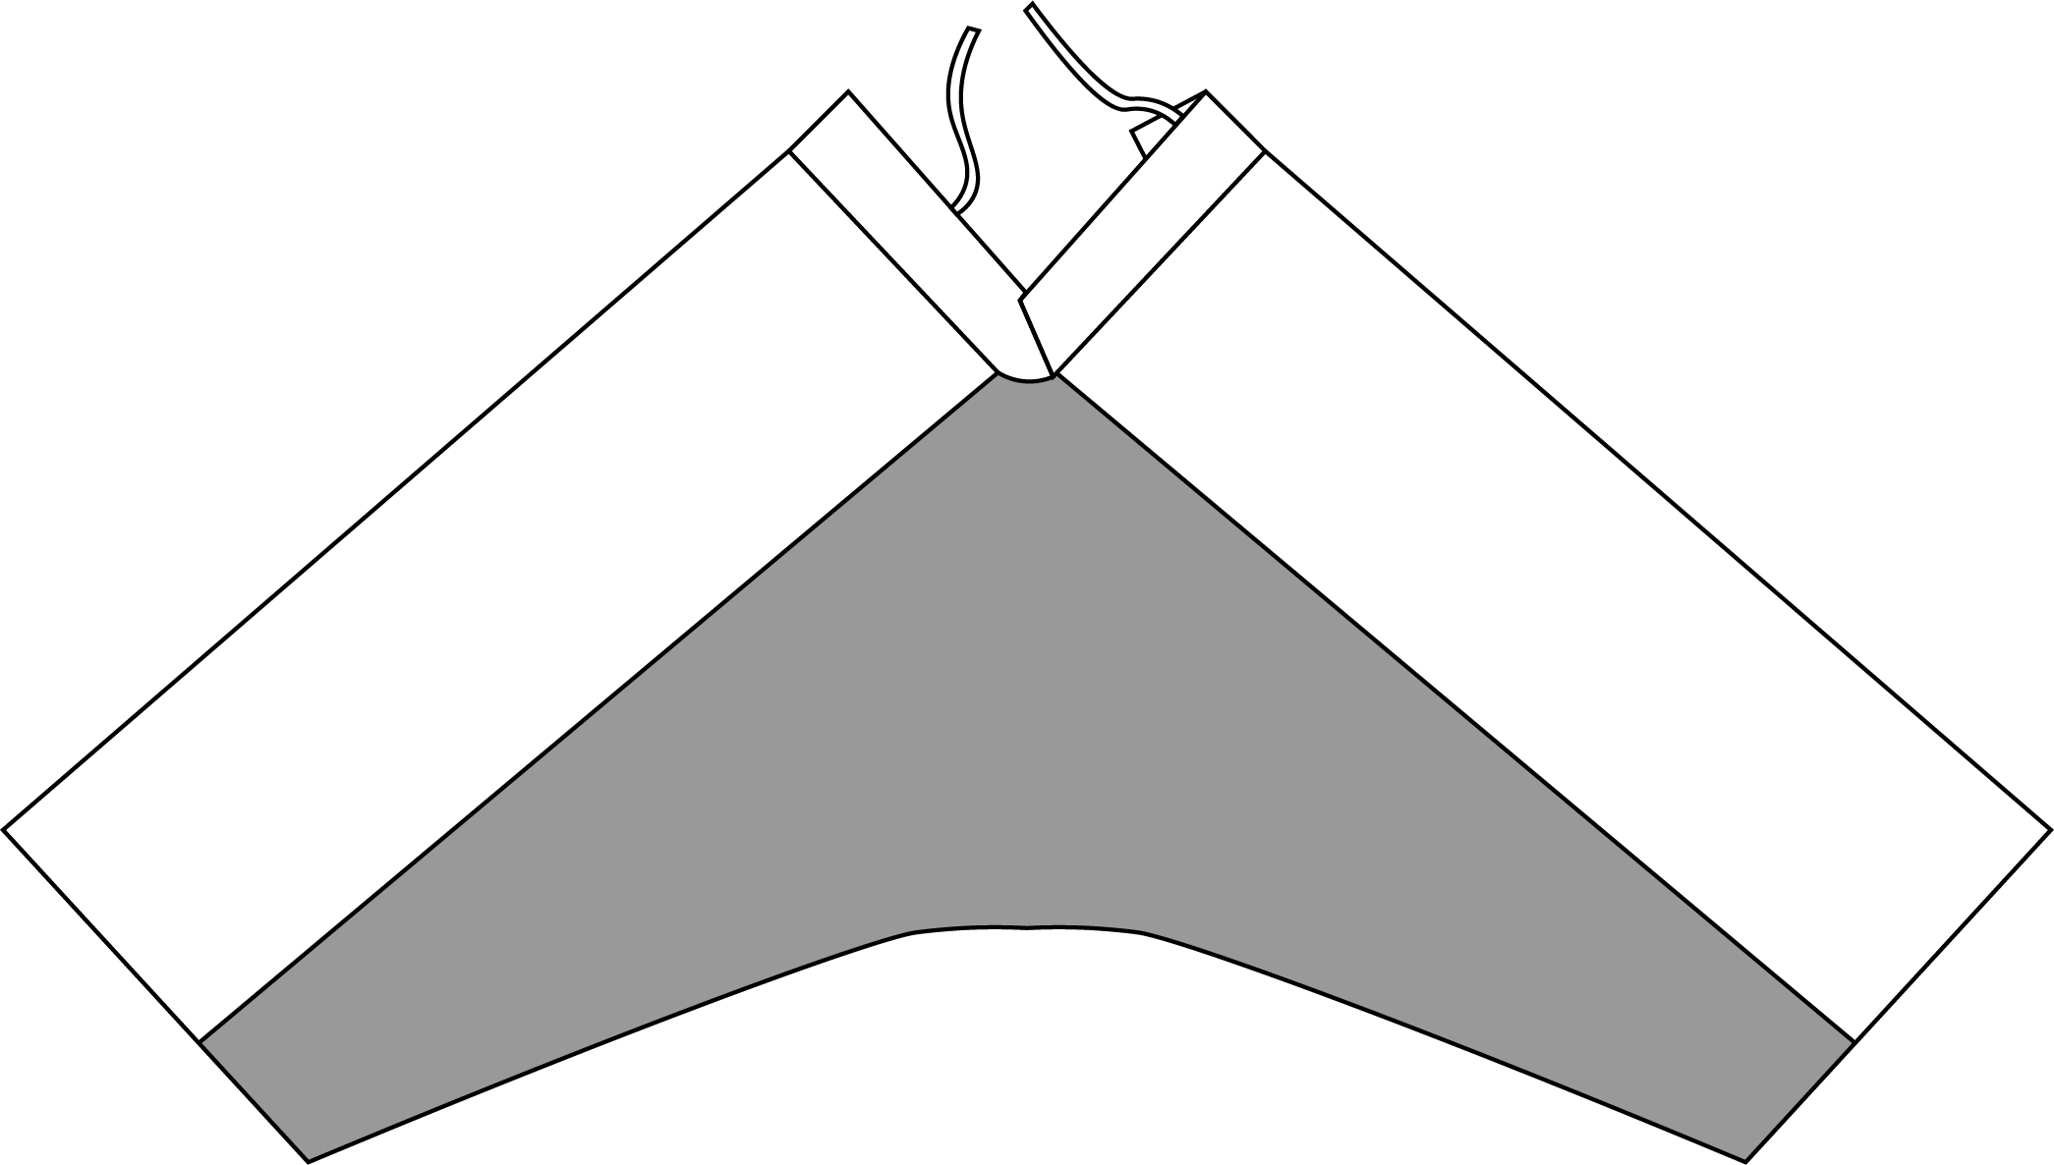
Tombs of Liu Xiang Couples in Taizhou, Jiangsu | Qiu | Satin single pants | 1 | Floral satin trousers. A 38 cm long slit on the right side of the waist. | Satin | 96 | 61 | 41 | 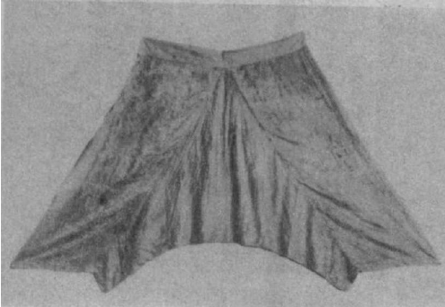 | 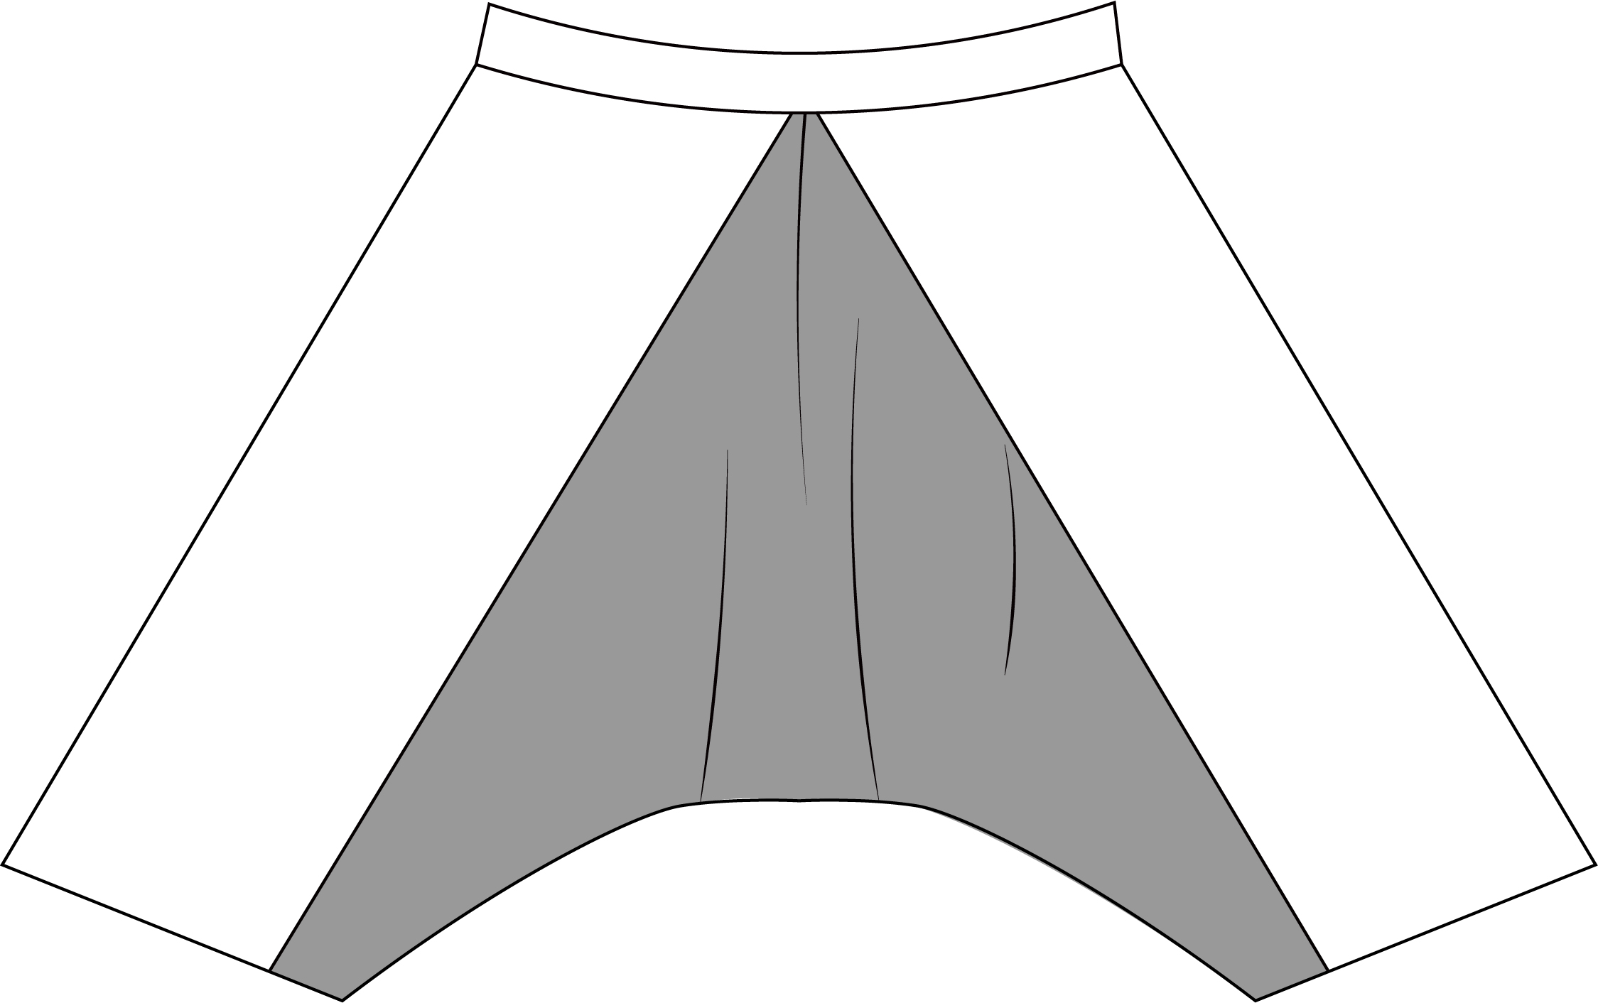
Tombs of Liu Xiang Couples in Taizhou, Jiangsu | Qiu | Plain silk clamp cotton-padded pants | 1 | A 29 cm long slit on the right side of the waist, and a tie is sewn on each side of the slit. | Plain silk | 87 | 49 | 31 | 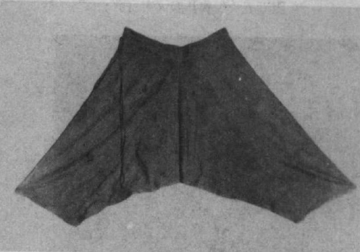 | 