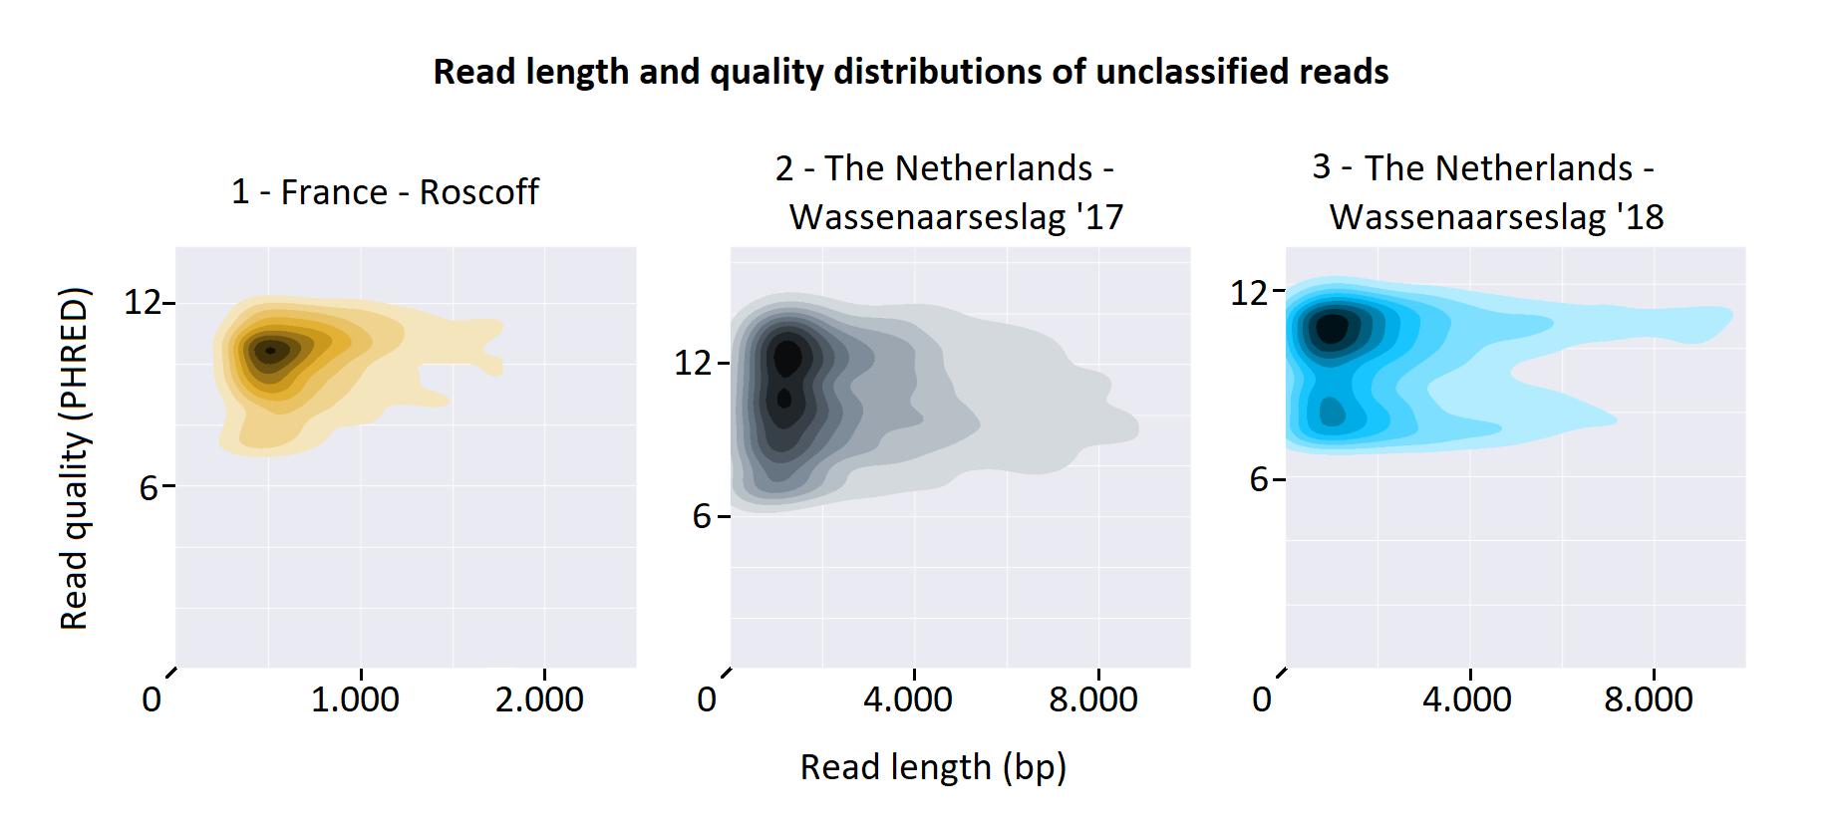

AF Figure 4: Read length and quality distributions of data that OneCodex labels unclassified. On average reads are shorter compared to raw sequencing data, however these lengths should still be sufficient to use for k-mer species characterization. Average quality distributions are very comparable to reads which OneCodex was able to classify species with.

