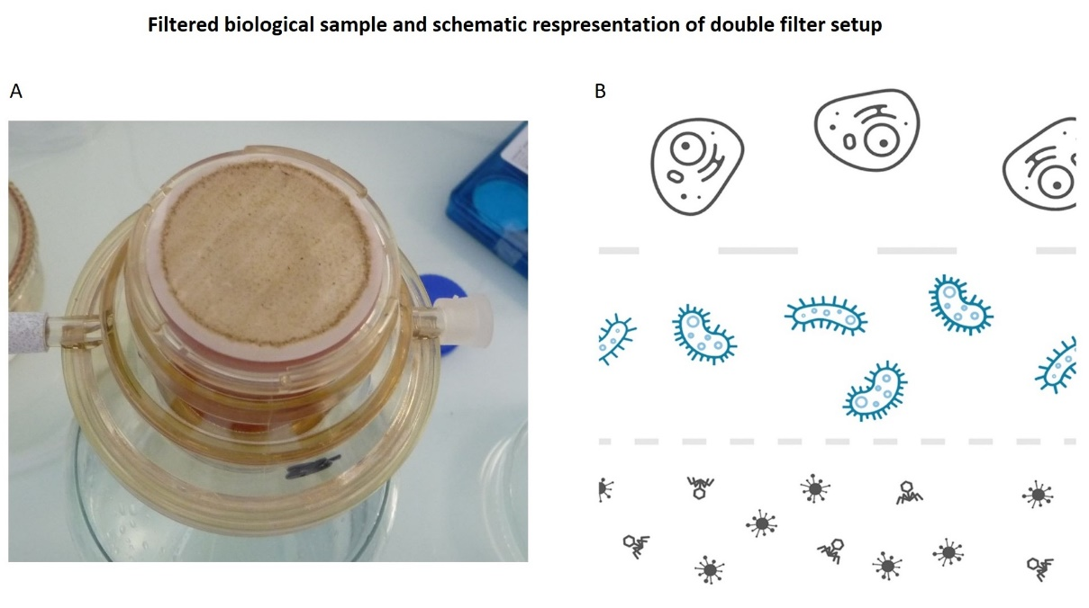
AF Figure 6 A) Filter setup; 0.22 µm containing biological material that represents the oceanic microbiome B) A schematic visualization of double filter setup. Discard eukaryotic cells during the first and viral/ phage content during the second filtering round.

