Image shows soil data collection
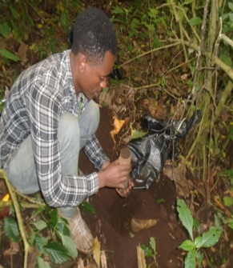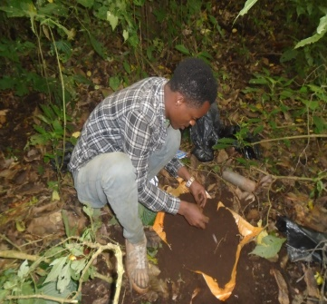
Forest with planted coffee
New degradation to plant coffee
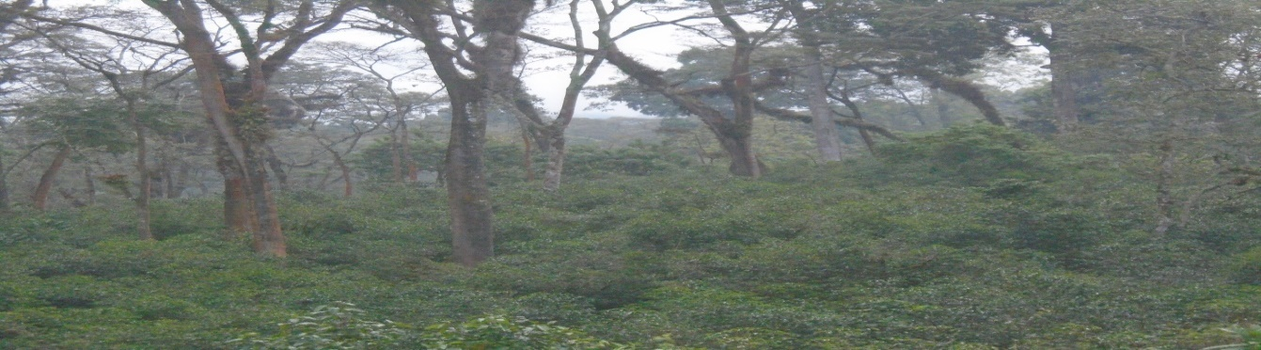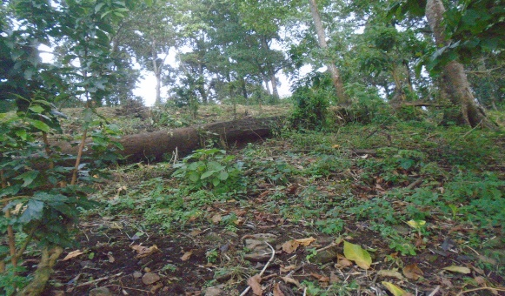
Intact natural forest
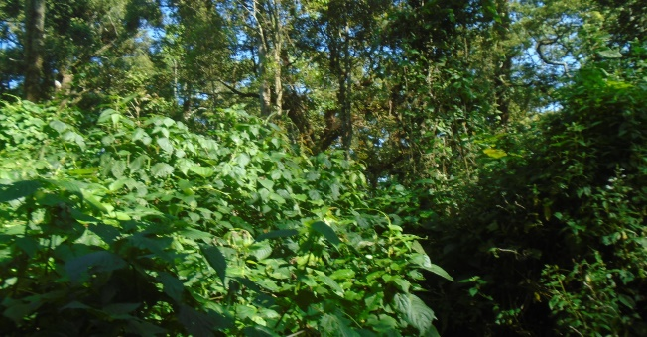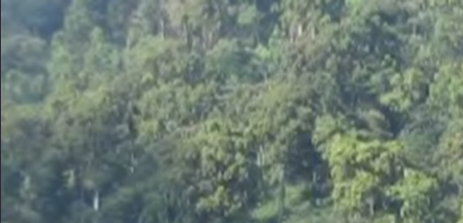
Photo by: Abraham Mohammed and Yohannes Shifera (Anfilo District natural forest, Oromia)

