Supplementary information

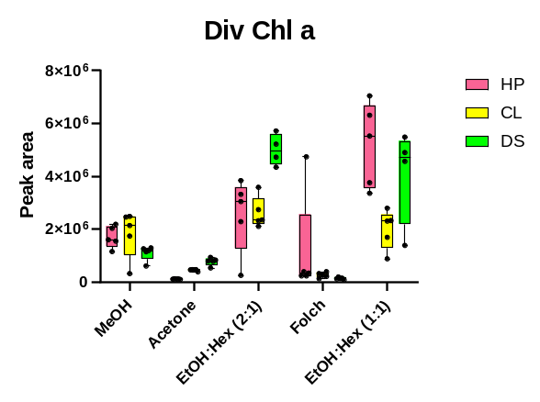 | 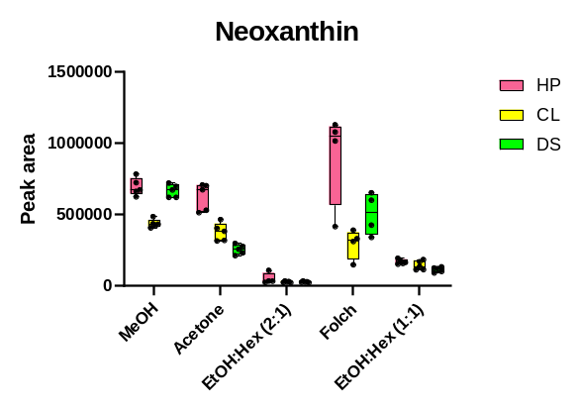
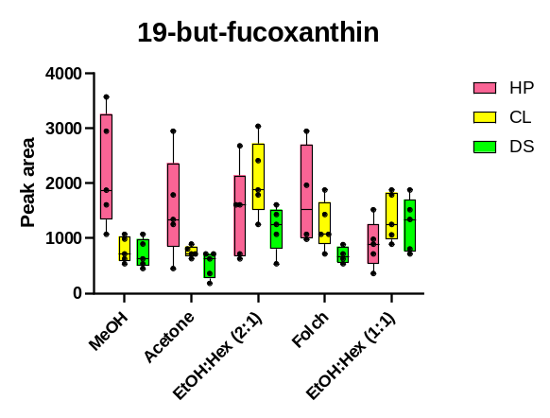 | 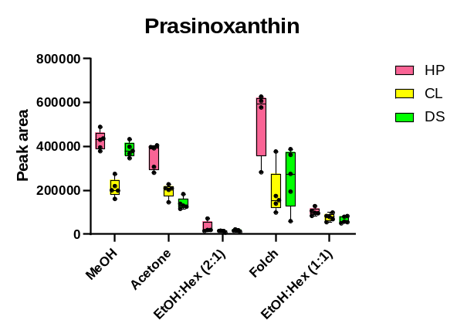
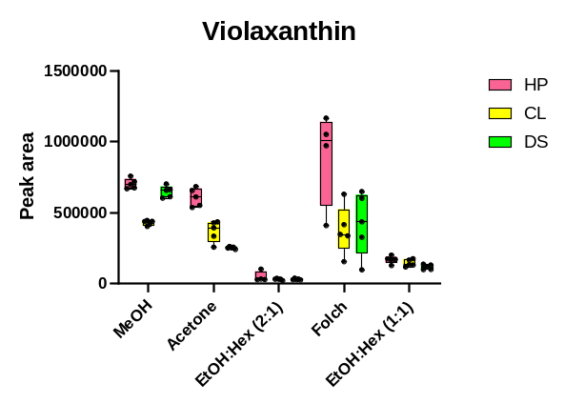 | 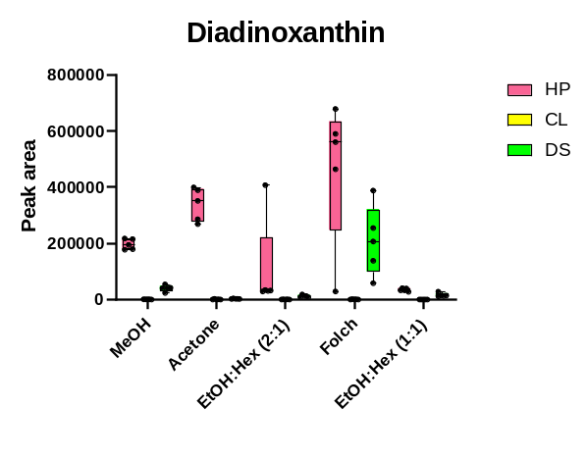
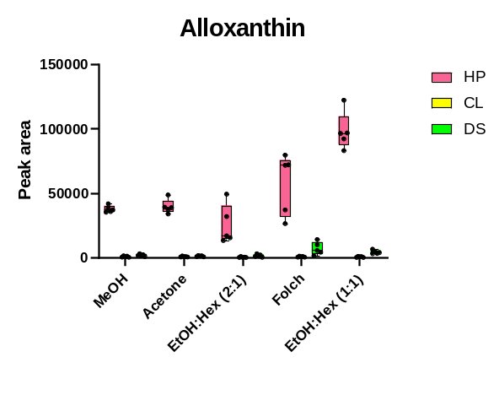 | 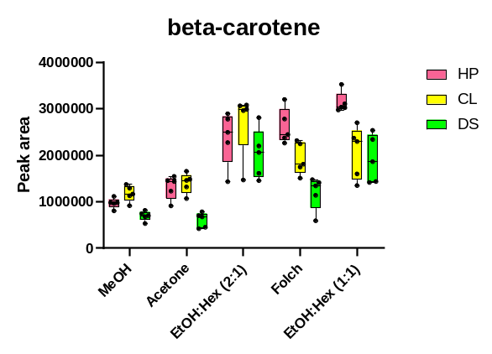
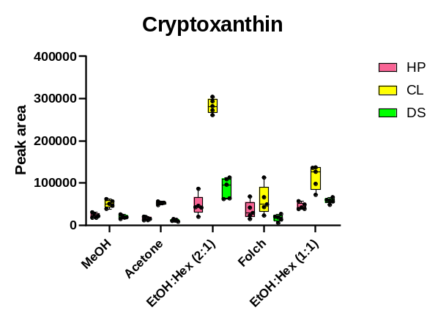 | 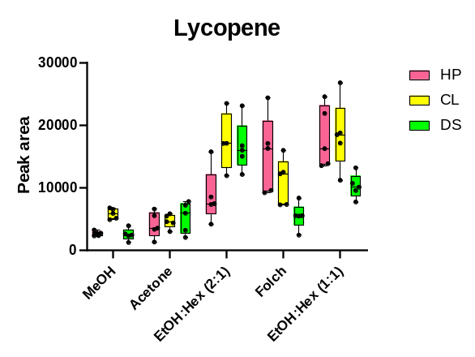
Supplementary Fig 1. Box and whisker plots for the pigments (n=5, p<0.05) measured by MRMs-19-but-fucoxanthin, prasinoxanthin, divinyl chlorophyll a, neoxanthin, violaxanthin, diadinoxanthin, alloxanthin, β-carotene, cryptoxanthin and lycopene for all the three microalgal species H. pluvialis (HP), C. variabilis (CL) and D. subspicatus (DS) with different extraction solvents

