Kairomonal effect of aphid alarm pheromones and analogues on the parasitoid Diaeretiella rapae
Yao-Guo Qin†, Shang-Yang Zhang and Zheng-Xi Li†
Department of Entomology and MOA Key Laboratory for Monitoring and Environment-Friendly Control of Crop Pests, College of Plant Protection, China Agricultural University, Beijing 100193, China
†Authors for correspondence: Department of Entomology, China Agricultural University, 2 Yuanmingyuan West Road, Beijing 100193, China. Yao-Guo Qin, E-mail: qinyaoguo@cau.edu.cn; Zheng-Xi Li, zxli@cau.edu.cn.

Supplementary Figure 1 (Fig. S1)
¹H NMR spectra of EβF Analog I
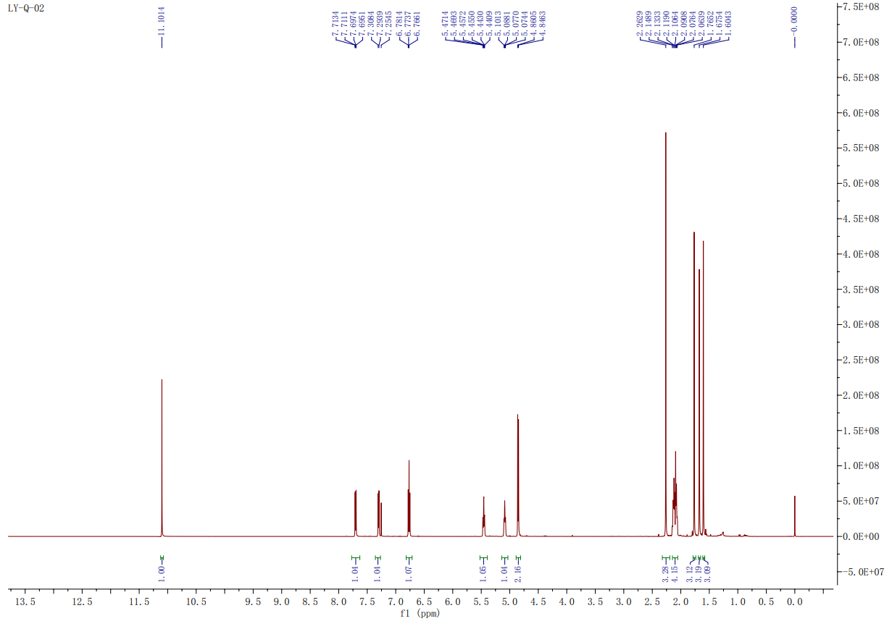

Supplementary Figure 2 (Fig. S2)
¹³C NMR spectra of EβF Analog I
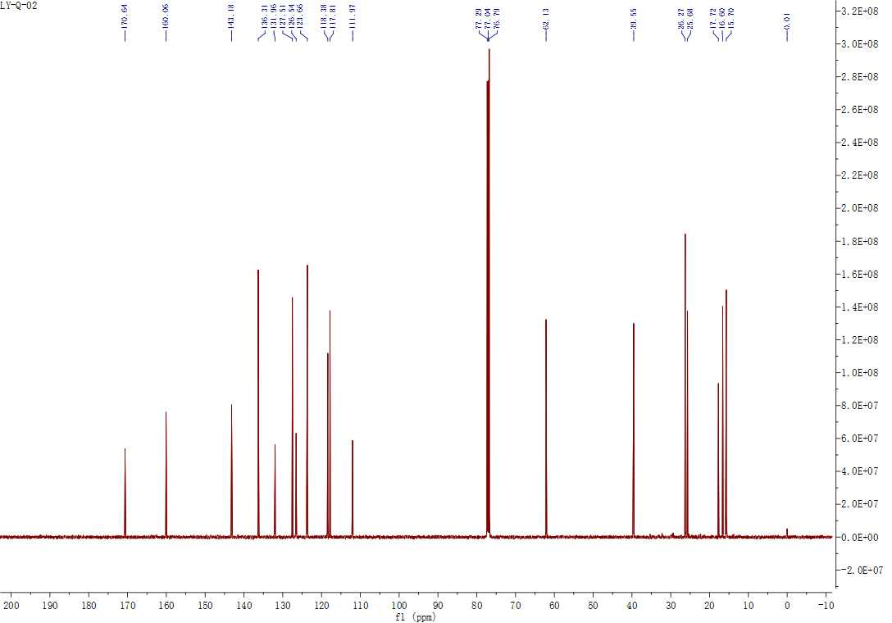

Supplementary Figure 3 (Fig. S3)
HRMS spectra of EβF Analog I

Supplementary Figure 4 (Fig. S4)
¹H NMR spectra of EβF Analog II
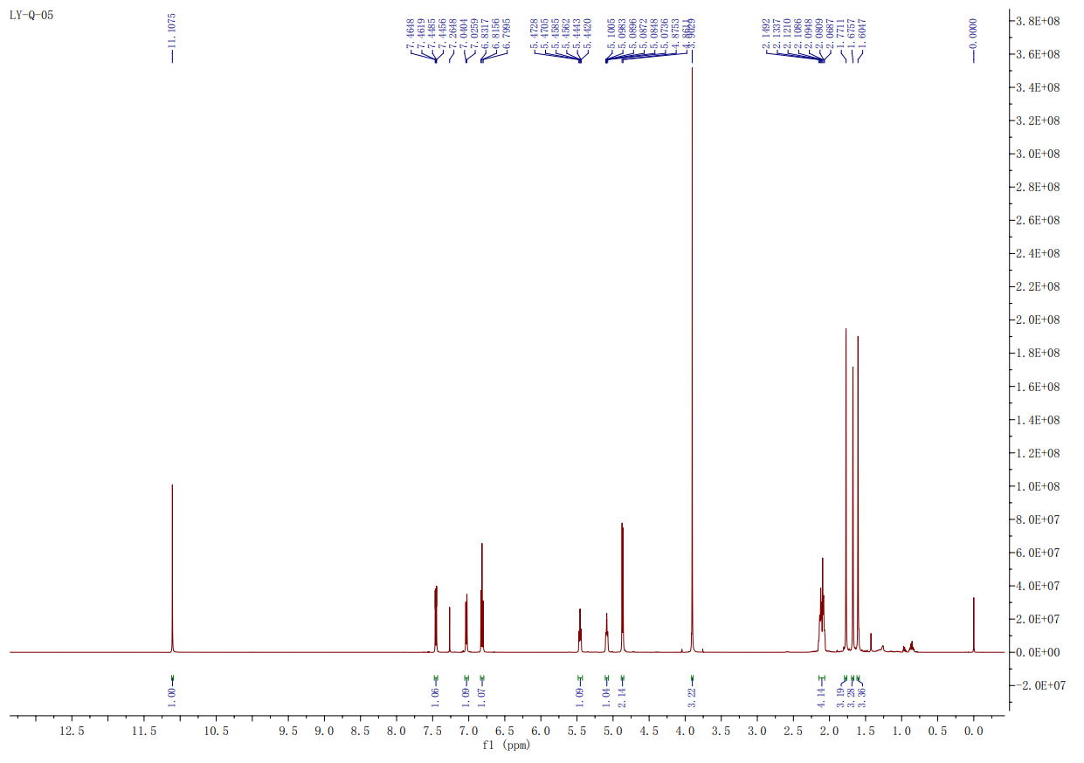

Supplementary Figure 5 (Fig. S5)
¹³C NMR spectra of EβF analogue II
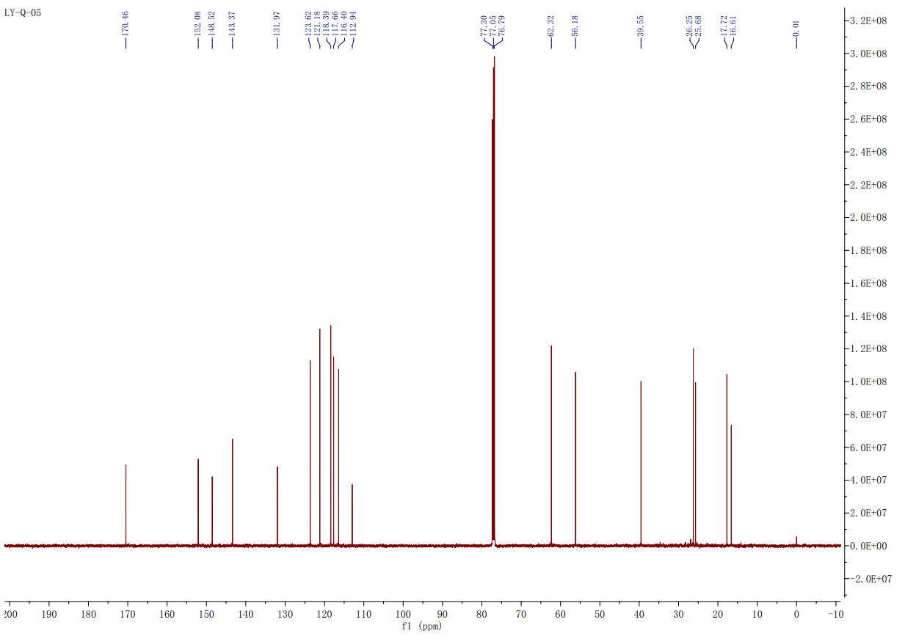

Supplementary Figure 6 (Fig. S6)
HRMS spectra of EβF analogue II

