Supplementary Material

Supplementary Table 1 Demographic information of COAD patients in the present study.
Variables | TCGA-COAD  (Training) | GSE14333  (Validation1) | GSE103479  (Validation2)
Total | 426 | 223 | 154
Gender
Female | 198 | 105 | 68
Male | 228 | 118 | 86
Age
<60 | 120 | 60 | 28
≥60 | 306 | 163 | 124
AJCC stage
I | 73 | - | 0
II | 165 | - | 82
III | 119 | - | 72
VI | 58 | - | 0
Unknow | 11 | - | 0
T stage
T1 | 10 | - | 1
T2 | 74 | - | 6
T3 | 291 | - | 109
T4 | 50 | - | 38
Tis | 1 | - | 0
M stage
M0 | 317 | - | 85
M1 | 58 | - | 0
Mx | 44 | - | 69
Unknow | 7 | - | 0
N stage
N0 | 253 | - | 82
N1 | 99 | - | 50
N2 | 74 | - | 22

Supplementary Table 2 44 membrane tension-related genes.
Number | Gene | Number | Gene
1 | RHOA | 23 | FNBP1
2 | CTNNBIP1 | 24 | MTSS1L
3 | EZR | 25 | TRIP10
4 | RDX | 26 | CRTC2
5 | MSN | 27 | CFL1
6 | MYO1A | 28 | CAPZB
7 | GSK3b | 29 | DIAPH1
8 | FGFR1 | 30 | MYH9
9 | GBF1 | 31 | MYH10
10 | BAIAP2 | 32 | PIEZO1
11 | ARF1 | 33 | SDC4
12 | CDC42 | 34 | PECAM1
13 | ACTR2 | 35 | CDH1
14 | ACTR3 | 36 | ITGB1
15 | PICK1 | 37 | FERMT2
16 | EGF | 38 | TIMP1
17 | CHMP4B | 39 | CAV1
18 | EGFR | 40 | DNM2
19 | TSG101 | 41 | MYO1B
20 | ALIX | 42 | ARHGAP26
21 | SLK | 43 | FLNA
22 | STK10 | 44 | MYO1C

Supplementary Table 3 Multivariate COX regression analysis results of model genes.
Gene | Coef | HR | HR.95L | HR.95H | p Value
CDC42 | -0.04318 | 0.957736 | 0.916508 | 1.000819 | 0.054418
EGFR | 0.032753 | 1.033295 | 1.004365 | 1.063058 | 0.023785
TIMP1 | 0.001374 | 1.001375 | 0.999951 | 1.002802 | 0.058403
CAV1 | 0.011181 | 1.011243 | 1.001203 | 1.021385 | 0.028088

Supplementary Table 4 Molecular docking scores of the three compounds.
Rank | PubChem CID | Compound name | Affinity score  (kcal/mol)
1 | 300471 | Elesclomol | -7.787
2 | 479503 | Shikonin | -7.2
3 | 5280757 | Bryostatin_1 | -7.1

Supplementary Figures
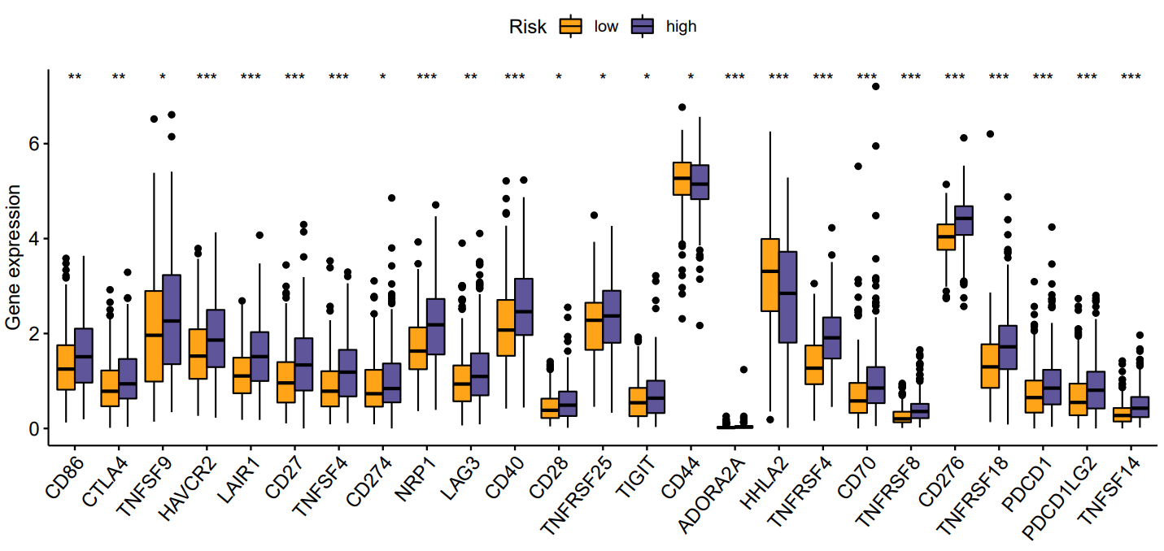
Supplementary Figure 1 The boxplots for the comparison of the immune checkpoints genes between the high-risk and low-risk groups in the colon cancer patients. *p < 0.05, **p < 0.01, and ***p < 0.001.
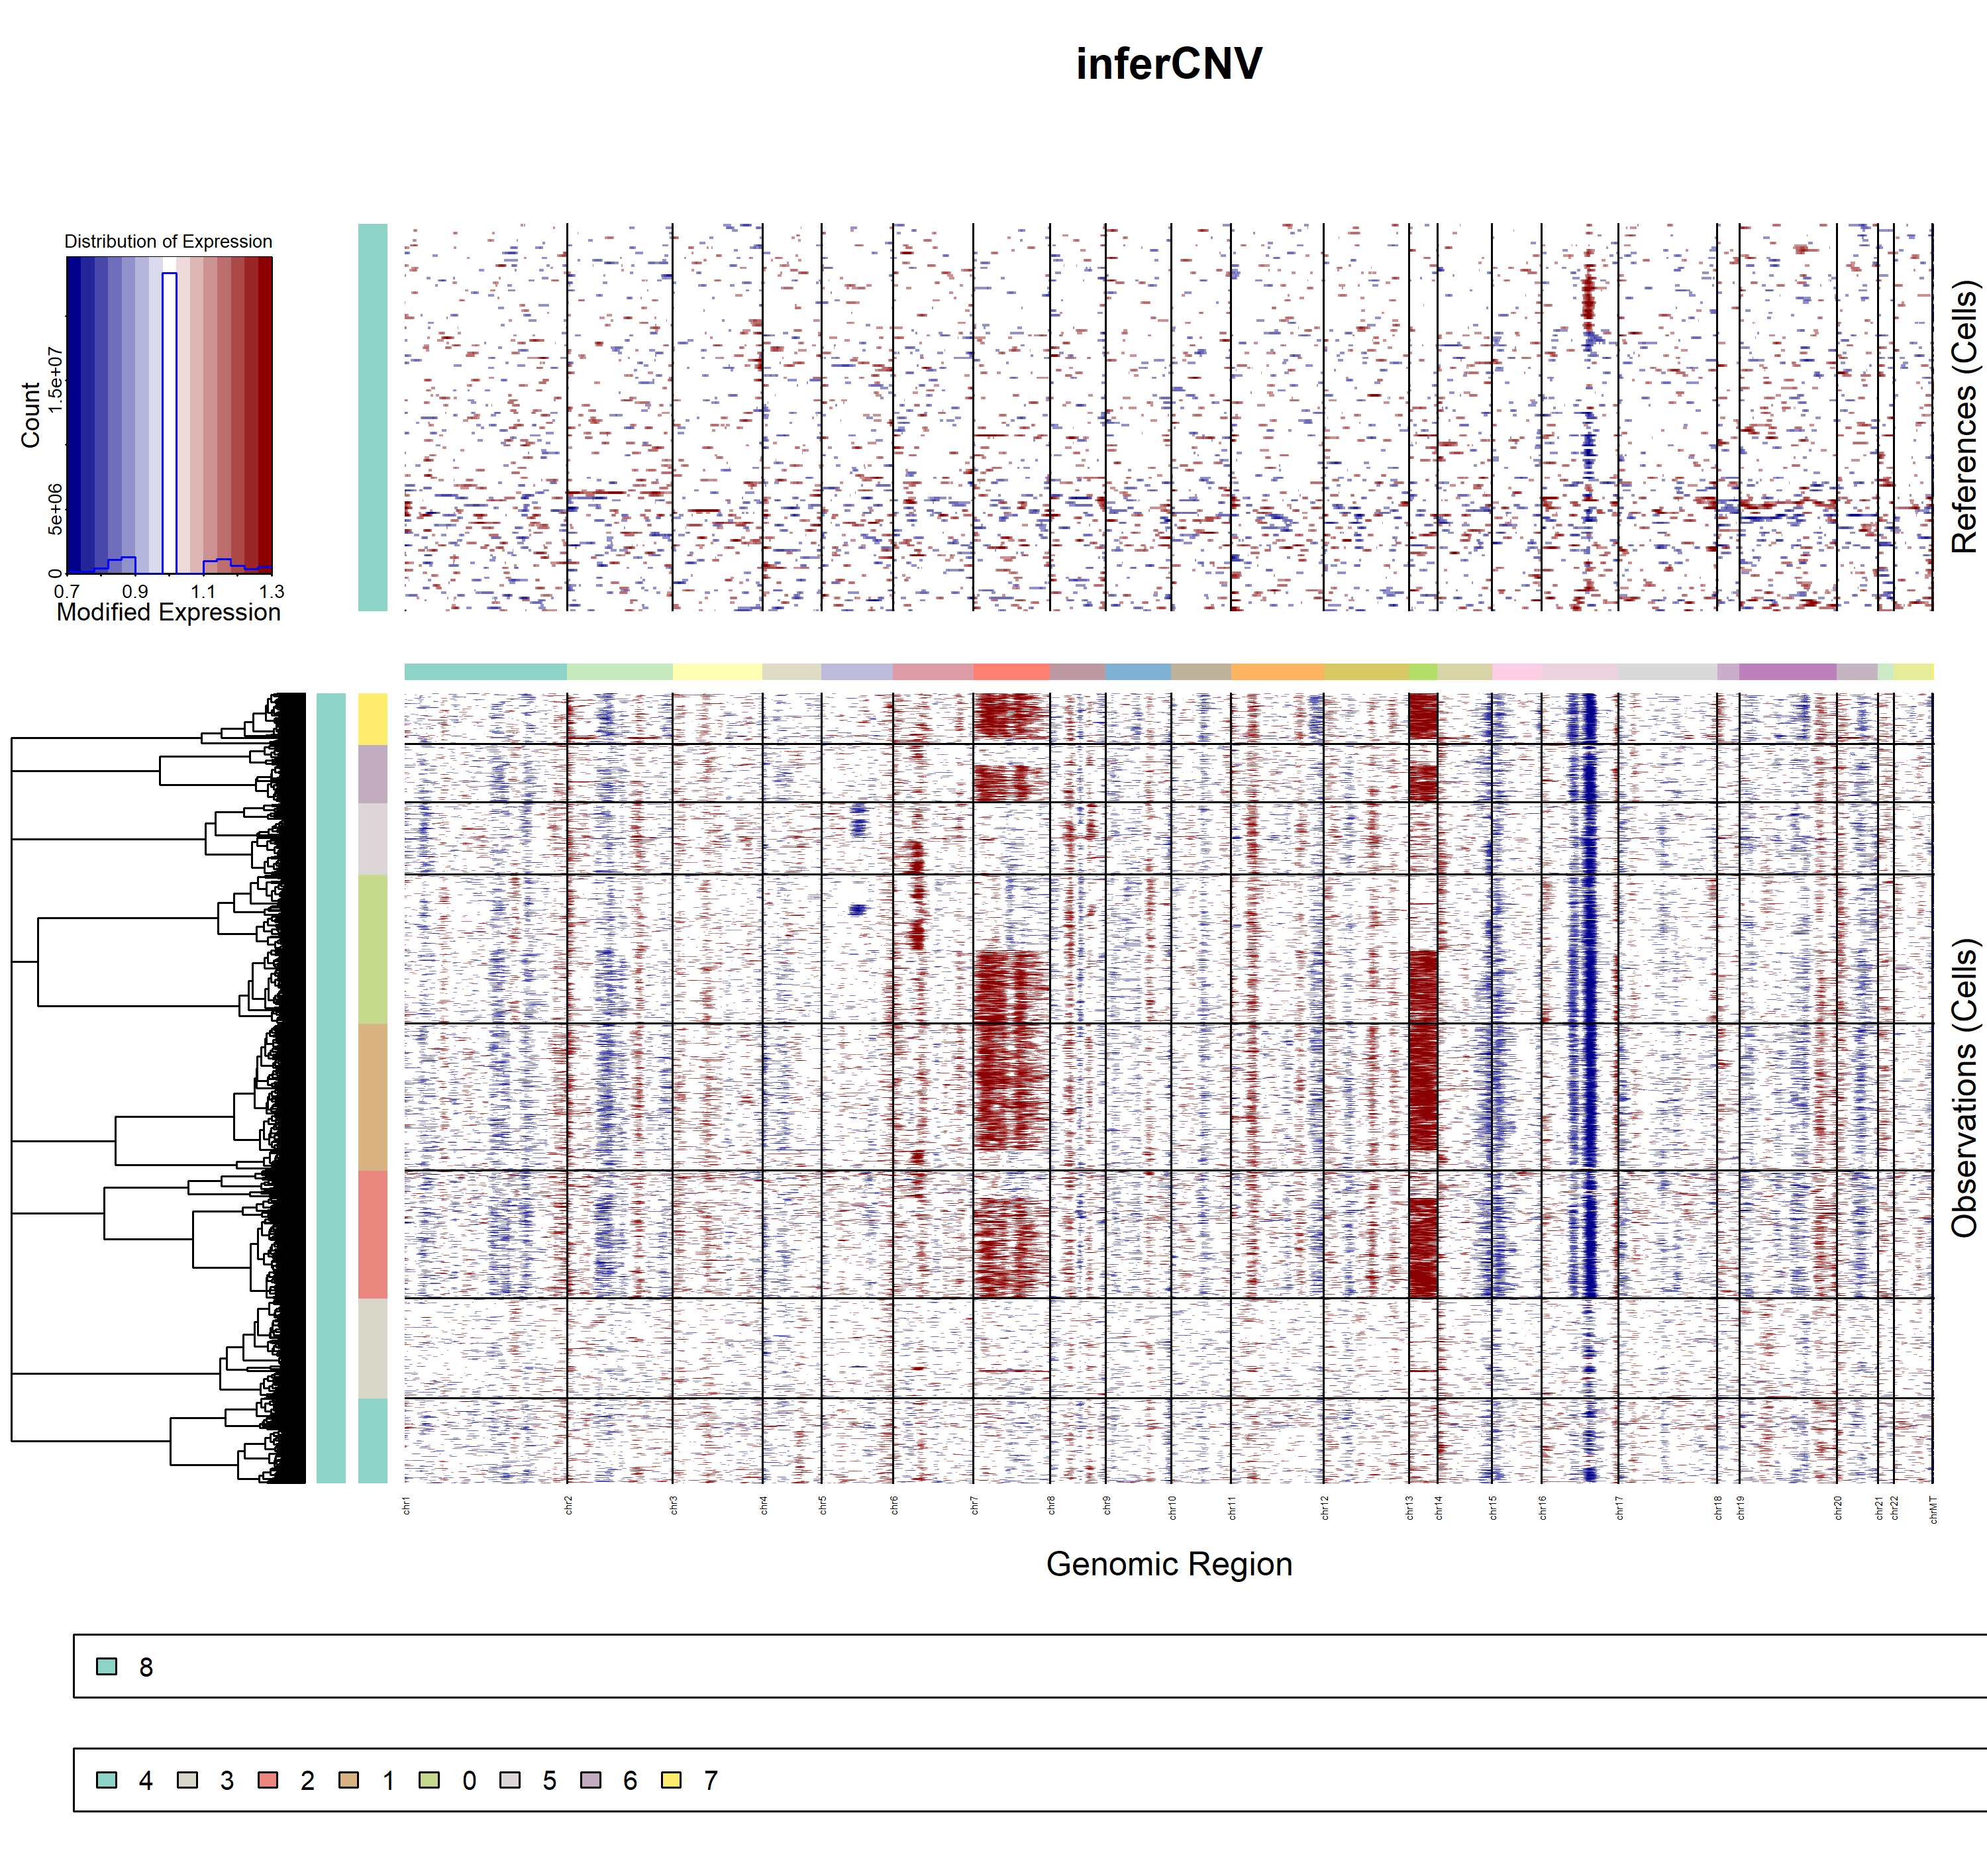
Supplementary Figure 2 InferCNV analysis in epithelial cell subsets.
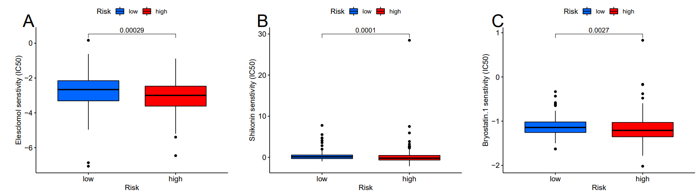
Supplementary Figure 3 Drug sensitivity analysis in the high-risk and low risk groups in colon cancer patients. (A) Elesclomol (B), Shikonin (C) and Bryostatin 1.

