Table 1, population characteristics, values are expressed as number (with corresponding percentage) or median [with interquartile range] :

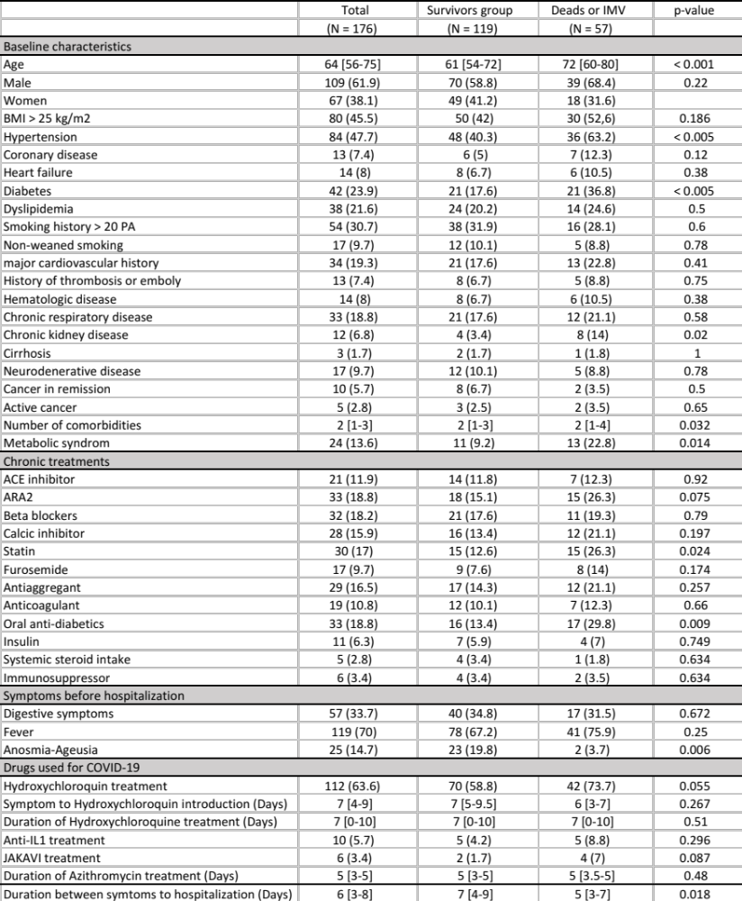

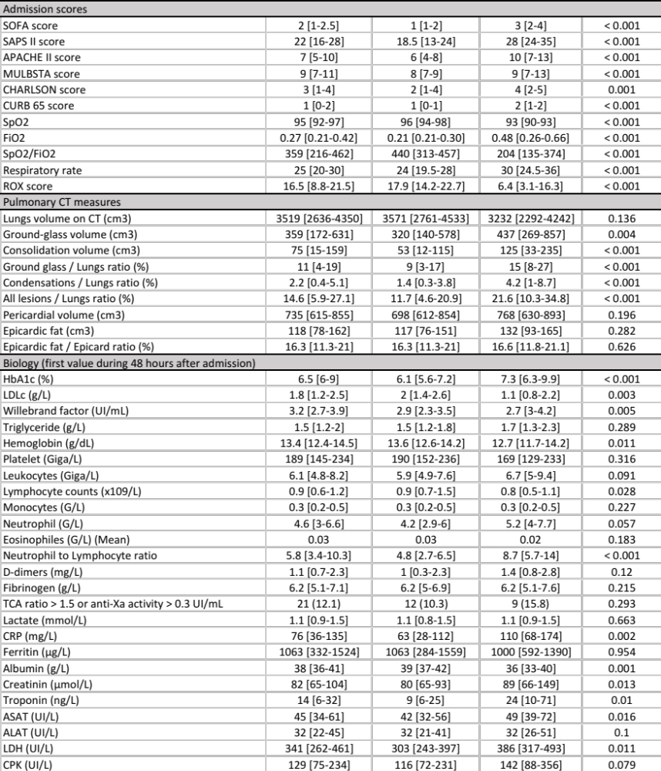

Table 2, Predictors of IMV or death - Multivariate analysis

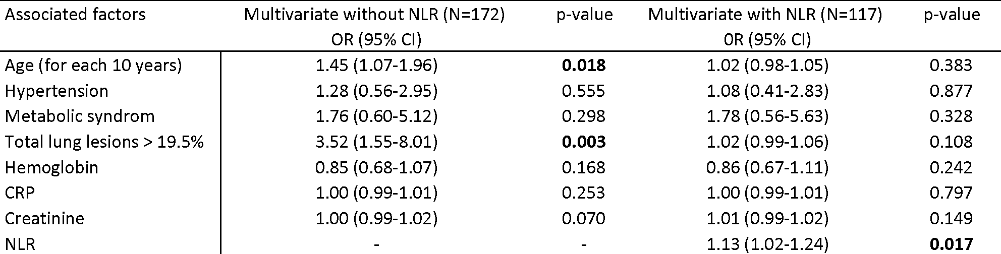

Table 3, Vital and respiratory status at day 15 :

