Supporting Information for

High efficiency electrochemiluminescence for copper(II) and cadmium(II) pyrazolate polymers

Feng-Zhen Hua ª, Chao Feng ^{b}, Wei-Nan Xie ª, Yi-Ni Luo ^{c}, Ling-Mei Zhang ª, Hong Zhao* ª
ª School of Chemistry and Chemical Engineering, Southeast University, Nanjing 211189, China.
^{b} School of Materials and Chemical Engineering, Bengbu University, Bengbu 233030, PR China.
^{c} Shiyan Hydrology and Water Resources Survey Bureau of Hubei Province, Shiyan 442000, China.
*Corresponding author: Hong Zhao
E-mail: zhaohong@seu.edu.cn
Table S1 Selected Bond Lengths (Å) and Bond Angles (°) for complexes 1-2
Figure. S1 The PXRD patterns of complexes 1 and 2
Figure. S2 The 2D fingerprint plots of complex 1
Figure. S3 The 2D fingerprint plots of complex 2
Figure. S4 Electrochemical luminescence for Ru(bpy)₃²⁺

Table S1 Selected Bond Lengths (Å) and Bond Angles (°) for complexes 1-2
1
Cu(1)-N(1)#1 | 1.948(8) | O(1)-Cu(1)#1 | 1.962(7)
Cu(1)-N(2) | 1.950(8) | Cu(1)-O(1)#1 | 1.962(7)
Cu(1)-N(3) | 1.996(8) | N(1)-Cu(1)#1 | 1.948(8)
N(2)-Cu(1)-N(3) | 93.6(3) | O(1)#1-Cu(1)-N(3) | 85.2(3)
N(2)-Cu(1)-O(1)#1 | 171.0(3) | C(3)-N(1)-Cu(1)#1 | 112.0(7)
C(4)-O(1)-Cu(1)#1 | 115.5(7) | N(2)-N(1)-Cu(1)#1 | 139.0(6)
N(1)#1-Cu(1)-N(3) | 167.4(3) | N(1)-N(2)-Cu(1) | 121.6(6)
C(9)-N(3)-Cu(1) | 119.6(7) | C(1)-N(2)-Cu(1) | 129.9(7)
N(1)#1-Cu(1)-N(2) | 98.2(3) | C(5)-N(3)-Cu(1) | 122.6(7)
N(1)#1-Cu(1)-O(1)#1 | 82.4(3)
2
Cd(1)-O(1)#1 | 2.2562(15) | Cd(1)-O(2) | 2.5162(15)
Cd(1)-N(3) | 2.2917(18) | Cd(1)-N(2) | 2.3545(18)
Cd(1)-N(1) | 2.387(2) | O(1)-Cd(1)#2 | 2.2563(15)
Cd(1)-Cl | 2.5284(6)
O(1)#1-Cd(1)-Cl | 94.95(5) | N(1)-Cd(1)-Cl | 159.02(5)
N(2)-Cd(1)-Cl | 96.77(5) | O(2)-Cd(1)-Cl | 81.57(4)
N(3)-Cd(1)-Cl | 98.27(5) | C(5)-N(1)-Cd(1) | 125.77(18)
N(1)-Cd(1)-O(2) | 81.04(6) | C(9)-N(1)-Cd(1) | 115.74(15)
O(1)#1-Cd(1)-N(3) | 111.38(6) | C(11)-N(2)-C(10) | 118.3(2)
O(1)#1-Cd(1)-N(2) | 94.63(6) | C(11)-N(2)-Cd(1) | 124.99(16)
N(3)-Cd(1)-N(2) | 148.50(7) | C(10)-N(2)-Cd(1) | 116.68(15)
O(1)#1-Cd(1)-N(1) | 102.46(7) | C(3)-N(3)-Cd(1) | 119.31(14)
N(3)-Cd(1)-N(1) | 86.31(7) | N(4)-N(3)-Cd(1) | 135.06(14)
N(3)-Cd(1)-O(2) | 68.89(6) | C(4)-O(1)-Cd(1)#2 | 113.41(14)
N(2)-Cd(1)-O(2) | 86.24(6) | C(4)-O(2)-Cd(1) | 114.59(13)
Symmetry code: (1) #1= -x+1,-y+1,-z; (2) #1 = x,-y+1/2,z-1/2 ; #2 = x,-y+1/2,z+1/2

Figure. S1 The PXRD patterns of complexes 1 and 2
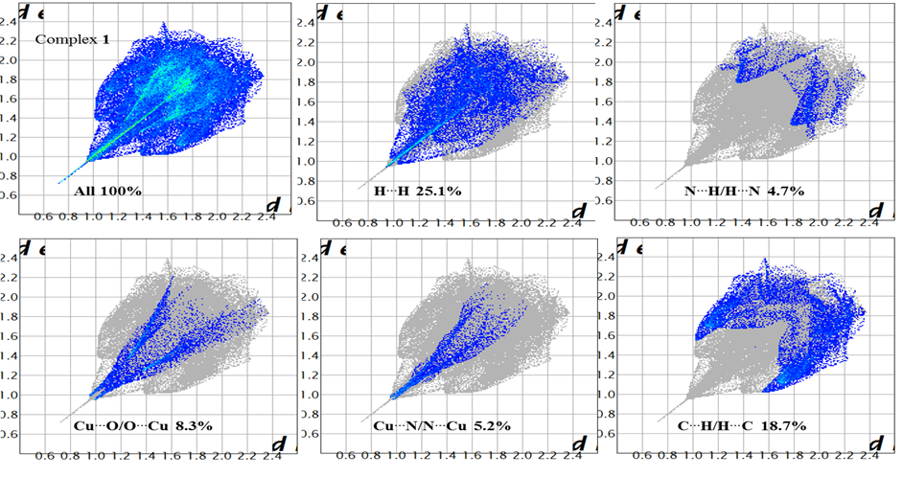
Figure. S2 The 2D fingerprint plots of complex 1

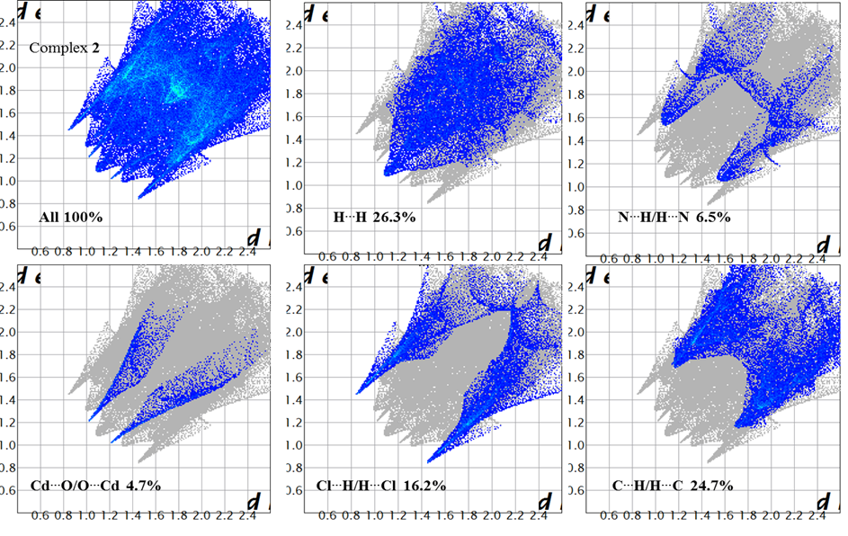
Figure. S3 The 2D fingerprint plots of complex 2

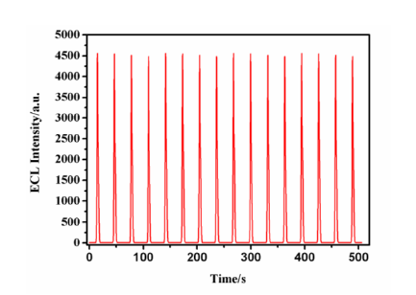
Figure. S4 Electrochemical luminescence for Ru(bpy)₃²⁺

