ESM_1 List of cowpea genotypes used and their origin/source
Entry | Genotypes | Origin/Source
1 | 24-125B-1 | Cameroon
2 | 524B | USA
3 | 58-77 | Senegal
4 | Aloka | Nigeria
5 | B301 | Bostwana
6 | CB27 | USA
7 | CB46 | USA
8 | Danila | Nigerian Landrace
9 | DanMisra | Nigerian Landrace
10 | IAR-48 | IAR-Nigeria
11 | IT00K-1263 | IITA-Nigeria
12 | IT82E-18 | IITA-Nigeria
13 | IT84S-2049 | IITA-Nigeria
14 | IT84S-2246-4 | IITA-Nigeria
15 | IT86D-1010 | IITA-Nigeria
16 | IT89KD-288 | IITA-Nigeria
17 | IT93K-503-1 | IITA-Nigeria
18 | IT97K-499-35 | IITA-Nigeria
19 | IT97K-556-6 | IITA-Nigeria
20 | Kanannado | Nigeria
21 | SAMPEA-17 | IAR-Nigeria
22 | SAMPEA-9 | IAR-Nigeria
23 | Sanzi | Ghana
24 | SuVita2 | Burkina Faso
25 | Tvu-14676 | IITA-Nigeria
26 | Tvu-7778 | IITA-Nigeria
27 | UAM-1055-6 | FUAM-Nigeria
28 | UCR779 | USA
29 | Vita7 | Burkina Faso
30 | Yacine | Senegal

ESM_2 Means of genotypes for shoot parameters measured in the screenhouse experiment under three soil phosphorous concentrations
Entry |  | Genotypes |  | phtHP |  | pht.MP |  | pht.LP |  | sdwt.HP |  | sdwt.MP |  | sdwt.LP |  | shoot.P.HP | shoot.P.MP |  | shoot.P.LP |  | shoot.Zn.HP |  | shoot.Zn.MP |  | shoot.Zn.LP
 | 1 |  | 24-125B-1 |  | 19.5 |  | 12.1 |  | 13.9 |  | 2.7 |  | 0.5 |  | 0.4 | 1350.0 |  | 1472.8 |  | 1254.6 |  | 70.8 |  | 50.7 |  | 74.9
 | 2 |  | 524B |  | 18.5 |  | 14.3 |  | 14.5 |  | 2.4 |  | 0.6 |  | 0.5 | 1663.6 |  | 1718.2 |  | 1809.8 |  | 63.9 |  | 101.3 |  | 102.0
 | 3 |  | 58-77 |  | 18.1 |  | 12.9 |  | 11.9 |  | 1.7 |  | 0.3 |  | 0.2 | 1377.3 |  | 886.4 |  | 709.1 |  | 70.7 |  | 55.5 |  | 69.2
 | 4 |  | Aloka |  | 24.2 |  | 15.3 |  | 15.1 |  | 2.2 |  | 0.4 |  | 0.3 | 1090.9 |  | 975.0 |  | 795.5 |  | 42.7 |  | 45.1 |  | 45.4
 | 5 |  | B301 |  | 36.5 |  | 12.0 |  | 11.0 |  | 1.6 |  | 0.3 |  | 0.2 | 1377.3 |  | 954.6 |  | 722.7 |  | 51.4 |  | 53.6 |  | 27.8
 | 6 |  | CB27 |  | 19.0 |  | 16.0 |  | 16.5 |  | 1.9 |  | 0.5 |  | 0.4 | 1390.9 |  | 927.3 |  | 763.7 |  | 99.6 |  | 89.0 |  | 79.0
 | 7 |  | CB46 |  | 17.8 |  | 15.5 |  | 15.3 |  | 1.8 |  | 0.6 |  | 0.5 | 1077.3 |  | 940.9 |  | 722.7 |  | 101.6 |  | 65.6 |  | 66.5
 | 8 |  | Danila |  | 15.7 |  | 12.7 |  | 12.8 |  | 1.4 |  | 0.5 |  | 0.5 | 900.0 |  | 968.2 |  | 654.6 |  | 101.2 |  | 111.8 |  | 58.5
 | 9 |  | DanMisra |  | 15.9 |  | 10.5 |  | 10.3 |  | 2.2 |  | 0.3 |  | 0.3 | 1186.4 |  | 1512.1 |  | 1363.7 |  | 78.8 |  | 64.3 |  | 58.4
 | 10 |  | IAR-48 |  | 17.8 |  | 12.7 |  | 12.8 |  | 2.4 |  | 0.4 |  | 0.4 | 1254.6 |  | 1322.8 |  | 1350.0 |  | 67.4 |  | 103.2 |  | 73.4
 | 11 |  | IT00K-1263 |  | 20.1 |  | 15.4 |  | 14.3 |  | 3.4 |  | 1.0 |  | 0.6 | 1322.7 |  | 913.6 |  | 777.3 |  | 80.0 |  | 61.7 |  | 82.3
 | 12 |  | IT82E-18 |  | 15.9 |  | 11.3 |  | 12.1 |  | 1.8 |  | 0.3 |  | 0.3 | 859.1 |  | 818.2 |  | 613.6 |  | 90.3 |  | 94.1 |  | 54.9
 | 13 |  | IT84S-2049 |  | 24.1 |  | 18.0 |  | 19.0 |  | 2.3 |  | 0.4 |  | 0.4 | 1554.5 |  | 927.3 |  | 1036.4 |  | 42.2 |  | 34.8 |  | 54.6
 | 14 |  | IT84S-2246-4 |  | 24.4 |  | 23.1 |  | 22.6 |  | 3.2 |  | 0.7 |  | 0.8 | 1200.0 |  | 954.6 |  | 968.2 |  | 41.5 |  | 36.2 |  | 41.9
 | 15 |  | IT86D-1010 |  | 32.2 |  | 16.8 |  | 16.5 |  | 2.3 |  | 0.5 |  | 0.3 | 1281.8 |  | 886.4 |  | 767.1 |  | 33.5 |  | 27.5 |  | 42.8
 | 16 |  | IT89KD-288 |  | 36.7 |  | 24.9 |  | 25.7 |  | 3.0 |  | 0.9 |  | 1.0 | 1104.6 |  | 790.9 |  | 845.5 |  | 39.3 |  | 51.3 |  | 51.6
 | 17 |  | IT93K-503-1 |  | 33.2 |  | 20.0 |  | 20.2 |  | 2.3 |  | 0.5 |  | 0.5 | 1118.2 |  | 722.7 |  | 804.5 |  | 101.3 |  | 271.6 |  | 87.9
 | 18 |  | IT97K-499-35 |  | 20.0 |  | 15.8 |  | 16.0 |  | 2.6 |  | 0.5 |  | 0.4 | 804.5 |  | 850.0 |  | 703.5 |  | 37.9 |  | 31.7 |  | 49.5
 | 19 |  | IT97K-556-6 |  | 21.6 |  | 14.4 |  | 19.5 |  | 2.0 |  | 0.5 |  | 0.4 | 1036.4 |  | 886.4 |  | 763.6 |  | 78.2 |  | 85.9 |  | 64.9
 | 20 |  | Kanannado |  | 33.1 |  | 15.8 |  | 16.0 |  | 1.9 |  | 0.4 |  | 0.3 | 1718.2 |  | 886.4 |  | 790.9 |  | 49.5 |  | 54.1 |  | 42.2
 | 21 |  | SAMPEA-17 |  | 17.7 |  | 12.9 |  | 10.8 |  | 3.1 |  | 0.5 |  | 0.4 | 1527.3 |  | 1090.9 |  | 1104.6 |  | 70.5 |  | 105.6 |  | 84.8
 | 22 |  | SAMPEA-9 |  | 17.9 |  | 10.0 |  | 11.3 |  | 2.4 |  | 0.3 |  | 0.3 | 1418.2 |  | 1322.7 |  | 1133.8 |  | 71.0 |  | 85.8 |  | 67.9
 | 23 |  | Sanzi |  | 45.4 |  | 14.9 |  | 14.6 |  | 2.4 |  | 0.4 |  | 0.3 | 1240.9 |  | 995.5 |  | 958.0 |  | 52.9 |  | 43.9 |  | 55.9
 | 24 |  | SuVita2 |  | 15.1 |  | 12.6 |  | 11.5 |  | 2.6 |  | 0.5 |  | 0.5 | 1322.7 |  | 1186.4 |  | 1133.8 |  | 81.3 |  | 69.2 |  | 158.5
 | 25 |  | Tvu-14676 |  | 22.0 |  | 8.9 |  | 9.0 |  | 2.1 |  | 0.3 |  | 0.2 | 1540.9 |  | 1227.3 |  | 950.6 |  | 45.1 |  | 37.7 |  | 37.4
 | 26 |  | Tvu-7778 |  | 14.5 |  | 12.2 |  | 11.8 |  | 1.3 |  | 0.3 |  | 0.1 | 1363.7 |  | 831.8 |  | 791.1 |  | 101.1 |  | 82.7 |  | 157.0
 | 27 |  | UAM-1055-6 |  | 15.6 |  | 12.2 |  | 12.4 |  | 1.6 |  | 0.4 |  | 0.4 | 1459.1 |  | 1393.4 |  | 1363.7 |  | 80.3 |  | 54.5 |  | 65.1
 | 28 |  | UCR779 |  | 14.1 |  | 10.0 |  | 9.6 |  | 1.6 |  | 0.5 |  | 0.3 | 1131.8 |  | 804.6 |  | 831.8 |  | 80.7 |  | 88.3 |  | 72.8
 | 29 |  | Vita7 |  | 21.6 |  | 11.5 |  | 13.9 |  | 3.0 |  | 0.6 |  | 0.4 | 1363.7 |  | 1527.3 |  | 1050.0 |  | 53.1 |  | 76.7 |  | 157.0
 | 30 |  | Yacine |  | 17.4 |  | 14.2 |  | 14.4 |  | 1.6 |  | 0.5 |  | 0.4 | 1240.9 |  | 927.3 |  | 736.4 |  | 70.5 |  | 68.5 |  | 37.5
 |  |  | Mean |  | 22.2 |  | 14.3 |  | 14.5 |  | 2.2 |  | 0.5 |  | 0.4 | 1275.9 |  | 1054.1 |  | 942.4 |  | 68.3 |  | 73.4 |  | 70.7

ESM_3 Means of cowpea genotypes for shoot parameters measured in the field experiment under three soil phosphorous concentrations
Entry | Genotype | PHTHP | PHTMP | PHTLP | SDWTHP | SDWTMP | SDWTLP | GrainhaHP | GrainhaMP | GrainhaLP | shootpcHP | shootpcMP | shootpcLP | shootznHP | shootznMP | shootznLP | GrainpcHP | GrainpcMP | GrainpcLP | GrainZnHP | GrainZnMP | GrainZnLP
1 | 24-125B-1 | 26.0 | 21.4 | 16.8 | 81.4 | 38.9 | 21.1 | 1098.35 | 375.3 | 297.3 | 1079.6 | 1335.2 | 909.1 | 85.5 | 123.8 | 84.7 | 2965.9 | 2420.5 | 2522.8 | 47.0 | 62.8 | 48.5
2 | 524B | 44.8 | 22.9 | 15.5 | 61.0 | 38.9 | 19.3 | 569.15 | 385.9 | 112.0 | 1590.9 | 1306.8 | 1108.0 | 76.1 | 93.1 | 97.2 | 3068.2 | 2454.6 | 2215.9 | 22.1 | 17.6 | 34.5
3 | 58-77 | 34.5 | 22.9 | 16.0 | 85.2 | 38.9 | 20.1 | 1137.7 | 152.0 | 209.3 | 1051.1 | 1363.7 | 1420.5 | 107.6 | 80.3 | 75.6 | 2318.2 | 2420.5 | 2250.0 | 20.9 | 30.4 | 36.4
4 | Aloka | 28.9 | 21.7 | 15.4 | 73.7 | 38.9 | 19.5 | 943.1 | 534.5 | 238.0 | 1051.1 | 1335.2 | 1420.5 | 77.9 | 92.1 | 79.9 | 2488.7 | 2181.8 | 2079.6 | 17.9 | 32.3 | 16.4
5 | B301 | 22.6 | 20.8 | 13.2 | 80.2 | 38.9 | 20.9 | 1295.65 | 1135.1 | 371.3 | 880.7 | 738.6 | 681.8 | 61.4 | 93.4 | 106.1 | 2079.6 | 2250.0 | 2011.4 | 15.5 | 9.0 | 20.4
6 | CB27 | 37.1 | 23.0 | 20.1 | 64.5 | 38.9 | 19.8 | 605.9 | 314.9 | 146.4 | 1448.9 | 1278.4 | 1306.8 | 94.2 | 99.2 | 100.7 | 3000.0 | 2863.7 | 2318.2 | 37.1 | 70.2 | 37.5
7 | CB46 | 54.7 | 24.9 | 16.6 | 71.7 | 38.9 | 19.9 | 736.8 | 396.2 | 162.0 | 1534.1 | 1221.6 | 1448.9 | 107.9 | 82.0 | 121.1 | 2625.0 | 3170.5 | 2352.3 | 27.0 | 35.0 | 23.4
8 | Danila | 27.2 | 21.0 | 13.3 | 119.1 | 38.9 | 20.2 | 1639.65 | 627.3 | 140.0 | 994.3 | 1335.2 | 1079.6 | 93.7 | 123.5 | 122.5 | 1772.8 | 1704.6 | 1363.7 | 32.5 | 38.2 | 36.2
9 | DanMisra | 27.3 | 22.2 | 16.7 | 127.6 | 38.9 | 22.1 | 2105.45 | 459.9 | 571.9 | 1278.4 | 1306.8 | 1164.8 | 57.8 | 118.1 | 136.4 | 1977.3 | 2965.9 | 1909.1 | 31.1 | 24.2 | 39.4
10 | IAR-48 | 35.0 | 22.5 | 15.3 | 116.5 | 38.9 | 21.9 | 1547.1 | 421.9 | 388.7 | 1022.7 | 1136.4 | 994.3 | 75.5 | 108.3 | 103.4 | 1602.3 | 1670.5 | 1636.4 | 41.1 | 22.6 | 26.3
11 | IT00K-1263 | 29.4 | 21.1 | 15.8 | 135.2 | 38.9 | 19.6 | 2070.8 | 321.9 | 212.0 | 1022.7 | 994.3 | 852.3 | 78.8 | 105.7 | 82.8 | 2522.8 | 2863.7 | 2386.4 | 26.2 | 24.0 | 39.2
12 | IT82E-18 | 24.5 | 20.9 | 15.8 | 90.8 | 38.9 | 21.3 | 1171.05 | 643.9 | 519.2 | 1534.1 | 1306.8 | 1534.1 | 116.0 | 93.7 | 100.7 | 2761.4 | 2761.4 | 2284.1 | 40.7 | 37.2 | 31.7
13 | IT84S-2049 | 33.7 | 22.4 | 16.0 | 91.5 | 38.9 | 19.5 | 1560.95 | 595.2 | 188.7 | 1335.2 | 1363.7 | 1335.2 | 96.0 | 72.2 | 97.1 | 3170.5 | 2659.1 | 2454.6 | 31.1 | 38.2 | 43.1
14 | IT84S-2246-4 | 26.3 | 21.6 | 15.7 | 85.4 | 38.9 | 20.5 | 1296.35 | 324.6 | 447.2 | 937.5 | 1108.0 | 965.9 | 80.0 | 86.7 | 100.1 | 2522.8 | 2420.5 | 2522.8 | 15.4 | 18.7 | 21.6
15 | IT86D-1010 | 65.0 | 25.3 | 23.2 | 113.4 | 38.9 | 21.5 | 2357.4 | 1037.8 | 484.6 | 880.7 | 965.9 | 1022.7 | 78.8 | 116.6 | 90.8 | 2488.7 | 2181.8 | 2250.0 | 31.1 | 40.7 | 42.8
16 | IT89KD-288 | 24.2 | 20.8 | 12.6 | 98.6 | 38.9 | 19.0 | 1475 | 599.2 | 99.9 | 1448.9 | 1392.1 | 1448.9 | 103.7 | 123.2 | 132.8 | 1977.3 | 1670.5 | 1840.9 | 43.7 | 39.2 | 36.2
17 | IT93K-503-1 | 36.9 | 21.1 | 14.6 | 97.3 | 38.9 | 19.8 | 1482.9 | 344.3 | 288.8 | 1164.8 | 1221.6 | 1278.4 | 96.2 | 107.1 | 132.1 | 1977.3 | 1840.9 | 1704.6 | 13.7 | 8.0 | 14.6
18 | IT97K-499-35 | 27.1 | 22.2 | 17.2 | 80.3 | 38.9 | 20.2 | 1261.05 | 925.1 | 289.3 | 965.9 | 994.3 | 1079.6 | 80.0 | 88.9 | 117.8 | 2556.8 | 1772.8 | 1875.0 | 39.5 | 34.6 | 30.3
19 | IT97K-556-6 | 30.1 | 21.3 | 15.7 | 76.4 | 38.9 | 22.2 | 913.3 | 283.8 | 550.7 | 1619.3 | 965.9 | 1278.4 | 125.3 | 68.2 | 93.5 | 2420.5 | 2454.6 | 2284.1 | 23.6 | 20.9 | 47.9
20 | Kanannado | 31.7 | 22.0 | 15.4 | 81.9 | 38.9 | 22.7 | 1375.7 | 1577.0 | 329.3 | 1079.6 | 1136.4 | 1079.6 | 79.9 | 89.2 | 117.2 | 1943.2 | 2284.1 | 2488.7 | 23.5 | 20.9 | 45.7
21 | SAMPEA-17 | 30.4 | 22.8 | 14.6 | 105.3 | 38.9 | 19.8 | 1661.6 | 427.2 | 177.3 | 1306.8 | 1392.1 | 1193.2 | 101.9 | 88.1 | 118.1 | 2284.1 | 2113.7 | 1977.3 | 26.5 | 32.7 | 29.7
22 | SAMPEA-9 | 29.7 | 21.5 | 15.2 | 143.3 | 38.9 | 24.8 | 1644.25 | 921.1 | 672.5 | 1079.6 | 1136.4 | 1022.7 | 83.2 | 77.6 | 115.4 | 1772.8 | 2011.4 | 1772.7 | 32.0 | 36.9 | 37.8
23 | Sanzi | 29.9 | 24.6 | 15.7 | 84.0 | 38.9 | 20.9 | 1994.85 | 547.2 | 409.9 | 1221.6 | 909.1 | 1051.2 | 69.9 | 75.5 | 95.6 | 2454.6 | 2181.8 | 2284.1 | 27.2 | 31.0 | 34.2
24 | SuVita2 | 25.3 | 21.8 | 14.3 | 90.6 | 38.9 | 19.5 | 1400.3 | 633.2 | 148.0 | 1363.7 | 1221.6 | 994.3 | 86.0 | 129.3 | 109.0 | 2863.7 | 2488.7 | 2454.6 | 24.7 | 26.6 | 33.5
25 | Tvu-14676 | 28.3 | 21.1 | 13.6 | 64.2 | 38.9 | 19.8 | 575.9 | 233.6 | 256.1 | 1164.8 | 1448.9 | 1278.4 | 83.8 | 84.9 | 113.3 | 1806.8 | 2147.8 | 2181.8 | 28.4 | 32.6 | 60.6
26 | Tvu-7778 | 35.3 | 22.2 | 17.0 | 108.8 | 38.9 | 19.1 | 1650.95 | 676.1 | 154.6 | 1278.4 | 1079.6 | 795.5 | 117.8 | 117.7 | 136.4 | 2522.8 | 2352.3 | 1943.2 | 26.1 | 29.3 | 19.4
27 | UAM-1055-6 | 32.2 | 20.3 | 14.7 | 93.4 | 38.9 | 20.6 | 1898.35 | 327.1 | 334.9 | 937.5 | 767.1 | 1108.0 | 74.0 | 86.4 | 85.1 | 2522.8 | 2284.1 | 1568.2 | 31.6 | 31.2 | 40.7
28 | UCR779 | 23.7 | 20.2 | 12.5 | 93.6 | 38.9 | 19.5 | 1197.05 | 232.0 | 22.2 | 1022.7 | 937.5 | 789.6 | 104.9 | 100.1 | 70.4 | 2284.1 | 2250.0 | 2045.5 | 31.4 | 19.0 | 21.1
29 | Vita7 | 32.9 | 22.2 | 15.7 | 142.9 | 38.9 | 22.8 | 2006.85 | 619.9 | 409.9 | 1108.0 | 1022.7 | 994.3 | 87.3 | 80.7 | 96.2 | 2079.6 | 1704.6 | 1738.7 | 41.9 | 48.7 | 55.4
30 | Yacine | 23.4 | 20.6 | 14.1 | 76.3 | 38.9 | 20.4 | 1524.95 | 695.2 | 191.3 | 1108.0 | 1164.8 | 1335.2 | 79.2 | 99.6 | 86.3 | 2215.9 | 2045.5 | 2488.7 | 30.0 | 33.1 | 23.6
 | Mean | 30.9 | 21.8 | 15.2 | 96.1 | 38.9 | 20.7 | 1495.2 | 590.9 | 293.8 | 1150.6 | 1100.1 | 1083.6 | 90.9 | 95.6 | 104.5 | 2276.5 | 2136.4 | 2081.5 | 29.0 | 29.0 | 34.2

ESM_4. Trait correlations between dry biomass yield and P & Zn content of shoot and root of genotypes evaluated in the screenhouse under varying soil P rates, * denotes significance at p ≤0.05, ** denotes significant at p ≤0.01, *** denotes significance at p < 0.01 and metrics without significant correlations are without asterik.
 | sdwt.  lp | rdwt.  lp | shoot.  P.lp | shoot.  Zn.lp | root.  P.lp | root.  Zn.lp | pht.  mp | sdwt.  mp | rdwt.  mp | shoot.  P.mp | shoot.  Zn.mp | rootPmp | root.  Zn.mp | sdwt.  hp | rdwt.  hp | shoot.  P.hp | shoot.  Zn.hp
rdwt.lp | 0.53**
shoot.P.lp | -0.01 | -0.02
shoot.Zn.lp | 0.02 | 0.01 | -0.06
root.P.lp | -0.09 | -0.24 | 0.34* | -0.06
root.Zn.lp | 0.14 | 0.14 | -0.12 | 0.05 | -0.14
sdwt.mp | 0.60** | 0.37* | -0.14 | 0.27* | -0.05 | 0.12 | 0.12
rdwt.mp | 0.38* | 0.59** | -0.14 | 0.30* | -0.16 | 0.21 | -0.08 | 0.72***
shoot.P.mp | -0.09 | -0.01 | 0.58** | -0.07 | 0.30* | 0.00 | -0.08 | -0.19* | -0.15
shoot.Zn.mp | 0.01 | 0.08 | -0.15 | 0.14 | -0.18* | 0.15 | -0.02 | 0.10 | 0.17* | -0.09
root.P.mp | -0.01 | -0.10 | 0.26* | -0.03 | 0.70*** | -0.12 | -0.12 | -0.01 | -0.12 | 0.30* | -0.13
root.Zn.mp | -0.06 | 0.05 | -0.20 | 0.02 | -0.12 | 0.25* | -0.12 | 0.10 | 0.21 | -0.10 | 0.36* | -0.11
sdwt.hp | 0.28** | 0.18* | 0.00 | 0.16 | 0.01 | 0.01 | 0.25** | 0.39* | 0.29** | 0.11 | -0.02 | 0.10 | -0.13
rdwt.hp | 0.07 | 0.34* | -0.04 | 0.17 | -0.08 | 0.08 | 0.01 | 0.27* | 0.46** | 0.16 | 0.06 | 0.03 | -0.01 | 0.68***
shoot.P.hp | -0.11 | -0.09 | 0.51** | 0.02 | 0.39* | -0.07 | 0.06 | -0.15 | -0.16 | 0.46* | -0.10 | 0.31* | -0.07 | -0.02 | -0.07
shoot.Zn.hp | -0.08 | 0.06 | -0.13 | 0.16 | -0.17 | 0.33* | -0.22** | -0.02 | 0.13 | -0.01 | 0.27** | -0.11 | 0.28** | -0.13 | 0.01 | 0.04
root.Ph.p | -0.08 | 0.02 | 0.00 | 0.03 | 0.18* | 0.00 | 0.05 | -0.06 | -0.01 | 0.18* | -0.03 | 0.19* | -0.01 | 0.15 | 0.17 | 0.22 | 0.01
root.Zn.hp | -0.06 | 0.05 | -0.24 | -0.12 | -0.23* | 0.29* | -0.12 | -0.08 | -0.01 | -0.09 | 0.25* | -0.19 | 0.26* | -0.20 | -0.19 | -0.08 | 0.35*

ESM_5. Trait correlations between grain yield and P & Zn content of shoot and grain of genotypes evaluated in the field under varying soil P rates, * denotes significance at p ≤0.05, ** denotes significant at p ≤0.01, *** denotes significance at p < 0.01 and metrics without significant correlations are without asterik.
 | sdwt.  lp | grain.  lp | shoot.  P.lp | shoot.  zn.lp | seed.  P.lp | seed.  Zn.lp | sdwt.  mp | grain.  mp | shoot.P.  mp | shoot.  zn.mp | seed  P.mp | seed.  zn.mp | sdwt.  hp | grain.  hp | shoot.  P.hp | shoot.  Zn.hp
grain.lp | 0.85***
shoot.P.lp | -0.16 | -0.09
shoot.Zn.lp | 0.11 | 0.14 | 0.11
seed.p.lp | 0.08 | 0.12 | 0.11 | -0.25
seed.Zn.lp | 0.38* | 0.34* | 0.04 | 0.01 | 0.23
sdwt.mp | 0.38* | 0.31* | -0.19 | 0.17 | -0.04 | 0.18
grain.mp | 0.38* | 0.33* | -0.16 | 0.17 | 0.12 | 0.16 | 0.86***
shoot.P.mp | -0.04 | -0.07 | 0.38* | 0.23 | 0.0 | 0.0 | -0.1 | -0.2
shoot.Zn.mp | -0.06 | 0.00 | -0.24 | 0.13 | 0.0 | -0.1 | 0.0 | 0.10 | 0.10
seed.P.mp | -0.14 | -0.06 | 0.13 | -0.13 | 0.31* | 0.05 | -0.10 | -0.16 | 0.15 | -0.20
seed.Zn.mp | 0.12 | 0.06 | 0.14 | -0.05 | 0.21 | 0.59*** | 0.14 | 0.05 | 0.13 | -0.07 | 0.07
sdwt.hp | 0.47** | 0.33* | -0.20 | 0.15 | -0.29* | 0.21287 | 0.36* | 0.13 | -0.11 | 0.05 | -0.16 | 0.11
grain.hp | 0.31* | 0.21 | -0.20 | 0.07 | -0.14 | 0.12 | 0.27* | 0.18 | -0.25 | 0.03 | -0.17 | -0.01 | 0.81***
shoot.P.hp | -0.29* | -0.28* | 0.42** | 0.21 | 0.04 | -0.09 | -0.16 | -0.17 | 0.34* | -0.17 | 0.35* | -0.04 | -0.24 | -0.24
shoot.Zn.hp | -0.10 | -0.07 | 0.24 | -0.01 | -0.01 | -0.25 | -0.09 | -0.13 | 0.18 | 0.25 | 0.01 | -0.15 | -0.16 | -0.31* | 0.26*
seed.P.hp | -0.29* | -0.16 | 0.09 | -0.26 | 0.42** | 0.06 | -0.12 | -0.12 | 0.05 | -0.14 | 0.46** | 0.34* | -0.25 | -0.13 | 0.24 | -0.09
seed.Zn.hp | 0.18 | 0.24 | 0.08 | 0.06 | 0.08 | 0.60*** | 0.21 | 0.16 | 0.05 | -0.03 | -0.11 | 0.78*** | 0.23 | 0.10 | -0.14 | -0.26*

ESM_6 Formulae used for computation of relative reduction (%), phosphorus and zinc content of samples
Phosphorus content (mg/kg) | $$Phosphorous content of samples \left(\frac{mg}{kg}\right)= \frac{ Standard curve factor×Volume of solution×Dilution factor × Absorbent value}{Weight of sample in grams}$$
Relative difference (%) | $$Relative difference (\%)= \frac{High P value-Low P value}{High P value} ×100$$
Zinc content (ppm) | $$Zinc content of samples (ppm)= \frac{AAS reading×Volume of solution × Dilution factor }{Weight of sample in grams}$$

Supplementary Figures
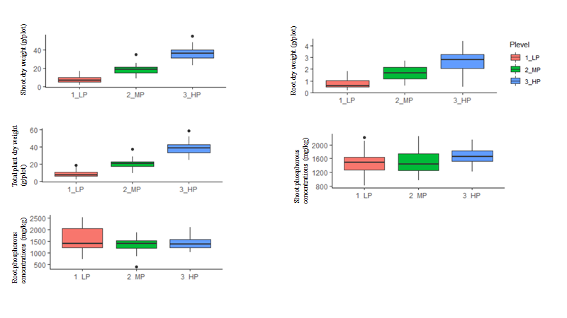
Supplementary Figure 1. Phenotypic distribution of traits measured in the field experiment at vegetative stage under varying soil phosphorous levels. Boxplot displays the median of each group bounded by the first and third quartile, with 1_LP = no-P application, 2_MP = 10 kg P₂O₅ ha⁻¹ & 3_HP = 60 kg P P₂O₅ ha⁻¹

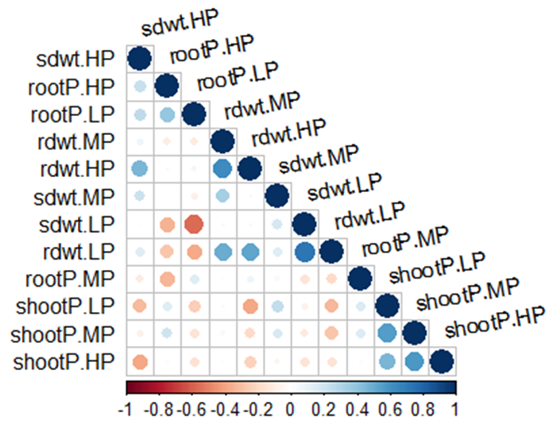
Supplementary Figure 2. Correlation matrices for traits measured across varying soil phosphorus concentrations in the field experiment at the vegetative stage (n = 30 genotypes). See Table 1 for list and abbreviations of the traits. Positive and negative associations between given traits are in blue and red, respectively. The color intensity and the size of the circle are proportional to the correlation coefficients. On the x-axis of the correlogram, the legend colour shows the correlation coefficients and the corresponding colours.

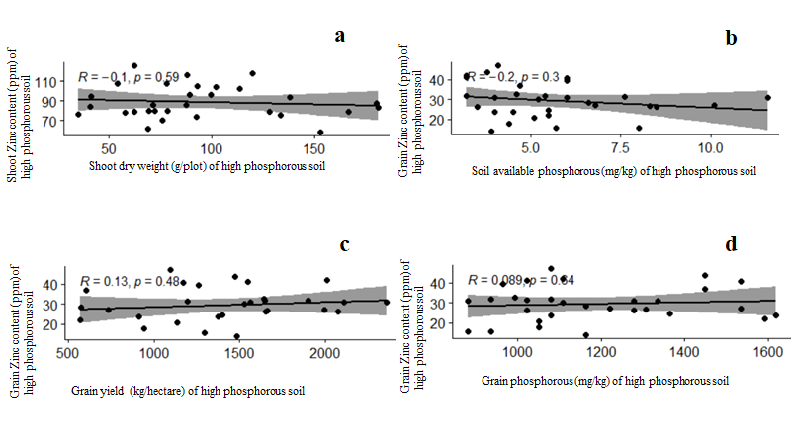
Supplementary Figure 3. Scatterplot showing weak correlations between pairs of traits from the field evaluation (A) Shoot dry weight (g/plot) and shoot Zinc content (ppm) of high phosphorous soil, R2 = -0.1; P = 0.59, (B) Soil available phosphorous (mg/kg) and grain Zinc content (ppm), R2 = -0.2, P = 0.3, (C) Grain yield (kg/hectare) and grain Zinc content (ppm), R2 = 0. 13, P = 0.48, (D) Grain phosphorous (mg/kg) and grain Zinc content (ppm), R2 = 0.089, P = 0.64. Each point represents average of a genotype.

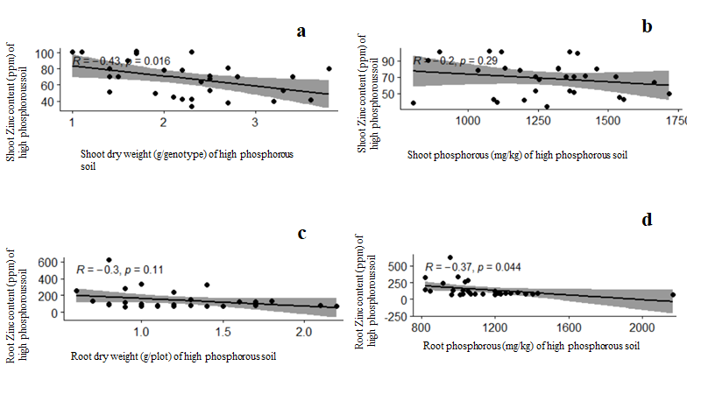
Supplementary Figure 4. Scatterplot showing weak correlations between pairs of traits from the screenhouse evaluation (A) Shoot dry weight (g/genotype) and shoot Zinc content (ppm) of high phosphorous soil, R2 = -0.43; P = 0.016, (B) Shoot phosphorous (mg/kg) and shoot Zinc content (ppm), R2 = -0.2, P = 0.29, (C) Root dry weight (g/genotype) and root Zinc content (ppm), R2 = -0. 3, P = 0.11, (D) Root phosphorous (mg/kg) and root Zinc content (ppm), R2 = 0.37, P = 0.0.44. Each point represents average of a genotype.

