Supplementary Material
Contents
Figure S1: SARS-cov2 Variants in Israel during the Study Period 2
Table S1: Components of the Risk Score Model 3
Data Sources 4
Explanation on the Socio-Economic Status (SES) Measure 5
Table S2: Association between participant characteristics and nirmatrelvir uptake* 6
Table S3: HR of Hospitalization, Ages 40-64, No Prior Immunity 8
Table S4: HR of Hospitalization, Ages 40-64, With Prior Immunity 9
Table S5: HR of Hospitalization, Ages 65+, No Prior Immunity 10
Table S6: HR of Hospitalization, Ages 65+, With Prior Immunity 11
Table S7: HR of Covid-19 death, Ages 65+ 12
Table S8: HR of Covid-19 death, Ages 40-64 13
References 14

Figure S1: SARS-cov2 Variants in Israel during the Study Period

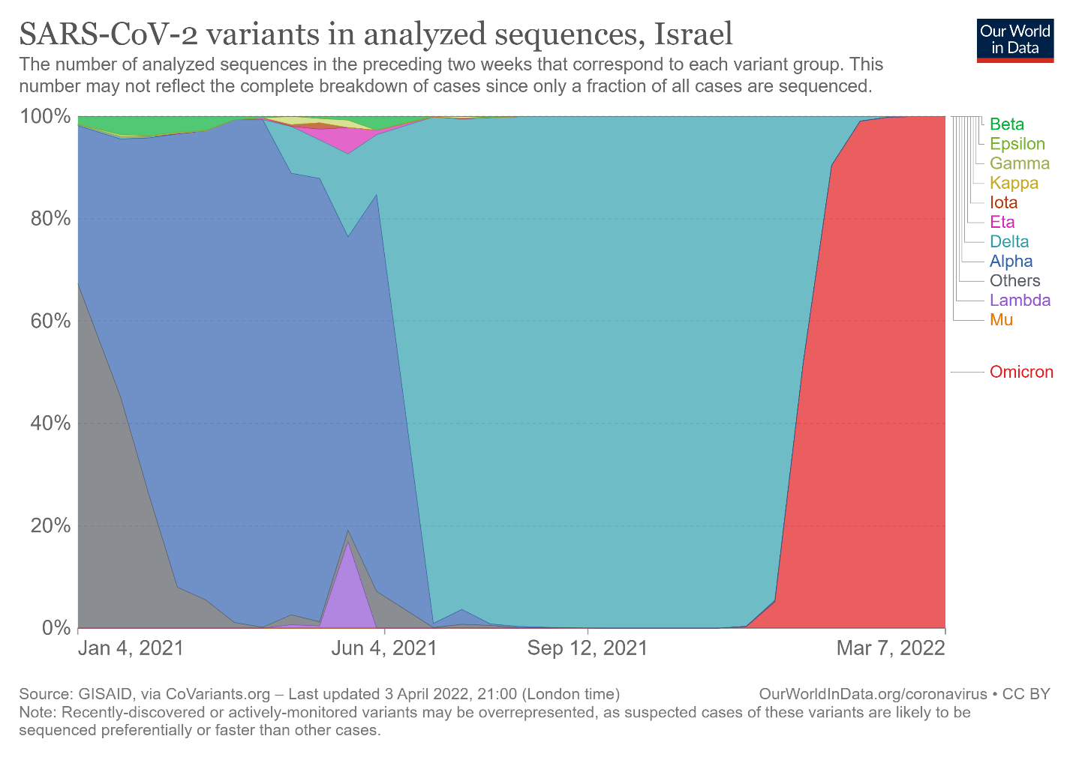

Table S1: Components of the Risk Score Model

Risk Criteria | Risk Score
Age >= 70 | Adds 2 points
Age 50-59 inclusive | Removes 1 point
Age 40-49 inclusive | Removes 3 points
Unvaccinated or a single dose of vaccine | Adds 5 points
Immunosuppression* (including indviduals between ages 12 and 40, who otherwise are not included in the intervention list) | Adds 7 points
Hospitalization in the past 3 years | Adds 1 point (Each hospitalization event)
COPD or >10 pack years | Adds 1 point
BMI > 30 | Adds 1 point
Heart disease, vascular disease or cerbrovascular disease | Adds 1 point
Renal Disease | Adds 1 point
Hepatic Disease | Adds 1 point
Neurological Disease | Adds 1 point
Active Malignancy | Adds 1 point
Diabetes | Adds 1 point
Organ Transplant | Adds 1 point
Bone Marrow Transplant or previous splenectomy or AIDS patient or HIV carrier | Adds 1 point
Treatment at least twice with immunosuppressants in the last year or steroid treatment at least twice in the last year | Adds 1 point
Immunosuppression*
Bone marrow transplant
Combined Anti-Retroviral Therapy (CAR-T)
Chronic Lymphocytic Leukemia
Acute Lymphocytic Leukemia
Multiple Myeloma
Non-Hodgkin Lymphoma
Aplastic Anemia
Hodgkin Lymphoma / Myelodysplastic Syndrome / Acute Myeloid Leukemia + hematological treatment
Myeloproliferative Disease + ruxolitinib treatment
Rutixumab treatment

Data Sources

Data in this study comes from the electronic medical records of Clalit Health
Services (CHS). CHS is the largest of four integrated payer-provider health care
organizations that provide mandatory health care coverage in Israel. CHS covers
approximately 52% of the population of Israel (4.7 million persons). The dropout
rate from CHS is 1- 2% yearly (1).
CHS pools the data from its many operational systems into a unified central data warehouse used for policy and research. This data repository includes detailed primary and secondary care information on hospitalizations, medications, laboratory results, and imaging tests. Due to the early adoption of electronic medical records and the low yearly dropout rate, CHS has good long-term follow-up of patients, ranging from the year 2000 (2).
Since the COVID-19 pandemic, the Israeli Ministry of Health (MOH) has centrally collected all COVID-19 related data. These include complete data on PCR testing, vaccination status, hospitalizations, and COVID-19 associated deaths, as reported daily to the MOH by all Israeli hospitals. The MOH transfers this data daily to the Israeli health funds (3). This allows integration of background medical information with vaccination status and COVID-19 related outcomes for the entire CHS patient population. The integrated data was used to generate the dataset for this study.

Explanation on the Socio-Economic Status (SES) Measure

SES was based on the small statistical areas (SSA) used in the 2008 Israeli census. The SSAs contain 3000–4000 people and are created to maintain homogeneity in terms of the sociodemographic composition of the population (4). The Israeli Central Bureau of Statistics (CBS) utilized demography, education, employment, housing conditions, and income to define the SSAs, and these were grouped into 20 categories. This data was updated by the POINTS Location Intelligence Company (5) to improve the accuracy of the SES measure, using up-to-date sociodemographic, commercial, and housing data (6). The entire CHS population was grouped into ten categories, ranging from 1 (lowest) to 10 (highest).

Table S2: Association between participant characteristics and nirmatrelvir uptake*

Characteristics | Adjusted Hazard Ratio (95% CI)
Age group  40-64  >65 | Reference  1.93 (1.80-2.08)
Male Sex | 0.97 (0.91-1.04)
Population sector  General Jewish  Ultra-orthodox Jewish  Arab | Reference  0.99 (0.85-1.17)  0.62 (0.55-0.71)
Socio-Economic Status** | 1.16 (1.13-1.18)*
Clinical risk factors  Obesity  Diabetes  Asthma  Hypertension  Current or former smoking  Immunosupression  Neurologic disease  Current cancer disease  Chronic hepatic disease  Chronic obstructive pulmonary disease  Chronic heart failure  Chronic kidney failure  History of stroke  Recent hospitalization | 1.34 (1.25-1.43)  1.49 (1.39-1.60)  1.20 (1.07-1.34)  1.07 (1.00-1.15)  1.12 (1.04-1.20)  2.11 (1.95-2.28)  1.23 (1.12-1.35)  2.01 (1.84-2.19)  1.03 (0.90-1.18)  1.52 (1.33-1.73)  1.14 (0.99-1.31)  1.03 (0.88-1.27)  1.16 (1.03-1.30)  1.45 (1.36-1.55)
Covid-19 immune status  With prior immunity  No prior immunity | Reference  0.76 (0.68-0.85)
Clalit Health Services District  Jerusalem  Tel-Aviv  Dan- Petach-Tikva  Center  South  Sharon- Shomron  North  Eilat | 1.40 (1.21-1.60)  1.56 (1.37-1.77)  1.36 (1.20-1.53)  1.02 (0.90-1.16)  1.52 (1.34-1.72)  0.88 (0.77-1.00)  1.89 (1.68-2.13)  0.34 (0.17-0.68)
* The association between all covariates and nirmatrelvir uptake was estimated using a multivariate Cox proportional-hazards regression model. The higher the hazard ratio, the greater the association between the listed characteristic and nirmatrelvir uptake.
** A hazard ratio of more than 1.00 indicates an association between a higher score for socioeconomic status and nirmatrelvir uptake.

Table S3: HR of Hospitalization, Ages 40-64, No Prior Immunity

 | Sig. | Exp(B) | 95.0% CI for Exp(B)
Variable | Sig. | Exp(B) | Lower | Upper
Treatment | 0.125 | 0.21 | 0.03 | 1.53
Sex | 0.000 | 2.00 | 1.49 | 2.70
age | 0.000 | 1.09 | 1.06 | 1.11
Riskobese | 0.001 | 1.69 | 1.24 | 2.30
RiskRecentHospitalizations | 0.000 | 2.47 | 1.79 | 3.41
RiskDiabetes | 0.013 | 1.59 | 1.10 | 2.29
RiskImmunosuppresion | 0.001 | 2.23 | 1.40 | 3.56
RiskLiver | 0.011 | 1.93 | 1.16 | 3.21
RiskNeurological | 0.088 | 1.57 | 0.94 | 2.62
Chf | 0.003 | 2.53 | 1.38 | 4.67
Cva | 0.008 | 2.14 | 1.23 | 3.75

Table S4: HR of Hospitalization, Ages 40-64, With Prior Immunity

 | Sig. | Exp(B) | 95.0% CI for Exp(B)
Variable | Sig. | Exp(B) | Lower | Upper
Treatment | 0.659 | 1.18 | 0.57 | 2.41
Sex | 0.328 | 1.17 | 0.85 | 1.60
age | 0.001 | 1.04 | 1.02 | 1.07
Riskobese | 0.743 | 0.95 | 0.69 | 1.31
RiskRecentHospitalizations | 0.000 | 3.96 | 2.79 | 5.62
RiskDiabetes | 0.248 | 1.23 | 0.87 | 1.74
RiskImmunosuppresion | 0.000 | 3.29 | 2.36 | 4.58
RiskLiver | 0.083 | 1.55 | 0.94 | 2.53
RiskNeurological | 0.007 | 1.82 | 1.18 | 2.80
Chf | 0.000 | 2.70 | 1.59 | 4.59
Cva | 0.071 | 1.60 | 0.96 | 2.67

Table S5: HR of Hospitalization, Ages 65+, No Prior Immunity

 | Sig. | Exp(B) | 95.0% CI for Exp(B)
Variable | Sig. | Exp(B) | Lower | Upper
Treatment | 0.006 | 0.14 | 0.04 | 0.57
Sex | 0.000 | 2.12 | 1.66 | 2.70
age | 0.000 | 1.09 | 1.08 | 1.11
DmgScoreSocioCalc | 0.000 | 0.87 | 0.81 | 0.94
RiskRecentHospitalizations | 0.445 | 1.10 | 0.86 | 1.43
RiskDiabetes | 0.007 | 1.40 | 1.10 | 1.79
RiskNeurological | 0.200 | 1.21 | 0.90 | 1.63
Chf | 0.032 | 1.46 | 1.03 | 2.07
Copd | 0.004 | 1.73 | 1.19 | 2.50
Cva | 0.014 | 1.47 | 1.08 | 2.01
ChronicRenalFailure | 0.097 | 1.59 | 0.92 | 2.76

Table S6: HR of Hospitalization, Ages 65+, With Prior Immunity

 | Sig. | Exp(B) | 95.0% CI for Exp(B)
Variable | Sig. | Exp(B) | Lower | Upper
Treatment | 0.002 | 0.40 | 0.23 | 0.71
Sex | 0.000 | 1.38 | 1.16 | 1.65
age | 0.000 | 1.08 | 1.07 | 1.10
DmgScoreSocioCalc | 0.000 | 0.90 | 0.86 | 0.94
RiskRecentHospitalizations | 0.000 | 3.00 | 2.47 | 3.64
RiskDiabetes | 0.000 | 1.38 | 1.15 | 1.65
RiskTransplant | 0.036 | 8.28 | 1.15 | 59.70
RiskNeurological | 0.000 | 1.79 | 1.46 | 2.20
Chf | 0.001 | 1.54 | 1.19 | 1.98
Copd | 0.000 | 1.83 | 1.41 | 2.37
Cva | 0.009 | 1.35 | 1.08 | 1.68
ChronicRenalFailure | 0.000 | 1.86 | 1.32 | 2.63

Table S7: HR of Covid-19 death, Ages 65+

 | Sig. | Exp(B) | 95.0% CI for Exp(B)
Variable | Sig. | Exp(B) | Lower | Upper
Treatment | 0.019 | 0.19 | 0.05 | 0.71
Sex | 0.000 | 2.34 | 1.68 | 3.26
age | 0.000 | 1.12 | 1.10 | 1.14
No prior immunity | 0.000 | 10.1 | 7.28 | 14.03
Risk Obese | 0.100 | 1.35 | 0.95 | 1.92
RiskRecentHospitalizations | 0.000 | 1.87 | 1.33 | 2.64
RiskDiabetes | 0.044 | 1.40 | 1.10 | 1.94
Riskimmunosuppresion | 0.000 | 2.84 | 1.92 | 4.20
Riskliver | 0.577 | 1.20 | 0.63 | 2.30
RiskNeurological | 0.000 | 1.94 | 1.36 | 2.76
Chf | 0.091 | 1.47 | 0.94 | 2.29
Cva | 0.004 | 1.72 | 1.19 | 2.51

Table S8: HR of Covid-19 death, Ages 40-64

 | Sig. | Exp(B) | 95.0% CI for Exp(B)
Variable | Sig. | Exp(B) | Lower | Upper
Treatment | 0.642 | 1.64 | 0.21 | 12.95
Sex | 0.240 | 1.92 | 0.65 | 5.69
age | 0.001 | 1.26 | 1.10 | 1.43
No prior immunity | 0.001 | 6.78 | 2.25 | 20.34
Risk Obese | 0.531 | 0.69 | 0.21 | 2.24
RiskRecentHospitalizations | 0.006 | 6.46 | 1.71 | 24.42
RiskDiabetes | 0.489 | 0.62 | 0.16 | 2.40
Riskimmunosuppresion | 0.048 | 3.39 | 1.01 | 11.32
Riskliver | 0.394 | 2.25 | 0.50 | 10.12
RiskNeurological | 0.027 | 3.82 | 1.17 | 12.50
Chf | 0.145 | 3.14 | 0.67 | 14.65
Cva | 0.235 | 2.32 | 0.58 | 9.30

References

- Dagan N, Barda N, Kepten E, et al. BNT162b2 mRNA Covid-19 Vaccine in a Nationwide Mass Vaccination Setting. N Engl J Med. 2021;384(15):1412-1423. doi:10.1056/NEJMoa2101765.
- Barda, N., Dagan, N., Ben-Shlomo, Y., Kepten, E., Waxman, J., Ohana, R., Hernán, M.A., Lipsitch, M., Kohane, I., Netzer, D. and Reis, B.Y., 2021. Safety of the BNT162b2 mRNA Covid-19 vaccine in a nationwide setting. New England Journal of Medicine, 385(12), pp.1078-1090.
- Bar-On YM, Goldberg Y, Mandel M, et al. Protection of BNT162b2 Vaccine Booster against Covid-19 in Israel [published online ahead of print, 2021 Sep 15. N Engl J Med. 2021; NEJMoa2114255. doi:10.1056/NEJMoa2114255
- Central Bureau of Statistics Israel. Characterization and classification of geographical units by the socio-economic level of the population 2008. Jerusalem, 2013.
- Points location intelligence, 2021. https://points.co.il/en/points-location-intelligence/[Accessed Oct 3, 2021].
- Weisband, Y.L., Kaufman-Shriqui, V., Sagy, Y.W., Krieger, M., Ahmad, W.A. and Manor, O., 2020. Area-level socio-economic disparity trends in nutritional status among 5–6-year-old children in Israel. Archives of disease in childhood, 105(11), pp.1049-1054.

