Supporting Information

Synthesis, and assessment of the cytotoxic effect of some of Novel Biginelli 3,4-dihydropyrmidine2-(1H) one derivatives Containing 2-mercapto-3-phenyl-4(3H)-quinazolinone.

Mojtaba Nouri¹, Nasim Pirmohammadi², Karim Akbari DILMAGHANI^{1*}, Yaghub Pazhang^{2*}.
¹Department of Organic Chemistry, Faculty of Chemistry, Urmia University, Urmia, Iran
² Department of Biology, Faculty of Sciences, Urmia University, Urmia, Iran
*Correspondence: k.adilmaghani@urmia.ac.ir and y.pazhang@urmia.ac.ir

¹HNMR, ¹³CNMR, FT-IR and Mass spectra of Compounds (4a-f):

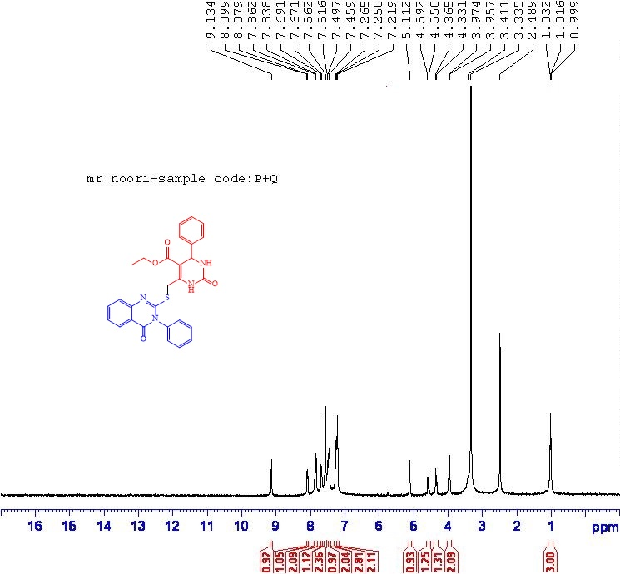
Figure 1. ¹HNMR (DMSO): Ethyl 2-oxo-6-(((4-oxo-3-phenyl-3,4-dihydroquinazolin-2-yl)thio)methyl)-4-phenyl-1,2,3,4-tetrahydropyrimidine-5-carboxylate (4a)

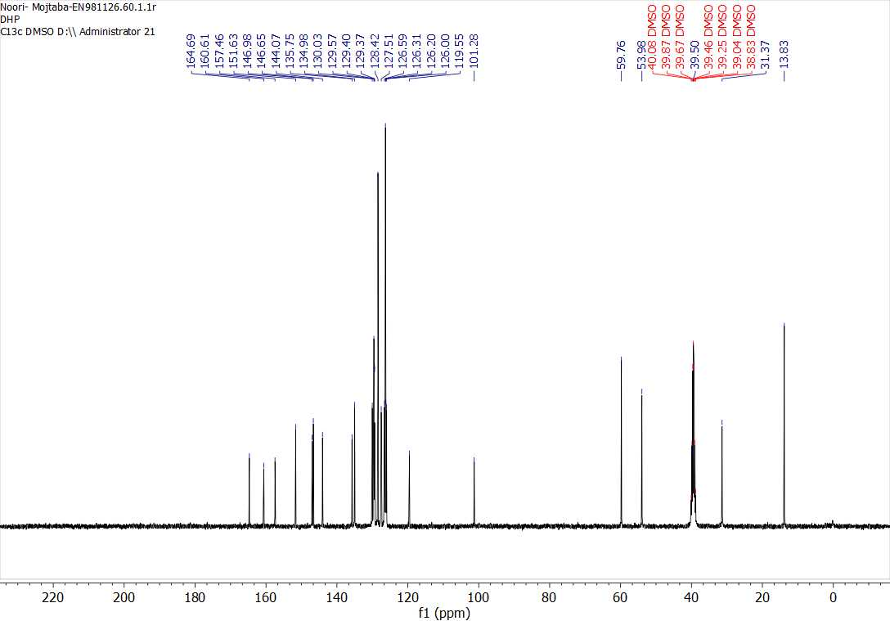
Figure 2. ¹³CNMR(DMSO): Ethyl 2-oxo-6-(((4-oxo-3-phenyl-3,4-dihydroquinazolin-2-yl)thio)methyl)-4-phenyl-1,2,3,4-tetrahydropyrimidine-5-carboxylate (4a)

Figure 3. FT-IR(KBr): Ethyl 2-oxo-6-(((4-oxo-3-phenyl-3,4-dihydroquinazolin-2-yl)thio)methyl)-4-phenyl-1,2,3,4-tetrahydropyrimidine-5-carboxylate (4a)
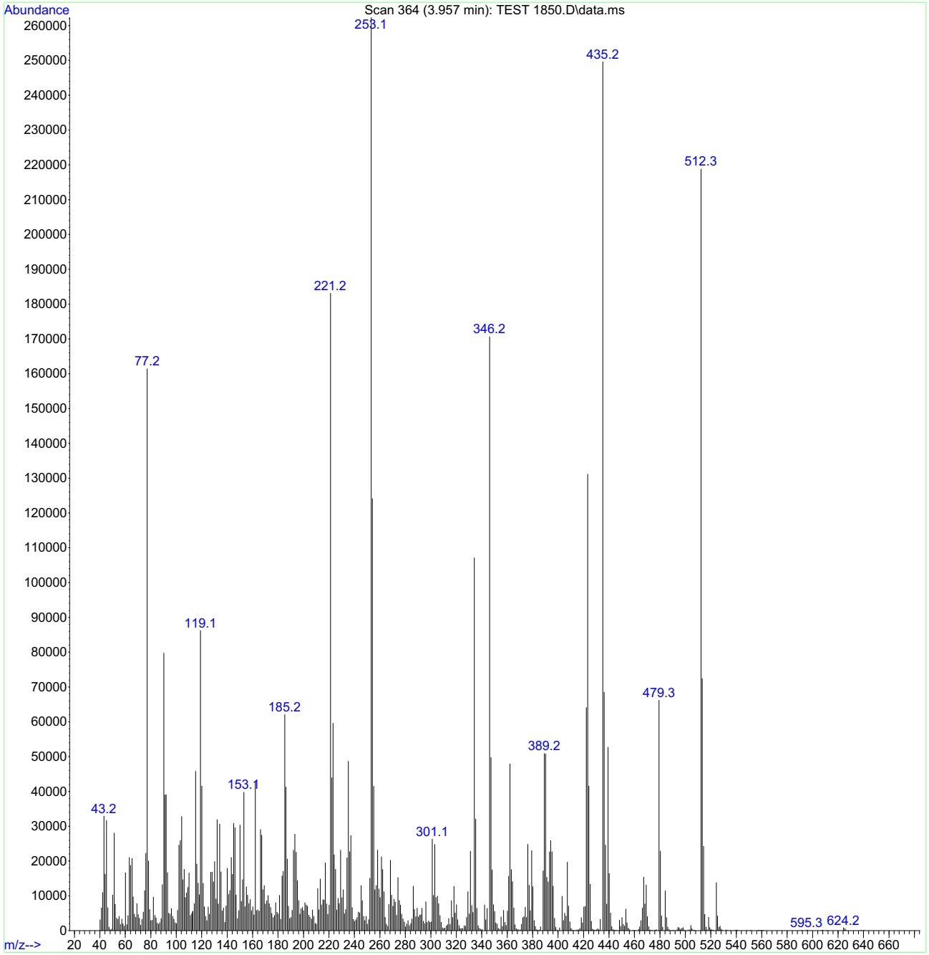
Figure 4. Mass(m/z): Ethyl 2-oxo-6-(((4-oxo-3-phenyl-3,4-dihydroquinazolin-2-yl)thio)methyl)-4-phenyl-1,2,3,4-tetrahydropyrimidine-5-carboxylate (4a)

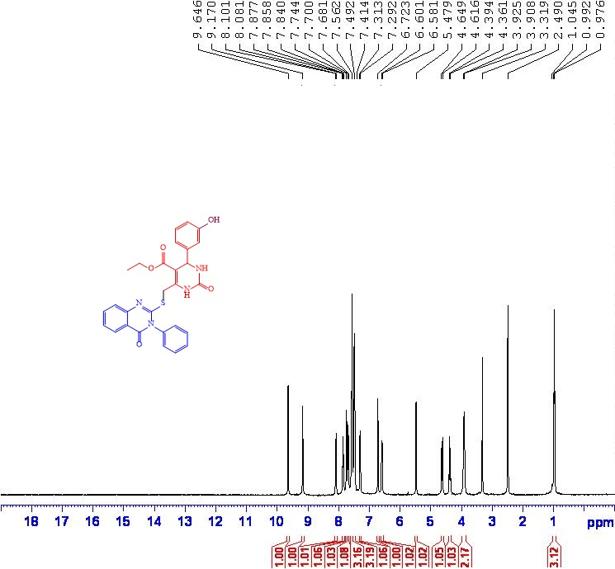
Figure 5. ¹HNMR (DMSO): Ethyl 4-(3-hydroxyphenyl)-2-oxo-6-(((4-oxo-3-phenyl-3,4-dihydroquinazolin-2-yl)thio)methyl)-1,2,3,4-tetrahydropyrimidine-5-carboxylate (4b).

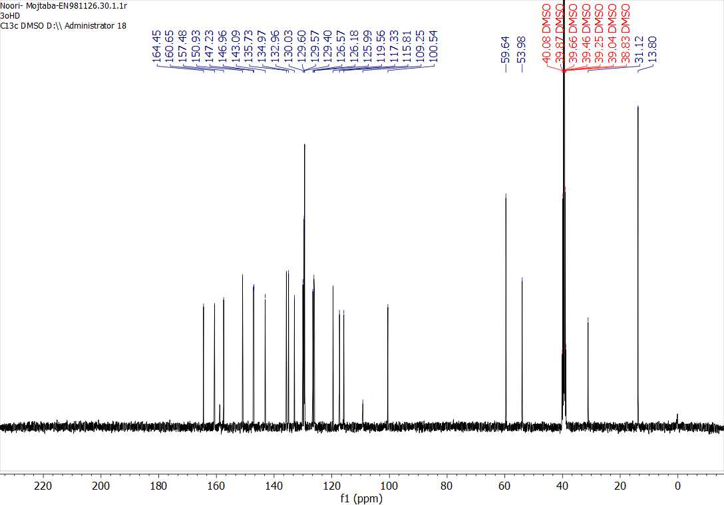
Figure 6. ¹³CNMR(DMSO): Ethyl 4-(3-hydroxyphenyl)-2-oxo-6-(((4-oxo-3-phenyl-3,4-dihydroquinazolin-2-yl)thio)methyl)-1,2,3,4-tetrahydropyrimidine-5-carboxylate (4b).
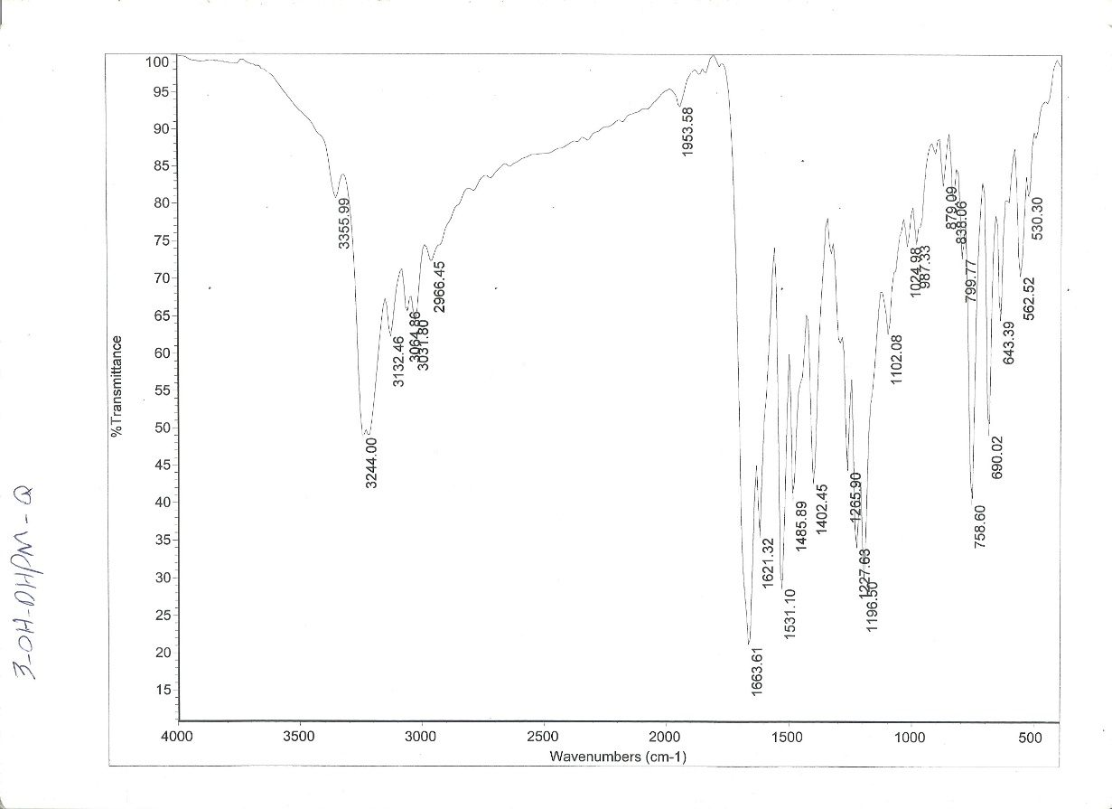
Figure 7. FT-IR(KBr): Ethyl 4-(3-hydroxyphenyl)-2-oxo-6-(((4-oxo-3-phenyl-3,4-dihydroquinazolin-2-yl)thio)methyl)-1,2,3,4-tetrahydropyrimidine-5-carboxylate (4b).

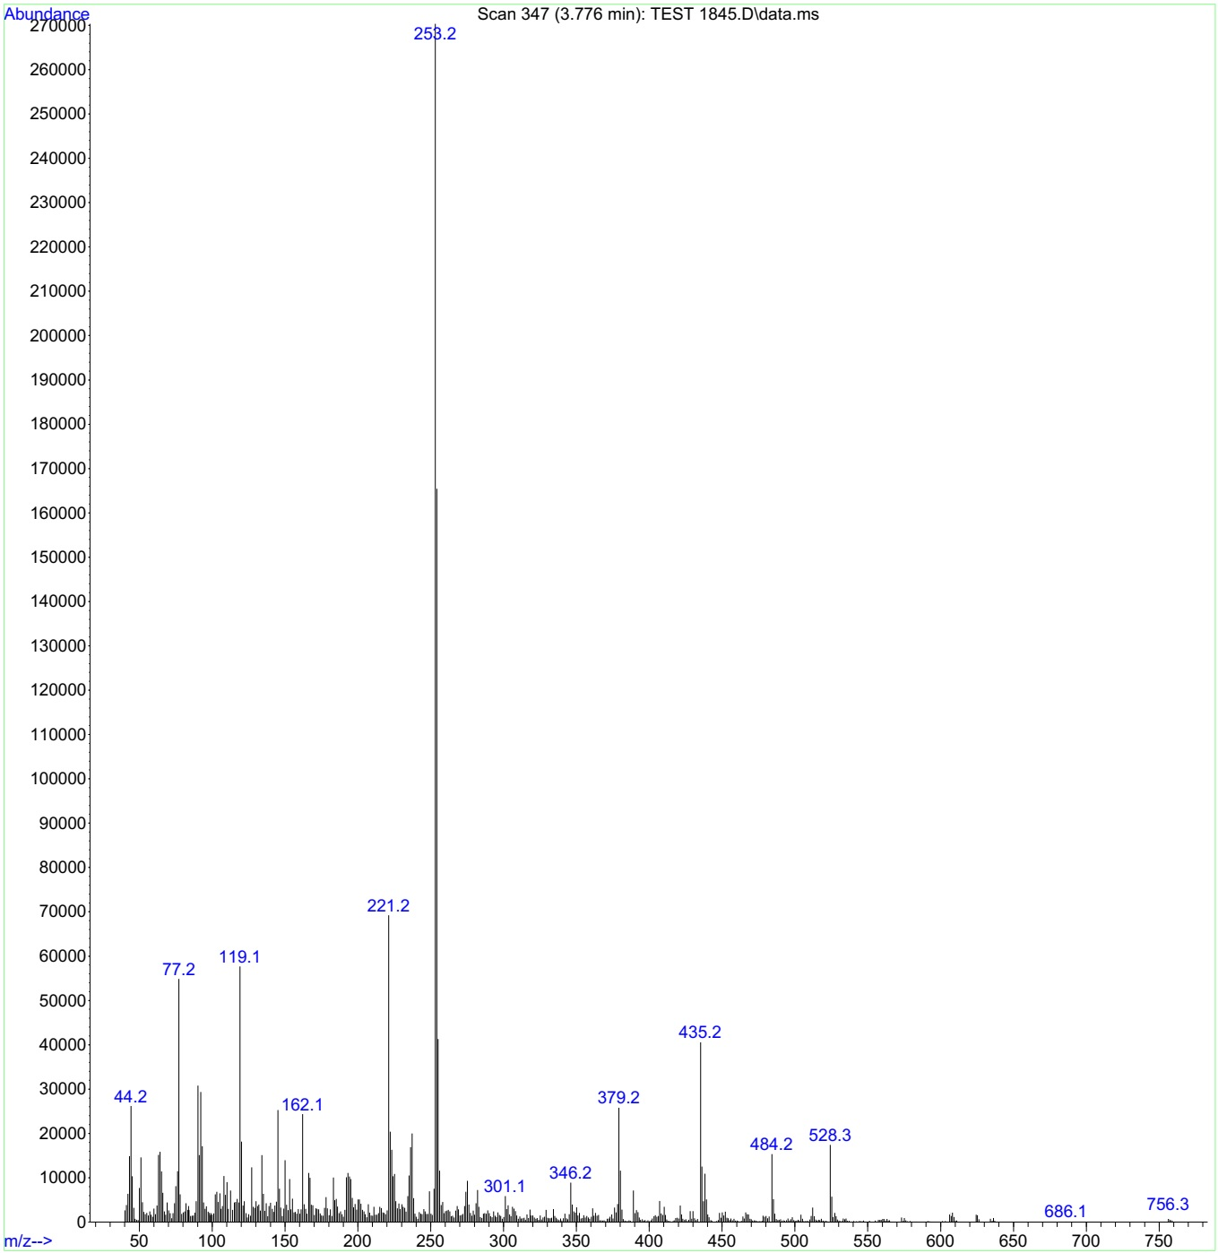
Figure 8. Mass(m/z): Ethyl 4-(3-hydroxyphenyl)-2-oxo-6-(((4-oxo-3-phenyl-3,4-dihydroquinazolin-2-yl)thio)methyl)-1,2,3,4-tetrahydropyrimidine-5-carboxylate (4b).

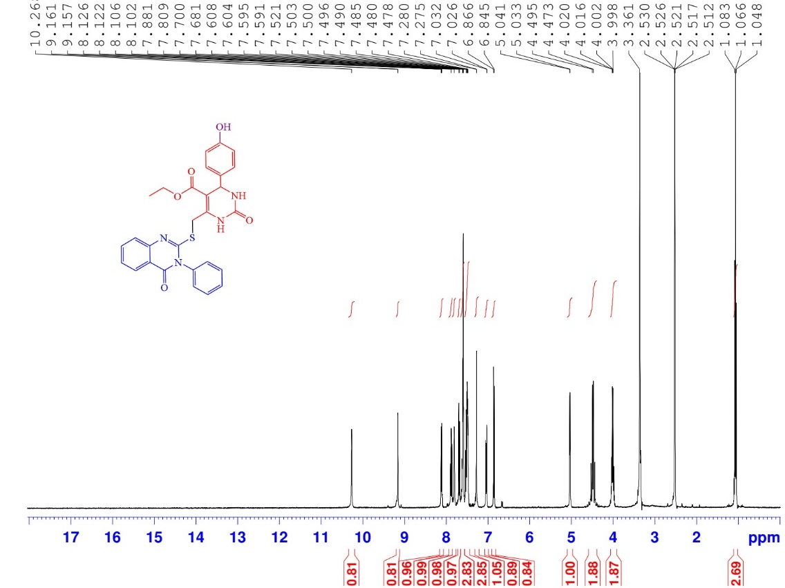
Figure 9. ¹HNMR (DMSO): Ethyl 4-(4-hydroxyphenyl)-2-oxo-6-(((4-oxo-3-phenyl-3,4-dihydroquinazolin-2-yl)thio)methyl)-1,2,3,4-tetrahydropyrimidine-5-carboxylate (4c).

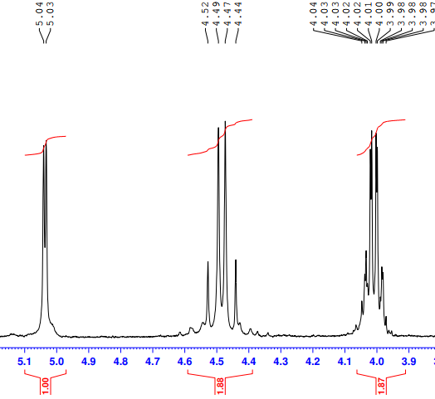
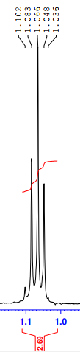
Expanded ¹HNMR spectrum (4c).

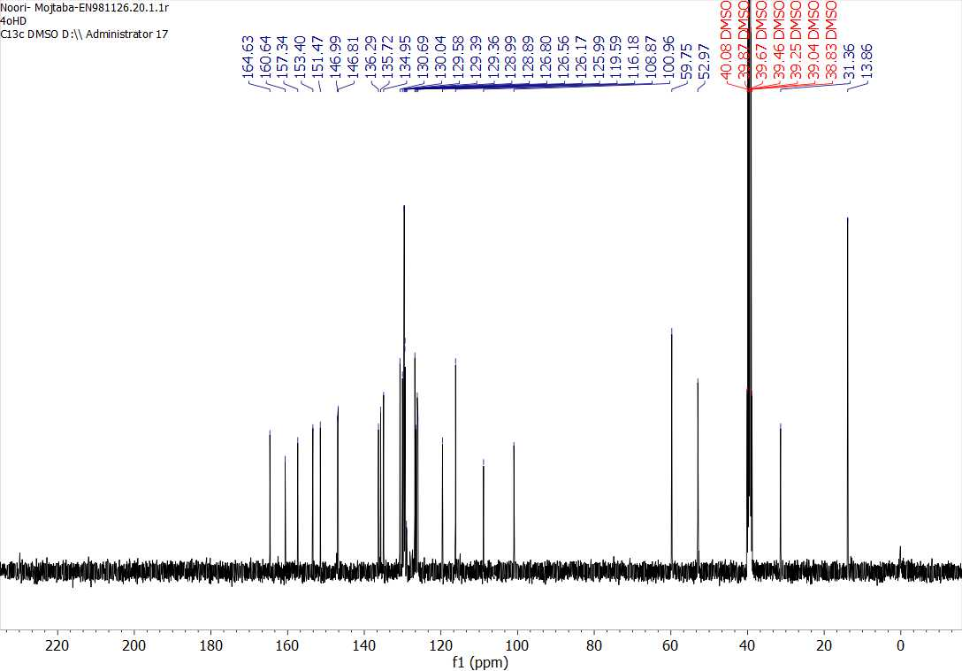
Figure 10. ¹³CNMR(DMSO): Ethyl 4-(4-hydroxyphenyl)-2-oxo-6-(((4-oxo-3-phenyl-3,4-dihydroquinazolin-2-yl)thio)methyl)-1,2,3,4-tetrahydropyrimidine-5-carboxylate (4c).

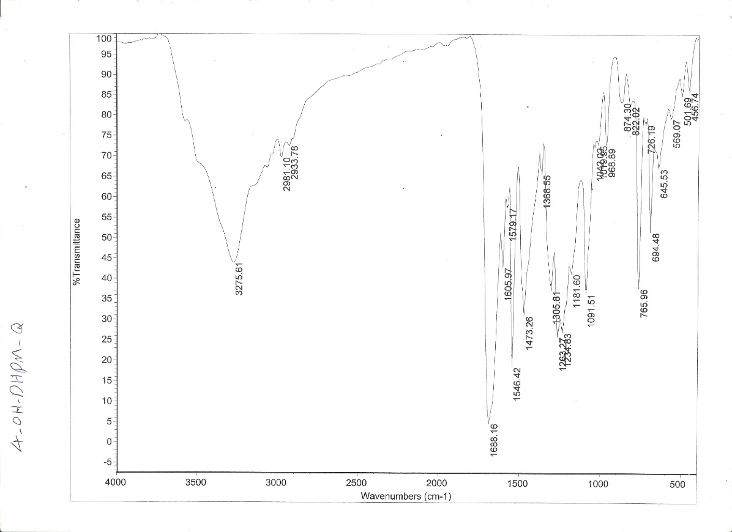
Figure 11. FT-IR(KBr): Ethyl 4-(4-hydroxyphenyl)-2-oxo-6-(((4-oxo-3-phenyl-3,4-dihydroquinazolin-2-yl)thio)methyl)-1,2,3,4-tetrahydropyrimidine-5-carboxylate (4c).
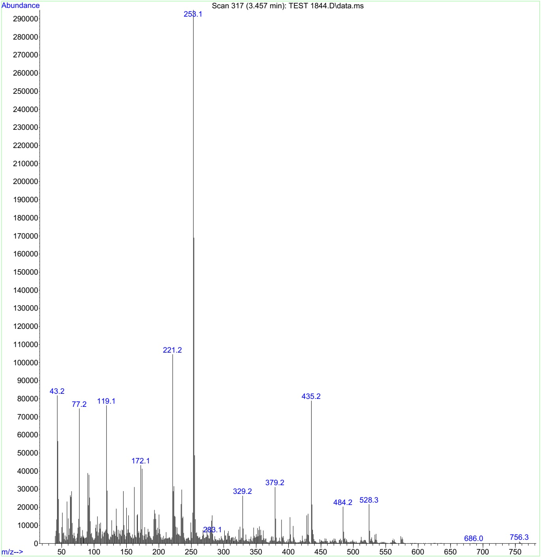
Figure 12. Mass(m/z): Ethyl 4-(4-hydroxyphenyl)-2-oxo-6-(((4-oxo-3-phenyl-3,4-dihydroquinazolin-2-yl)thio)methyl)-1,2,3,4-tetrahydropyrimidine-5-carboxylate (4c).

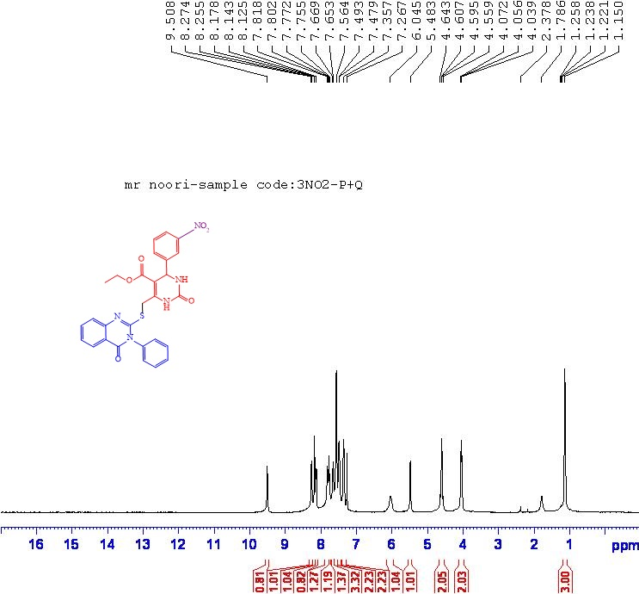
Figure 13. ¹HNMR (DMSO): Ethyl 4-(3-nitrophenyl)-2-oxo-6-(((4-oxo-3-phenyl-3,4-dihydroquinazolin-2-yl) thio) methyl)-1,2,3,4-tetrahydropyrimidine-5-carboxylate (4d).

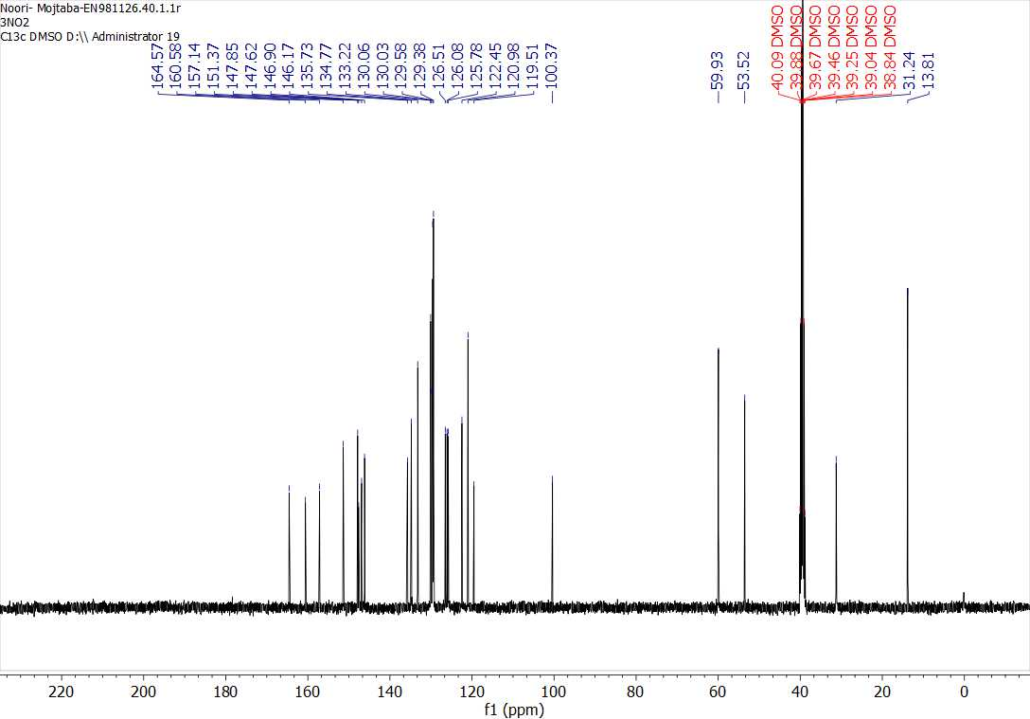
Figure 14. ¹³CNMR(DMSO): Ethyl 4-(3-nitrophenyl)-2-oxo-6-(((4-oxo-3-phenyl-3,4-dihydroquinazolin-2-yl) thio) methyl)-1,2,3,4-tetrahydropyrimidine-5-carboxylate (4d).
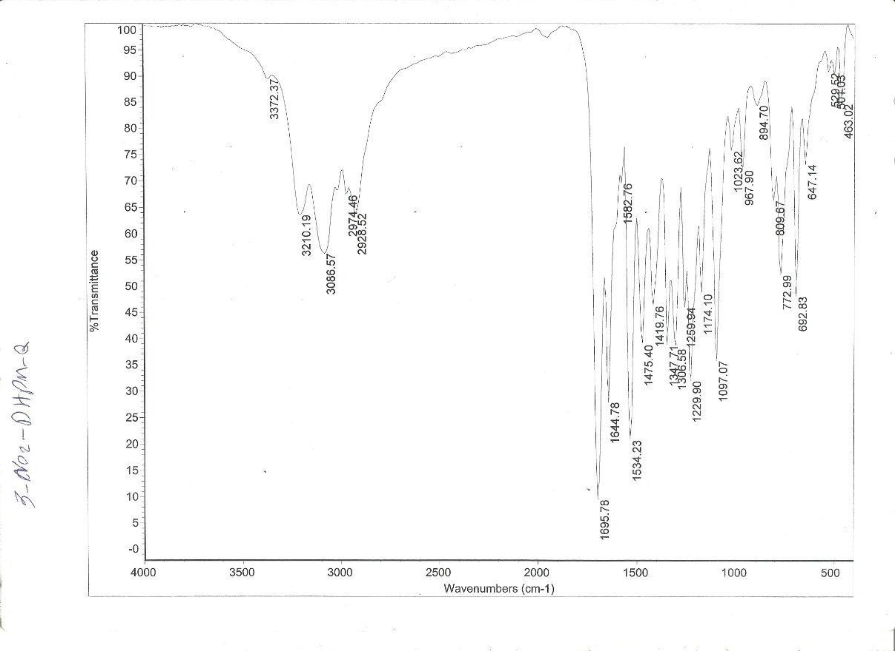
Figure 15. FT-IR(KBr): Ethyl 4-(3-nitrophenyl)-2-oxo-6-(((4-oxo-3-phenyl-3,4-dihydroquinazolin-2-yl) thio) methyl)-1,2,3,4-tetrahydropyrimidine-5-carboxylate (4d).
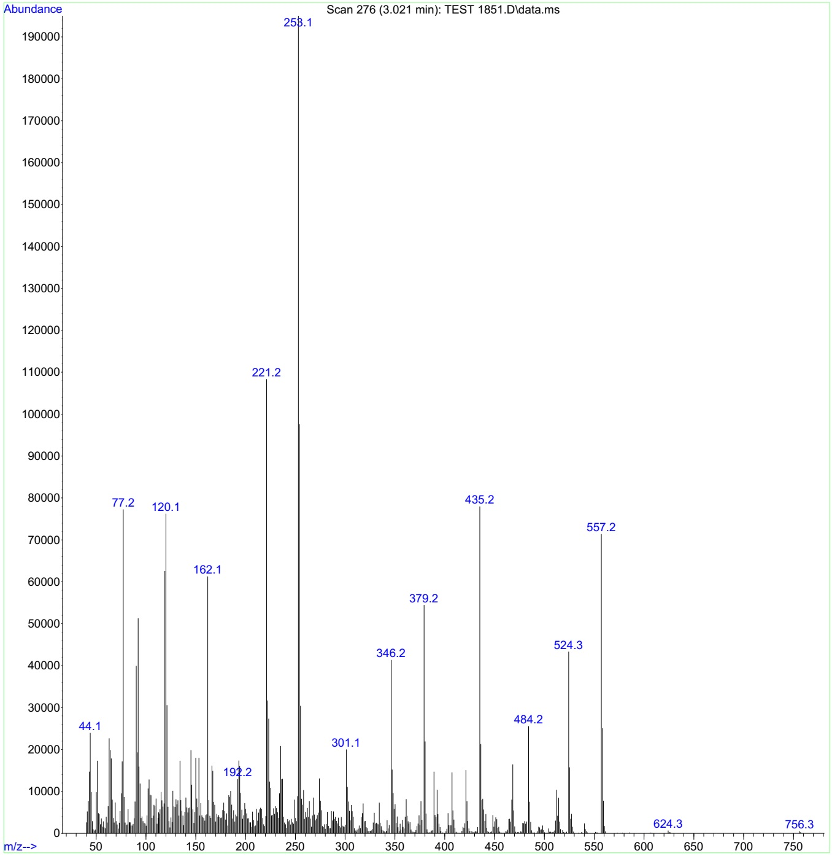
Figure 16. Mass(m/z): Ethyl 4-(3-nitrophenyl)-2-oxo-6-(((4-oxo-3-phenyl-3,4-dihydroquinazolin-2-yl) thio) methyl)-1,2,3,4-tetrahydropyrimidine-5-carboxylate (4d).

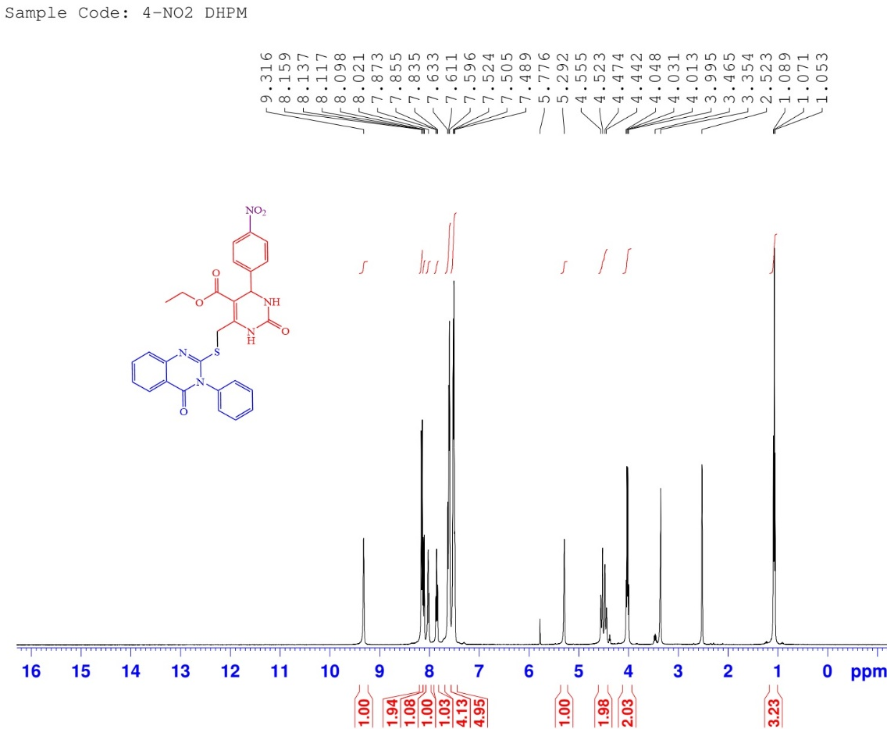
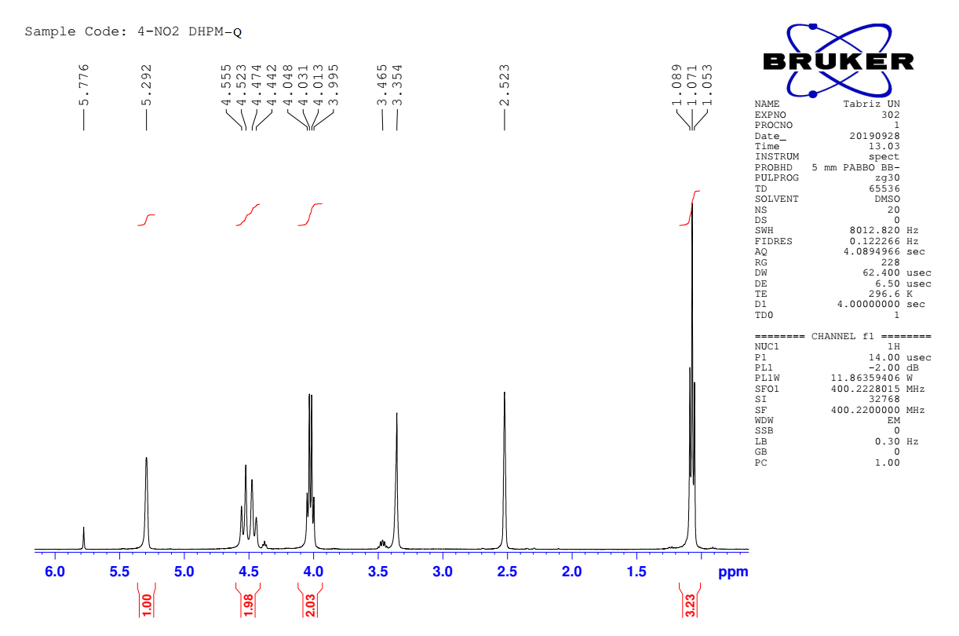
Figure 17. ¹HNMR (DMSO): Ethyl 4-(4-nitrophenyl)-2-oxo-6-(((4-oxo-3-phenyl-3,4-dihydroquinazolin-2-yl) thio) methyl)-1,2,3,4-tetrahydropyrimidine-5-carboxylate(4e).
Expanded ¹HNMR spectrum (4e).
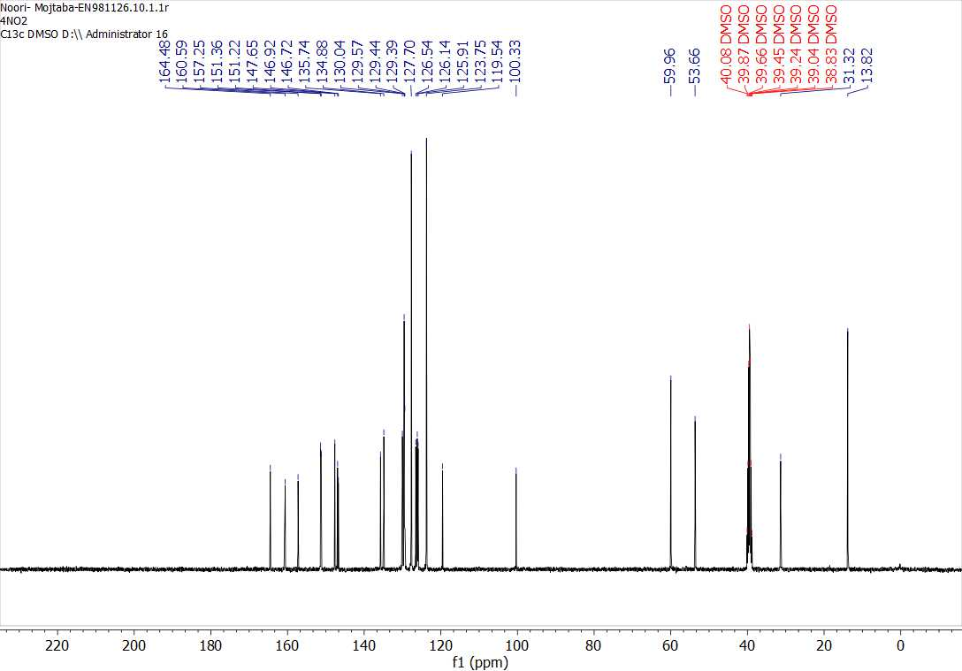
Figure 18. ¹³CNMR(DMSO): Ethyl 4-(4-nitrophenyl)-2-oxo-6-(((4-oxo-3-phenyl-3,4-dihydroquinazolin-2-yl) thio) methyl)-1,2,3,4-tetrahydropyrimidine-5-carboxylate(4e).

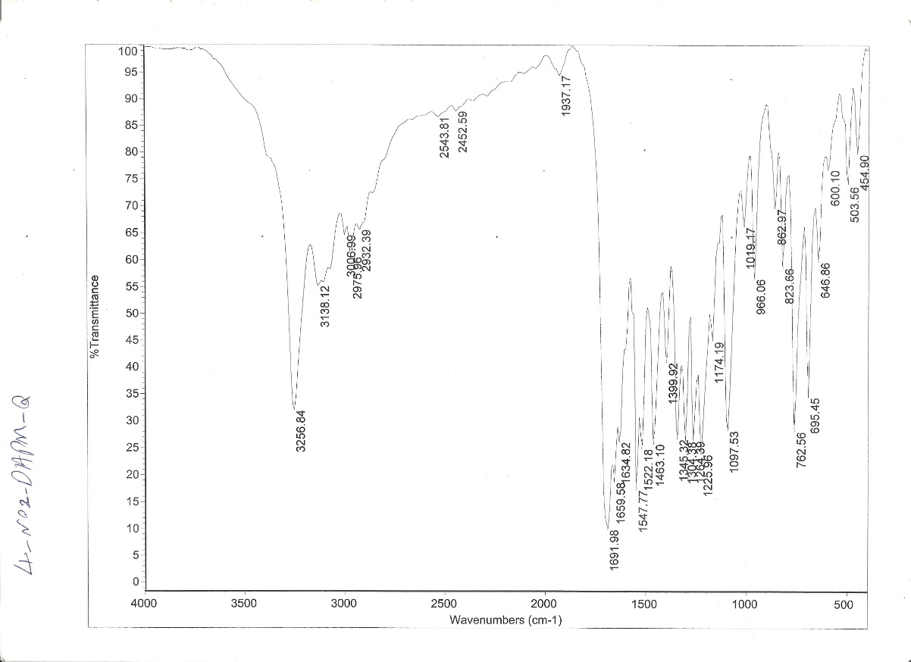
Figure 19. FT-IR(KBr): Ethyl 4-(4-nitrophenyl)-2-oxo-6-(((4-oxo-3-phenyl-3,4-dihydroquinazolin-2-yl) thio) methyl)-1,2,3,4-tetrahydropyrimidine-5-carboxylate(4e).
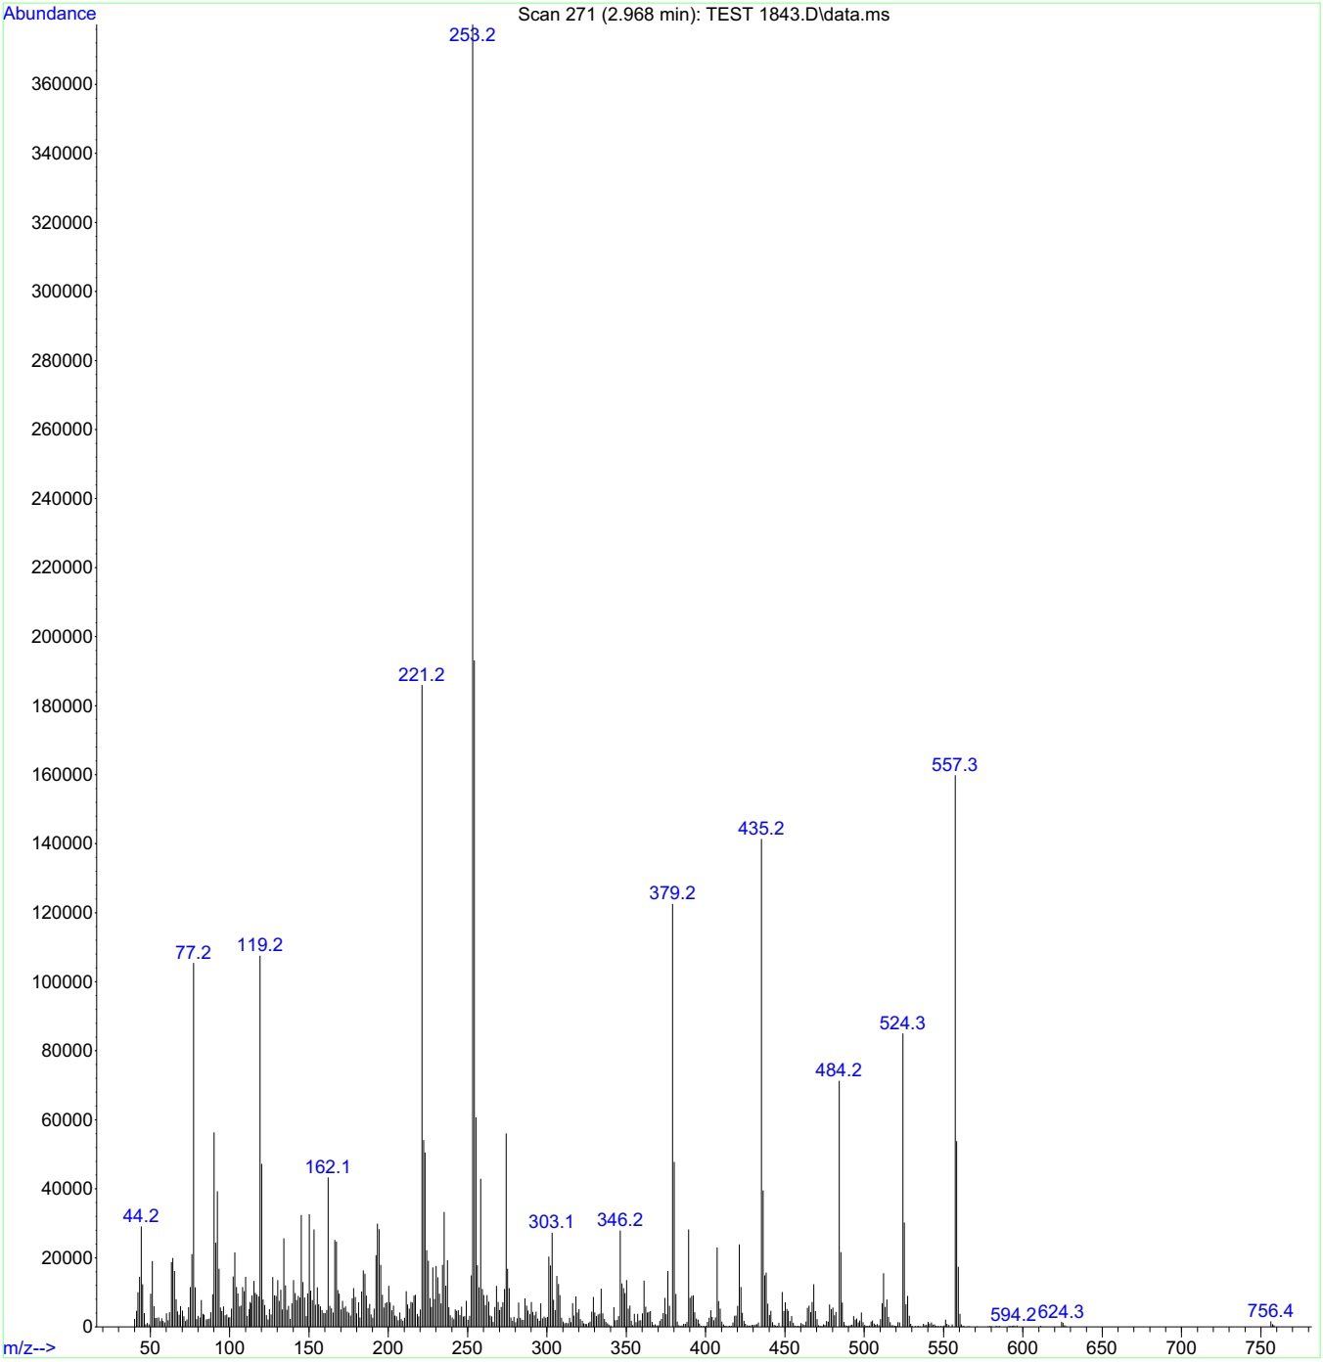
Figure 20. Mass(m/z): Ethyl 4-(4-nitrophenyl)-2-oxo-6-(((4-oxo-3-phenyl-3,4-dihydroquinazolin-2-yl) thio) methyl)-1,2,3,4-tetrahydropyrimidine-5-carboxylate(4e).

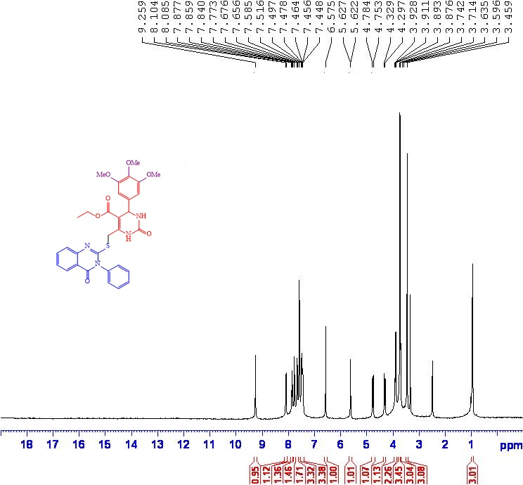
Figure 21. ¹HNMR (DMSO): Ethyl 2-oxo-6-(((4-oxo-3-phenyl-3,4-dihydroquinazolin-2-yl) thio) methyl)-4-(3,4,5-trimethoxyphenyl)-1,2,3,4-tetrahydropyrimidine-5-carboxylate (4f).
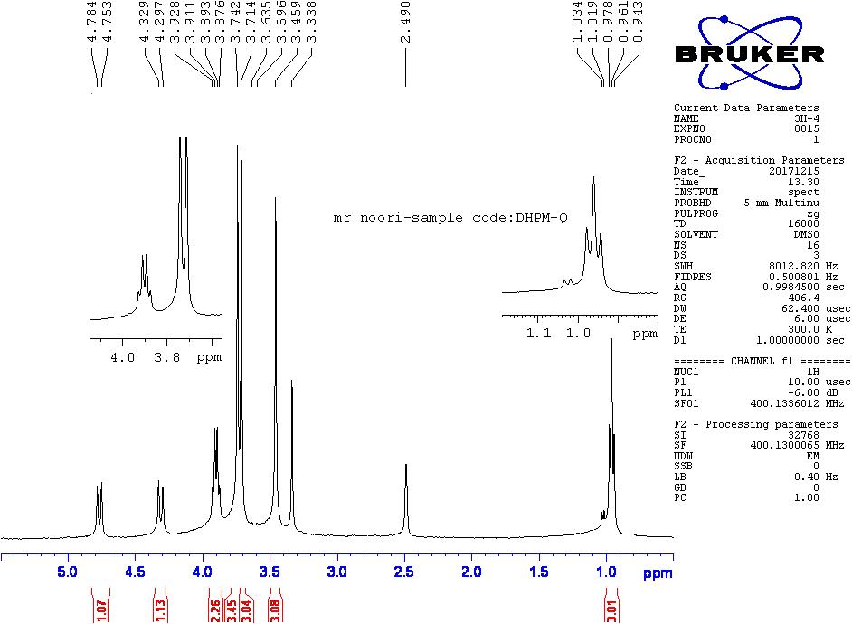
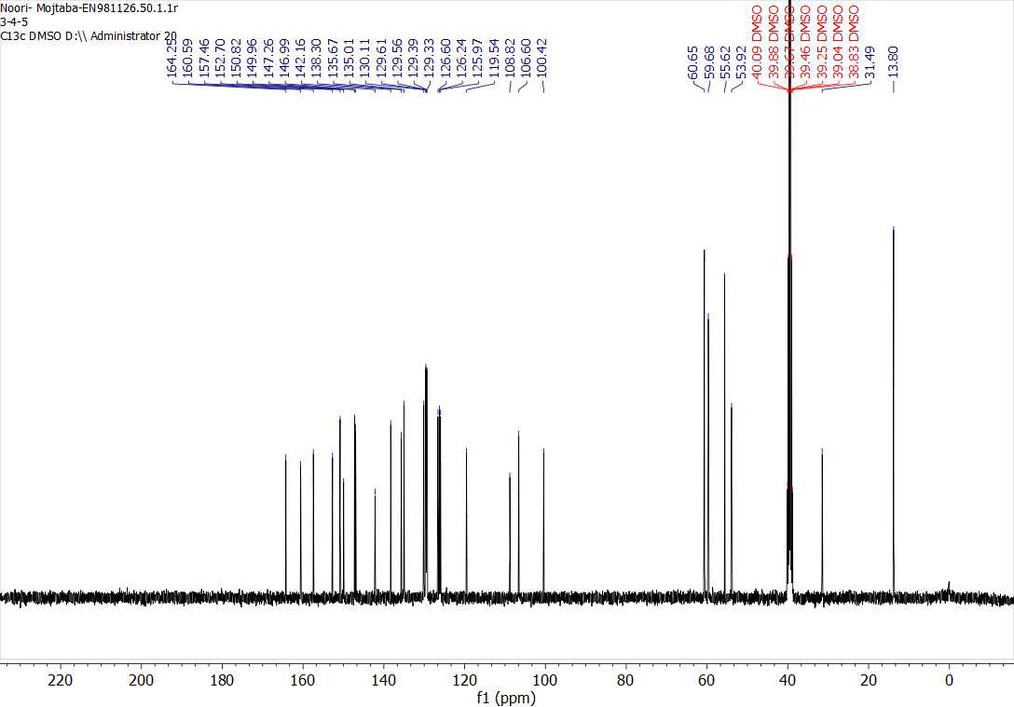
Figure 22. ¹³CNMR(DMSO): Ethyl 2-oxo-6-(((4-oxo-3-phenyl-3,4-dihydroquinazolin-2-yl) thio) methyl)-4-(3,4,5-trimethoxyphenyl)-1,2,3,4-tetrahydropyrimidine-5-carboxylate (4f).

Figure 23. FT-IR(KBr): Ethyl 2-oxo-6-(((4-oxo-3-phenyl-3,4-dihydroquinazolin-2-yl) thio) methyl)-4-(3,4,5-trimethoxyphenyl)-1,2,3,4-tetrahydropyrimidine-5-carboxylate (4f).

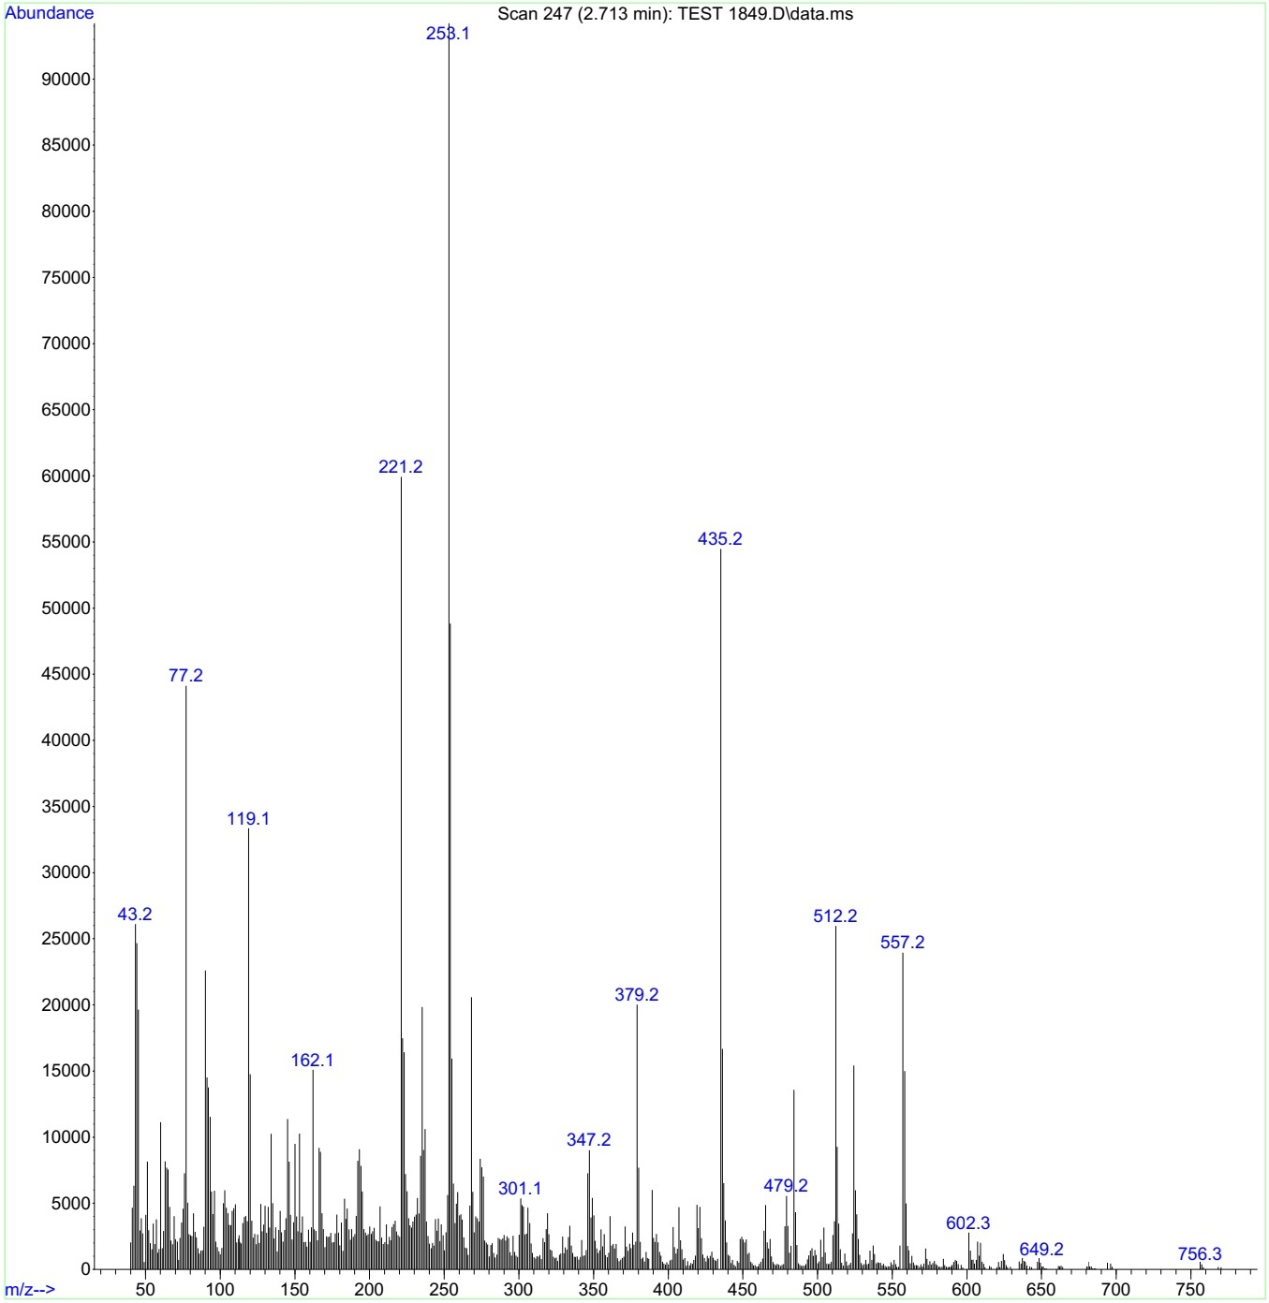
Figure 24. Mass(m/z): Ethyl 2-oxo-6-(((4-oxo-3-phenyl-3,4-dihydroquinazolin-2-yl) thio) methyl)-4-(3,4,5-trimethoxyphenyl)-1,2,3,4-tetrahydropyrimidine-5-carboxylate (4f).

Docking results
Analysis of the docking results showed that hydrophobic interactions and hydrogen bonds have the key contributions in keeping the compounds bound into the minor groove of DNA.

As seen in Figure 25 there are three hydrogen bonds between nitrogen atoms of pyrimidine group in 4a and oxygen atoms of thymine nucleotides (dT20,dT19 and dT7) in DNA. Carboxyl of 4a interacts with oxygen atom of thymine nucleotide (dT8) through hydrogen bond interaction. Moreover, 4a interacts with DNA through hydrophobic interactions with cytosine nucleotides (dC9, anddC21) and adenine nucleotides (dA18and dA6).
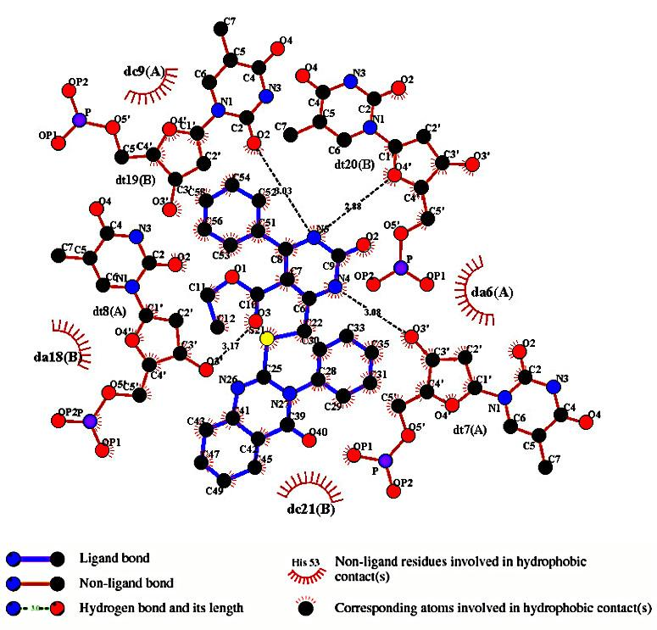
Figure25.The 2D interaction plotbetween best binding modes of 4a and DNA provided with Ligplot program.

Figure 26 shows hydrophobic interactions and hydrogen bonds between 4b and DNA. 4b interacts with DNA through hydrophobic interactions with thymine nucleotide (dT20), adenine nucleotides (dA18and dA6)and cytosine nucleotide (dC21). Moreover, there are two hydrogen bonds between nitrogen atoms of pyrimidine group in 4b and oxygen atoms of thymine nucleotides (dT19 and dT7) in DNA. Hydroxyl group of 4b forms two hydrogen bondswith oxygen atoms of thymine nucleotide(dT8) and cytosine nucleotide (dC9).

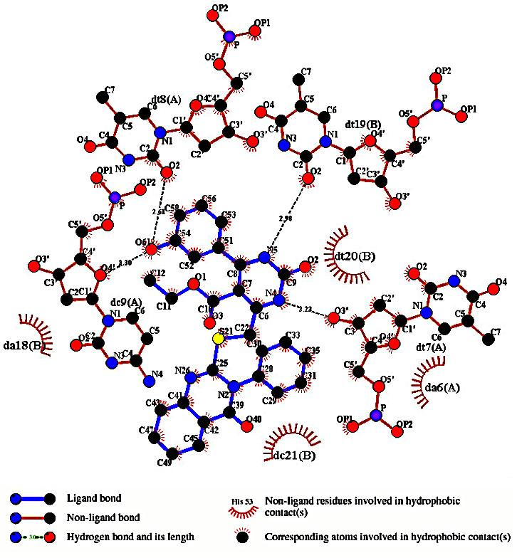
Figure26.The 2D interaction plot between best binding modes of 4b and DNA provided with Ligplot program.

As seen in Figure 27 there isone hydrogen bond between nitrogen atom of pyrimidine group in 4c and oxygen atom of thymine nucleotide (dTt20) in DNA. Moreover, 4c interacts with DNA through hydrophobic interactions with adenine nucleotides (da5, dA6 anddA18), cytosine nucleotides(dcC21and dC9), thymine nucleotides (dT7,dT19and dT8) and guanine nucleotide(dG22).
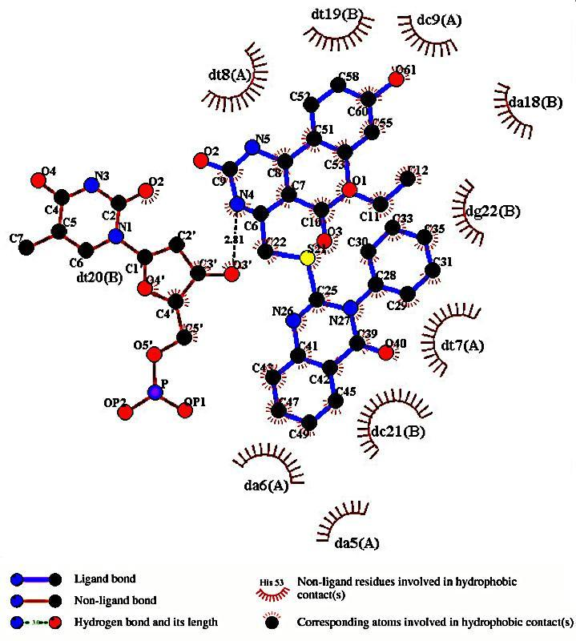
Figure27.The 2D interaction plot between best binding modes of 4c and DNA provided with Ligplot program.

Figure 28 provides hydrophobic interactions and hydrogen bonds between 4d and DNA.This compound interacts with DNA through hydrophobic interactions with adenine nucleotide (dA5) and cytosine nucleotides (dC21 and dC9).Moreover, there are two hydrogen bonds between nitrogen atoms of pyrimidine group in 4d and oxygen atoms of thymine nucleotides (dT19 and dT7) in DNA. Carboxyl groups of 4d forms four hydrogen bonds with oxygen atoms of thymine nucleotides (dT8, dT19 and dT20).
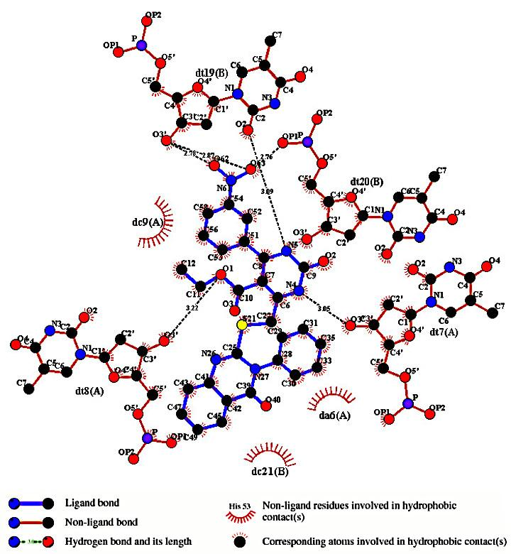
Figure28.The 2D interaction plotbetween best binding modes of 4d and DNA provided with Ligplot program.

Figure 29 shows hydrophobic interactions and hydrogen bonds between 4e and DNA. This compound interacts with DNA through hydrophobic interactions with thymine nucleotides (dT8 and dT7), adenine nucleotides (dA5 and dA6),guanine nucleotide (dG22)and cytosine nucleotides (dc9 and dc21).Moreover, there isone hydrogen bond between nitrogen atom of pyrimidine groupin 4e and oxygen atom of thymine nucleotide (dTt20) in DNA. Carboxyl group of 4e forms three hydrogen bondswith oxygen atoms of thymine nucleotides (dT19 and dT20).

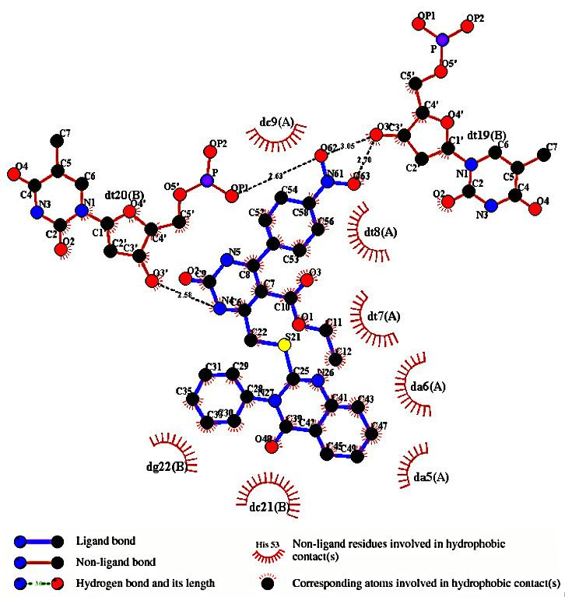
Figure29.The 2D interaction plotbetween best binding modes of 4e and DNA provided with Ligplot program.

As seen in Figure 30 there isone hydrogen bond between nitrogen atom of pyrimidine group in 4f and oxygen atom of thymine nucleotide (dT8) in DNA andthere is one hydrogen bond between carbonyl group of 4f and oxygen atom of thymine nucleotide (dT8) in DNA. Carboxyl group of 4f form one hydrogen bond with oxygen atomof thymine nucleotide (dTt20). Moreover, 4f interacts with DNA through hydrophobic interactions with adenine nucleotides (dA6 anddA18), cytosine nucleotide(dC21), and thyminenucleotides (dT7 anddt19).
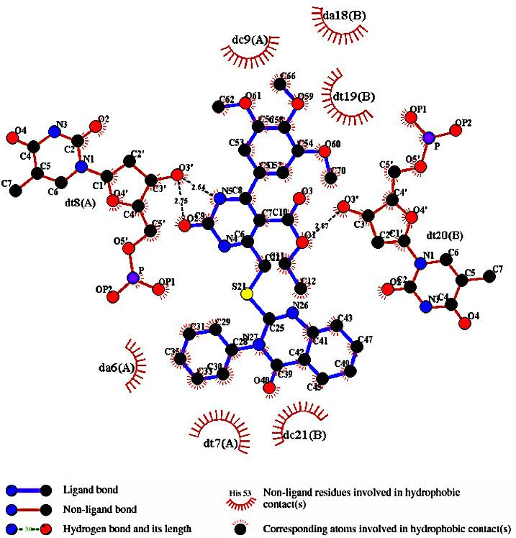
Figure 30.The 2D interaction plot between best binding modes of 4f and DNA provided with Ligplot program.

Table 1: Binding energies and inhibition constants of the compounds in the DNA minor groove.
Complex | ΔG (KCal/mol) | K_{i} (nM)
DNA-4a | -9.95 | 50.48
DNA-4b | -10.36 | 25.32
DNA-4c | -10.64 | 15.92
DNA-4d | -10.62 | 16.49
DNA-4e | -9.28 | 157.32
DNA-4f | -8.42 | 668.82

The compound 4c showed the lowest level of ΔG among the compounds. Also the Ki of the 4c is more than other compounds. Therefore, the 4c binds to DNA with higher affinity rather than other compounds.

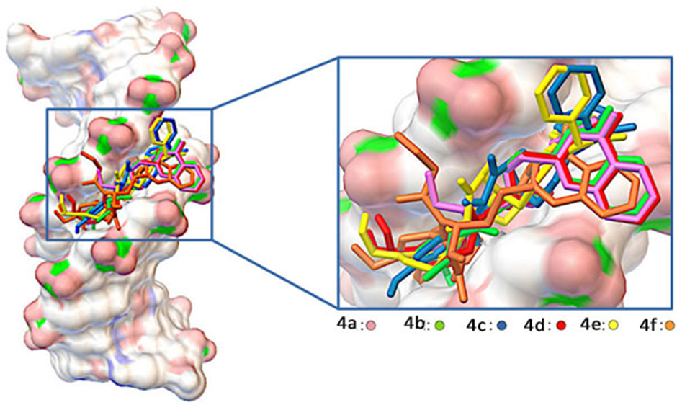
Figure 31. The superimposition of the best docking structures of the compounds in the DNA minor groove. All of the compounds can bind to DNA via hydrogen bond formation with the minor groove.

3.Docking Methods:
Crystal structure of DNA dodecamerd(CGCGAATTCGCG)₂with entry code 1BNA was taken from the Brookhaven Protein Data Bank (RCSB)[1].The 3D structures of the compounds were prepared using Gauss view 5.0.Thereafter in order to get the most stable geometry all structures were optimized by using Gaussian 09 software by using the B3LYP hybrid density functional theory at the 6-31G** level [2]. Flexible ligand docking calculations were performed with the Auto Dock 4.2 package by using empirical free energy function and Lamarckian genetic algorithm with local search [3]. During the preparation of the DNA in Auto Dock Tools environment, water molecules were removed from crystal structure and missing hydrogen atoms and Gasteiger charges were added to the molecule. At first a grid box, containing the whole DNA was used to allow the compounds move freely during docking run. Thereafter, the grid map was set at 40 Å ×40 Å ×40 Å with a grid-point spacing of 0.375 Å to cover the binding site. For all docking parameters, default values were used excepting 200 separated docking runs contain of the maximum 25,000,000 energy evaluations. For each compound the docking conformation with the lowest binding energy in the highest populated cluster was selected as the most probable binding mode.

4. Supplementary refrences
[1]. Berman, Helen M., John Westbrook, Zukang Feng, Gary Gilliland, Talapady N. Bhat, Helge Weissig, Ilya N. Shindyalov, and Philip E. Bourne. "The protein data bank." Nucleic acids research 28, no. 1 (2000): 235-242.
[2]. Hiscocks, Joanne, and Michael J. Frisch. Gaussian 09: IOps Reference. Edited by Marco Caricato, and Michael J. Frisch. Gaussian, 2009.
[3]. Morris, Garrett M., Ruth Huey, William Lindstrom, Michel F. Sanner, Richard K. Belew, David S. Goodsell, and Arthur J. Olson. "AutoDock4 and AutoDockTools4: Automated docking with selective receptor flexibility." Journal of computational chemistry 30, no. 16 (2009): 2785-2791.

