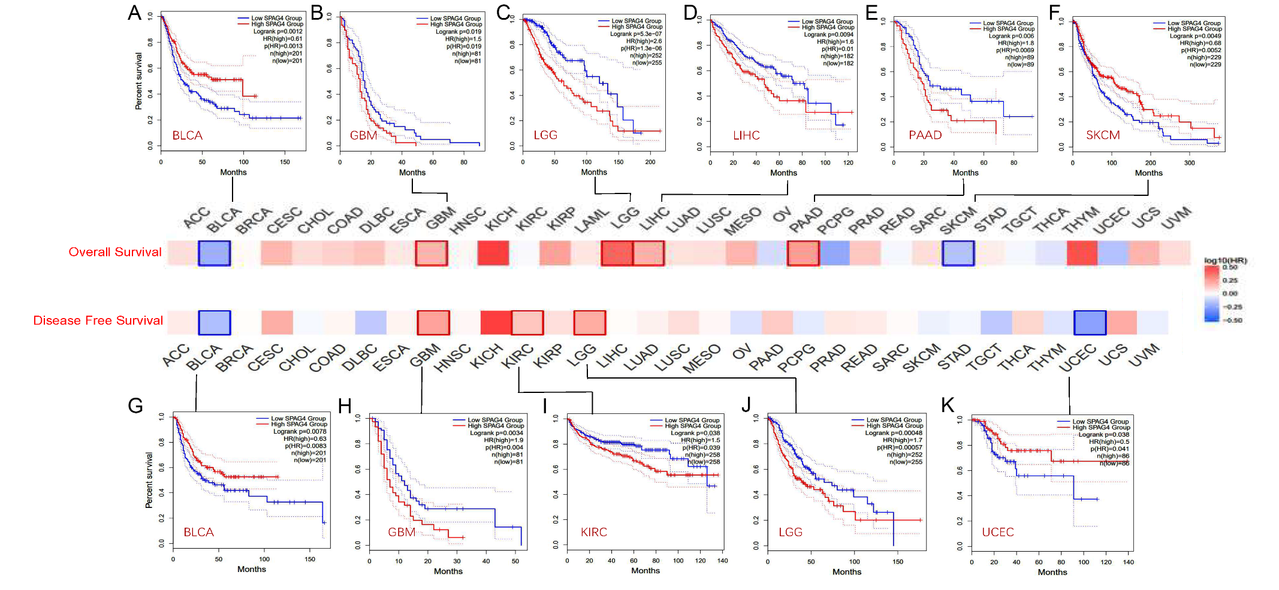
Supplementary Figure.1 Kaplan-Meier survival curve of human tumors with high and low SPAG4 expression analyzed by the GEPIA2 database. (A, F) The higher expression of SPAG4 has a better overall survival in BLCA (HR-high=0.61, Logrank p=0.0012) and in SKCM (HR-high=0.68, Logrank p=0.0049). (B-E) The higher expression of SPAG4 has a worse overall survival in GBM (HR-high=1.5, Logrank p-=0.019), LGG (HR-high=2.6, Logrank p=5.3e-07), LIHC(HR-high=1.6, Logrank p=0.0094) and PAAD(HR-high=1.8, Logrank p=0.0069). (G, K) The higher expression of SPAG4 has a better overall survival in BLCA (HR-high=0.63, Logrank p=0.0078) and in UCEC (HR-high=0.5, Logrank p=0.038). (H-J) The higher expression of SPAG4 has a worse overall survival in GBM (HR-high=1.9, Logrank p=0.0034), KIRC (HR-high=1.5, Logrank p=0.038) and LGG (HR-high=1.7, Logrank p=0.00048).
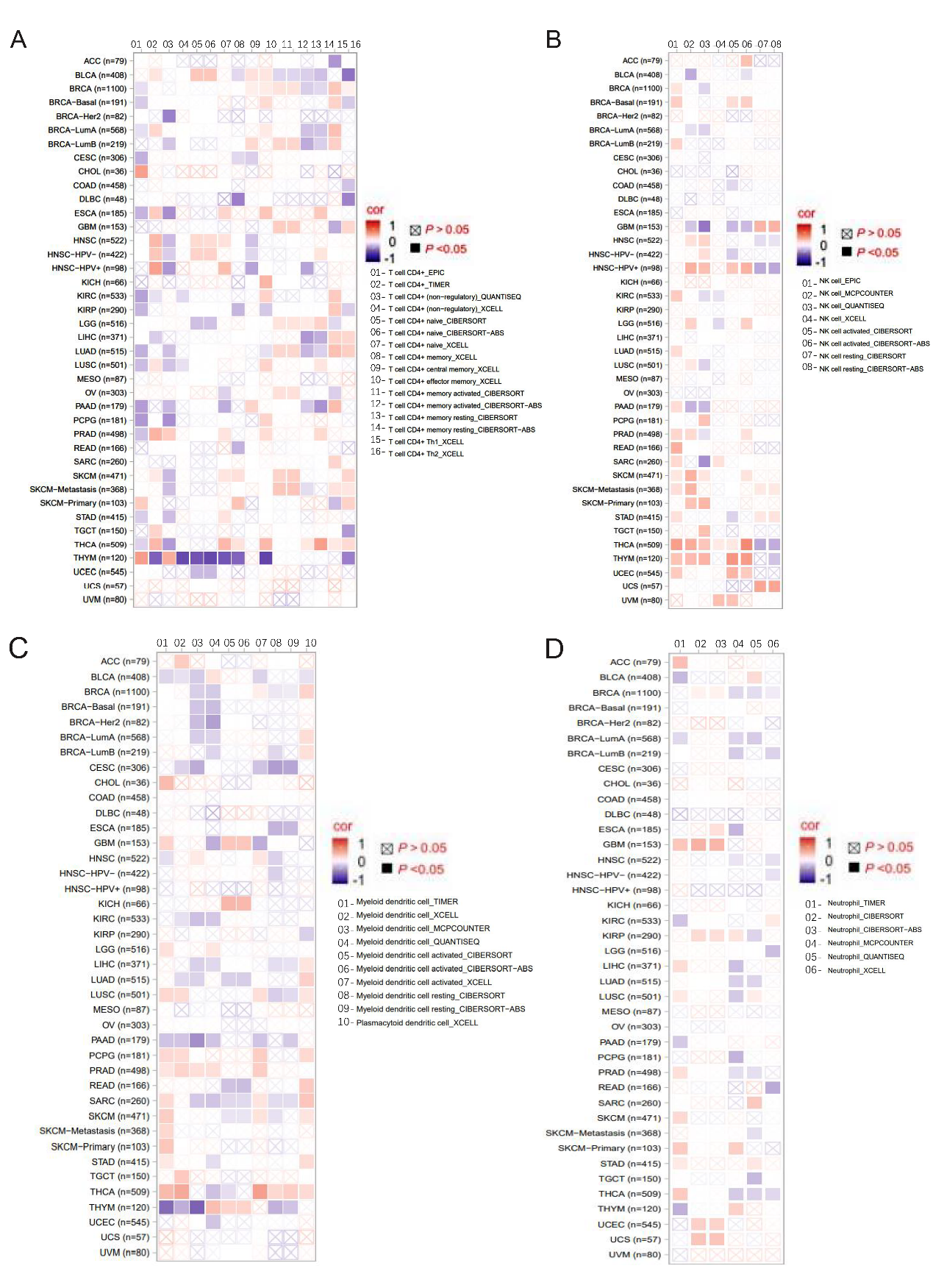
Supplementary Figure.2 SPAG4 is significantly associated with CD4+T cell (A), NK cell (B), dendritic cell (C), neutrophil cell (D) in a variety of tumors.
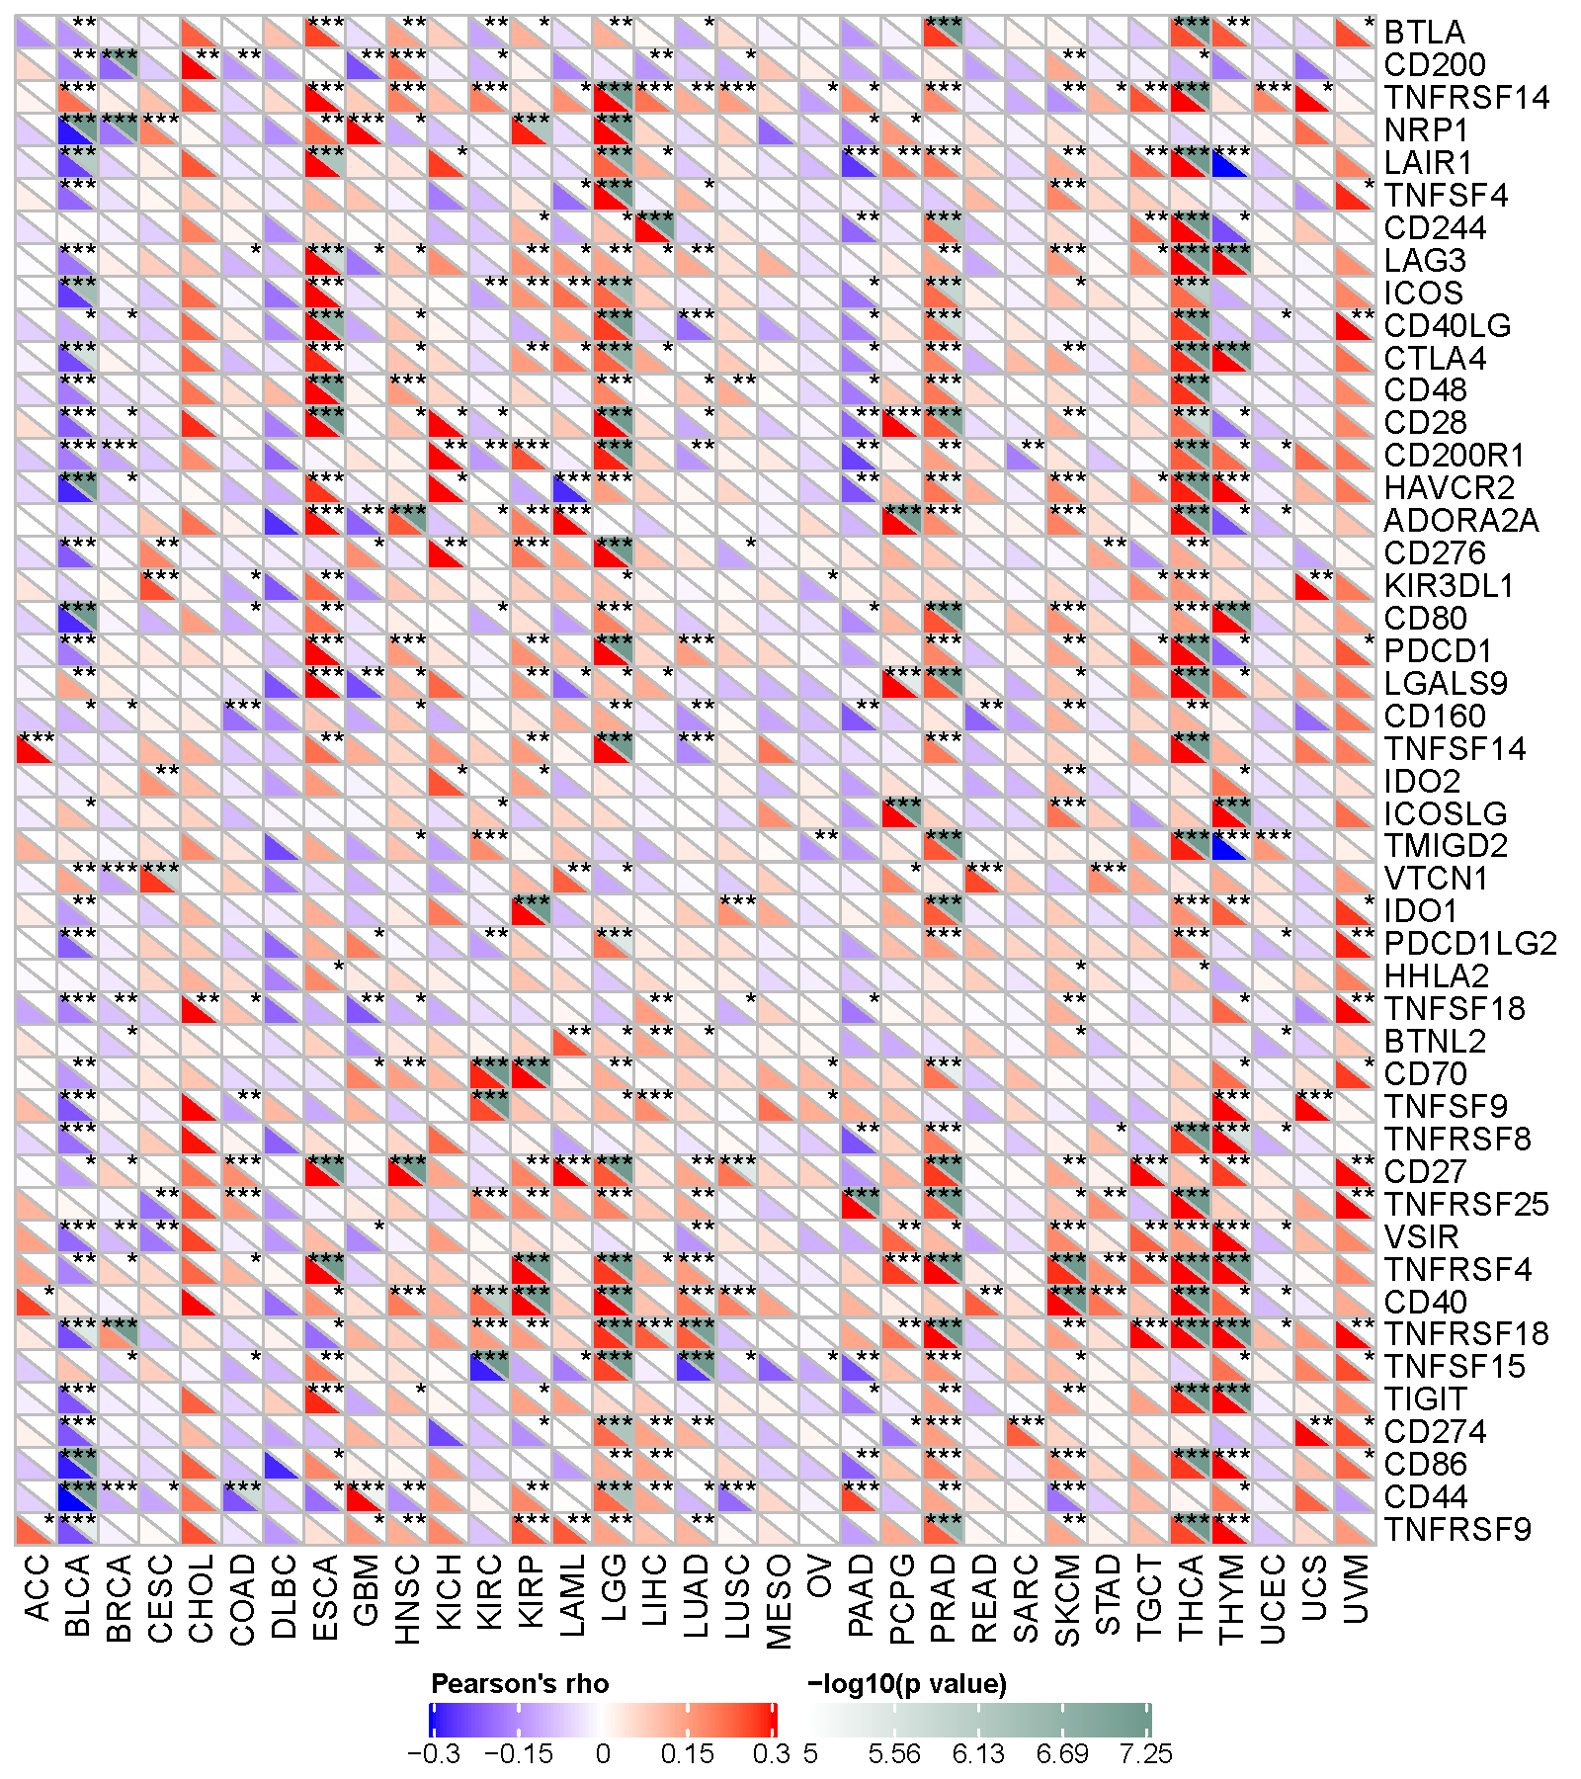
Supplementary Figure.3 The relationship between SPAG4 expression and pan-cancer immune checkpoint genes (*p< 0.05; **p< 0.01; ***p< 0.001).
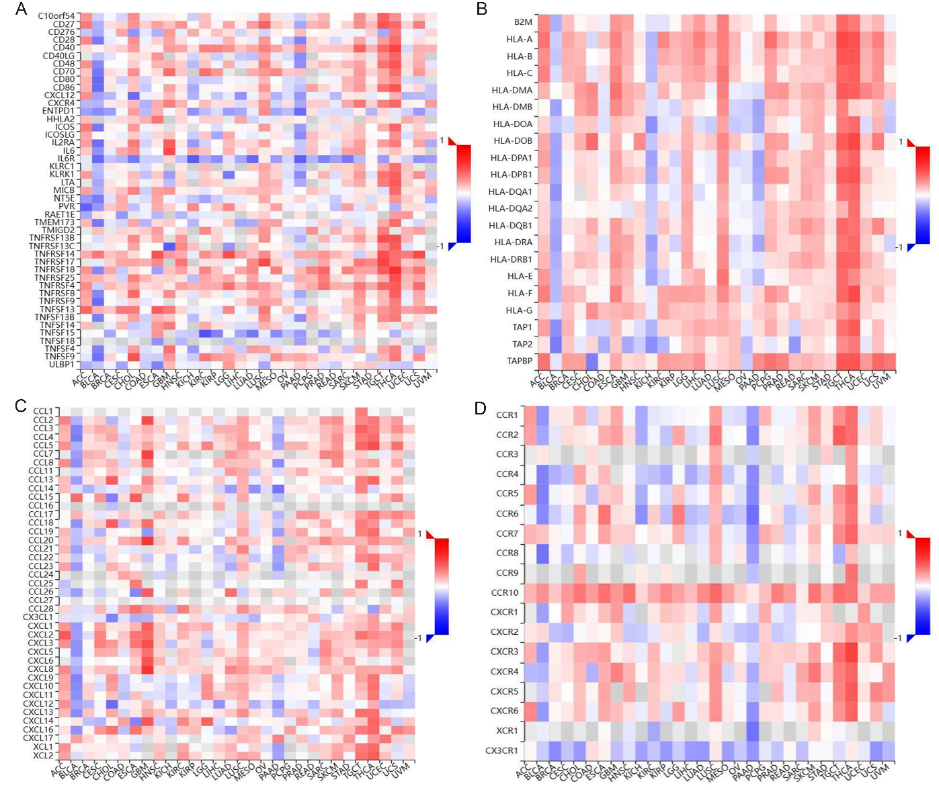
Supplementary Figure.4 The relations between the expression of SPAG4 and 2 kinds of immunomodulators and chemokines (or receptors) in human tumors. (A,B) The expression of SPAG4 associated with pan-cancer Immunostimulator and MHC molecule in most tumors. (C, D) The expression of SPAG4 positively associated with pan-cancer chemokines and its receptors in most tumors. These suggest that the immunomodulators and chemokines (or receptors) might be regulated by SPAG4.

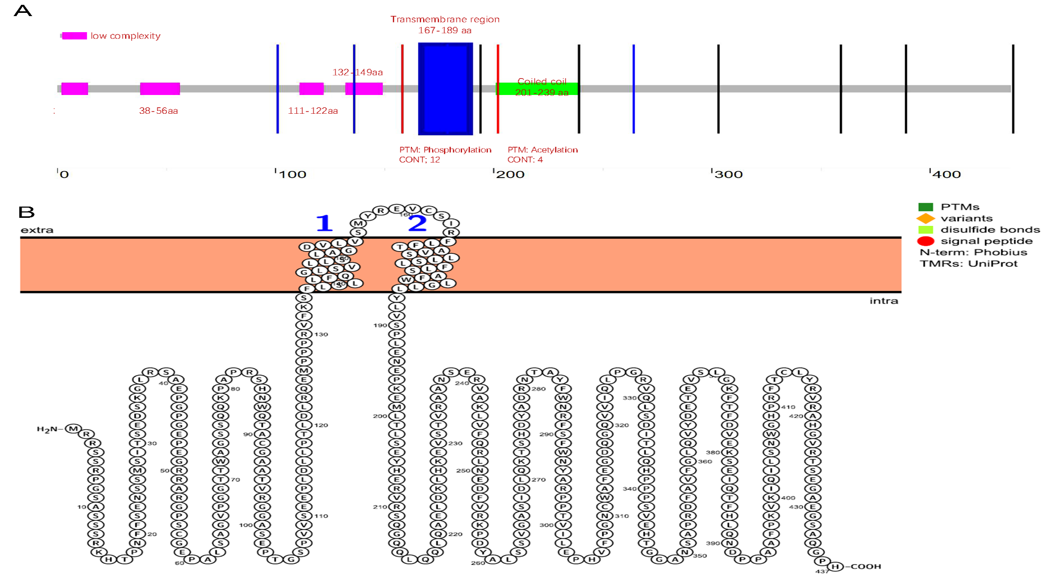
Supplementary Figure.5 The schematic diagram of the protein structure of SPAG4 obtained from the SMART database (A) and the PROTTER database(https://wlab.ethz.ch/protter)(B). SPAG4 is a nuclear membrane protein consisting of a conserved SUN structural domain at the C-terminus, a transmembrane region at the N-terminus and a coiled-coil structural domain in the middle, with phosphorylation and acetylation sites in the transmembrane and helical regions respectively.

