Figure S1. Comparison of observed versus predicted probabilities, and statistical fit indicators, of Poisson (PRM), Negative Binomial (NBRM), Zero-inflated Poisson (ZIP), and Zero-inflated Negative Binomial (ZINB) regression adjusted models

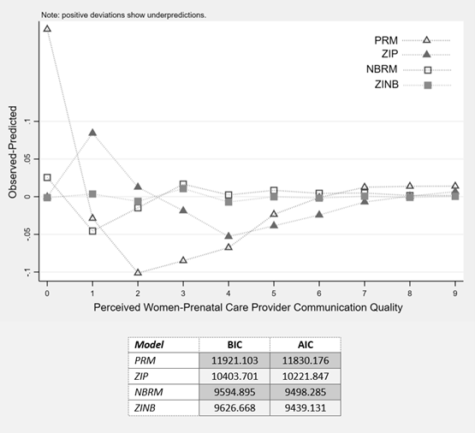
Table S1. Maternal characteristics by participation status among eligible women who consented to participate (n = 4978)
Characteristics | Eligible non-participantsᵅ  (n = 2368) | Participants  (n = 2610) | p
 | n (%) | n (%)
Sociodemographic characteristics
Migrant (n = 4978) | 1291 (54.5) | 1210 (46.4) | <0.001
Region of birth (n = 4978)
Portugal | 1077 (45.5) | 1400 (53.7)
Brazil | 179 (7.6) | 285 (10.9)
PALOP ᵇ | 738 (31.2) | 512 (19.6)
Other African countries | 51 (2.1) | 32 (1.2) | <0.001
Europe | 212 (8.9) | 283 (10.9)
Asia | 68 (2.9) | 58 (2.2)
America | 43 (1.8) | 40 (1.5)
Age (years) (n = 4955)
18-24 | 455 (19.4) | 389 (14.9) | <0.001
25-34 | 1306 (55.7) | 1442 (55.2) | <0.001
≥35 | 584 (24.9) | 779 (29.9) | <0.001
Marital status (no partner) (n = 4944) | 703 (30.1) | 666 (25.5) | <0.001
Highest education level attained (n = 4765)
Post-secondary (>12th grade) | 574 (26.7) | 906 (34.7) | <0.001
Upper secondary (12th grade) | 755 (35.0) | 970 (37.2) | <0.001
Lower secondary (9th grade) | 546 (25.3) | 543 (20.8) | <0.001
None or primary (≤4th grade) | 281 (13.0) | 190 (7.3) | <0.001
Administrative health region (n = 4978)
Lisbon and Tagus valley | 1703 (71.9) | 1548 (59.3) | <0.001
Center | 168 (7.1) | 298 (11.4) | <0.001
North | 400 (16.9) | 580 (22.2) | <0.001
Algarve | 97 (4.1) | 184 (7.1) | <0.001
Obstetric characteristics
Primiparous (n = 4730) | 969 (43.5) | 1221 (48.8) | <0.001
Smoking during pregnancy (n = 4856) | 330 (14.3) | 281 (11.0) | <0.001
Complications during pregnancy ᶜ (n = 4863) | 642 (27.8) | 742 (29.1) | 0.33
Twin pregnancy (n = 4978) | 51 (2.2) | 43 (1.7) | 0.19
Inadequate prenatal care utilization ᵈ (n = 4511) | 789 (37.5) | 537 (22.3) | <0.001
Delivery with any obstetric intervention ᵉ (n = 4830) | 1488 (64.8) | 1744 (68.8) | 0.003
Adverse neonatal outcomes ^{f} (n = 4950) | 384 (16.4) | 394 (15.2) | 0.25
ª Eligible non-participants included women who were: unreachable, did not complete the interview, or had missing information on language proficiency or communication quality, and excluded refusals. ᵇ PALOP refers to Portuguese-speaking African countries. ᶜ Complications during pregnancy were retrieved from clinical records and included: high blood pressure, preeclampsia, gestational diabetes, acute pyelonephritis, placenta praevia, placental abruption, and other rare complications. ᵈ Inadequate utilization of prenatal care is based on the Adequacy of Prenatal Care Utilization (APNCU) Index and it refers to initiation of prenatal care after 12 gestational weeks or having less than 80% of the recommended number of prenatal visits according to gestational age. ᵉ Obstetric interventions included instrumented delivery (vacuum or forceps), episiotomy, and caesarean section. ^{f} Adverse neonatal outcomes included preterm birth, low birth weight, congenital malformation, or admission to a neonatal intensive care unit.

Table S2. Zero-inflated negative binomial regression models estimating the association between language proficiency and perceived communication quality scores after inverse probability weighting (n=2367)
 | Communication quality score | Zero-inflated part |  |  |  | Negative binomial part
 | Weighted Mean (95% CI) | OR | 95% CI | aOR | 95% CI | IRR | 95% CI | aIRR | 95% CI
Language proficiency
Native (ref) | 2.5 (2.31-2.63) | 1.00 | - | 1.00 | - | 1.00 | - | 1.00 | -
Full | 3.1 (2.85-3.40) | 1.24 | (0.86-1.80) | 1.08 | (0.73-1.61) | 1.32 | (1.18-1.47) | 1.28 | (1.14-1.43)
Intermediate | 3.2 (2.84-3.63) | 1.48 | (0.95-2.31) | 1.31 | (0.79-2.17) | 1.41 | (1.24-1.61) | 1.33 | (1.15-1.54)
Limited | 4.5 (3.88-5.13) | 0.48 | (0.18-1.32) | 0.54 | (0.22-1.33) | 1.67 | (1.44-1.93) | 1.62 | (1.37-1.90)
Age
18-24 | 3.2 (2.86-3.57) | 0.76 | (0.44-1.31) | 0.78 | (0.48-1.27) | 1.07 | (0.94-1.21) | 1.02 | (0.89-1.17)
25-34 (ref) | 2.9 (2.71-3.08) | 1.00 | - | 1.00 | - | 1.00 | - | 1.00 | -
≥35 | 2.7 (2.49-2.96) | 1.16 | (0.81-1.66) | 1.13 | (0.78-1.63) | 0.97 | (0.87-1.08) | 1.01 | (0.91-1.13)
Highest education level attained
Post-secondary (>12th grade) (ref) | 3.0 (2.73-3.17) | 1.00 | - | 1.00 | - | 1.00 | - | 1.00 | -
Upper-secondary (12th grade) | 2.9 (2.69-3.14) | 2.69 | (1.43-5.06) | 2.74 | (1.39-5.41) | 1.12 | (1.00-1.25) | 1.08 | (0.96-1.23)
< Upper-secondary | 2.8 (2.59-3.10) | 3.72 | (1.96-7.07) | 3.74 | (1.95-7.18) | 1.17 | (1.04-1.31) | 1.11 | (0.97-1.27)
Healthcare system used
National health services | 3.0 (2.79-3.14) | 1.00 | - | 1.00 | - | 1.00 | - | 1.00 | -
Extra individual health insurance plan | 2.7 (2.45-2.85) | 0.63 | (0.42-0.95) | 0.95 | (0.62-1.45) | 0.83 | (0.75-0.92) | 0.95 | (0.85-1.06)
Administrative health region
Lisbon and Tagus valley (ref) | 3.1 (2.92-3.28) | 1.00 | - | 1.00 | - | 1.00 | - | 1.00 | -
Center | 2.4 (2.05-2.69) | 1.20 | (0.71-2.03) | 1.67 | (0.99-2.81) | 0.79 | (0.68-0.92) | 0.85 | (0.73-0.99)
North | 2.4 (2.18-2.71) | 1.27 | (0.85-1.89) | 1.35 | (0.88-2.08) | 0.82 | (0.72-0.94) | 0.83 | (0.73-0.94)
Algarve | 3.3 (2.79-3.78) | 0.86 | (0.43-1.72) | 0.91 | (0.47-1.78) | 1.03 | (0.88-1.21) | 1.04 | (0.89-1.22)
Parity
Multiparous (ref) | 2.7 (2.56-2.91) | 1.00 | - | 1.00 | - | 1.00 | - | 1.00 | -
Primiparous | 3.1 (2.89-3.28) | 0.56 | (0.39-0.81) | 0.73 | (0.50-1.06) | 1.02 | (0.93-1.12) | 1.05 | (0.95-1.17)
Complications during pregnancy ᵅ
No (ref) | 2.8 (2.7-3.0) | 1.00 | - | 1.00 | - | 1.00 | - | 1.00 | -
Yes | 3.1 (2.81-3.30) | 0.78 | (0.53-1.15) | 0.74 | (0.50-1.09) | 1.03 | (0.93-1.14) | 1.04 | (0.94-1.14)
OR: weighted crude odds ratios; aOR: weighted adjusted odds ratios ; IRR: weighted crude incidence rate ratios; aIRR: weighted adjusted incidence rate ratios.
n=2367 in the weighted adjusted models.
ᵅ Complications during pregnancy were retrieved from clinical records and included: high blood pressure, preeclampsia, gestational diabetes, acute pyelonephritis, placenta praevia, placental abruption, and other rare complications.

