Graphical abstract

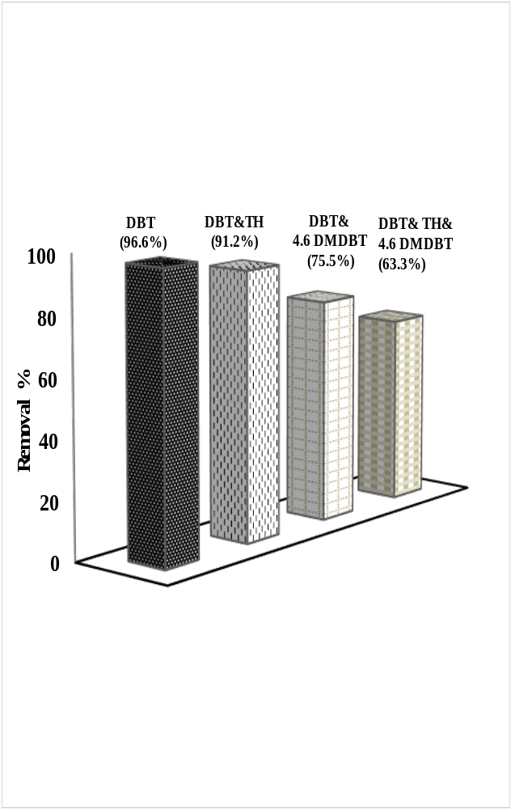
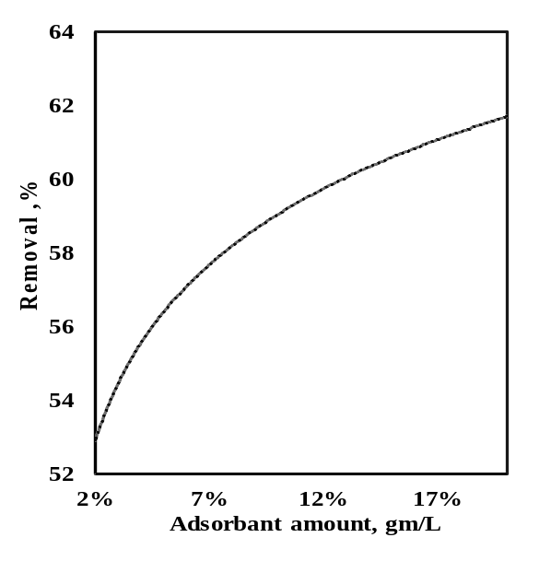
B
A
Adsorptive desulfurization

Influence of the prepared MOF/Gr sample on the removal of TH , DBTand 4,6-DMDBT sulfur compounds (A) and for the desulfurization of diesel feul (600 ppm sulfur)(B)

