Multiple abiotic and biotic drivers of soil water storage capacity in temperate forests recovering from disturbances

Shufang Liu^{1,2}, Zuoqiang Yuan^{1*}, Arshad Ali^{3,4}, Anvar Sanaei¹, Fan Ding⁵, Di Zheng¹, Shuai Fang¹, Zhaojie Jia³, Zhao Tao³, Fei Lin¹, Ji Ye¹, Xugao Wang¹, Zhanqing Hao^{6*}

¹CAS Key Laboratory of Forest Ecology and Management, Institute of Applied Ecology, Chinese Academy of Sciences, Shenyang 110164 China
²University of Chinese Academy of Sciences, Beijing 100049, China
³Department of Forest Resources Management, College of Forestry, Nanjing Forestry University, Nanjing 210037, Jiangsu, China
⁴Co-Innovation Center for Sustainable Forestry in Southern China, Nanjing Forestry University, Nanjing 210037, Jiangsu, China
⁵College of Land and Environment, Shenyang Agriculture University, Shenyang, China
⁶School of Ecology and Environment, Northwestern Polytechnical University, China
*Corresponding author: Zuoqiang Yuan (zqyuan@iae.ac.cn), Zhanqing Hao (hzq@iae.ac.cn)
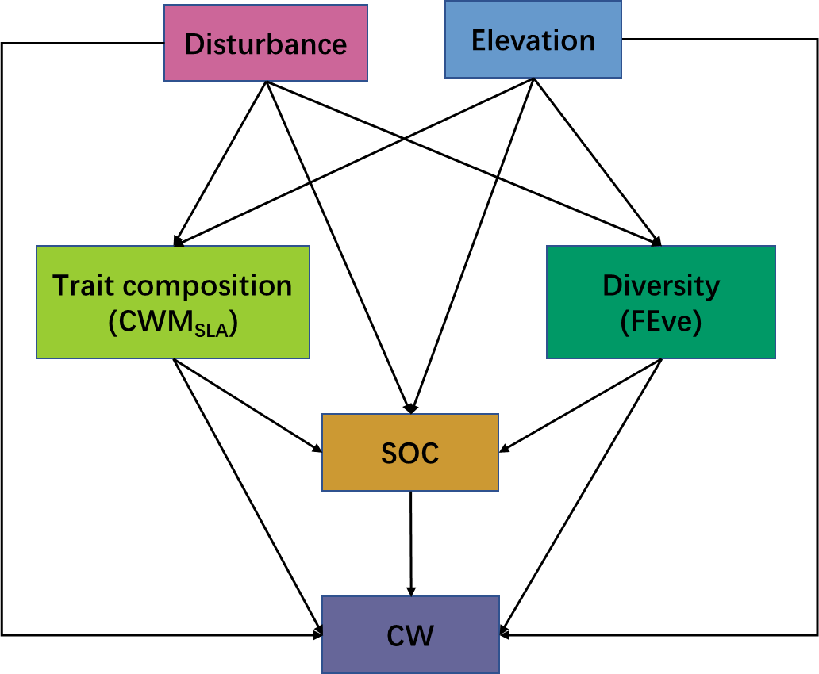
Fig. S1 A conceptual model for linking the hypothesized multiple abiotic (i.e., disturbance, elevation, and soil organic carbon) and biotic (functional trait diversity and composition) pathways to soil water storage capacity in temperate forests.

Fig. S2. Soil water storage capacity of top 20cm soil layers in different sites over three disturbance levels. (a): CW: soil capillary water storage contents; (b) NCW: soil non-capillary water storage contents; (c) TSW: soil total water storage contents. The yellow, green and blue column represent the low, medium and high level of disturbance, respectively.

Fig. S3 Boxplots of each soil water storage capacity and other associated variables over three disturbance levels. Letters above the box are significantly different at p < 0.05(Tukey’s test). Even, evenness diversity of plot; SWC, soil water content at natural state; AGB, aboveground biomass; CV_{DBH}, the coefficient of variation of DBH (Diameter at Breast Height).

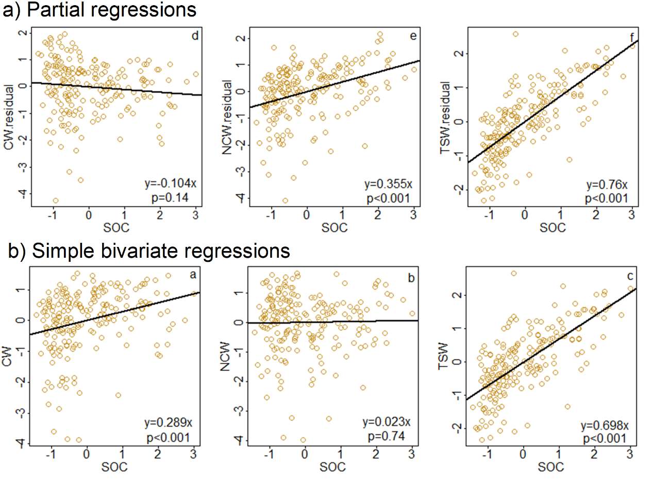

Fig. S4 the partial regressions (a) and bivariate simple regressions (b) analyses between SOC and soil water storage capacity (i.e., CW, NCW and TSW). All variables were standardized before analyses.

Fig. S5 Bivariate relationships between explanatory variables and CW. Fitted regression is significant at p < 0.05 and the relationships without fitted lined are non-significant. Among the explanatory variables, MAP, MAT, MTWQ, TPWQ are mean annual precipitation, mean annual temperature, mean temperature of the wettest quarter of the year, and total precipitation of the warmest quarter of the year according to http://www.worldclim.org/. Meanelev, Slope and Convex are the mean elevation, convex and slope of the subplot. This analysis also shows that most climate factors are insignificant with CW. Among the topography factors, only elevation and slope had a significant relation with CW.

Fig. S6 Bivariate relationships between explanatory variables and NCW.

Fig. S7 Bivariate relationships between explanatory variables and TSW.

