Supplementary Materials
DNA methylation at insulin-insulin like growth factor 2 is associated with prenatal exposure to sulfur dioxide and childhood attention-deficit hyperactivity disorder symptoms
Yoon-Jung Choi^{1,2,3#}, Jinwoo Cho^{4#}, Yun-Chul Hong^{2,3,5}, Dong-wook Lee^{3,6}, Sungji Moon², Soo Jin Park⁷, Kyung-shin Lee^{2,3,8}, Choong Ho Shin⁹, Young Ah Lee⁹, Bung-Nyun Kim¹⁰, Zachary Kaminsky^{11,12,13}, Johanna Inhyang Kim^{14*}, Youn-Hee Lim^{2,15*}
¹National Cancer Center Graduate School of Cancer Science and Policy, Goyang, Republic of Korea
²Department of Preventive Medicine, Seoul National University College of Medicine, Seoul, Republic of Korea
³Environmental Health Center, Seoul National University College of Medicine, Seoul, Republic of Korea
⁴Department of Statistics, University of Pittsburgh, Pittsburgh, PA, USA
⁵Institute of Environmental Medicine, Seoul National University Medical Research Center, Seoul, Republic of Korea
⁶Public Healthcare Center, Seoul National University Hospital, Republic of Korea
⁷Department of Surgery, Wonkwang University Sanbon Hospital, Gunpo, Republic of Korea
⁸Office for the Central Infectious Disease Hospital, National Medical Center, Seoul, Republic of Korea
⁹Department of Pediatrics, Seoul National University College of Medicine, Seoul National University Children’s Hospital, Seoul, Republic of Korea
¹⁰Division of Children and Adolescent Psychiatry, Department of Psychiatry, Seoul National University Hospital, Seoul, Republic of Korea
¹¹Institute of Mental Health Research, University of Ottawa, Ottawa, Canada
¹²Department of Cellular and Molecular Medicine, University of Ottawa, Ottawa, Canada
¹³Department of Psychiatry and Behavioral Sciences, Johns Hopkins University School of Medicine, Baltimore, USA
¹⁴Department of Psychiatry, Hanyang University Medical Center, Seoul, Republic of Korea
¹⁵Section of Environmental Epidemiology, Department of Public Health, University of Copenhagen, Copenhagen, Denmark
# These authors have contributed equally to this work and share the first authorship.
* These authors have contributed equally to this work and share the last authorship.
*Correspondence
Johanna Inhyang Kim,
Department of Psychiatry, Hanyang University Medical Center,
222-1 Wangsimni-ro, Seongdong-gu, Seoul, 04763, Republic of Korea
Telephone: +82 2 2290 9469,
E-mail: iambabyvox@hanmail.net

Youn-Hee Lim
Section of Environmental Epidemiology, Department of Public Health, University of Copenhagen,
Øster Farimagsgade 5, 1014 København K, Denmark
Telephone: +45 35 33 68 62
E-mail: younhee.lim@sund.ku.dk

Results
Selection of candidate genes
By using predetermined criteria, we identified 29 studies from PubMed, 61 studies from EMBASE, 60 studies from Web of Science, 54 studies from Scopus, and 5 studies from manual bibliographic search. After excluding 108 duplicated studies, 69 studies were remained. We further excluded irrelevant studies, studies with insufficient information, and studies that did not satisfy the selection criteria, finally leaving 22 studies (Supplementary Figure 1).
We pooled a total of 597 CpG sites from these studies, then excluded duplicated CpG sites (n=22), leaving 575 CpG sites. As we had information on 326,898 CpG sites from the study samples, 486 overlapping CpG sites were finally selected for further statistical analysis.

Methods
DNAm analysis
Bisulfite sequencing and microarray
Whole blood samples were repeatedly obtained from 51 children at ages 2 and 6. The quality of the DNA samples was assessed by the NanoDrop® ND-1000 UV-Vis Spectrophotometer (Thermo Fisher Scientific, Wilmington, DE, USA). Samples with intact genomic DNA (gDNA) were selected after electrophoresis on a 1% agarose gel, followed by dilution to 50 ng/μL according to Quanti-iT Picogreen quantification (Thermo Fisher Scientific, Wilmington, DE, USA). A minimum of 500 ng of gDNA was bisulfate-converted using Zymo EZ DNAm kit (Zymo Research, Irvine, CA, USA).
The amplified (×1000) bisulfite-converted DNA was used on each BeadChip, and was fragmented and hybridized by 50 mer capture probes at each CpG locus. Primers were extended using Two-Color Extension Master Mix (Illumina, San Diego, CA, USA), followed by staining, washing, and coating. The image intensities were extracted by Illumina GenomeStudio software, and the image was read by the Illumina BeadArray Reader. Microarrays were conducted by Macrogen (Seoul, Korea).
The level of DNAm at a single CpG locus was estimated as a beta value, which was calculated by the ratio of the methylated signal intensity divided by the sum of methylated and unmethylated signal intensities at the 5th carbon, ranging from 0 (no methylation) to 1 (fully methylated). Background signals from the negative control were subtracted from each signal. Gene-enrichment and functional annotation for each probe was performed by the Database for Annotation, Visualization and Integrated Discovery (DAVID) (http://david.abcc.ncifcrf.gov/home.jsp).

Systematic review of literature and selection of candidate CpGs
The following keywords were used to search titles from Pubmed, EMBASE, Web of Science, and Scopus from May 2 to May 9, 2021: ("ADHD" or "attention deficit hyperactivity disorder" or "inattentive" or "attention" or "hyperactive" or "hyperactivity") and ("DNAm" or "epigenome-wide association study" or "EWAS" or "epigenetics" or "epigenetic" or "CpGs" or "CpG"). The selection criteria were peer-reviewed original articles written in English which studied the epigenetic profiles of ADHD in human case-control studies or cohort studies. Animal studies, review articles, studies regarding genetic effects only, and studies that did not provide specific DNAm positions and only indicated gene names were excluded (Peter et al., 2016).
We pooled significant or suggestive CpGs associated with ADHD diagnosis or scales from the selected studies from the systematic review. If a study only provided probe position instead of the exact probe name, we selected CpGs closest to the probe position. In case of studies reporting significant or suggestive differentially methylated regions (DMRs) associated with ADHD, we pooled CpGs located within the reported DMRs.

SNP Genotyping
200ng of genomic DNA was amplified and randomly fragmented into 25 to 125 base pair (bp) sequence. Initial gDNA amplification was reacted in 40㎕ reaction volume, which contained 20㎕ volume of genomic DNA in concentration of 10ng/㎕, and 20㎕ of Denaturation Master Mix. The initial amplification was performed for 10 minutes at room temperature with 130㎕ of Axiom 2.0 Neutral Soln, 225㎕ Axiom 2.0 Amp Soln and 5㎕ Axiom 2.0 Amp Enzyme. The amplification reactions were performed for 23 hours ± 1 hour at 37℃ to produce 200-1,100 base pair fragments, which were further fragmented to segments of 25-50 bp. The fragments were end-labeled using biotinylated nucleotides, followed by hybridization. The bound targets were washed to remove non-specific background noise caused by random ligation events. Polymorphic nucleotides were queried through a multi-color ligation event on the array surface. After ligation, the arrays were stained and imaged on the GeneTitan MC Instrument (Affymetrix, Santa Clara, CA, USA), and the images were analyzed by using Genotyping Console™ Software (Affymetrix, Santa Clara, CA, USA).

Figure S1. Flow diagram of selection of target CpG sites 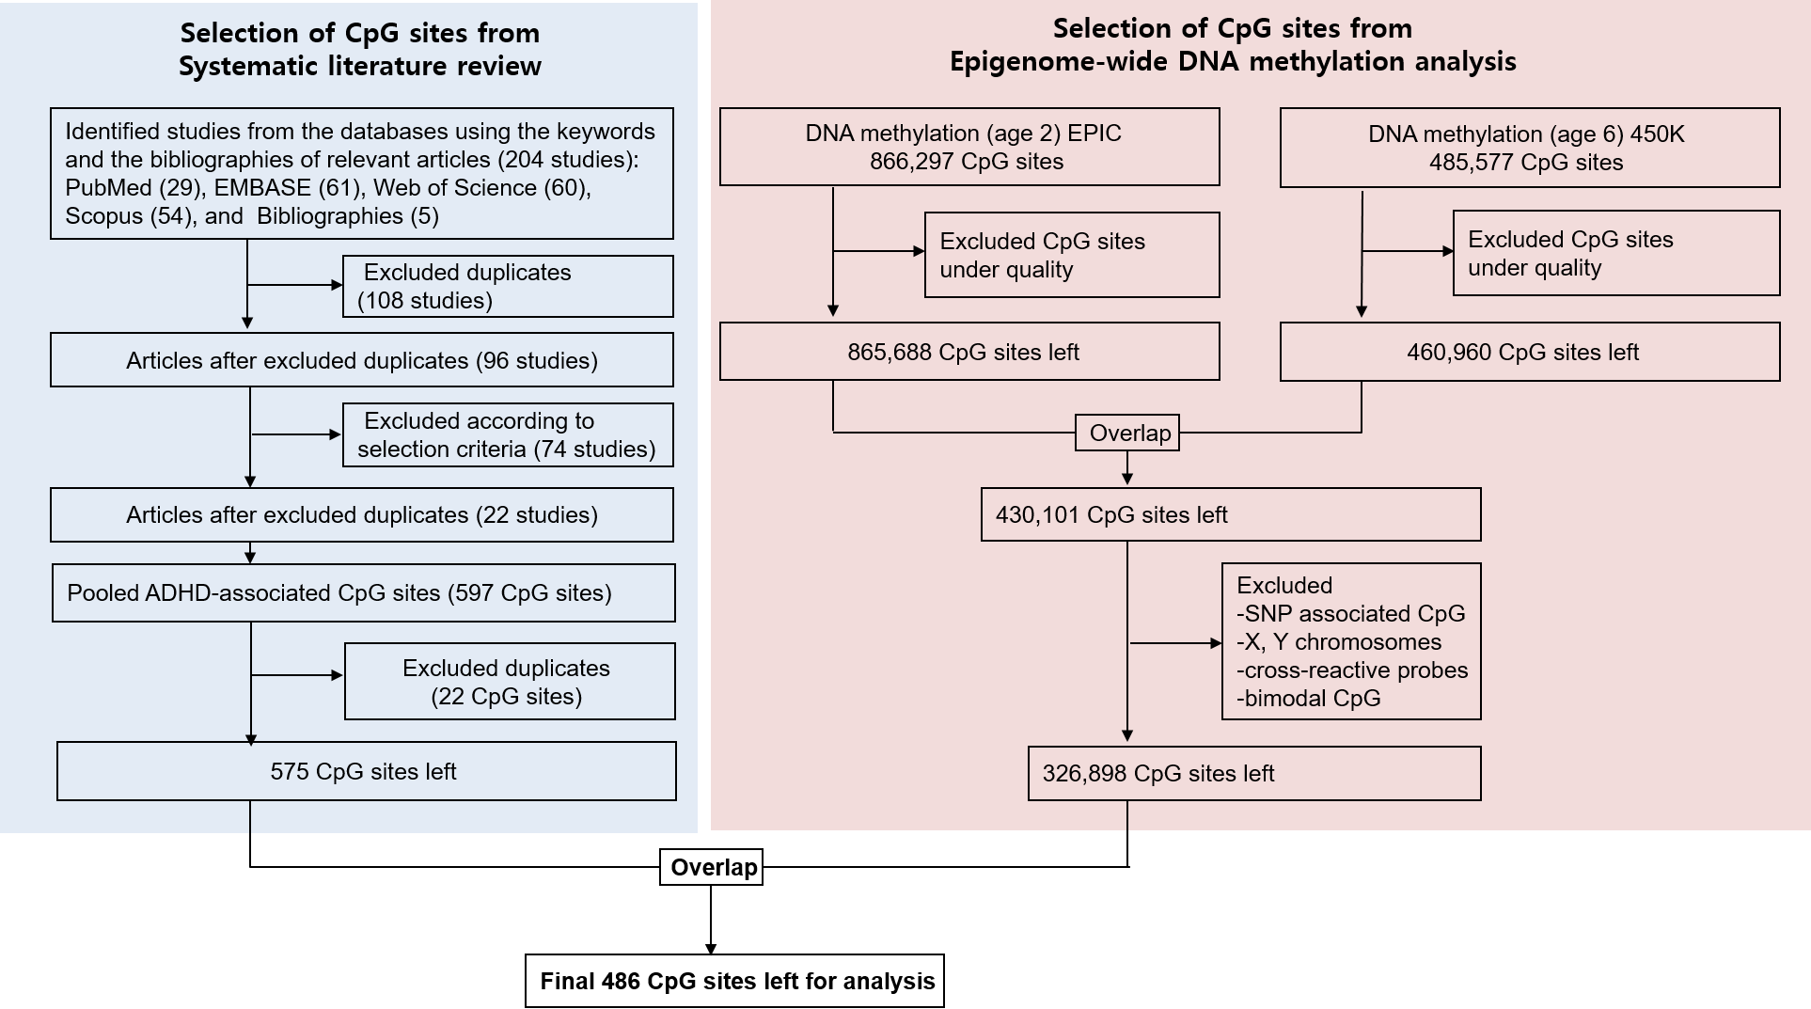
Figure S2. mQTL at cg07583420 (INS-IGF2) with 100kb window either side of the CpG site

Figure S3. DAG for covariates used for the association between prenatal SO2 exposure and ADHD
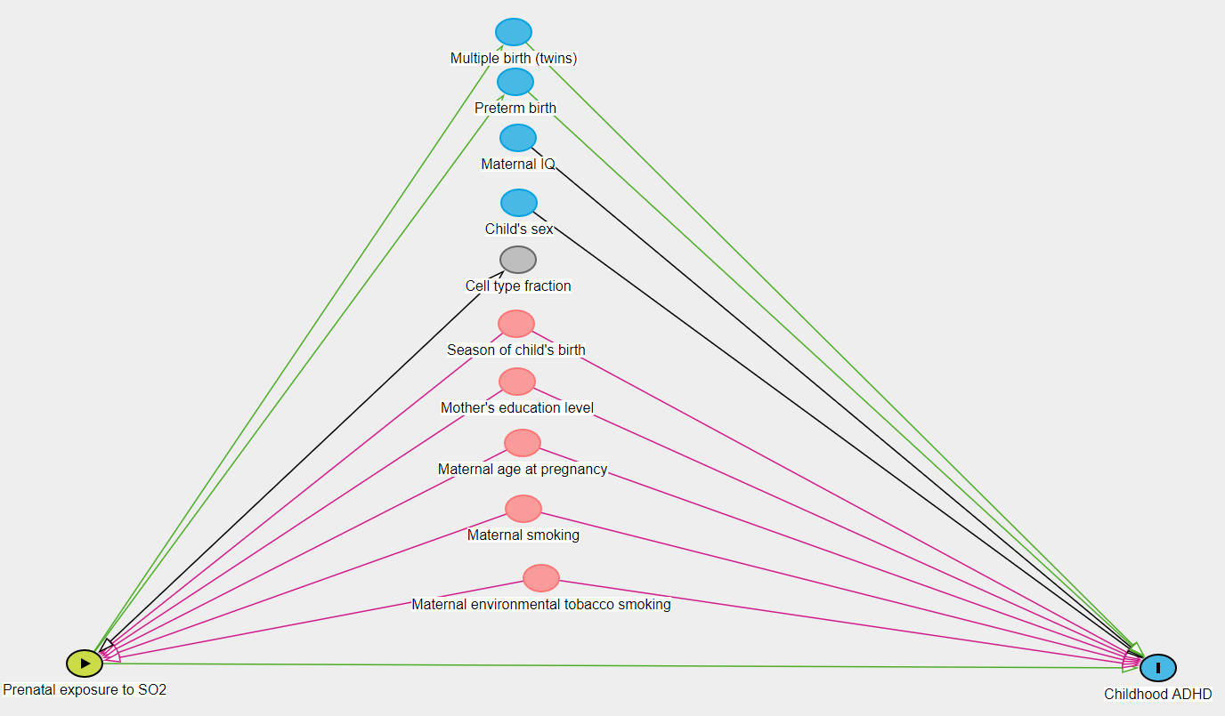
Figure S4. DAG for covariates used for the association between prenatal SO2 exposure and DNAm 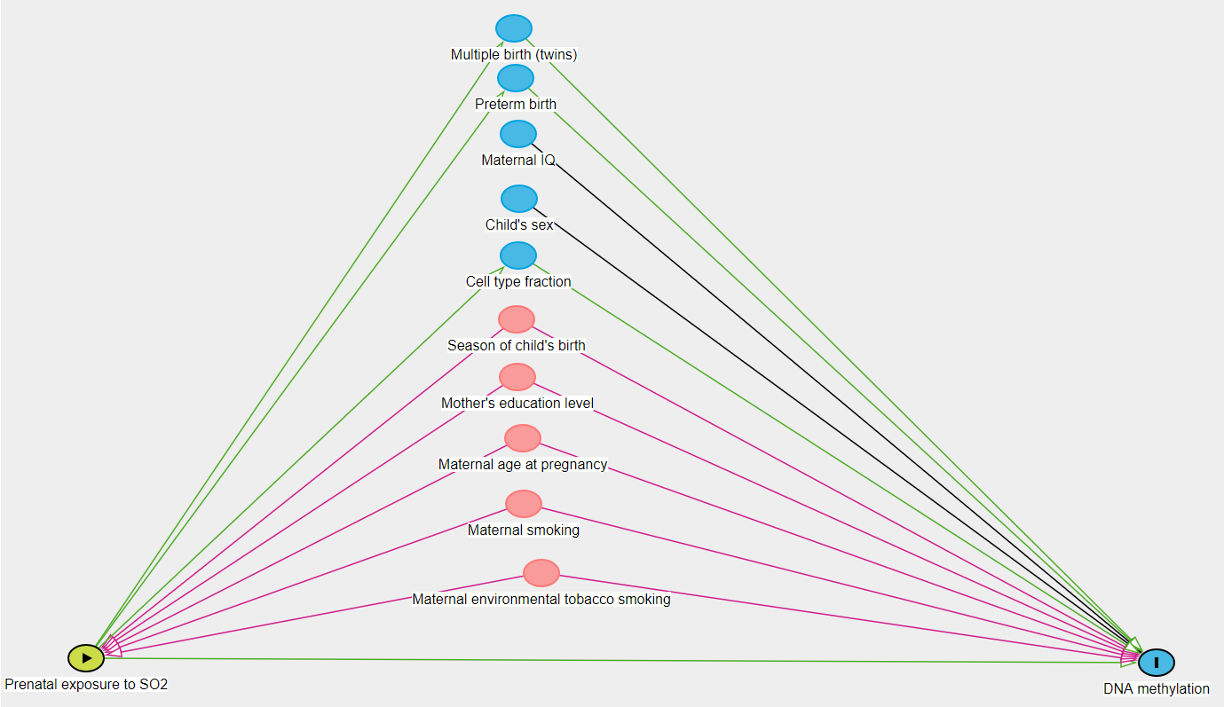
Figure S5. DAG for covariates used for the association between DNAm and ADHD 