Supplementary Material

Ce³⁺-induced fluorescence amplification of cooper nanoclusters based on aggregation-induced emission for specific sensing 2,6-pyridine dicarboxylic acid

Jingxiang Shen^{1,2}, Zhefeng Fan^{1*}
- School of Chemistry and Material Science, Shanxi Normal University, Taiyuan, 030006, People’s Republic of China
- Department of Chemistry, Changzhi University, Changzhi, 046011, People’s Republic of China
*Corresponding author: E-mail: zhefengfan@126.com

Instruments
Fig.S1 Comparison of fluorescence emission spectrum with Ce³⁺, Ce³⁺/GSH, GSH-CuNCs and Ce³⁺/GSH-CuNCs.
Fig.S2 Change of fluorescence intensity along with incubitation time.
Fig.S3 Effect of reaction time between DPA and Ce³⁺/GSH-CuNCs
Fig.S4 UV absorption spectrum of Ce³⁺, DPA and Ce³⁺-DPA complexes at pH=5.0 in HAc-NaAc buffer.
Table S1 Quantum yield calculation of GSH-CuNCs and Ce³⁺/GSH-CuNCs
Table S2 Comparison of our method with previously reported methods for sensing DPA

Experimental instruments
Fluorescent intensity were carried out by LS-55 fluorescence/phosphor spectrophotometer (Perkin-Elmer Company, USA). UV-vis absorbance measurements were performed by TU-1901 UV/Visible spectrophotometer (Beijing Purkinje General Instrument Co., Ltd, China). X-ray photoelectron spectroscopy (XPS) were measured using Thermo EscalAB 250Xi (Thermoelectric Corporation, USA). Fourier transform infrared (FTIR) spectra were obtained by Niocolet 380 spectrograph (Var-ian Instrument Co., Ltd, USA). Dynamic light scattering (DLS) and zeta potential were recorded by 90Plus PALS (NanoBrook, USA).

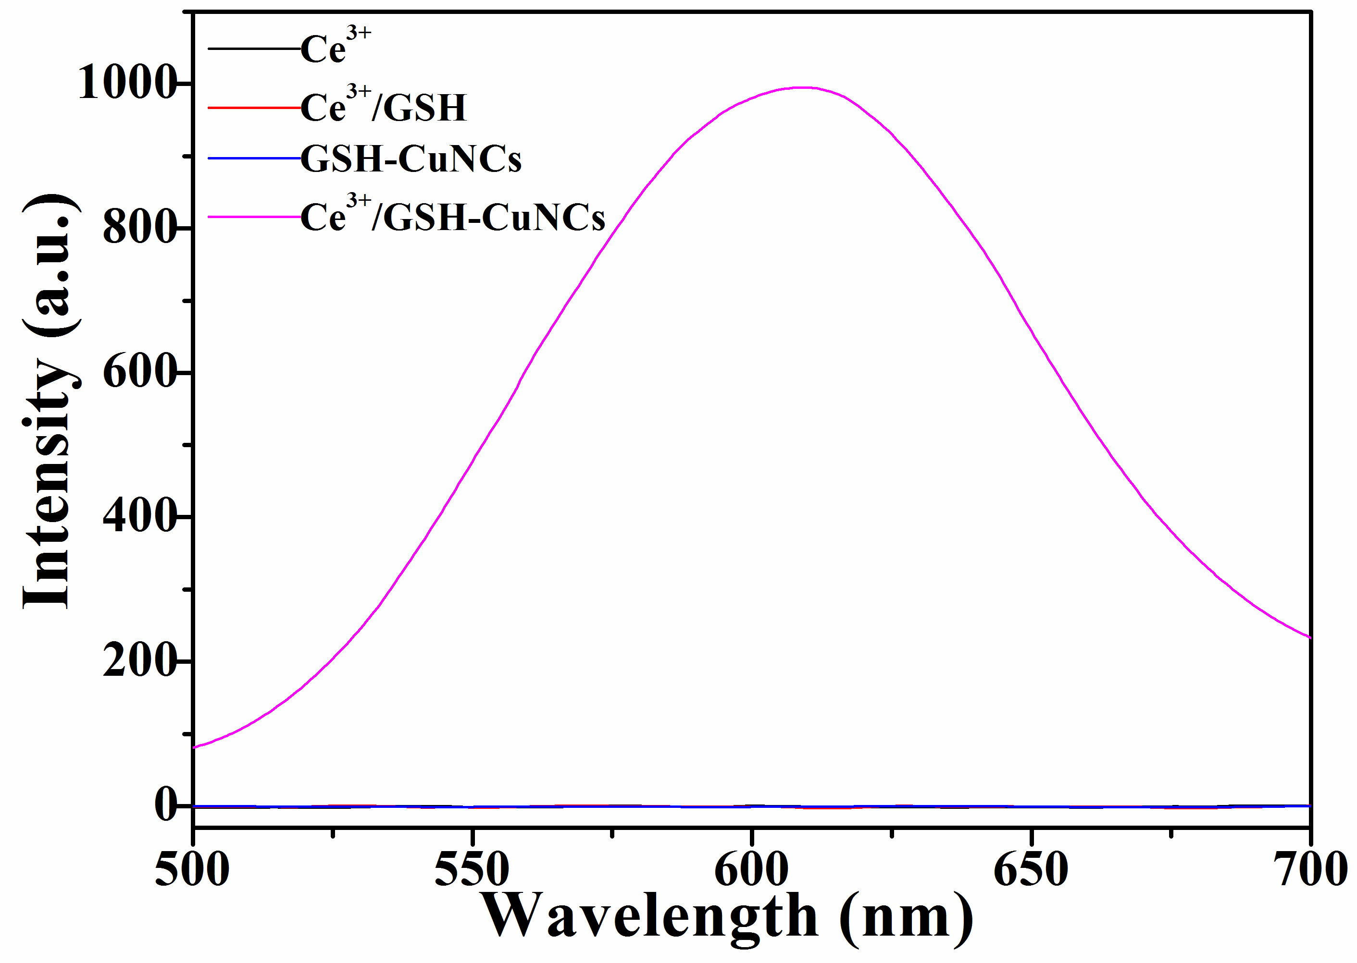
Fig. S1. Comparison of fluorescence emission spectrum with Ce³⁺, Ce³⁺/GSH, GSH-CuNCs and Ce³⁺/GSH-CuNCs
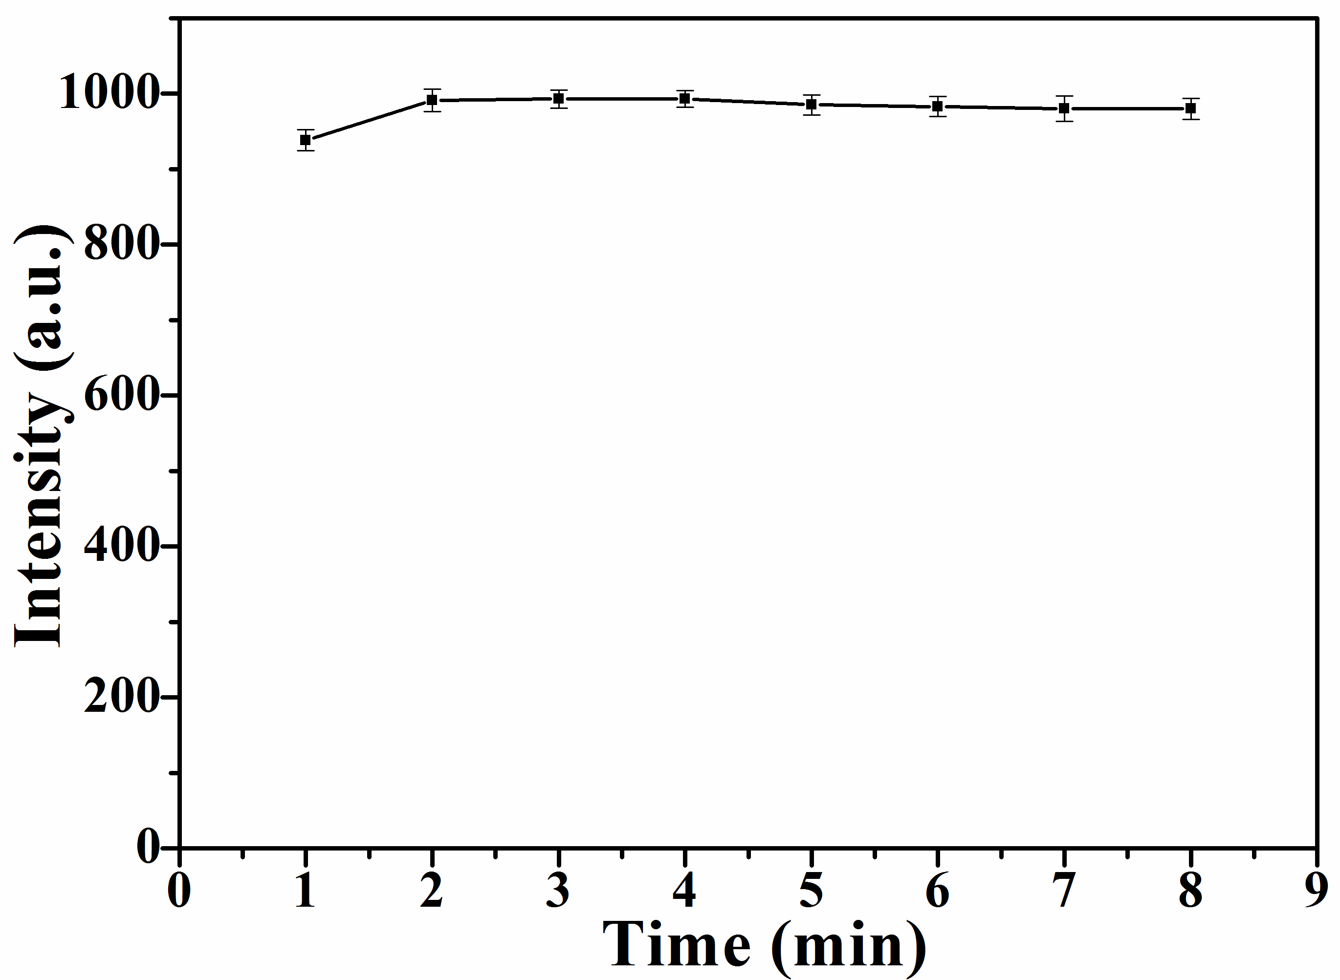
Fig. S2. Change of fluorescence intensity along with incubitation time
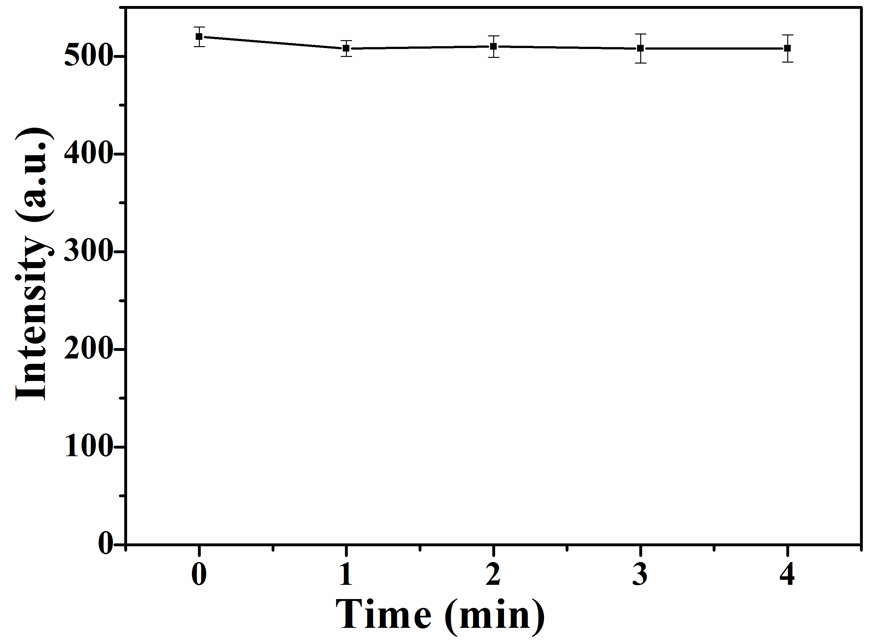
Fig. S3. Effect of reaction time between DPA and Ce³⁺/GSH-CuNCs
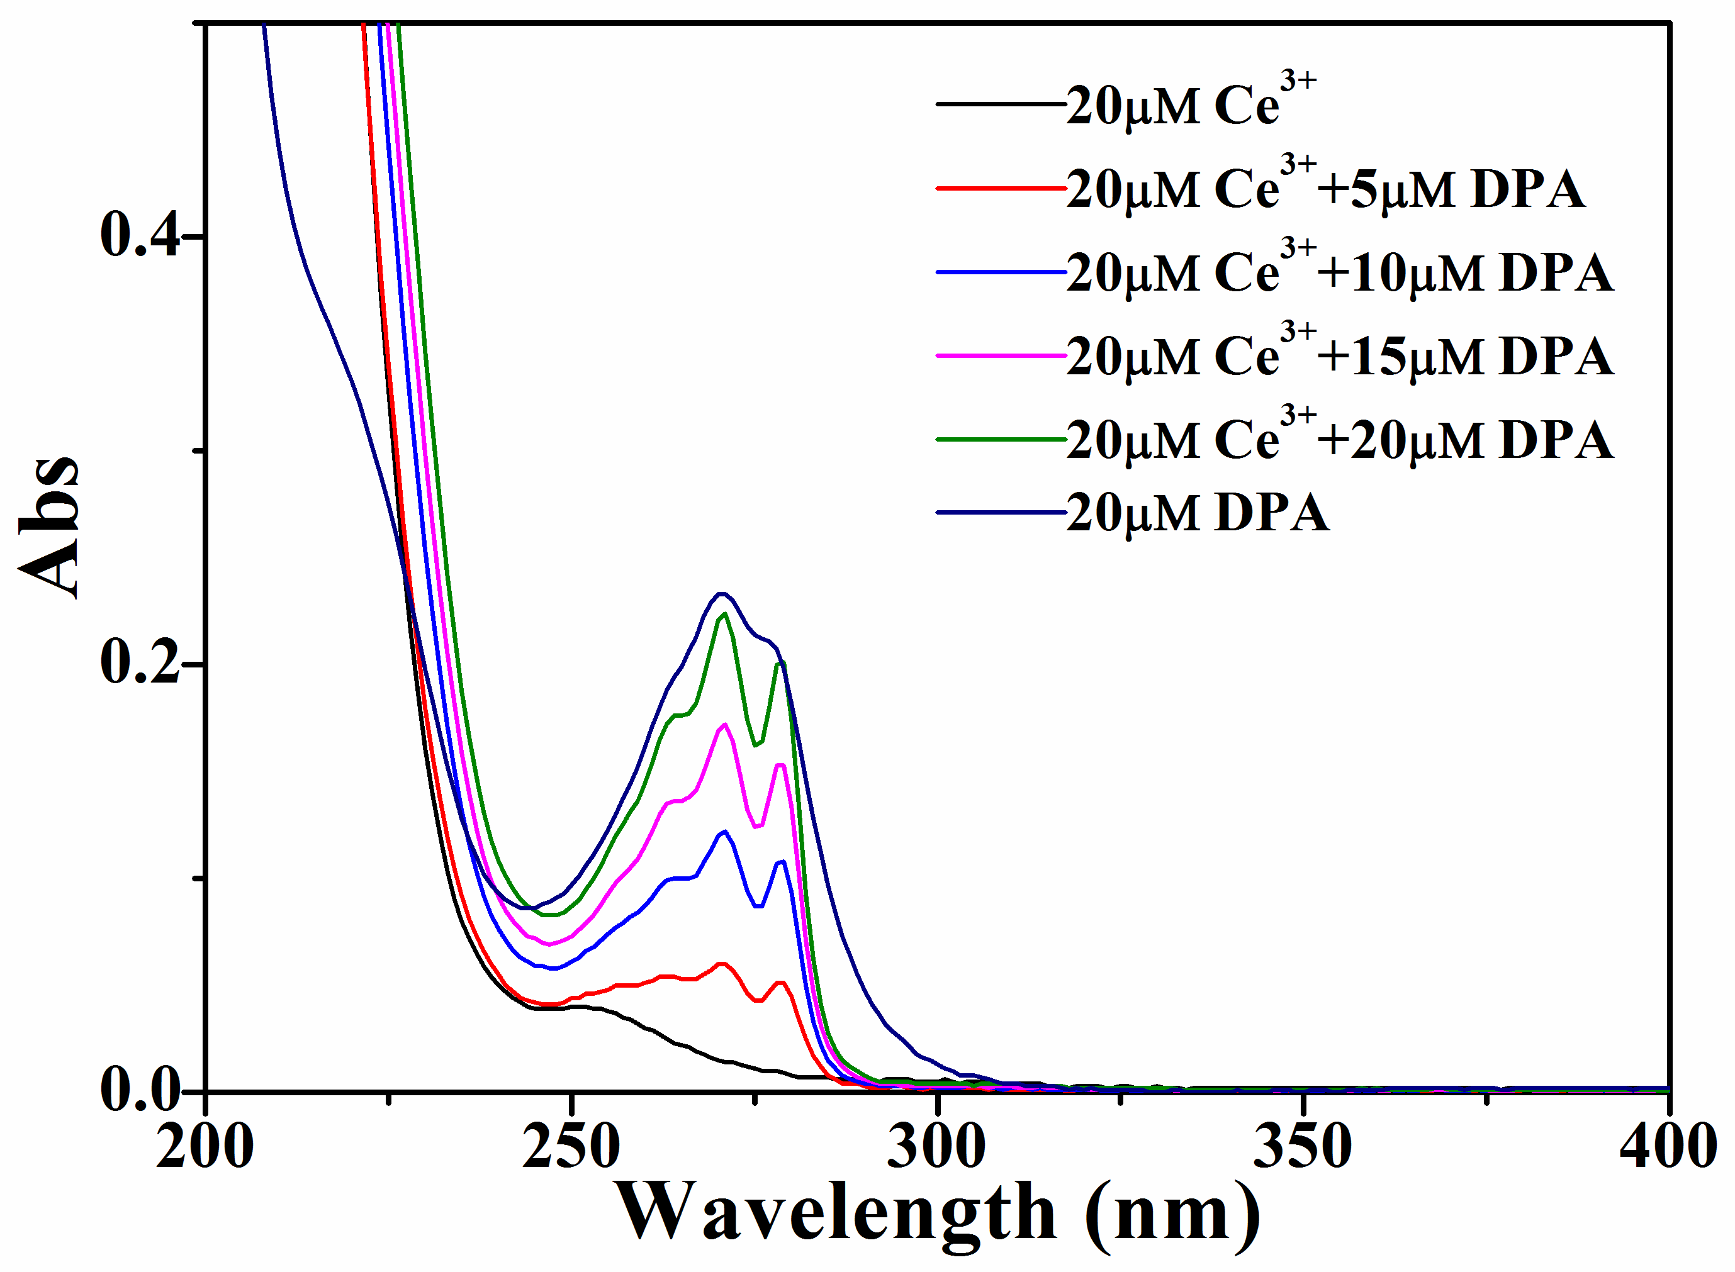
Fig. S4. UV absorption spectrum of Ce³⁺, DPA and Ce³⁺-DPA complexes at pH=5.0 in HAc-NaAc buffer.

Table S1. Quantum yield calculation of GSH-CuNCs and Ce³⁺/GSH-CuNCs
Samples | Integrated area  (F) | Absorbance  (A) | Refractive index of solvent (η) | QY(Ø)
Quinine sulfate | 76234.8 | 0.011 | 1 | 54%
GSH-CuNCs | 50.62 | 0.019 | 1 | 0.02%
Ce³⁺/GSH-CuNCs | 5436.1 | 0.025 | 1 | 1.7%

Table S2. Comparison of our method with previously reported methods for sensing DPA
Sensor materials | Linear range | LOD | refs
β-diketonate coordinated Eu(III)-complexes | 0–6 μM | 1.2μM | [1]
Cd₆ Eu₂ nanocluster | 30-60 μM | 8.7 μM | [2]
ZIF-8@AuNCs-Tb | 40-200 μM 200-100 μM | 1.8 μM | [3]
Cadmium sulfide quantum dots (CdSQDs) | 1-120 μM | 0.2 μM | [4]
Nanoscaled bimetallic lanthanoid MOF | 20-100 μM | 0.17 μM | [5]
Ce³⁺/GSH-CuNCs ensemble probe | 0.3-18 μM | 0.19 μM | This work

1. Abbas Z, Patra AK (2022) Luminescent β-diketonate coordinated europium(III) sensor for rapid and sensitive detection of Bacillus Anthracis biomarker. J Lumin 244:118726. https:// doi.org/10.1016/j.jlumin.2022.118726.
2. Leng X, Shi D, Yang X, Zhang Z, Li H, Cheng Y, Ma Y, Schipper D (2022) Construction of a luminescent square-like Cd₆Eu₂ nanocluster for the quantitative detection of 2,6-dipicolinic acid as an anthrax biomarker. J Mater Chem C 10:510-516. https:// doi.org/10.1039/d1tc05929g.
3. Shao K, Wen S, Zhang M, Wang J, Ye S, Pan Z(2021) A ratiometric fluorescent nanoprobe based on ZIF-8@AuNCs–Tb for visual detection of 2,6-pyridinedicarboxylic acid. J Rare Earths https:// doi.org/10.1016/j.jre.2021.08.005.
4. Li X, Deng L, Ma F, Yang M (2020) A luminous off-on probe for the determination of 2,6-pyridinedicarboxylic acid as an anthrax biomarker based on water-soluble cadmium sulfide quantum dots. Microchim acta 187:287. https:// doi.org/10.1007/s00604-020-04272-0.
5. Othong J, Boonmak J, Kielar F, Hadsadee S, Jungsuttiwong S, Youngme S (2020). Self-calibrating sensor with logic gate operation for anthrax biomarker based on nanoscaled bimetallic lanthanoid MOF. Sens Actuators B Chem 316:128156. https://doi.org/10.1016/ j.snb.2020.128156.

