SUPPLEMENTARY INFORMATION

Platinum Shortage Threatens China's Hydrogen Ambition for Carbon Neutrality
Peng Wang, Fan Yang, Chenyang Wang, Klaus Hubacek, Laixiang Sun, Wei-Qiang Chen, Kuishuang Feng & Jiashuo Li

Summary Information:
Number of SI Pages: 38
Number of SI Figures: 14
Number of SI Tables: 15
TABLE OF CONTENTS
S1. Abbreviated letter index table 2
S2. Comparison with the results of previous studies 3
S3. Data and method details 7
S3.1. Data used for evaluating Pt demand 7
S3.2. Method of mapping the platinum cycle in the future 8
S4. Scenarios instruction 11
S4.1. Description of climate scenarios 11
S4.2. Description of circular economy scenarios 11
S5. Supporting results 13
S5.1. China's Pt demand trend associated with hydrogen development 13
S5.2. China's cumulative Pt demand structure associated with H₂ development 14
S5.3. China’s Pt import map in 2019 15
S5.4. Pt supplier countries’ pressure caused by China's hydrogen infrastructure 16
S5.5. Benefits of circular measures under each scenario 17
S5.6. China’s platinum supply and consumption mix from 2021 to 2060 20
S5.7. Pt cost driven by the rapidly growing Pt demand under the CN scenario 23
S5.8. Share of Pt cost in the total cost of each hydrogen technology in 2060 25
S6. Parament setting 26
S6.1. Carbon emissions pathway of each climate scenario 26
S6.2. Classification and technical parameters of hydrogen production technology 27
S6.3. Cost evolution of hydrogen production technology 28
S6.4. Cost evolution of road transport technology 29
S6.5. Market share of fuel cell technologies in industry energy and CHP use area 31
S6.6. Lifetime setting of Pt-containing hydrogen equipment 32
S6.7. Recycling patterns for key hydrogen energy infrastructure 33
S6.8. Parament settings of different recycling patterns 34
S6.9. Pt intensity evolution of key hydrogen technologies 35
Supplemental References 36

Abbreviated letter index table
Table S1 List of abbreviations.
Abbreviation | Full Name
H₂ | Hydrogen
Pt | Platinum
LDV | Light-duty Vehicles
CN | Carbon Neutrality
BAU | Business-As-Usual
CCS | Carbon Capture and Storage
FC | Fuel Cell
FCEV | Fuel Cell Electric Vehicle
BEV | Battery Electric Vehicle
PEM | Polymer Electrolyte Membrane
PAFC | Phosphoric Acid Fuel Cell
SOFC | Solid Oxide Fuel Cell
HRS | Hydrogen Refuelling Station
MCFC | Molten Carbonate Fuel Cell
PEMFC | Proton Exchange Membrane Fuel Cell
CHP | Combined Heat and Power
CR | collection rate
ZA | South Africa
RUS | Russia
RoW | Rest of World
EOL-RR | end-of-life recycling rate

Comparison with the results of previous studies
Table S2 Comparison of our hydrogen demand forecast with previous studies
Reference | H₂  demand | Region | Climate target | H₂  application | End-use sector coverage
Hydrogen council¹ | 200 Mt  in 2050 | China | 1.5℃ | H₂ as fuels  and H₂ for industrial applications | Building (20%)  Industry (50%)  Power (10%)  Transport (40%)
International Energy Agency² | 90 Mt  in 2060 | China | Carbon neutrality | H₂ fuels  and H₂ for industrial applications | Industry (40%)  Refinery (20%)  Transport (25%)  Others (15%)
China hydrogen alliance³ | 130 Mt  in 2060 | China | Carbon neutrality | H₂ as fuels  and H₂ for industrial applications | Building (5.5%)  Industry (60%)  Power (4.5%)  Transport (30%)
Shell⁴ | 25.5 Mt  in 2060 | China | 2℃ | H₂ as fuels | Heavy industry (25%)  Transport (22%)  Others (53%)
BP⁵ | 93 Mt  in 2050 | China | 1.5℃ | H₂ as fuels  and H₂ for industrial applications | Not Available
CN scenario, this study | 20.0 Mt  in 2060 | China | Carbon neutrality | H₂ as fuels | Industry (37.6%)  Transport (62.4%)
1.5℃ scenario, this study | 32.1 Mt  in 2060 | China | 1.5℃ | H₂ as fuels | Industry (27.6%)  Transport (72.4%)
BAU scenario, this study | 38.0 Mt  in 2060 | China | No climate target | H₂ as fuels | Industry (6.7%)  Transport (93.3%)

Table S3 Review on the key Pt demand results from previous studies
Reference | Pt demand* | Technology  Scope | Key assumption | Key results
(Raymond, Sterck and Clifford, 2022)⁶ | 31.1 t (1M oz) p.a. by 2030  124.4t (4M oz) p.a. by 2040  40.4t (1.3M oz) p.a. by 2028  208.4t (6.7M oz) p.a. by 2040 | FCEVs | Policy-driven scenario: FCEV adoption is driven by government and regional subsidies, incentives, and legislated targets. FCEVs reaches 2m in 2030 and 11m in 2040.  Commercially enhanced adoption scenario: government and regional policies have engendered infrastructure critical mass. FCEVs reaches 3m in 2030 and 15m in 2040. | Supply without increases can cause platinum scarcity, which would hinder FCEV growth rates, while Pt production can be expanded with time to satisfy the demand growth.
(Tong et al., 2022)⁷ | nearly 280-350 t p.a. in 2050 | Transportation (FCEVs, ICEVs) | Energy scenario: carbon neutrality within half a century.  Technology assumption:  S1: Technological Substitution–substituting ICEs with FCVs and BEVs.  S2: Diversified niches-considering the path-dependency of technological change.  S3: Landscape change–combined with a systematic change in mobility landscape | There is an imbalance between supply and demand for Pt between regions, calling for a global coordination to enhance the material efficiency for Pt
(Hao et al., 2019)⁸ | 33.8 kt(D1)  93.2 kt(D2)  56.1 kt(D3)  2010-2100  cumulatively | Transportation (FCEVs, ICEVs) | Population and economic growth: SSP2.  Vehicle sales, scrappage, and stock: the global vehicle sales will increase from the current level of 97 million to 144 million in 2030 (49% increase), 192 million in 2050 (98% increase), and 220 million in 2100 (127% increase).  Technology assumption:  D1: FCVs penetrating only the HDV segment.  D2: FCVs into the HDV & LDV segment.  D3: Lowering PGM loading of fuel cells. | PGMs are not likely to be a constraint for the mass deployment of FCEVs at the global level, there could be significant supply risks due to resource location.
(Alonso, Field and Kirchain, 2012)⁹ | 59 kt  2010-2050  cumulatively | All platinum-using industries | Energy scenario: IEA projected fleet for meeting 450 greenhouse gas goals.  Technology assumption: simulate historical platinum usage and its growth rate for individual Pt-using industries, and FCEVs reach 12% in 2035. | The demand can only be met by the primary supply curve （projected based on 5% exponential growth rate）.
(Rasmussen et al., 2019)¹⁰ | 51.4 kt  (the most aggressive fuel cell scenario)  2016-2050  cumulatively | All platinum-using industries | FCEVS: bottom-up approach, fuel cell rapid development scenario  Electrolyser: extrapolate Danish to all other countries  Other sectors: assumption based on their historical patterns | Only in high demand scenarios and when fuel cell market penetration is higher than the expected, the aggregate demand to 2050 will exceed the 2016 global platinum reserves.
(Elshkaki, 2013)¹¹ | over 1.4 kt p.a. in 2050  over 8.0 kt p.a. in 2100 | All platinum-using industries | Fuel Cells are modelled based on the demand for vehicles, the share of Fuel Cell Vehicles (FCVs). FCEVs market share reaches 50% by the year 2050 and 100% by the year 2100.  Catalytic Converters are modelled based on the demand for vehicles, FCVs market share, CC market share.  Other Applications are modelled based on socio-economic variables, metal price and time. | Platinum identified resources are expected to deplete with or without the introduction of FCVs before the end of the century.
Note: Those values are obtained roughly based on their result presentations.

Data and method details

Data used for evaluating Pt demand
Table S4 Data used for evaluating Pt demand
Variable | Value | Unit | Source | Process
China's Pt primary production | 2.5 | ton | BGS¹² | the average of data during 2015-2020
Global Pt primary production | 180.3 | ton | USGS¹³ | the average of data during 2013-2020
China's current Pt gross demand | 72.4 | ton | SFA Oxford¹⁴ | the average of data during 2013-2020
China's recycling | 13.94 | ton | SFA Oxford¹⁴ | the average of data during 2013-2020
Pt content of PGM mines  (Pt ratio) | 51.3 | % | (Nassar, 2015)¹⁵  (Rasmussen et al., 2019)¹⁶ | the average of 21 PGM mines
China's Pt reserve | 65 | ton | China Mineral Resources¹⁷ | Pt ratio * PGMs reserve of 2020
Global Pt reserve | 35397 | ton | USGS¹³ | Pt ratio * PGMs reserve of 2020
Pt reserve of ZA | 32319 | ton | USGS¹³ | Pt ratio * PGMs reserve of 2020
Pt reserve of RUS | 2000.7 | ton | USGS¹³ | Pt ratio * PGMs reserve of 2020
Pt reserve of RoW | 1077.3 | ton | USGS¹³ | Pt ratio * PGMs reserve of 2020
Pt price ⁽¹⁾ | 1064.6 | USD/troy ounce | LBMA¹⁸ | the average of data during 2013-2021
Pt import share of ZA ⁽²⁾ | 60.3 | % | UN Comtrade¹⁹ | Share sourced from South Africa of the imported Pt
Pt import share of RUS ⁽²⁾ | 10.2 | % | UN Comtrade¹⁹ | Share sourced from Russia of the imported Pt
Pt import share of RoW ⁽²⁾ | 29.4 | % | UN Comtrade¹⁹ | Share sourced from RoW of the imported Pt
Note: (1) The figure is in 2020 dollars.
(2) The selected year is 2019. Trade pattern in 2019 is more convincing, considering the Covid-19’s effect to the Pt supply chain²⁰.

Method of mapping the platinum cycle in the future

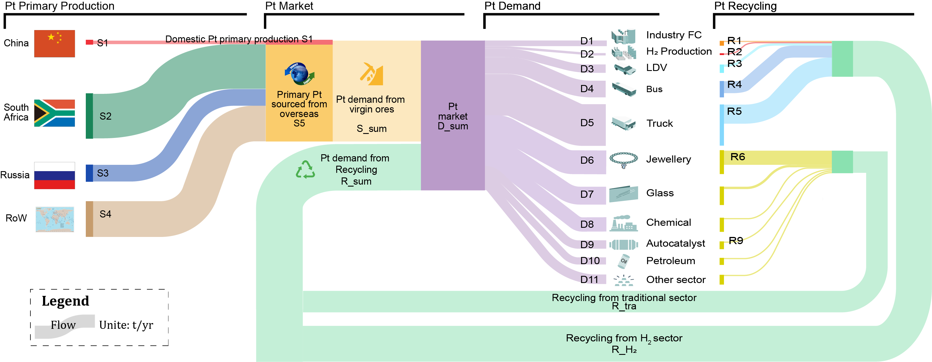
Figure S1 Framework of China's Pt cycle in the future

Table S5 Detailed explanation of the calculation of each flow in China's Pt cycle.
Flow | Description | Calculation | Data source
D1 | Pt demand for Industry FC | Stock-driven model | Calculation in this study
D2 | Pt demand for H₂ Production | Stock-driven model | Calculation in this study
D3 | Pt demand for LDV | Stock-driven model | Calculation in this study
D4 | Pt demand for Bus | Stock-driven model | Calculation in this study
D5 | Pt demand for Truck | Stock-driven model | Calculation in this study
D6 | Pt demand for Jewellery | Statistics | SFA Oxford¹⁴
D7 | Pt demand for Glass | Statistics | SFA Oxford¹⁴
D8 | Pt demand for Chemical | Statistics | SFA Oxford¹⁴
D9 | Pt demand for Autocatalyst | Statistics | SFA Oxford¹⁴
D10 | Pt demand for Petroleum | Statistics | SFA Oxford¹⁴
D11 | Pt demand for Other sector | Statistics | SFA Oxford¹⁴
D_sum | Total Pt demand | D_sum=D1+…+D11 | Mass balance
R1 | Recycling of Industry FC | Stock-driven model | Calculation in this study
R2 | Recycling of H₂ Production | Stock-driven model | Calculation in this study
R3 | Recycling of LDV | Stock-driven model | Calculation in this study
R4 | Recycling of Bus | Stock-driven model | Calculation in this study
R5 | Recycling of Truck | Stock-driven model | Calculation in this study
R6 | Pt demand for Jewellery | Statistics | SFA Oxford¹⁴
R9 | Pt demand for Autocatalyst | Statistics | SFA Oxford¹⁴
R_tra | Recycling from traditional sector | Statistics | SFA Oxford¹⁴
R_H₂ | Recycling from H₂ sector | R_H₂=R1+R2+R3+R4+R5 | Mass balance
R_sum | Pt demand from Recycling | R_sum=R_tra+R_H₂ | Mass balance
S_sum | Pt demand from virgin ores | S_sum=D_sum-R_sum | Mass balance
S1 | China's domestic Pt primary production | Statistics | BGS¹²
S5 | Primary Pt sourced from overseas | S5=S_sum-S1 | Mass balance
S2 | Primary Pt sourced from South Africa | S2=S5*Import share_ZA | Mass balance
S3 | Primary Pt sourced from Russia | S3=S5*Import share_RUS | Mass balance
S4 | Primary Pt sourced from Rest of World | S4=S5*Import share_RoW | Mass balance

Scenarios instruction

Description of climate scenarios
Table S6 Description of climate scenarios
Scenario | Social Economic Parament | Climate Target | Temperature Increase in 2060
BAU | SSP2 | No climate policy constraints | 2.341°C
1.5°C | SSP1 | No more than 1.5°C temperature increase in 2100 | 1.819°C
CN | SSP1 | Carbon emissions are reduced to zero in 2060 | 1.684°C

Description of circular economy scenarios
Material efficiency improvement strategies such as increasing recycling, product redesign and material substitution can improve Pt supply resilience in the face of future uncertainties^{21–23}. Here, we quantify the potential benefits of four sets of Pt material-based efficiency strategies across Pt life cycle, which are: (1) Pt-free technology substitution, (2) Pt service life extension, (3) Pt recycling enhancement, and (4) Reducing Pt content. Strategy (1) lies in the planning stage and aims to avoid Pt usage in H₂ value chain by selecting alternative Pt-free technologies. For instance, in the industrial use of hydrogen energy, those emerging Pt-free technologies (e.g., SOFC and MCFC) are assumed to quickly replace PAFC and PEMFC and fully occupy the market by 2045. Strategy (2) focuses on the in-use stage to extend key Pt technology service lifetime by ensuring asset durability and optimising operation. Strategy (3) incorporates various end-of-life strategies for better management of end-of-life products and high efficiency of the Pt recovery process. Strategy (4) complies with the principle of material reduction for the same hydrogen service, mainly through technology breakthroughs and R&D to reduce the platinum content in hydrogen equipment.

Table S7 Description of circular economy scenarios
Strategy | Technology market share |  | Life  time |  | Recycling |  | Material intensity
Strategy | I | II | I | II | I | II | I | II
No policy | √ |  | √ |  | √ |  | √
(1) Pt-free technology substitution |  | √ | √ |  | √ |  | √
(2) Pt service life extension | √ |  |  | √ | √ |  | √
(3) Pt recycling enhancement | √ |  | √ |  |  | √ | √
(4) Pt basic reduction | √ |  | √ |  | √ |  |  | √
Note:
- Technology market share: Type I means general technology mix; Type II means No-Pt technology mix.
- Life time: Type I means general lifetime, Type II means the extended lifetime.
- Pt recycling enhancement: Type I adopts current recycling setting; Type II adopts enhanced recycling setting.
- Material intensity: Type I means the current advanced intensity; Type II means the basic reduction intensity.

Supporting results

China's Pt demand trend associated with hydrogen development
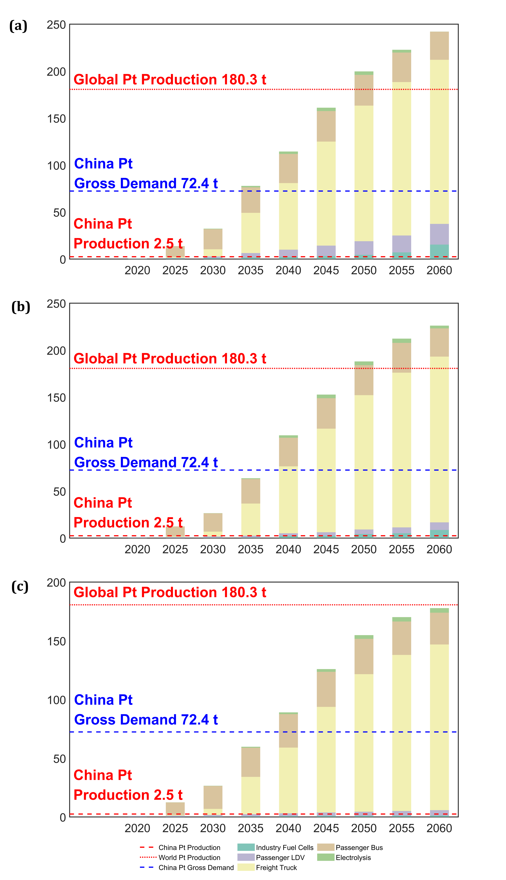
Figure S2 China's Pt demand trend associated with hydrogen development from 2021 to 2060. (a) the CN scenario, (b) the 1.5°C scenario, and (c) the BAU scenario

China's cumulative Pt demand structure associated with H₂ development
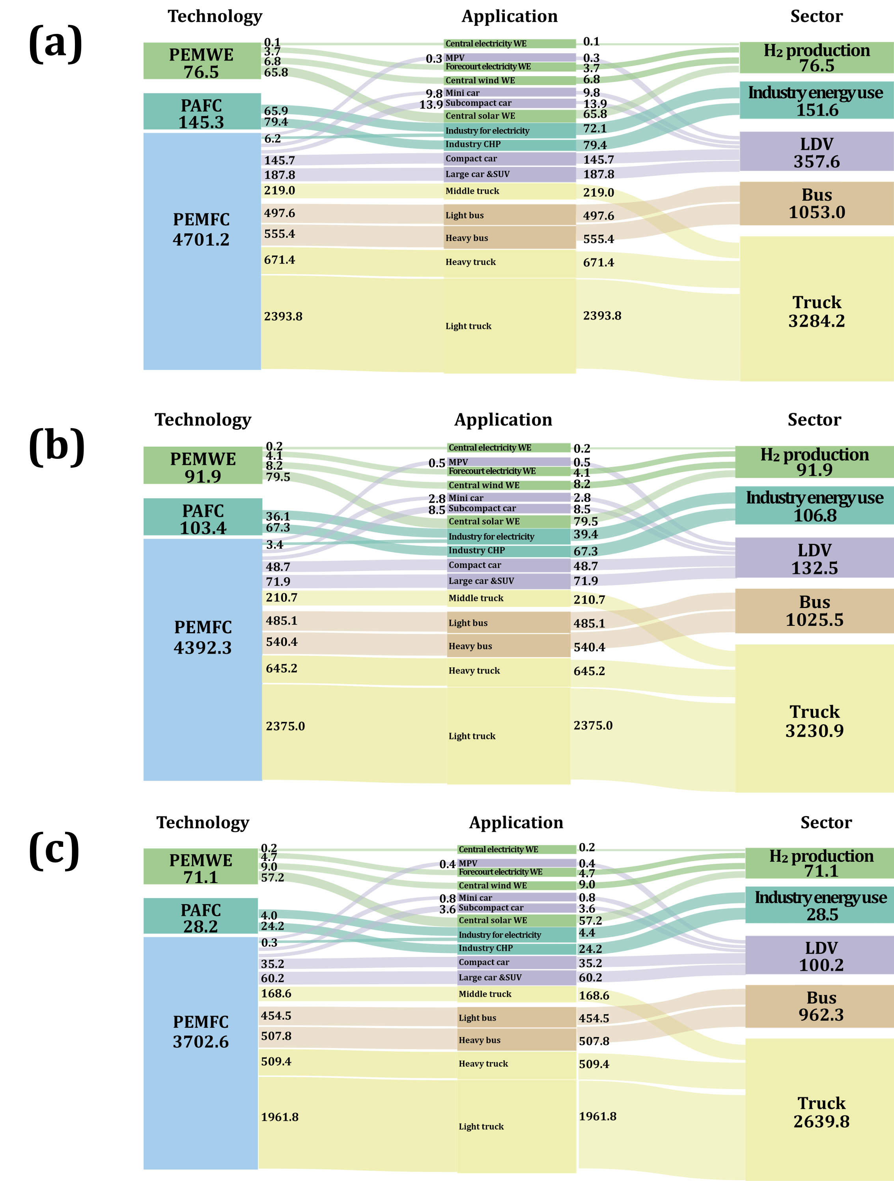
Figure S3 China's cumulative Pt demand structure associated with hydrogen development during 2021-2060. (a) the CN scenario, (b) the 1.5°C scenario, and (c) the BAU scenario

China’s Pt import map in 2019

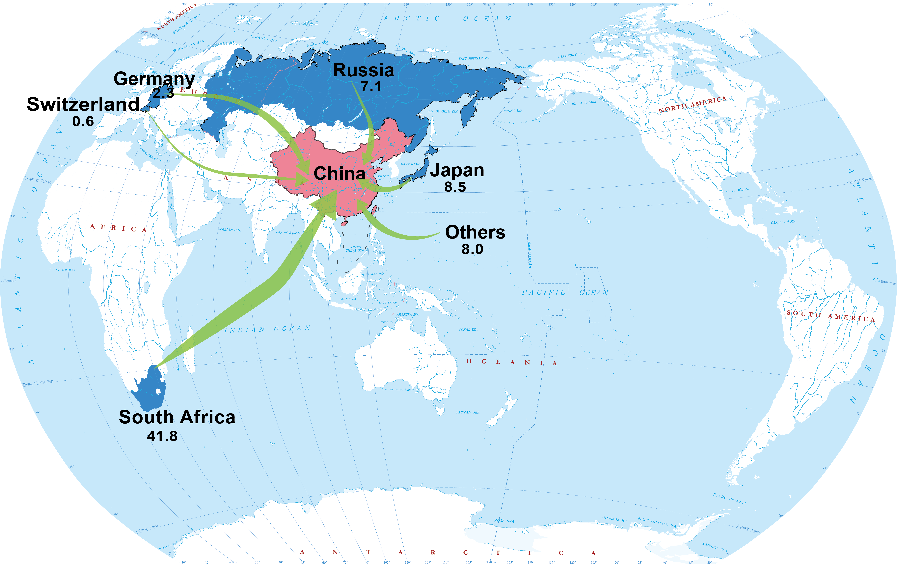

Figure S4 China’s Pt import map in 2019 (Unite: ton/year)

Pt supplier countries’ pressure caused by China's hydrogen infrastructure
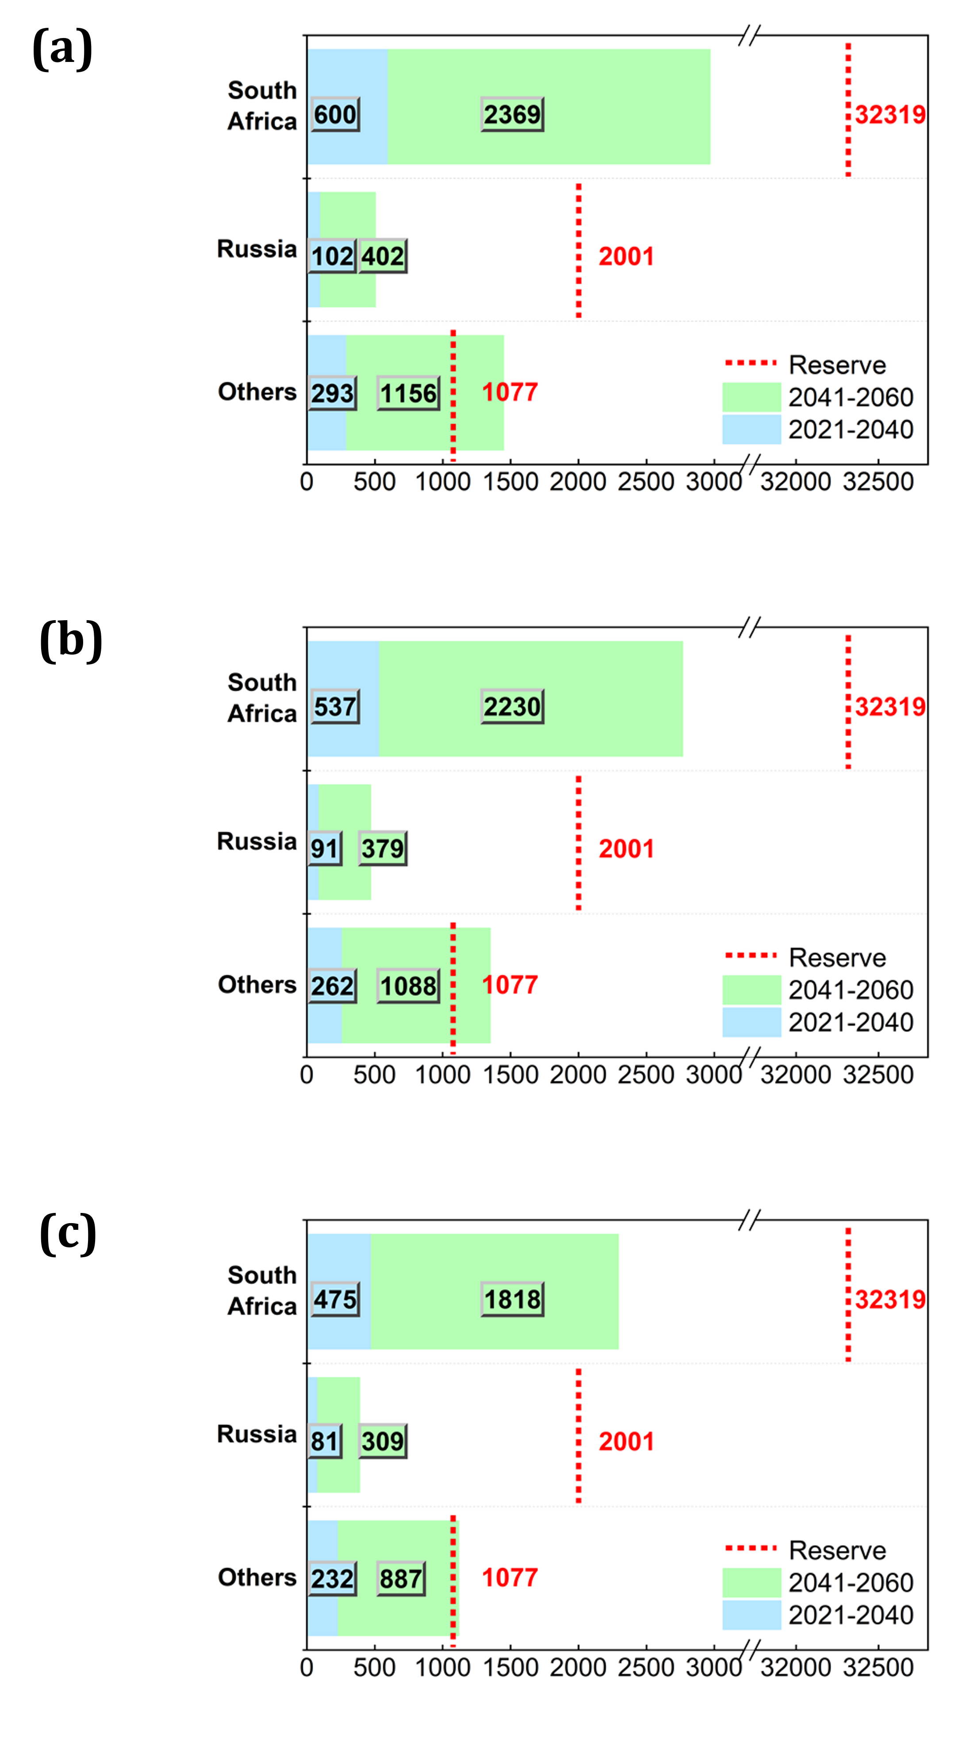
Figure S5 Pt supplier countries’ pressure caused by China's hydrogen infrastructure. (a) the CN scenario, (b) the 1.5°C scenario, and (c) the BAU scenario

Benefits of circular measures under each scenario
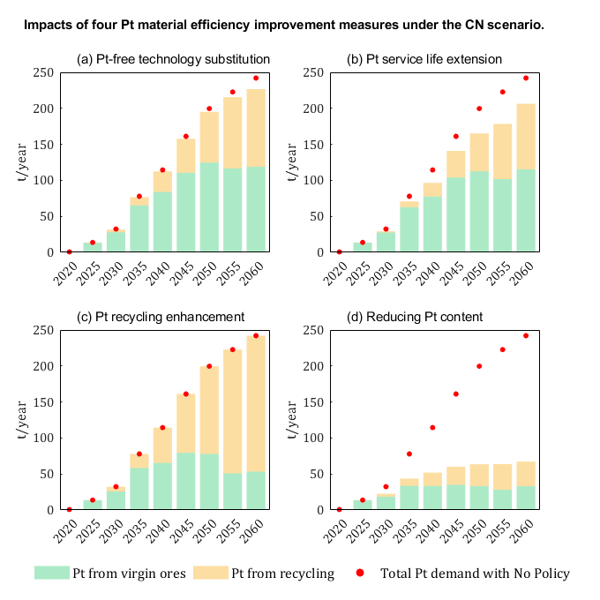
Figure S6 Benefits of circular measures under the CN scenario. (a) Pt-free technology substitution; (b) Pt service life extension; (c) Pt recycling enhancement, and (d) Reducing Pt content.
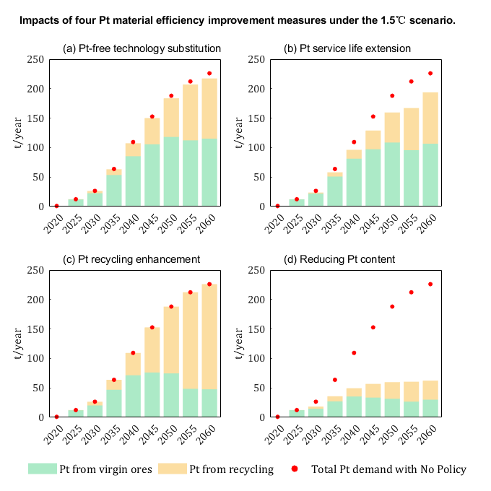
Figure S7 Benefits of circular measures under the 1.5°C scenario. (a) Pt-free technology substitution; (b) Pt service life extension; (c) Pt recycling enhancement, and (d) Reducing Pt content.

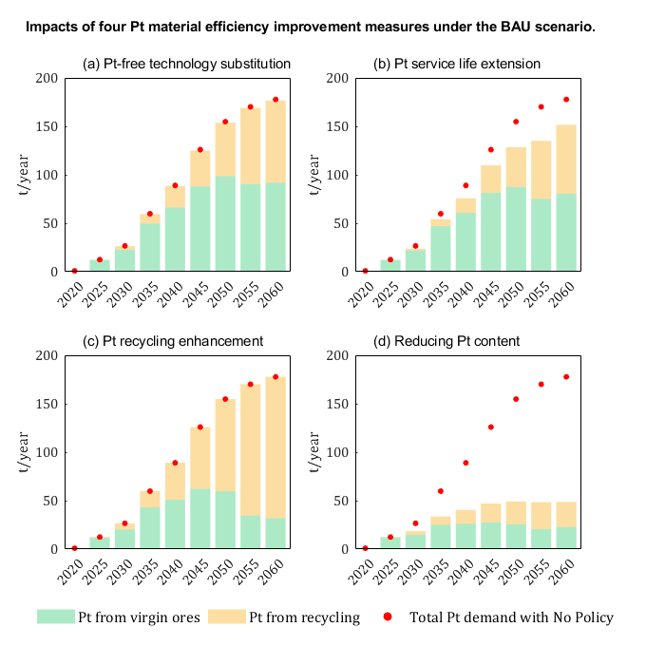
Figure S8 Benefits of circular measures under the BAU scenario. (a) Pt-free technology substitution; (b) Pt service life extension; (c) Pt recycling enhancement, and (d) Reducing Pt content.

China’s platinum supply and consumption mix from 2021 to 2060
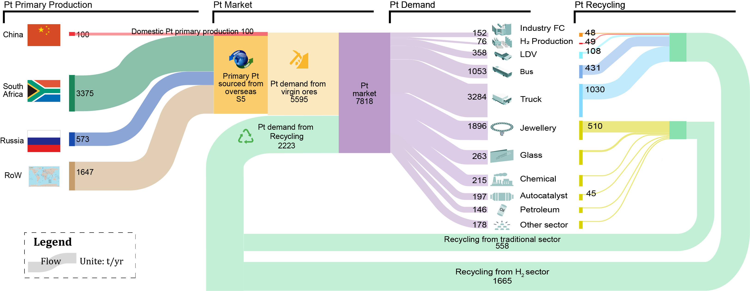
Figure S9 China’s platinum supply and consumption mix from 2021 to 2060 under the carbon neutrality (CN) scenario

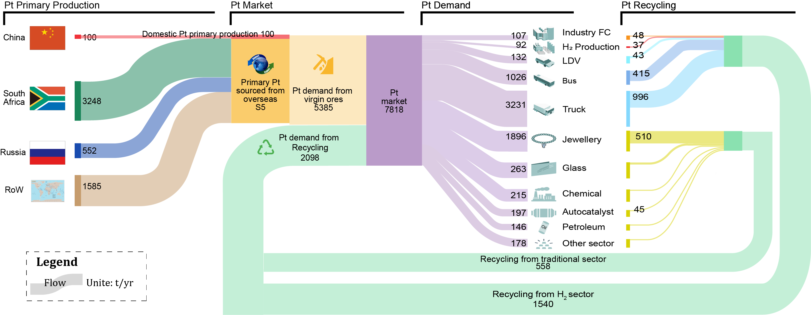
Figure S10 China’s platinum supply and consumption mix from 2021 to 2060 under the 1.5°C scenario

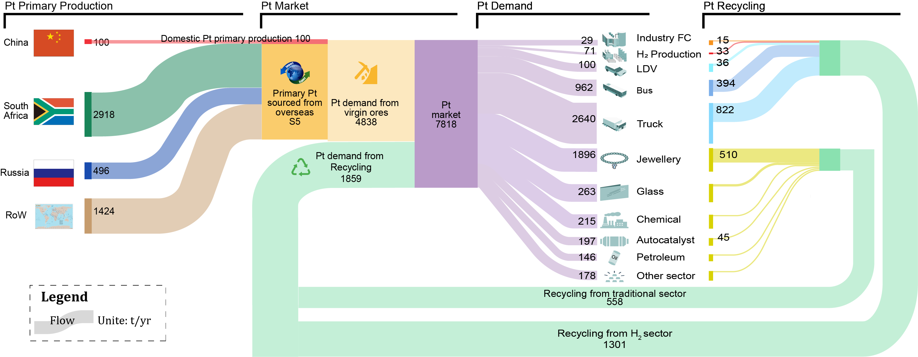

Figure S11 China’s platinum supply and consumption mix from 2021 to 2060 under the BAU scenario

Pt cost driven by the rapidly growing Pt demand under the CN scenario
Table S8 Pt cost driven by the rapidly growing Pt demand under the CN scenario (Unite: $/g)
Scenario | CM |  |  | CA |  |  | RR |  |  | AR
Discount rate | D1 | D2 | D3 | D1 | D2 | D3 | D1 | D2 | D3 | D1 | D2 | D3
2021 | 48.60 | 68.12 | 70.91 | 48.56 | 67.89 | 70.64 | 48.56 | 67.88 | 70.63 | 48.54 | 67.77 | 70.50
2022 | 49.91 | 76.98 | 81.62 | 49.76 | 75.74 | 80.09 | 49.75 | 75.70 | 80.04 | 49.64 | 74.86 | 79.01
2023 | 50.79 | 84.95 | 91.72 | 50.50 | 82.12 | 88.08 | 50.49 | 82.03 | 87.96 | 50.26 | 79.84 | 85.19
2024 | 51.36 | 91.67 | 100.62 | 50.98 | 87.03 | 94.44 | 50.97 | 86.93 | 94.30 | 50.62 | 83.27 | 89.55
2025 | 51.73 | 96.92 | 107.83 | 51.28 | 90.61 | 99.19 | 51.28 | 90.61 | 99.19 | 50.89 | 86.07 | 93.18
2026 | 52.30 | 107.02 | 122.41 | 51.73 | 96.85 | 107.74 | 51.74 | 97.01 | 107.96 | 51.29 | 90.74 | 99.37
2027 | 52.87 | 121.44 | 145.06 | 52.30 | 106.90 | 122.24 | 52.20 | 104.97 | 119.38 | 51.67 | 96.01 | 106.56
2028 | 53.20 | 132.89 | 164.81 | 52.66 | 115.39 | 135.27 | 52.47 | 110.64 | 127.89 | 51.92 | 99.94 | 112.10
2029 | 53.37 | 141.09 | 180.07 | 52.90 | 122.10 | 146.15 | 52.64 | 114.79 | 134.33 | 52.11 | 103.33 | 116.98
2030 | 53.47 | 146.01 | 189.74 | 53.04 | 126.95 | 154.36 | 52.76 | 118.19 | 139.76 | 52.29 | 106.83 | 122.13
2031 | 53.74 | 165.28 | 231.79 | 53.37 | 140.80 | 179.53 | 53.07 | 128.04 | 156.24 | 52.57 | 113.13 | 131.73
2032 | 53.96 | 192.22 | 305.38 | 53.68 | 160.88 | 221.52 | 53.39 | 141.66 | 181.17 | 52.86 | 120.84 | 144.07
2033 | 54.04 | 208.11 | 360.31 | 53.83 | 174.82 | 255.56 | 53.55 | 151.01 | 199.97 | 53.04 | 126.98 | 154.40
2034 | 54.07 | 215.89 | 391.50 | 53.90 | 183.10 | 278.13 | 53.63 | 156.55 | 211.83 | 53.17 | 131.74 | 162.75
2035 | 54.07 | 217.49 | 398.34 | 53.92 | 186.29 | 287.33 | 53.66 | 158.75 | 216.71 | 53.25 | 135.34 | 169.26
2036 | 54.08 | 220.10 | 409.86 | 53.95 | 190.32 | 299.46 | 53.69 | 161.56 | 223.10 | 53.34 | 139.21 | 176.48
2037 | 54.10 | 226.94 | 442.09 | 53.99 | 198.13 | 324.61 | 53.75 | 166.80 | 235.42 | 53.43 | 144.00 | 185.74
2038 | 54.11 | 233.02 | 473.83 | 54.03 | 205.55 | 350.74 | 53.80 | 171.80 | 247.79 | 53.51 | 148.79 | 195.37
2039 | 54.12 | 238.35 | 504.35 | 54.05 | 212.48 | 377.46 | 53.85 | 176.56 | 260.13 | 53.59 | 153.59 | 205.42
2040 | 54.13 | 242.93 | 533.04 | 54.07 | 218.86 | 404.34 | 53.88 | 181.06 | 272.38 | 53.65 | 158.45 | 216.05
2041 | 54.13 | 247.12 | 561.61 | 54.09 | 225.04 | 432.82 | 53.92 | 185.61 | 285.34 | 53.72 | 163.45 | 227.47
2042 | 54.14 | 250.87 | 589.35 | 54.11 | 230.95 | 462.66 | 53.95 | 190.21 | 299.13 | 53.77 | 168.52 | 239.61
2043 | 54.14 | 253.93 | 613.76 | 54.12 | 236.21 | 491.73 | 53.97 | 194.63 | 313.05 | 53.82 | 173.55 | 252.26
2044 | 54.14 | 256.38 | 634.76 | 54.12 | 240.83 | 519.58 | 53.99 | 198.88 | 327.13 | 53.86 | 178.52 | 265.41
2045 | 54.14 | 258.32 | 652.39 | 54.13 | 244.84 | 545.76 | 54.01 | 202.98 | 341.39 | 53.90 | 183.42 | 279.02
2046 | 54.14 | 260.69 | 675.39 | 54.14 | 250.07 | 583.22 | 54.04 | 208.88 | 363.26 | 53.94 | 189.28 | 296.30
2047 | 54.14 | 262.26 | 691.72 | 54.14 | 254.23 | 616.26 | 54.06 | 214.55 | 385.89 | 53.97 | 195.09 | 314.54
2048 | 54.14 | 262.80 | 697.66 | 54.14 | 256.05 | 631.84 | 54.07 | 217.69 | 399.21 | 54.00 | 199.36 | 328.78
2049 | 54.14 | 262.81 | 697.83 | 54.14 | 256.37 | 634.66 | 54.07 | 218.78 | 403.99 | 54.01 | 202.23 | 338.75
2050 | 54.14 | 262.30 | 692.14 | 54.14 | 255.28 | 625.17 | 54.07 | 218.07 | 400.89 | 54.02 | 203.80 | 344.33
2051 | 54.14 | 261.65 | 685.28 | 54.14 | 254.08 | 615.03 | 54.07 | 217.74 | 399.45 | 54.03 | 205.43 | 350.29
2052 | 54.14 | 261.60 | 684.71 | 54.14 | 254.22 | 616.20 | 54.08 | 219.30 | 406.25 | 54.04 | 208.13 | 360.38
2053 | 54.14 | 261.73 | 686.13 | 54.14 | 254.73 | 620.49 | 54.08 | 221.35 | 415.51 | 54.05 | 211.04 | 371.67
2054 | 54.14 | 262.05 | 689.46 | 54.14 | 255.59 | 627.87 | 54.09 | 223.85 | 427.11 | 54.06 | 214.15 | 384.24
2055 | 54.14 | 262.49 | 694.24 | 54.14 | 256.74 | 637.96 | 54.10 | 226.71 | 440.97 | 54.07 | 217.43 | 398.10
2056 | 54.14 | 262.90 | 698.75 | 54.14 | 257.85 | 647.96 | 54.10 | 229.59 | 455.53 | 54.08 | 220.68 | 412.44
2057 | 54.14 | 263.18 | 701.96 | 54.14 | 258.68 | 655.70 | 54.11 | 232.18 | 469.23 | 54.09 | 223.68 | 426.31
2058 | 54.14 | 263.40 | 704.52 | 54.14 | 259.36 | 662.26 | 54.11 | 234.61 | 482.62 | 54.10 | 226.52 | 440.01
2059 | 54.14 | 263.58 | 706.53 | 54.14 | 259.93 | 667.74 | 54.12 | 236.87 | 495.61 | 54.10 | 229.17 | 453.39
2060 | 54.14 | 263.71 | 708.14 | 54.14 | 260.40 | 672.42 | 54.12 | 238.98 | 508.15 | 54.11 | 231.64 | 466.34
Note: D1=1.4; D2=5.4%; D3=8%.

Share of Pt cost in the total cost of each hydrogen technology in 2060
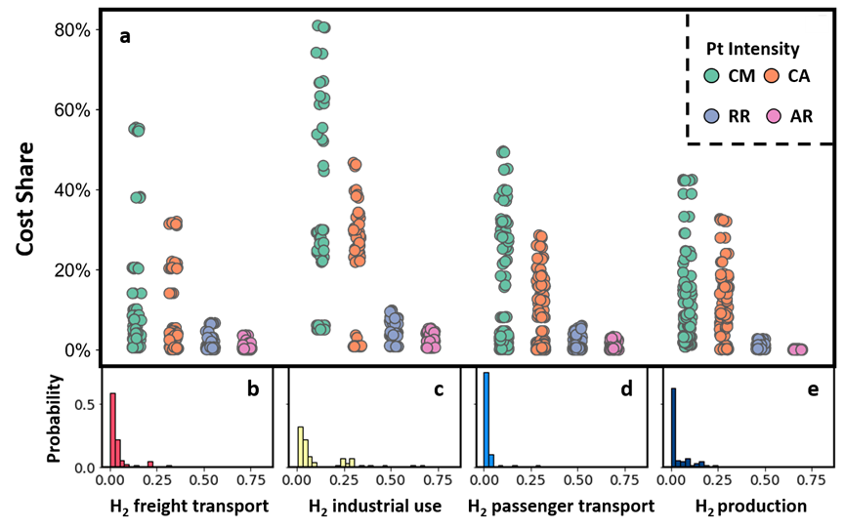
Figure S12 Share of platinum cost in the total cost of individual hydrogen technologies in 2060. (a) Cost share of platinum in different hydrogen technologies with varying assumptions of platinum intensity (CM = Current Mainstream, CA = Current Advance, RR = Reference Reduction, AR = Advanced Reduction); (b) – (d) Probability distributions of platinum cost share in hydrogen technologies.

Parament setting

Carbon emissions pathway of each climate scenario
Table S9 Carbon emissions pathway of each climate scenario
(Unite: Mt carbon/year)
Year | BAU | 1.5°C | CN
2020 | 3203.15 | 3207.16 | 3125.24
2025 | 3504.89 | 3510.71 | 2734.59
2030 | 3700.54 | 3707.34 | 2343.93
2035 | 3805.97 | 3813.61 | 1953.28
2040 | 3848.96 | 2709.80 | 1562.62
2045 | 3841.63 | 2063.31 | 1171.97
2050 | 3801.75 | 1257.86 | 781.31
2055 | 3702.83 | 616.80 | 390.66
2060 | 3595.11 | 172.94 | 0.00

Classification and technical parameters of hydrogen production technology
Table S10 Classification and technical parameters of hydrogen production technology
Technology | Type | Input | Plant Lifetime  (year) | Stack Lifetime  (year) | Capacity factor
Biomass to H₂ | Central production | biomass | 40 | NA | 90%
Biomass to H₂ CCS | Central production | biomass | 40 | NA | 90%
Coal chemical | Central production | coal | 30 | NA | 90%
Coal chemical CCS | Central production | coal | 30 | NA | 90%
Electrolysis | Central production | electricity | 40 | 7 | 97%
Natural gas steam reforming | Central production | gas | 40 | NA | 90%
Natural gas steam reforming CCS | Central production | gas | 40 | NA | 90%
Thermal splitting | Central production | nuclear | 40 | 7 | 90%
Electrolysis | Central production | solar | 40 | 7 | 50%
Electrolysis | Central production | wind | 40 | 7 | 50%
Electrolysis | Forecourt production | electricity | 20 | 7 | 86%
Natural gas steam reforming | Forecourt production | gas | 20 | NA | 86%

Cost evolution of hydrogen production technology
Table S11 Cost evolution of hydrogen production technology from 2020 to 2060 (Unite: $/GJ)
Technology | 2020 | 2025 | 2030 | 2035 | 2040 | 2045 | 2050 | 2055 | 2060
Biomass to H₂ | 7.11 | 7.03 | 6.90 | 6.79 | 6.81 | 6.80 | 6.76 | 6.72 | 6.67
Biomass to H₂ CCS | 20988.10 | 20758.00 | 20803.40 | 20579.70 | 20360.80 | 20365.40 | 20153.30 | 19945.60 | 19995.10
Coal chemical | 4.11 | 4.06 | 4.03 | 3.97 | 3.92 | 3.87 | 3.83 | 3.79 | 3.76
Coal chemical CCS | 19170.60 | 18976.30 | 18992.30 | 18803.60 | 18618.70 | 18607.40 | 18428.20 | 18252.40 | 18245.60
Electrolysis | 20.95 | 20.34 | 18.87 | 17.73 | 17.31 | 17.13 | 16.99 | 16.77 | 16.54
Natural gas steam reforming | 3.57 | 3.66 | 3.63 | 3.66 | 3.76 | 3.85 | 3.99 | 4.08 | 4.10
Natural gas steam reforming CCS | 8909.44 | 8828.80 | 8858.83 | 8779.89 | 8715.26 | 8732.77 | 8669.56 | 8594.82 | 8625.17
Thermal splitting | 7.30 | 7.31 | 7.32 | 7.33 | 7.35 | 7.37 | 7.39 | 6.56 | 5.72
Electrolysis | 7.40 | 6.42 | 4.94 | 3.83 | 3.46 | 3.37 | 3.27 | 3.18 | 3.09
Electrolysis | 9.44 | 8.66 | 7.38 | 6.44 | 6.16 | 6.15 | 6.12 | 5.99 | 5.81
Electrolysis | 24.83 | 24.11 | 22.57 | 21.31 | 20.77 | 20.48 | 20.23 | 19.89 | 19.57
Natural gas steam reforming | 13.91 | 14.13 | 13.84 | 13.77 | 13.95 | 14.06 | 14.31 | 14.33 | 14.04
Data Source: Reference ^{24,25}

Cost evolution of road transport technology
Table S12 Cost evolution of different road transport technology from 2020 to 2060 (Unite: $/vehicle*km)
Sector | Scenario | Subsector | Technology | 2020 | 2025 | 2030 | 2035 | 2040 | 2045 | 2050 | 2055 | 2060
LDV | BAU | Mini Car | BEV | 0.096 | 0.087 | 0.078 | 0.069 | 0.069 | 0.069 | 0.068 | 0.068 | 0.068
LDV | BAU | Mini Car | FCEV | 0.109 | 0.099 | 0.089 | 0.079 | 0.079 | 0.079 | 0.079 | 0.079 | 0.079
LDV | BAU | Subcompact Car | BEV | 0.156 | 0.140 | 0.124 | 0.107 | 0.107 | 0.106 | 0.105 | 0.105 | 0.105
LDV | BAU | Subcompact Car | FCEV | 0.157 | 0.144 | 0.131 | 0.118 | 0.117 | 0.117 | 0.117 | 0.117 | 0.117
LDV | BAU | Compact Car | BEV | 0.233 | 0.215 | 0.197 | 0.179 | 0.178 | 0.177 | 0.176 | 0.175 | 0.175
LDV | BAU | Compact Car | FCEV | 0.242 | 0.223 | 0.204 | 0.185 | 0.184 | 0.183 | 0.183 | 0.183 | 0.183
LDV | BAU | Multipurpose Vehicle | BEV | 0.206 | 0.205 | 0.203 | 0.202 | 0.202 | 0.201 | 0.200 | 0.196 | 0.192
LDV | BAU | Multipurpose Vehicle | FCEV | 0.162 | 0.164 | 0.166 | 0.167 | 0.168 | 0.170 | 0.172 | 0.171 | 0.170
LDV | BAU | Large Car& SUV | BEV | 0.390 | 0.360 | 0.329 | 0.299 | 0.298 | 0.296 | 0.294 | 0.294 | 0.293
LDV | BAU | Large Car& SUV | FCEV | 0.378 | 0.359 | 0.340 | 0.313 | 0.308 | 0.304 | 0.308 | 0.308 | 0.308

Sector | Scenario | Subsector | Technology | 2020 | 2025 | 2030 | 2035 | 2040 | 2045 | 2050 | 2055 | 2060
Truck | BAU | Heavy Truck | BEV | 0.530 | 1.400 | 2.270 | 3.139 | 4.009 | 4.878 | 5.748 | 6.617 | 7.487
Truck | BAU | Heavy Truck | FCEV | 0.739 | 0.739 | 0.739 | 0.739 | 0.739 | 0.739 | 0.739 | 0.739 | 0.739
Truck | BAU | Middle Truck | BEV | 0.508 | 1.342 | 2.175 | 3.008 | 3.842 | 4.675 | 5.508 | 6.342 | 7.175
Truck | BAU | Middle Truck | FCEV | 0.708 | 0.708 | 0.708 | 0.708 | 0.708 | 0.708 | 0.708 | 0.708 | 0.708
Truck | BAU | Light Truck | BEV | 0.610 | 1.610 | 2.610 | 3.610 | 4.610 | 5.610 | 6.610 | 7.610 | 8.610
Truck | BAU | Light Truck | FCEV | 0.850 | 0.850 | 0.850 | 0.850 | 0.850 | 0.850 | 0.850 | 0.850 | 0.850
Truck | 1.5°C&CN | Heavy Truck | BEV | 0.530 | 0.374 | 0.317 | 0.261 | 0.229 | 0.197 | 0.165 | 0.165 | 0.165
Truck | 1.5°C&CN | Heavy Truck | FCEV | 0.739 | 0.417 | 0.330 | 0.243 | 0.212 | 0.180 | 0.148 | 0.148 | 0.148
Truck | 1.5°C&CN | Middle Truck | BEV | 0.508 | 0.358 | 0.304 | 0.250 | 0.220 | 0.189 | 0.158 | 0.158 | 0.158
Truck | 1.5°C&CN | Middle Truck | FCEV | 0.708 | 0.400 | 0.317 | 0.233 | 0.203 | 0.172 | 0.142 | 0.142 | 0.142
Truck | 1.5°C&CN | Light Truck | BEV | 0.610 | 0.430 | 0.365 | 0.300 | 0.263 | 0.227 | 0.190 | 0.190 | 0.190
Truck | 1.5°C&CN | Light Truck | FCEV | 0.850 | 0.480 | 0.380 | 0.280 | 0.243 | 0.207 | 0.170 | 0.170 | 0.170

Sector | Scenario | Subsector | Technology | 2020 | 2025 | 2030 | 2035 | 2040 | 2045 | 2050 | 2055 | 2060
Bus | BAU | Heavy Bus | BEV | 1.083 | 1.083 | 1.083 | 1.083 | 1.083 | 1.083 | 1.083 | 1.083 | 1.083
Bus | BAU | Heavy Bus | FCEV | 1.289 | 1.289 | 1.289 | 1.289 | 1.289 | 1.289 | 1.289 | 1.289 | 1.289
Bus | BAU | Light Bus | BEV | 0.967 | 0.967 | 0.967 | 0.967 | 0.967 | 0.967 | 0.967 | 0.967 | 0.967
Bus | BAU | Light Bus | FCEV | 1.151 | 1.151 | 1.151 | 1.151 | 1.151 | 1.151 | 1.151 | 1.151 | 1.151
Bus | 1.5°C&CN | Heavy Bus | BEV | 1.083 | 0.934 | 0.672 | 0.659 | 0.646 | 0.633 | 0.633 | 0.633 | 0.633
Bus | 1.5°C&CN | Heavy Bus | FCEV | 1.289 | 1.112 | 0.800 | 0.659 | 0.587 | 0.551 | 0.551 | 0.541 | 0.537
Bus | 1.5°C&CN | Light Bus | BEV | 0.967 | 0.834 | 0.600 | 0.588 | 0.577 | 0.565 | 0.565 | 0.565 | 0.565
Bus | 1.5°C&CN | Light Bus | FCEV | 1.151 | 0.992 | 0.714 | 0.588 | 0.524 | 0.492 | 0.492 | 0.483 | 0.479
Data Source: ^{25,26}

Market share of fuel cell technologies in industry energy and CHP use area
There is currently no statistic about the fuel cells type in industry energy and CHP use area. this study collects historical shipment and megawatts data of the fuel cells by type from E4Tech report²⁷, and provides a market share estimate worthy of reference in this area.
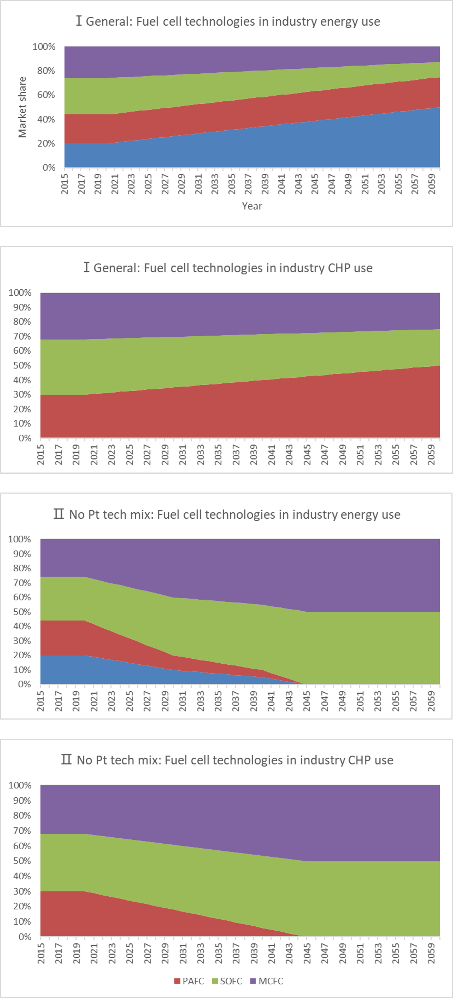
Figure S13 Market share of fuel cell technologies in industry energy and CHP use

Lifetime setting of Pt-containing hydrogen equipment
Table S13 Lifetime setting of Pt-containing hydrogen equipment
Sector | Subsector | General |  | Extended
Sector | Subsector | Plant Lifetime (year) | Stack Lifetime (year) | Plant Lifetime (year) | Stack Lifetime (year)
Industry energy use & CHP | hydrogen | 20 | 10 | 20 | 15
Industry energy use & CHP | hydrogen | 20 | 10 | 20 | 15
LDV | Compact Car | 15 | 8 | 15 | 10
LDV | Large Car and SUV | 15 | 8 | 15 | 10
LDV | Mini Car | 15 | 8 | 15 | 10
LDV | Multipurpose Vehicle | 15 | 8 | 15 | 10
LDV | Subcompact Car | 15 | 8 | 15 | 10
Truck | Light Truck | 15 | 8 | 15 | 10
Truck | Middle Truck | 15 | 8 | 15 | 10
Truck | Heavy Truck | 15 | 8 | 15 | 10
Bus | Heavy Bus | 15 | 8 | 15 | 10
Bus | Light Bus | 15 | 8 | 15 | 10
H₂ Production | Electrolysis | 20 | 7 | 20 | 10
Note: Extended stack life time are collected from literature ^{28,29}.

Recycling patterns for key hydrogen energy infrastructure
Table S14 Recycling patterns for key hydrogen energy infrastructure
Sector | Subsector | Recycling Pattern
Industry energy use & CHP | hydrogen | Closed-Loop
Industry energy use & CHP | hydrogen | Closed-Loop
H₂ Production-Electrolysis | H2 central production | Closed-Loop
H₂ Production-Electrolysis | H2 central production | Closed-Loop
H₂ Production-Electrolysis | H2 central production | Closed-Loop
H₂ Production-Electrolysis | H2 forecourt production | Open-Loop
LDV | Compact Car | Open-Loop
LDV | Large Car and SUV | Open-Loop
LDV | Mini Car | Open-Loop
LDV | Multipurpose Vehicle | Open-Loop
LDV | Subcompact Car | Open-Loop
Truck | Light Truck | Open-Loop
Truck | Middle Truck | Open-Loop
Truck | Heavy Truck | Open-Loop
Bus | Heavy Bus | Open-Loop
Bus | Light Bus | Open-Loop

Parament settings of different recycling patterns
Table S15 Parament settings of different recycling patterns
Recycling Indicator | General |  | Enhancement
Recycling Indicator | Closed  -loop | Open  -loop | Closed  -loop | Open  -loop
CR^{15,30,31} | 100.0% | 70.0% | 100.0% | 99.0%
Recovery rate³² | 78.0% | 78.0% | 95.0% | 95.0%
EOL-RR | 78.0% | 54.6% | 95.0% | 94.1%
Note³¹:
- CR is the abbreviation of old scrap collection rate, and describes the amount of the end-of -life metals which is collected and sent to the recycling chain.
- Recovery rate is also known as recycling process efficiency rate, and describe the efficiency in the given recycling process.
- EOL-RR is the abbreviation of end-of-life recycling rate, and refers to functional recycling, and includes recycling as a pure metal and as an alloy.
- The relationship between these three variables are as follows:
EOL-RR = CR × Recovery rate.

Pt intensity evolution of key hydrogen technologies
Pt intensities of those hydrogen technologies are collected from extensive literature review^{16,28,33–35}. The evolution of Pt intensity of PEM electrolyser was collected from NREL³⁶. For PEMFC, its Pt intensity during 2020-2060 is assumed to follow the trajectory calibrated by Ministry of Industry and Information Technology of China^{8,37,38}. For PAFC, its Pt intensity was 19 times that of PEMFC in the same year^{39,40}. This study assumed the same ratio between Pt intensity of PAFC and that of PEMFC throughout the study period.
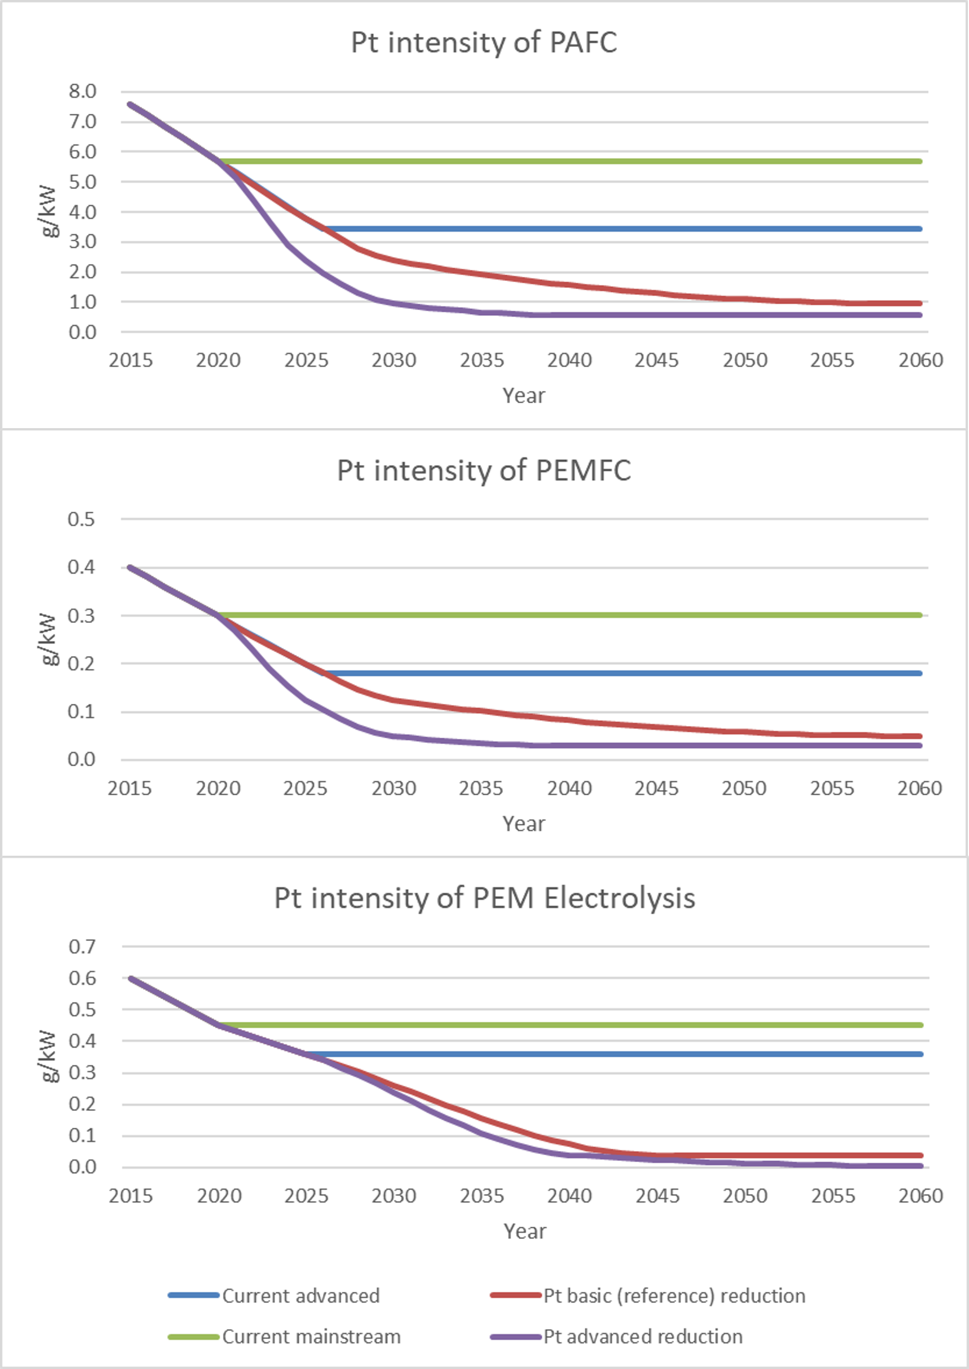
Figure S14 Pt intensity evolution of key hydrogen technologies

Supplemental References
1. Hydrogen Council. Hydrogen for Net Zero-A Critical Cost-competitive Energy Vector. https://hydrogencouncil.com/wp-content/uploads/2021/11/Hydrogen-for-Net-Zero_Full-Report.pdf (2021).
2. IEA. An Energy Sector Roadmap to Carbon Neutrality in China. https://www.iea.org/reports/an-energy-sector-roadmap-to-carbon-neutrality-in-china (2021).
3. China Hydrogen Alliance. White Paper on China Hydrogen and Fuel Cell Industry(2020). (2021).
4. Shell. Shell Scenarios: Sky - Meeting the goals of the Paris agreement. 72 (2018).
5. BP. BP Energy Outlook 2022. https://www.bp.com/content/dam/bp/business-sites/en/global/corporate/pdfs/energy-economics/energy-outlook/bp-energy-outlook-2022.pdf (2021).
6. Raymond, T., Sterck, E. & Clifford, B. PLATINUM ESSENTIALS: Fuel cell electric vehicles are forecast to drive material long-term demand growth for platinum. https://platinuminvestment.com/files/438859/WPIC_Platinum_Essentials_March_2022 (Potential FCEV demand).pdf (2022).
7. Tong, X., Dai, H., Lu, P., Zhang, A. & Ma, T. Saving global platinum demand while achieving carbon neutrality in the passenger transport sector: linking material flow analysis with integrated assessment model. Resour. Conserv. Recycl. 179, 106110 (2022).
8. Hao, H. et al. Securing Platinum-Group Metals for Transport Low-Carbon Transition. One Earth 1, 117–125 (2019).
9. Alonso, E., Field, F. R. & Kirchain, R. E. Platinum Availability for Future Automotive Technologies. Environ. Sci. Technol. 46, 12986–12993 (2012).
10. Rasmussen, K. D., Wenzel, H., Bangs, C., Petavratzi, E. & Liu, G. Platinum Demand and Potential Bottlenecks in the Global Green Transition: A Dynamic Material Flow Analysis. Environ. Sci. Technol. 53, 11541–11551 (2019).
11. Elshkaki, A. An analysis of future platinum resources, emissions and waste streams using a system dynamic model of its intentional and non-intentional flows and stocks. Resour. Policy 38, 241–251 (2013).
12. Idoine, N. E. et al. World Mineral Production 2016-20. (British Geological Survey, 2022).
13. U.S. Geological Survey. Mineral commodity summaries 2022. https://doi.org/10.3133/mcs2022 (2022).
14. SFA Oxford. Platinum Standard. https://www.sfa-oxford.com/media/bgqp0zlh/sfa-oxford-edition-10-the-platinum-standard-may-2021.pdf (2021).
15. Nassar, N. T. Global stocks and flows, losses, and recoveries of platinum-group elements. (2015).
16. Rasmussen, K. D., Wenzel, H., Bangs, C., Petavratzi, E. & Liu, G. Platinum Demand and Potential Bottlenecks in the Global Green Transition: A Dynamic Material Flow Analysis. Environ. Sci. Technol. (2019) doi:10.1021/acs.est.9b01912.
17. Ministry of Natural Resources, P. China Mineral Resources. (GEOLOGICAL PUBLISHING HOUSE, 2021).
18. LBMA. LBMA Precious Metal Prices: Platinum. https://www.lbma.org.uk/cn/prices-and-data#/%0A.
19. UN Comtrade. United Nations commodity trade statistics database. https://comtrade.un.org/.
20. Nansai, K. et al. Global Flows of Critical Metals Necessary for Low-Carbon Technologies: The Case of Neodymium, Cobalt, and Platinum. Environ. Sci. Technol. 48, 1391−1400 (2014).
21. Catlow, C. R., Davidson, M., Hutchings, G. J. & Mulholland, A. Science to enable the circular economy. Philos. Trans. R. Soc. A Math. Phys. Eng. Sci. 378, 20200060 (2020).
22. Khan, S., Nontso, Z., Magweregwede, F., Godfrey, L. & Sereme, B. Placing the South African mining sector in the context of a circular economy transition. Circ. Econ. AS Dev. Oppor. 9 (2021).
23. Burlakovs, J. et al. Platinum Group Elements in Geosphere and Anthroposphere: Interplay among the Global Reserves, Urban Ores, Markets and Circular Economy. Minerals vol. 10 (2020).
24. Abdelkareem, M. A. et al. Environmental aspects of fuel cells: A review. Sci. Total Environ. 752, (2021).
25. Calvin, K. et al. GCAM v5. 1: representing the linkages between energy, water, land, climate, and economic systems. Geosci. Model Dev. 12, 677–698 (2019).
26. Zhang, Y., Zhang, Z., Miao, Y., Liu, X. & Wu, Y. Report on the development of China’s hydrogen industry (in Chinese). http://pg.jrj.com.cn/acc/Res/CN_RES/INDUS/2020/10/22/73726abb-c2db-4c81-b0d7-1f6aa3c36707.pdf (2020).
27. E4Tech. The Fuel Cell Industry Review 2020. https://fuelcellindustryreview.com/ (2021).
28. Bareiß, K., de la Rua, C., Möckl, M. & Hamacher, T. Life cycle assessment of hydrogen from proton exchange membrane water electrolysis in future energy systems. Appl. Energy 237, 862–872 (2019).
29. Staffell, I. et al. The role of hydrogen and fuel cells in the global energy system. Energy Environ. Sci. 12, 463–491 (2019).
30. Graedel, T. E. et al. What do we know about metal recycling rates? J. Ind. Ecol. 15, 355–366 (2011).
31. Graedel, T. E. et al. Recycling rates of metals: a status report. (United Nations Environment Programme, 2011).
32. Duclos, L. et al. Closing the loop: Life cycle assessment and optimization of a PEMFC platinum-based catalyst recycling process. Green Chem. 22, 1919–1933 (2020).
33. Carmo, M., Fritz, D. L., Mergel, J. & Stolten, D. A comprehensive review on PEM water electrolysis. Int. J. Hydrogen Energy 38, 4901–4934 (2013).
34. Smolinka, T., Wiebke, N., Sterchele, P., Lehner, F. & Jansen, M. Sudie_IndWEDe-Industrialisierung der Wasserelektrolyse in Deutschland: Chancen und Herausforderungen für nachhaltigen Wasserstoff für Verkehr, Strom und Wärme. (NOW GmbH, 2018).
35. Bernt, M., Siebel, A. & Gasteiger, H. A. Analysis of voltage losses in PEM water electrolyzers with low platinum group metal loadings. J. Electrochem. Soc. 165, F305 (2018).
36. Mayyas, A. T., Ruth, M. F., Pivovar, B. S., Bender, G. & Wipke, K. B. Manufacturing cost analysis for proton exchange membrane water electrolyzers. (2019).
37. Ministry of Industry and Information Technology. Technology Roadmap for Energy-Saving and New Energy Vehicles. (China Machine Press, 2016).
38. New Energy and Industrial Technology Development Organization. Fuel cell and hydrogen technology roadmap. (China Machine Press, 2017).
39. Remick, R. & Wheeler, D. Molten Carbonate and Phosphoric Acid Stationary Fuel Cells: Overview and Gap Analysis. https://www.osti.gov/biblio/990108 (2010) doi:10.2172/990108.
40. Staffell, I. Zero carbon infinite COP heat from fuel cell CHP. Appl. Energy 147, 373–385 (2015).

