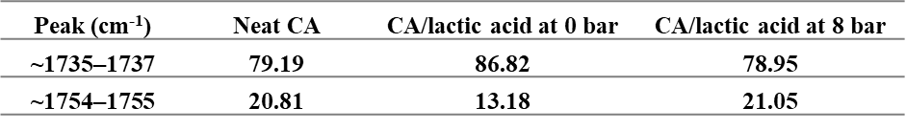
Table 1. Deconvolution data of the neat CA membrane and the CA/lactic acid membranes at 0 and 8 bar (C=O)

Table 2. Deconvolution data of the pristine and the CA/lactic acid composites
