eFigure1: Markov state transition probability diagram.
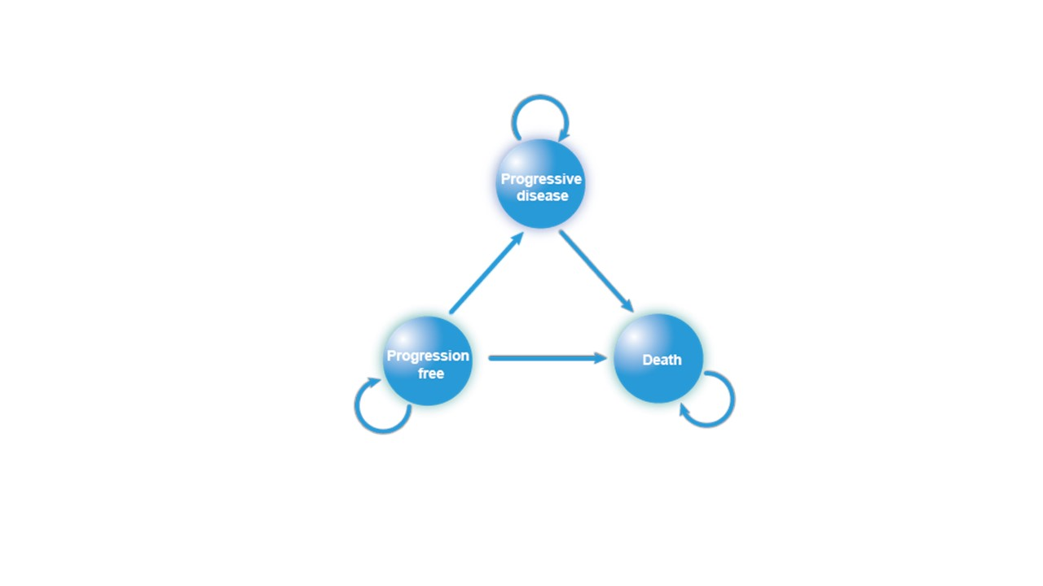
eFigure2. Fitting and extrapolation of Kaplan Meier survival curve for PFS.
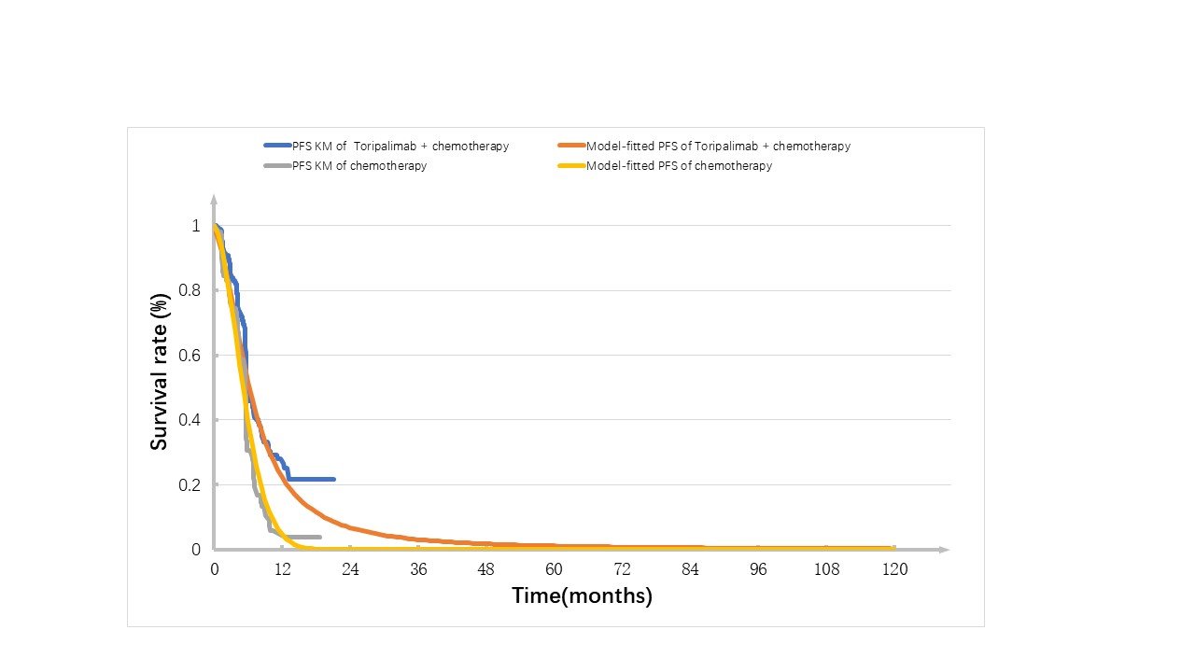

eFigure3. Fitting and extrapolation of Kaplan Meier survival curve for OS.
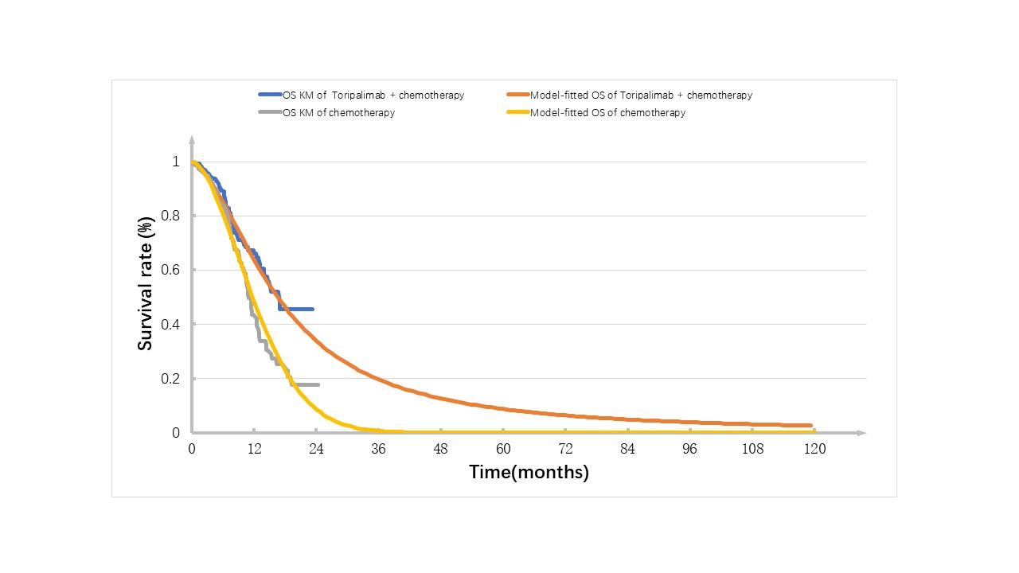

eTable1.AIC and BIC scores of fitted distribution.
Table1.AIC and BIC scores of fitted distribution in all patients from JUPITER-06
Distribution | OS of sintilimab + chemotherapy |  |  | OS of chemotherapy |  | PFS of sintilimab + chemotherapy |  | PFS of chemotherapy
All patients | AIC | BIC | AIC |  | BIC | AIC | BIC | AIC | BIC
Exponential | 830.26 | 837.358 | 634.8465 |  | 641.9446 | 949.2233 | 956.3215 | 880.9016 | 887.9997
Weibull | 789.9487 | 800.5959 | 617.188 |  | 627.8352 | 887.131 | 897.7782 | 857.1192 | 867.7664
Gamma | 792.9981 | 803.6454 | 615.5751 |  | 626.2223 | 888.9482 | 899.5955 | 848.8005 | 859.4477
Log-normal | 814.2142 | 824.8615 | 616.7231 |  | 627.3704 | 911.8905 | 922.5377 | 838.8103 | 849.4576
Log-logistic | 793.3314 | 803.9786 | 614.2898 |  | 624.9371 | 896.2415 | 906.8887 | 836.1278 | 846.7751
Gompertz | 798.8829 | 809.5301 | 626.6851 |  | 637.3323 | 913.6033 | 924.2505 | 878.5962 | 889.2434
The results showed that the Log-logistic and Weibull distribution had the lowest AIC and BIC values, so we used Log-logistic and Log-normal to fit the OS and PFS curves in our analysis.
Abbreviation: OS=Overall survival; PFS= Progression-free survival; AIC= Akaike information criterion; BIC= Bayesian information criterion.

