Supplementary data

Title: Chemical nature of attention deficit hyperactivity disorder (ADHD)- related chemical subfamily.

Author: Masami Ishido

Supplementary Figure legends

Supplementary Fig. 1. Typical patterns of behavioural traits. Spontaneous motor activity was measured using the Supermex system after the administration of vehicle (open circle), DPP (A; closed circle) or benzophenone (C; closed circle) every 2 h during the dark (closed bar) and light (open bar) phases, as indicated. The dose of chemicals was fixed at 87 nmol. The total spontaneous motor activity in dark periods (12 h) was integrated (B and D), as indicated. *p < 0.01, **p<0.001. NS: not significant.

Supplementary Fig. 2. A support vector machine failed to classify the two chemical groups. The Tanimoto coefficient was calculated based on the phthalate ester DPP (the hyperactivity-associated chemical with the highest spontaneous motor activity), and the results are presented as a scatter plot versus spontaneous motor activity (SMA) with classification by a support vector machine shown on different coloured backgrounds. Note that negative compounds (orange) and hyperactivity-associated compounds (blue) are shown in light blue and orange background colours, respectively.

Supplementary Fig. 3. Ward dendrogram failed to classify the two chemical groups. The clustering distance of all chemicals screened was analysed using a hierarchical agglomerative Ward dendrogram. ○; A hyperactivity-associated chemical: ●; A negative chemical.

Supplementary Fig. 1
A
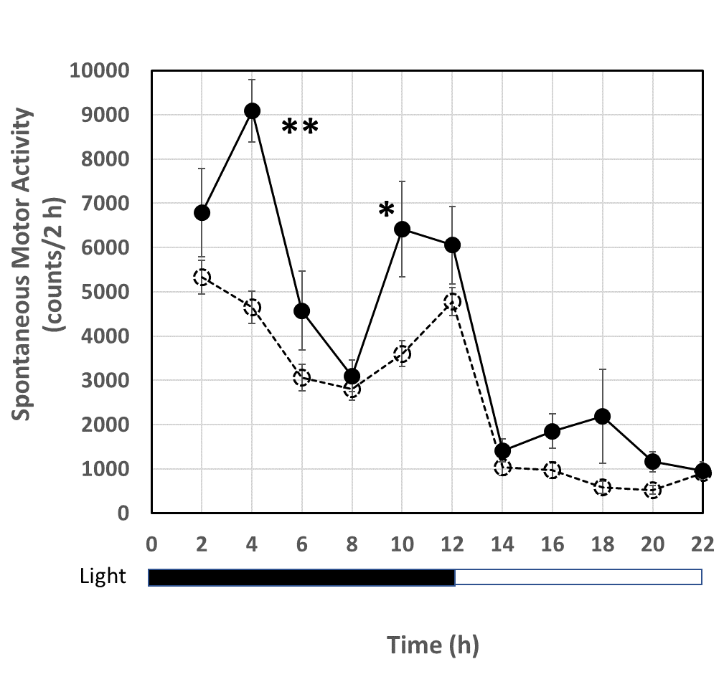
B
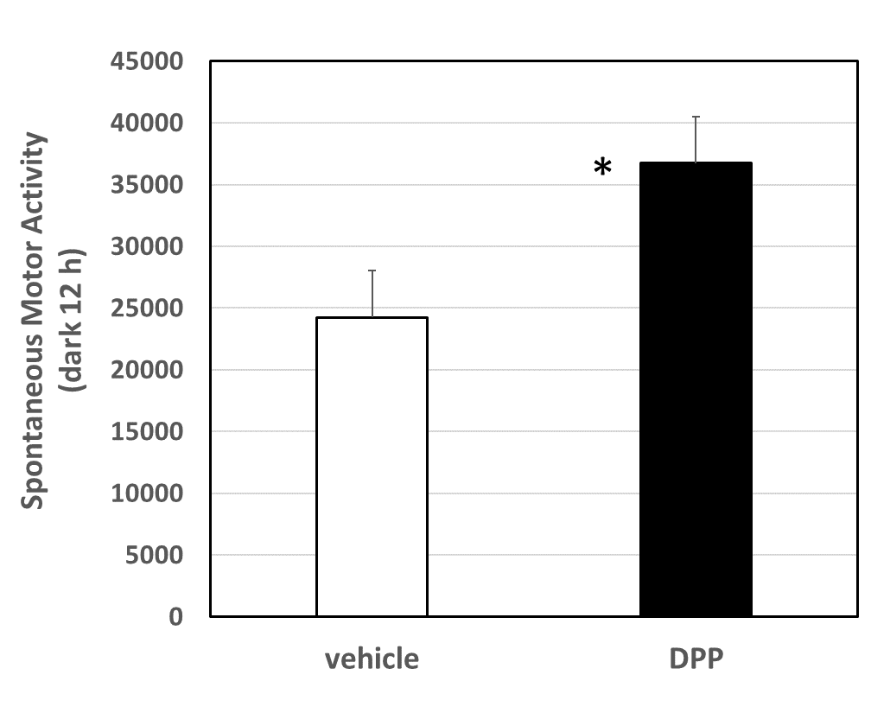

C
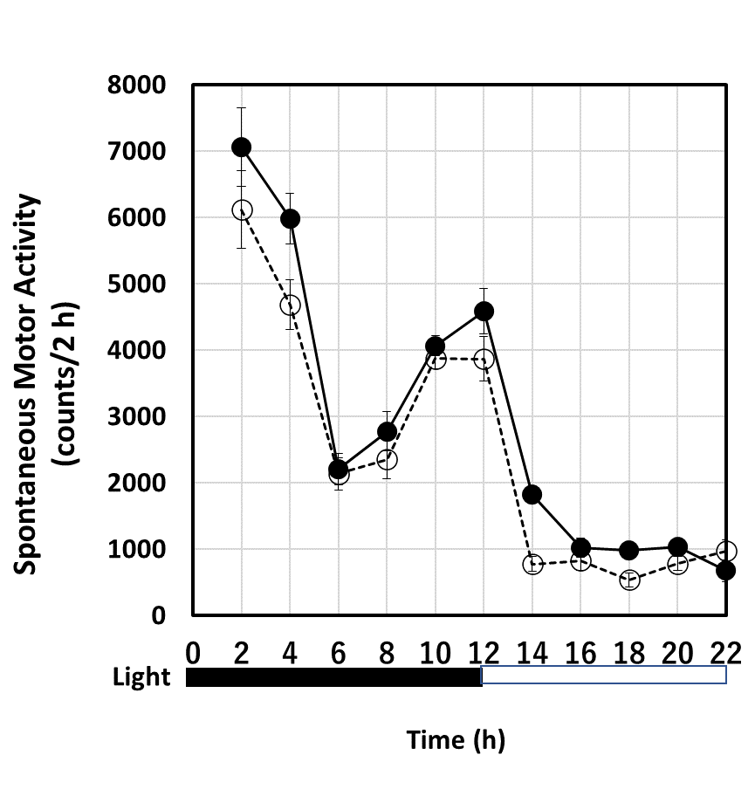

D
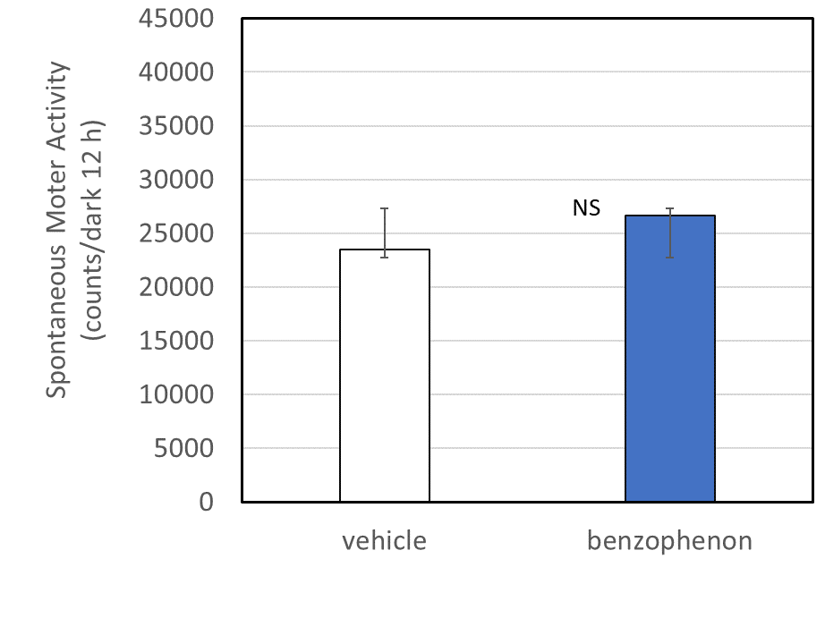

Supplementary Fig. 2

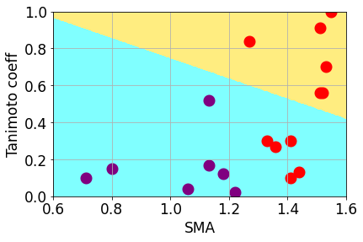

Supplementary Fig. 3.

