Supplementary Data: Species-specific transcriptomic changes upon Respiratory Syncytial Virus infection in cotton rats

Britton A. Strickland¹, Seesandra V. Rajagopala², Arash Kamali³, Meghan H Shilts², Suman B. Pakala², Mariana S. Boukhvalova³, Shibu Yooseph⁴, Jorge C. G. Blanco^{3#}, and Suman R. Das^{1,2#}

¹Department of Pathology Microbiology and Immunology, Vanderbilt University Medical Center, Nashville, Tennessee, USA
² Department of Medicine, Vanderbilt University Medical Center, Nashville, Tennessee, USA
³ Sigmovir Biosystems Inc., Rockville, Maryland, USA
⁴Department of Computer Science, Genomics and Bioinformatics Cluster, University of Central Florida, Orlando, Florida, USA

SUPPLEMENTARY FIGURES

Supplemental Figure 1. (A) Top Signaling and Membrane Transport and (B) Viral and Bacterial Infection Pathways on the x-axis with total number of protein-coding genes on the y-axis. Infections in which there is published literature using cotton rats as a model are bold italics. Pathways assigned using TransDecoder-determined CDS followed by GhostKOALA (https://www.kegg.jp/ghostkoala/).
A.
B.
Supplemental Figure 2. The COVID-19 Disease Pathway (adapted from Kyoto Encyclopedia of Genes and Genomes [KEGG]). 96 of the 104 essential genes of SARS-CoV-2 pathogenesis were successfully assembled and annotated in our de novo transcriptome of S. fulviventer and S. hispidus. Created with BioRender.
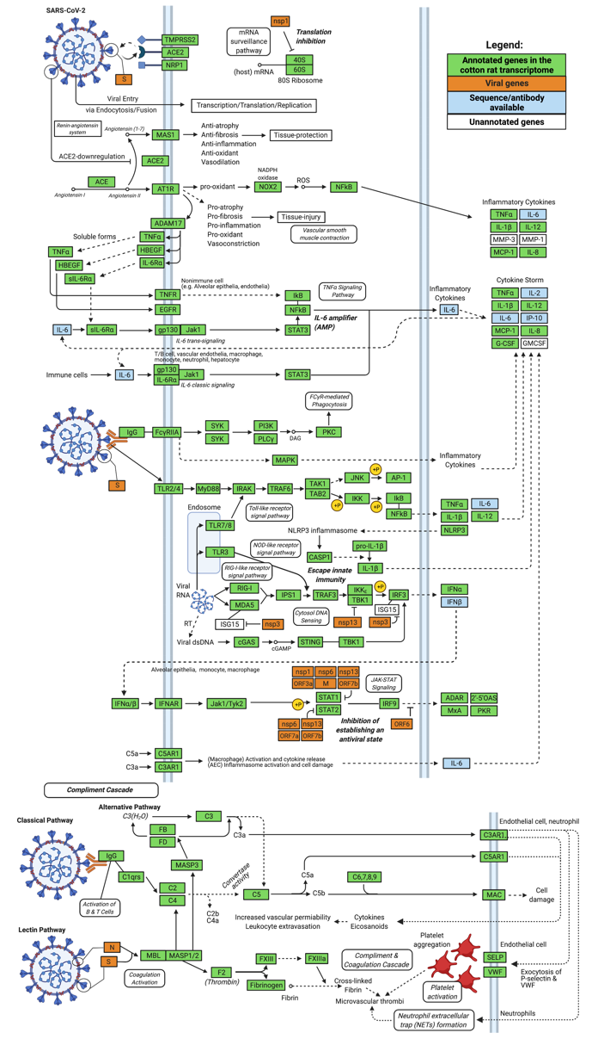
Supplemental Figure 3. Principle component analysis of RSV-infected lungs vs uninfected controls.
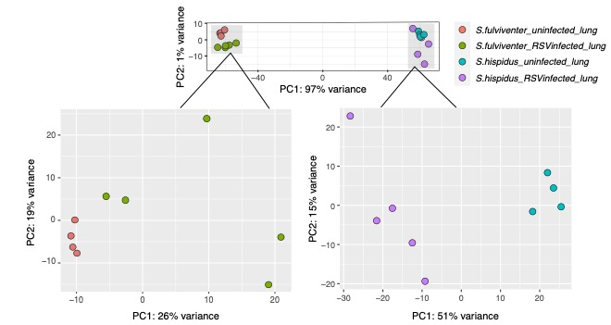
Supplementary Table 1. (A) Sequencing statistics as raw data and Trimmomatic-processed paired-end reads separated by organ type. (B) Filtering statistics for final assembly. Contigs <200bp removed using seqkit. Contigs with taxonomic annotation (BlastX) as “virus”, “bacteria”, or “fungi” were removed from transcriptome assembly. Contigs with 95% similarity were removed with CD-HIT. Primary/non-redundant mRNAs were picked by EvidentialGene tr2aacds pipeline for final assembly file.

Species | Sample Type (n) |  | Raw Data (Mb) | Trimmed/QC PE Data (Mb) | GC%
 | Lung (4 healthy, 5 infected) |  | 410.0 | 206.0 | 53.3
 | Intestines (2) |  | 138.0 | 72.3 | 52.5
S. fulviventer | Heart (2) |  | 132.8 | 70.5 | 56.0
 | Spleen (2) |  | 113.8 | 56.7 | 58.5
 | Kidney (2) |  | 112.9 | 50.5 | 54.0
 |  |  | 907.5 | 456
S. hispidus | Lung (4 healthy, 5 infected) |  | 421.8 | 211.9 | 52.0
S. hispidus | Intestines (2) |  | 127.7 | 66.4 | 54.0
S. hispidus | Heart (2) |  | 109.6 | 56.4 | 50.0
S. hispidus | Spleen (2) |  | 135.9 | 66.4 | 54.5
S. hispidus | Kidney (2) |  | 123.8 | 63.9 | 55.0
 |  |  | 918.8 | 465
Species | Raw Assembly | Filter 200bp |  | CD-Hit 95% | Evidential  Gene
S. fulviventer | 1,399,089 | 1,326,282 |  | 1,323,179 | 620,569
S. hispidus | 1,399,138 | 1,326,220 |  | 1,249,645 | 592,099

SUPPLEMENTARY FILES

Supplementary File 1: Reference Transcriptome (fasta) for S. hispidus
Supplementary File 2: Reference Transcriptome (fasta) for S. fulviventer
Supplementary File 3: Full annotation file for both Sigmodon hispidus and S. fulviventer (separated by xlsx sheet).
Supplementary File 4: KEGG annotations, Gene Ontologies, and taxonomic source of transcript annotation. All KEGG pathways can be reconstructed using data from the “KEGG_reconstruct” tab.
Supplementary File 5: Differential expression analysis data for both S. hispidus and S. fulviventer, including analysis by DESeq2 and GOSeq. Results are reported in separate tabs for each species.
Supplementary File 6: TransDecoder output identifying coding regions in each transcript for both S. hispidus and S. fulviventer.
Supplementary File 7: Raw expression count data (generated via Salmon; used for DESeq2 analysis) from tissues of S. hispidus and S. fulviventer.

