Supplementary information

Table S1 Required specifications for solid state hydrogen storage systems as proposed by U.S. Department of Energy (DOE).

Storage parameters | Required specifications  (2017)
Gravimetric capacity (kWh/kg) | 1.8
H₂ (wt.%) | 5.5
Volumetric capacity (kWh/kg) | 1.3
Cycle life | 1500
Operating temperature (ºC) | – 40 to 60 °C
Min/max delivery temperature (°C) | – 40 to 85 °C
System fill time for 5 kg H₂ (min) | 3.3

Table S2 Comparison of physical properties and hydrogen uptake capacity at different temperatures for samples prepared in this study with that reported in the literature.

Graphene type | Treating condition | Temperature  (K) |  |  | Surface area  (m²/g) | Pressure (bar) | Hydrogen uptake (wt.%) |  | Ref.
 |  |  |  |  |  |  | 77 K | 298 K | Ref.
Exfoliated sheets | H₂–Ar |  | – | 300 |  | 54 | 1.75 | 0.10ª | [12]
Exfoliated graphite nanofibres | Ar |  | 1273 | 555 |  | 20 | 1.20 | 0.29 | [45]
nanofibers
Thermally reduced | Ar |  | 1323 | 375 |  | 50 | 2.07 | 0.32 | [47]
graphene oxide
Exfoliated graphite oxide | Ar |  | 1323 | 925 |  | 100 | 3.0 | – | [48]
ZTC (graphene like) | – |  | – | 3021 |  | 20 | 6.6 | – | [49]
Hydrazine reduced graphene oxide | – |  | - | 640 |  | 10 | 1.17 | 0.1 | [62]
EGO(H₂) | H₂ |  | 573 | 248 |  | 30 | 3.1 | 0.20 | Present study
EGO(Ar) | Ar |  | 573 | 155 |  | 30 | 2.2 | 0.11 | Present study
EGO(Air) | Air |  | 573 | 268 |  | 30 | 3.34 | 0.22 | Present study
Note: a) at 40 bar
ZTC: Zeolite Templated Carbon, EGO: Thermally exfoliated graphene oxide;

The deconvolution of the XPS profiles of the samples was done by OriginPro 8.5 software using Gaussian method. The peak area details of O1s XPS spectra for EGO(H₂) and EGO(Air) samples are given in Table S2.

Table S3 Peak areas of de-convoluted peaks of O1s XPS spectra for EGO(H₂) and EGO(Air) samples

Sample ID | O1s peaks
Sample ID | C=O | C–O | C–OH
EGO(H₂) | 37066 | 36353 | 24948
EGO(Air) | 38994 | 36914 | 25069

Preparation of graphite oxide (GO)
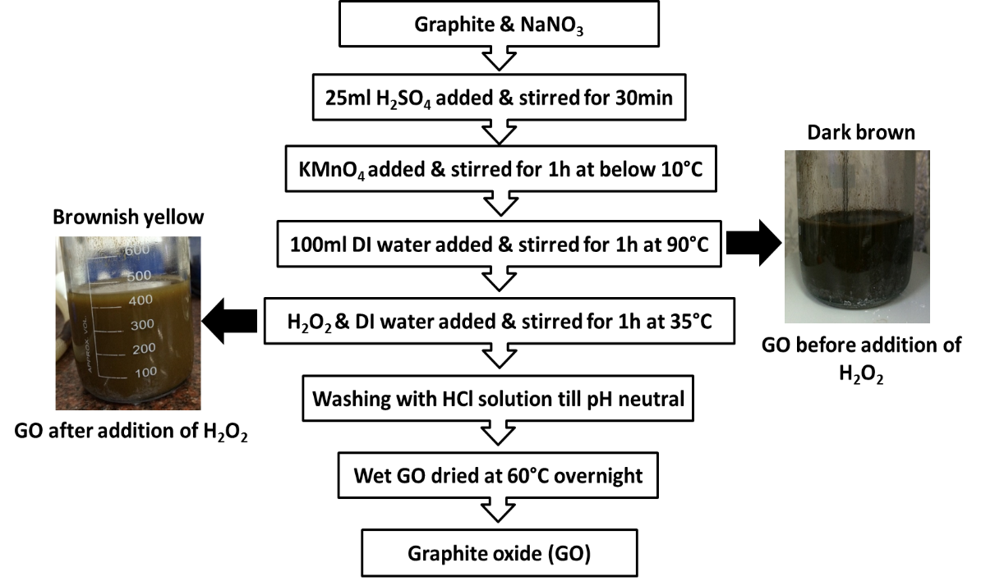
Fig. S1 Preparation steps of graphite oxide (GO).

The GO was prepared by oxidizing of graphite powder (Sigma–Aldrich, 3–20 µm) based on the modified Hummers method as shown above in Fig. S1. The about 1 gm pure graphite was taken in beaker into which NaNO₃ (Merck) and H₂SO₄ (98 %, Merck) were added. After that, the mixture was stirred for 1 h in an ice bath maintaining a temperature less than 283 K. KMnO₄ (98.5 %, Merck) was added slowly to the mixture and stirred for another 1 h under the same condition. The mixture was removed from the ice bath and further stirred for 1 h at room temperature (308 K). Thereafter, 100 ml of deionized water was added with a rate of 10 ml/min. Then, the mixture was heated up to 363 K using hot plate and stirred at room temperature for 1 h. The color of the mixture appeared dark brown. The mixture was then cooled to room temperature followed by addition of 100 ml of deionized water and 10 ml of H₂O₂ (30 %, Merck). The entire mixture was stirred for 1 h at room temperature and the color of the mixture changed from dark brown to yellowish. The mixture at different stages is shown in Supplementary Fig. S1. Finally, filtration of the mixture was done and the solid sample was washed with acidic water (HCl:H₂O::1:9) (37 %, Merck) followed by repeated washing with deionized water until pH was neutralized. Finally obtained solid GO was dried in air oven at 333 K for overnight. The nearly ~0.50 gm weight of GO was achieved after drying.

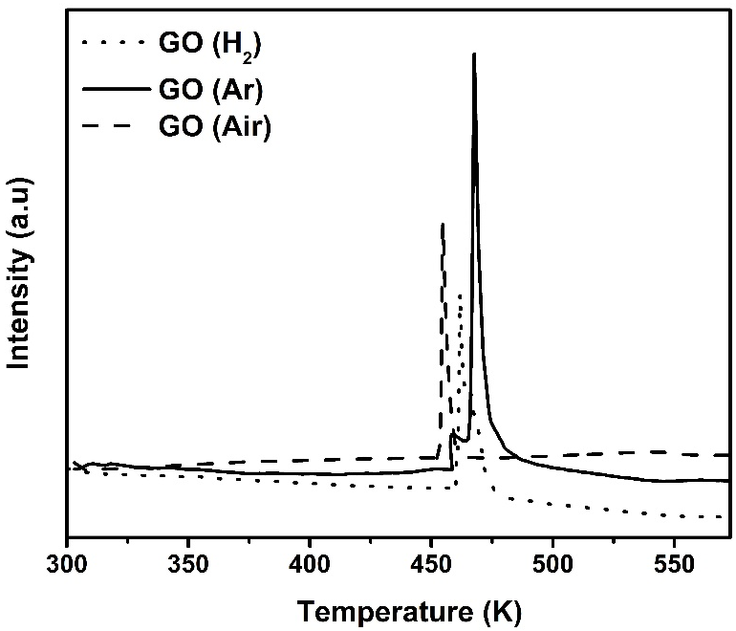
(C)

Fig. S2 TPD profiles of GO in different carrier gas of H₂, Ar and air. It was carried out in Chemisorb 2720 (Micromeritics). In this method, the required amount of GO was taken in U–shape quartz tube and degassed at 313 K for 1 h in the flow of He gas. Then the GO was heated in desired carrier gas from room temperature to 573 K at a heating rate of 10 K/min.

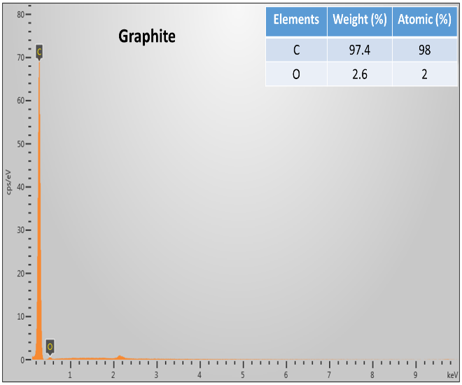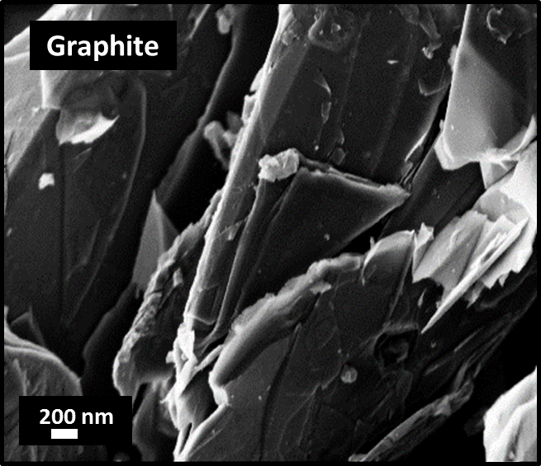
(B)
(A)
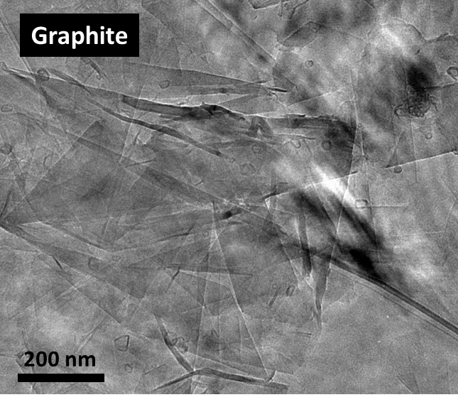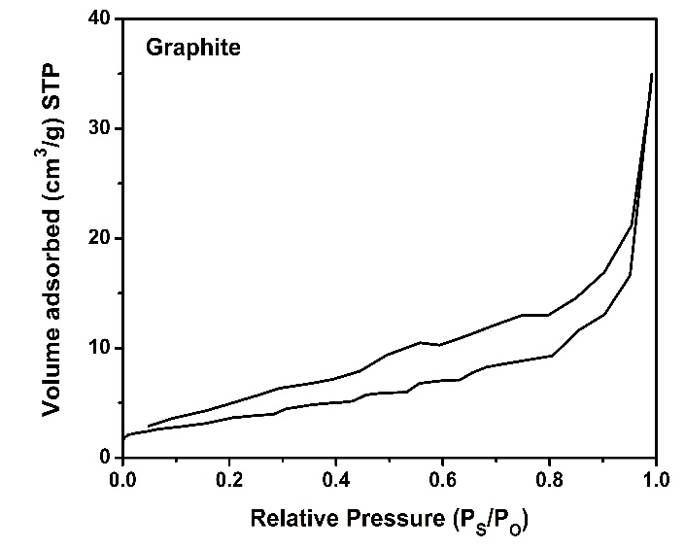
(C)
(D)
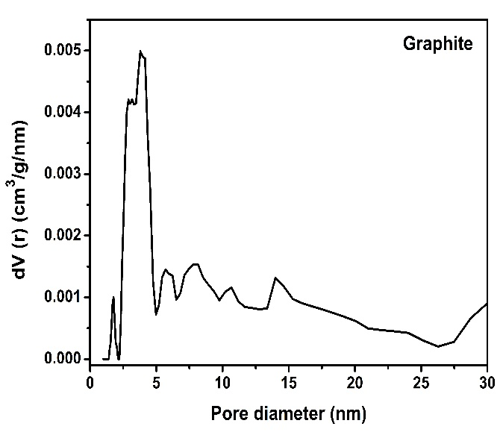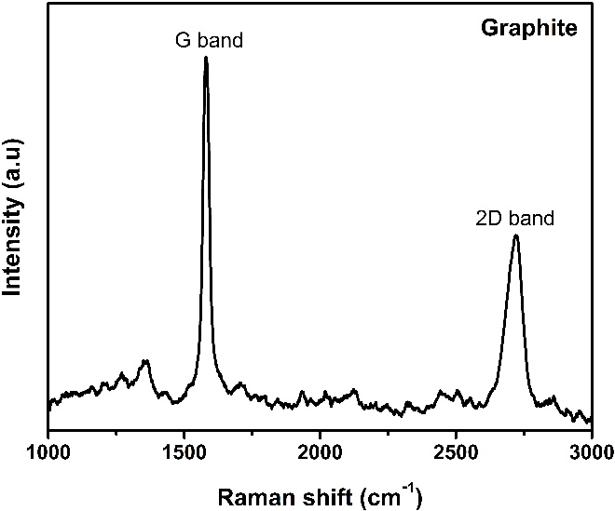
(F)
(E)

Fig. S3 For graphite (A) EDX spectra (B) FESEM image (C) TEM image (D) N₂ adsorption–desorption isotherm (E) DFT pore size distribution (F) Raman spectra.

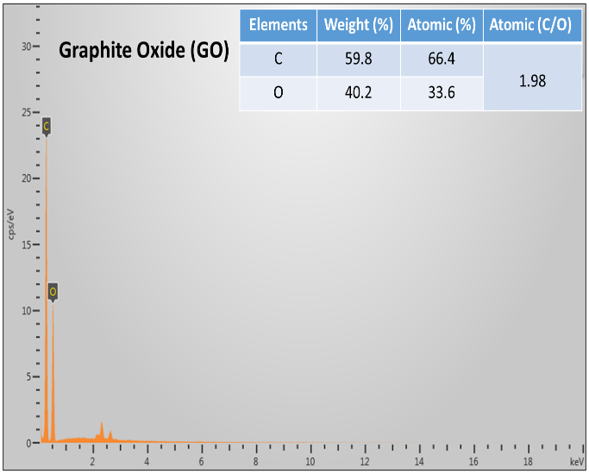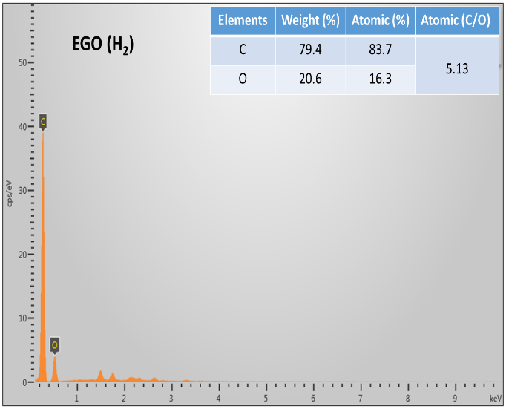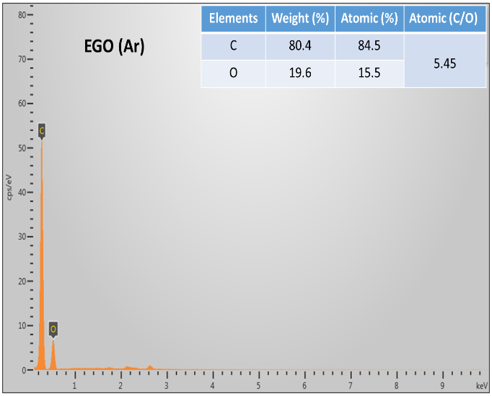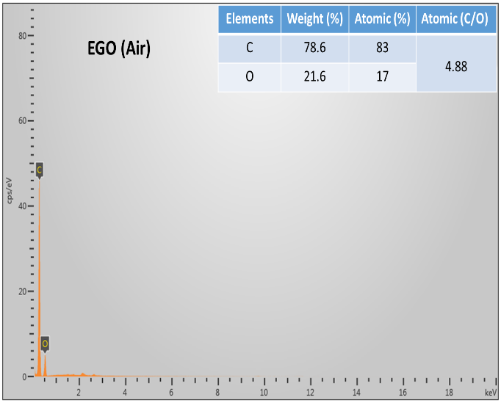

Fig. S4 EDX spectra of samples.

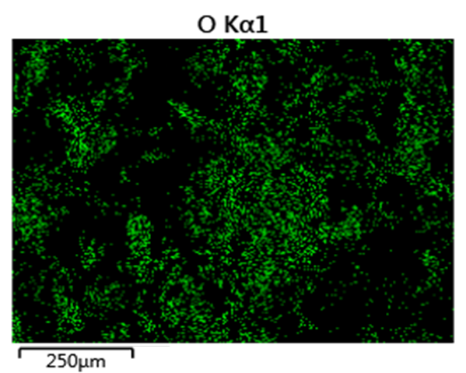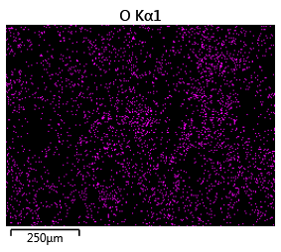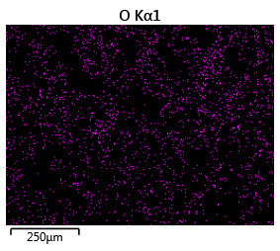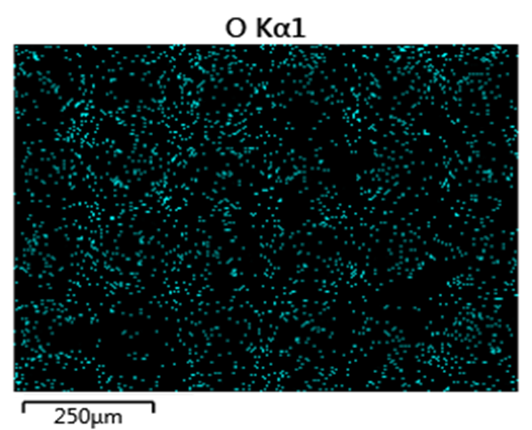
EGO (Air)
EGO (Ar)
EGO (H₂)
GO

Fig. S5 EDX mapping images of samples.

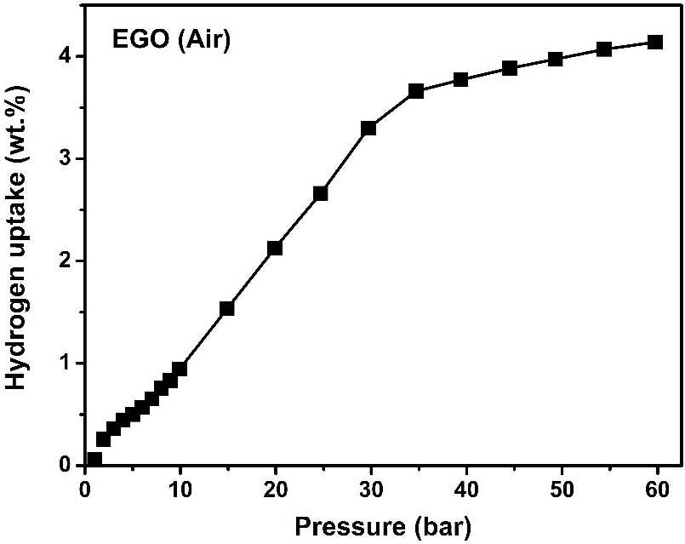

Fig. S6 Hydrogen adsorption isotherms of EGO(Air) at 77 K up to 60 bar.

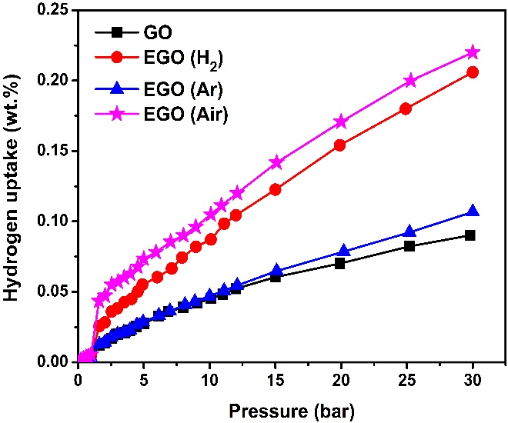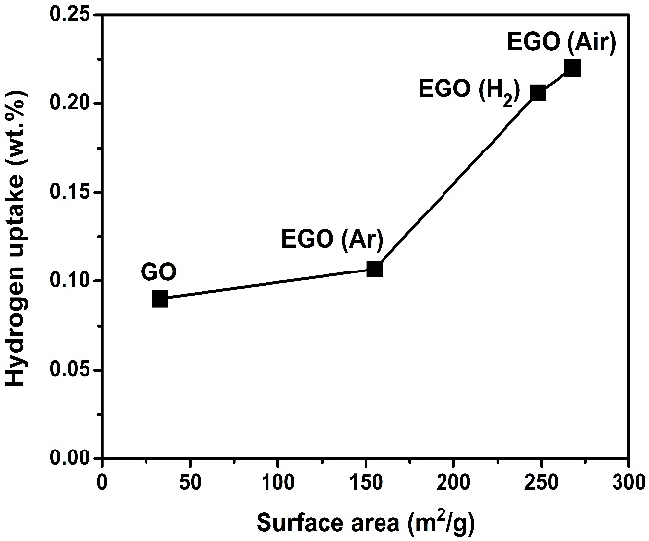
(B)
(A)

Fig. S7 (A) Hydrogen adsorption isotherms of samples at 298 K up to 30 bar (B) Relation between hydrogen uptake capacity and surface area of the samples at room temperature.

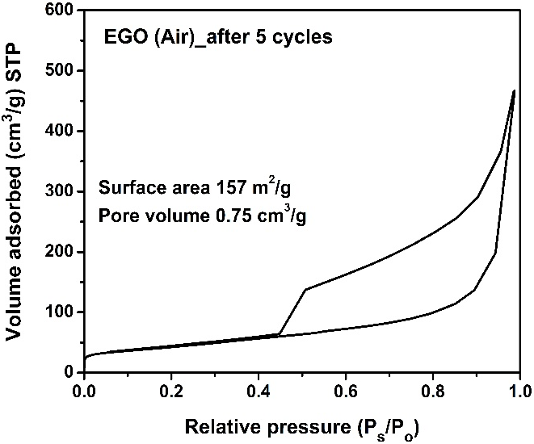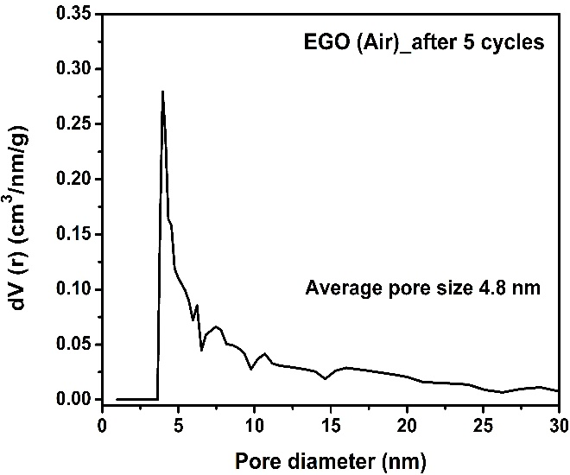
(A)
(B)

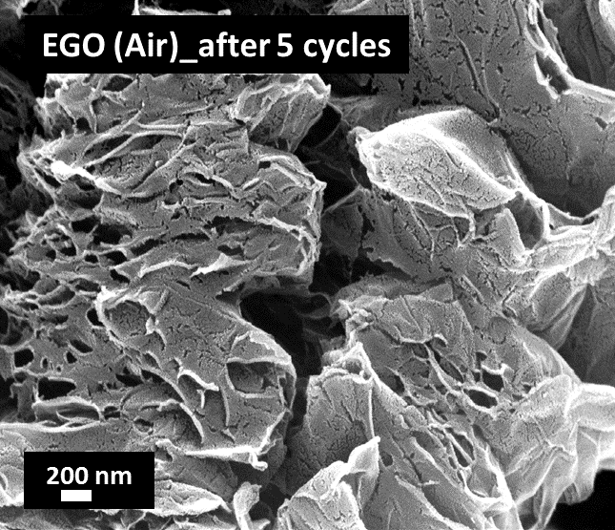
(C)

Fig. S8 Properties of EGO (Air) after 5 cycles of hydrogen uptake. (A) N₂ adsorption–desorption isotherm (B) pore size distribution (C) FESEM image.

