Glucose Tolerance and cardiovascular outcomes after an acute coronary syndrome – Predictive role of the 1-h plus 2-h plasma glucose at the oral glucose tolerance test

Short title: 1-h plus 2-h plasma glucose at the OGTT and cardiovascular outcomes

Viola Zywicki, MD¹, Paola Francesca Capozza, MD¹, Paolo Caravelli, MD, PhD¹,
Stefano Del Prato, MD², and Raffaele De Caterina, MD, PhD^{1, 3}

¹Cardiology and ²Diabetology Divisions, Pisa University Hospital, University of Pisa and ³Fondazione VillaSerena per la Ricerca, Città Sant’Angelo, Pescara, Italy

Online Supplement

Address for correspondence:
Prof. Raffaele De Caterina, MD, PhD
Chair of Cardiology, University of Pisa, and Cardiovascular Division - Pisa University Hospital, Via Paradisa, 2 - 56124 Pisa, Italy
Tel.: +39-050-996-751
E-mail: raffaele.decaterina@unipi.it

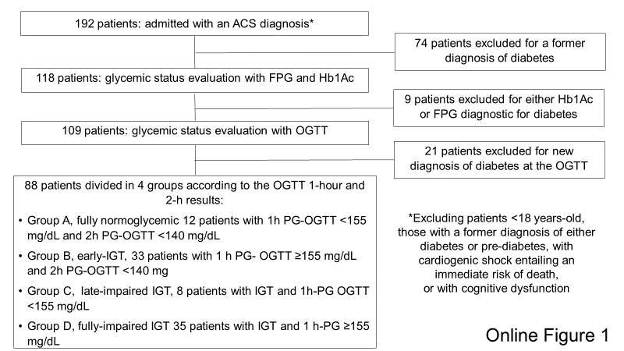
Online Figure 1: Patient enrollment and disposition. Abbreviations: ACS, acute coronary syndrome, FPG, fasting plasma glucose; IGT, impaired glucose tolerance; OGTT, oral glucose tolerance test.

