SUPPLEMENT 1
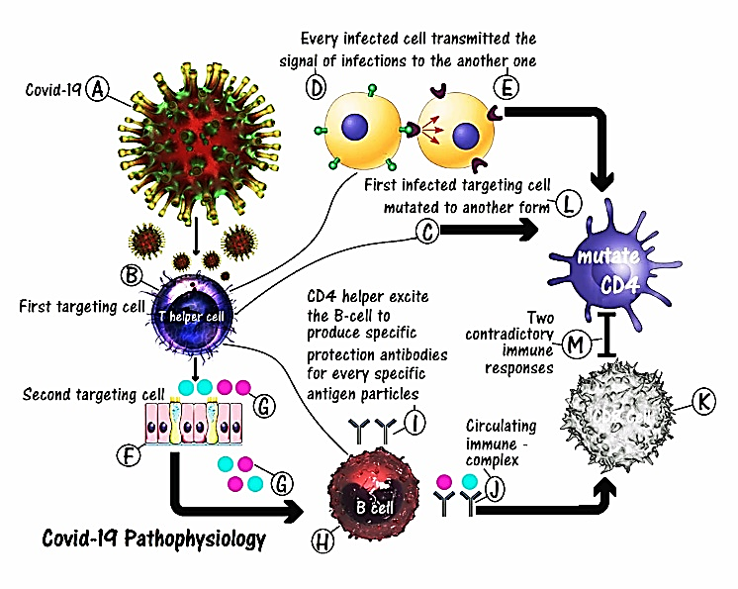 | 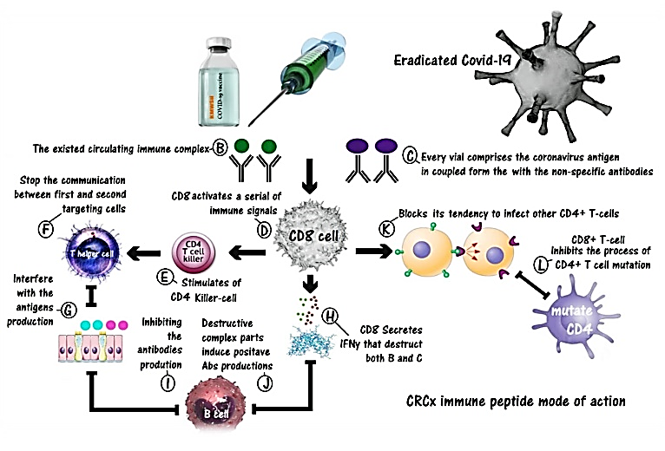
Figure 1: Hypothetical mode of action for Coronavirus. (A) Virus particles. (B) CD4+ T-cell as the first susceptible cell. (C) Evolution of the CD4+ T-cell mutating to be an unaccountable CD8+ T-cell. (D) Tendencies of the first susceptible infected cell to infect other healthy ones and to be a new form of CD8+ T-cells. (E) Newly formed infected first susceptible cell. (F) Cells of the upper and lower respiratory tract as second susceptible cells. (G) Productions of viral antigen particles from the second susceptible cells under the induction of the first susceptible cells’ stimulus of transmitted ions signals. (H) CD4+ T-cell stimulating B-cells to produce negative neutralized coating antibodies to form a complex with antigen particles. (I) B-cells producing negative neutralizing antibodies. (J) Formations of circulating immune complex comprising coronavirus antigens and its specific negative neutralizing antibodies. (K) CD8+ T-cells. (L) Inhibitory effect of these complexes in preventing the cytotoxic CD8+ T-cells from attacking these viral particles. (M) The interaction mechanisms that originate as a result of antagonism between the newly formed mutated CD4+ T- cells and the normal CD8+ T-cells. |  | Figure 2: Immunity stimulating action of the CRCx3 vaccine. (A) CRCx immune peptide. (B) Existing circulating immune complex. (C) Every vial comprises the coronavirus antigen in coupled form with non-specific antibodies. (D) CD8+ T-cell stimulated to induce a process of scanning and comparison between these non-complex combinations and those already existing during the vaccine injection. Also. CD8 stimulates a series of immune signals. (E) Stimulation of CD4+ killer cells. (F) Stimulation of CD4+ Helper cell. (G) CD4+ T-cell sending a signal that inhibits the formations of the coronavirus antigens. (H) Cytotoxic T-cells secreting IFNy that destroys the circulating immune complex and the intruder non-complexes.. (J) Destructive complex particles inducing positive antibody productions from B-cells. (K) Blocking of the tendency of CD4+ to infect other cells. (L) CD8+ T-cells inhibiting the process of CD4+ T-cell mutation.
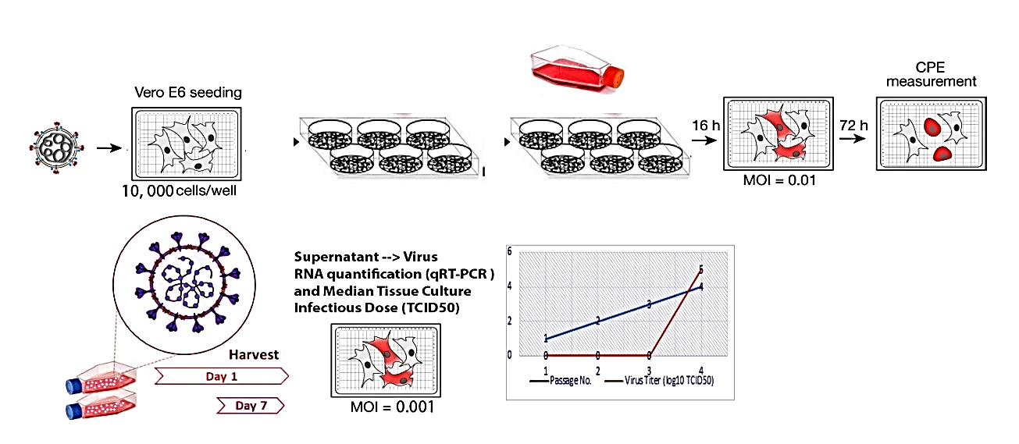
Figure 3: Preparation and titration of SARS-CoV-2 Stock Solution

Anti-complex antibodies production in immunized rabbits
Fc of IgG Goat anti-human IgM as adjutant immunogenic dissolved in human albumin & phosphate buffered saline and packed in 1 ml vials
CRCx3 | CRCx2
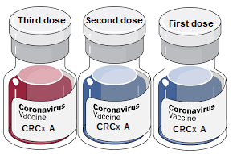 | 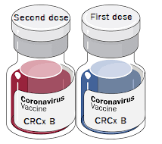
Figure 4: Formulation of CRCx2 & CRCx3

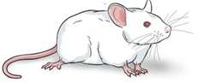
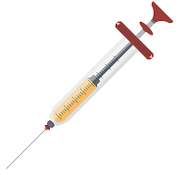
Figure 5: CRCx vaccines experiment as prophylactic candidates in Balb/c mice.

Figure 6: CRCx vaccines experiment as therapeutic candidates in Balb/c mice.

Table 1: Animal studies for evaluating the safety and efficacy of the CRCx series vaccine.
Study | Topic | Animal model
Safety Assay | Abnormal toxicity test / Single dose toxicity/ Acute toxicity | Rats
Safety Assay | Repeated dose toxicity | Rats, Guinea pigs
Safety Assay | Pyrogenicity assay | Rabbits
Safety Assay | Active systemic anaphylaxis | Guinea pigs
Safety Assay | Local injection irritation | Mice, Rats, Guinea pigs, Rabbits
Efficacy: Vaccine immunogenicity analysis (Prophylactic/ Therapeutic) | Evaluation of the humoral immune response (IgG antibody titer 'ELISA'), Blood biochemical and hematological analysis, Virus Neutralizing Test (VNT), Cytokines assay | Mice, Rabbits
 | Evaluation of the cellular immune response ( SARS-CoV-2 challenge): Virus quantification in tissues, Cytokines assay, inflammatory markers, Histopathology and immune-histochemistry | Mice, Rats

Table 2: Immuno-chemistry studies at 14, 28, 42 & 56 days after immunization with CRCx candidate vaccines in prophylactic trails mice groups.
Animal Groups | Days | Group A | Group B | Group C | Group D | Group E | Group F
CD4+ (Cells/μl) | 14 Days | 285 | 305 | 321 | 1550 | 550 | 420
CD4+ (Cells/μl) | 28 Days | 220 | 180 | 140 | 430 | 330 | 310
CD4+ (Cells/μl) | 42 Days | 550 | 510 | 470 | 280 | 820 | 780
CD4+ (Cells/μl) | 56 Days | 790 | 670 | 600 | 120 | 1300 | 1230
CD4+ (Cells/μl) | Normal Range | 359-1954
CD8+ (Cells/μl) | 14 Days | 720 | 600 | 540 | 900 | 830 | 770
CD8+ (Cells/μl) | 28 Days | 930 | 820 | 760 | 850 | 650 | 550
CD8+ (Cells/μl) | 42 Days | 520 | 600 | 500 | 560 | 440 | 340
CD8+ (Cells/μl) | 56 Days | 390 | 430 | 400 | 400 | 400 | 320
CD8+ (Cells/μl) | Normal Range | 220-1100
CRP (ng/ml) | 14 Days | 6 | 5.3 | 3.8 | 0.8 | 8 | 11
CRP (ng/ml) | 28 Days | 18 | 24 | 30 | 120 | 10 | 13
CRP (ng/ml) | 42 Days | 42 | 49 | 55 | 45 | 60 | 55
CRP (ng/ml) | 56 Days | 20 | 22 | 27 | 40 | 14 | 22
CRP (ng/ml) | Normal Range | 0.78-25
D-dimer (ng/ml) | 14 Days | 58 | 55 | 50 | 0.7 | 22 | 15
D-dimer (ng/ml) | 28 Days | 58 | 61 | 66 | 65 | 54 | 58
D-dimer (ng/ml) | 42 Days | 34 | 37 | 42 | 44 | 19 | 22
D-dimer (ng/ml) | 56 Days | 17 | 22 | 28 | 42 | 15 | 14
D-dimer (ng/ml) | Normal Range | 0.6-50
IL-6 (ng/ml) | 14 Days | 0.8 | 0.5 | 0.4 | 1.4 | 0.4 | 0.2
IL-6 (ng/ml) | 28 Days | 1.6 | 1.9 | 2.4 | 2.2 | 1.2 | 1.4
IL-6 (ng/ml) | 42 Days | 0.8 | 1.2 | 1.3 | 3 | 0.16 | 0.13
IL-6 (ng/ml) | 56 Days | 0.15 | 0.33 | 0.4 | 14 | 0.03 | 0.06
IL-6 (ng/ml) | Normal Range | 0.01-0.2
Qualitative IgM | 14 Days | Negative | Negative | Negative | Negative | Negative | Negative
Qualitative IgM | 28 Days | Positive | Positive | Positive | Positive | Positive | Positive
Qualitative IgM | 42 Days | Positive | Positive | Positive | Positive | Positive | Positive
Qualitative IgM | 56 Days | Positive | Positive | Positive | Positive | Positive | Positive
Qualitative IgG | 14 Days | Negative | Negative | Negative | Negative | Negative | Negative
Qualitative IgG | 28 Days | Negative | Negative | Negative | Negative | Negative | Positive
Qualitative IgG | 42 Days | Positive | Positive | Positive | Negative | Positive | Positive
Qualitative IgG | 56 Days | Positive | Positive | Negative | Positive | Positive | Positive
Qualitative RNA | 14 Days | Negative | Negative | Negative | Negative | Negative | Negative
Qualitative RNA | 28 Days | Positive | Positive | Positive | Positive | Positive | Positive
Qualitative RNA | 42 Days | Positive | Positive | Negative | Positive | Positive | Positive
Qualitative RNA | 56 Days | Negative | Negative | Negative | Positive | Negative | Negative

(a) | (b)
(c) |  | (d)
(e) |  | (f)
(g) |  | (h)
Figure 7: Quantitative and Qualitative Immunological and Biochemical Assays for Prophylactic Approach Groups on Days 14, 28, 42 & 56 with CRCx3 (Groups A, B & C), CRCx2 (Groups (E & F) and Control (D): (a) Qualitative SARS-Cov-2 RNA. (b) Quantitative IL-6. (c) Qualitative SARS-Cov-2 IgM. (d) Qualitative SARS-Cov-2 IgG. (e) Quantitative CD4+. (f) Quantitative CD8+. (g) Quantitative C-Reactive Proteins (CRP). (h) Quantitative D-dimer. Note: In quantitative assays, the horizontal lines represent the low and high normal values. In qualitative assays, 1=Positive; 0=Negative.
Table 3: Neutralizing antibodies (NAbs) titers on days 14, 28, 42 and 56 in prophylactic regimens.
Animal Groups | Days | Group A | Group B | Group C | Group D | Group E | Group F
 | Regimen | CRCx3 (0.4x3) + Cov-2 | CRCx3 (0.35x3) + Cov-2 | CRCx3 (0.25x3) + Cov-2 | NaCl + Cov | CRCx2 (0.4x2) + Cov-2 | CRCx2 (0.25x2) + Cov-2
Anti-A1 (ng/ml) | 14 Days | 200 | 110 | 67 | 0
Anti-A1 (ng/ml) | 28 Days | 550 | 310 | 200 | 0
Anti-A1 (ng/ml) | 42 Days | 650 | 520 | 320 | 0
Anti-A1 (ng/ml) | 56 Days | 340 | 300 | 180 | 0
Anti-A1 (ng/ml) | Normal Range | 0.2-1
Anti-A2 (ng/ml) | 14 Days | 85 | 72 | 57 | 0
Anti-A2 (ng/ml) | 28 Days | 260 | 210 | 170 | 0
Anti-A2 (ng/ml) | 42 Days | 430 | 300 | 240 | 0
Anti-A2 (ng/ml) | 56 Days | 150 | 120 | 90 | 0
Anti-A2 (ng/ml) | Normal Range | 0.5-1
Anti-A3 (ng/ml) | 14 Days | 10 |  | 0 | 0
Anti-A3 (ng/ml) | 28 Days | 250 | 200 | 150 | 0
Anti-A3 (ng/ml) | 42 Days | 600 | 480 | 350 | 0
Anti-A3 (ng/ml) | 56 Days | 410 | 340 | 300 | 0
Anti-A3 (ng/ml) | Normal Range | 0.5-5
Anti-B1 (ng/ml) | 14 Days |  |  |  | 0 | 90 | 75
Anti-B1 (ng/ml) | 28 Days |  |  |  | 5 | 450 | 410
Anti-B1 (ng/ml) | 42 Days |  |  |  | 180 | 800 | 780
Anti-B1 (ng/ml) | 56 Days |  |  |  | 240 | 600 | 560
Anti-B1 (ng/ml) | Normal Range | 0.5-2
Anti-B2 (ng/ml) | 14 Days |  |  |  | 0 | 10 | 6
Anti-B2 (ng/ml) | 28 Days |  |  |  | 2 | 230 | 180
Anti-B2 (ng/ml) | 42 Days |  |  |  | 80 | 630 | 500
Anti-B2 (ng/ml) | 56 Days |  |  |  | 95 | 450 | 400
Anti-B2 (ng/ml) | Normal Range | 0.2-2

(a) | (b)
(c) | (d)
(e) | (f)
Figure 8: Different neutralizing antibodies (NAbs) in Prophylactic Approach Groups on Days 14, 28, 42 & 56 with CRCx3 (Groups A, B & C), CRCx2 (Groups (E & F) and Control (D): (a) Anti-A1. (b) Anti-A2. (c) Anti-A3. (d) Anti-B1. (e) Anti-B2. (f) All NAbs. Note: The horizontal lines represent the low and high normal values.

Table 4: Immuno-chemistry studies at 42 & 56 days after immunization with CRCx candidate vaccines in therapeutic trails mice groups.
Animal Groups | Days | Group G | Group H | Group I | Group J | Group K | Group L
CD4+ (Cells/μl) | 14 Days | 120 | 110 | 120 | 120 | 100 | 120
CD4+ (Cells/μl) | 28 Days | 470 | 450 | 370 | 320 | 230 | 260
CD4+ (Cells/μl) | 42 Days | 1200 | 1100 | 900 | 380 | 540 | 700
CD4+ (Cells/μl) | 56 Days | 900 | 830 | 600 | 385 | 500 | 560
CD4+ (Cells/μl) | Normal Range | 359-1954
CD8+ (Cells/μl) | 14 Days | 900 | 830 | 770 | 120 | 820 | 880
CD8+ (Cells/μl) | 28 Days | 660 | 600 | 420 | 120 | 700 | 780
CD8+ (Cells/μl) | 42 Days | 340 | 390 | 420 | 80 | 630 | 570
CD8+ (Cells/μl) | 56 Days | 380 | 320 | 400 | 78 | 600 | 460
CD8+ (Cells/μl) | Normal Range | 220-1100
CRP (ng/ml) | 14 Days | 48 | 47 | 49 | 50 | 44 | 45
CRP (ng/ml) | 28 Days | 5.8 | 6.5 | 4.6 | 66 | 29 | 22
CRP (ng/ml) | 42 Days | 89 | 92 | 22 | 100 | 122 | 105
CRP (ng/ml) | 56 Days | 4 | 11 | 22 | 140 | 0.9 | 2
CRP (ng/ml) | Normal Range | 0.78-25
D-dimer (ng/ml) | 14 Days | 66 | 64 | 65 | 69 | 65 | 64
D-dimer (ng/ml) | 28 Days | 36 | 42 | 47 | 42 | 55 | 50
D-dimer (ng/ml) | 42 Days | 28 | 33 | 37 | 59 | 55 | 49
D-dimer (ng/ml) | 56 Days | 22 | 26 | 33 | 67 | 20 | 15
D-dimer (ng/ml) | Normal Range | 0.6-50
IL-6 (ng/ml) | 14 Days | 38 | 34 | 36 | 1.3 | 40 | 38
IL-6 (ng/ml) | 28 Days | 0.3 | 0.4 | 0.7 | 2.1 | 1.4 | 1
IL-6 (ng/ml) | 42 Days | 0.18 | 0.23 | 0.32 | 2.9 | 0.34 | 0.24
IL-6 (ng/ml) | 56 Days | 0.1 | 0.14 | 0.02 | 23 | 0.44 | 0.19
IL-6 (ng/ml) | Normal Range | 0.01-0.2
Qualitative IgM | 14 Days | Positive | Positive | Positive | Positive | Positive | Positive
Qualitative IgM | 28 Days | Positive | Positive | Positive | Positive | Positive | Positive
Qualitative IgM | 42 Days | Positive | Positive | Positive | Positive | Positive | Positive
Qualitative IgM | 56 Days | Negative | Negative | Positive | Negative | Negative | Positive
Qualitative IgG | 14 Days | Negative | Negative | Negative | Negative | Negative | Negative
Qualitative IgG | 28 Days | Negative | Negative | Negative | Negative | Negative | Positive
Qualitative IgG | 42 Days | Positive | Negative | Negative | Negative | Positive | Positive
Qualitative IgG | 56 Days | Positive | Positive | Negative | Positive | Positive | Positive
Qualitative RNA | 14 Days | Negative | Negative | Negative | Negative | Negative | Positive
Qualitative RNA | 28 Days | Negative | Negative | Negative | Negative | Negative | Positive
Qualitative RNA | 42 Days | Negative | Negative | Negative | Positive | Negative | Negative
Qualitative RNA | 56 Days | Negative | Negative | Negative | Positive | Negative | Negative

(a) | (b)
(c) | (d)
(e) | (f)
(g) | (h)
Figure 9: Quantitative and Qualitative Immunological and Biochemical Assays for Therapeutic Approach Groups on Days 14, 28, 42 & 56 with CRCx3 (Groups G, H & I), CRCx2 (Groups (K & L) and Control (J): (a) Quantitative CD4+. (b) Quantitative CD8+. (c) Quantitative C-Reactive Proteins (CRP). (d) Quantitative D-dimer. (e) Quantitative IL-6. (f) Qualitative SARS-Cov-2 IgM. (g) Qualitative SARS-Cov-2 IgG. (h) Qualitative SARS-Cov-2 RNA. Note: In quantitative assays, the horizontal lines represent the low and high normal values. In qualitative assays, 1=Positive; 0=Negative.

Table 5: Table 3: Neutralizing antibodies (NAbs) titers on days 14, 28, 42 and 56 in therapeutic regimens.
Animal Groups | Days | Group G | Group H | Group I | Group J | Group K | Group L
 | Regimen | CoV-2 + CRCx3 (0.4x3) | CoV-2 + CRCx3 (0.35x3) | CoV-2 + CRCx3 (0.25x3) | CoV-2 + Nil | CoV-2 + CRCx2 (0.4x2) | CoV-2 + CRCx2 (0.25x2)
Anti-A1 (ng/ml) | 14 Days | 0 | 0 | 0 | 0
Anti-A1 (ng/ml) | 28 Days | 400 | 340 | 300 | 0
Anti-A1 (ng/ml) | 42 Days | 950 | 800 | 710 | 0
Anti-A1 (ng/ml) | 56 Days | 600 | 520 | 480 | 0
Anti-A1 (ng/ml) | Normal Range | 0.2-1
Anti-A2 (ng/ml) | 14 Days | 0 | 0 | 0 | 0
Anti-A2 (ng/ml) | 28 Days | 230 | 200 | 140 | 0
Anti-A2 (ng/ml) | 42 Days | 450 | 410 | 350 | 0
Anti-A2 (ng/ml) | 56 Days | 320 | 270 | 200 | 0
Anti-A2 (ng/ml) | Normal Range | 0.5-1
Anti-A3 (ng/ml) | 14 Days | 0 | 0 | 0 | 0
Anti-A3 (ng/ml) | 28 Days | 450 | 380 | 300 | 0
Anti-A3 (ng/ml) | 42 Days | 750 | 640 | 575 | 0
Anti-A3 (ng/ml) | 56 Days | 500 | 400 | 310 | 0
Anti-A3 (ng/ml) | Normal Range | 0.5-5
Anti-B1 (ng/ml) | 14 Days |  |  |  | 0 | 100 | 85
Anti-B1 (ng/ml) | 28 Days |  |  |  | 100 | 1200 | 1000
Anti-B1 (ng/ml) | 42 Days |  |  |  | 200 | 950 | 870
Anti-B1 (ng/ml) | 56 Days |  |  |  | 360 | 600 | 520
Anti-B1 (ng/ml) | Normal Range | 0.5-2
Anti-B2 (ng/ml) | 14 Days |  |  |  | 22 | 30 | 24
Anti-B2 (ng/ml) | 28 Days |  |  |  | 120 | 600 | 520
Anti-B2 (ng/ml) | 42 Days |  |  |  | 180 | 500 | 450
Anti-B2 (ng/ml) | 56 Days |  |  |  | 300 | 430 | 400
Anti-B2 (ng/ml) | Normal Range | 0.2-2

(a) | (b)
(c) | (d)
(e) | (f)
Figure 10: Different neutralizing antibodies (NAbs) in Therapeutic Approach Groups on Days 14, 28, 42 & 56 with CRCx3 (Groups A, B & C), CRCx2 (Groups (E & F) and Control (D): (a) Anti-A1. (b) Anti-A2. (c) Anti-A3. (d) Anti-B1. (e) Anti-B2. (f) All NAbs. Note: The horizontal lines represent the low and high normal values.

