Supplementary Information

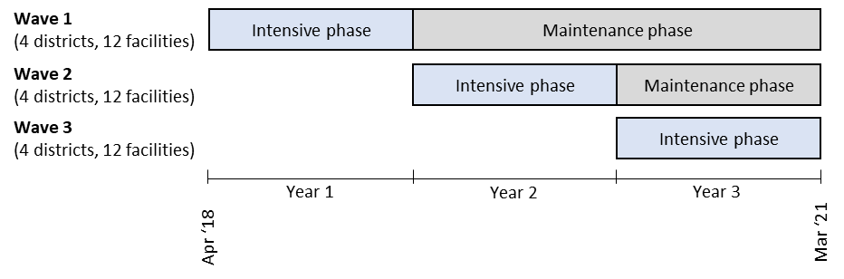
Figure S1. Implementation and maintenance stages of the SAIA-SCALE stepped wedge cluster randomized trial.

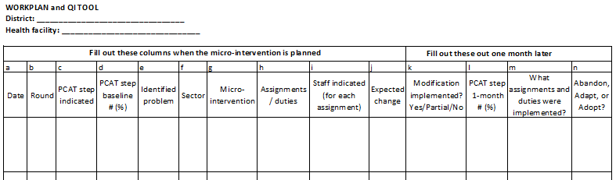
Figure S2. Blank workplan template.

Figure S3. Average number of micro-interventions proposed per workplan, by round, for all 36 facilities across all 3 waves.

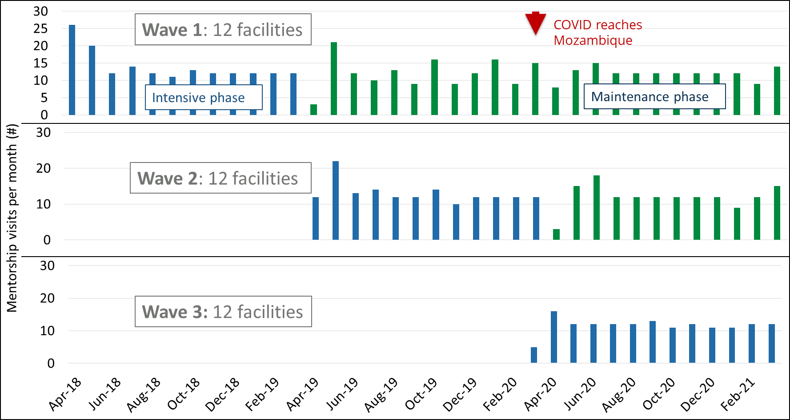
Figure S4. Intensive and maintenance phase mentorship visits per month for wave 1, wave 2, and wave 3 facilities.

Table S1. Comparison of external support to district leadership during intensive and maintenance phases.
External support to district supervisors | Intensive phase | Maintenance phase
External staff schedule mentorship visits | ●
External organization provides transport to mentorship visits | ●
External study nurse participation in mentorship visits | ●
External phone-call check-ins with district supervisors | ● | ●
Per diem for days in the field | ● | ●
Transport reimbursement for days in the field |  | ●

Table S2. Reporting the SAIA-SCALE program using the Template for Intervention Description and Replication (TIDieR) checklist
Item number | Item | Where located
Item number | Item | Primary paper | Other
 | BRIEF NAME
1. | Provide the name or a phrase that describes the intervention. | Page 1 - Title and abstract
 | WHY
2. | Describe any rationale, theory, or goal of the elements essential to the intervention. | Page 3 - Methods, Program description, paragraph 1
 | WHAT
3. | Materials: Describe any physical or informational materals used in the intervention, including those provided to participants or used in intervention delivery or in training of intervention providers. | Page 3 - Methods, Program description, paragraph 2.  Supplemental Information, Figure S2. | Information on SAIA implementation can be found at https://www.saia-strategy.com. Specific training materials from the SAIA-SCALE program will be made available in Portuguese from the corresponding author upon reasonable request.  Training materials consisted of Powerpoint presentations. Districts were provided with tablets with a PMTCT cascade analysis tool pre-installed. Health facilities were provided with flipcharts and snacks for monthly SAIA meetings.
4. | Procedures: Describe each of the procedures, activities, and/or processes used in the intervention, including any enabling or support activities. | Page 3 - Methods, Program description, paragraph 2.  Page 5 - Methods, R-AIM measures and data collection, Implementation and maintenance.  Supplemental information, Table S1. | Published protocol: https://implementationscience.biomedcentral.com/articles/10.1186/s13012-019-0889-z

 | WHO PROVIDED
5. | For each category of intervention provider (e.g. psychlogist, nursing assistant), describe their expertise, background and any specific training given. | Page 3 - Methods, Program description, paragraph 2. | NGO study staff had previous experience working as nurses in public sector health facilities in Mozambique. They had implemented the SAIA strategy on a previous cluster-randomized trial.
 | HOW
6. | Describe the modes of delivery (e.g. face-to-face or by some other mechanish, such as internet or telephone) of the intervention and whether it was provided individually or in a group. | Page 3 - Methods, Program description, paragraph 2.  Supplemental Information, Figure S2.
 | WHERE
7. | Describe the type(s) of location(s) where the intervention occurred, including any necessary infrastucture or relevant features. | Page 4 - Methods, Study setting.  Page 6 - Results, Reach, paragraph 2.  Page 6 - Table 2. | Initial training sessions were held at rented hotel venues in the district seat, Chimoio. A projector and cell service were required.
 | WHEN and HOW MUCH
8. | Describe the number of times the intervention was delivered and over what period of time including the number of sessions, their schedule, and their duration, intensity or dose. | Page 8 - Results, Implementation & maintenance, paragraph 1.  Page 9 - Table 5.

 | TAILORING
9. | If the intervention was planned to be personalised, titrated or adapted, then describe what, why, when, and how. | Page 9 - Table 5. Explanation: Each health facility proposed micro-interventions suited to the different problems identified in their facility. Table 5 shows how micro-interventions were distributed across different categories of actions.
 | MODIFICATIONS
10. | If the intervention was modified during the course of the study, describe the changes (what, why, when, and how). | NA
 | HOW WELL
11. | Planned: If intervention adherence or fidelity was assessed, describe how and by whom, and if any strategies were used to maintain or improve fidelity, describe them. | Page 5 - Methods, R-AIM measures and data collection, Implementation and maintenance.
12. | Actual: If intervention adherence or fidelity was assessed, describe the extent to which the intervention was delivered as planned. | Page 8 - Results, Implementation & maintenance, paragraph 1.  Page 9 - Table 5.

