Article Title: Topographic ruggedness indices in ecology: past, present and future
Journal Name: Landscape Ecology
Author Names: Thomas E. Dilts · Marcus E. Blum · Kevin T. Shoemaker ·
Peter J. Weisberg · Kelley M. Stewart

Corresponding Author: Thomas E. Dilts, Natural Resources and Environmental Science, University of Nevada, Reno, NV 89557; e-mail: tdilts@unr.edu

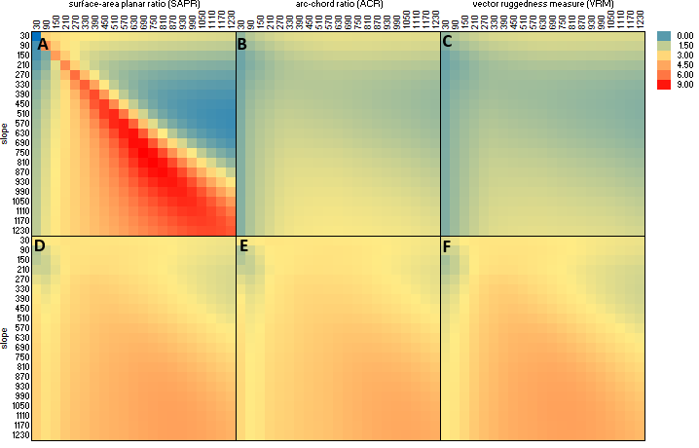Figure S1: Ruggedness coefficients for habitat selection functions for 1-month post-parturition female big horn sheep in the Lone Mountain study area. Red colors indicate a steeper positive slope while blue colors indicate a negative or neutral slope. Models were tested across twenty-one spatial scales ranging from 30 meters to 1230 meters for all scale combinations of ruggedness (columns) and slope (rows). The top row of models used the original A) surface-area planar ratio, B) arc-chord ratio, and C) vector ruggedness without the modification used in this study. The bottom row used the novel local versions of D) surface-area planar ratio, E) arc-chord ratio, and F) vector ruggedness with underlying topographic variation removed.
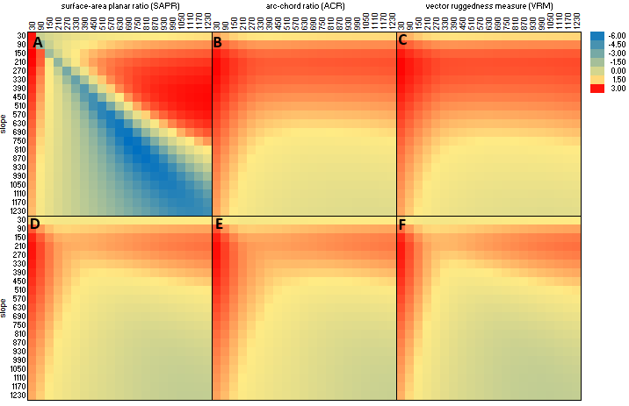
Figure S2: Slope coefficients for habitat selection functions for 1-month post-parturition female big horn sheep in the Lone Mountain study area. Red colors indicate a steeper positive slope while blue colors indicate a negative or neutral slope. Models were tested across twenty-one spatial scales ranging from 30 meters to 1230 meters for all scale combinations of ruggedness (columns) and slope (rows). The top row of models used the original A) surface-area planar ratio, B) arc-chord ratio, and C) vector ruggedness without the modification used in this study. The bottom row used the novel local versions of D) surface-area planar ratio, E) arc-chord ratio, and F) vector ruggedness with underlying topographic variation removed.

