Expended Data for

Asymmetric Pendrin Homodimer Reveals its Molecular Mechanism as Anion Exchanger

Qianying Liu^{1#}, Xiang Zhang^{1#}, Hui Huang^{1#}, Yuxin Chen^{2#}, Fang Wang², Aihua Hao¹, Wuqiang Zhan¹, Qiyu Mao¹, Yuxia Hu¹, Lin Han¹, Yifang Sun¹, Meng Zhang¹, Zhimin Liu¹, Genglin Li², Weijia Zhang¹, Yilai Shu^{2*}, Lei Sun^{1*}, Zhenguo Chen^{1*}

Correspondence to: zhenguochen@fudan.edu.cn (Z.C.); llsun@fudan.edu.cn (L.S.); and yilai_shu@fudan.edu.cn (Y.S.)

This PDF file includes:

Expended data Fig. 1-6
Expended data Table 1-4

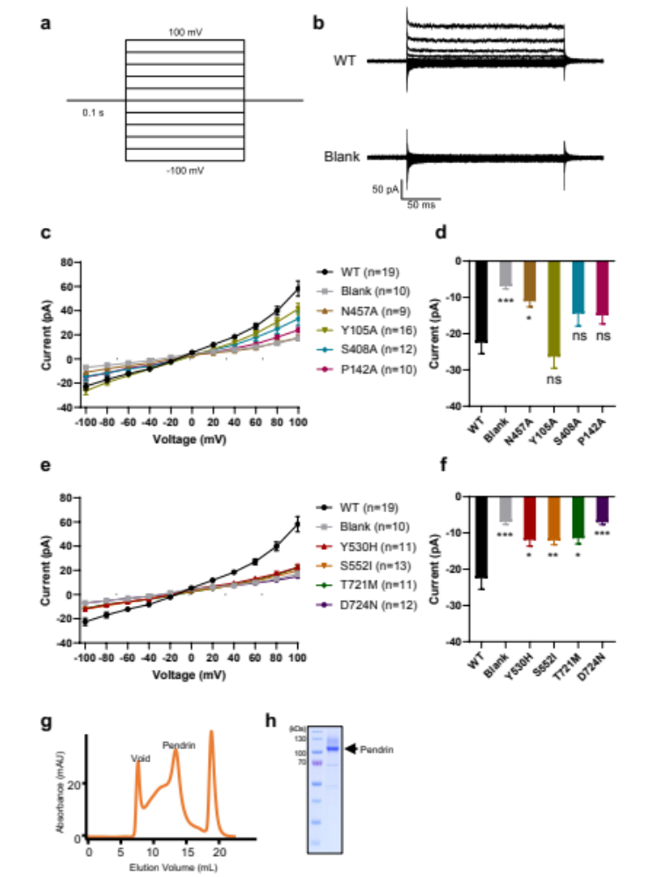

Extended data Fig. 1 Electrophysiology and biochemistry of pendrin.
a, The stimulation protocol of whole-cell voltage-clamp recording. The experiments were carried out in HEK293T cells with a holding potential of 0 mV. Obtain the currents by a series of 200 ms depolarizing steps between -100 mV and 100 mV in 20 mV increments. b, The representative Cl⁻ current traces of WT pendrin (up) and Blank (bottom). Blank, non-transfected HEK293T cells. c, The current-voltage relation curves of anion-binding site mutants. The number of collected cells was shown. d, Currents of anion-binding site mutants at the voltage of -100 mV. ***P < 0.001 and *P < 0.05 versus the cells transfected with WT pendrin, unpaired t test. e, The current-voltage relation curves of STAS domain mutants. Chloride currents were recorded. The number of collected cells was shown. f, Chloride currents of STAS domain mutants at the voltage of -100 mV. ***P < 0.001, **P < 0.01 and *P < 0.05 versus the cells transfected with WT pendrin, unpaired t test. g, Size exclusion chromatography of pendrin-Cl⁻. h, SDS-PAGE gel of the pulled peak fraction of pendrin-Cl⁻.

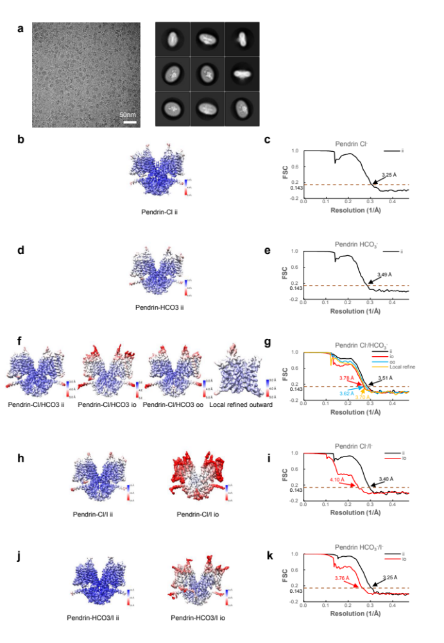

Extended data Fig. 2 Cryo-EM micrograph and data processing results.
a, Cryo-EM micrograph and 2D average of pendrin-Cl⁻. b, d, f, h, j, cryo-EM maps colored according to local resolution estimations. c, e, g, i, k, Corresponding FSC curves of the masked cryo-EM maps. ii: inward-inward, io: inward-outward, oo: outward-outward for protomer A and protomer B, respectively.

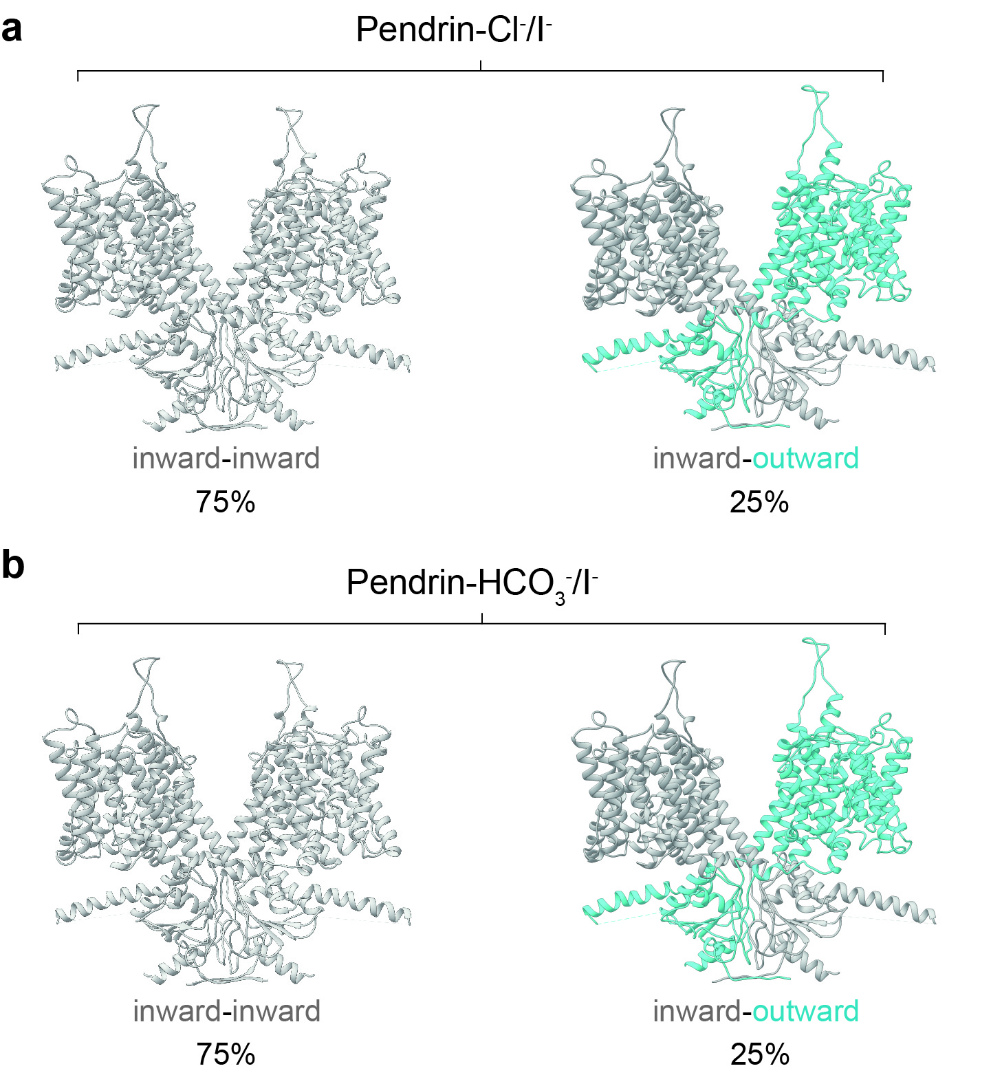

Extended data Fig. 3 Conformations of pendrin-Cl⁻/I⁻ and HCO₃⁻/I⁻.
a, Two conformations of pendrin-Cl⁻/I⁻. b, Two conformations of pendrin-HCO₃⁻/I⁻. Proportion of particles is indicated.

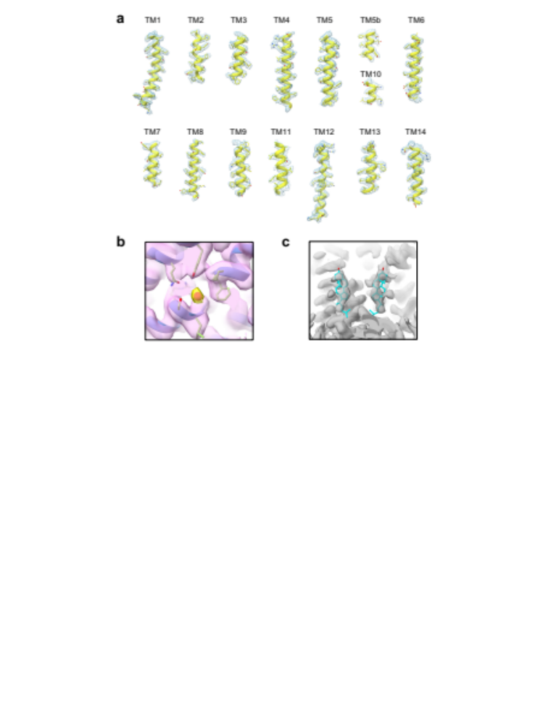

Extended data Fig. 4 Local cryo-EM densities of pendrin-Cl⁻ structures.
a, Representative local cryo-EM densities of pendrin-Cl⁻. b, Cryo-EM densities near the anion binding site in pendrin-Cl⁻. Density representing Cl⁻ is colored in yellow. c, Cryo-EM densities representing cholesterol. Cholesterol is shown in cyan stick representation.

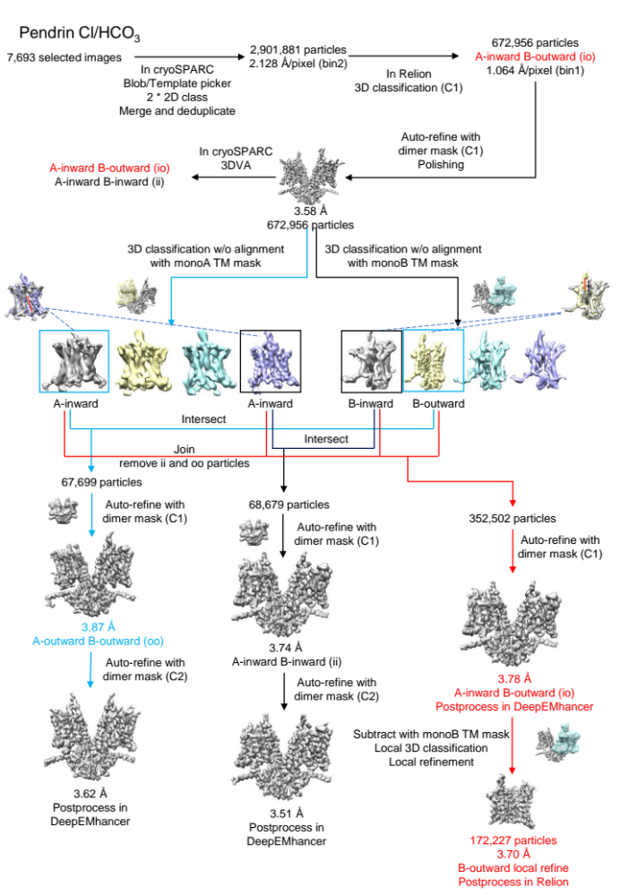

Extended data Fig. 5 Flowchart of pendrin-Cl⁻/HCO₃⁻ data processing.
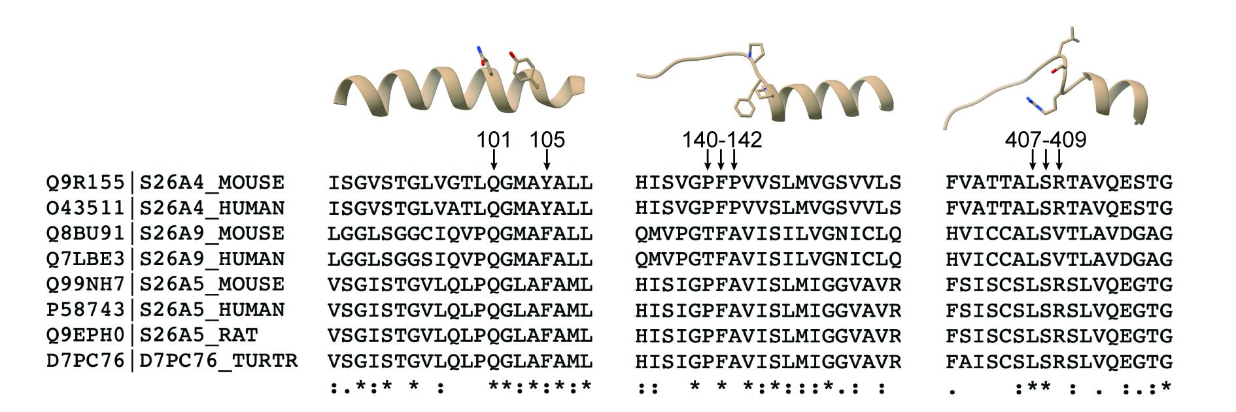

Extended data Fig. 6 SLC26A homologues sequence alignment around the binding pocket.
These sequences information can be found on Uniport. The entry identifier is listed along with the protein name in the left.

Extended data Table 1 Comparison of pendrin structures at different conditions (r.m.s.d).
pendrin-Cl

Pendrin-HCO₃ | 0.3 (Å)
pendrin-Cl/HCO_{3 ii} | 0.4 | 0.4
pendrin-Cl/I _{ii} | 0.3 | 0.4 | 0.3
pendrin-HCO₃/I _{ii} | 0.3 | 0.4 | 0.4 | 0.4
pendrin-Cl/HCO_{3 io} A | 0.5 | 0.5 | 0.4 | 0.5 | 0.5
pendrin-Cl/HCO_{3 io} B | 4.4 | 4.6 | 4.3 | 4.3 | 4.3 | 4.3
pendrin-  Cl/I _{io} A | 0.7 | 0.7 | 0.6 | 0.6 | 0.6 | 0.6 | 4.1
pendrin-  Cl/I _{io} B | 4.1 | 4.2 | 4.0 | 4.1 | 4.1 | 4.0 | 0.8 | 3.9
pendrin-HCO₃/I _{io} A | 0.7 | 0.7 | 0.7 | 0.7 | 0.7 | 0.6 | 4.4 | 0.8 | 4.2
pendrin-HCO₃/I _{io} B | 4.3 | 4.4 | 4.2 | 4.2 | 4.3 | 4.2 | 0.6 | 4.1 | 0.9 | 4.3
pendrin-Cl/HCO_{3 oo} | 4.5 | 4.6 | 4.4 | 4.4 | 4.4 | 4.4 | 0.6 | 4.2 | 0.9 | 4.5 | 0.8
 | pendrin-Cl | pendrin-HCO₃ | pendrin-Cl  /HCO_{3 ii} | pendrin-Cl/I _{ii} | pendrin-HCO₃  /I _{ii} | pendrin-Cl/  HCO_{3 io} A | pendrin-Cl/  HCO_{3 io} B | pendrin-Cl/I _{io} A | pendrin-Cl/I _{io} B | pendrin-HCO₃  /I _{io} A | pendrin-HCO₃  /I _{io} B | pendrin-Cl/  HCO_{3 oo}

Extended data Table 2 Comparison of pendrin structures with representative structures of prestin and SLC26A9 (r.m.s.d).
Pendrin-Cl

SLC26A9  (6RTC) | 4.6 (Å)
SLC26A9  (7CH1) | 4.1 | 3.4
Prestin  (7S9C) | 3 | 5.3 | 5.3
Prestin  (7LH2) | 3.8 | 6.3 | 6.3 | 2.3
Prestin  (7S9D) | 3.1 | 6.1 | 6 | 2.1 | 1.9
Prestin  (7S8X) | 3.6 | 6.9 | 7.2 | 2.7 | 1.6 | 1.9
Prestin  (7LGU) | 4.5 | 7.5 | 8 | 3.1 | 1.2 | 2.4 | 1.4
SLC26A9  (6RTF) | 4.3 | 3 | 4.8 | 4.3 | 4.4 | 4.8 | 5.1 | 5.8
Pendrin-Cl/HCO_{3 oo} | 4.5 | 7 | 6.8 | 4.4 | 4.2 | 3.8 | 3.3 | 3.9 | 5.1
 | Pendrin-Cl | SLC26A9(6RTC) | SLC26A9(7CH1) | Prestin  (7S9C) | Prestin  (7LH2) | Prestin  (7S9D) | Prestin  (7S8X) | Prestin  (7LGU) | SLC26A9(6RTF)) | Pendrin-Cl/HCO_{3oo}

Residue change | Protein location | Cellular localization | Functionality | Predicted molecular effect
S28R | NTD-Nα1 | PM | Loss of Cl- uptake | Disruption of H bond with E29; interfere the relative folding and orientation surround
G102R | Core-TM1 | ER |  | Clash between TM1 and TM2; Insertion of charged residue in a hydrophobic interface between TM1 and TM2
P123S | Core-TM2 | Intracell. |  | Disruption of hydrophobic interaction between TM9 and TM10; destabilize the binding pocket
V138F | Core-TM3 loop | ER |  | Destabilize the binding pocket
R185T | Core-TM4 | Intracell. |  | Change the positive charge of surface
G209V | Intracellular loop between Core and Gate | PM | Severe reduction of I- transport | Change the interface between TMD and STAS
L236P | Gate-TM5 | ER, Intracell. |  | Insertion of Pro in α-helix; introduce a kink and leads to the misfolding of TM5
V239D | Gate-TM5 | ER |  | Disruption of hydrophobic interaction between TM5 and TM6
E303Q | Gate-TM7 | PM | Loss of Cl-/ I- and Cl-/HCO3- exchange activity | Change the positive charge of surface
F335L | Hydrophobic loop between TM7 and TM8 | PM | Reduction of Cl-/ I- and Cl-/HCO3-exchange activity | Disruption of hydrophobic interaction with lipids
E384G | Core-TM9 | ER, Intracell. |  | Disruption of H bond with Y127 necessary for TM9 and TM2 interaction
N392Y | Core-TM9 | Intracell. |  | Larger side chain; clash between TM9 and TM10; destabilize the binding pocket
R409H | Core-TM10 | Partially PM | Reduction of Cl- and I- transport | Destabilize the binding pocket
T410M | Core-TM10 | ER |  | Larger side chain; destabilize the binding pocket
L445W | Loop between Core and Gate | ER, Intracell. |  | Larger side chain, change in steric hindrance
G497S | Gate-TM14 | Intracell. |  | Disruption of interaction between TM13 and TM14
Y530H/S | STAS-Loop | ER, Intracell. |  | Interfere local folding of the long loop
Y556C | STAS-Loop | Partially PM | Loss of I- transport | Disruption of hypothetical ion binding pocket
C565Y | STAS-Cα1 | PM | Reduction of Cl-/ I- and Cl-/HCO3-exchange activity | Larger side chain, change in steric hindrance
G672E | STAS-Cα2 | Partially PM | Loss of I- transport | Disruption of hypothetical ion binding pocket
T721M | STAS-Cα4 | Intracell. |  | Disruption of H bond with D724; affect the folding of Cα4 and decrease the solubility of STAS domain.
H723R | STAS-Cα4 | ER, Intracell. |  | Affect hypothetical interactions surround; interfere the relative folding and orientation of Cα4.

Extended data Table 3 Pathogenetic missense variants.

Extended data Table 4 Cryo-EM data collection and refinement statistics.
PDB ID  EMDB | pendrin-Cl  7WK1  32555 | pendrin-HCO₃  7WK7  32561 | pendrin-Cl/I _{ii}  7WL8  32577 | pendrin-Cl/I _{io}  7WLB  32580 | pendrin-Cl/HCO_{3 ii}  7WL7  32576 | pendrin-Cl/HCO_{3 io}  7WL9  32578 | Local refinement of pendrin-Cl/HCO_{3 io}  33232 | pendrin-Cl/HCO_{3 oo}  7WLE  32583 | pendrin- HCO₃/I _{ii}  7WL2  32574 | pendrin- HCO₃/I _{io}  7WLA  32579
 | Data collection and processing
Data sets | pendrin-Cl | pendrin-HCO₃ | pendrin-Cl/I |  | pendrin-Cl/HCO₃ |  |  |  | pendrin- HCO₃/I
Voltage (kV) | 300 | 300 | 300 |  | 300 |  |  |  | 300
Detector | K2 | K2 | K3 |  | K3 |  |  |  | K2
Pixel size (Å) | 1.046 | 1.046 | 1.064 |  | 1.064 |  |  |  | 1.046
Electron dose (e⁻/Å²) | 53 | 53 | 58 |  | 58 |  |  |  | 53
Defocus range (μm) | −1.2 to −2.2 | −1.2 to −2.2 | −1.2 to −2.2 |  | −1.2 to −2.2 |  |  |  | −1.2 to −2.2
Final particles | 120,887 | 134,404 | 79,043 | 45,859 | 68,679 | 353,288 | 172,227 | 67,699 | 221,446 | 365,679
Final resolution (Å) | 3.25 | 3.49 | 3.40 | 4.10 | 3.51 | 3.78 | 3.70 | 3.62 | 3.25 | 3.76
 | Model refinement and validation statistics
 | Ramachandran statistics
Favored (%) | 94.70 | 94.93 | 95.31 | 95.45 | 95.31 | 95.30 |  | 93.92 | 95.01 | 94.92
Allowed (%) | 5.22 | 4.99 | 4.61 | 4.55 | 4.61 | 4.62 |  | 6.08 | 4.92 | 5.08
Outliers (%) | 0.08 | 0.08 | 0.08 | 0.00 | 0.08 | 0.08 |  | 0.00 | 0.08 | 0.00
Rotamer outliers (%) | 3.12 | 2.94 | 1.87 | 3.92 | 3.39 | 4.27 |  | 5.25 | 2.14 | 4.01
 | R.m.s.deviations
Bond lengths (Å) | 0.002 | 0.001 | 0.002 | 0.002 | 0.001 | 0.002 |  | 0.002 | 0.002 | 0.002
Bond angles (º) | 0.406 | 0.406 | 0.402 | 0.400 | 0.409 | 0.403 |  | 0.426 | 0.412 | 0.405

