Supplemental Methods
A. Harvesting Osteochondral plugs
Mosaicplasty tool set (Smith & Nephew, Cat No. 7207098, Fig 1a) comprising of a mallet, 3.5mm diameter tubular chisel and harvesting tamps (2.7mm and 3.5mm) were used for harvesting of osteochondral plugs [Fig.1f]. The sharp edge of the tubular chisel was placed perpendicular to the cartilage surface of the knee joint. The mallet was then used to impact the chisel to a depth of 10-12 mm [Fig. 1d]. Harvesting tamp was then inserted into the chisel at the opposite end, parallel to the cartilage surface. Holding the harvesting tamp, the chisel was withdrawn from the joint by applying pressure in the opposite direction accompanied by wiggling motion to break away the osteochondral plug from the subchondral bone. The chisel was then placed on a sterile gauze, bone surface facing upward. Harvesting tamp (3.5mm) was placed perpendicular and flush against the surface of the bone and the pressure was applied using a mallet to release the osteochondral plug from the chisel.

B. Measurement of ARGS-aggrecan fragments
Five selected medium samples were chosen for performance a test-of-assay. Samples diluted between 2 and 10 times and spiked with standards showed good spiking-recovery (mean 96-115%, range 90-120%). Test medium samples (n = 5) diluted between 1.3 and 10.1 times showed no dilution-linearity (recovery at: 3x dilution = 170-183%, 6.8x dilution = 246-295%, 10.1x dilution = 285-365%). All medium samples were run in duplicates at 2.6X dilution.

Supplementary Table S1: Summary of human donor joints used in the study. 25 cadaveric knees from 16 donors were classified as Collin’s grade 0 (normal, n=1), grade 1 (near normal, n=8) and grade 2 (fibrillation in some delimited regions, n=16). Donors age 23-83 yo; 8 females, 8 males. Groups studied: C – cartilage monocultures; B – Bone monocultures; S – monocultures of full thickness explant tissue inclusive of synovium and fibrous joint capsule, referred to as synovium S for simplicity; CB – intact osteochondral plugs; CBS – osteochondral plugs cocultured with synovium S; CBS + INJ – Mechanically injured osteochondral plugs (CB) cocultured with synovium to simulate PTOA-disease like condition. The “Groups” column lists treatment groups that were chosen to be tested for each donor, based on the total available tissues that could be harvested from each knee.
Donor No. | Knee No. | Sex | Age | Grade | Groups | Outcome measurement
1 | 1 | M | 81 | 2 | C B S CB CBS | Biochemistry, Inflammation, Metabolomics,  Histology
1 | 2 | M | 81 | 2 | C B S CB CBS | Biochemistry, Inflammation, Metabolomics,  Histology
2 | 3 | F | 41 | 1 | C B S CB | Biochemistry, Inflammation, Metabolomics,  Histology
2 | 4 | F | 41 | 1 | C B S CB | Biochemistry, Inflammation, Metabolomics,  Histology
3 | 5 | M | 76 | 2 | C B S CBS | Biochemistry, Inflammation, Metabolomics,  Histology
3 | 6 | M | 76 | 2 | C B S CBS | Biochemistry, Inflammation, Metabolomics,  Histology
4 | 7 | M | 83 | 1 | C B S CB | Biochemistry, Inflammation
5 | 8 | F | 72 | 2 | CB | Biochemistry, Inflammation
5 | 9 | F | 72 | 2 | CB | Biochemistry, Inflammation
6 | 10 | F | 76 | 2 | CBS | Biochemistry, Inflammation, Histology
6 | 11 | F | 76 | 1 | CBS | Biochemistry, Inflammation, Histology
7 | 12 | F | 76 | 2 | C B S CB CBS | Biochemistry, Inflammation, Metabolomics,  Histology
7 | 13 | F | 76 | 2 | C B S CB CBS | Biochemistry, Inflammation, Metabolomics,  Histology
8 | 14 | M | 67 | 2 | CBS CBS + INJ | Biochemistry, Inflammation
9 | 15 | F | 75 | 2 | CBS + INJ | Biochemistry, Inflammation
9 | 16 | F | 75 | 2 | CBS + INJ | Biochemistry, Inflammation
10 | 17 | F | 79 | 2 | CBS + INJ | Biochemistry, Inflammation
11 | 18 | F | 78 | 2 | CB CBS CBS + INJ | Biochemistry, Inflammation, Metabolomics,  Histology
11 | 19 | F | 78 | 2 | CB CBS CBS + INJ | Biochemistry, Inflammation, Metabolomics,  Histology
12 | 20 | M | 79 | 1 | CB CBS + INJ | Biochemistry, Inflammation, Metabolomics,  Histology
12 | 21 | M | 79 | 1 | CB CBS + INJ | Biochemistry, Inflammation, Metabolomics,  Histology
13 | 22 | M | 34 | 0 | CB CBS + INJ | Biochemistry, Inflammation, Metabolomics,  Histology
14 | 23 | M | 23 | 1 | CB CBS + INJ | Biochemistry, Inflammation, Metabolomics,  Histology
15 | 24 | M | 54 | 2 | CB CBS + INJ | Biochemistry, Inflammation, Histology
16 | 25 | F | 58 | 1 | CB CBS + INJ | Biochemistry, Inflammation, Metabolomics,  Histology

Supplementary Table S2: Analysis of Fig. 4 Data. Group differences in the total amount (over 14-days) of secreted cytokines analyzed using donor-matched mixed-effects model (REML). False discovery rate (FDR, Benjamini Hochberg method) was used to adjust for multiple comparisons. Only statistically significant (q < 0.05) comparisons are tabulated for each cytokine measured.
TNF-α total release
Fixed effect (type III) | p-value | (p < 0.05)? | F (DFn, DFd)
Treatment (culture) | 0.0071 | Yes | F (4, 17) = 5.069
Multiple comparisons | Mean Diff. | SE of diff. | q-value | p-value
CBS vs. C | 186.8 | 54.86 | 0.0169 | 0.0034
CB vs. CBS | -173.9 | 46.48 | 0.0163 | 0.0016
CBS+INJ vs. CB | 123.3 | 42.91 | 0.0352 | 0.0105
IL-1 total release
Fixed effect (type III) | p-value | (p < 0.05)? | F (DFn, DFd)
Treatment (culture) | 0.0730 | No | F (4, 17) = 2.601
IFNγ total release
Fixed effect (type III) | p-value | (p < 0.05)? | F (DFn, DFd)
Treatment (culture) | 0.0041 | Yes | F (4, 17) = 5.748
Multiple comparisons | Mean Diff. | SE of diff. | q-value | p-value
CBS vs. C | 326.6 | 82.65 | 0.0052 | 0.0010
CB vs. S | 268.8 | 82.65 | 0.0156 | 0.0047
CB vs. CBS | -299.1 | 70.36 | 0.0052 | 0.0005
IL-6 total release
Fixed effect (type III) | p-value | (p < 0.05)? | F (DFn, DFd)
Treatment (culture) | 0.3110 | No | F (4, 17) = 1.296

Supplementary Table S3: Further Analysis of Fig. 4 Data. Analysis of group differences in secreted cytokines TNF-α, IL-1, IFNγ, and IL-6, over 14 days in mono- or cocultures. Time point-matched mixed-effects (REML) analysis was performed with Geisser-Greenhouse correction for sphericity. False discovery rate (FDR, Benjamini Hochberg method) was used to adjust for multiple comparisons. Only statistically significant (q < 0.05) comparisons are tabulated for each cytokine measured.
TNF-α release
Fixed effect (type III) | p-value | (p < 0.05)? | F (DFn, DFd) | Geisser-Greenhouse's epsilon
Treatment (culture) | 0.0218 | Yes | F (1.719, 10.31) = 5.978 | 0.4297
Multiple comparisons | Mean Diff. | SE of diff. | q-value | p-value
CBS vs. C | 21.98 | 3.131 | 0.0045 | 0.0009
CB vs. C | -3.724 | 0.9563 | 0.0229 | 0.0115
CBS+INJ vs. C | 23.94 | 6.107 | 0.0229 | 0.0112
CB vs. CBS | -25.71 | 3.052 | 0.0007 | <0.0001
CBS+INJ vs. CB | 27.66 | 6.434 | 0.0119 | 0.0036
IL-1 release
Fixed effect (type III) | p-value | (p < 0.05)? | F (DFn, DFd) | Geisser-Greenhouse's epsilon
Treatment (culture) | 0.0021 | Yes | F (1.651, 9.906) = 13.29 | 0.4127
Multiple comparisons | Mean Diff. | SE of diff. | q-value | p-value
S vs. C | 28.84 | 8.372 | 0.0305 | 0.0183
CBS vs. C | 23.49 | 4.617 | 0.0106 | 0.0038
CBS+INJ vs. C | 46.87 | 10.28 | 0.0121 | 0.0061
CB vs. S | -34.19 | 6.893 | 0.0106 | 0.0042
CB vs. CBS | -28.84 | 5.474 | 0.0106 | 0.0012
CBS+INJ vs. CBS | 23.38 | 8.435 | 0.0395 | 0.0276
CBS+INJ vs. CB | 52.21 | 12.50 | 0.0106 | 0.0041
IFNγ release
Fixed effect (type III) | p-value | (p < 0.05)? | F (DFn, DFd) | Geisser-Greenhouse's epsilon
Treatment (culture) | 0.0045 | Yes | F (1.332, 7.993) = 13.52 | 0.3330
Multiple comparisons | Mean Diff. | SE of diff. | q-value | p-value
CBS vs. C | 44.05 | 8.358 | 0.0146 | 0.0033
CBS+INJ vs. C | 53.72 | 17.04 | 0.0422 | 0.0253
CBS vs. S | 25.22 | 5.120 | 0.0146 | 0.0044
CB vs. S | -23.44 | 6.671 | 0.0341 | 0.0170
CB vs. CBS | -48.66 | 7.505 | 0.0034 | 0.0003
CBS+INJ vs. CB | 58.33 | 16.11 | 0.0212 | 0.0085
IL-6 release
Fixed effect (type III) | p-value | (p < 0.05)? | F (DFn, DFd) | Geisser-Greenhouse's epsilon
Treatment (culture) | 0.2192 | No | F (1.043, 6.259) = 1.875 | 0.2608
Multiple comparisons | Mean Diff. | SE of diff. | q-value | p-value
S vs. C | 1.966 | 0.1759 | 0.0010 | 0.0001
CB vs. S | -1.997 | 0.2485 | 0.0024 | 0.0005

Supplementary Table S4: Analysis of pairwise comparisons of differences in GAG content from Fig. 6b. Analysis of pairwise comparisons of differences in tissue GAG content between groups shown in Fig. 6b. The significant differences have been noted with + for C vs CBS and + for C vs CBS+INJ. The significant difference between CB vs CBS have been marked with # and # for CB vs CBS+INJ.
Group | Summary | P-values
Day 2
C vs. CB | ** | 0.0010
C vs. CBS (+) | **** | <0.0001
C vs. CBS+INJ (+) | **** | <0.0001
CB vs. CBS (#) | ** | 0.0062
CB vs. CBS+INJ (#) | **** | <0.0001
CBS vs. CBS+INJ | ns | 0.5688
Day 4
C vs. CB | ns | 0.2899
C vs. CBS (+) | **** | <0.0001
C vs. CBS+INJ (+) | **** | <0.0001
CB vs. CBS (#) | **** | <0.0001
CB vs. CBS+INJ (#) | **** | <0.0001
CBS vs. CBS+INJ | ns | 0.3327
Day 7
C vs. CB | ns | 0.4364
C vs. CBS (+) | **** | <0.0001
C vs. CBS+INJ (+) | **** | <0.0001
CB vs. CBS (#) | **** | <0.0001
CB vs. CBS+INJ (#) | **** | <0.0001
CBS vs. CBS+INJ | ns | >0.9999
Day 9
C vs. CB | ns | 0.1639
C vs. CBS (+) | **** | <0.0001
C vs. CBS+INJ (+) | **** | <0.0001
CB vs. CBS (#) | **** | <0.0001
CB vs. CBS+INJ (#) | **** | <0.0001
CBS vs. CBS+INJ | ns | >0.9999
Day 11
C vs. CB | ns | 0.1330
C vs. CBS (+) | **** | <0.0001
C vs. CBS+INJ (+) | **** | <0.0001
CB vs. CBS (#) | **** | <0.0001
CB vs. CBS+INJ (#) | **** | <0.0001
CBS vs. CBS+INJ | ns | 0.9735
Day 14
C vs. CB | ns | 0.2042
C vs. CBS (+) | **** | <0.0001
C vs. CBS+INJ (+) | **** | <0.0001
CB vs. CBS (#) | **** | <0.0001
CB vs. CBS+INJ (#) | **** | <0.0001
CBS vs. CBS+INJ | ns | 0.9792

Supplementary Table S5: Analysis of Fig 6d data. Summary of Wilcoxon rank sum test results for ARGS-aggrecan release for conditions with significant differences. Data are grouped by condition and day.

Test Groups | Conditions with significant differences | P values
Overall results – for data grouped by condition
 | C and CBS + INJ | .0133
 | CB and CBS | .0011
 | CB and CBS + INJ | .0002
Pair wise comparison for data grouped by condition
Day 2 | CB and CBS + INJ | .0312
Day 7 | CB and CBS | .00266
Day 7 | CB and CBS + INJ | .00524
Day 14 | None | --
Overall results – for data grouped by time point (day)
 | Day 2 and 14 | 0.0119
Pair wise comparison for data grouped by timepoint (day)
C | None | --
CB | None | --
CBS | None | --
CBS + INJ | None | --

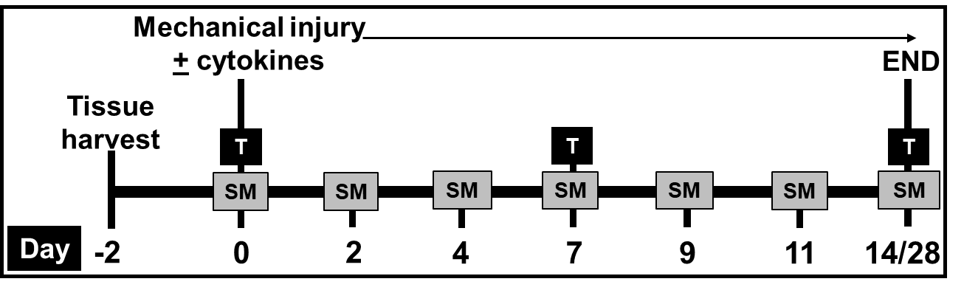
Supplementary Fig. S1: Experimental design and sample collection time points. Following a 2-day pre-equilibration after the tissue harvest, experiments started on day 0. Experiments included cartilage, bone and synovium monocultures (C, B, S), osteochondral (cartilage-bone) plug cultures (CB), osteochondral plugs cocultured with synovium (CBS). The cultures were maintained for a period of 4 weeks for initial experiments comparing C, B, S monocultures, CB and CBS coculture conditions (donors # 1-7). Since introduction of injury adversely impacted the viability at much earlier time point, the cultures were terminated at 2 weeks in the later experiments comparing CB, CBS and CBS+INJ conditions (donors # 8-16). For the condition CBS+INJ, the cartilage surface of osteochondral plugs was first subjected to a single compressive impact injury and then CB was cocultured with synovium explants S. Spent media (SM) was collected at every media change and tissue samples (T) were collected weekly for determination of viability, metabolic, and biochemical alterations.
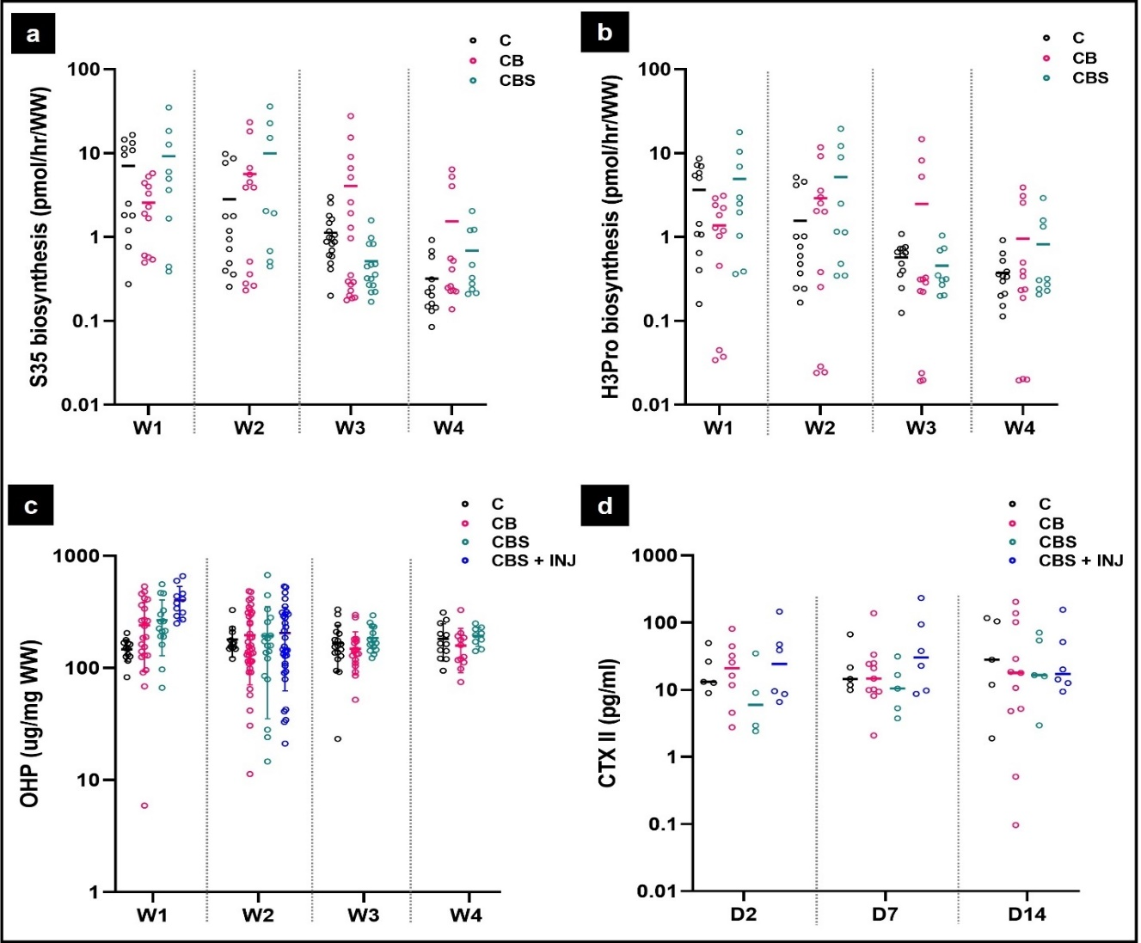
Supplementary Fig. S2: (a) Rate of biosynthesis of sGAG and (b) total protein was measured in monoculture and cocultures at week (W) 1, 2, 3 and 4. (c) Changes in collagen content were measured in cartilage tissue in response to coculture with inflammatory cytokines and mechanical impact injury. (d) Release of collagenase generated CTX-II fragments was measured in pooled spent media samples on day 2, 7 and 14 of culture to assess early changes in collagen degradation.
C (Cartilage monocultures, n=5); CB (CB cocultures, n = 10); CBS (CBS cocultures, n=5); CBS + INJ (Disease group, n = 6).
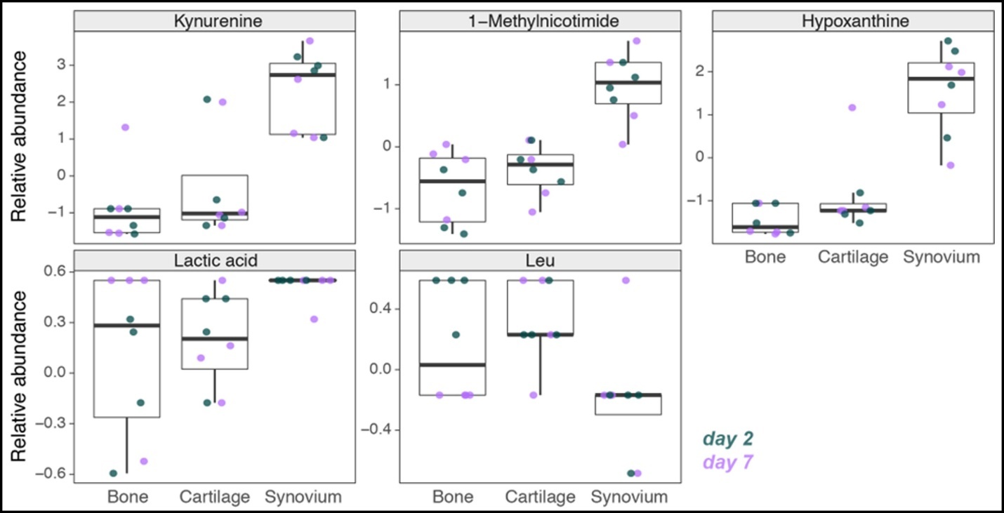
Supplementary Fig. S3: Significantly altered metabolites in CB and CBS group comparison examined in monocultures. Circulating metabolites measured in cartilage, bone, and synovium monocultures from donors # 1, 2, 3, and 7 on days 2 (green) and 7 (purple).

