Ecological, flexible and transparent cellulose-based substrates without post-production treatment for organic electronic devices
Martina Carneiro ª, Matheus F. F. das Neves^{b}, Graciela I. B. de Muniz^{c}, Marco A. S. C. Filho^{d}, Camilla K. Oliveira ^{a,b}, Lucimara S. Roman^{*, a, b}

ªGraduate Program in Materials Science and Engineering (PIPE), Universidade Federal do Paraná, Curitiba (81531-990), Paraná, Brazil
^{b}Department of Physics, Universidade Federal do Paraná, Curitiba (81531-990), Paraná, Brazil
^{c}Department of Florestal Engineering and Technology, Universidade Federal do Paraná, Curitiba (81531-900), Paraná, Brazil
^{d}Department of Chemistry, Universidade Positivo, Curitiba (81280-330), Paraná, Brazil.

*Corresponding authors (LSR)
Email: mneves@fisica.ufpr.br; lsroman@fisica.ufpr.br

- Calculation of pulp Kraft humidity
It is necessary to determine the pulp mass amount to be processed to obtain a mass concentration C equal to 2 %. The pulp humidity (H) was determined from thermogravimetric analysis. Total solid content (TS) is determined decreasing 100 % and H. The value of H is 9.98 %, then resulting in TS = 90.02 %.
Concentration (C) is determined dividing the dried mass (M_{d}) and the volume (V), fixed in 1 L resulting in M_{d} = 40 g. Then the pulp mass amount (P) considering the present humidity is determined by dividing M_{d} and TS, resulting in P = 44.43 g.

- Total solid content of nanocellulose and mass determination to obtain the grammage of nanocellulose films
The total solid content (TS) procedure was applied to nanocellulose in order to determine how much mass would be necessary to obtain a grammage of 25 g m⁻² for a film with area equal to 1.22 × 10⁻² m².
25 g of nanocellulose was put in a beaker, with previously determined mass, and then heated in an oven at 103 °C for 24 h. This step was applied to remove the large water mass in the samples. Then, the beaker was cooled down to room temperature in a desiccator, followed by the dried mass determination discounting the beaker mass. This procedure was repeated so that the difference between the current dried mass value and the previous one did not exceed 4 %, as the stablished protocol 2540 G determines (APHA, 1998).
TS can be calculated by dividing the wet sample mass and the dried sample mass values. The determined concentration was 2 % and it is necessary to determine the required wet nanocellulose mass to obtain a grammage (G) 25 g m⁻² in the cited area. This procedure was produced in triplicate. Büchner funnel radius (r) is equal to 0.065 m. M_{d} is the dried mass and M_{w} is the wet mass. TS is equal to 2.02 %.
Grammage and ST are determined by the respectively equations $G= \frac{M_{d}}{π{ r}^{2}}$ and $ST= \frac{M_{d}}{M_{w}} ×100$. It was obtained M_{d} = 0.305 g, which results in M_{w} = 15.09 g. The M_{w} value is then used to form the nanocellulose films.

- SEM and TEM of Cellulosic Fiber and Microfibrils

Figure S1 shows the SEM images of the bleached pulp Kraft, obtained from Eucalyptus sp. wood. The images reveal the initial dimensions before the mechanical defibrillation process. Figure A) presents magnification of 2 kX, while B) presents magnification of 500 X.

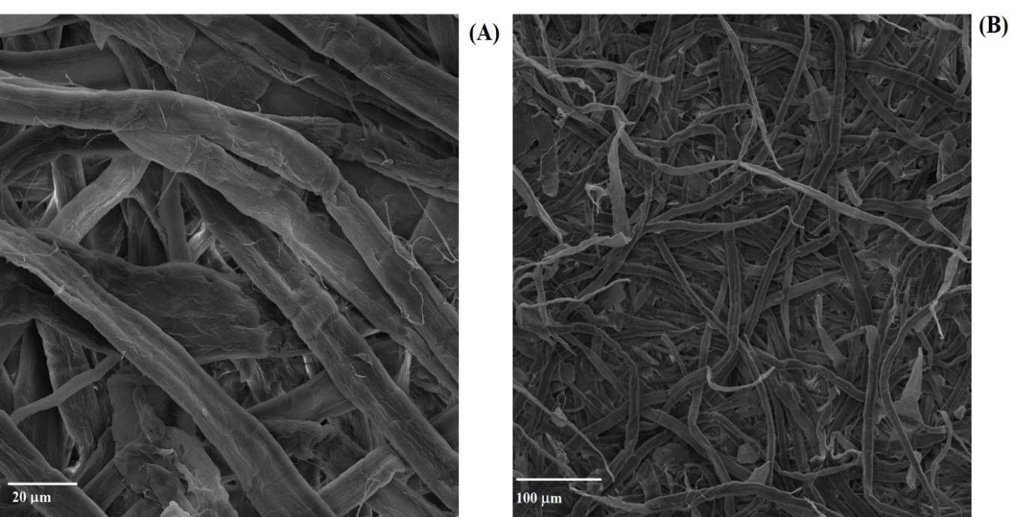
Fig. S1 SEM images for bleached pulp Kraft obtained from Eucalyptus sp. before mechanical defibrillation process with different magnifications of A) 20 kX and B) 500 X.

Figure S2 shows the TEM images for cellulose microfibrils obtained after the fiber mechanical defibrillation process, revealing that it is possible to reduce the fibrils diameters from micro to nano scale, indicating a non-structuring process that may serve as a reinforcement for the composites. Parts A) and B) are in 5 μm scale, while C) presents an image with 1 μm scale and a zoom in a delimited area of 500 nm.

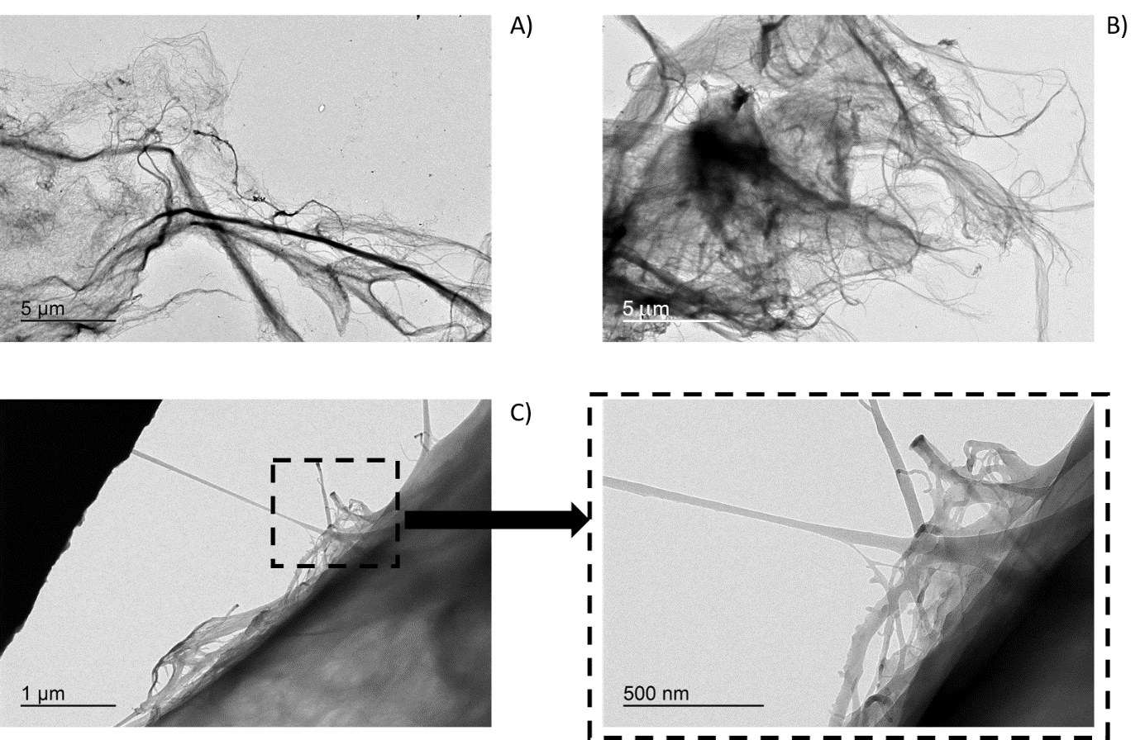
Fig. S2 TEM images of cellulose microfibrils after mechanical defibrillation process in with 5 μm scale in A) and B). C) presents a zoom image, of a delimited area with 1 μm scale, with 500 nm of length scale.

- Cross section images
Figure S3 presents SEM cross section images obtained for the fabricated membranes. From the images it was possible to estimate the samples thickness.

Fig. S3 SEM cross section images of A) PCA, B) CA-0.5cp, C) CA-1.0cp, D) CA-1.5cp, E) NC-25, F) CA-1.0nc and their thickness’ values.

- AFM Images for PET and glass samples
Figure S4 presents AFM images for PET and glass substrates without (A, B) and with (C, D) a thin film of PEDOT:PSS.
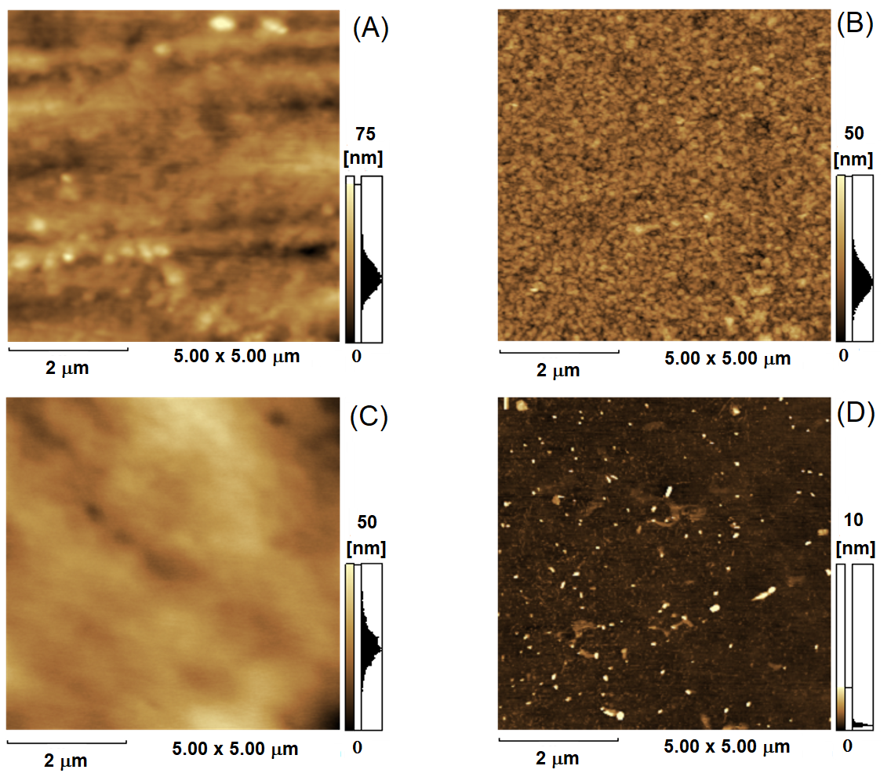
Fig. S4 AFM topographic images for A) PET and B) glass without PSS deposited and C) PET and D) glass with PEDOT:PSS deposited on the substrates. The z-scale are shown in the sidebar of each image.

- Contact Angle Measurements
Figure S5 presents the images obtained for the fabricated and commercial PET and glass substrates with a water drop on the surface to measure the contact angle and to compare their wettability.
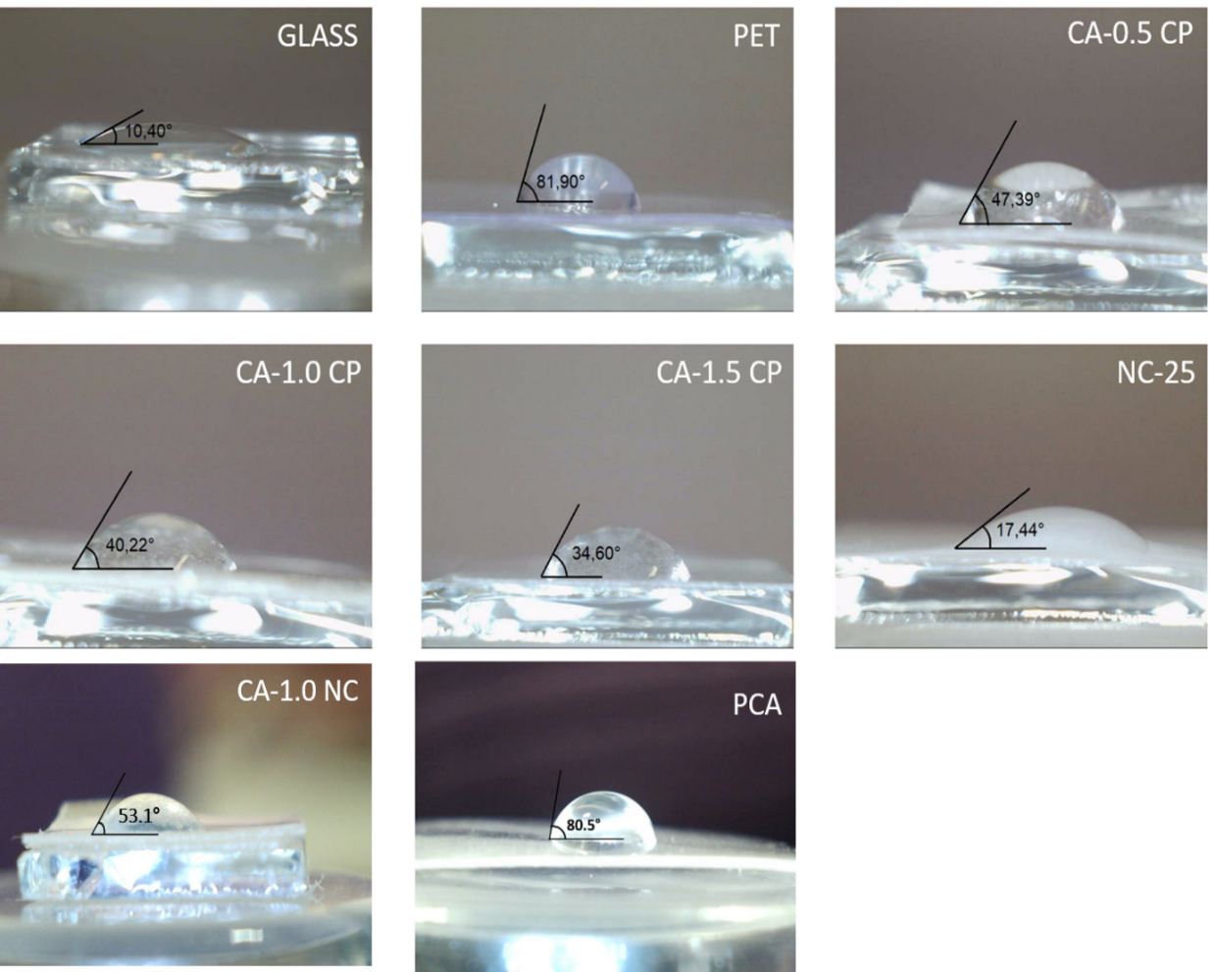
Fig. S5 Presents the contact angle measurement, comparing the wettability between the commercial and fabricated substrates.
- References

APHA, Awwa. Wpcf. (1998) Standard methods for the examination of water and wastewater, 22nd ed. American Public Health Association, Washington, DC.

