Supplementary figure 1. Balance of elective and emergency surgery by trial arm.

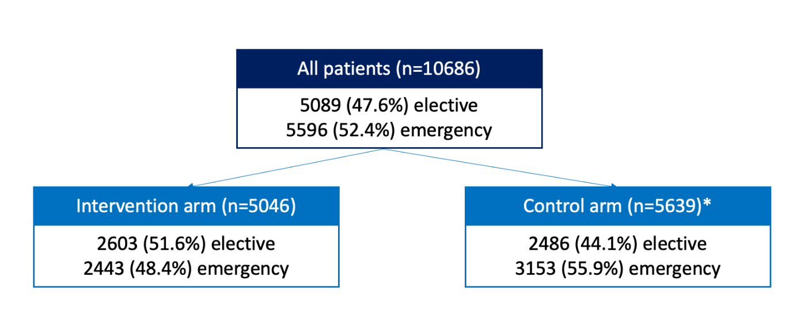
* 1 missing urgency of operation
Supplementary figure 2. Changes in imbalance by arm of urgency of surgery over time

Supplement figure 3. Flowchart of key surgery characteristics overall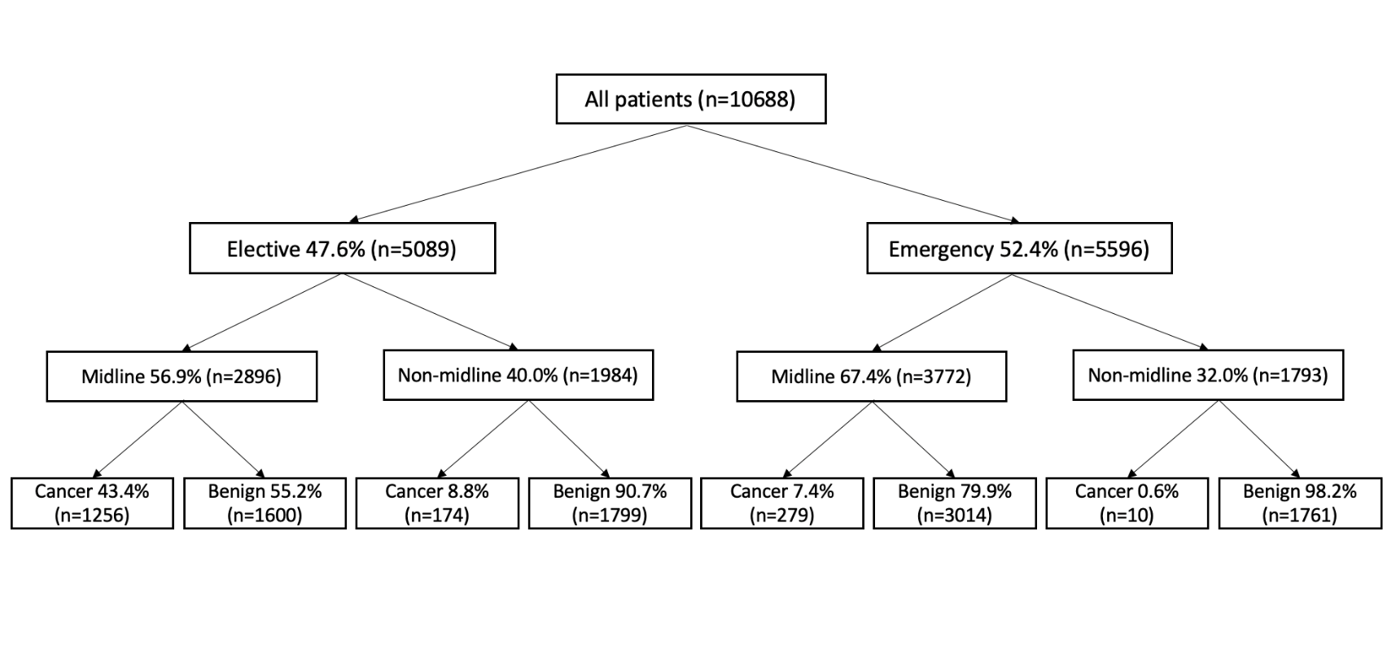

Supplementary table 1. Number of eligible patients included (patient-level analysis)

Hospital ID | Country | Number of eligible patients | Number of patients included | % of patients included | Number of patients missed from inclusion
1 | Benin | 53 | 53 | 100 | 0
2 | Benin | 18 | 18 | 100 | 0
3 | Benin | 5 | 5 | 100 | 0
4 | Benin | 90 | 89 | 98.89 | 1
5 | Benin | 40 | 40 | 100 | 0
6 | Ghana | 201 | 201 | 100 | 0
7 | Ghana | 71 | 66 | 92.96 | 5
8 | Ghana | 177 | 177 | 100 | 0
9 | Ghana | 91 | 91 | 100 | 0
10 | Ghana | 223 | 220 | 98.65 | 3
11 | Ghana | 234 | 216 | 92.31 | 18
12 | Ghana | 202 | 202 | 100 | 0
13 | Ghana | 20 | 19 | 95 | 1
14 | Ghana | 187 | 187 | 100 | 0
15 | Ghana | 185 | 185 | 100 | 0
16 | India | 300 | 300 | 100 | 0
17 | India | 226 | 220 | 97.35 | 6
18 | India | 140 | 135 | 96.43 | 5
19 | India | 220 | 220 | 100 | 0
20 | India | 133 | 133 | 100 | 0
21 | India | 80 | 71 | 88.75 | 9
22 | India | 204 | 200 | 98.04 | 4
23 | India | 220 | 220 | 100 | 0
24 | India | 238 | 238 | 100 | 0
25 | India | 71 | 71 | 100 | 0
26 | India | 223 | 215 | 96.41 | 8
27 | India | 67 | 66 | 98.51 | 1
28 | India | 206 | 205 | 99.51 | 1
29 | India | 258 | 252 | 97.67 | 6
30 | India | 220 | 220 | 100 | 0
31 | India | 220 | 220 | 100 | 0
32 | India | 62 | 62 | 100 | 0
33 | India | 67 | 67 | 100 | 0
34 | India | 246 | 246 | 100 | 0
35 | India | 96 | 95 | 98.96 | 1
36 | India | 217 | 202 | 93.09 | 15
37 | Mexico | 8 | 8 | 100 | 0
38 | Mexico | 144 | 144 | 100 | 0
39 | Mexico | 3 | 3 | 100 | 0
40 | Mexico | 34 | 34 | 100 | 0
41 | Nigeria | 154 | 154 | 100 | 0
42 | Nigeria | 118 | 102 | 86.44 | 16
43 | Nigeria | 20 | 20 | 100 | 0
44 | Nigeria | 33 | 33 | 100 | 0
45 | Nigeria | 40 | 40 | 100 | 0
46 | Nigeria | 220 | 220 | 100 | 0
47 | Nigeria | 220 | 220 | 100 | 0
48 | Nigeria | 220 | 220 | 100 | 0
49 | Nigeria | 118 | 118 | 100 | 0
50 | Nigeria | 20 | 20 | 100 | 0
51 | Nigeria | 202 | 202 | 100 | 0
52 | Nigeria | 97 | 97 | 100 | 0
53 | Nigeria | 147 | 147 | 100 | 0
54 | Nigeria | 224 | 220 | 98.21 | 4
55 | Nigeria | 77 | 77 | 100 | 0
56 | Nigeria | 35 | 35 | 100 | 0
57 | Rwanda | 284 | 284 | 100 | 0
58 | Rwanda | 9 | 9 | 100 | 0
59 | Rwanda | 300 | 300 | 100 | 0
60 | Rwanda | 300 | 300 | 100 | 0
61 | Rwanda | 220 | 220 | 100 | 0
62 | Rwanda | 319 | 300 | 94.04 | 19
63 | Rwanda | 300 | 300 | 100 | 0
64 | Rwanda | 300 | 300 | 100 | 0
65 | Rwanda | 221 | 220 | 99.55 | 1
66 | Rwanda | 182 | 166 | 91.21 | 16
67 | Rwanda | 300 | 300 | 100 | 0
68 | Rwanda | 29 | 26 | 89.66 | 3
69 | South Africa | 252 | 200 | 79.37 | 52
70 | South Africa | 236 | 220 | 93.22 | 16

Supplementary table 2. Baseline characteristics of included patients (N=, %) (hospital-level analysis)
Hospital ID | Country | Age ≥18 years | Gender, Female | Elective | Clean-  contaminated | Contaminated | Dirty | Malignant disease | Open-Midline | Open Non-midline
1 | Benin | 44 (83.0) | 23 (43.4) | 2 (3.8) | 21 (39.6) | 1 (1.9) | 31 (58.5) | 1 (1.9) | 14 (26.4) | 39 (73.6)
2 | Benin | 10 (55.6) | 9 (50.0) | 4 (22.2) | 2 (11.1) | 5 (27.8) | 11 (61.1) | 0 (0.0) | 17 (94.4) | 1 (5.6)
3 | Benin | 3 (60.0) | 1 (20.0) | 2 (40.0) | 2 (40.0) | 1 (20.0) | 2 (40.0) | 0 (0.0) | 4 (80.0) | 1 (20.0)
4 | Benin | 63 (70.8) | 35 (39.3) | 5 (5.6) | 40 (44.9) | 0 (0.0) | 49 (55.1) | 1 (1.1) | 24 (27.0) | 65 (73.0)
5 | Benin | 32 (80.0) | 24 (60.0) | 0 (0.0) | 14 (35.0) | 21 (52.5) | 5 (12.5) | 0 (0.0) | 10 (25.0) | 30 (75.0)
6 | Ghana | 174 (86.6) | 70 (34.8) | 7 (3.5) | 57 (28.4) | 74 (36.8) | 70 (34.8) | 12 (6.0) | 102 (50.7) | 99 (49.3)
7 | Ghana | 61 (92.4) | 49 (74.2) | 6 (9.1) | 27 (40.9) | 29 (43.9) | 10 (15.2) | 2 (3.0) | 29 (43.9) | 37 (56.1)
8 | Ghana | 161 (91.0) | 79 (44.6) | 73 (41.2) | 109 (61.6) | 29 (16.4) | 39 (22.0) | 21 (11.9) | 134 (75.7) | 41 (23.2)
9 | Ghana | 76 (83.5) | 27 (29.7) | 21 (23.1) | 40 (44.0) | 8 (8.8) | 43 (47.3) | 0 (0.0) | 59 (64.8) | 32 (35.2)
10 | Ghana | 183 (83.2) | 108 (49.1) | 7 (3.2) | 88 (40.0) | 89 (40.5) | 43 (19.5) | 0 (0.0) | 150 (68.2) | 70 (31.8)
11 | Ghana | 178 (82.4) | 77 (35.6) | 26 (12.0) | 121 (56.0) | 71 (32.9) | 24 (11.1) | 27 (12.5) | 187 (86.6) | 29 (13.4)
12 | Ghana | 171 (84.7) | 70 (34.7) | 55 (27.2) | 60 (29.7) | 64 (31.7) | 78 (38.6) | 55 (27.2) | 140 (69.3) | 61 (30.2)
13 | Ghana | 10 (52.6) | 4 (21.1) | 3 (15.8) | 4 (21.1) | 2 (10.5) | 13 (68.4) | 0 (0.0) | 15 (78.9) | 4 (21.1)
14 | Ghana | 171 (91.4) | 61 (32.6) | 1 (0.5) | 102 (54.5) | 71 (38.0) | 14 (7.5) | 4 (2.1) | 131 (70.1) | 56 (29.9)
15 | Ghana | 150 (81.1) | 63 (34.1) | 16 (8.6) | 34 (18.4) | 50 (27.0) | 101 (54.6) | 9 (4.9) | 134 (72.4) | 51 (27.6)
16 | India | 298 (99.3) | 136 (45.3) | 210 (70.0) | 298 (99.3) | 1 (0.3) | 1 (0.3) | 218 (72.7) | 298 (99.3) | 2 (0.7)
17 | India | 204 (92.7) | 131 (59.5) | 146 (66.4) | 163 (74.1) | 21 (9.5) | 36 (16.4) | 106 (48.2) | 143 (65.0) | 57 (25.9)
18 | India | 131 (97.0) | 81 (60.0) | 80 (59.3) | 74 (54.8) | 42 (31.1) | 19 (14.1) | 2 (1.5) | 52 (38.5) | 70 (51.9)
19 | India | 205 (93.2) | 66 (30.0) | 62 (28.2) | 55 (25.0) | 53 (24.1) | 112 (50.9) | 19 (8.6) | 172 (78.2) | 47 (21.4)
20 | India | 128 (96.2) | 82 (61.7) | 102 (76.7) | 96 (72.2) | 26 (19.5) | 11 (8.3) | 6 (4.5) | 47 (35.3) | 86 (64.7)
21 | India | 67 (94.4) | 47 (66.2) | 48 (67.6) | 63 (88.7) | 2 (2.8) | 6 (8.5) | 2 (2.8) | 22 (31.0) | 21 (29.6)
22 | India | 188 (94.0) | 114 (57.0) | 88 (44.0) | 111 (55.5) | 65 (32.5) | 24 (12.0) | 18 (9.0) | 124 (62.0) | 74 (37.0)
23 | India | 220 (100.0) | 134 (60.9) | 171 (77.7) | 185 (84.1) | 26 (11.8) | 9 (4.1) | 130 (59.1) | 195 (88.6) | 15 (6.8)
24 | India | 228 (95.8) | 128 (53.8) | 221 (92.9) | 218 (91.6) | 17 (7.1) | 3 (1.3) | 77 (32.4) | 185 (77.7) | 33 (13.9)
25 | India | 60 (84.5) | 31 (43.7) | 16 (22.5) | 21 (29.6) | 31 (43.7) | 19 (26.8) | 3 (4.2) | 30 (42.3) | 40 (56.3)
26 | India | 196 (91.2) | 107 (49.8) | 108 (50.2) | 100 (46.5) | 41 (19.1) | 74 (34.4) | 2 (0.9) | 85 (39.5) | 129 (60.0)
27 | India | 66 (100.0) | 45 (68.2) | 66 (100.0) | 66 (100.0) | 0 (0.0) | 0 (0.0) | 66 (100.0) | 62 (93.9) | 4 (6.1)
28 | India | 198 (96.6) | 125 (61.0) | 181 (88.3) | 183 (89.3) | 22 (10.7) | 0 (0.0) | 6 (2.9) | 80 (39.0) | 123 (60.0)
29 | India | 241 (95.6) | 147 (58.3) | 163 (64.7) | 203 (80.6) | 39 (15.5) | 10 (4.0) | 10 (4.0) | 124 (49.2) | 128 (50.8)
30 | India | 199 (90.5) | 127 (57.7) | 95 (43.2) | 152 (69.1) | 19 (8.6) | 49 (22.3) | 10 (4.5) | 96 (43.6) | 108 (49.1)
31 | India | 202 (91.8) | 71 (32.3) | 93 (42.3) | 48 (21.8) | 66 (30.0) | 106 (48.2) | 10 (4.5) | 144 (65.5) | 68 (30.9)
32 | India | 0 (0.0) | 31 (50.0) | 33 (53.2) | 35 (56.5) | 20 (32.3) | 7 (11.3) | 9 (14.5) | 18 (29.0) | 40 (64.5)
33 | India | 66 (98.5) | 46 (68.7) | 57 (85.1) | 59 (88.1) | 6 (9.0) | 2 (3.0) | 26 (38.8) | 47 (70.1) | 17 (25.4)
34 | India | 246 (100.0) | 102 (41.5) | 168 (68.3) | 19 (7.7) | 222 (90.2) | 5 (2.0) | 135 (54.9) | 173 (70.3) | 53 (21.5)
35 | India | 89 (93.7) | 36 (37.9) | 51 (53.7) | 43 (45.3) | 24 (25.3) | 28 (29.5) | 14 (14.7) | 53 (55.8) | 31 (32.6)
36 | India | 202 (100.0) | 79 (39.1) | 184 (91.1) | 195 (96.5) | 7 (3.5) | 0 (0.0) | 198 (98.0) | 152 (75.2) | 14 (6.9)
37 | Mexico | 0 (0.0) | 6 (75.0) | 1 (12.5) | 6 (75.0) | 2 (25.0) | 0 (0.0) | 1 (12.5) | 1 (12.5) | 7 (87.5)
38 | Mexico | 143 (100.0) | 73 (51.0) | 126 (87.5) | 132 (91.7) | 12 (8.3) | 0 (0.0) | 58 (40.3) | 63 (43.8) | 69 (47.9)
39 | Mexico | 3 (100.0) | 2 (66.7) | 0 (0.0) | 2 (66.7) | 1 (33.3) | 0 (0.0) | 0 (0.0) | 3 (100.0) | 0 (0.0)
40 | Mexico | 0 (0.0) | 10 (29.4) | 9 (26.5) | 34 (100.0) | 0 (0.0) | 0 (0.0) | 0 (0.0) | 2 (5.9) | 32 (94.1)
41 | Nigeria | 120 (77.9) | 88 (57.1) | 76 (49.4) | 83 (53.9) | 39 (25.3) | 32 (20.8) | 20 (13.0) | 70 (45.5) | 84 (54.5)
42 | Nigeria | 75 (73.5) | 51 (50.0) | 47 (46.1) | 71 (69.6) | 19 (18.6) | 12 (11.8) | 12 (11.8) | 53 (52.0) | 48 (47.1)
43 | Nigeria | 14 (70.0) | 13 (65.0) | 15 (75.0) | 15 (75.0) | 0 (0.0) | 5 (25.0) | 0 (0.0) | 10 (50.0) | 10 (50.0)
44 | Nigeria | 28 (84.8) | 23 (69.7) | 16 (48.5) | 16 (48.5) | 8 (24.2) | 9 (27.3) | 1 (3.0) | 19 (57.6) | 14 (42.4)
45 | Nigeria | 37 (92.5) | 19 (47.5) | 30 (75.0) | 32 (80.0) | 5 (12.5) | 3 (7.5) | 6 (15.0) | 19 (47.5) | 21 (52.5)
46 | Nigeria | 199 (90.5) | 146 (66.4) | 123 (55.9) | 147 (66.8) | 40 (18.2) | 33 (15.0) | 43 (19.5) | 160 (72.7) | 54 (24.5)
47 | Nigeria | 169 (76.8) | 125 (56.8) | 85 (38.6) | 97 (44.1) | 21 (9.5) | 102 (46.4) | 19 (8.6) | 78 (35.5) | 142 (64.5)
48 | Nigeria | 196 (89.1) | 162 (73.6) | 164 (74.5) | 176 (80.0) | 16 (7.3) | 28 (12.7) | 48 (21.8) | 146 (66.4) | 72 (32.7)
49 | Nigeria | 98 (83.1) | 69 (58.5) | 47 (39.8) | 52 (44.1) | 26 (22.0) | 40 (33.9) | 27 (22.9) | 72 (61.0) | 46 (39.0)
50 | Nigeria | 17 (85.0) | 10 (50.0) | 18 (90.0) | 19 (95.0) | 1 (5.0) | 0 (0.0) | 1 (5.0) | 6 (30.0) | 14 (70.0)
51 | Nigeria | 182 (90.1) | 138 (68.3) | 109 (54.0) | 135 (66.8) | 36 (17.8) | 31 (15.3) | 24 (11.9) | 106 (52.5) | 96 (47.5)
52 | Nigeria | 91 (93.8) | 60 (61.9) | 53 (54.6) | 69 (71.1) | 12 (12.4) | 16 (16.5) | 19 (19.6) | 44 (45.4) | 53 (54.6)
53 | Nigeria | 131 (89.1) | 90 (61.6) | 90 (61.6) | 101 (68.7) | 30 (20.4) | 16 (10.9) | 34 (23.1) | 85 (57.8) | 61 (41.5)
54 | Nigeria | 190 (86.4) | 145 (65.9) | 102 (46.4) | 96 (43.6) | 87 (39.5) | 37 (16.8) | 16 (7.3) | 206 (93.6) | 13 (5.9)
55 | Nigeria | 65 (84.4) | 45 (58.4) | 32 (41.6) | 56 (72.7) | 13 (16.9) | 8 (10.4) | 8 (10.4) | 36 (46.8) | 38 (49.4)
56 | Nigeria | 30 (85.7) | 18 (51.4) | 15 (42.9) | 19 (54.3) | 13 (37.1) | 3 (8.6) | 3 (8.6) | 21 (60.0) | 14 (40.0)
57 | Rwanda | 276 (97.2) | 265 (93.3) | 217 (76.4) | 275 (96.8) | 2 (0.7) | 7 (2.5) | 4 (1.4) | 213 (75.0) | 71 (25.0)
58 | Rwanda | 9 (100.0) | 5 (55.6) | 4 (44.4) | 6 (66.7) | 2 (22.2) | 1 (11.1) | 2 (22.2) | 8 (88.9) | 1 (11.1)
59 | Rwanda | 260 (86.7) | 117 (39.0) | 131 (43.7) | 182 (60.7) | 34 (11.3) | 84 (28.0) | 49 (16.3) | 272 (90.7) | 25 (8.3)
60 | Rwanda | 274 (91.3) | 117 (39.0) | 137 (45.7) | 216 (72.0) | 52 (17.3) | 32 (10.7) | 83 (27.7) | 258 (86.0) | 38 (12.7)
61 | Rwanda | 216 (98.2) | 197 (89.5) | 118 (53.6) | 184 (83.6) | 17 (7.7) | 19 (8.6) | 3 (1.4) | 111 (50.5) | 109 (49.5)
62 | Rwanda | 293 (97.7) | 253 (84.3) | 137 (45.7) | 233 (77.7) | 25 (8.3) | 42 (14.0) | 16 (5.3) | 124 (41.3) | 176 (58.7)
63 | Rwanda | 274 (91.3) | 203 (67.7) | 105 (35.0) | 191 (63.7) | 70 (23.3) | 39 (13.0) | 6 (2.0) | 160 (53.3) | 140 (46.7)
64 | Rwanda | 282 (94.0) | 230 (76.7) | 82 (27.3) | 196 (65.3) | 52 (17.3) | 52 (17.3) | 21 (7.0) | 140 (46.7) | 160 (53.3)
65 | Rwanda | 209 (95.0) | 183 (83.2) | 102 (46.4) | 187 (85.0) | 26 (11.8) | 7 (3.2) | 6 (2.7) | 111 (50.5) | 109 (49.5)
66 | Rwanda | 156 (94.0) | 117 (70.5) | 109 (65.7) | 118 (71.1) | 26 (15.7) | 22 (13.3) | 38 (22.9) | 70 (42.2) | 95 (57.2)
67 | Rwanda | 276 (92.0) | 179 (59.7) | 98 (32.7) | 154 (51.3) | 75 (25.0) | 71 (23.7) | 16 (5.3) | 230 (76.7) | 69 (23.0)
68 | Rwanda | 25 (96.2) | 12 (46.2) | 11 (42.3) | 15 (57.7) | 5 (19.2) | 6 (23.1) | 0 (0.0) | 18 (69.2) | 8 (30.8)
69 | South Africa | 200 (100.0) | 148 (74.0) | 103 (51.5) | 163 (81.5) | 30 (15.0) | 7 (3.5) | 25 (12.5) | 100 (50.0) | 100 (50.0)
70 | South Africa | 220 (100.0) | 50 (22.7) | 6 (2.7) | 93 (42.3) | 117 (53.2) | 10 (4.5) | 7 (3.2) | 202 (91.8) | 12 (5.5)

Supplement table 3. Refusal of consent for outcome assessment (patient-level analysis)

 |  | Yes refused (N ,%) | No did not refuse (N ,%)
Randomised allocation | Control | 24 (0.5) | 4825 (99.5)
Randomised allocation | Intervention | 17 (0.4) | 4321 (99.6)
Age | <18 | 8 (0.9) | 862 (99.1)
Age | >=18 | 33 (0.4) | 8284 (99.6)
Gender | Male | 18 (0.4) | 3962 (99.6)
Gender | Female | 23 (0.4) | 5184 (99.6)
Urgency | Elective | 16 (0.4) | 4423 (99.6)
Urgency | Emergency | 25 (0.5) | 4723 (99.5)
Contamination | Clean-contaminated | 21 (0.4) | 5871 (99.6)
Contamination | Contaminated | 12 (0.6) | 1836 (99.4)
Contamination | Dirty | 8 (0.6) | 1439 (99.4)
Indication | Malignant disease | 8 (0.5) | 1479 (99.5)
Indication | Benign disease | 33 (0.5) | 7207 (99.5)
Indication | Trauma | 0 (0) | 460 (100)
Operative approach | Open – midline | 23 (0.4) | 5575 (99.6)
Operative approach | Open – non-midline | 17 (0.5) | 3362 (99.5)

Appendix A. Author list
Writing group (alphabetical by surname)
Adesoji O Ademuyiwa, Adewale O. Adisa, Aneel Bhangu, Peter Brocklehurst, Sohini Chakrabortee, Dhruva Ghosh, James C Glasbey, Parvez D Haque, Pollyanna Hardy, Ewen Harrison, JC Allen Ingabire, Lawani Ismail, Bryar Kadir, Rachel Lillywhite, Laura Magill, Antonio Ramos de la Medina, Rachel Moore, Mark Monahan, Dion Morton, Dmitri Nepogodiev, Faustin Ntirenganya, Omar Omar, Thomas Pinkney, Natalie Rowland, Donna Smith, Stephen Tabiri, Neil Winkles

Collaborating authors
TBC

Appendix B: Strategies following identification of potential sources of bias
A number of strategies were deployed following identification of potential sources of bias and concerns around adherence rates.

Routine central monitoring of the CHEETAH aggregate registers data (to monitor the total number of patients eligible for the trial), versus the actual patients registered on the REDCap trial database allowed the central trials team to quickly identify sites where some bias had potentially occurred, in particular one site was identified which facilitated further investigation. Swift action involved a teleconference call between the CI/central trials team and the in-country Hub team to (a) quickly identify the potential areas of concern, (b) allow the central trials team to define and share some preventative measures particularly around the patient pathway processes and (c) determine a strategy to minimise further issues which included reducing the number of pre-identified (predicted) emergency CHEETAH theatres to a more manageable number of CHEETAH theatres to ensure consecutive recruitment of ALL abdominal surgical patients.
Lessons learned were immediately shared across the GSU network with the Hub Directors both in writing via email, and directly via teleconference, information was also shared with all Hub Managers for dissemination to their Hub and Spoke teams. Hub Leads communicated the findings via a number of in-country trial-specific meetings and/or via email directly to site leads.
Fundamentally, corrective and preventative measures were largely around re-training and the provision of additional guidance to ALL sites reinforcing a number of key trial processes including; (i) a reminder to sites completion of the operation sticker is mandatory for ALL abdominal cases going through the theatres identified as CHEETAH theatres, (ii) re-emphasising the operation sticker must be an accurate reflection of what actually happened in theatre not what should have happened according to hospital randomisation (iii) re-iterating ALL pre-defined theatres (prior to site opening) must open to CHEETAH and ALL identified theatres MUST open at the same time and begin consecutive recruitment at the time of site activation, (iv) encouraged sites to make good use of laminated theatre wall charts to visually remind theatre teams of the randomised site allocation and the associated trial processes, (v) re-emphasised the importance of the CHEETAH Registers to be completed each day from the operations listed on the standard theatre logbooks from all participating CHEETAH theatres and must include ALL abdominal surgeries performed in those theatres, (vi) encouraged timely completion of the CHEETAH Aggregate register to aid central monitoring for bias.
As a result of this communication, a few sites confirmed some patients had not been included if for example the intervention of change of gloves/instruments had not been performed. Early identification of discrepancies allowed us to identify sites where bias may have occurred and to correct this by instructing sites to revisit their operation lists and CHEETAH registers and immediately enter any `missed` patients i.e. patients that may have been excluded because the intervention of change of gloves/instruments was not performed as per hospital randomisation. All patients that met the eligibility criteria were retrospectively registered into CHEETAH. Where cases were not included and the site were unable to make contact with the patient these have been recorded and included in the final paper.
Open communication between the central trials team at BCTU, Hub(s) and Spoke(s) along with central monitoring of CHEETAH registers and the CHEETAH trial data uploaded on the REDCap database, was key to managing bias. Any discrepancies were quickly identified, communicated and queried via Hub Managers/Teams until resolution.

Predicted vs Actual Theatres
Central monitoring also included monitoring of predicted vs actual participating CHEETAH theatres any discrepancies between the two, were again queried and explanations sought via in-country Hub teams.

Monitoring for evidence of bias
Monitoring for evidence of bias and ensuring consecutive recruitment is critical to the integrity of the data in CHEETAH. The hospital`s standard theatre logbook/register is reviewed during on-site visits or via tele/videoconference if done remotely to confirm all eligible cases have been included, compared with the patients that have been registered in CHEETAH according to the CHEETAH Register, the CHEETAH REDCap database and the CHEETAH Identification Log. Prior to monitoring visits a proportion of CHEETAH registers are selected, at random, by the programming team at BCTU to be reviewed during site monitoring visits/calls.
Monitoring of the sites both centrally and via on-site visits helped to provide further reassurances that adherence (and other trial processes) were being performed and reported correctly. Prior to restrictions around travel the central trials team from the Birmingham Clinical Trials Unit (BCTU) had planned visits to monitor the Hub teams along with a selection of in-country Spoke hospitals where possible. Unfortunately, the COVID pandemic prevented travel and alternative plans were developed to monitor sites remotely via tele/videoconference. A pre-defined monitoring plan, checklist(s) and guidance document set was developed and Hub teams were trained in their use by the central teams at BCTU. In line with our Hub-Spoke model, BCTU monitored Hub sites and trained Hub teams in order for them to monitor and manage oversight of their Spokes in each country.
The purpose of the Monitoring checks (not limited to):
- to assess adherence to the trial protocol
- to determine compliance with key CHEETAH pathway processes e.g. completion of the CHEETAH operation sticker, completion of the CHEETAH register(s)
- to ensure that consecutive patients were included, by comparing the standard theatre logbook(s) with the CHEETAH registers
- to determine if the pre-defined (predicted) CHEETAH theatres aligns with the actual theatres participating and registering patients into the trial

Appendix C: ChEETAh trial-specific register
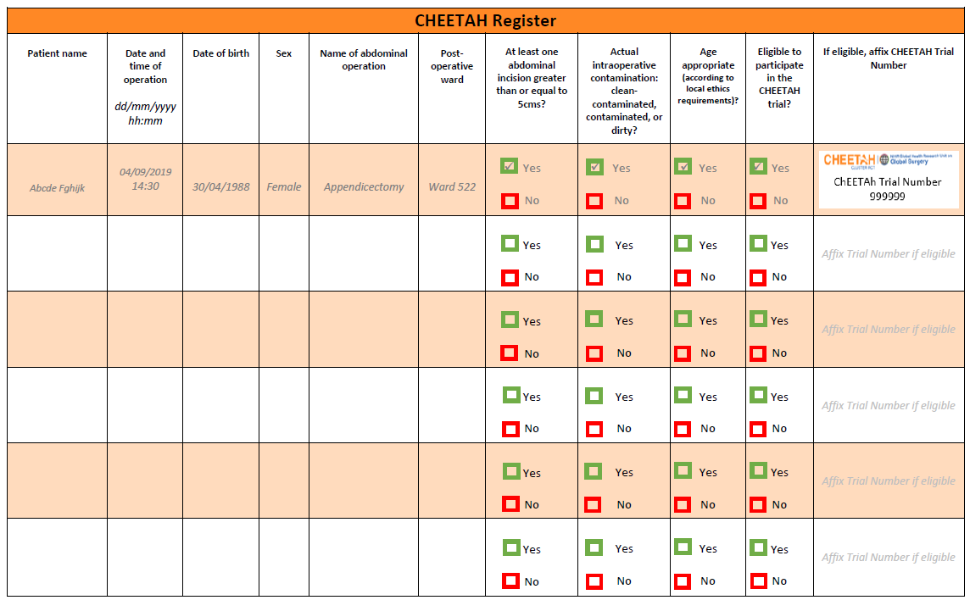

Appendix D: ChEETAh trial operation sticker
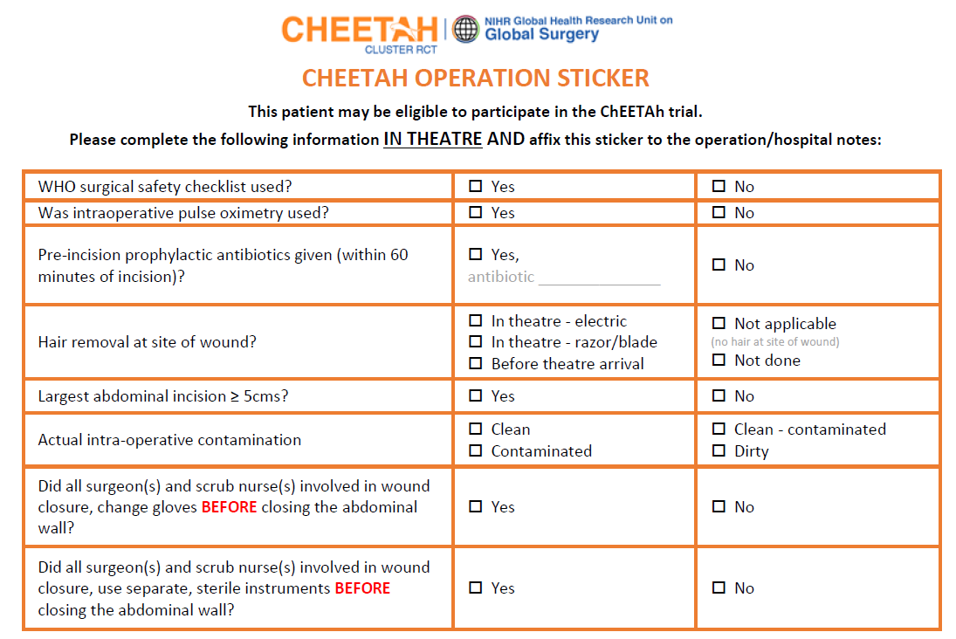

Appendix E: ChEETAh aggregate register

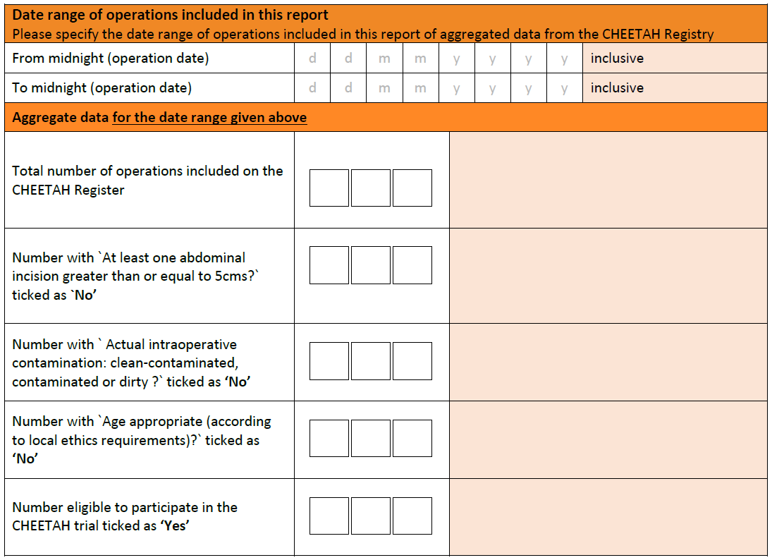

Appendix F: ChEETAh Patient Pathway Flowchart

