Supplementary Material
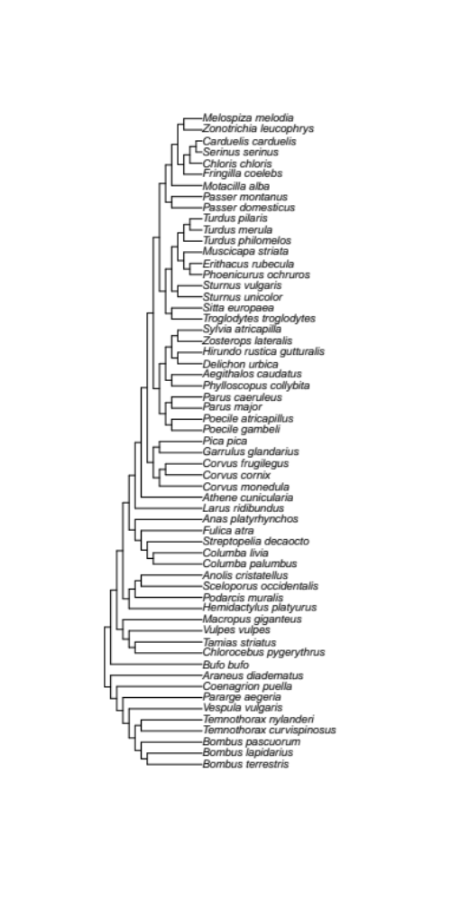
Figure S1. Tree illustrating the phylogenetic relationships used in the phylogenetic metanalyses.

Table S1. Top models identified through the model selection process (within 2 units of the lowest AICc value).
Taxonomic Group | Model | AICc | Weight
All | yi ~ 1 + factor(Trait) + Number of cities + Distance + Human population density | 604.10 | 0.33
 | yi ~ 1 + factor(Trait) + factor(A priori expectation) + Number of cities + Distance + Human population density | 604.75 | 0.24
 | yi ~ 1 + Number of cities + Distance + Human population density | 606.08 | 0.12
Birds | yi ~ 1 + Number of cities + Distance + Human population density | 453.89 | 0.39
 | yi ~ 1 + factor(Trait) + Number of cities + Distance + Human population density | 455.51 | 0.17
Invertebrates | yi ~ 1 + Number of cities | 22.15 | 0.55
Reptiles | yi ~ 1 + factor(Trait) + Distance | 88.98 | 0.23
Reptiles | yi ~ 1 + factor(Trait) + Number of cities + Distance | 90.50 | 0.11
Reptiles | yi ~ 1 + factor(Trait) + factor(A priori expectation) + Distance | 90.77 | 0.09

Figure S2. Information Criteria profile plots for A) the full dataset, B) birds only, C) invertebrates only, and D) reptiles only showing model rankings (x-axis) and associated AICc values (y-axis). The red line indicates 2 AICc units above the model with the lowest AICc value.

Table S2. Multivariate meta-analytic results for the top model (AICc = 604.10): yi ~ 1 + factor(Trait) + Number of cities + Distance + Human population density. Within this model, the tests for residual heterogeneity (Q = 1012.33, df = 245, P < 0.001) and of moderators (Q = 19.33, df = 5, P = 0.002) were both significant.
Model Factors | Estimate | 95% CI | Z | P
Intercept | 0.452 | 0.019–0.885 | 2.046 | 0.041
Trait (physiological) | -0.267 | -0.700–0.163 | -1.218 | 0.223
Trait (morphological) | -0.433 | -0.949–0.083 | -1.643 | 0.100
Number of Cities | 0.164 | 0.070–0.258 | 3.421 | <0.001
Distance | 0.000 | 0.000–0.000 | 1.769 | 0.077
Population Density | 0.000 | 0.000–0.000 | -1.389 | 0.165

Table S3. Multivariate meta-analytic results for the second-best model for the full dataset (all taxonomic groups): yi ~ 1 + factor(Trait) + factor(A priori expectation) + Number of cities + Distance + Human population density. Within this model, the tests for residual heterogeneity (Q = 966.57, df = 244, P < 0.001) and of moderators (Q = 20.53, df = 6, P = 0.002) were both significant.
Model Factors | Estimate | 95% CI | Z | P
Intercept | 0.576 | 0.158–0.995 | 2.698 | 0.007
Trait (physiological) | -0.265 | -0.699–0.170 | -1.194 | 0.233
Trait (morphological) | -0.394 | -0.866–0.078 | -1.637 | 0.102
A priori Expectation | -0.238 | -0.811–0.335 | -0.814 | 0.416
Number of Cities | 0.151 | 0.073–0.223 | 3.792 | <0.001
Distance | 0.000 | 0.000–0.000 | 2.084 | 0.037
Population Density | 0.000 | 0.000–0.000 | -1.632 | 0.103

Table S4. Multivariate meta-analytic results for the third-best model for the full dataset (all taxonomic groups): yi ~ 1 + Number of cities + Distance + Human population density. Within this model, the tests for residual heterogeneity (Q = 1121.45, df = 247, P < 0.001) and of moderators (Q = 14.40, df = 3, P = 0.002) were both significant.
Model Factors | Estimate | 95% CI | Z | P
Intercept | 0.135 | -0.414–0.683 | 0.481 | 0.631
Number of Cities | 0.157 | 0.067–0.248 | 3.400 | 0.001
Distance | 0.000 | 0.000–0.000 | 2.683 | 0.007
Population Density | 0.000 | 0.000–0.000 | -1.515 | 0.130

Table S5. Model-averaged parameter estimates, which are weighted averages of the model coefficients across all potential models, along with 95% confidence intervals, the Z value, P value, and importance value of each model factor.
Taxonomic Group | Model Factor | Estimate | 95% CI | Z | P | Importance
All | Intercept | 0.417 | -0.081–0.915 | 1.642 | 0.101 | 1.00
 | Number_of_Cities | 0.155 | 0.071–0.240 | 3.594 | <0.001 | 1.00
 | Distance | 0.000 | 0.000–0.000 | 1.792 | 0.073 | 0.96
 | Population_Density | 0.000 | 0.000–0.000 | -1.185 | 0.236 | 0.85
 | factor(Trait_physiological) | -0.199 | -0.632–0.234 | -0.901 | 0.368 | 0.74
 | factor(Trait_morphological) | -0.303 | -0.837–0.231 | -1.112 | 0.266 | 0.74
 | factor(Apriori_Expectation) | -0.087 | -0.433–0.258 | -0.496 | 0.620 | 0.38
 | Population_Size | 0.000 | 0.000–0.000 | -0.387 | 0.699 | 0.10
Birds | Intercept | 0.695 | 0.290–1.100 | 3.365 | 0.001 | 1.00
 | Number_of_Cities | 0.093 | 0.016–0.169 | 2.367 | 0.018 | 0.99
 | Distance | 0.000 | 0.000–0.000 | 2.555 | 0.011 | 0.97
 | Population_Density | 0.000 | 0.000–0.000 | -1.890 | 0.059 | 0.93
 | factor(Trait_physiological) | -0.129 | -0.541–0.283 | -0.614 | 0.539 | 0.32
 | factor(Trait_morphological) | -0.130 | -0.543–0.284 | -0.614 | 0.539 | 0.32
 | factor(Apriori_Expectation) | -0.005 | -0.139–0.130 | -0.069 | 0.945 | 0.24
 | Population_Size | 0.000 | 0.000–0.000 | -0.327 | 0.744 | 0.18
Invertebrates | Intercept | 0.108 | -0.295–0.512 | 0.525 | 0.599 | 1.00
 | Number_of_Cities | 0.152 | 0.079–0.226 | 4.069 | <0.001 | 0.99
 | Distance | 0.000 | 0.000–0.000 | 0.474 | 0.636 | 0.18
 | factor(Apriori_Expectation) | 0.033 | -0.110–0.176 | 0.452 | 0.651 | 0.16
 | Population_Size | 0.000 | 0.000–0.000 | -0.069 | 0.945 | 0.14
 | factor(Trait_physiological) | 0.002 | -0.021–0.025 | 0.188 | 0.851 | 0.04
 | factor(Trait_morphological) | -0.009 | -0.049–0.031 | -0.439 | 0.661 | 0.04
 | Population_Density | 0.000 | 0.000–0.000 | -0.349 | 0.727 | 0.04
Reptiles | Intercept | 1.018 | -0.427–2.462 | 1.380 | 0.167 | 1.00
 | Distance | -0.001 | -0.001–0.000 | -1.463 | 0.143 | 0.81
 | factor(Trait_morphological) | -0.511 | -1.379–0.358 | -1.153 | 0.249 | 0.72
 | Number_of_Cities | 0.092 | -0.179–0.363 | 0.663 | 0.507 | 0.39
 | factor(Apriori_Expectation) | 0.070 | -0.249–0.389 | 0.427 | 0.669 | 0.28
 | Population_Size | 0.000 | 0.000–0.000 | -0.005 | 0.996 | 0.20
 | Population_Density | 0.000 | 0.000–0.000 | 0.086 | 0.932 | 0.18

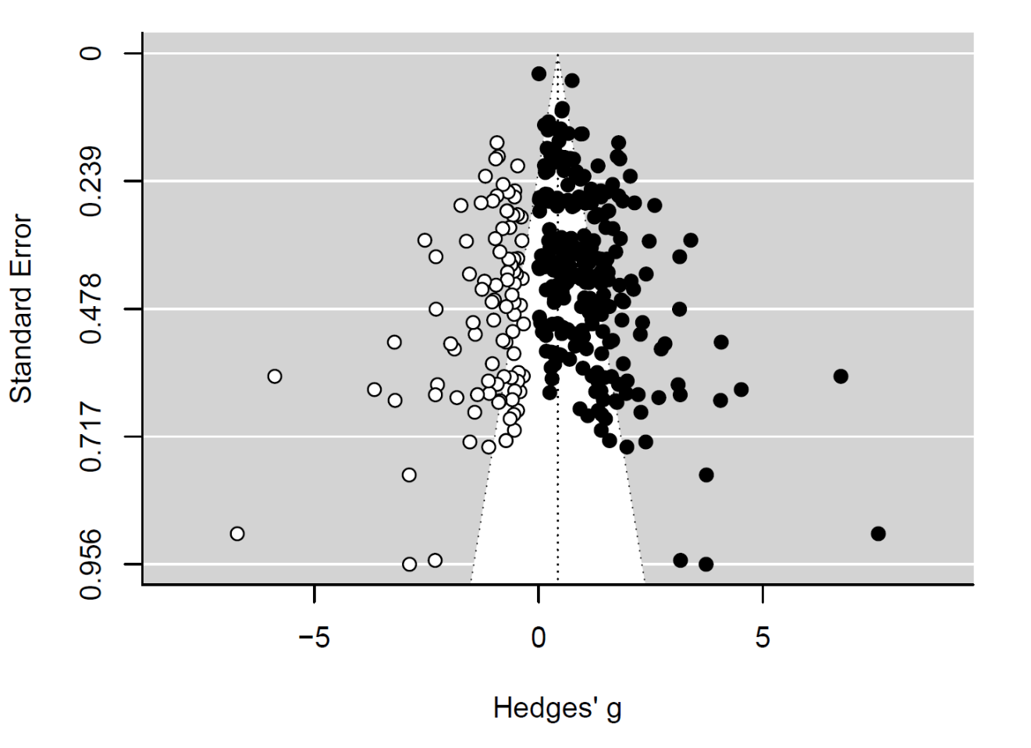
Figure S3. Funnel plot showing asymmetry in effect sizes (Hedges’ g) and study size (as standard error with larger studies having smaller standard errors) in the original dataset (black points). Missing small studies identified through the trim-and-fill method are plotted as white points. It must be noted that we used the difference between the smallest and largest phenotype between cities, which led only to positive effect sizes.

