Targeting Human Thymidylate Synthase: Computational Drug Repurposing and the Role of Water in Interactions
Denis Mteremkoª, Jaffu Chilongola^{b}, Andrew S. Paluch^{c}, Musa Chacha^{a,d}
ªThe Nelson Mandela African Institution of Science and Technology, Arusha, Tanzania; ^{b}Kilimanjaro Christian Research Institute, Moshi, Tanzania; ^{c}Department of Chemical, Paper, and Biomedical Engineering, Miami University, Oxford, OH 45096, USA; ^{d}Arusha Technical College, Arusha, Tanzania

- Validation of the Docking Protocol
Molecular docking was done using AutoDock Vina. Prior to virtual screening of FDA drugs, validation of the docking Protocol was done by extracting the bound ligands from experimental structures, followed by redocking the ligands back into the same receptors, in order to assess whether the docking tools could reproduce the experimental poses of the bound ligands, using the RMSD criteria. The X-ray crystallographic structures and experimental binding affinity data used for comparison to the theoretical data was based on Baum et al., 2009 and Baum et al., 2010 (Baum et al., 2009; Baum et al., 2010). Indeed, the protocol used reproduced the docking pose as shown in the RMSD data in Table S 1

Table S 1: Validation of the Docking Protocol
PDB code | RMSD (Å)
2ZFP | 0.37
2ZGB | 0.31
2ZC9 | 0.31
2ZI2 | 1.98
2ZIQ | 0.37
2ZHQ | 0.35
2ZGX | 0.32
2ZNK | 0.40
2ZDA | 0.42
2ZF0 | 0.44
2ZDV | 0.30
2ZFF | 0.34

- Ensemble and single crystal structure Docking with or without explicit water
Molecular docking was done using an explicit water model developed by Forli et al., 2012, and the results compared to docking using an implicit water model intrinsic in the AutoDock4.2 scoring function. Figure S 1, Figure S 2 and Figure S 3 illustrate the interactions formed when explicit water is included in docking ensemble-based structures.
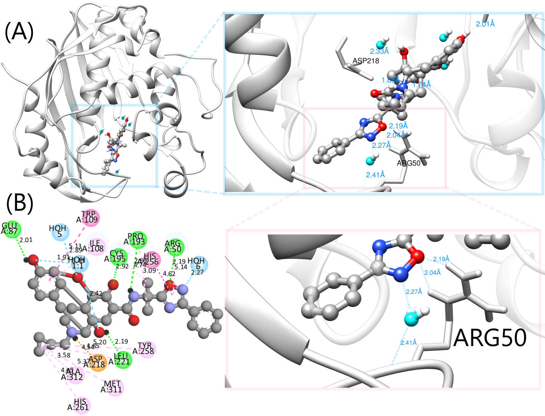
Figure S 1: The complex of hydrated Naldemedine and the ensemble structure at the eighth nanosecond. Key for the colour-coded protein-ligand interactions: Salt bridge, Conventional hydrogen bond, π-π T-shaped, Alkyl, π-alkyl, and metal acceptor.
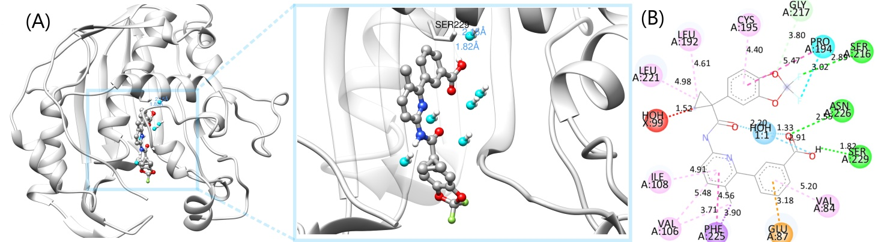
Figure S 2: The complex of hydrated Lumacaftor and an ensemble conformation extracted from the 44th nanosecond. Key for the colour-coded interactions: Unfavourable bump, Conventional hydrogen bond, Carbon hydrogen bond, Water Hydrogen Bond, Halogen, π-sigma, π-π stacked, Alkyl, π-alkyl, π-anion, and amide-π stacked.
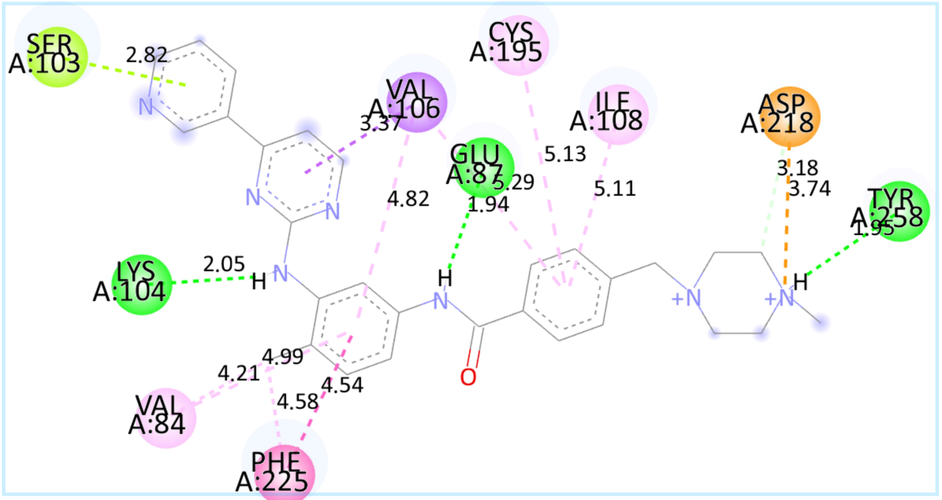
Figure S 3: The complex of hydrated Imatinib with an ensemble structure extracted from the 116th nanosecond, showing protein-ligand interactions. Key for the colour-coded interactions: Conventional hydrogen bond, Carbon hydrogen bond, π-sigma, π-π stacked, π-lone pair, Attractive charge, Alkyl, and π-alkyl.
Similar to the case of docking ligands hydrated with explicit water to an X-ray crystallographic structure of the receptor, docking the ensemble structures to FDA drugs that gave the best binding affinity scores, further improved the binding energy scores. In addition, an explicit water model revealed the bridging waters that mediated interactions between the ligands and the receptors in the complexes. For instance in Figure S 1 (A) showing interactions in the complex of hydrated Naldemedine and an ensemble hTS structure extracted from the eighth nanosecond, a water molecule bridges interactions between the Nitrogen, N of the 1,2,4-oxadiazole moiety and the residue ARG50 at distances of 2.27 and 2.41 Å respectively.
The interactions in the complex of Lumacaftor with an ensemble receptor structure, in the presence of explicit waters, showed three Hydrogen Bond interactions (Figure S 2). A HBond was formed between SER229 and the Hydrogen, H atom of the –OH group of benzenecarboxylic moiety with the D-H…A distance of 1.82 Å, while another Hbond was formed between SER216 and Fluorine, F atom of the 1,3-benzodioxole moiety, at 2.89 Å. Another Hbond was formed between ASN226 (Donor) and carbonyl oxygen of benzenecarboxylic moiety of Lumacaftor (Acceptor), at the D-H…A distance of 2.6 Å. A water molecule placed between the benzenecarboxylic moiety and carbonyl oxygen formed three Hbonds which stabilized the folded conformation of Lumacaftor. PRO194 formed a Hbond with Fluorine of Lumacaftor at 3.02 Å, while GLU87 formed a π-Anion interaction with the Benzene ring of the benzenecarboxylic acid moiety.
Three hydrogen bonds were formed in the complex between hydrated Imatinib and an ensemble conformation extracted at the 116th nanosecond (Figure S 3). One hydrogen bond was formed between LYS104 and a secondary amine Nitrogen, N at a distance of 2.05 Å, while GLU87 formed HBond at a distance of 1.94 Å. Also, TYR258 formed a Hbond with quaternary amine Nitrogen, N of the piperazine moiety of Imatinib at a distance of 1.95 Å. An interesting observation in this case was that all the explicit water molecules present in the hydrated Imatinib were displaced on binding, probably contributing to entropy.

- Dynamics in the formation of hydrogen Bonds
A perl script plot_hbmap_generic.pl written by Prof. Justin Lemkul was downloaded from https://osf.io/3wunt/ and used for GROMACS post-processing, for the generated trajectories, to determine the probability of finding a particular hydrogen bond. The protocol summarized in Box 1 was used.
Box 1: The Protocol for generation of D-H…A pairs for hydrogen bond formation
# Generate the structure file
> gmx trjconv –f <.xtc> –s <.tpr> -n index.ndx –o structure.pdb –b 0 -e 0
# Delete chain identifiers from structure.pdb from column, n
> awk ‘{$n=” ”; print $0}’ structure.pdb
# Generate input files hbond.ndx and hbmap
> gmx hbond –f <.xtc> –s <.tpr> -n index.ndx –hbn hbond.ndx –hbm hbmap.xpm –b <time> -e <time>
# Delete everything in the file hbond.ndx leaving only the section [hbond…]
# Generate output file, summary_HBmap, with Donor-Acceptor, D-H…A residue pairs and the corresponding proportion of snapshots that form a particular Hbond
> perl plot_hbmap_generic.pl –s structure.pdb –map hbmap.xpm –index hbond.ndx
Results in Table 2 showed that three D-H…A hydrogen bond pairs, TYR258-OH…LIG-N0K, LIG-N0K…LEU221-O and LIG-N0K…GLU87-OE2, had the highest probability of occurrence, as evident from their respective percentage existence scores. Similarly, Table 3, showed three D-H…A pairs that had the highest probability of forming Hydrogen bonds in the hTS-Lumacaftor complex. These were SER216-OG…LIG-O0F, HIS256-NE2…LIG-O0F and ASP218-N…LIG-O0U.
Table S 2: Dynamics in Hydrogen bond formation along MD trajectory in the hTS-Imatinib Complex
S.No. | Donor |  | Acceptor |  | % Existence
1 | PHE80 | N | IMATINIB | N0Y | 0.004
2 | TRP109 | NE1 | IMATINIB | N09 | 0.012
3 | ASN112 | ND2 | IMATINIB | N0I | 0.728
4 | TYR135 | OH | IMATINIB | N09 | 0.040
5 | SER216 | OG | IMATINIB | N0I | 0.552
6 | ASP218 | N | IMATINIB | N0I | 0.016
7 | ASN226 | ND2 | IMATINIB | N07 | 0.208
8 | SER229 | OG | IMATINIB | O0N | 0.092
9 | HIS256 | NE2 | IMATINIB | N0I | 0.008
10 | TYR258 | OH | IMATINIB | N0I | 15.387
11 | IMATINIB | N07 | LEU192 | O | 0.004
12 | IMATINIB | N0K | GLU87 | OE1 | 0.004
13 | IMATINIB | N0K | GLU87 | OE2 | 5.964
14 | IMATINIB | N0K | LEU 221 | O | 19.591
15 | IMATINIB | N0V | LYS104 | O | 0.196
16 | IMATINIB | N0V | GLY105 | N | 0.288
17 | IMATINIB | N0V | GLY105 | O | 0.236
18 | IMATINIB | N0Y | SER103 | O | 0.388
19 | IMATINIB | N0Y | LYS104 | O | 0.280
20 | IMATINIB | N0Y | GLY105 | O | 0.040
21 | IMATINIB | N0Y | GLU310 | OE1 | 0.032
Table S 3: The dynamics in hydrogen bond formation in hTS-Lumacaftor Complex
S/No. | Donor |  | Acceptor |  | % Existence
2 | LYS47 | NZ | LUMACAFTOR | O0E | 0.032
3 | LYS47 | NZ | LUMACAFTOR | O0F | 0.016
4 | ASN112 | ND2 | LUMACAFTOR | O0I | 0.005
7 | TYR135 | OH | LUMACAFTOR | O0I | 0.016
8 | TYR135 | OH | LUMACAFTOR | O0S | 0.491
9 | TYR135 | OH | LUMACAFTOR | O0U | 0.054
10 | GLN214 | NE2 | LUMACAFTOR | O0S | 0.005
11 | ARG215 | NH1 | LUMACAFTOR | O0E | 0.011
12 | ARG215 | NH2 | LUMACAFTOR | O0F | 0.005
13 | SER216 | OG | LUMACAFTOR | O0E | 0.011
14 | SER216 | OG | LUMACAFTOR | O0F | 47.496
16 | ASP218 | N | LUMACAFTOR | O0U | 2.997
17 | ASN226 | ND2 | LUMACAFTOR | O0S | 0.075
18 | ASN226 | ND2 | LUMACAFTOR | O0U | 0.005
19 | TYR230 | OH | LUMACAFTOR | O0S | 0.005
20 | HIS256 | NE2 | LUMACAFTOR | N05 | 0.005
21 | HIS256 | NE2 | LUMACAFTOR | O0E | 0.092
22 | HIS256 | NE2 | LUMACAFTOR | O0F | 2.102
Table 4 revealed three D-H…A pairs that had the highest probability for formation of hydrogen bonds in hTS-Naldemedine complex. These were LIG-N11…MET311-O, LIG-N11…ALA312-O, and LIG-O1P…TRP109-NE1.

Table S 4: The dynamics in hydrogen bond formation in hTS-Naldemedine Complex
S/No. | Donor |  | Acceptor |  | % Existence
1 | ASP218 | N | NALDEMEDINE | O0B | 0.008
2 | HIS256 | NE2 | NALDEMEDINE | N1S | 0.524
3 | TYR258 | OH | NALDEMEDINE | O1N | 0.004
4 | TYR258 | OH | NALDEMEDINE | N1U | 0.004
5 | TYR258 | OH | NALDEMEDINE | O1V | 0.044
6 | NALDEMEDINE | N11 | ASN112 | OD1 | 0.384
7 | NALDEMEDINE | N11 | MET311 | O | 12.356
8 | NALDEMEDINE | N11 | ALA312 | O | 2.032
9 | NALDEMEDINE | N09 | ILE108 | O | 0.028
10 | NALDEMEDINE | N09 | ASN112 | OD1 | 0.156
11 | NALDEMEDINE | O1N | ASP218 | OD1 | 0.144
12 | NALDEMEDINE | O1P | GLU87 | OE1 | 0.072
13 | NALDEMEDINE | O1P | GLU87 | OE2 | 0.100
14 | NALDEMEDINE | O1P | TRP109 | NE1 | 19.923
- Complex Stability based on RMSD, Rg, SASA and RMSF Data
The data on RMSF, RMSD, Rg and SASA provided information on the stability of the protein-ligand complexes for Imatinib, Lumacaftor and Naldemedine is presented in Figures 4 and 5.
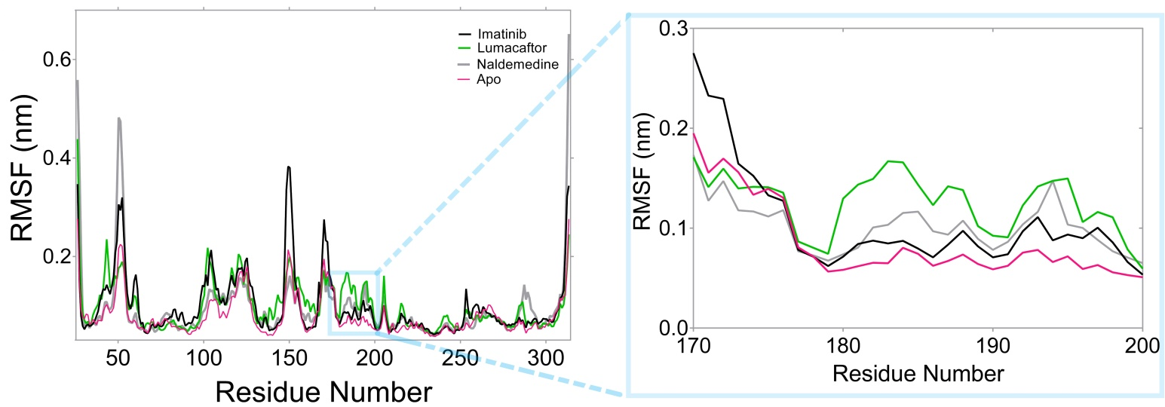
Figure S 4: RMSF showing residual fluctuations. The time-averaged fluctuations in the catalytic loop amino acid residues 181-197 showed that the catalytic loop remained stable, within 0.2 nm, after the binding of the investigated FDA drugs to hTS.
The information was compared against the data on the Apo structure, for comparison, based on our previous work (Mteremko et al., 2022).
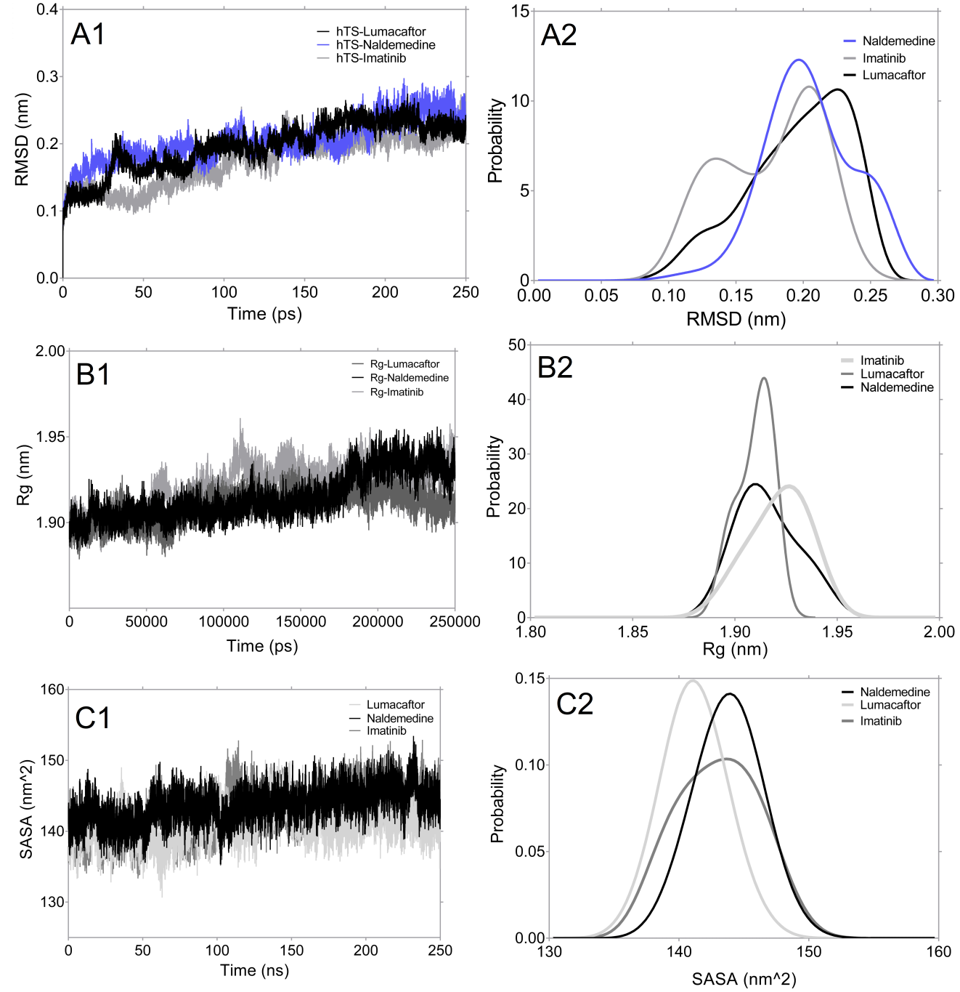
Figure S 5: Time-dependent fluctuations and the corresponding probability distributions for RMSD in (A1) and (A2); for Rg in (B1) and (B2); and for SASA in (C1) and (C2) for the complex between hTS and Imatinib, Lumacaftor and Naldemedine, respectively.
- Binding Free Energy calculations using MM-PBSA approach
Time-dependent fluctuations in the Binding free energy were calculated using the MM-PBSA method, and showed how the dynamics in the different energy components.

Figure S 6: The total Binding Free Energy (BFE), and the different energetic contributions, including the vdW and electrostatic energy contributions for the complexes between hTS and the Imatinib. The vdW interactions were the most favourable in this case.
Figure S 7: The contribution of different energy components to the total BFE, determined using MM-PBSA method in hTS-Lumacaftor complex. Electrostatic and vdW contributions were the most favourable and largely contributed to the total BFE.
- References

Baum, B., Mohamed, M., Zayed, M., Gerlach, C., Heine, A., Hangauer, D., and Klebe, G. (2009). More than a simple lipophilic contact: a detailed thermodynamic analysis of nonbasic residues in the S1 pocket of thrombin. Journal of molecular biology, 390(1), 56-69.
Baum, B., Muley, L., Smolinski, M., Heine, A., Hangauer, D., and Klebe, G. (2010). Non-additivity of functional group contributions in protein–ligand binding: a comprehensive study by crystallography and isothermal titration calorimetry. Journal of molecular biology, 397(4), 1042-1054.
Forli, S., and Olson, A. J. (2012). A force field with discrete displaceable waters and desolvation entropy for hydrated ligand docking. Journal of medicinal chemistry, 55(2), 623-638.
Mteremko, D., Shadrack, D. M., Ntie-Kang, F., Chilongola, J., and Chacha, M. (2022). Finding alternatives to 5-fluorouracil: application of ensemble-based virtual screening for drug repositioning against human thymidylate synthase. Journal of Biomolecular Structure and Dynamics, 1-17.

