APPENDIX

Appendix 1 Basic information of study sites
Table A1 Socioeconomics and TB epidemiology in study sites, 2015
 | Zhejiang | Jilin | Ningxia
Population（million） | 55.39 | 27.53 | 6.67
Proportion of agriculture population | 34.2% | 44.7% | 44.7%
GDP per capita (CNY) | 77,644 | 51,851 | 44,015
Notified TB incidence (per 100 000 population) | 49.4 | 45.7 | 37.6
1CNY = 0.16USD in 2015

Appendix 2 Checklist for medical record review
______Province_______Prefecture________County_________Name of hospital
Patient code |  |  |  |  |  |  | Sex |  | M□ F□ |  |  |  |  |  |  | Age |  |  |  |  |  |  |  | #Medical record |  |  |  |  |  |  |  |  | Treatment type |  |  | New□ Relapse□
Date of diagnosis |  |  |  |  |  |  | Type of patient |  | TB□ DR-TB□ |  |  |  |  |  |  | Type of DR |  |  |  |  | H□ R□ MDR□ Injection resistant MDR□ Quinolone resistance□ Extensive resistance □
Diagnosis |  |  |  |  |  |  |  |  |  |  |  |  |  |  |  |  |  |  |  |  |  |  |  |  |  |  |  | Adequate diagnosis |  |  |  |  |  |  |  | Yes□ No□
Number of sputum smears submitted for examination |  |  |  | 0□ 1□ 2□ 3□ |  |  |  |  |  |  |  |  |  |  |  | Smear result |  |  |  |  | Negative□ Positive □
Phenotypic sputum culture |  |  |  | No□ Negative□ Positive□ |  |  |  |  |  |  |  |  |  |  |  | Cultivation method |  |  |  |  | L-J □ M960/460 □ Micropore-plate method(Microdrug sensitivity, MicroDST □
Phenotypic susceptibility results |  |  |  | No□ Susceptible □ Drug resistance□ |  |  |  |  |  |  |  |  |  |  |  | Drug resistance |  |  |  |  | Isoniazid □ Rifampicin□ ofloxacin (Ofx) □ levofloxacin (Lfx) □ moxifloxacin (Mfx) □ KM□ AK□ CM□ SM□
Molecular diagnosis of drug resistance |  |  |  | No□ Susceptible □ Drug resistance□ |  |  |  |  |  |  |  |  |  |  |  | Drug resistance |  |  |  |  | H□ R□ E□ SM□ Quinolone□ |  |  |  |  |  |  | Detection method |  |  |  |  | Hain□ Xpert□ Gene chip □  Fusion curve □ Other □ please describe: ___________
X ray |  |  |  | No□ Yes□ |  |  |  |  |  |  |  |  |  |  |  | CT |  |  |  |  | No□ Yes□ |  |  |  |  |  |  | Contact history of TB patients |  |  |  |  | No□ Yes□
PPD |  |  |  | No□ Negative□ Positive□ |  |  |  |  |  |  |  |  |  |  |  | Anti-tuberculosis antibody |  |  |  |  | No□ Negative□ Positive□ |  |  |  |  |  |  | IGRAs |  |  |  |  | No□ Negative□ Positive□
TB symptoms |  |  |  | No□ Cough□ Expectoration □ Fever□ Hemoptysis □ |  |  |  |  |  |  |  |  |  |  |  | Anti-inflammatory treatment |  |  |  |  | No□ Rational anti-inflammatory□ Irrational anti-inflammatory (No assessment, use of fluoroquinolone or aminoglycoside anti-inflammatory) □
Tumor marker |  |  |  | No□ Normal□ Abnormal □，CEA_________ ug/ml，other abnormal, please describe_________ |  |  |  |  |  |  |  |  |  |  |  |  |  |  |  |  |  |  |  |  |  |  |  | Exfoliated cells |  |  |  |  | No□ Negative□ Positive□
Bronchoscopy |  |  |  | Normal□ Abnormal □ please describe: ________ |  |  |  |  |  |  |  |  |  |  |  | Lung or other biopsy |  |  |  |  | No□ Normal□ Abnormal□ please describe: ___________
Reasons for hospital admission (choose all that apply)
Reasons for hospital admission |  |  |  | TB：1TB□ 2 Hematogenous disseminated TB □ 3 Tubercular meningitis□ 4 Pleurisy □ 5 Peritonitis □ 6 Pericarditis □ 7Surgery for TB□ 8 Body temperature≥38.5℃□
 |  |  |  | Differential diagnosis：9 Anti-inflammatory □ 10Tumor □ 11 Biopsy □
 |  |  |  | TB complications：12 Hemoptysis □ 13 Pneumothorax □ 14 Respiratory failure□ 15 Intestinal obstruction □
 |  |  |  | Adverse reactions：16Allergic□ 17Liver damage□ 18Renal damage□ 19 Bone marrow suppression □ 20 Electrolyte disturbance □ 21 Gastrointestinal symptoms □
 |  |  |  | Comorbidities：22 Diabetes□ 23 Coronary Heart Disease □ 24 Cerebrovascular Disease □ 25Infection, body temperature ≥38.5℃□ 26Insurance policy□ 27Other, please describe____
Treatment plan and outcome
Treatment plan |  | Include treatment |  |  |  |  | No□ Yes□ |  |  |  | Initial standard chemotherapy regimen |  |  |  |  |  |  |  | No□ Yes□ |  |  |  |  | Adjustment |  |  | No□ Yes□ |  |  |  |  | Date of starting treatment
 |  | Is the adjustment reasonable |  |  |  |  | No□ Yes□ |  |  |  | Reason for adjustment |  |  | 1 Adverse reaction□ 2Financial burden□ 3 Shortage of medicine □ 4 No injection conditions □ 5Severe TB□ 6 Complications □ 7Aged 70 years or older □ 8Other, please describe______
Treatment outcome assessment for TB |  | At the end of second months for initial treatment / third months for retreatment |  |  |  |  |  |  |  |  | Sputum |  |  | No□ Negative□ Positive□ |  |  |  |  |  |  |  |  |  | Image |  |  | No□ Improved□ Same□ Deterioration □
 |  | At the end of sixth months for initial treatment / eighth months for retreatment |  |  |  |  |  |  |  |  | Sputum |  |  | No□ Negative□ Positive□ |  |  |  |  |  |  |  |  |  | Image |  |  | No□ Improved□ Same□ Deterioration □
 |  | Treatment outcome |  |  |  |  | 1Cure□ 2Finish treatment□ 3TB death□ 4Non-TB death□ 5Treatment failure□ 6lose follow-up□ 7Adverse reaction and pause treatment□ 8Change diagnosis□ 9Refuse treatment □ 10Become MDR-TB□ 11Not able to assess□
Treatment outcome assessment for DR-TB |  | At the end of second months for initial treatment / third months for retreatment |  |  |  |  |  |  |  |  | Sputum |  |  | No□ Negative□ Positive□ |  |  |  |  |  |  |  |  |  | Image |  |  | No□ Improved□ Same□ Deterioration □
 |  | At the end of sixth months for initial treatment / eighth months for retreatment |  |  |  |  |  |  |  |  | Sputum |  |  | No□ Negative□ Positive□ |  |  |  |  |  |  |  |  |  | Image |  |  | No□ Improved□ Same□ Deterioration □
 |  | Treatment outcome |  |  |  |  | 1Cure□ 2Finish treatment□ 3TB death□ 4Non-TB death□ 5Treatment failure□ 6lose follow-up□ 7Adverse reaction and pause treatment□ 8Change diagnosis□ 9Refuse treatment □ 10Become MDR-TB□ 11Not able to assess□
Diagnostic tests (by months)
Test | 0 |  | 1 |  | 2 | 3 | 4 | 5 |  | 6 |  | 7 | 8 |  | 9 |  | 10 | 11 |  | 12 |  | 13 | 14 |  | 15 | 16 |  |  | 17 | 18 | 19 |  |  | 20 | 21 |  | 22 | 23 | 24
Blood routine
Liver function
Renal function
Urine routine
Electrolyte
TSH
Hearing
Vision
Sputum smear
Sputum Culture
X Ray
CT
Weight
Take medicine

Appendix 3 Additional figures

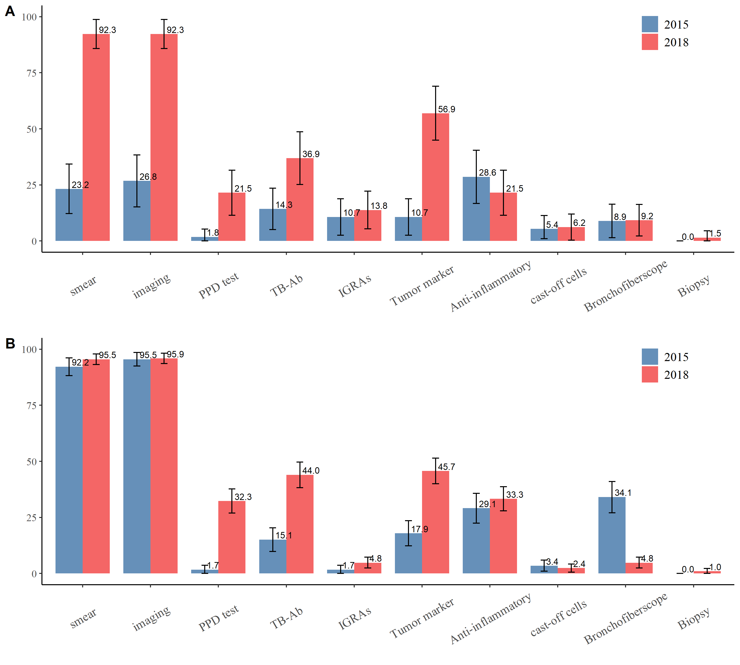
Figure A3.1 Proportion of different tests used by TB patients A) among asymptomatic pulmonary TB patients B) among symptomatic pulmonary TB patients (Source: medical record review)

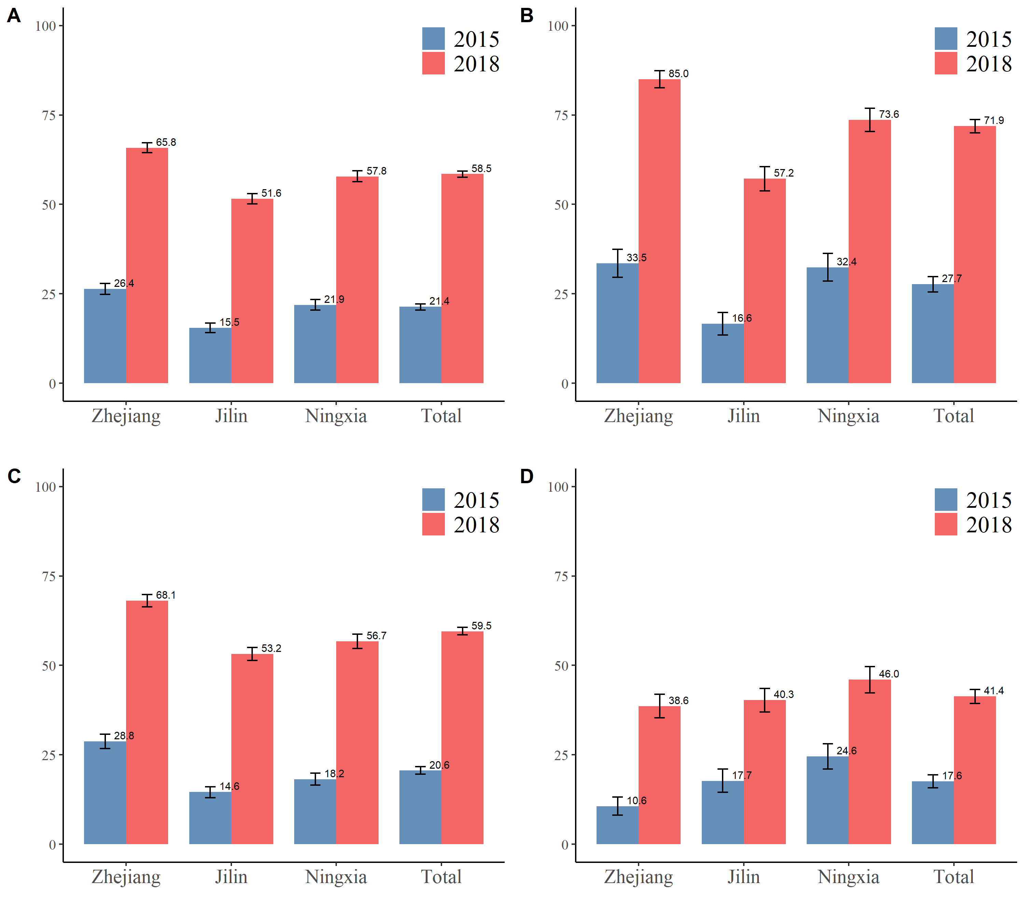
Figure A3.2 Proportion of TB patients receiving minimal recommended follow-up examinations during treatment course in 2015 and 2018, disaggregated by province A) all test B) routine blood test C) liver function test D) routine urine test (Source: medical record review)

Appendix 4 Tables

Table A4.1 Coverage of smear culture and RMT among smear-negative patients
Study sites | 2015 |  |  |  | 2018 |  |  | P value
Study sites | # Patients | # of tests * | Proportion (%) |  | # Patients | # of tests * | Proportion (%) | P value
Zhejiang | 536 | 158 | 29.5 |  | 472 | 391 | 82.8 | <0.001
Jilin | 948 | 306 | 32.3 |  | 867 | 752 | 86.7 | <0.001
Ningxia | 429 | 199 | 46.4 |  | 289 | 280 | 96.9 | <0.001
Total | 1913 | 663 | 34.7 |  | 1628 | 1423 | 87.4 | <0.001
Notes: total of smear culture and RMT

Table A4.2 Coverage of different types of TB diagnostic tests among smear-negative patients
Study sites | 2015 |  |  |  |  |  | 2018 |  |  |  |  |  | P value
Study sites | #Patients | #Smear (%) | #Smear  + RMT (%) | #Smear +culture (%) | #Smear  +culture  +RMT (%) |  |  | #Patients | #Smear (%) | #Smear  + RMT (%) | #Smear +culture (%) | #Smear  +culture  +RMT (%) | P value
Zhejiang | 536 | 378 (70.5) | 0 | 158  (29.5) | 0 |  |  | 472 | 81  (17.2) | 42  (8.9) | 265  (56.1) | 84  (17.8) | <0.001
Jilin | 948 | 642  (67.7) | 0 | 306  (32.3) | 0 |  |  | 867 | 115  (13.3) | 90  (10.4) | 303  (34.9) | 359  (41.4) | <0.001
Ningxia | 429 | 230  (53.6) | 0 | 199  (46.4) | 0 |  |  | 289 | 9  (3.1) | 129  (44.6) | 35  (12.1) | 116  (40.1) | <0.001
Total | 1913 | 1250  (65.3) | 0 | 663  (34.7) | 0 |  |  | 1628 | 205  (12.6) | 261  (16.0) | 603  (37.0) | 559  (34.3) | <0.001

Table A4.3 Percentage of pulmonary TB cases confirmed by bacteriology
Study sites | 2015 |  |  |  | 2018 |  |  | P value
Study sites | #Patients | #Bacteriologically positive | Positive rate (%) |  | #Patients | #Bacteriologically positive | Positive rate (%) | P value
Zhejiang | 899 | 380 | 42.3 |  | 783 | 445 | 56.8 | <0.001
Jilin | 1427 | 501 | 35.1 |  | 1356 | 661 | 48.7 | <0.001
Ningxia | 578 | 171 | 29.6 |  | 467 | 241 | 51.6 | <0.001
Total | 2904 | 1052 | 36.2 |  | 2606 | 1347 | 51.7 | <0.001

Table A4.4 Proportion of diagnostic tests in bacteriological-confirmed TB patients
Study sites | 2015 |  |  |  |  | 2018 |  |  |  | P value
Study sites | #Patients | #Smear positive (%) | #RMT positive (%) | #Culture positive (%) |  | #Patients | #Smear positive (%) | #RMT positive (%) | #Culture positive (%) | P value
Zhejiang | 380 | 363(95.5) | 0 | 17(4.5) |  | 445 | 311(69.9) | 85(19.1) | 49(11.0) | <0.001
Jilin | 501 | 463(92.4) | 0 | 38(7.6) |  | 661 | 426(64.4) | 135(20.4) | 100(15.1) | <0.001
Ningxia | 171 | 149(87.1) | 0 | 22(12.9) |  | 241 | 178(73.9) | 53(22.0) | 10(4.1) | <0.001
Total | 1052 | 975(92.7) | 0 | 77(7.3) |  | 1347 | 915(67.9) | 273(20.3) | 159(11.8) | <0.001

Table A4.5 DST coverage for bacteriologically confirmed TB patients
Study sites | 2015 |  |  |  | 2018 |  |  | P value
Study sites | #Patients | #DST tests | DST coverage (%) |  | #Patients | #DST tests | DST coverage (%) | P value
Zhejiang | 380 | 306 | 80.5 |  | 445 | 413 | 92.8 | <0.001
Jilin | 501 | 47 | 9.4 |  | 661 | 478 | 72.3 | <0.001
Ningxia | 171 | 70 | 40.9 |  | 241 | 211 | 87.6 | <0.001
Total | 1052 | 423 | 40.2 |  | 1347 | 1102 | 81.8 | <0.001

Table A4.6 Proportion of diagnostic tests for bacteriologically confirmed TB patients testing for drug susceptibility
Study sites | 2015 |  |  |  |  | 2018 |  |  |  | P value
Study sites | #Patients | #Culture (%) | #RMT+culture (%) | #RMT (%) |  | #Patients | #Culture (%) | #RMT+culture (%) | #RMT (%) | P value
Zhejiang | 306 | 306(100.0) | 0(0.0) | 0(0.0) |  | 413 | 10(2.4) | 374(90.6) | 29(7.0) | <0.001
Jilin | 47 | 25(53.2) | 22(46.8) | 0(0.0) |  | 478 | 252(52.7) | 147(30.8) | 79(16.5) | <0.001
Ningxia | 70 | 66(94.3) | 4(5.7) | 0(0.0) |  | 211 | 10(4.7) | 189(89.6) | 12(5.7) | <0.001
Total | 423 | 397(93.9) | 26(6.1) | 0(0.0) |  | 1102 | 272(24.7) | 710(64.4) | 120(10.9) | <0.001

Table A4.7 Proportion of TB patients received adequate diagnostic services
Study sites | 2015 |  |  |  | 2018 |  |  | P value
Study sites | #Patients | #Patients received adequate diagnostic services | Proportion (%) |  | #Patients | #Patients received adequate diagnostic services | Proportion (%) | P value
Zhejiang | 282 | 227 | 80.5 |  | 420 | 372 | 88.6 | 0.003
Jilin | 268 | 233 | 86.9 |  | 418 | 413 | 98.8 | <0.001
Ningxia | 279 | 247 | 88.5 |  | 347 | 345 | 99.4 | <0.001
Total | 829 | 707 | 85.3 |  | 1185 | 1130 | 95.4 | <0.001

Table A4.8 Proportion of smear-negative TB patients received recommended diagnostic services by Guideline
Study sites | 2015 |  |  |  |  | 2018 |  |  |  | P value
Study sites | #Patients | #Patients received recommended diagnostic services |  | Proportion (%) |  | #Patients | #Patients received recommended diagnostic services |  | Proportion (%)
Among asymptomatic pulmonary TB patients
Zhejiang | 43 | 7 |  | 16.3 |  | 41 | 21 |  | 51.2 | 0.001
Jilin | 8 | 3 |  | 37.5 |  | 7 | 4 |  | 57.1 | 0.447
Ningxia | 4 | 0 |  | 0 |  | 17 | 16 |  | 94.1 | <0.001
Total | 55 | 10 |  | 18.2 |  | 65 | 41 |  | 63.1 | <0.001
Among symptomatic pulmonary TB patients
Zhejiang | 22 | 21 |  | 95.5 |  | 61 | 47 |  | 77.0 | 0.054
Jilin | 116 | 105 |  | 90.5 |  | 130 | 124 |  | 95.4 | 0.133
Ningxia | 42 | 42 |  | 100 |  | 100 | 95 |  | 95.0 | 0.140
Total | 180 | 168 |  | 93.3 |  | 291 | 266 |  | 91.4 | 0.451

Table A4.9 Proportion of drug susceptible TB patients treated by second-line drug (SLD)
Study sites | 2015 |  |  |  |  | 2018 |  |  |  | P value
Study sites | #Patients | #Patients treated by SLD |  | Proportion (%) |  | #Patients | #Patients treated by SLD |  | Proportion (%) | P value
Zhejiang | 81 | 12 |  | 14.8 |  | 249 | 80 |  | 32.1 | 0.003
Jilin | 148 | 16 |  | 10.8 |  | 228 | 49 |  | 21.5 | 0.007
Ningxia | 57 | 8 |  | 14 |  | 213 | 30 |  | 14.1 | 0.992
Total | 286 | 36 |  | 12.6 |  | 690 | 159 |  | 23 | <0.001

Table A4.10 Proportion of TB patients receiving recommended follow-up examinations during treatment course in 2015 and 2018, disaggregated by province A) all test B) blood routine test C) liver function test D) liver function test (routine urine test)routine
Study sites | 2015 |  |  |  |  | 2018 |  |  |  | P value
Study sites | #Patients | #Tests received by patients | #Recommended tests | Proportion (%) |  | #Patients | #Tests received by patients | #Recommended tests | Proportion (%) | P value
All tests
Zhejiang | 282 | 561 | 1974 | 28.42 |  | 420 | 2077 | 2940 | 70.65 | <0.001
Jilin | 268 | 344 | 1876 | 18.34 |  | 418 | 1674 | 2926 | 57.21 | <0.001
Ningxia | 279 | 607 | 1953 | 31.08 |  | 347 | 1609 | 2429 | 66.24 | <0.001
Total | 829 | 1512 | 5803 | 26.06 |  | 1185 | 5360 | 8295 | 64.62 | <0.001
Routine blood test
Zhejiang | 282 | 189 | 564 | 33.51 |  | 420 | 714 | 840 | 85.00 | <0.001
Jilin | 268 | 89 | 536 | 16.60 |  | 418 | 478 | 836 | 57.18 | <0.001
Ningxia | 279 | 181 | 558 | 32.44 |  | 347 | 511 | 694 | 73.63 | <0.001
Total | 829 | 459 | 1658 | 27.68 |  | 1185 | 1703 | 2370 | 71.86 | <0.001
Liver function test
Zhejiang | 282 | 312 | 846 | 36.88 |  | 420 | 1039 | 1260 | 82.46 | <0.001
Jilin | 268 | 160 | 804 | 19.90 |  | 418 | 859 | 1254 | 68.50 | <0.001
Ningxia | 279 | 289 | 837 | 34.53 |  | 347 | 779 | 1041 | 74.83 | <0.001
Total | 829 | 761 | 2487 | 30.60 |  | 1185 | 2677 | 3555 | 75.30 | <0.001
Routine urine test
Zhejiang | 282 | 60 | 564 | 10.64 |  | 420 | 324 | 840 | 38.57 | <0.001
Jilin | 268 | 95 | 536 | 17.72 |  | 418 | 337 | 836 | 40.31 | <0.001
Ningxia | 279 | 137 | 558 | 24.55 |  | 347 | 319 | 694 | 45.97 | <0.001
Total | 829 | 292 | 1658 | 17.61 |  | 1185 | 980 | 2370 | 41.35 | <0.001
Note: number of recommended tests = number of patients * 7 (number of recommended tests per patients by guideline)
Recommended tests per patients by guideline: routine blood test *2 (before treatment, first month completion of treatment), liver and renal function test *3 (before treatment, first and second months completion of treatment) and routine urine test *2 (before treatment, first month completion of treatment),

Table A4.11 Proportion of TB patients receiving recommended follow-up examinations during treatment course in 2015 and 2018, disaggregated by province
Study sites | 2015 |  |  |  |  | 2018 |  |  |  | P value
Study sites | #Patients | #Number of patients tested | # Number of patients not tested | Proportion (%) |  | #Patients | #Number of patients tested | # Number of patients not tested | Proportion (%) | P value
Routine blood test: before treatment
Zhejiang | 282 | 0 | 282 | 0.00 |  | 420 | 401 | 19 | 95.48 | <0.001
Jilin | 268 | 81 | 187 | 30.22 |  | 418 | 396 | 22 | 94.74 | <0.001
Ningxia | 279 | 150 | 129 | 53.76 |  | 347 | 334 | 13 | 96.25 | <0.001
Total | 829 | 231 | 598 | 27.86 |  | 1185 | 1131 | 54 | 95.44 | <0.001
Routine blood test: first month completion of treatment
Zhejiang | 282 | 189 | 93 | 67.02 |  | 420 | 313 | 107 | 74.52 | 0.031
Jilin | 268 | 8 | 260 | 2.99 |  | 418 | 82 | 336 | 19.62 | <0.001
Ningxia | 279 | 31 | 248 | 11.11 |  | 347 | 177 | 170 | 51.01 | <0.001
Total | 829 | 228 | 601 | 27.50 |  | 1185 | 572 | 613 | 48.27 | <0.001
Liver function test: before treatment
Zhejiang | 282 | 0 | 282 | 0.00 |  | 420 | 402 | 18 | 95.71 | <0.001
Jilin | 268 | 65 | 203 | 24.25 |  | 418 | 414 | 4 | 99.04 | <0.001
Ningxia | 279 | 51 | 228 | 18.28 |  | 347 | 338 | 9 | 97.41 | <0.001
Total | 829 | 116 | 713 | 13.99 |  | 1185 | 1154 | 31 | 97.38 | <0.001
Liver function test: first month completion of treatment
Zhejiang | 282 | 188 | 94 | 66.67 |  | 420 | 317 | 103 | 75.48 | 0.011
Jilin | 268 | 51 | 217 | 19.03 |  | 418 | 101 | 317 | 24.16 | 0.114
Ningxia | 279 | 117 | 162 | 41.94 |  | 347 | 200 | 147 | 57.64 | <0.001
Total | 829 | 356 | 473 | 42.94 |  | 1185 | 618 | 567 | 52.15 | <0.001
Liver function test: second month completion of treatment
Zhejiang | 282 | 124 | 158 | 43.97 |  | 420 | 320 | 100 | 76.19 | <0.001
Jilin | 268 | 44 | 224 | 16.42 |  | 418 | 344 | 74 | 82.30 | <0.001
Ningxia | 279 | 121 | 158 | 43.37 |  | 347 | 241 | 106 | 69.45 | <0.001
Total | 829 | 289 | 540 | 34.86 |  | 1185 | 905 | 280 | 76.37 | <0.001
Routine urine test: before treatment
Zhejiang | 282 | 0 | 282 | 0.00 |  | 420 | 227 | 193 | 54.05 | <0.001
Jilin | 268 | 95 | 173 | 35.45 |  | 418 | 332 | 86 | 79.43 | <0.001
Ningxia | 279 | 133 | 146 | 47.67 |  | 347 | 258 | 89 | 74.35 | <0.001
Total | 829 | 228 | 601 | 27.50 |  | 1185 | 817 | 368 | 68.95 | <0.001
Routine urine test: first month completion of treatment
Zhejiang | 282 | 60 | 222 | 21.28 |  | 420 | 97 | 323 | 23.10 | 0.571
Jilin | 268 | 0 | 268 | 0.00 |  | 418 | 5 | 413 | 1.20 | 0.072
Ningxia | 279 | 4 | 275 | 1.43 |  | 347 | 61 | 286 | 17.58 | <0.001
Total | 829 | 64 | 765 | 7.72 |  | 1185 | 163 | 1022 | 13.76 | <0.001

