Supplementary material: Changes in non-oscillatory features of the cortical sensorimotor rhythm in Parkinson's disease across age

Authors
Mikkel C. Vinding* 1), Allison Eriksson 1)2), Cassia Man Ting Low 1)3), Josefine Waldthaler 4)5), Daniel Ferreira 6,7), Martin Ingvar 1), Per Svenningsson 4), Daniel Lundqvist 1).

Affiliations
- NatMEG, Department of Clinical Neuroscience, Karolinska Institutet, Sweden.
- Department of Women's and Children's Health, Uppsala University, Sweden.
- Cognitive Neuroimaging Centre, Lee Kong Chien School of Medicine, Nanyang Technological University, Singapore.
- Section of Neurology, Department of Clinical Neuroscience, Karolinska Institutet, Sweden.
- Department of Neurology, University Hospital Marburg, Marburg, Germany.
- Division of Clinical Geriatrics, Center for Alzheimer's Research, Department of Neurobiology, Care Sciences, and Society, Karolinska Institutet, Stockholm, Sweden.
- Department of Radiology, Mayo Clinic, Rochester, MN, USA.

Model coefficients from regression analysis

Regression coefficients for group, age, sex, and cortical thickness
Table S1: regression coefficients and 95% CI for the regression models of the sensorimotor signal features (Table 2) with Group, Age, Sex, and Cortical Thickness. Values in red indicate factors with Bayes Factor > 3 in the model comparison (see main text). LL: lower limit, UL: upper limit.
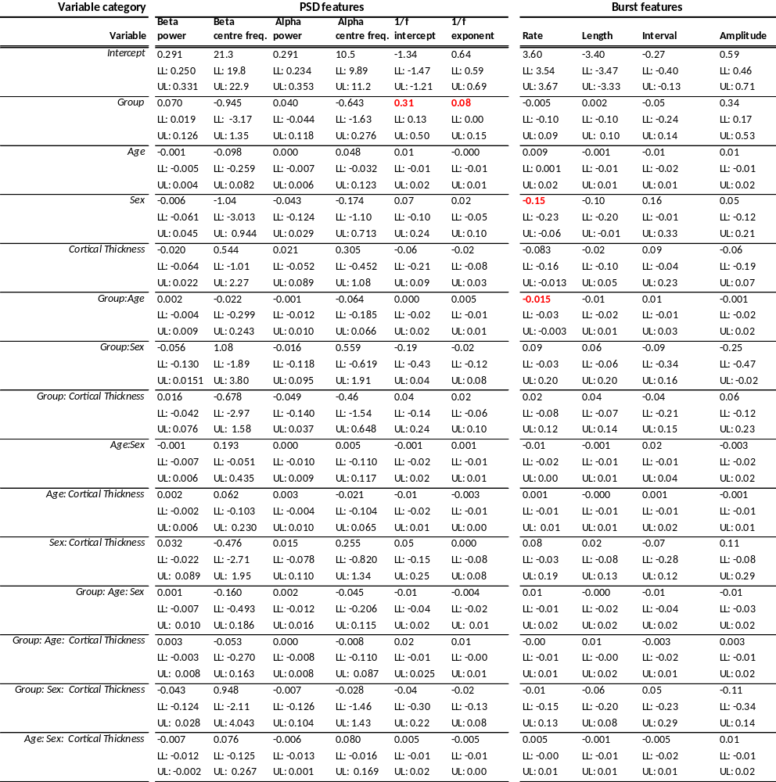

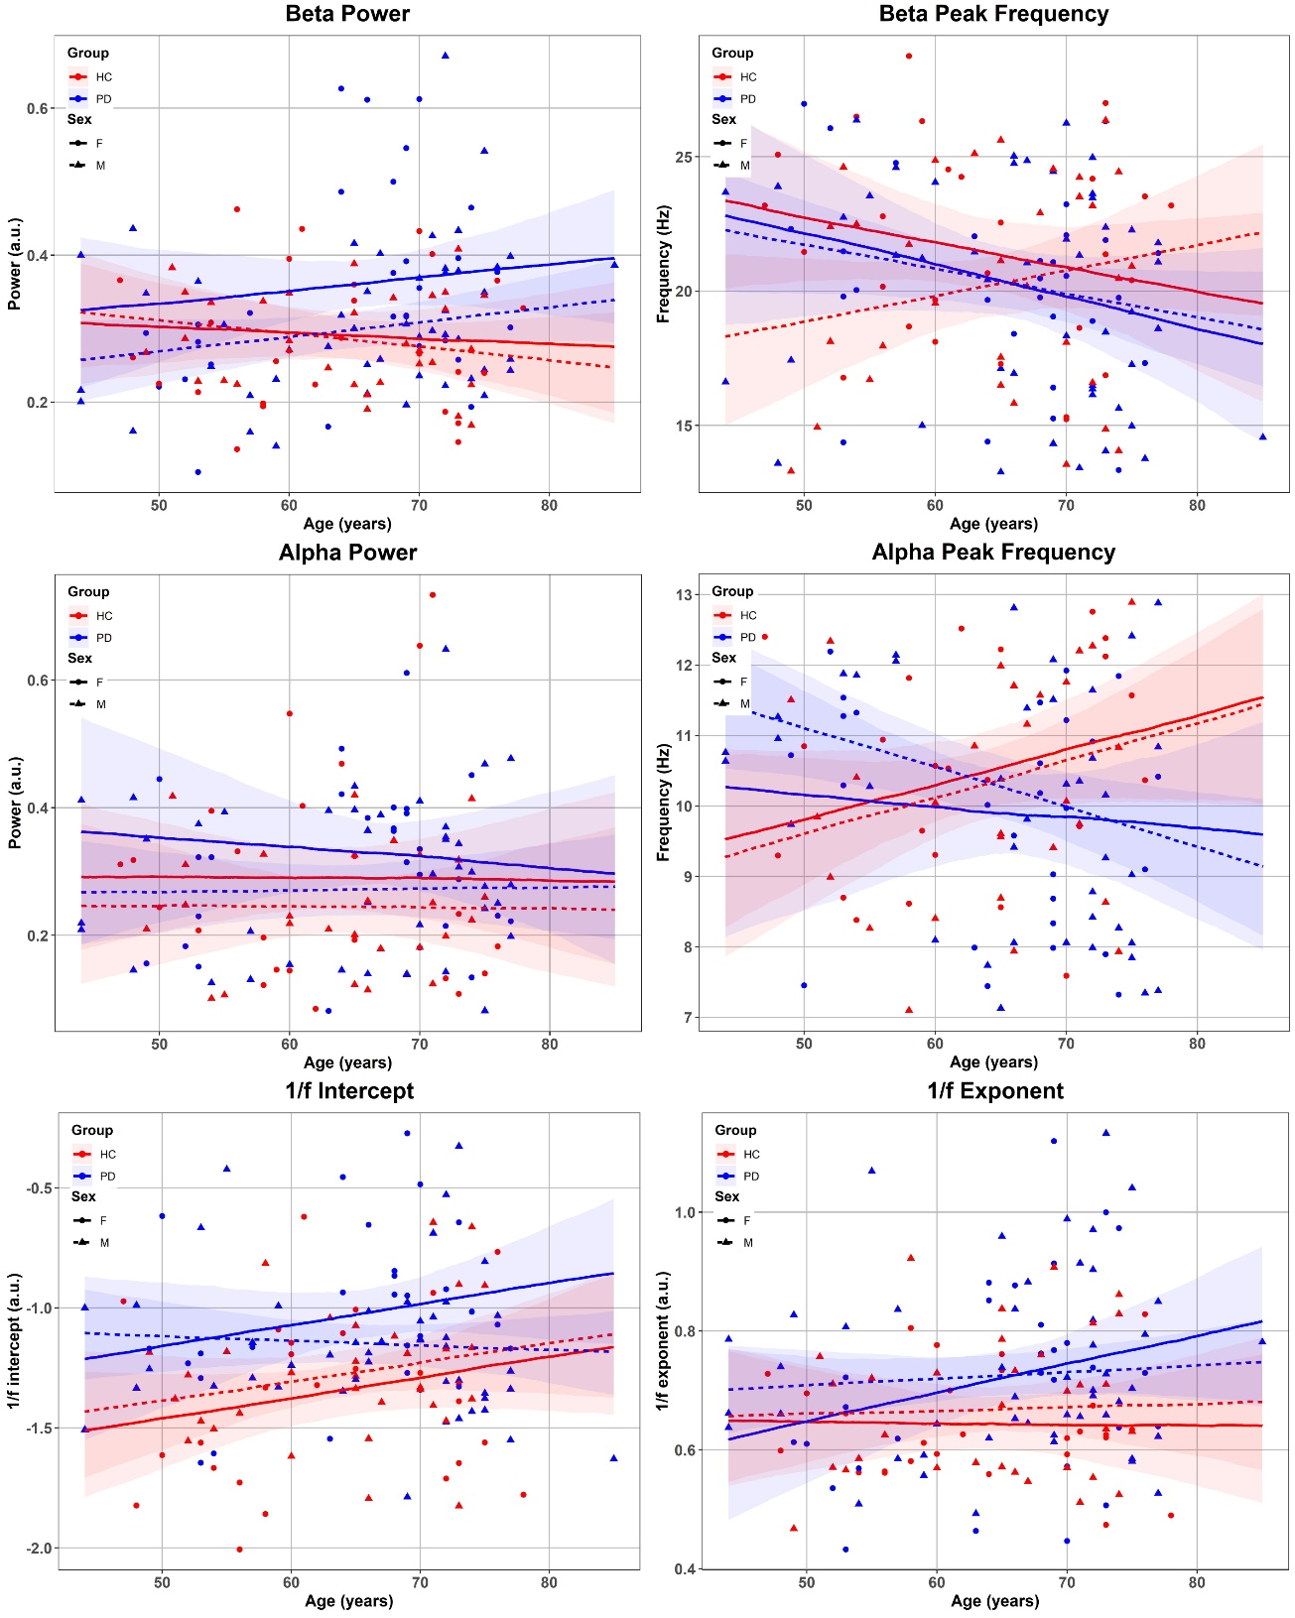
Figure S1: PSD feature over age for PD patients (blue) and healthy controls (red) split between females (solid lines) and males (dashed lines). The lines are the group-level predicted trends of the regression models. Shaded areas represent the 95% CI of the model prediction.

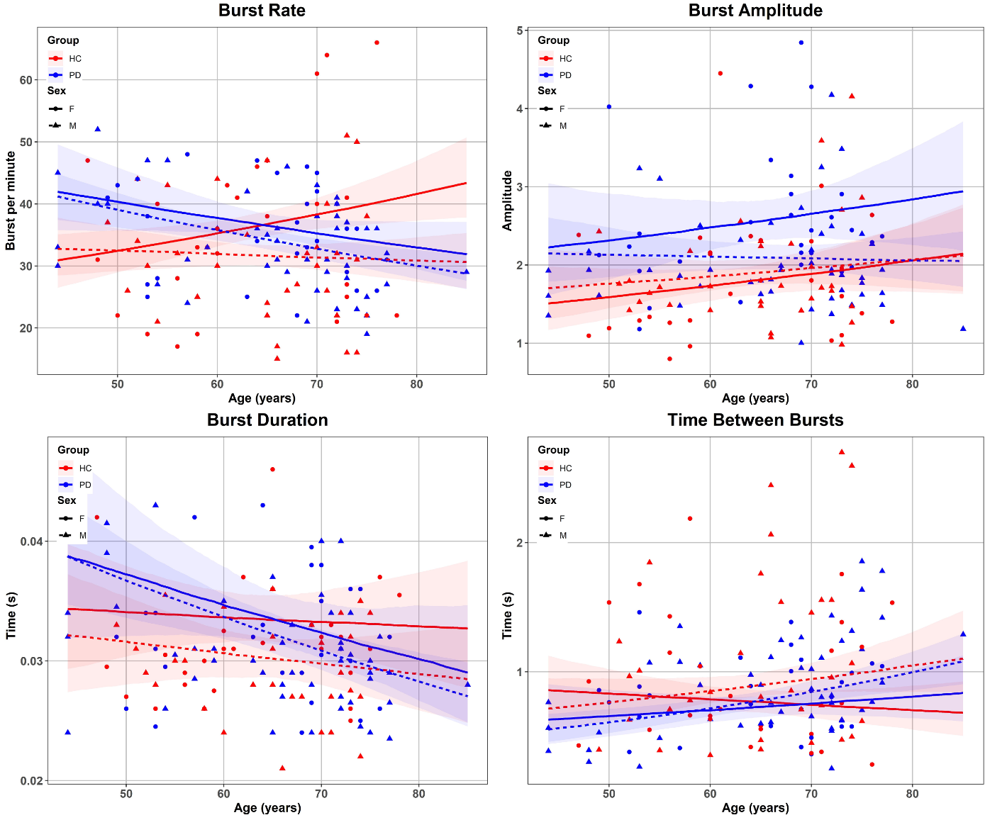
Figure S2: Burst features over age for PD patients (blue) and healthy controls (red) split between females (solid lines) and males (dashed lines). The lines are the group-level predicted trends of the regression models. Shaded areas represent the 95% CI of the model prediction.

Regression coefficients for clinical scores
Table S2: Standardised regression coefficients (95% CI) for the six regression models on motor symptoms measured with the MDS-UPDRS-III. Values in bold indicate factors with Bayes Factor > 3 in the model comparison. LL: lower limit, UL: upper limit.
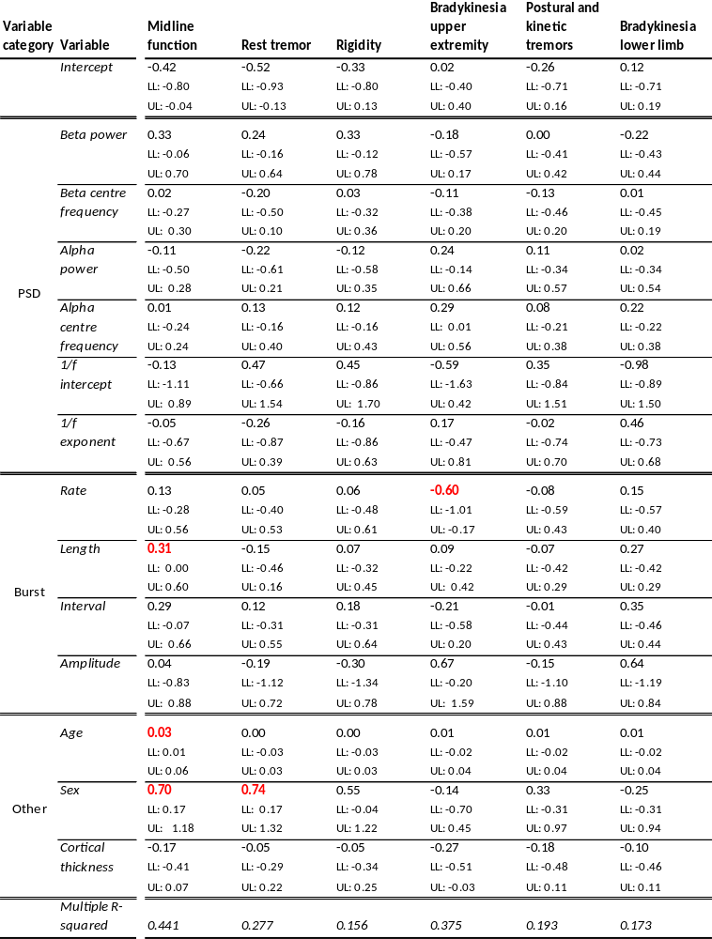

Bayes factors
Table S3: Bayes factors for the analysis of the effect of Group, Age, Sex, and Cortical Thickness on signal features (columns). BFs indicate comparisons for models with and without the factors in the rows in descending order. Red numbers indicate BF above the threshold (BF > 3) for substantial evidence for an effect. Blue numbers indicate BF below the threshold (BF < 1/3) for substantial evidence for no effect. Black numbers indicate BF in the inconclusive range (1/3 < BF < 3).
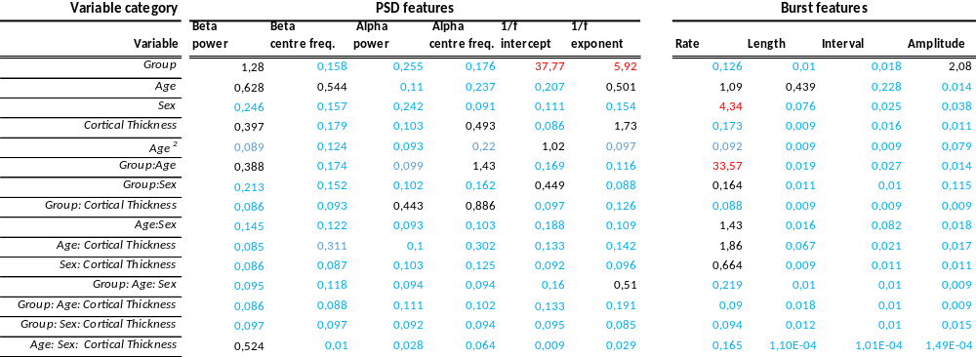

Table S4: Bayes factors for the analysis of signal features on clinical ratings of motor symptoms in the PD group. BFs indicate comparisons for models with and without the factors in the rows in descending order. Red numbers indicate BF above the threshold (BF > 3) for substantial evidence for an effect. Blue numbers indicate BF below the threshold (BF < 1/3) for substantial evidence for no effect. Black numbers indicate BF in the inconclusive range (1/3 < BF < 3).
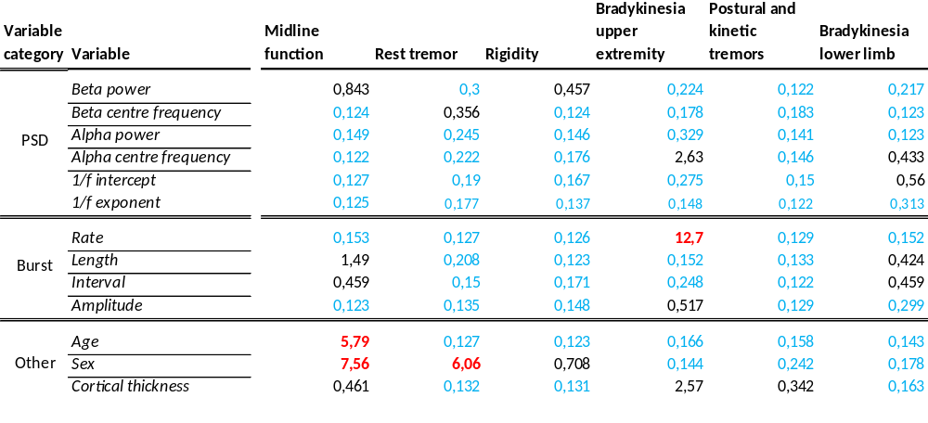

Correlation between variables
Table 5: Statistically significant (p < 0.05) correlation coefficients between all main variables. Green colours indicate a positive correlation between variables, and red colours indicate a negative correlation between variables—the intensity of the colour scales with the correlation coefficient.
