Supplementary Information
Multiplexed DNA-functionalized graphene sensor with artificial intelligence discrimination performance of chemical vapor composition

Gilho Lee‡, Heejin Yu‡, Yun Ji Hwang‡, Jin Seong, Youngmo Jung, Jongeun Choi*, and Seong Chan Jun*

G. Lee, H. Yu, Y. J. Hwang, J. Seong, Y. Jung, J. Choi, S. C. Jun
School of Mechanical Engineering, Yonsei University, 50, Yonsei-ro, Seodaemun-gu, Seoul 03722, Republic of Korea

‡ These authors contributed equally.

*Corresponding author
Seong Chan Jun
Tel: +82-2-2123-5817; E-mail: scj@yonsei.ac.kr

Jongeun Choi
Tel: +82-2-2123-2813; E-mail: jongeunchoi@yonsei.ac.kr

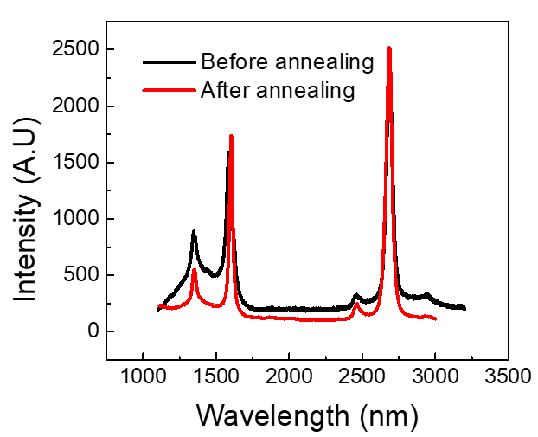
Figure S1. Changes in Raman spectra of monolayer graphene before and after annealing.

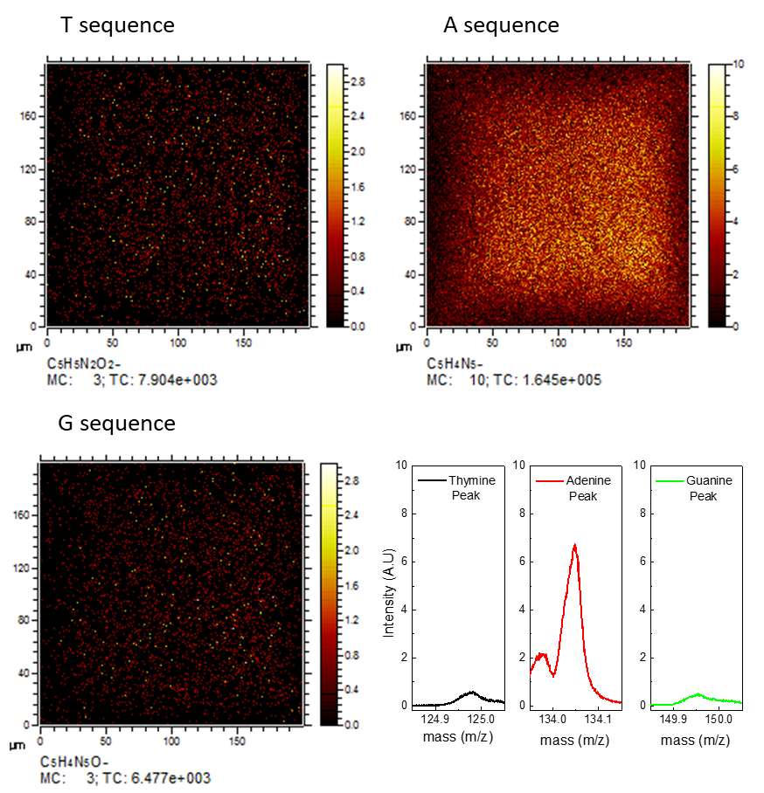
Figure S2. TOF-SIMS image and peak of sensing channel in A6 DNA sequence.

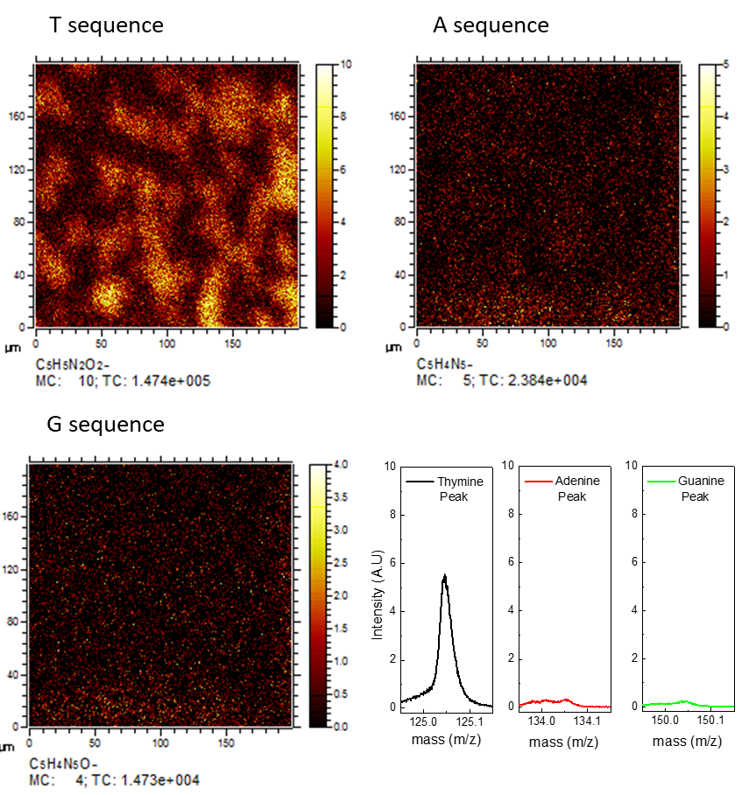
Figure S3. TOF-SIMS image and peak of sensing channel in T6 DNA sequence.

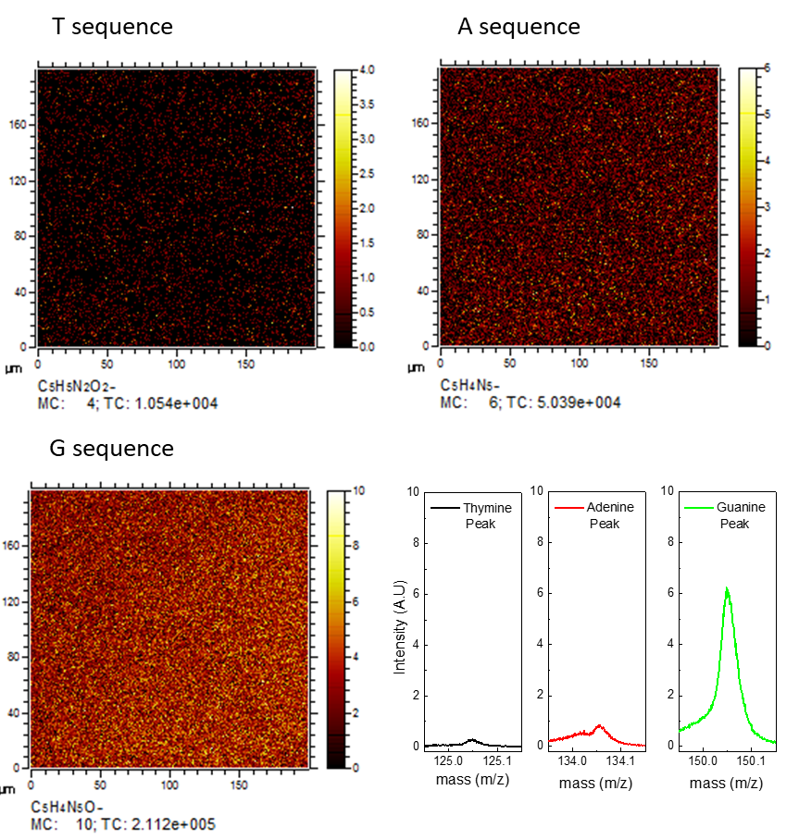
Figure S4. TOF-SIMS image and peak of sensing channel in G6 DNA sequence.

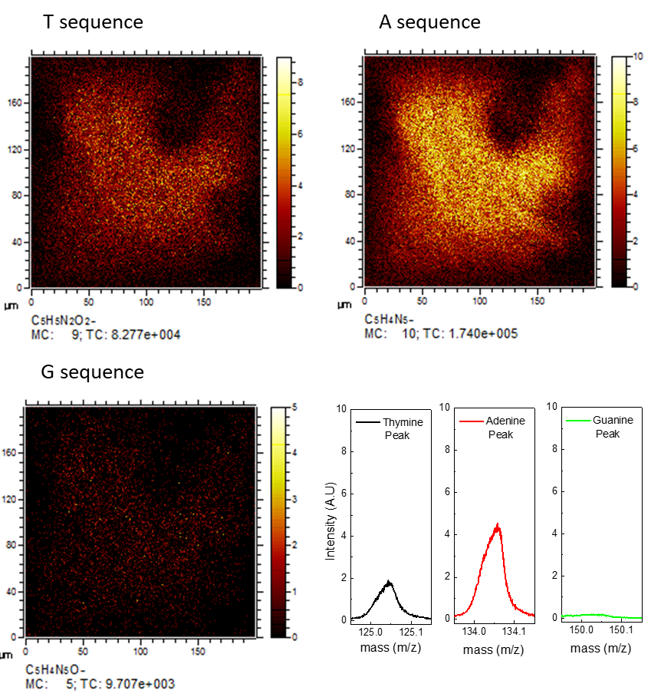
Figure S5. TOF-SIMS image and peak of sensing channel in A6T6 DNA sequence.

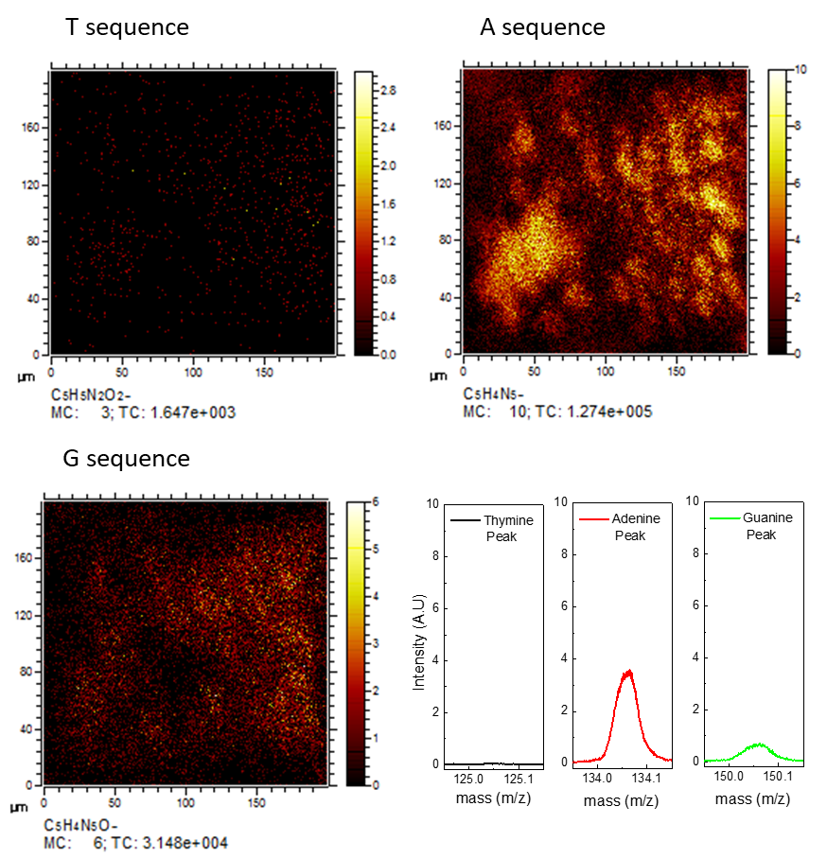
Figure S6. TOF-SIMS image and peak of sensing channel in A6G6 DNA sequence.

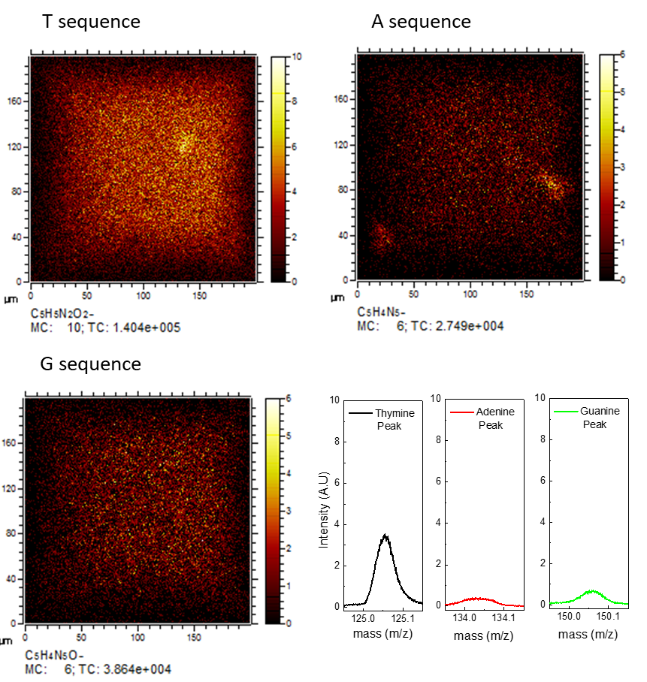
Figure S7. TOF-SIMS image and peak of sensing channel in T6G6 DNA sequence.

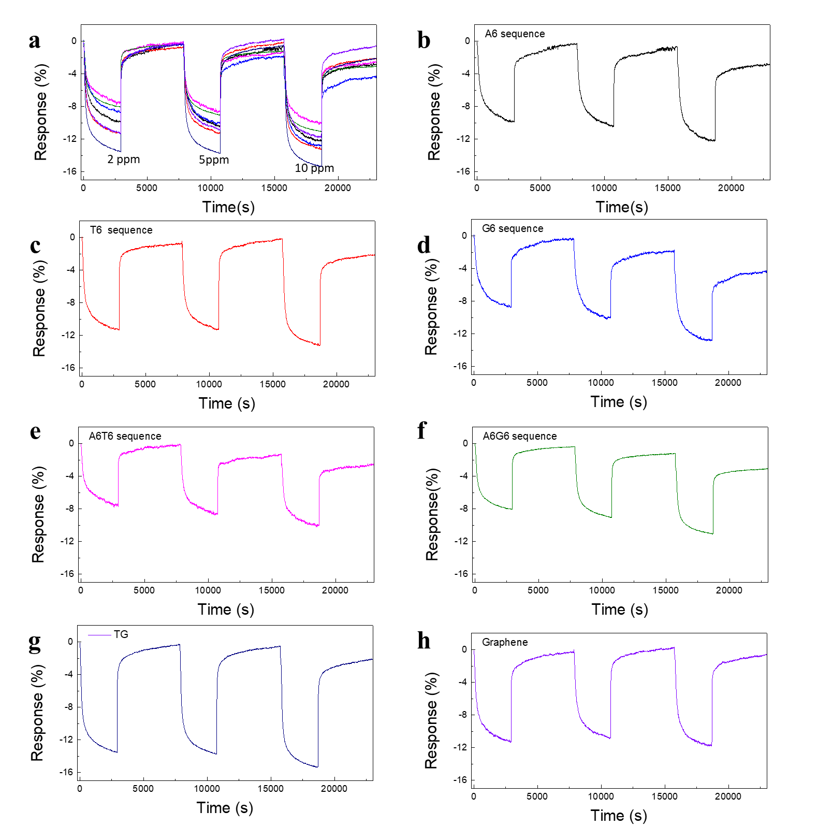
Figure S8. Response of NH₃ individual gas under low-humidity condition.

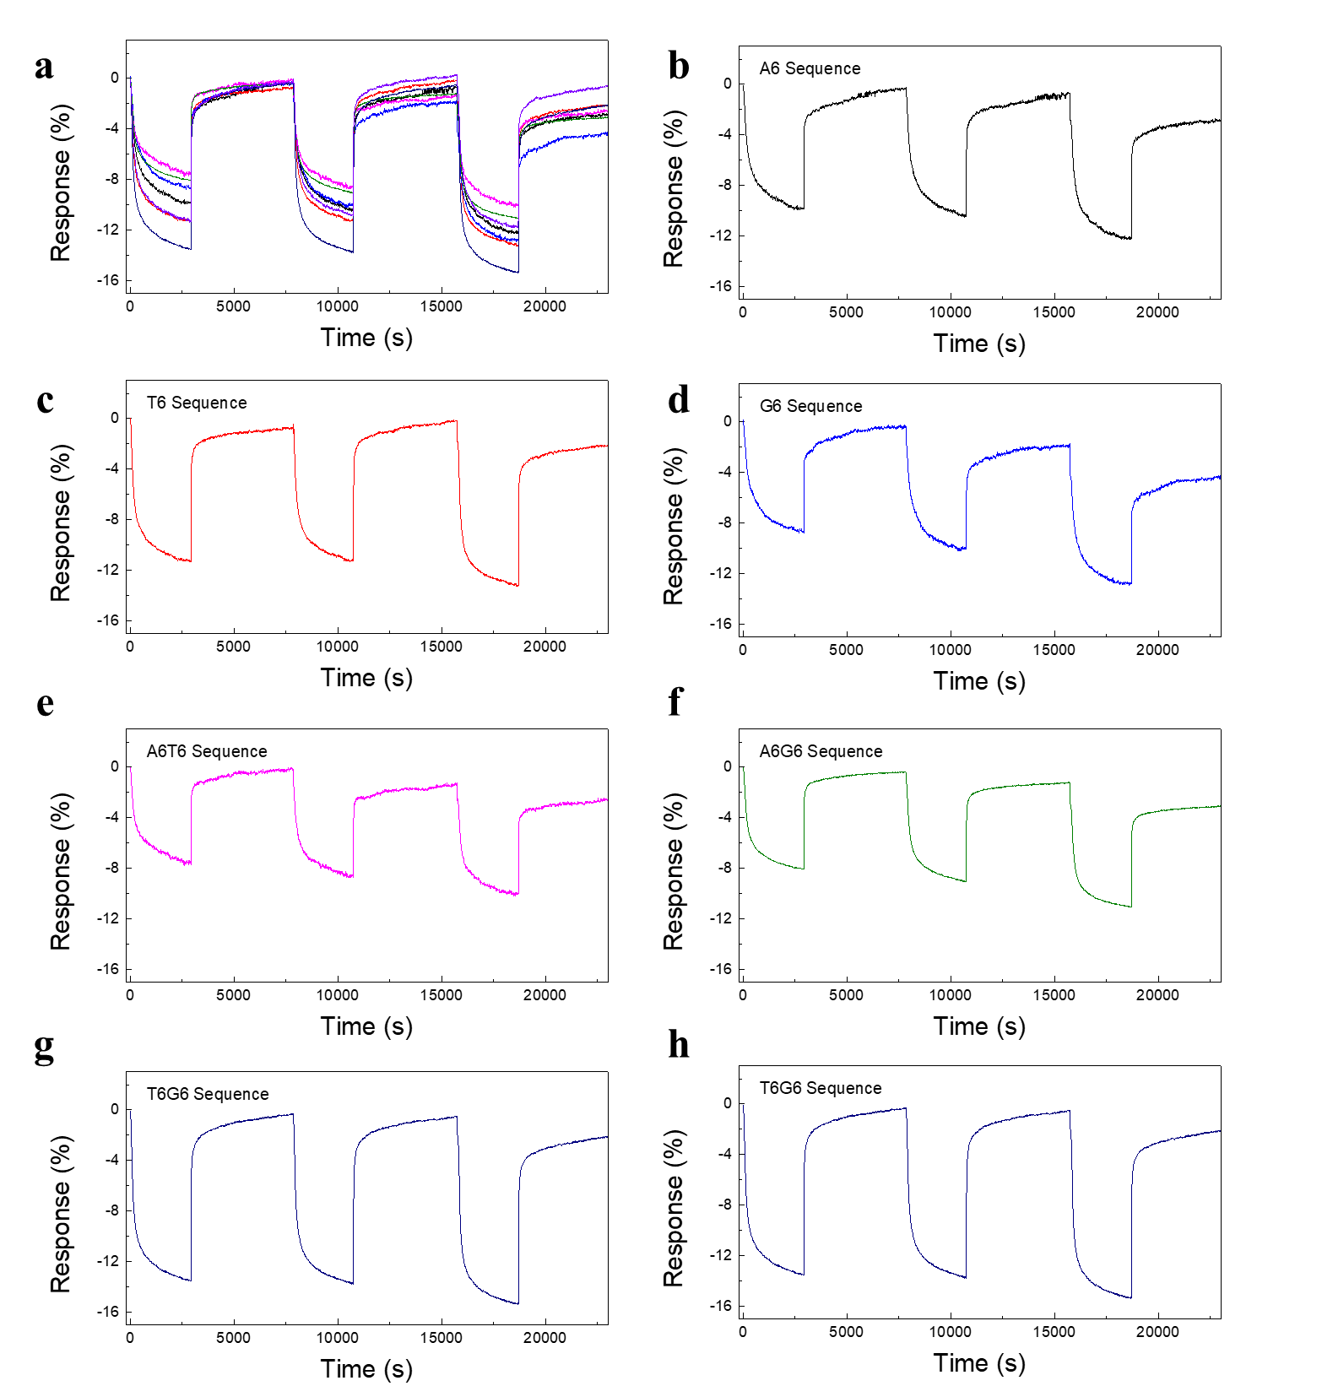
Figure S9. Response of NO₂ individual gas under low-humidity condition.

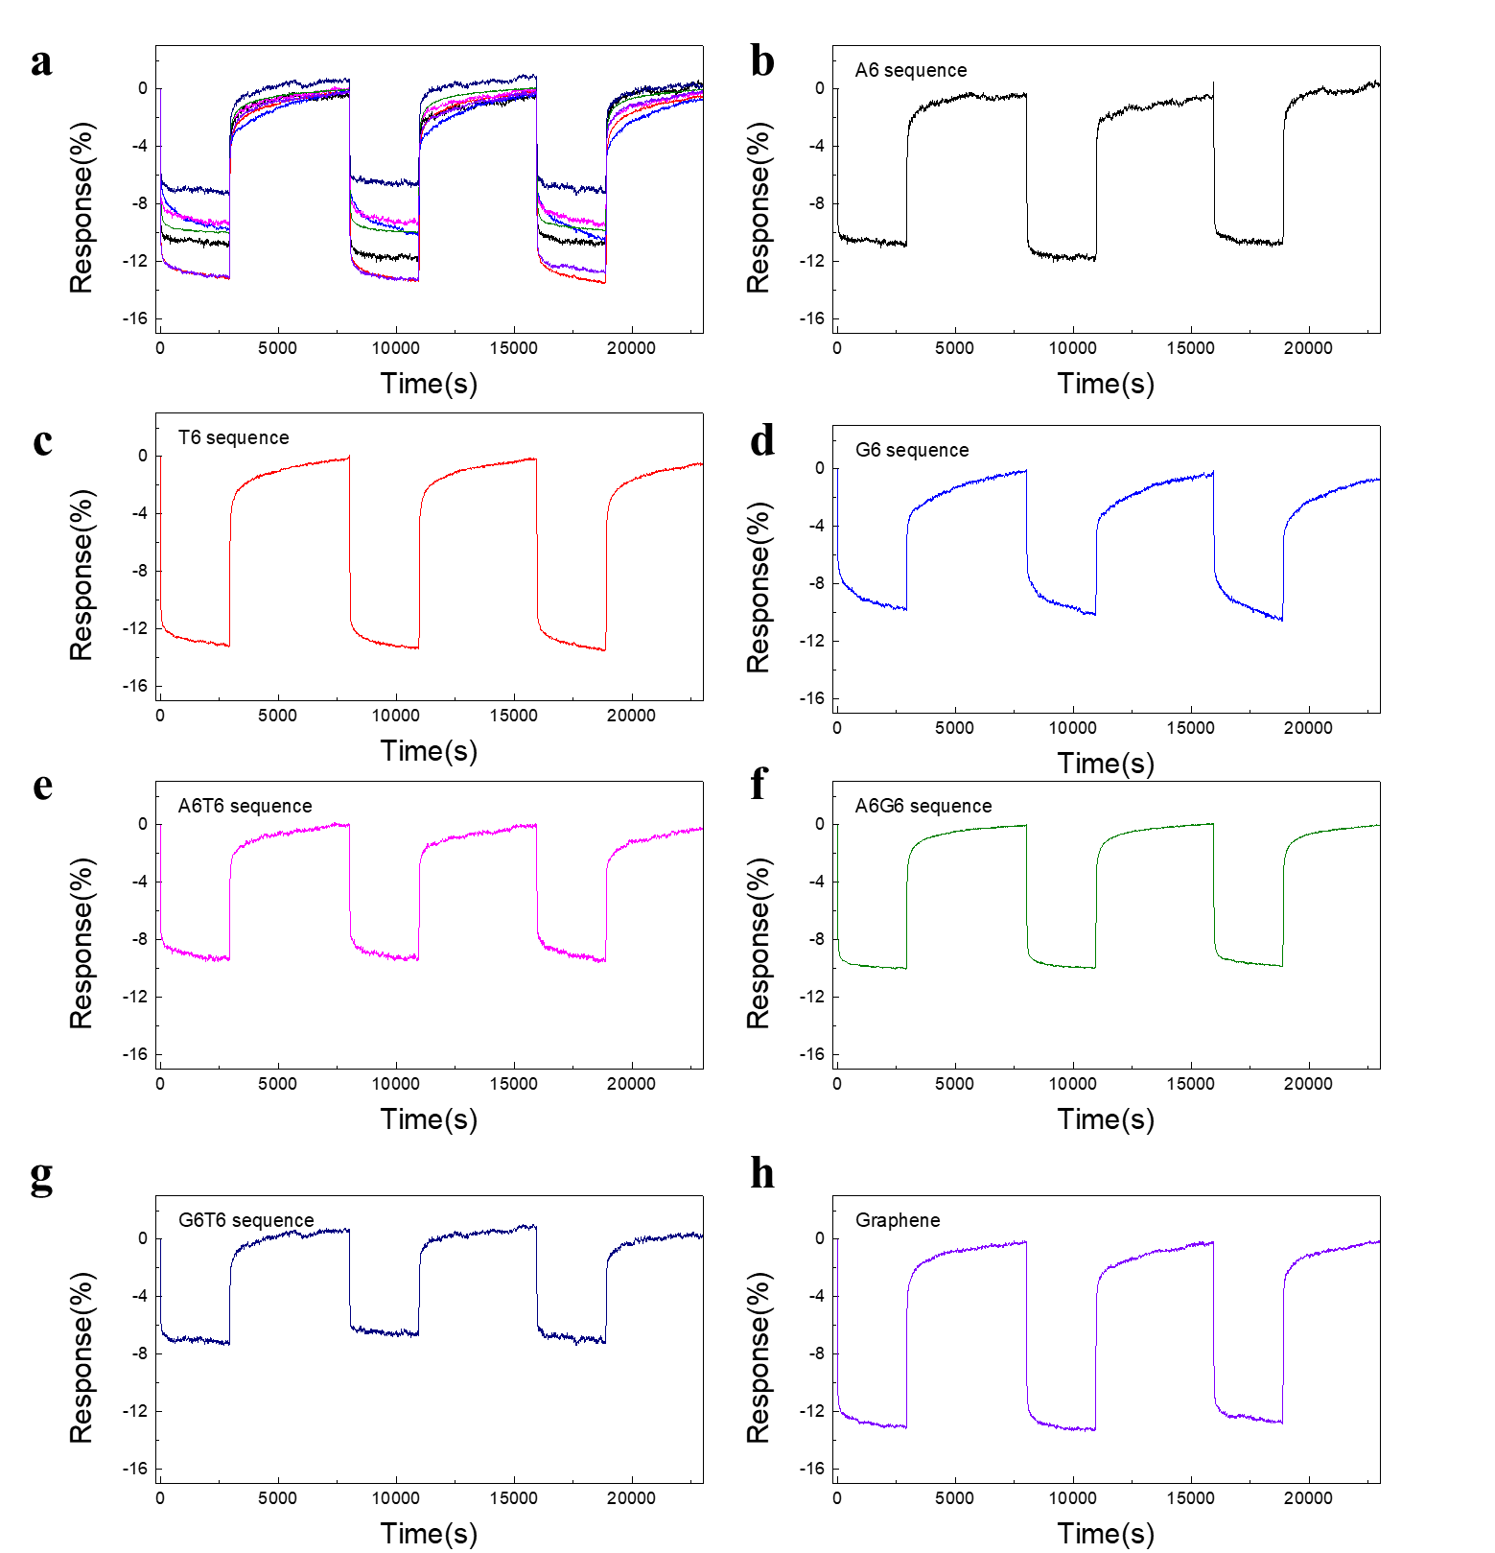
Figure S10. Response of individual NO gas under low-humidity condition.

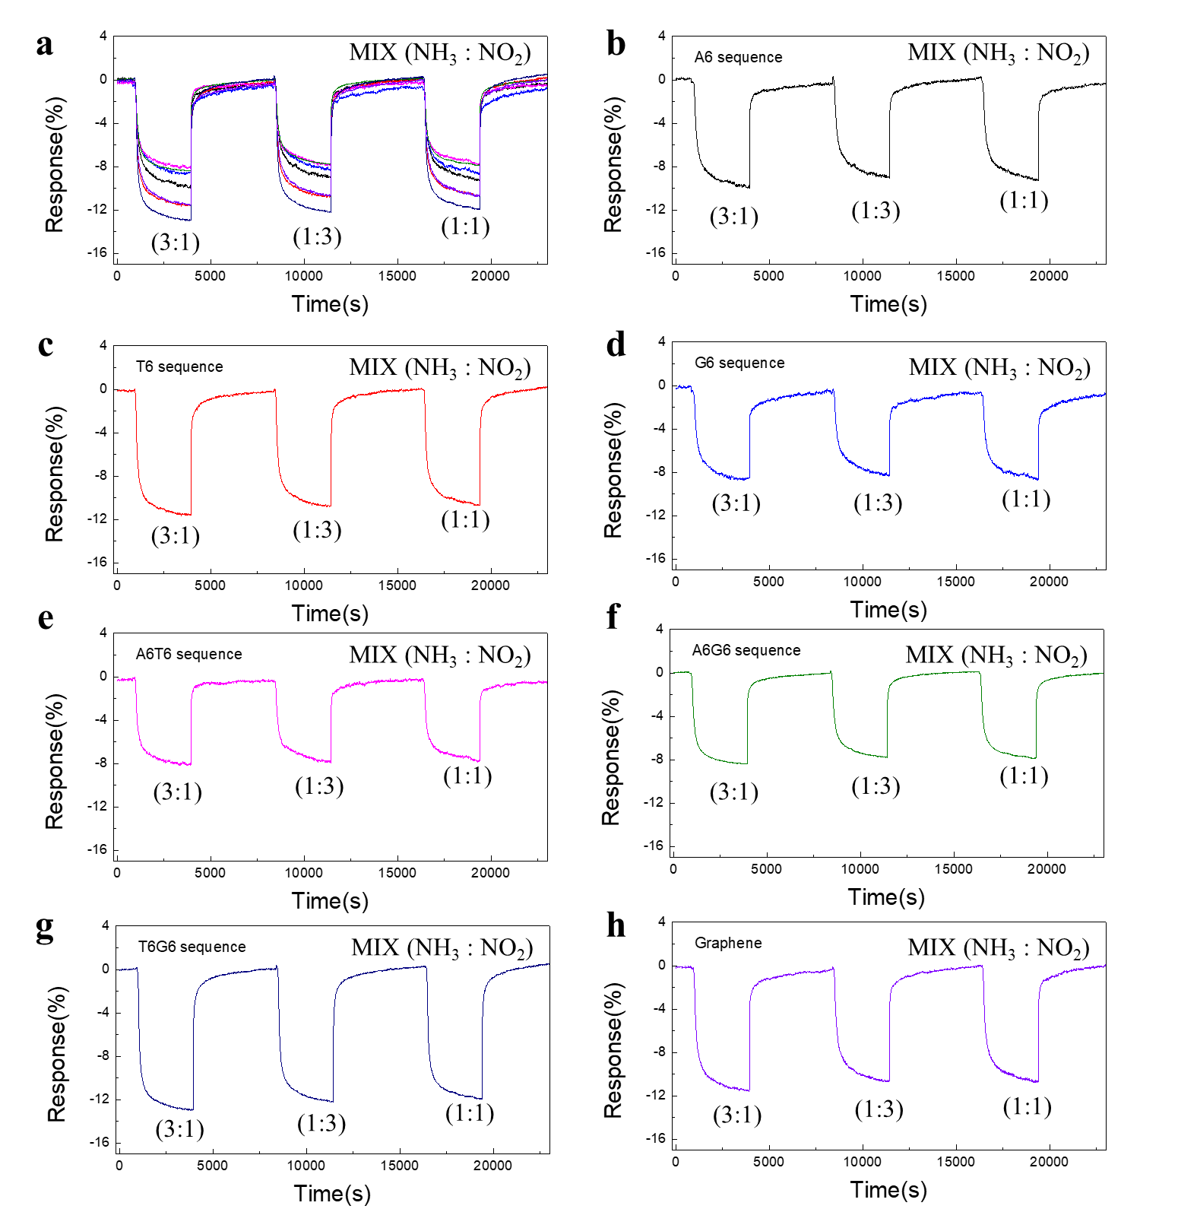
Figure S11. Response of NH₃–NO₂ mixed gases under low-humidity condition.

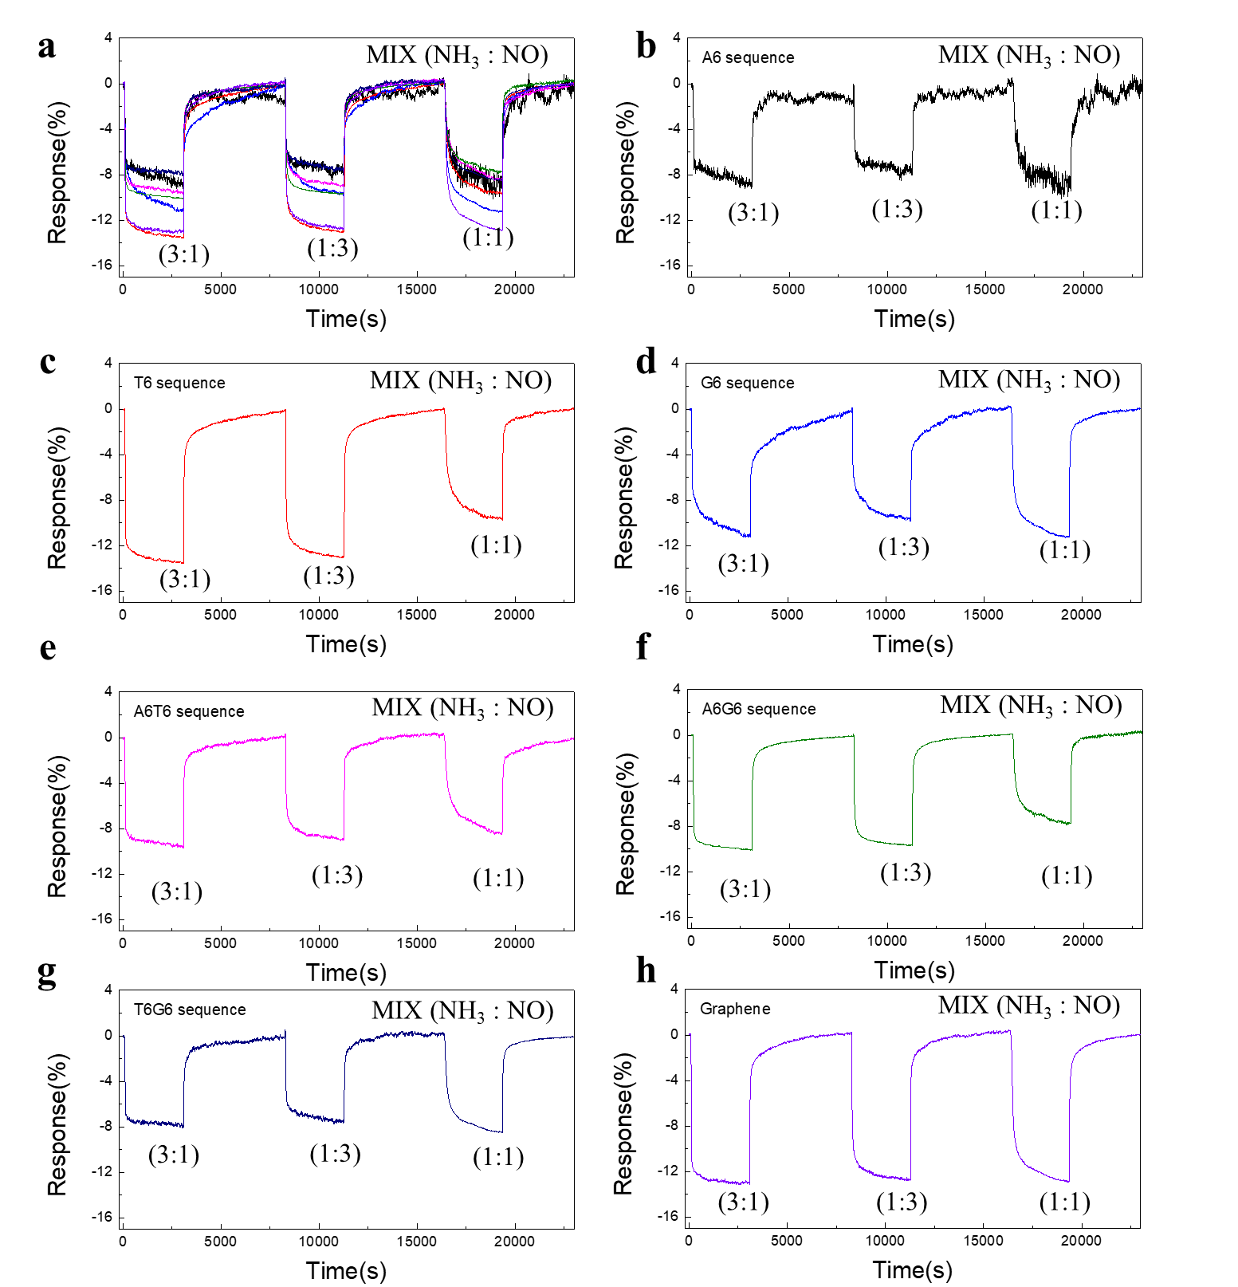
Figure S12. Response of NH₃–NO mixed gases under low-humidity condition.

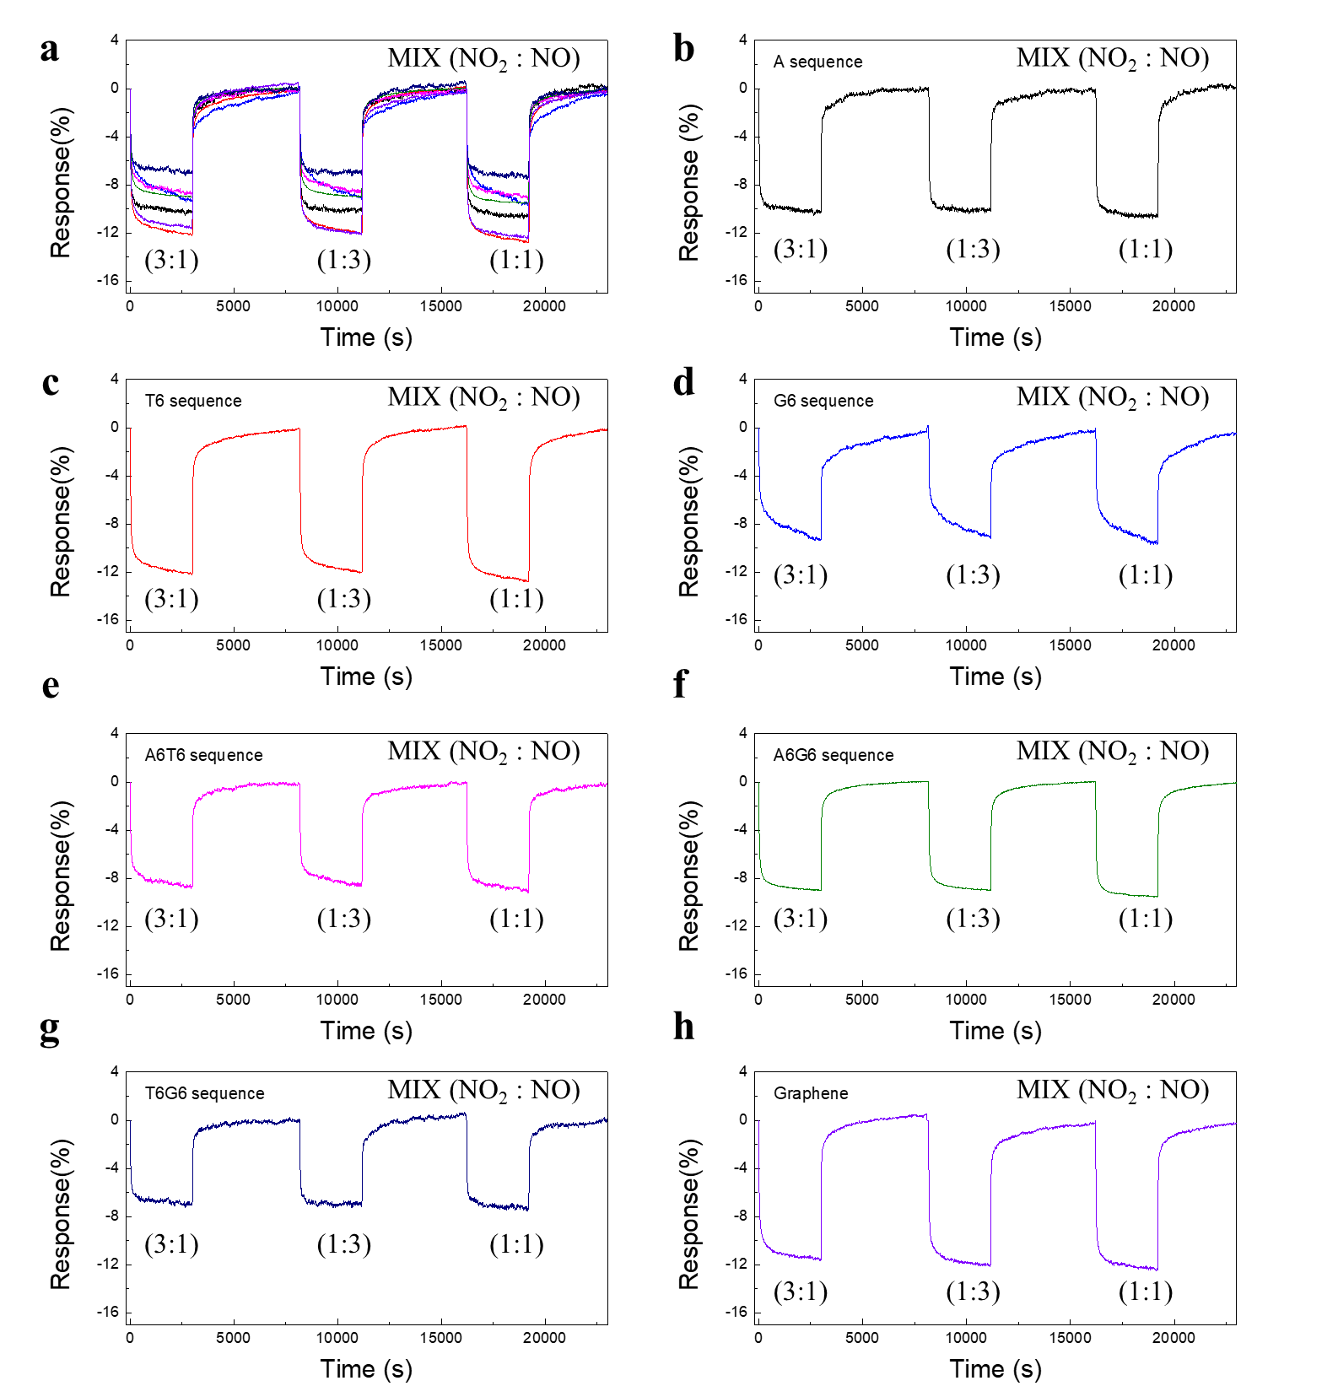
Figure S13. Response of NO₂–NO mixed gases under low-humidity condition.

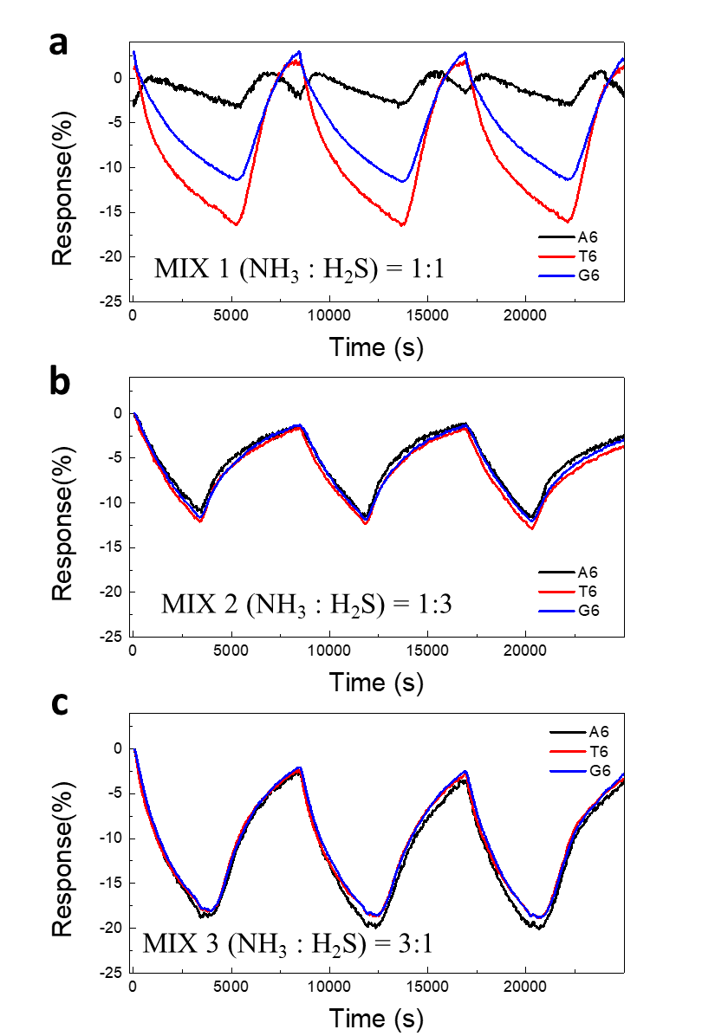
Figure S14. Response of NH₃–H₂S mixed gases under high-humidity condition.

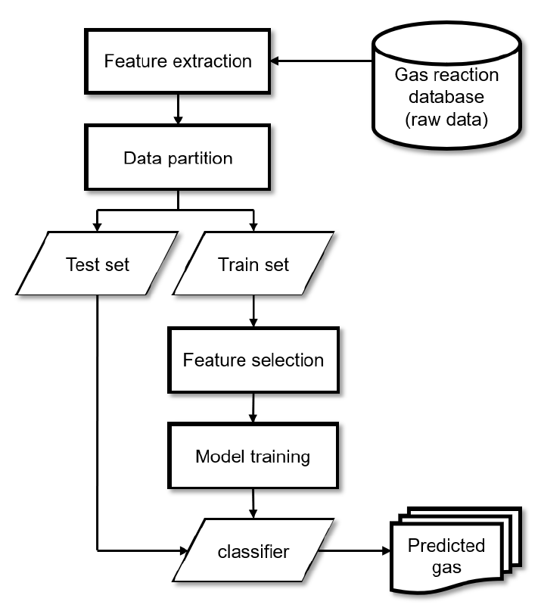
Figure S15. Feature selection analysis using Boruta algorithm.

Table S1. Individual and mixture gases used for measurement.
 | Individual gas |  |  |  | Mixture gas
Species | NO₂ | NO | NH₃ | Species | NO₂/NO | NO₂/NH₃ | NO/NH₃
Concentration [ppm] | 2, 5, 10 |  |  | Mixing Ratio | 5:5, 2.5:7.5, 7.5:2.5

Table S2. Feature description
Feature | Description | Number of features
Magnitude | Down-sampled values of the magnitude  The maximum or minimum magnitude  Down-sampled values of the normalized magnitude | 31  1  31
Derivative | Down-sampled values of derivative D  The maximum and minimum derivatives  The maximum and minimum second derivative during both injection and purging stages | 31  2  4
Difference | The difference (D) in magnitude | 5
Time constant | The time when the reaction reaches 30%, 60%, 90%, and 100% of its maximum or minimum value (and 90%, 60%, and 30% of its maximum or minimum value during the purging stage) | 7
Area | The area under the eight intervals of the curve, where the interval is divided by the time constant features | 8

Table S3. Accuracy of classification model with low humidity condition.
Low Humidity Condition |  | Accuracy [%]
Chemical Vapor Composition | Mixing ratio | With feature selection | With 1D CNN
NH₃–NO₂ | 1:1 | 96 | 100
NH₃–NO₂ | 1:3 | 100 | 100
NH₃–NO₂ | 3:1 | 100 | 100
NH₃–NO | 1:1 | 100 | 100
NH₃–NO | 1:3 | 100 | 100
NH₃–NO | 3:1 | 100 | 100
NO₂–NO | 1:1 | 100 | 100
NO₂–NO | 1:3 | 99.5 | 100
NO₂–NO | 3:1 | 100 | 100

Table S4. Performance of classification model with low humidity condition.
 | With feature selection |  |  |  | Using all features
Chemical Vapor Composition | Precision  [%] | Recall  [%] | F1 score  [%] | Compression ratio | Precision  [%] | Recall  [%] | F1 score  [%] | Compression ratio
NO₂–NH₃ | 98.67 | 98.67 | 98.69 | 7.01 | 98.14 | 98.08 | 98.11 | 1
NO–NH₃ | 100 | 100 | 100 | 4.62 | 100 | 100 | 100 | 1
NO–NO₂ | 99.33 | 99.83 | 99.85 | 6.02 | 99.48 | 99.47 | 99.47 | 1

Table S5. Accuracy of classification model with high humidity condition.
High Humidity Condition |  | Accuracy [%]
Chemical Vapor Composition | Mixing ratio | With feature selection | With 1D CNN
NH₃–H₂S | NH₃ | 85 | 100
NH₃–H₂S | H₂S | 96.5 | 100
NH₃–H₂S | 1:1 | 100 | 100
NH₃–H₂S | 1:3 | 100 | 100
NH₃–H₂S | 3:1 | 100 | 100
NH₃–NO | NH₃ | 100 | 100
NH₃–NO | NO | 99.83 | 100
NH₃–NO | 1:1 | 100 | 100
NH₃–NO | 1:3 | 100 | 100
NH₃–NO | 3:1 | 96.83 | 100
H₂S–NO | H₂S | 100 | 100
H₂S–NO | NO | 99 | 100
H₂S–NO | 1:1 | 100 | 100
H₂S–NO | 1:3 | 100 | 100
H₂S–NO | 3:1 | 100 | 100

Table S6. Performance of classification model with high humidity condition.
 | Classification Accuracy [%]
Chemical Vapor Composition | With feature selection | Using all features
NH₃–H₂S | 100 | 100
NH₃–NO | 98.94 | 97.23
H₂S–NO | 100 | 100

