Supporting Information

Lactate as a major epigenetic carbon source for histone acetylation via nuclear LDH metabolism

Yong Jin An,¹ Sihyang Jo,¹ Jin-Mo Kim,¹ Han Sun Kim,¹ Hyun Young Kim,² Sang-Min Jeon,³ Dawool Han,⁴ Jong In Yook,⁴ Keon Wook Kang,² Sunghyouk Park^{1*}

¹Natural Product Research Institute, College of Pharmacy, Seoul National University, 1, Gwanak-ro, Gwanak-gu, Seoul 08826, Korea.
²College of Pharmacy, Seoul National University, 1, Gwanak-ro, Gwanak-gu, Seoul 08826, Korea.
³College of Pharmacy and Institute of Pharmaceutical Science and Technology, Ajou University, 206, World cup-ro, Yeongtong-gu, Suwon-si, Gyeonggi-do 16499, Korea.
⁴Department of Oral Pathology, Oral Cancer Research Institute, Yonsei University College of Dentistry, 50, Yonsei-ro, Seodaemun-gu, Seoul 03722, Korea.

*Corresponding author:
Sunghyouk Park
Natural Product Research Institute, College of Pharmacy, Seoul National University, Gwanak-ro 1, Gwanak-gu, Seoul, 08826, Korea.
Phone: +82-2-880-7831
Fax: +82-2-880-7831
Email: psh@snu.ac.kr

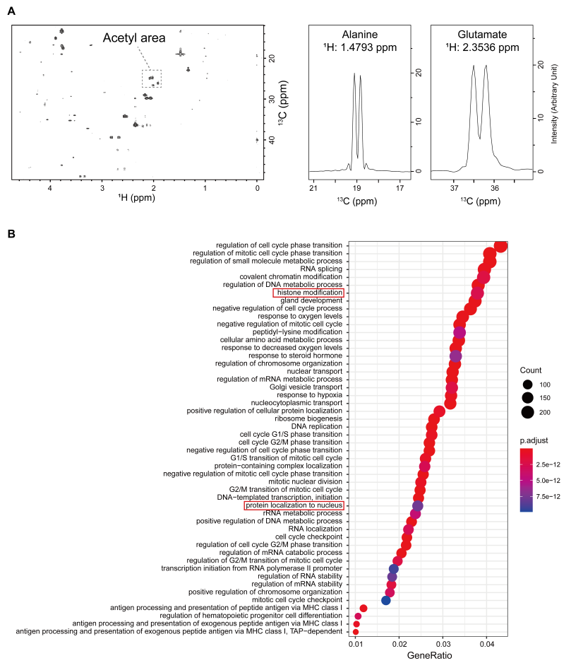
Figure S1. ¹H-¹³C 2D HSQC for water-soluble extracts from PANC-1 cells and genes affected by external lactate. (A) ¹H-¹³C 2D HSQC spectrum of the water-soluble extracts (left). 1D slice along the carbon dimension of the peaks for alanine (middle) and glutamate (right). (B) Gene ontology enrichment analysis for MCF-7 cells treated with 10 mM lactate. The raw data is from GSE29406 dataset.
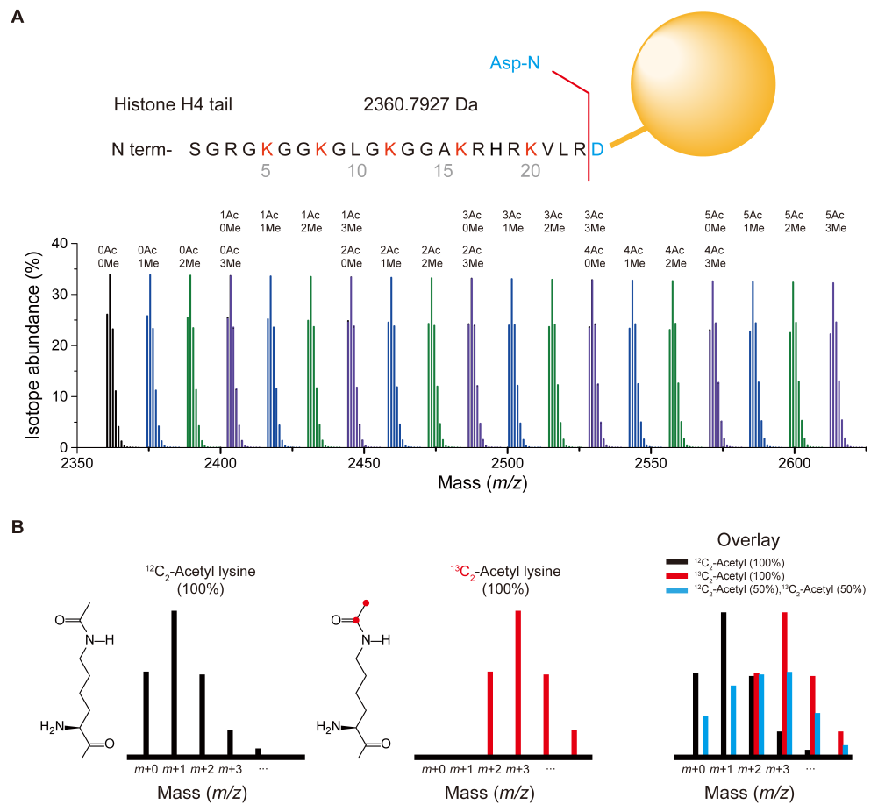
Figure S2. Analysis of ¹³C-carbon incorporation into Histone H4 tail using Asp-N and MALDI-TOF. (A) The primary sequence of H4 tail and the cleavage site of Asp-N. Theoretical patterns of the MALDI-TOF spectrum from various combinations of H4 methylation and acetylation with Asp-N digestion. Scales are for within-cluster only, and not for inter-cluster comparison. (B) Theoretical isotopomers peak patterns of a peak cluster according to the ¹³C-acetyl incorporation. Left: 100% ¹²C-actyl group; Middle: 100% ¹³C-acetyl group denoted by red dots; Right: overlay of 100% ¹²C, ¹³C, and 50% ¹³C-acetylation.

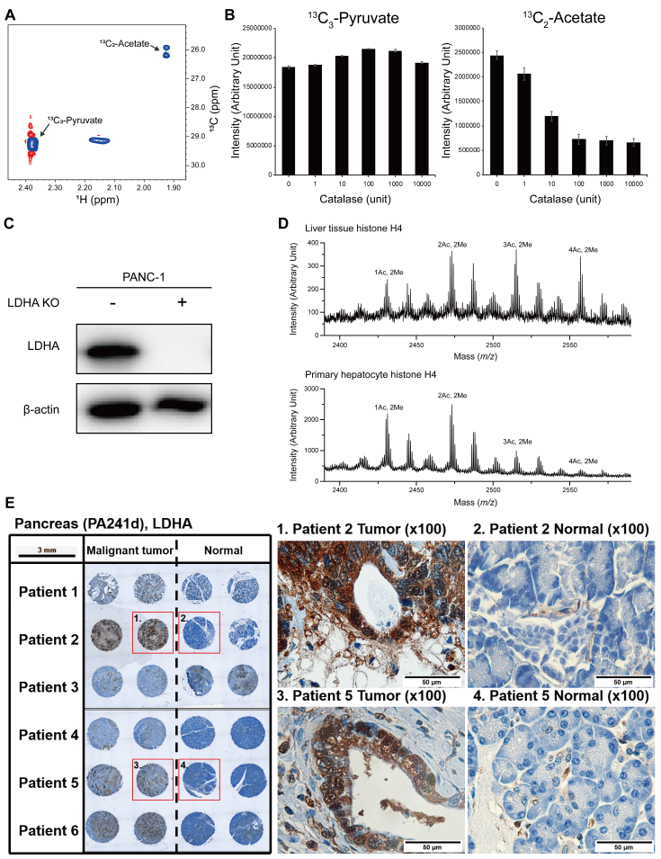
Figure S3. Verification of histone modification by lactate metabolism of nuclear LDHA and increase of nuclear LDHA localization in human cancer tissue. (A) ¹H-¹³C 2D HSQC spectrum of pyruvate incubated for overnight and the non-enzymatic formation of acetate. (B) Suppression of non-enzymatic pyruvate degradation into acetate by catalase, as measured by the intensities of the NMR peak on ¹H-¹³C 2D HSQC spectra. (C) Expression of LDHA observed with western blot in WT and KO cells obtained with CRISPR-Cas9. MALDI-TOF spectra of H4 tails obtained from liver tissue and primary hepatocyte cultured in vitro (D). H4 tails were obtained by the Asp-N treatment. (E) Cancer and normal adjacent tissues from a pancreatic cancer tissue array (PA241d) were stained with an LDHA antibody. Two regions per tumor and normal tissues were stained as shown on the left. Middle and right images are the magnified ones for the red boxed images on the left.
* Our re-evaluation of the pathology revealed that the patient 3 samples in the purchased array did not contain normal pancreatic cells. Therefore, the patient 3 samples should not be considered for cancer vs. normal comparison.

Table S1. Concentrations of metabolites from water-soluble extracts of PANC-1 cells.
Compound Name | Concentration  (pM/Cell) | Compound Name | Concentration  (pM/Cell)
myo-inositol | 7.61 | Isoleucine | 0.80
Glutamate | 6.46 | Ethanol | 0.77
O-phosphocholine | 3.89 | Creatine phosphate | 0.67
Glucose | 3.42 | Creatine | 0.67
Glutamine | 2.76 | N-Acetyl-aspartate | 0.63
GSH | 2.54 | Valine | 0.54
Lactate | 2.22 | Alanine | 0.52
Threonine | 1.92 | Phenylalanine | 0.27
Glycine | 1.56 | NAD⁺ | 0.27
Taurine | 1.33 | Pyruvate | 0.25
Proline | 1.31 | Choline | 0.21
Glycero-3-phosphocholine | 1.24 | UDP-N-Acetyl-glucosamine | 0.20
Aspartate | 1.19 | Tyrosine | 0.19
ANP | 0.98 | Acetate | 0.09
Leucine | 0.85
The metabolites were measured and identified with 1D NMR using in-house database and by comparison with standard compounds. The concentrations were calculated with Chenomx software (Edmonton, Alberta, Canada).

Table S2. The ¹³C₃-lactate incorporation ratio into histone H4 in mouse liver.
¹³C incorporation  ratio (%) |  | 10 mg ¹³C₃-lactate |  | 20 mg ¹³C₃-lactate
 |  | 1 hr | 4 hr | 1 hr | 4 hr
2Me | 2Ac | 4.4±4.2 | 6.2±5.2 | 14.6±4.4 | 34.0±21.3
2Me | 3Ac | 9.3±1.9 | -0.4±2.4 | 31.4±11.0 | 37.4±7.8
2Me | 4Ac | -6.7±3.1 | -0.4±3.8 | Overlap | Overlap
¹³C₃-lactate at doeses of 0.5 and 1 g/kg were injected into tail veins, and mice were sacrificed at 0, 1, 4 hr time points. Liver tissues were obtained and analyzed for ¹³C labeled histone with MALDI-TOF. Each cluster was normalized by the sum of the total intensity of the cluster, and the incorporation was calculated by the ratio of decrease in the M+0 peak.

Table S3. The ¹³C₃-lactate incorporation ratio into histone H4 in primary and transformed liver cells.
¹³C incorporation ratio (%)* |  | Primary | NKNT-3 | HepG2
2Me | 1Ac | 7.1±3.2 | 8.9±2.3 | 14.8±2.7
2Me | 2Ac | 6.5±2.2 | 35.8±1.7 | 47.6±2.7
2Me | 3Ac | 12.9±6.5 | 46.3±2.7 | 59.7±2.9
2Me | 4Ac | 16.1±11.8 | 46.2±4.0 | 49.0±4.8
¹³C₃-lactate (10 mM) was treated to the cells overnight, and the H4 incorporation was analyzed with MALDI-TOF spectrum on the Asp-N digest of the H4 tail. The incorporation was calculated as in Supplementary Table 2. * Mean ± standard deviation.

Table S4. Expression of LDHA in the nucleus of human normal and cancer tissues.
Tissue | LDHA antibody | Intensity | Nucleus LDHA /  Number of patients | Percent
Cancer liver | CAB015336 | Moderate | 11 / 11 | 100%
Cancer liver | CAB069404 | Strong, Moderate, Weak | 7 / 12 | 58.3%
Normal liver | CAB015336 | Moderate | 3 / 3 | 100%
Normal liver | CAB069404 | Strong | 0 / 3 | 0%
Cancer pancreas | CAB015336 | Weak, Moderate | 10 / 10 | 100%
Cancer pancreas | CAB069404 | Strong | 3 / 8 | 37.5%
Normal pancreas | CAB015336 | Weak | 0 / 3 | 0%
Normal pancreas | CAB069404 | Moderate | 0 / 3 | 0%
The images and localization annotation of LDHA from immunohistochemistry data in Human protein atlas (proteinatlas.org) were analyzed. The nucleus LDHA information is as annotated in the database. Two different validated antibodies were used for LDHA. The staining intensities and the ratios of the number of samples with nuclear localization to the total number of samples are given.

Table S5. Survival analysis according to the LDHA expression level in pancreatic adenocarcinoma.
 | Number of patients |  |  | Survival Statistics
 | Total | LDHA high | LDHA low | Log-rank p | HR* | HR*  (p-value)
Overall survival | 177 | 43 | 134 | 8.53E-07 | 2.82 | 2.39E-06
Disease-specific survival | 171 | 40 | 131 | 6.52E-07 | 3.18 | 2.37E-06
Disease-free interval | 69 | 20 | 49 | 1.92E-03 | 3.42 | 3.48E-03
Progression-free interval | 177 | 66 | 111 | 4.80E-05 | 2.20 | 7.22E-05
The survival data is from the TCGA pancreas adenocarcinoma cohort. The LDHA high and low groups were divided to give the optimum p-value. *HR = Hazard Ratio.

