Supplementary Information
Nanonitrator: novel enhancer of inorganic nitrate’s protective effects, predicated on deep learning approach

Wen Pan^{1,12}, Geng Hu^{2,12}, Shaorong Li^{1,3,12}, Guoqing Li⁴, Xiaoyu Feng^{1,5}, Zhifang Wu¹, Hua Jin^{3,6}, Guangyong Sun^{3,6}, Dong Zhang^{1,3,6}, Lizheng Qin^{1,7}, Xue Wang¹, Liang Hu^{1,7}, Junji Xu^{1,3}, Lei Hu^{1,3}, Yijiang Jia^{8,9}, Jingsong Wang^{1,10}, Chunmei Zhang^{1,10}, Wenbin Li^{1,11}, Jian Zhou¹, Xiaogang Wang^{1,2}*, Yuji Wang^{1,8,9}* & Songlin Wang^{1,3,10,11}*
¹Salivary Gland Disease Center and Beijing Key Laboratory of Tooth Regeneration and Function Reconstruction, School of Stomatology, Beijing Laboratory of Oral Health, Capital Medical University, Beijing, 100050, China.
²Key Laboratory of Big Data-Based Precision Medicine, School of Engineering Medicine, Beihang University, Beijing, 100191, China.
³Immunology Research Center for Oral and Systemic Health, Beijing Friendship Hospital, Capital Medical University, Beijing, 100050, China.
⁴Department of Dental Implantology, The Affiliated Stomatological Hospital of Nanjing Medical University, Nanjing, Jiangsu, 210029, China.
⁵Department of Pediatric Dentistry, School of Stomatology, Capital Medical University, Beijing, 100050, China.
⁶Beijing Key Laboratory of Tolerance Induction and Organ Protection in Transplantation, Beijing, 100050, China.
⁷Department of Oral Maxillofacial Surgery, Capital Medical University School of Stomatology, Beijing, 100050, China.
⁸School of Pharmaceutical Sciences, Capital Medical University, Beijing, 100069, China.
⁹Beijing Area Major Laboratory of Peptide and Small Molecular Drugs, Engineering Research Center of Endogenous Prophylactic of Ministry of Education of China, Beijing, 100069, China.
¹⁰Department of Biochemistry and Molecular Biology, School of Basic Medical Sciences, Capital Medical University, Beijing, 100069, China.
¹¹Laboratory for Oral and General Health Integration and Translation, Beijing Tiantan Hospital, Capital Medical University, Beijing, 100070, China.

¹²These authors contributed equally to this work.
*Corresponding authors’ email addresses: xiaogangwang@buaa.edu.cn (XW); wangyuji@ccmu.edu.cn (YW); slwang@ccmu.edu.cn (SW)

Inventory of Supplementary Information
Supplementary Methods
Supplementary Figure 1 to 9
Supplementary Table S1
Supplementary Data File 1. List of all drugs screened with DLCDPS
Supplementary Data File 2. Prediction result scores 1.0 from drug-drug network
Supplementary Data File 3. Prediction result scores 2.0 from drug-pathway network
Supplementary Data File 4. Prediction result scores 3.0 from drug-target network
Supplementary Data File 5.Analysis of the comprehensive scores predicted by system and drugs pharmacology from DrugBank

Supplementary Methods
Use of artificial intelligence methods to develop deep learning–based combination drug prediction system
XGBoost used in the DDN of DLCDPS is an integrated model that is composed of integrates multiple tree models. It belongs to the integrated decision tree method, and its training data comprised more than 50,000 samples. Suppose there are k trees in total and f represents the basic tree model, the following formula can be used to calculate the sum of the scores predicted by K trees:
$$\hat{y}=\sum_{k=1}^{K}{f_{k}(x_{i}),f_{k}∈F}$$
where x_{i} is the i-th training sample, f_{k}(x_{i}) is the score value for the k-th tree model, and F is the space of functions containing all regression trees.
We used the area under the ROC curve (AUC) as evaluation criterion in our DDN and DPN, and sensitivity of AUC represents the proportion of positive samples in all cases to be recognized, specificity of AUC is the proportion of all negative cases in the sample.
$$sensitive=\frac{TP}{TP+FN}$$
$$specificity=\frac{TN}{TN+FP}$$
In the DPN of DLCDPS, transformer was the deep learning pretrained model used to produce molecular characteristics, while normalization of the loss of function was used to make the model learn faster. The training data of the DPN consisted of more than 60,000 samples. The rectified linear unit based on functions is widely used as an activation function of hidden layers, and the softmax function was used for the output layers. The following formula of softmax measures whether the model is suitable for training set data:
$$L_{s}=-\frac{1}{n}\sum_{i=1}^{n}{\lg{\frac{e^{W_{y_{i}}^{T}x_{i}+b_{y_{i}}}}{\sum_{j=1}^{C}{e^{W_{j}^{T}x_{i}+b_{j}}}}}}$$
where $L_{s}$ represents the loss variable, W and b are the weights obtained by the relevant network learning, n represents the total data amount, C is the total category amount, $x_{i}$ represents the matrix space of the training sample，$y_{j}$ is the label value of the training sample.
In the DTN of DLCDPS, the GCN block was used to learn the spatial relationships between the drug-target nodes, and its training data comprised more than 10,000 samples. The following formula applies:
$$h_{i}^{(l+1)}=σ(\sum_{j∈N_{i}}{\frac{1}{c_{ij}}h_{j}^{(l)}w^{(l)}})$$
Where $x_{i}^{(l+1)}$ is Characteristics of node i in layer L, $σ$ is the nonlinear transformation, and $C_{ij}$ is normalization factor, Ni is all neighbors of node i, including node itself, W(l) is the weight of layer L.

Screening for optimal ratio of nitrate to vitamin C to synthesize Nanonitrator
We attempted to manufacture a nanomolecule comprising VC, sodium nitrate, and chitosan 3000 as the core material, surrounded by a protective wall of pectin and Na-CMC. To screen for the optimal ratio of sodium nitrate to VC, we prepared different microcapsules using the following steps:
- For the core material solution, five different ratios of VC to sodium nitrate (1:1, 1:2, 1:3, 1:4, and 1:5) were prepared by dissolving VC, nitrate, and chitosan 3000 in water (final concentration of nitrate was 4 mg/mL and that of chitosan ~12 mg/mL).
- To prepare the wall material solution, we mixed equal amounts of pectin and Na-CMC (95 mg) with purified water (4.7 mL), to reach a total mass percentage concentration of the wall material in water of 2.5%.
- Equal amounts of each of the five core material solutions (ratio 1:1, 1:2, 1:3, 1:4, or 1:5) and wall material solutions were mixed evenly, freeze-dried, and crushed to obtain microcapsule 1~5.

Animals
Male C57BL/6J mice (8 weeks old and weighing 20-30 g) were obtained from Beijing Vital River Laboratory (Beijing, China). All mouse experimental animal protocols and procedures were approved by the Institutional Animal Care and Ethics Committee at Beijing Friendship Hospital (IACUC ID: 18-2009). Animal care and handling were conducted in compliance with the Ethical Guidelines for Animal Studies.

Pharmacokinetics of Nanonitrator in mice
C57BL/6J mice were given a single oral dose of 0.75 mmol/kg Nanonitrator, 0.75 mmol/kg nitrate plus VC, or 0.75 mmol/kg nitrate (n = 5). After inhalation anesthesia with isoflurane, angular vein blood was collected from mice before and after drug administration at different time points to draw a plasma NOx concentration–time curve.

Hepatic ischemia-reperfusion injury mouse model
Nanonitrator administration and induction of hepatic ischemia-reperfusion
Mice were divided into four groups (n = 5 each): (1) control group, which received sham surgery; (2) hepatic ischemia-reperfusion injury (HIRI) only group, which received ischemia surgery; (3) Nanonitrator group, which received 0.75 mmol/kg Nanonitrator daily 5 days prior to the same ischemia surgery; and (4) nitrate group, which received 0.75 mmol/kg nitrate daily 5 days prior to the same ischemia surgery. All groups had access to normal food and water.
Before surgery, mice were anesthetized and heparinized to prevent blood clotting. A midline laparotomy incision was made, after which an atraumatic clip was used to completely clamp the hepatic artery and portal vein, causing ischemia of the left lateral and median lobes of the liver. Mice were wrapped in a gauze and placed on a heating pad to maintain their body temperature at 37 °C. After 1 h, the atraumatic clip was removed to allow reperfusion, and the wound was sutured. After another 6 h, mice were anesthetized further and their liver and plasma were collected for measurement.

Plasma transaminase activity measurement
Plasma alanine aminotransferase (ALT) and aspartate aminotransferase (AST) activities were determined as quantitative indices of liver injury using the Alanine Aminotransferase Assay Kit (NJJC Bio) and Aspartate Aminotransferase Assay Kit (NJJC Bio), respectively, according to the manufacturer’s instructions.

Supplementary Figures
Supplementary Figure 1. Comprehensive schematic representation of artificial intelligence framework underlying DLCDPS. a Evaluation result of drug-drug network (DDN). ROC: receiver operating characteristic curve; AUC: area under curve; UMAP: Uniform Manifold Approximation and Projection. b Evaluation result of drug-pathway network (DPN). c Evaluation result of drug-target network (DPN). Epoch is model training time. GCN train: the change of loss function in model training process; GCN val: the change of mean square error verification index in model training process. d DDN, DPN, and DTN for protective effect of nitrate.

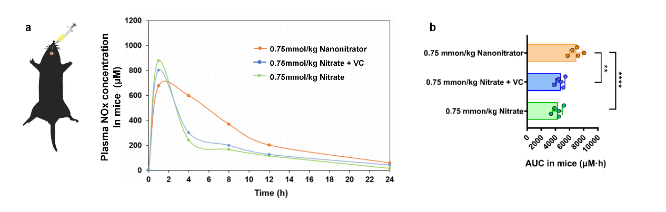
Supplementary Figure 2. Pharmacokinetics of Nanonitrator in mice. a Plasma NOx concentration–time curves after single oral dose of 0.75 mmol/kg Nanonitrator, 0.75 mmol/kg nitrate + vitamin C (VC), or 0.75 mmol/kg nitrate only was administered to C57BL/6J mice (n=5). b Area under the curve (AUC) of plasma concentration–time curves. Data are mean ± SD. **P < 0.01, ****P < 0.0001.

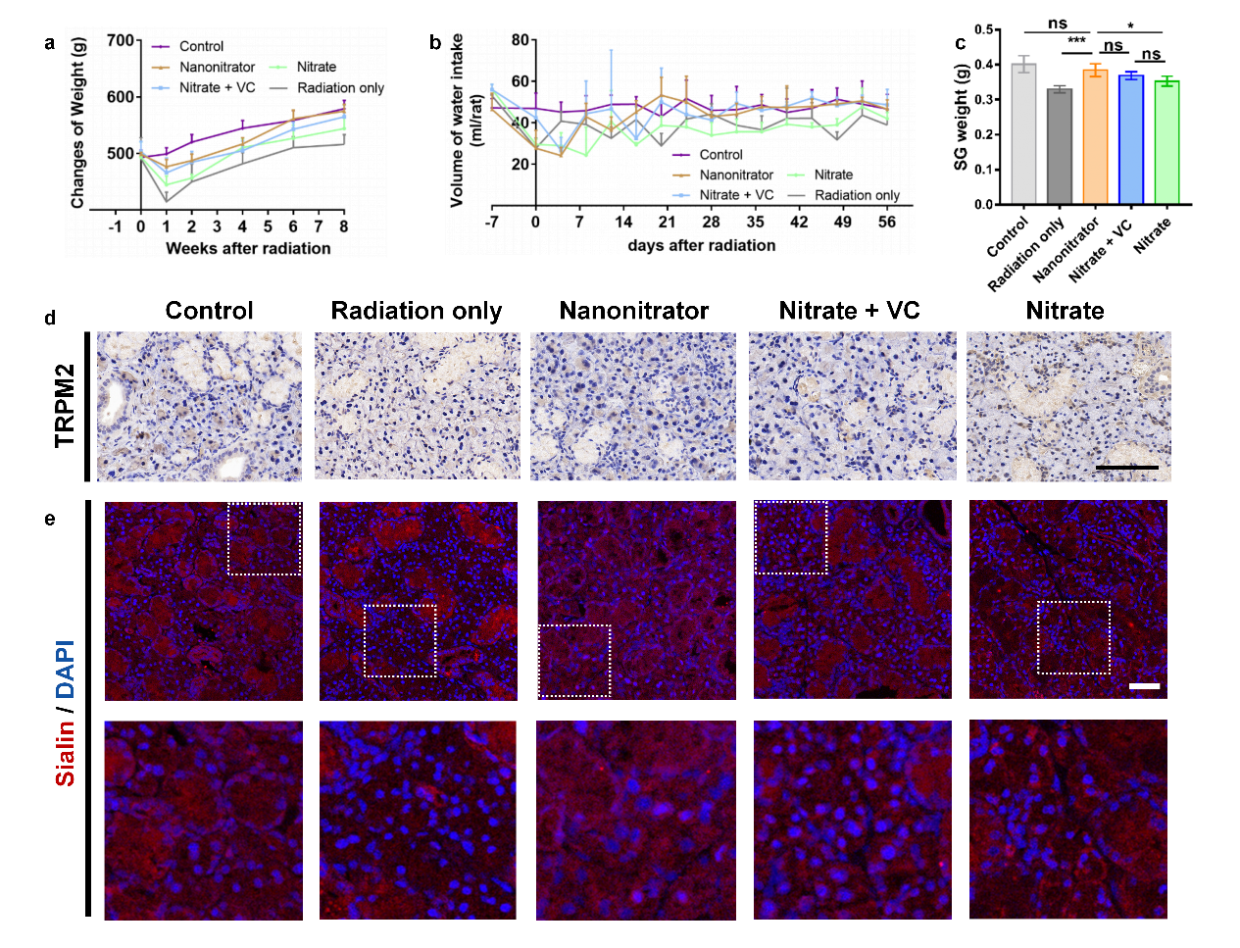
Supplementary Figure 3. Body weight, water intake, and local channel protein expression after irradiation of submandibular glands in rats. 2.25 mmol/kg Nanonitrator, 2.25 mmol/kg nitrate, or 2.25 mmol/kg nitrate + vitamin C (VC) was administered orally daily to SD rats 1 week before irradiation up to 8 weeks after irradiation; control groups were no radiation (control) and radiation only (n=5). a Changes in body weight over time after irradiation. b Changes in water intake over time after radiotherapy. c The average weight of the two submandibular glands 8 weeks after irradiation. d TRPM2 protein expression (yellow staining) ans e Sialin protein expression in rat submandibular glands 8 weeks after radiotherapy as examined by immunofluorescence (scale bar = 100 μm). Representative images are shown. Data are mean ± SD. *P < 0.05, ***P < 0.001, ns = not significant.

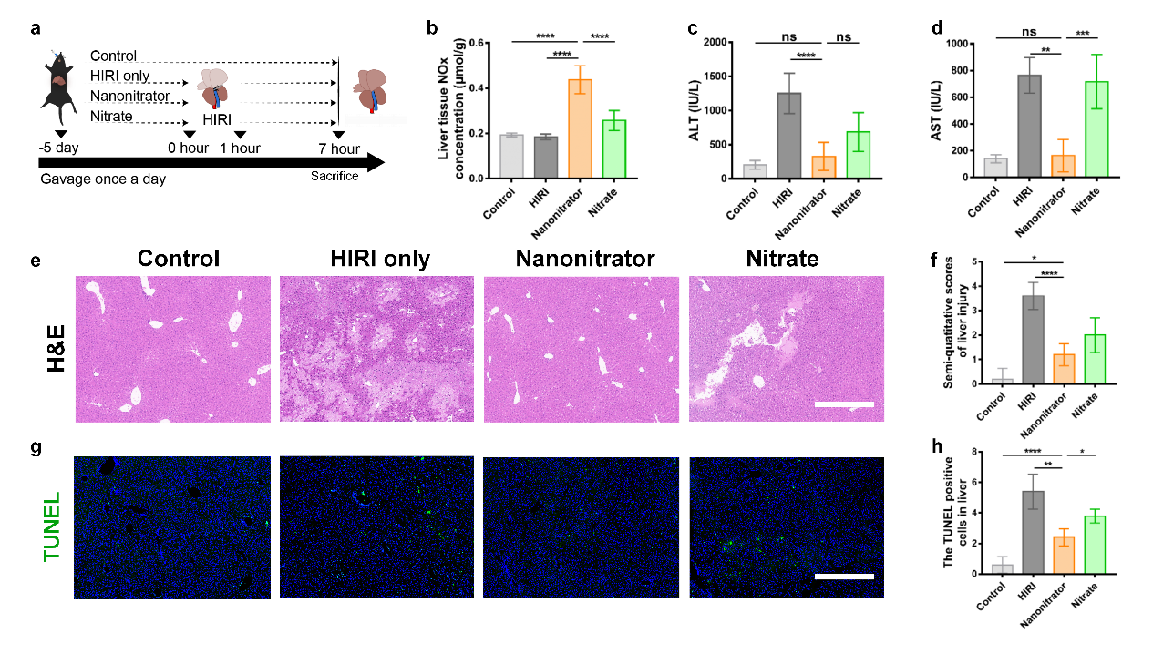
Supplementary Figure 4. Effect of Nanonitrator on prevention of hepatic ischemia-reperfusion injury in mice. a Schematic overview of hepatic ischemia-reperfusion injury (HIRI) model: 0.75 mmol/kg Nanonitrator or 0.75 mmol/kg nitrate was administered daily to C57BL/6J mice (n=5) 5 days before operation, which consisted of ischemia stage (1 h) and reperfusion stage (6 h). Thereafter, livers and plasma were collected. Control groups were no HIRI (control) and HIRI only (n=5). b Liver tissue concentration of NOx. c Plasma level of alanine aminotransferase (ALT). d Plasma level of aspartate aminotransferase (AST). e H&E staining of liver tissue sections (scale bar = 200 μm). Representative images are shown. f Semiquantitative scores of histological study. g TUNEL staining of liver tissue (scale bar = 200 μm). Representative images are shown. h Quantitative scores of TUNEL assay. Data are mean ± SD . *P < 0.05, **P < 0.01, ***P < 0.001, ****P < 0.0001, ns = not significant.

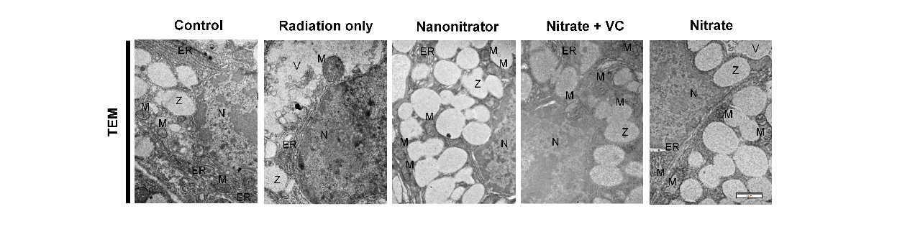
Supplementary Figure 5. Acinar cells were observed by transmission electron microscopy (TEM). 2.25 mmol/kg Nanonitrator was orally administered daily to SD rats 1 week before irradiation up to 1 day after irradiation; control groups were radiation only (n=4). Representative images are shown. Z = zymogen granule, M = mitochondria, N = nucleus, ER = endoplasmic reticulum, V= vacuole. (scale bar = 1 μm)

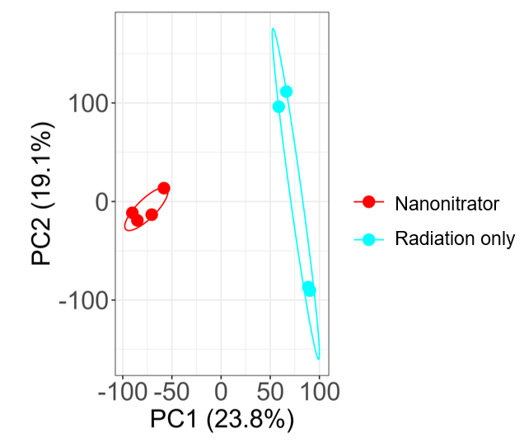
Supplementary Figure 6. Quality control results of rat submandibular gland RNA products. 2.25 mmol/kg Nanonitrator was orally administered daily to SD rats 1 week before irradiation up to 1 day after irradiation; control group were radiation only. Principal component analysis of Nanonitrator and radiation only groups (n=4).

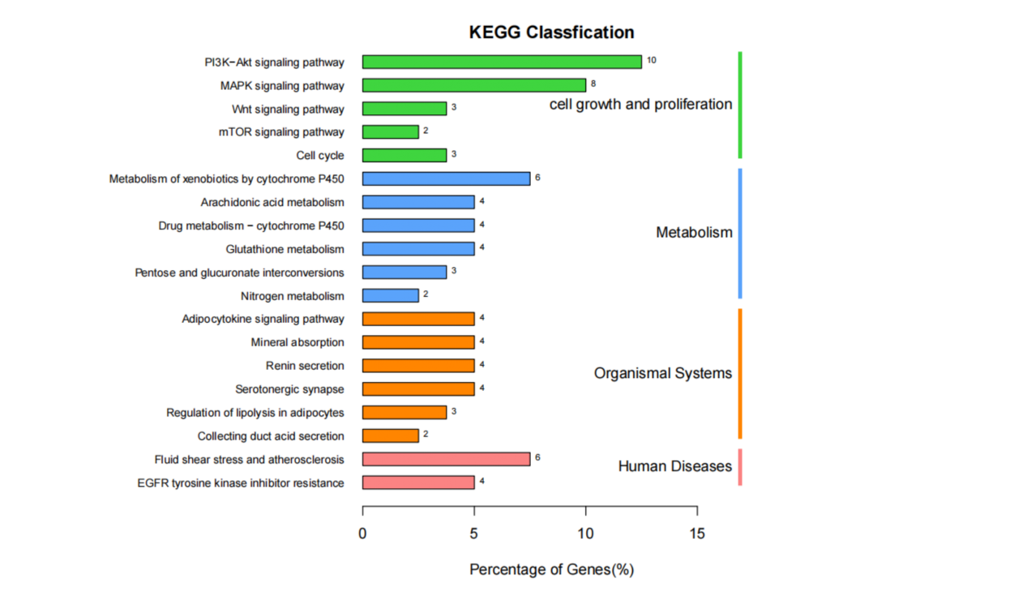
Supplementary Figure 7. KEGG pathway annotation and classification. 2.25 mmol/kg Nanonitrator was orally administered daily to SD rats 1 week before irradiation up to 1 day after irradiation; control group were radiation only.

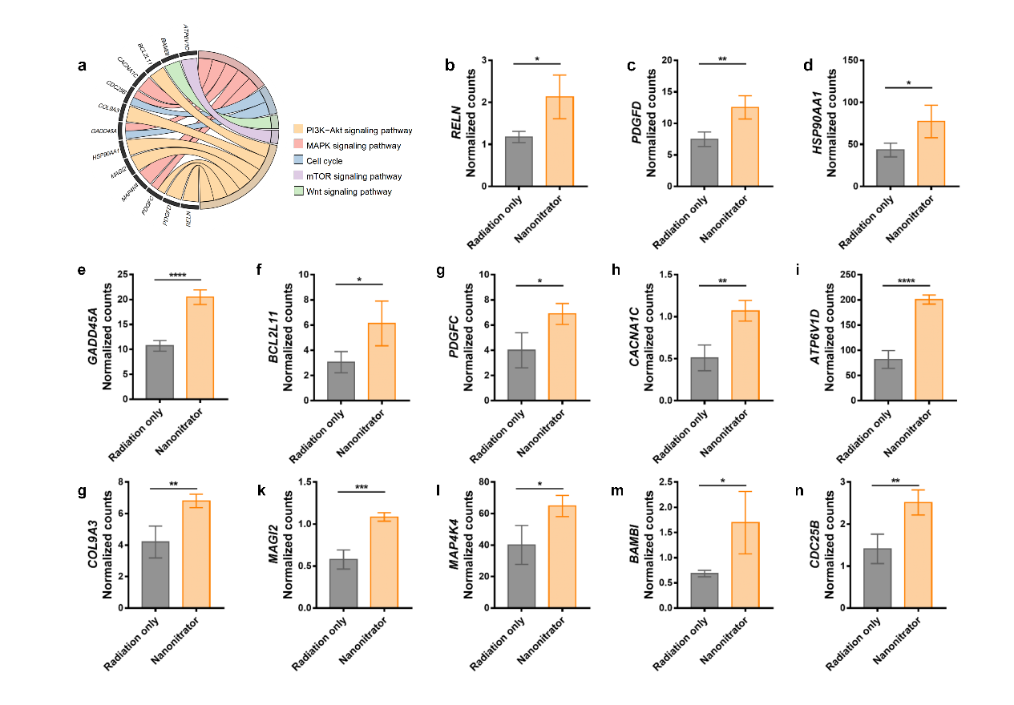
Supplementary Figure 8. RNA sequencing analysis of the top ranked up-regulated genes in signaling pathways. 2.25 mmol/kg Nanonitrator was intragastrically administered daily to SD rats 1 week before radiation up to 1 day after radiation; control groups were radiation only. a Chord plot of protective pathways with Nanonitrator’s promotion of cell homeostasis after irradiation. b Counts are shown based on normalized expression of genes, obtained from RNA sequencing data of the two groups (n=4). *P < 0.05, **P < 0.01, ***P < 0.001, ****P < 0.0001.

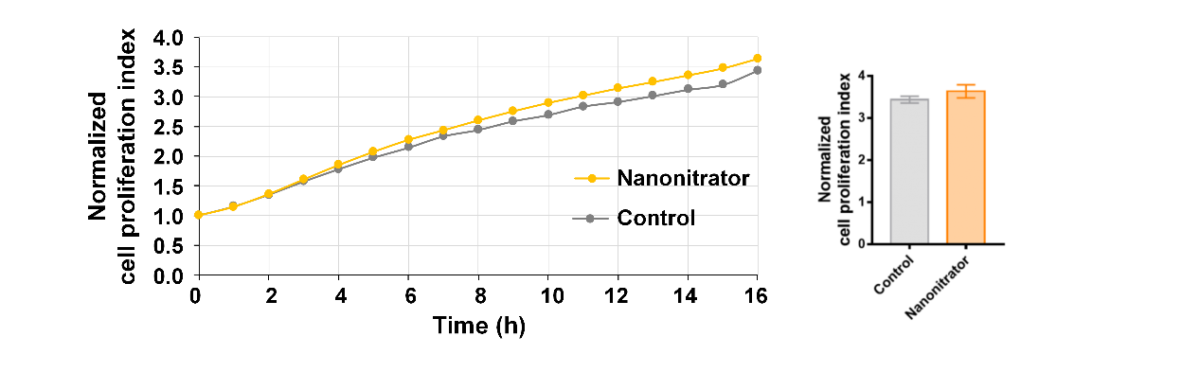
Supplementary Figure 9. Biocompatibility assay for Nanonitrator. Quantification of cell proliferation index of HSG cells treated with 0.25mM Nanonitrator or culture medium only (control) (n=3). Cell proliferation index was measured continuously for 16 h. Data are mean ± SD.

Supplementary table
Supplementary table1. Nanosize and zeta potential of different ratios of vitamin C to sodium nitrate (with chitosan 3000)
Preferably, the molar ratio of VC to sodium nitrate is 1:5 based on the nanosize and zeta potential.

