Supplementary material
Spatial distribution and influencing factors of China’s household biogas: Evidence from provincial-level data
Zhenghao Liang¹, Chaojie Lan¹, Xin Jin¹, Pengfei Zhai¹, Yan Zhao¹, Jinwen Cai¹, Shoupeng Li¹, Shuyun Yang¹, Changjiang Li ^{*1}, Changzhen Li^{*1}

¹Hainan Key Laboratory for Sustainable Utilization of Tropical Bioresources, College of Tropical Crops, Hainan University, Haikou, 570228, Hainan, China

* Corresponding author.
- mail address: lichangjiang99@hainanu.edu.cn (Changjiang Li),
lichangzhen029@163.com (Changzhen Li).

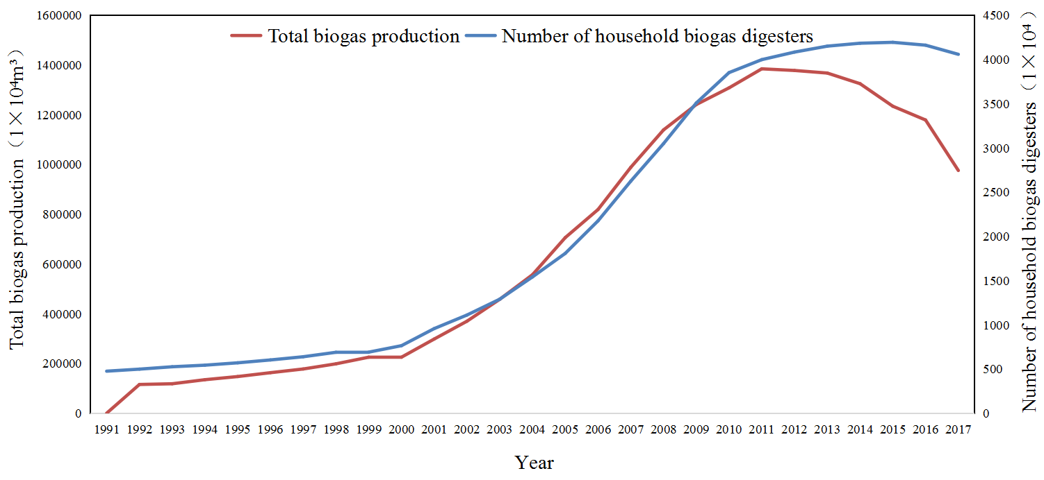Figure S1. Number of household biogas digesters and total biogas production in China from 1991 to 2017¹² (MOA, 2017).

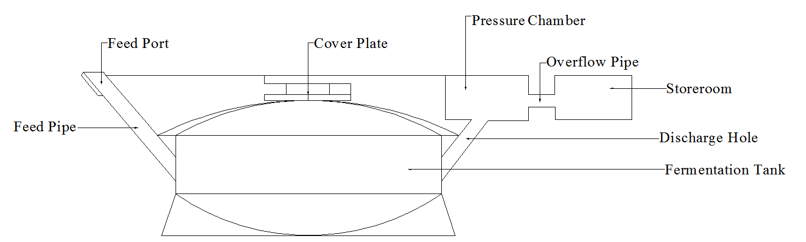
Figure S2. Schematic diagram of the hydraulic biogas digester²⁸ (Mutungwazi et al., 2018).

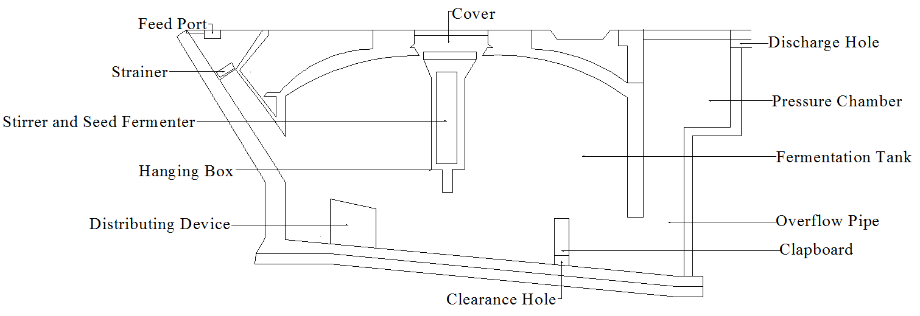
Figure S3. Schematic diagram of the continuously stirred biogas digester³⁰ (Abd Allah et al., 2021).

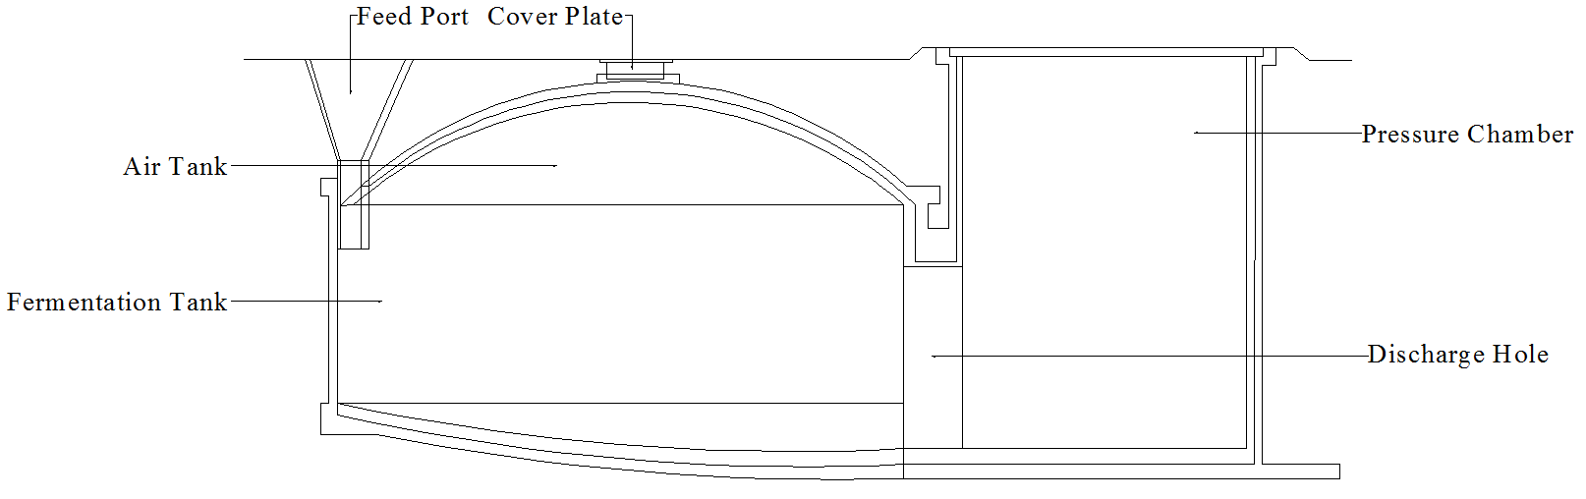
Fig S4. Schematic diagram of the bottom-discharging biogas digester³¹ (Ding et al., 2012).

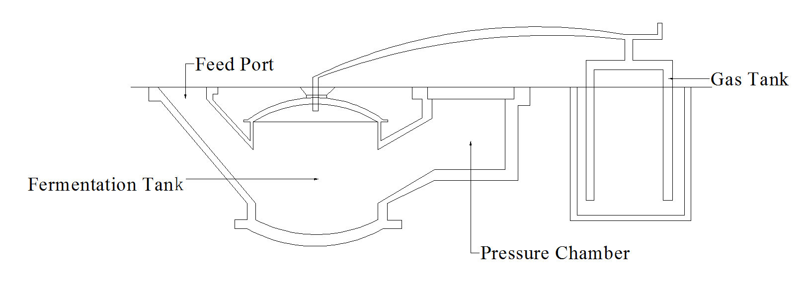
Fig S5. Schematic diagram of the floating-drum biogas digester³⁴ (Singh and Sooch, 2004).

Fig S6. Distribution of biogas digesters with heating equipment in China. Data source: Our household survey.

Fig S7. Schematic diagram of the solar heating system³⁶ (Curry and Pillay, 2015).

