Supplement
Table 1: CVD classification code system used in this study. ICD-10 codes (given in brackets) have been adapted to form the categories used in this study. We divided the CVDs into 3 broad categories, namely ischemic heart diseases, cerebrovascular accidents, and other heart diseases, which included 7 sub-categories.

Sensitivity analysis
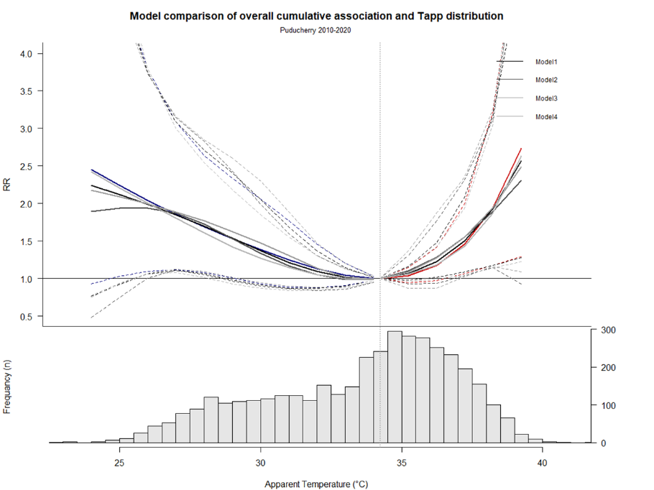
All models are compared to the model used in the final analysis. We changed the placement of the exposure-response knots as shown in Figure 1 and 2. Here, model 1 has 2 equally placed knots, model 2 has 3 knots at the 5th, 50th and 95th percentile of the T_{app} model3 has 3 knots at the 25th, 50th and 75th percentile and model 4 has 2 knots on the 5th and 95th percentile. There is no significant difference between models.
Figure 1: Comparing the T_{app}-mortality association in models with varying knot placements. Model 1 has 2 equally placed knots, model2 has 3 knots at the 5th, 50th and 95th percentile of the T_{app} model3 has 3 knots at the 25th, 50th and 75th percentile and model 4 has 2 knots on the 5th and 95th percentile of the T_{app.}

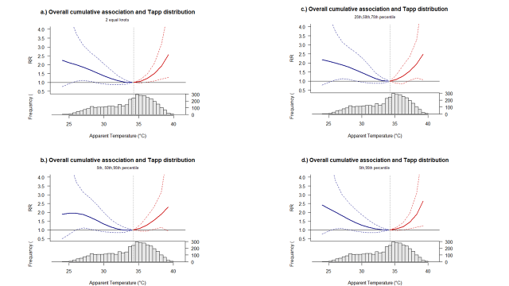
Figure 2: Individual exposure-response associations for the 4 models depicted in figure 1.

We repeated the analysis comparing the binomial regression used in our final analysis with a quasipoisson regression as shown in Figure 3, as commonly used in many studies and found the association to be similar.
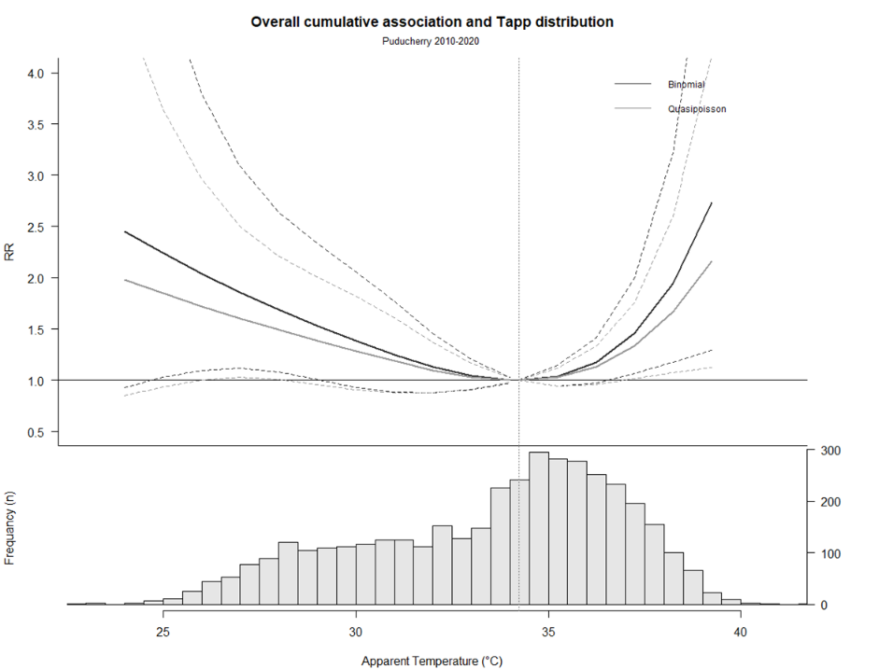
Figure 3: Comparison of the exposure-response association assuming either a Quasi-poission or binomial regression, such as the one we used.

We repeated the analysis using data from only 2016-2020, which had data across the entire hospital. As seen in Figure 4, there does not appear to be a significant difference between the associations.
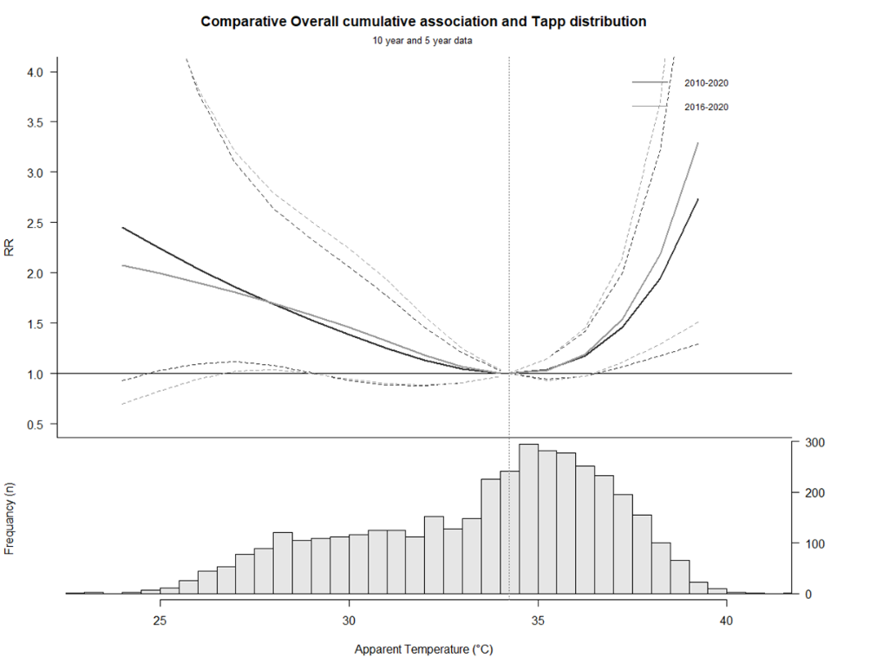
Figure 4: Comparison of the exposure-response association using the complete 10 year data set with cases only from the cardiology department for 2011-2015 and from both the cardiology department and all other departments for 2016-2020 vs using only 5 year data with cases from all the departments from 2016-2020.

Figure 5 shows the annual trends in the monthly hospital admission and mortality from CVDs. A.) shows the annul CVD mortality while b.) shows the CVD mortality relative to the total mortality. C.) shows the annual CVD admissions while d.) shows the annual CVD admissions relative to the total admissions. As can be seen, there is an increase in both the hospital admissions and mortalities from CVDs over the past 10 years.

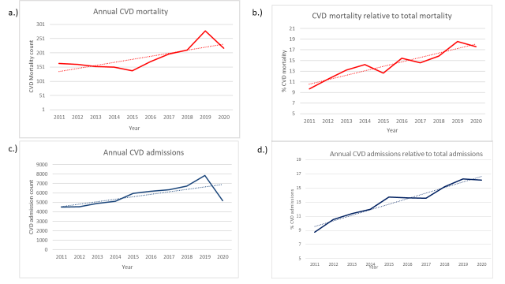
Figure 5: Annual trends in CVD admissions and mortality
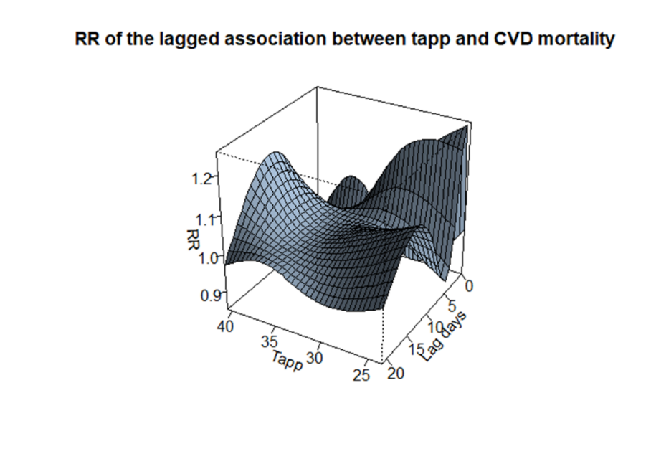
Figure 6 shows the 3-D plot of the lagged association between T_{app} and CVD mortality in Puducherry. The temperature-CVD mortality association shows a non-linear pattern. The 3-D view of this relationship shows that the risks of in-hospital CVD mortality attributed to temperature has a temporal distribution.
Figure 6: 3D- model depicting the RR for the lagged exposure-response association.
We see that cold temperature has an almost immediate response or increase in RR while hot temperatures show a delayed association by about 5 days. The cold effect peaks at day 1 before gradually decreasing below 1 around lag day 5. The cold-CVD mortality association risk increases slightly from around day 9 to day 16 where it peaks at day 11. Hot temperatures show a delayed response with the risk of CVD-mortality only seen after 5 lag days which persists for 16 days. This risk is relatively lesser compared to the cold-CVD mortality risk for 5 lag days.
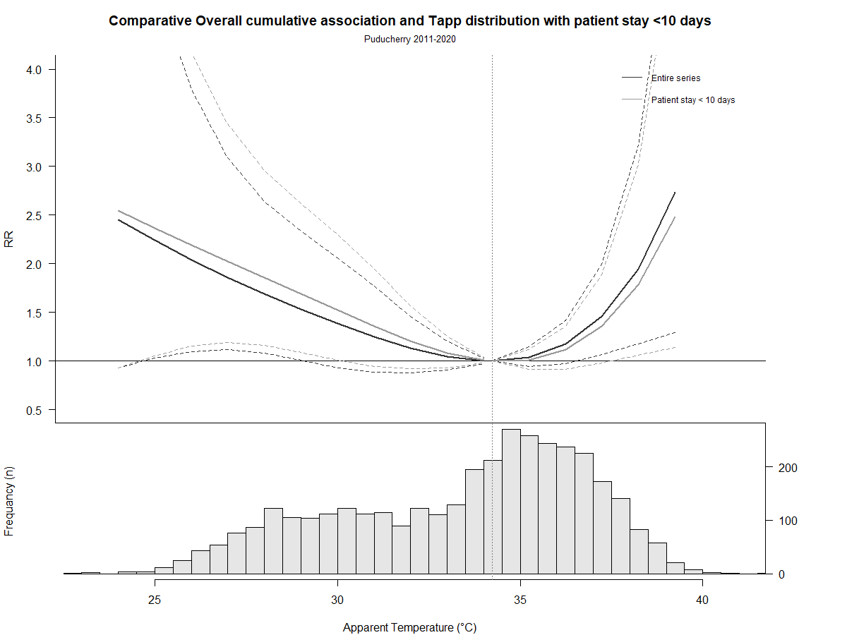
Figure 7 shows the results of the sensitivity analysis comparing all the patients versus patients who were admitted for less than 10 days before dying. The results show that there is relatively no difference in the association between patients who spent less than 10 days and the association for all patients.
Figure 7: Comparison of the exposure-response association using the complete 10 year data set vs restricting it to patients who spent less than 10 days in hospital. The black line depicts the overall association while the grey line depicts the patients who spent less than 10 days admitted to hospital before dying.
Figure 8 shows the RR of CVDs at lag day 1, 5, 15 and 20. Cold has an immediate outcome at lag day 1 which attenuates around day 5 as heat starts to have an effect. The effects of both hot and cold temperatures last for about 15 days.
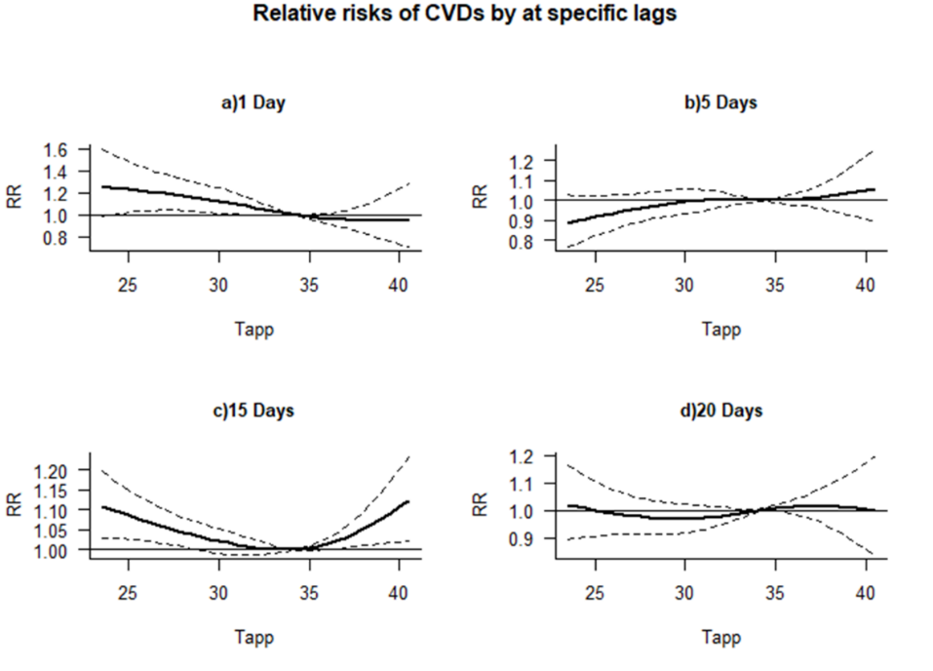
Figure 8: Exposure-response association at different lag days. a.) 1 day, b.) 5 days, c.) 10 days and d.) 20 days.

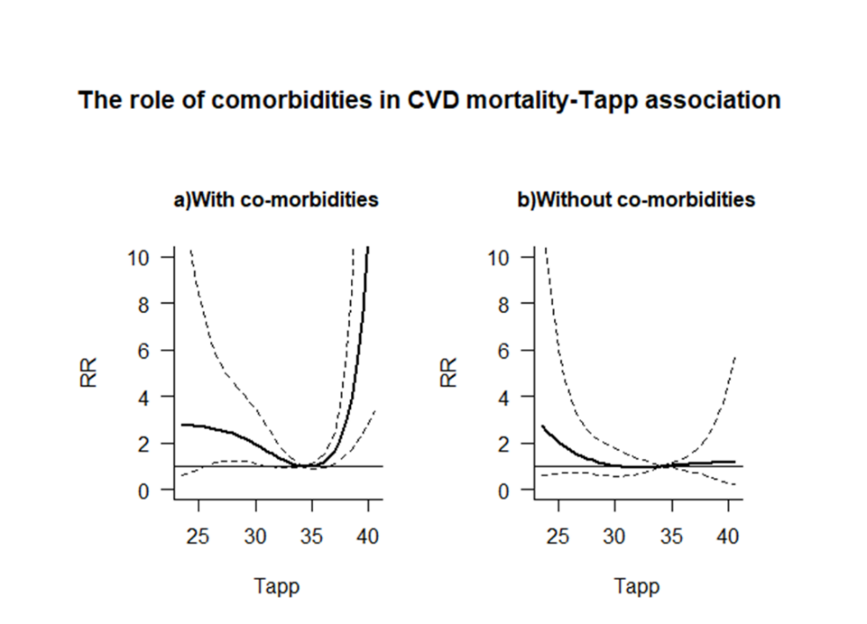
Figure 9 shows the RR for temperature associated CVD mortalities between people with and without co-morbidities such as hypertension, diabetes and alcoholism. People with co-morbidities appear to be more vulnerable to the effects of non-optimal temperatures than those without.
Figure 9: The role of co-morbidities in the exposure-response association. a.) population with co-morbidities and b.) Population without co-morbidities.
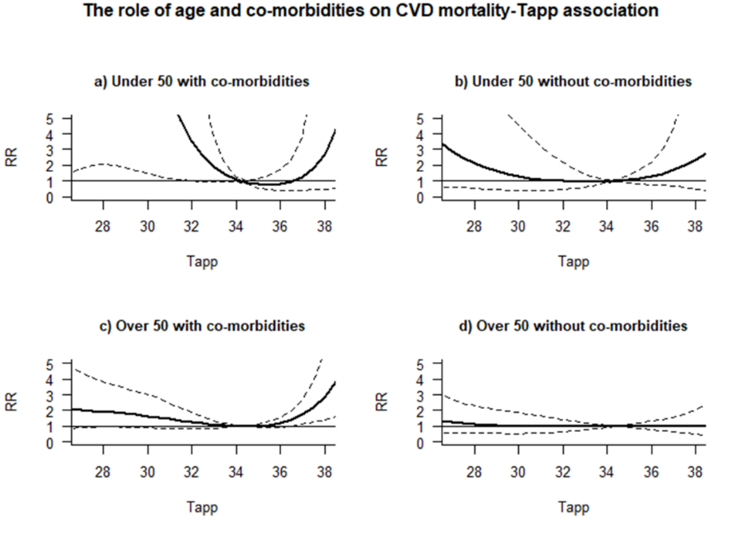
This association was further stratified by age groups as shown in Figure 10. All groups were vulnerable to non-optimal temperatures except for those over 50 without co-morbidities. We recommend further studies to better understand this phenomenon.
Figure 10: The role of age and co-morbidities in the exposure-CVD mortality association. a.) Population under 50 with co-morbidities, b.) Population under 5o without co-morbidities, c.) Population over 5 with co-morbidities and d.) Population over 50 without co- morbidities. Graph restricted to the central 95t percentile of the T_{app} distribution due to wide Cis at extreme ends.

