Supporting File
Bioelectronic Screening Platform for Real-Time Monitoring of Tumour-derived Extracellular Vesicle-Induced Epithelial-to-Mesenchymal Transition

Walther. C. Traberg¹, Johana Uribe², Victor Druet³, Adel Hama³, Chrysanthi-Maria Moysidou¹, Miriam Huerta², Reece McCoy¹, Daniel Hayward⁴, Achilleas Savva¹, Amaury M. R. Genovese¹, Suraj Pavagada^{1,4}, Zixuan Lu¹, Anil, Koklu³, Anna-Maria Pappa^{1,5,6}, Rebecca Fitzgerald⁴, Sahika Inal³, Susan Daniel², Róisín M. Owens¹
¹Department of Chemical Engineering and Biotechnology, University of Cambridge, Cambridge CB3 0AS, United Kingdom
²Robert F. Smith School of Chemical and Biomolecular Engineering, Cornell University, Olin Hall, Ithaca, New York 14853, United States.
³Biological and Environmental Sciences and Engineering Division, King Abdullah University of Science and Technology (KAUST), Thuwal 3955, Kingdom of Saudi Arabia
⁴Early Cancer Institute, University of Cambridge, Hutchison Research Centre, Cambridge, CB2 0XZ, United Kingdom
⁵Healthcare Innovation Engineering Center, Khalifa University, Abu Dhabi, United Arab Emirates
⁶Department of Biomedical Engineering, Khalifa University of Science and Technology, PO BOX 127788, Abu Dhabi, United Arab Emirates
Content
Supplementary Discussion 1: A model to recapitulate TEV-driven invasive ductal carcinoma. 4
Figure S1: Unedited Western blots for EV characterisation, showing samples probed for EV markers CD63 and CD9, microvesicle marker annexin A1, and negative marker calreticulin. 5
Supplementary Discussion 2: Investigating EMT requires high temporal resolution and functional readouts 6
Schematic S1: Experimental overview and design 7
Figure S2: Cells cultured for 12 days on OECTs stained with viability/cytotoxicity kit probes (green-LIVE: calcein AM; red-DEAD: ethidium homodimer-1). 8
Figure S3: Representative cut-off frequency and cell layer resistance, $Rcell$ vs time plots for all conditions tested. (a) Non-treated. (b) MDA-TEV treated. (c) HEK-EV treated. (d) TGF-β1 treated. (e) Heparin treated. (f) MDA-TEV + heparin treated. 9
Figure S4. Asymptotic regression of non-treated and MDA-TEV + heparin treated MCF10A cells, demonstrating that the normalised cut-off frequency tends towards 0.88 $±$ 0.034 and 0.92 $±$ 0.051, respectively. The two models are very similar, indicating that heparin treatment of cells exposed to MDA-TEVs block any malignant transformation. 10
Figure S5: Linear regression of MDA-TEV treatment condition and residual analysis plots. 11
Supplementary Discussion 3: Molecular mechanisms of EMT and determining its occurrence 12
Figure S6: Immunofluorescence of E-cadherin (green), N-cadherin (red), and nuclei (blue) on MCF10A monolayer with no treatment (left column), treated with 50 μg of MDA_TEVs (middle column), or with 10 ng/mL TGFβ (right column) every 12 hours for 60 hours. 13
Figure S7: Unedited x/z and y/z orthogonal views (ortho-views, right) of each cell layer in the OECT channel (treatment day 9), obtained by z-stacked confocal images. Cell height was calculated using the built-in tools in the Zen software, as shown in the images. 14
Figure S8: Unedited immunoblots of whole-cell lysates collected on treatment day 9 against EMT markers.. Equal quantities of protein were separated on SDS-PAGE gels and membranes were blotted with indicated antibodies. Vimentin, predicted: 54-75 kDa; E-cadherin, predicted: 97 kDa; N-cadherin, predicted: 125-135 kDa; fibronectin (slightly smeared due to glycosylation¹ and shows multiple bands with lower MW;), predicted: 262-285 kDa; and F-actin (band at ~70 kDa may indicate presence of dimers), predicted 42 kDa. The presence of multiple bands is also indicated on antibody product page (Abcam). 15
Figure S9: Unedited immunoblots of TWIST1 protein expression in (a) MDA-MB-231 total cell lysate and MDA-TEVs, and (b) MCF10A cells treated under conditions indicated. TWIST1 has a predicted Mw of 21 kDa 16
Figure S10: LHS: Cut-off frequency normalised to day 0 (treatment start day) over time for the four drug treatment conditions: non-treated; 200 μg MDA-TEVs; 10 μg/ml heparin; and 200 μg MDA-TEVs + 10 μg/ml heparin, (mean ± s.e.m.; s.e.m. indicated by lightly coloured areas; n=3). Data points before treatment day 0 are omitted for clarity. RHS: Interaction plot illustrating the relationship between MDA-TEV and heparin treatment (mean; n=3). 17

Supplementary Discussion 1: A model to recapitulate TEV-driven invasive ductal carcinoma.
It is now well established that TEVs provide autocrine and paracrine signals within the tumour ecosystem to activate an EMT programme in neoplastic epithelial cells^{1,2}. This endows the recipient cells with the ability to invade the tissue surrounding the primary tumour, intravasate, and enter the circulation³ (Fig. 1). TEVs accomplish this by transferring functional cargo comprising transcriptional regulators⁴, EMT drivers^{1,5}, and signalling molecules⁶ that influences signalling pathways, such as the canonical Wnt/β-catenin pathway⁷, and alters the transcriptome and proteome of recipient cells, thereby inducing a change in cell phenotype⁷. TEVs derived from TNBC cells were reported to promote proliferation and drug resistance in non-tumourigenic breast cells⁸, and TEVs from young women’s breast cancer patients were found to drive increased invasion of non-malignant cells⁹. In breast carcinomas, the proclivity for mesenchymal transition may be related to the high aggressiveness and characteristic metastatic spread of these tumours¹⁰. TNBC is a particularly aggressive and invasive breast cancer subtype¹¹ with metastases frequently occurring in the first 3 years following surgery and a very low 5-year survival rate for afflicted patients (77% compared to 93% for other breast cancer subtypes¹²). The higher mortality is partly due to a disproportionate number of metastatic disease cases¹³. Treatment of TNBC has been limited due to the lack of well-defined therapeutic targets¹⁴ and the scarcity of effective targeted therapies is in part to blame for a poorer prognosis and treatment outcome for TBNC than other types of breast cancer¹¹. Studies of progression from ductal carcinoma in situ to invasive disease have been facilitated by the use of the MCF10A series^{4,15}, which have intrinsic phenotypic plasticity for mesenchymal transition¹⁰ and are widely used for investigating EMT in premalignant cells^{16,17}. By contrast, MDA-MB-231 is a cancerous epithelial cell line isolated from a patient with metastatic mammary adenocarcinoma; a type of cancer that begins in the glandular tissue of breast lobules and ducts. Therefore, inducing EMT in MCF10A cells by exposure to MDA-MB-231-derived TEVs (MDA-TEVs) represents a highly relevant disease model for investigating the lesions preceding invasive breast cancer. There is ample precedent for using it, as TEVs derived from MDA-MB-231 cells stimulated with linoleic acid¹⁸ or insulin-like growth factor-1¹⁹ were found to mediate EMT in MCF10A cells, as did hypoxic small EVs derived from the same cell line²⁰.
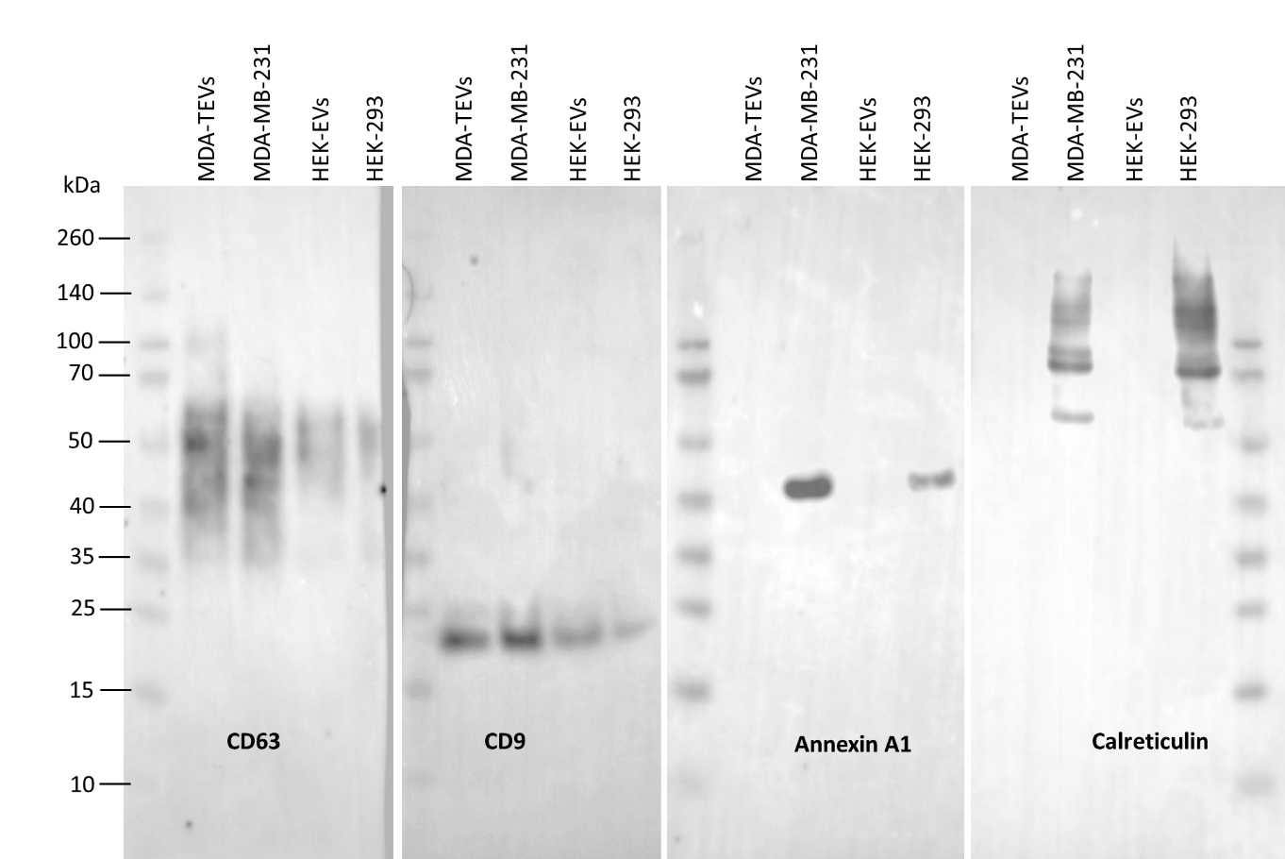
Figure S1: Unedited Western blots for EV characterisation, showing samples probed for EV markers CD63 and CD9, microvesicle marker annexin A1, and negative marker calreticulin.
Supplementary Discussion 2: Investigating EMT requires high temporal resolution and functional readouts
Our platform aims to address the limitations of current sensing technologies in metastasis research. Namely, the inability to monitor the transient state of a dynamic biological system and produce quantitative, time-series data relevant to the biology at play. EMT is a transient process and one of the difficulties in its study arises because the transitions between epithelial and mesenchymal states are not binary²¹. Carcinoma cells often exhibit a spectrum of epithelial-mesenchymal characteristics^{22,23} and studies have shown that cancer cells, including breast cancers, express both epithelial and mesenchymal markers^{24,25}. As such, the existence of hybrid EMT states or phenotypes (partial EMT) have been suggested to describe a tumour cell differentiation state in which cancer cells keep both EMT and mesenchymal-to-epithelial transition (MET; reverse-EMT) characteristics. This may promote tumour cell plasticity and tumour progression^{24,26,27} and is thus an important feature to capture during phenotype screening. Moreover, migration of cells does not necessarily require the cells to lose all epithelial features, as epithelial cells can migrate as single cells or collectively, while attached with one another via weakened cell-cell interactions²⁸. This indicates that the migratory and invasive capacity of cells undergoing EMT is not accurately represented by the simple expression, or lack of expression, of selected (mesenchymal) markers. As such, functional changes in the biological properties of cells must be assessed as well²⁹.
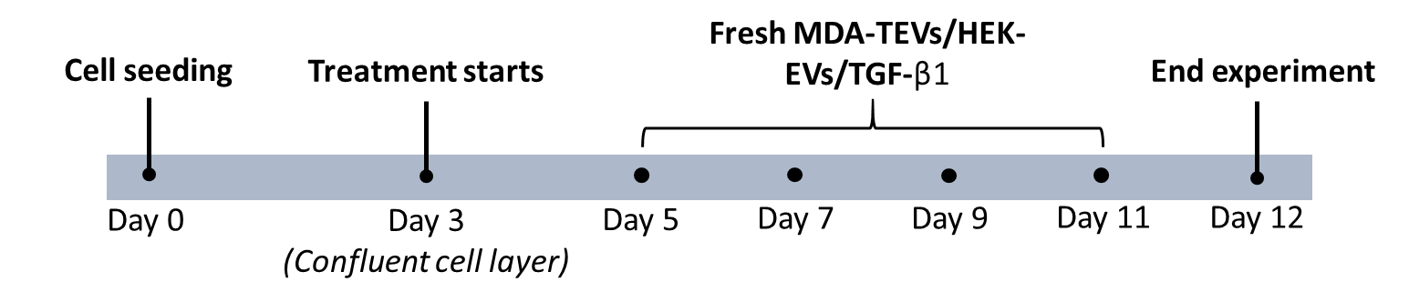
Schematic S1: Experimental overview and design
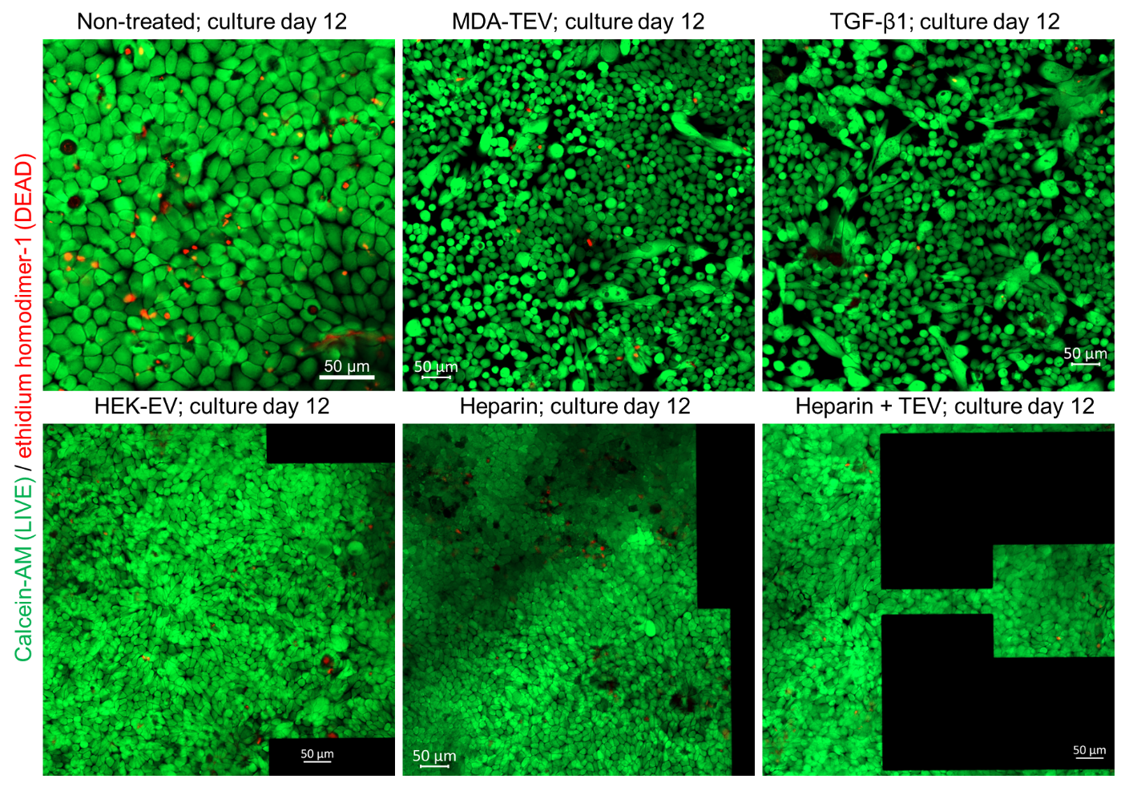
Figure S2: Cells cultured for 12 days on OECTs stained with viability/cytotoxicity kit probes (green-LIVE: Calcein AM; red-DEAD: ethidium homodimer-1).
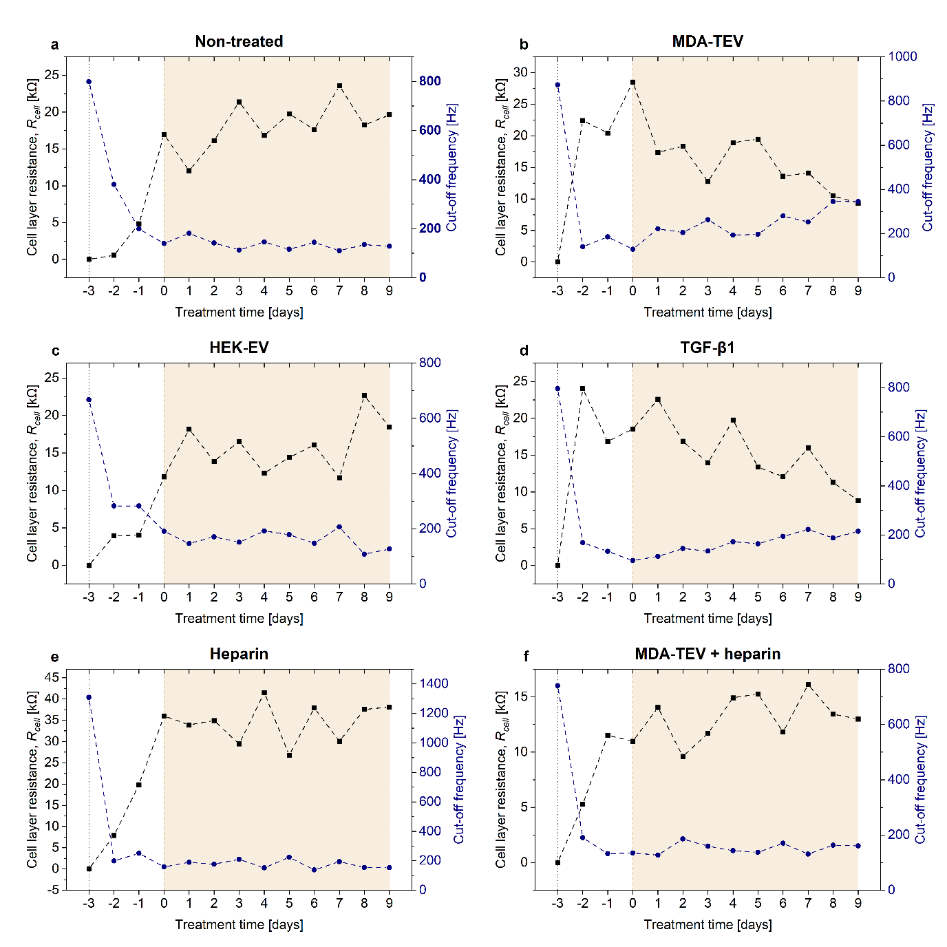
Figure S3: Representative cut-off frequency and cell layer resistance, $R_{cell}$ vs time plots for all conditions tested. (a) Non-treated. (b) MDA-TEV treated. (c) HEK-EV treated. (d) TGF-β1 treated. (e) Heparin treated. (f) MDA-TEV + heparin treated.
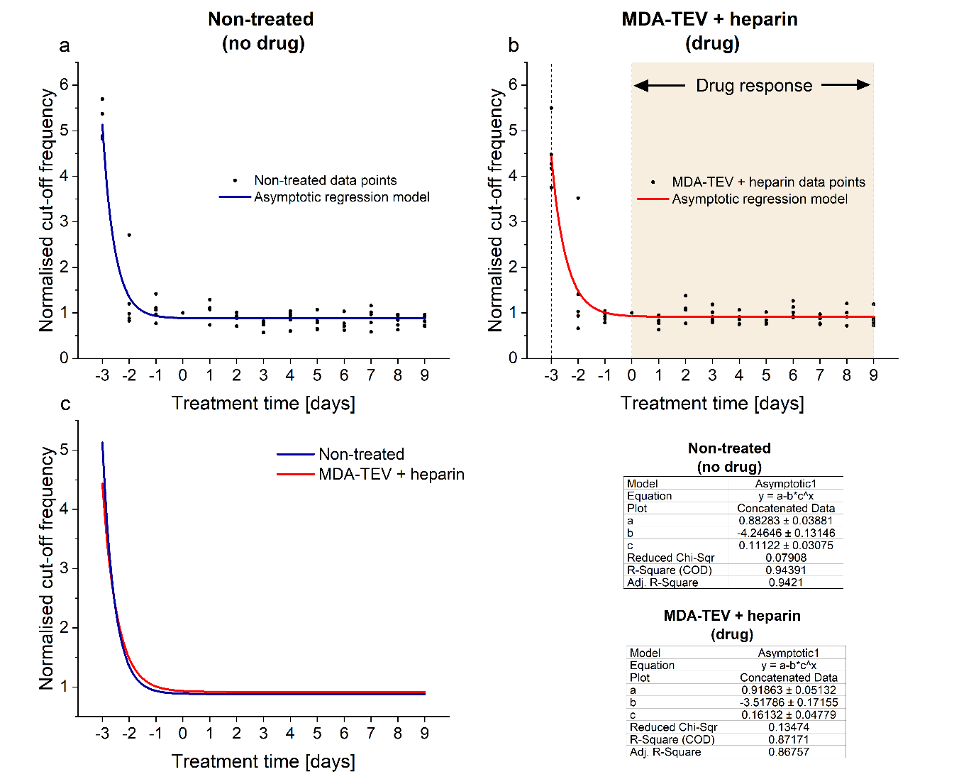
Figure S4. Asymptotic regression of non-treated and MDA-TEV + heparin treated MCF10A cells, demonstrating that the normalised cut-off frequency tends towards 0.88 $±$ 0.034 and 0.92 $±$ 0.051, respectively. The two models are very similar, indicating that heparin treatment of cells exposed to MDA-TEVs block any malignant transformation.
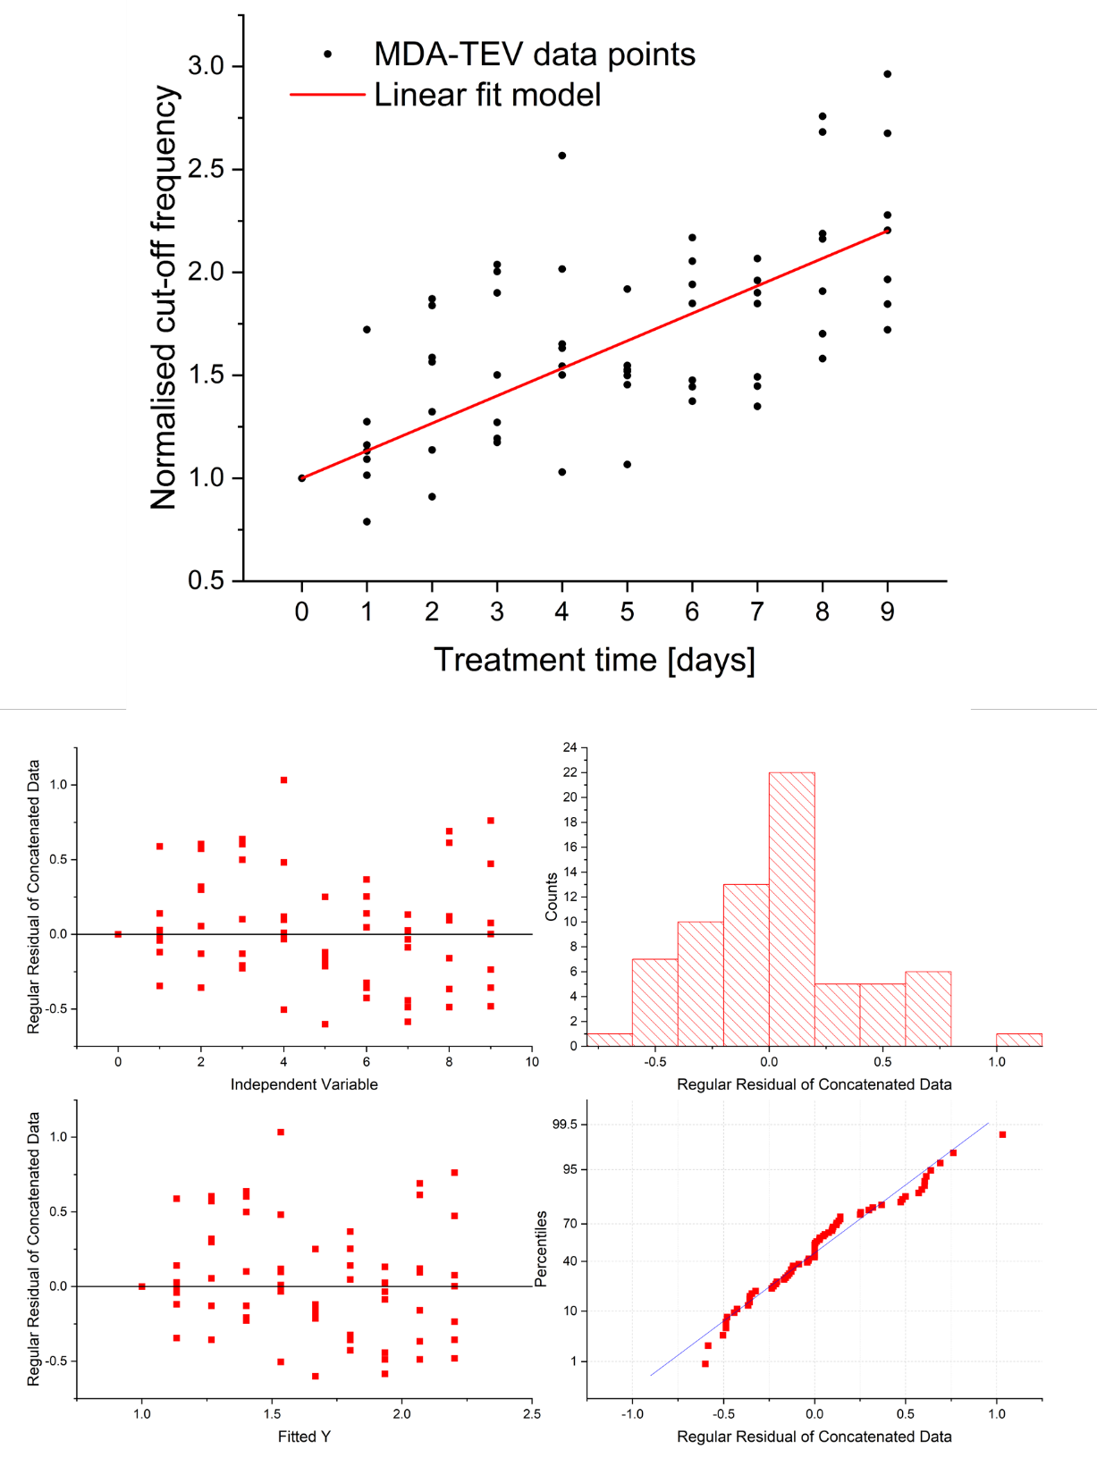
Figure S5: Linear regression of MDA-TEV treatment condition and residual analysis plots.
Supplementary Discussion 3: Molecular mechanisms of EMT and determining its occurrence
EMT status is typically defined by changes in cellular properties together with a set of molecular markers²⁹. Epithelial cells are connected to one another via a variety of epithelial cell junctions that help maintain epithelial polarity, while mesenchymal cells do not contain functional epithelial junctions and present a back-front polarity in their actin stress fibres, characteristic of a migrating cell²⁹. During EMT, epithelial cells lose their apical-basal polarity and lateral cell–cell adhesion and gain migratory and invasive properties. Loss of apico-basal polarity leads to destabilisation of adhesion complexes, such as tight junctions and adherens junctions at the lateral membrane³⁰, and is preceded by reorganisation of filamentous actin (F-actin) (Fig 1). Actin filaments in mesenchymal cells are bundled into thick contractile stress fibres that increase cellular contractability for migration³¹. Vimentin, a type III intermediate filament found in mesenchymal cells, mediates cytoskeletal organisation and focal adhesion maturation, which the migrating cells utilise to attach to the ECM³². Previous studies using the same MDA-TEV-EMT model^{18,19} assessed transcript and protein expression using RT-qPCR and Western blot and demonstrated that MDA-TEVs induced down-regulation of E-cadherin (epithelial marker) expression and upregulation of Twist-related protein 1 (TWIST1) transcripts, as well as vimentin and N-cadherin (mesenchymal markers) expression in MCF10A cells. TWIST1 is an E-cadherin transcriptional repressors that bind to promoter E-boxes on E-cadherin to repress transcription and they are part of the canonical Wnt/β-catenin pathway, indicating that TEVs (and their cargo) modulate this EMT pathway. Functionally, TEVs promoted migration and invasion in MCF10A cells, as measured by migration/wound-healing and Boyden chamber assays^{18,19}.
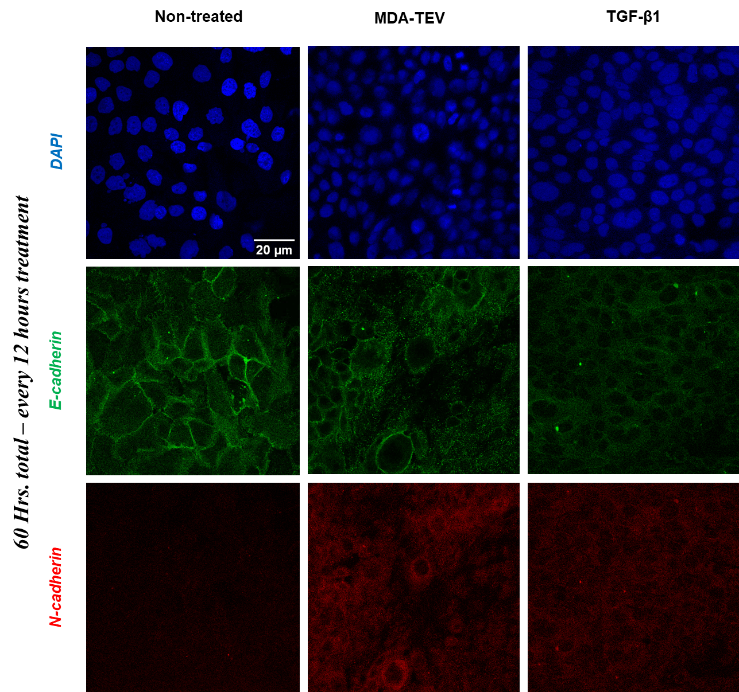
Figure S6: Immunofluorescence of E-cadherin (green), N-cadherin (red), and nuclei (blue) on MCF10A monolayer with no treatment (left column), treated with 50 μg of MDA-TEVs (middle column), or with 10 ng/mL TGFβ (right column) every 12 hours for 60 hours.
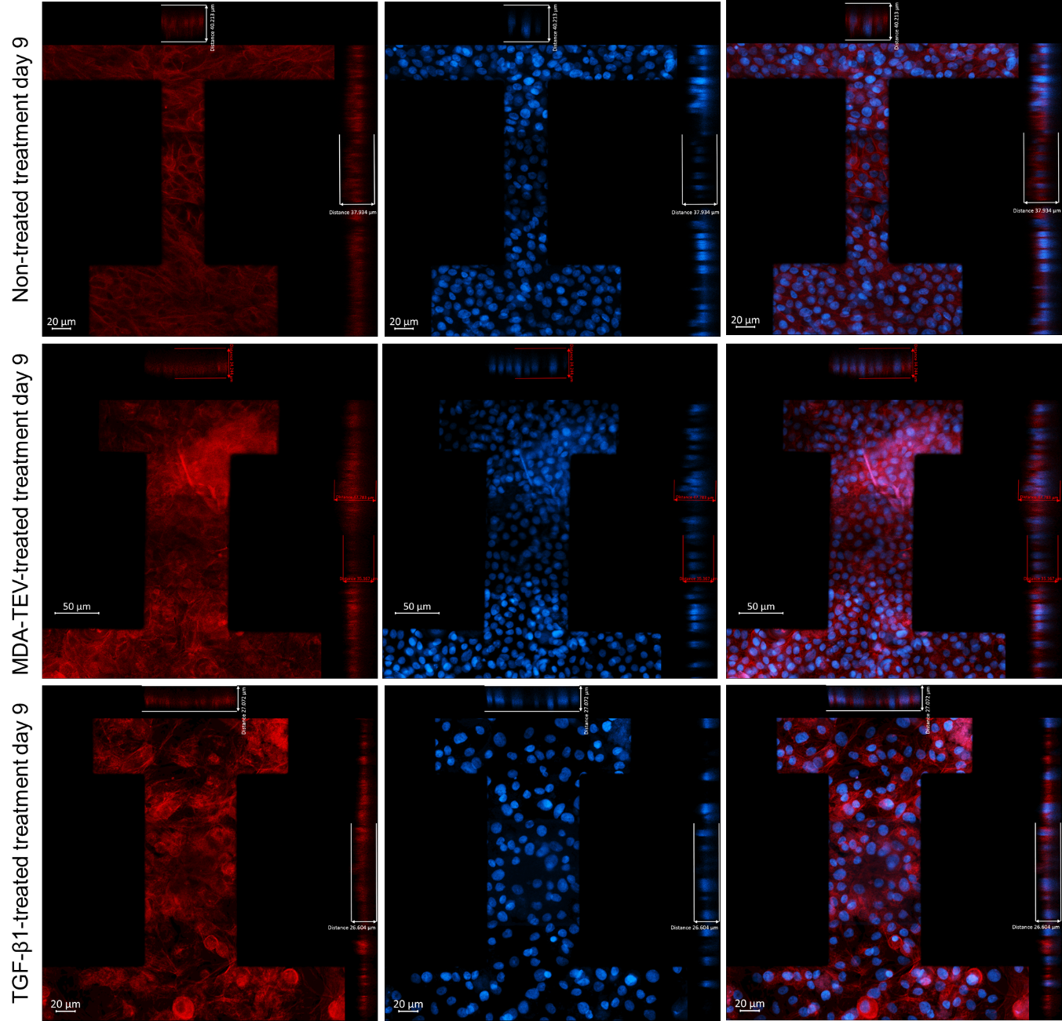
Figure S7: Unedited x/z and y/z orthogonal views (ortho-views, right) of each cell layer in the OECT channel (treatment day 9), obtained by z-stacked confocal images. Cell height was calculated using the built-in tools in the Zen software, as shown in the images.
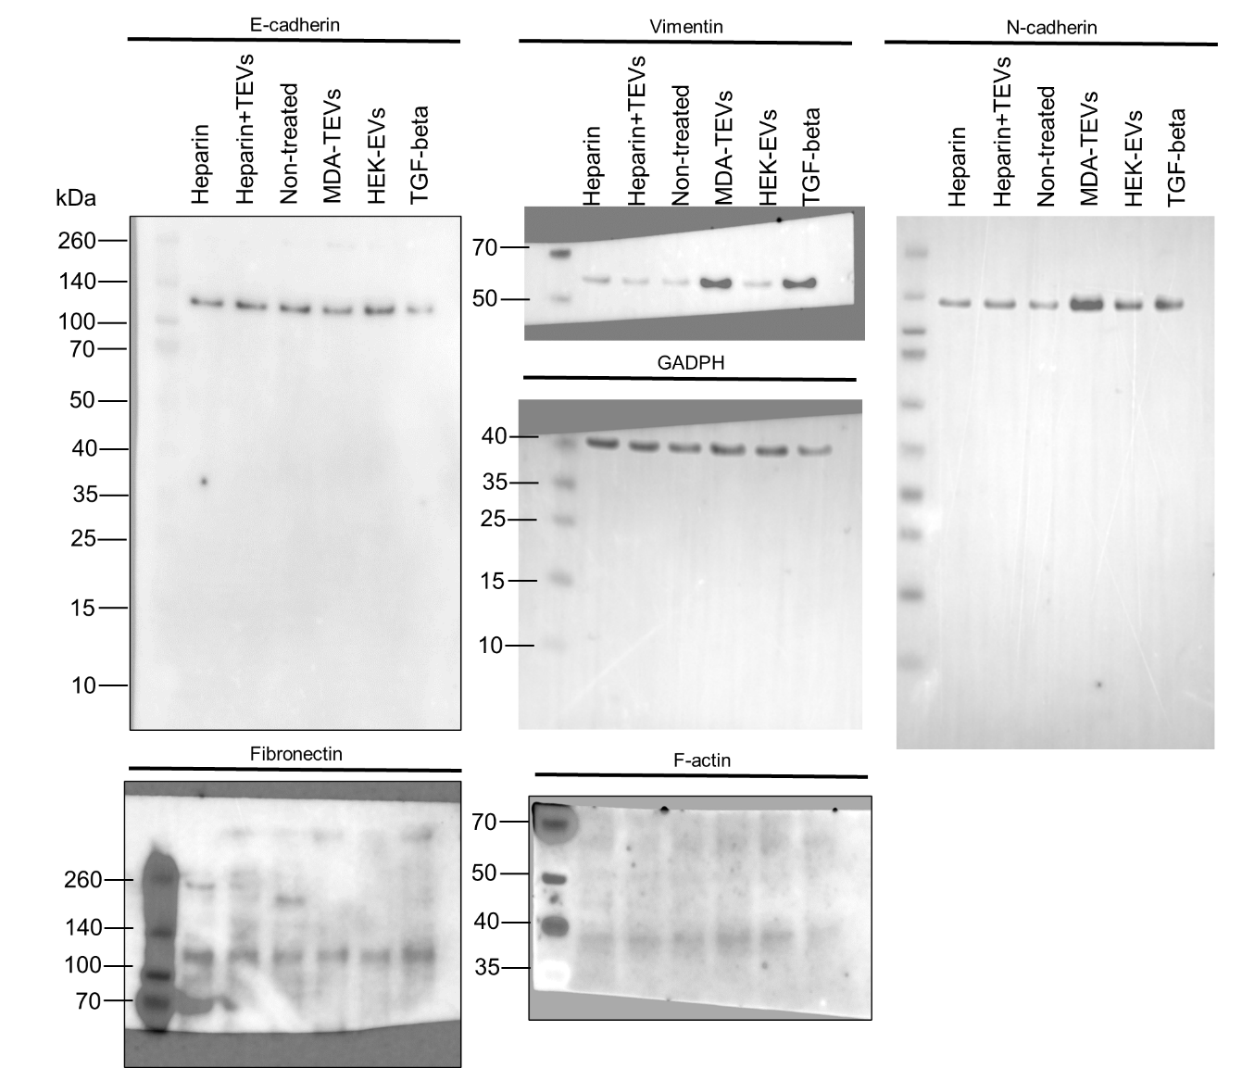
Figure S8: Unedited immunoblots of whole-cell lysates collected on treatment day 9 against EMT markers. Equal quantities of protein were separated on SDS-PAGE gels and membranes were blotted with indicated antibodies. Vimentin, predicted: 54-75 kDa; E-cadherin, predicted: 97 kDa; N-cadherin, predicted: 125-135 kDa; fibronectin (slightly smeared due to glycosylation³³ and shows multiple bands with lower MW;), predicted: 262-285 kDa; and F-actin (band at ~70 kDa may indicate presence of dimers), predicted 42 kDa. The presence of multiple bands is also indicated on antibody product page (Abcam).
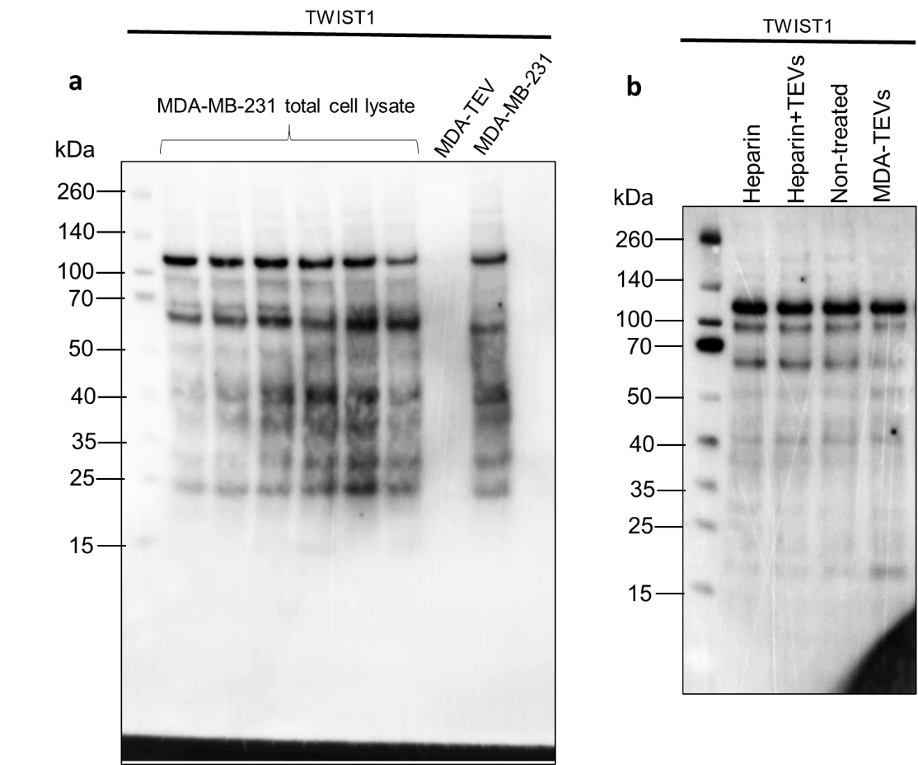
Figure S9: Unedited immunoblots of TWIST1 protein expression in (a) MDA-MB-231 total cell lysate and MDA-TEVs, and (b) MCF10A cells treated under conditions indicated. TWIST1 has a predicted Mw of 21 kDa
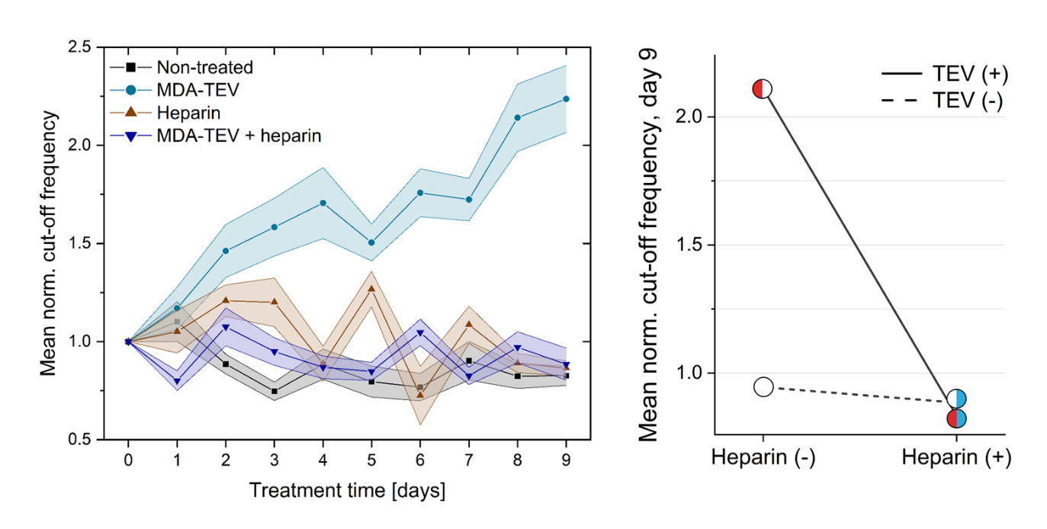
Figure S10: LHS: Cut-off frequency normalised to day 0 (treatment start day) over time for the four drug treatment conditions: non-treated; 200 μg MDA-TEVs; 10 μg/ml heparin; and 200 μg MDA-TEVs + 10 μg/ml heparin, (mean ± s.e.m.; s.e.m. indicated by lightly coloured areas; n=3). Data points before treatment day 0 are omitted for clarity. RHS: Interaction plot illustrating the relationship between MDA-TEV and heparin treatment (mean; n=3).
References
1. Aga, M. et al. Exosomal HIF1α supports invasive potential of nasopharyngeal carcinoma-associated LMP1-positive exosomes. Oncogene 33, 4613–4622 (2014).
2. Franzen, C. A. et al. Urothelial cells undergo epithelial-to-mesenchymal transition after exposure to muscle invasive bladder cancer exosomes. Oncogenesis 4, e163–e163 (2015).
3. Syn, N., Wang, L., Sethi, G., Thiery, J.-P. & Goh, B.-C. Exosome-Mediated Metastasis: From Epithelial–Mesenchymal Transition to Escape from Immunosurveillance. Trends Pharmacol. Sci. 37, 606–617 (2016).
4. Melo, S. A. et al. Cancer Exosomes Perform Cell-Independent MicroRNA Biogenesis and Promote Tumorigenesis. Cancer Cell 26, 707–721 (2014).
5. You, Y. et al. Matrix metalloproteinase 13-containing exosomes promote nasopharyngeal carcinoma metastasis. Cancer Sci. 106, 1669–1677 (2015).
6. Ramteke, A. et al. Exosomes secreted under hypoxia enhance invasiveness and stemness of prostate cancer cells by targeting adherens junction molecules. Mol. Carcinog. 54, 554–565 (2015).
7. Chen, Y. et al. Aberrant low expression of p85α in stromal fibroblasts promotes breast cancer cell metastasis through exosome-mediated paracrine Wnt10b. Oncogene 36, 4692–4705 (2017).
8. Ozawa, P. M. M. et al. Extracellular vesicles from triple-negative breast cancer cells promote proliferation and drug resistance in non-tumorigenic breast cells. Breast Cancer Res. Treat. 172, 713–723 (2018).
9. Jordan, K. R. et al. Extracellular vesicles from young women’s breast cancer patients drive increased invasion of non-malignant cells via the Focal Adhesion Kinase pathway: a proteomic approach. Breast Cancer Res. 22, 128 (2020).
10. Sarrió, D. et al. Epithelial-Mesenchymal Transition in Breast Cancer Relates to the Basal-like Phenotype. Cancer Res. 68, 989–997 (2008).
11. Goh, C. Y. et al. Exosomes in triple negative breast cancer: Garbage disposals or Trojan horses? Cancer Lett. 473, 90–97 (2020).
12. Bauer, K. R., Brown, M., Cress, R. D., Parise, C. A. & Caggiano, V. Descriptive analysis of estrogen receptor (ER)-negative, progesterone receptor (PR)-negative, and HER2-negative invasive breast cancer, the so-called triple-negative phenotype. Cancer 109, 1721–1728 (2007).
13. Fulford, L. G. et al. Basal-like grade III invasive ductal carcinoma of the breast: patterns of metastasis and long-term survival. Breast Cancer Res. 9, R4 (2007).
14. Yao, H. et al. Triple-negative breast cancer: is there a treatment on the horizon? Oncotarget 8, 1913–1924 (2016).
15. Santner, S. J. et al. Malignant MCF10CA1 Cell Lines Derived from Premalignant Human Breast Epithelial MCF10AT Cells. Breast Cancer Res. Treat. 65, 101–110 (2001).
16. Qu, Y. et al. Evaluation of MCF10A as a Reliable Model for Normal Human Mammary Epithelial Cells. PLOS ONE 10, e0131285 (2015).
17. Puleo, J. & Polyak, K. The MCF10 Model of Breast Tumor Progression. Cancer Res. 81, 4183–4185 (2021).
18. Galindo-Hernandez, O., Serna-Marquez, N., Castillo-Sanchez, R. & Salazar, E. P. Extracellular vesicles from MDA-MB-231 breast cancer cells stimulated with linoleic acid promote an EMT-like process in MCF10A cells. Prostaglandins Leukot. Essent. Fatty Acids 91, 299–310 (2014).
19. Leal-Orta, E., Ramirez-Ricardo, J., Garcia-Hernandez, A., Cortes-Reynosa, P. & Salazar, E. P. Extracellular vesicles from MDA-MB-231 breast cancer cells stimulated with insulin-like growth factor 1 mediate an epithelial–mesenchymal transition process in MCF10A mammary epithelial cells. J. Cell Commun. Signal. (2021) doi:10.1007/s12079-021-00638-y.
20. Bertolini, I., Perego, M., Ghosh, J. C., Kossenkov, A. V. & Altieri, D. C. NFκB activation by hypoxic small extracellular vesicles drives oncogenic reprogramming in a breast cancer microenvironment. Oncogene 41, 2520–2525 (2022).
21. Lai, X. et al. Epithelial-Mesenchymal Transition and Metabolic Switching in Cancer: Lessons From Somatic Cell Reprogramming. Front. Cell Dev. Biol. 8, (2020).
22. Zhang, Y. & Weinberg, R. A. Epithelial-to-mesenchymal transition in cancer: complexity and opportunities. Front. Med. 12, 361–373 (2018).
23. Jolly, M. K., Ware, K. E., Gilja, S., Somarelli, J. A. & Levine, H. EMT and MET: necessary or permissive for metastasis? Mol. Oncol. 11, 755–769 (2017).
24. Hiew, M. S. Y. et al. Incomplete cellular reprogramming of colorectal cancer cells elicits an epithelial/mesenchymal hybrid phenotype. J. Biomed. Sci. 25, 57 (2018).
25. Bronsert, P. et al. Cancer cell invasion and EMT marker expression: a three-dimensional study of the human cancer–host interface. J. Pathol. 234, 410–422 (2014).
26. Sampson, V. B. et al. Wilms’ Tumor Protein Induces an Epithelial-Mesenchymal Hybrid Differentiation State in Clear Cell Renal Cell Carcinoma. PLOS ONE 9, e102041 (2014).
27. Schliekelman, M. J. et al. Molecular Portraits of Epithelial, Mesenchymal, and Hybrid States in Lung Adenocarcinoma and Their Relevance to Survival. Cancer Res. 75, 1789–1800 (2015).
28. Wrenn, E. D. et al. Regulation of Collective Metastasis by Nanolumenal Signaling. Cell 183, 395-410.e19 (2020).
29. Yang, J. et al. Guidelines and definitions for research on epithelial–mesenchymal transition. Nat. Rev. Mol. Cell Biol. 21, 341–352 (2020).
30. Barrios-Rodiles, M. et al. High-Throughput Mapping of a Dynamic Signaling Network in Mammalian Cells. Science 307, 1621–1625 (2005).
31. Haynes, J., Srivastava, J., Madson, N., Wittmann, T. & Barber, D. L. Dynamic actin remodeling during epithelial–mesenchymal transition depends on increased moesin expression. Mol. Biol. Cell 22, 4750–4764 (2011).
32. Liu, C.-Y., Lin, H.-H., Tang, M.-J. & Wang, Y.-K. Vimentin contributes to epithelial-mesenchymal transition cancer cell mechanics by mediating cytoskeletal organization and focal adhesion maturation. Oncotarget 6, 15966–15983 (2015).
33. Verma, R. Fibronectin. in Encyclopedia of Cancer (ed. Schwab, M.) 1399–1402 (Springer, 2011). doi:10.1007/978-3-642-16483-5_2182.

