Supplementary Table 1 Parcels associated with resolution of symptoms from Beck’s Depression Inventory, and the area under the curve (AUC) for each model
1 - Sadness |  | 2 - Pessimism |  | 3 – Perceived failure |  | 4 – Loss of pleasure |  | 5 - Guilt |  | 6 – Punishment |  | 7 – Self-dislike |  | 8 – Self-critical |  | 9 - Suicidal
AUC = 0.800 |  | AUC = 0.860 |  | AUC = 0.773 |  | AUC = 0.850 |  | AUC = 0.745 |  | AUC = 0.910 |  | AUC = 0.918 |  | AUC = 0.933 |  | AUC = 0.900
Area | Network | Area | Network | Area | Network | Area | Network | Area | Network | Area | Network | Area | Network | Area | Network | Area | Network
L_47m | DMN | L_STSva | DMN | L_PFt | DAN | L_9-46d | Salience | R_6v | SM | R_6mp | SM | R_TPOJ3 | Visual | L_47m | DMN | R_LO2 | Visual
R_V6 | Visual | L_PFt | DAN | L_FOP1 | Salience | R_5m | SM | R_IPS1 | Visual | L_31pv | DMN | R_7Pm | CEN | L_2 | SM | R_31pv | DMN
R_PFm | CEN | L_STSda | DMN | R_24dv | SM | R_A5 | SM | R_a47r | CEN | R_LIPv | DAN |  |  | R_STGa | DMN | R_PBelt | SM
R_PreS | DMN | R_V2 | Visual | L_6v | SM | R_8C | CEN | R_11l | Limbic | L_FOP4 | Salience |  |  | L_RSC | CEN | R_Thalamus | Subcortical
L_POS2 | CEN | L_3b | SM | L_IFSa | DAN | L_9p | DMN | R_V7 | Visual |  |  |  |  | R_d23ab | DMN | R_LO3 | Visual
L_3b | SM | R_STGa | DMN | L_31a | DMN | L_31pv | DMN | L_FST | Visual |  |  |  |  | L_1 | SM | R_TE2p | Limbic
L_3a | SM | L_6d | SM |  |  | L_p9-46v | CEN | R_6ma | Salience |  |  |  |  | L_PeEc | Limbic | L_FST | Visual
L_24dd | SM | R_PGp | DAN |  |  | L_STSda | DMN | R_10r | DMN |  |  |  |  | L_31pv | DMN | L_IP0 | Visual
R_LO2 | Visual | R_10d | DMN |  |  | L_8BL | DMN | R_1 | SM |  |  |  |  | R_47s | DMN | L_PFcm | SM
R_2 | SM | R_IP1 | CEN |  |  | R_p24pr | Salience | R_46 | Salience |  |  |  |  | L_V1 | Visual | L_MST | Visual
R_24dd | SM | L_A5 | DMN |  |  | R_i6-8 | CEN |  |  |  |  |  |  | R_Accumbens | Subcortical | R_TPOJ3 | Visual
L_2 | SM | L_Cerebellum | Subcortical |  |  | R_V1 | Visual |  |  |  |  |  |  | L_Accumbens | Subcortical | L_FOP3 | Salience
10 – Crying |  | 11 - Agitation |  | 12 – Loss of interest |  | 13 – Indecisiveness |  | 14 – Worthlessness |  | 15 – Loss of Energy |  | 16 – Change in sleep |  | 17 – Irritability |  | 18 – Change in Appetite
AUC = 0.835 |  | AUC = 0.960 |  | AUC = 0.971 |  | AUC = 0.777 |  | AUC = 0.825 |  | AUC = 0.867 |  | AUC = 0.771 |  | AUC = 0.729 |  | AUC = 0.770
Area | Network | Area | Network | Area | Network | Area | Network | Area | Network | Area | Network | Area | Network | Area | Network | Area | Network
R_TPOJ3 | Visual | R_SCEF | Salience | L_STSda | DMN | R_v23ab | DMN | L_POS1 | DMN | R_47m | DMN | L_FOP1 | Salience | L_STSdp | DMN | L_Thalamus | Subcortical
L_OP2-3 | SM | L_7PL | DAN | L_31pv | DMN | R_FOP5 | Salience | R_7Pm | CEN | L_IFSp | CEN | L_8Ad | DMN | L_1 | SM | R_PIT | Visual
R_8Ad | DMN | L_SFL | DMN | L_Pbelt | SM | R_PHA2 | DMN | L_IP0 | Visual | R_PBelt | SM | L_a9-46v | CEN | R_p47r | CEN | L_PreS | DMN
R_6mp | SM | L_PFt | DAN | R_8Ad | DMN | R_Lbelt | SM | L_3b | SM | L_46 | Salience | L_TA2 | SM | R_Accumbens | Subcortical | L_PGp | DAN
 |  | L_TPOJ1 | DMN | R_13I | Limbic | L_TPOJ3 | Visual | R_STGa | DMN | R_PHT | DAN | R_7PC | DAN |  |  | L_IFJp | CEN
 |  | L_RSC | CEN | L_PHA2 | DMN | L_PFt | DAN | R_Thalamus | Subcortical | R_V6A | Visual |  |  |  |  | L_10r | Limbic
 |  | R_Caudate | Subcortical | L_OP1 | SM | R_s6-8 | CEN | R_d32 | CEN | L_9m | DMN |  |  |  |  | L_p32 | DMN
 |  | L_Caudate | Subcortical | R_V3 | Visual | R_d23ab | DMN | R_v23ab | DMN | L_V4 | Visual |  |  |  |  | R_24dv | SM
 |  |  |  | R_VMV1 | Visual | R_LO1 | Visual | L_V7 | Visual | R_TA2 | SM |  |  |  |  | L_DVT | Visual
 |  |  |  | L_9p | DMN | L_AIP | DAN | L_VIP | DAN | R_AAIC | CEN
 |  |  |  | R_47m | DMN | L_V8 | Visual | L_A5 | DMN | L_STSda | DMN
 |  |  |  | L_8Av | CEN | L_IFSa | DAN | R_4 | SM | L_47 | DMN
19 – Concentration Difficulty
AUC = 0.723
Area | Network
R_Thalamus | Subcortical
L_31pv | DMN
L_TGv | DMN
R_TE2p | Limbic
L_46 | Salience
R_v23ab | DMN
L_7AL | Salience
L_PF | DAN
L_1 | SM
CEN, Central Executive Network; DAN, Dorsal Attention Network; DMN, Default Mode Network; SM, Sensorimotor.

Supplementary Table 2 Beck’s Depression Inventory Symptom based parcellation mapping, and the area under the curve (AUC) for each model
1 - Sadness |  | 2 - Pessimism |  | 3 – Perceived failure |  | 4 – Loss of pleasure |  | 7 – Self-dislike |  | 8 – Self-critical |  | 10 – Crying |  | 11 - Agitation |  | 12 – Loss of interest
AUC = 0.733 |  | AUC = 0.790 |  | AUC = 0.800 |  | AUC = 0.967 |  | AUC = 0.950 |  | AUC = 0.923 |  | AUC = 0.733 |  | AUC = 0.900 |  | AUC = 0.853
Area | Network | Area | Network | Area | Network | Area | Network | Area | Network | Area | Network | Area | Network | Area | Network | Area | Network
L_FST | Visual | R_V6A | Visual | R_PIT | Visual | L_6a | DAN | R_FOP5 | Salience | L_IPS1 | Visual | R_POS2 | CEN | L_SCEF | Salience | R_PFop | Salience
R_p32 | DMN | R_IPS1 | Visual | R_7Pm | CEN | L_24dv | SM | R_31pv | DMN | L_STSdp | DMN | R_8Ad | DMN | L_3a | SM | R_p32 | DMN
L_FOP5 | Salience | L_10d | DMN | L_TE1a | DMN | R_3a | SM | R_FEF | Salience | R_A4 | SM | R_10r | DMN | L_6d | SM | R_PoI2 | Salience
R_p24 | CEN | R_2 | SM | L_a24pr | Salience | L_23c | Salience | R_LO2 | Visual | L_LIPv | Visual | L_Thalamus | Subcortical | R_Caudate | Subcortical | R_11l | Limbic
R_p24pr | Salience | L_V3B | Visual | L_IFJa | CEN | R_LIPv | Visual | R_1 | SM | R_PIT | Visual |  |  | L_Caudate | Subcortical | L_STSda | DMN
R_TE1m | CEN | R_AVI | CEN | L_p47r | CEN | L_V7 | Visual | R_PFcm | SM | L_OP4 | SM |  |  | L_RSC | CEN | L_FEF | Salience
R_TF | Limbic | R_PHA2 | DMN | L_V4 | Visual | R_IP1 | CEN | R_Amygdala | Subcortical | L_STSda | DMN |  |  | L_PFm | CEN | L_PHA3 | DMN
L_PreS | DMN | R_47m | DMN | L_PHA3 | DMN | L_RI | SM | L_s6-8 | CEN | L_STV | DMN |  |  | R_SCEF | Salience | L_6a | DAN
L_V3A | Visual | R_6mp | SM | L_4 | SM | R_STSva | DMN | L_DVT | Visual | L_MST | Visual |  |  | R_Putamen | Subcortical | L_V3 | Visual
R_8BL | DMN | L_6a | DAN | R_p32 | DMN | R_PI | Salience |  |  | L_Amygdala | Subcortical |  |  | L_a24 | DMN | R_47m | DMN
L_PoI2 | Salience | L_a24pr | Salience | L_31pd | DMN | L_FOP1 | Salience |  |  | L_PreS | DMN |  |  |  |  | L_3b | SM
L_MT | Visual | L_STSvp | DMN |  |  | L_3b | SM |  |  |  |  |  |  |  |  | R_d23ab | DMN
14 - Worthlessness |  | 15 – Loss of energy |  | 16 – Change in sleep |  | 17 – Irritability |  | 19 – Concentration difficulty |  | 20 – Tiredness |  | 21 – Loss of interest in sex
AUC = 0.767 |  | AUC = 0.877 |  | AUC = 0.785 |  | AUC = 0.840 |  | AUC = 0.840 |  | AUC = 0.860 |  | AUC = 0.823
Area | Network | Area | Network | Area | Network | Area | Network | Area | Network | Area | Network | Area | Network
R_Thalamus | Subcortical | R_PBelt | SM | L_11l | CEN | R_5L | SM | R_TE1m | CEN | R_LIPv | DAN | R_6ma | SM
L_Pallidum | Subcortical | L_7PC | SM | L_OP2-3 | SM | L_p32 | DMN | R_1 | SM | L_PF | DAN | L_7Am | DAN
L_MST | Visual | L_a10p | CEN | L_TPOJ1 | DMN | L_FOP2 | Salience | R_V4 | Visual | R_9-46d | Salience | L_STV | DMN
Brainstem | Subcortical | L_24dv | SM | L_10pp | Limbic | L_9a | DMN | L_PIT | Visual | Brainstem | Subcortical | R_LBelt | SM
 |  | R_PoI2 | Salience | L_TPOJ3 | Visual | L_FOP1 | Salience |  |  | R_PF | DAN | R_6a | SM
 |  | R_PGs | CEN | L_d32 | CEN | L_11l | Salience |  |  | R_PoI1 | Salience | R_Caudate | Subcortical
 |  | R_Putamen | Subcortical | L_8Ad | DMN | R_s6-8 | CEN |  |  | L_1 | SM | R_MI | Salience
 |  | L_TE2p | DAN | L_FOP1 | Salience | R_VentralDC | Subcortical |  |  | R_PBelt | SM | R_7Pm | CEN
 |  | R_a24 | DMN | R_V3 | Visual | L_Pallidum | Subcortical |  |  | L_p24pr | Salience | L_A1 | SM
 |  |  |  | R_IFJa | CEN | R_Cerebellum | Subcortical |  |  | R_TE1m | CEN | L_PF | DAN
 |  |  |  | R_i6-8 | CEN | L_VentralDC | Subcortical |  |  | L_V4 | Visual | L_FOP4 | Salience
 |  |  |  | R_Ig | SM | L_SFL | DMN |  |  | L_DVT | Visual
CEN, Central Executive Network; DAN, Dorsal Attention Network; DMN, Default Mode Network; SM, Sensorimotor.

a
b
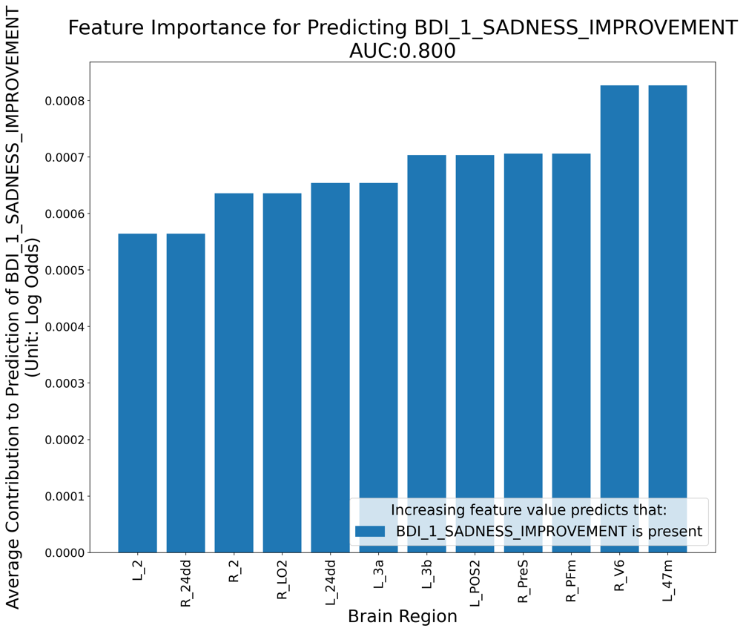
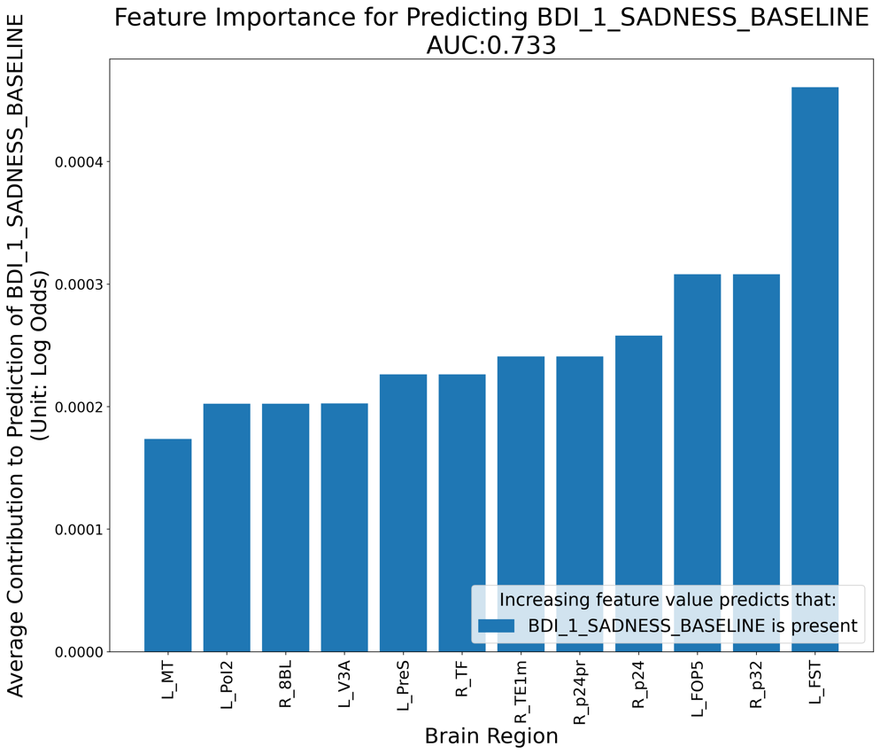

Supplementary Figure 1 Predictors of a) BDI 1 – Sadness at Baseline and b) Improvement of BDI 1 -Sadness after rTMS treatment to area left 46.

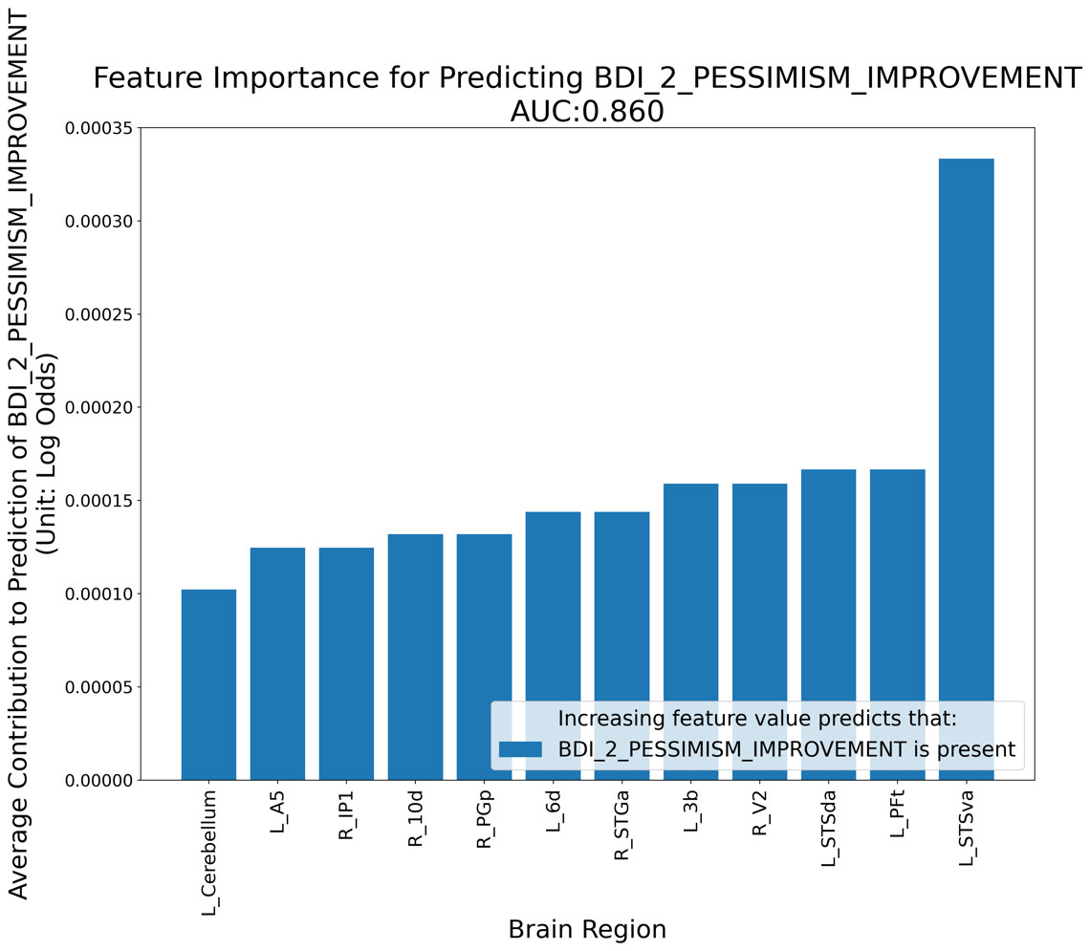
a
b
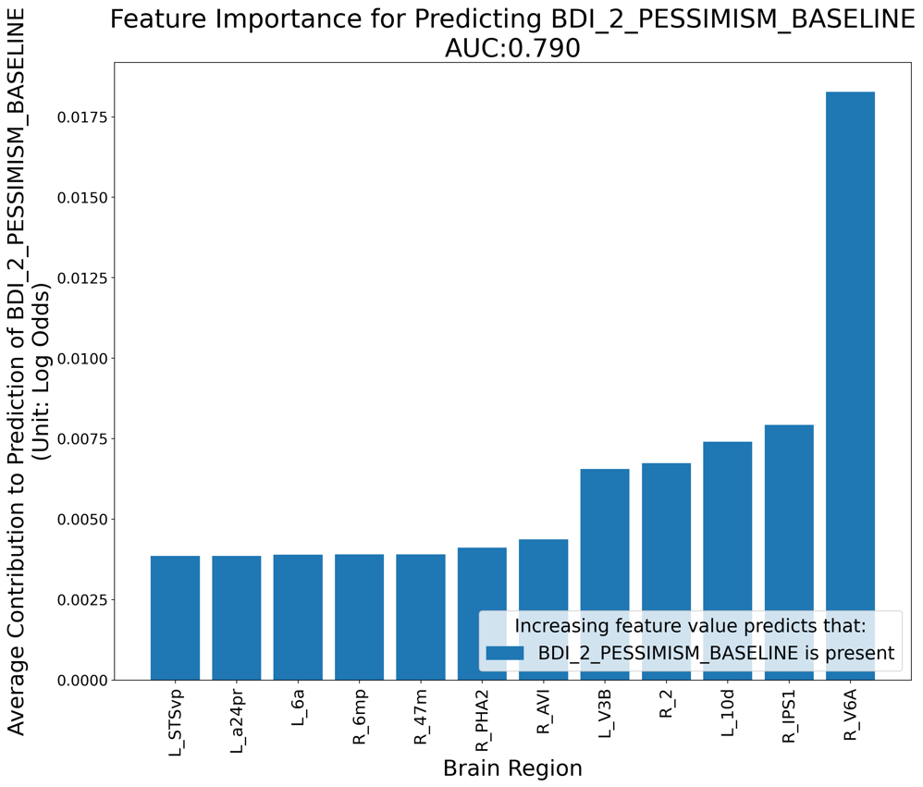

Supplementary Figure 2 Predictors of a) BDI 2 – Pessimism at Baseline and b) Improvement of BDI 2 -Pessimism after rTMS treatment to area left 46.

a
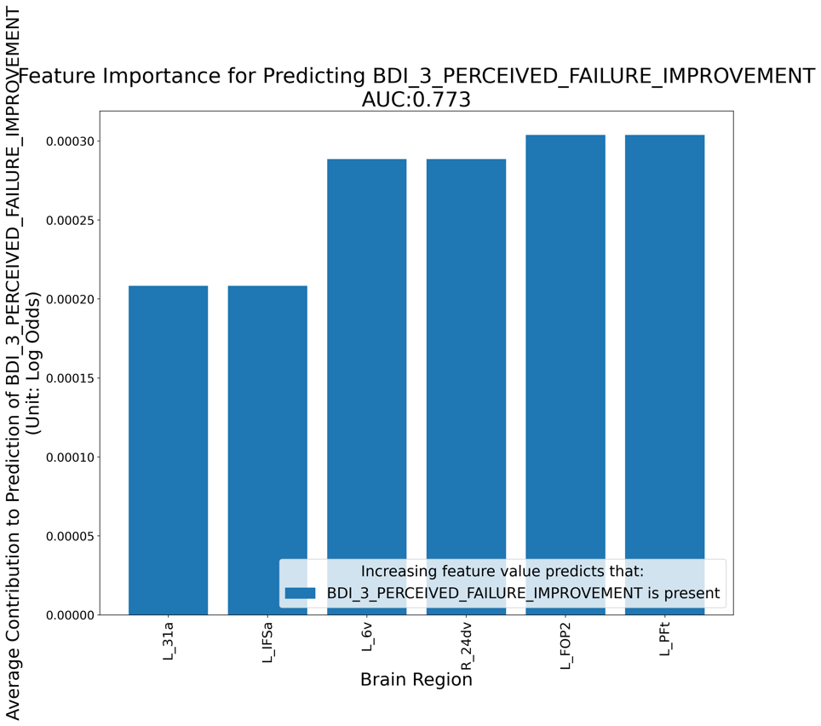
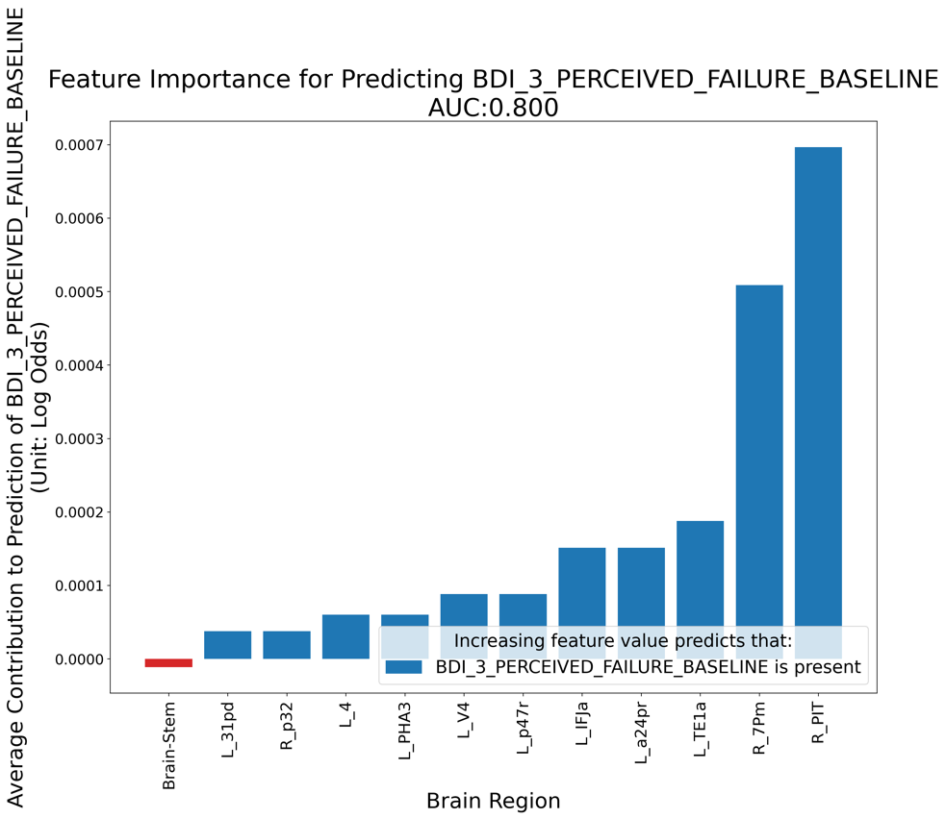
b

Supplementary Figure 3 Predictors of a) BDI 3 – Perceived failure and b) Improvement of BDI 3 – Perceived failure after rTMS treatment to area left 46.

a
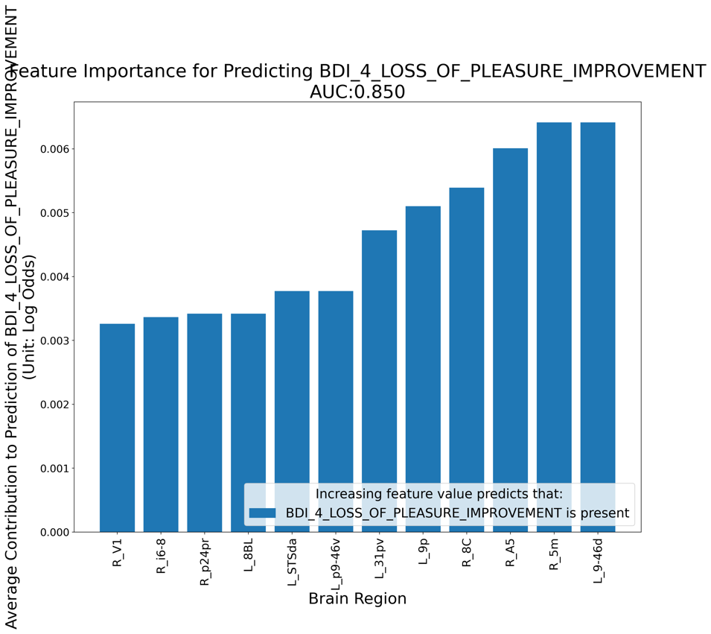
b
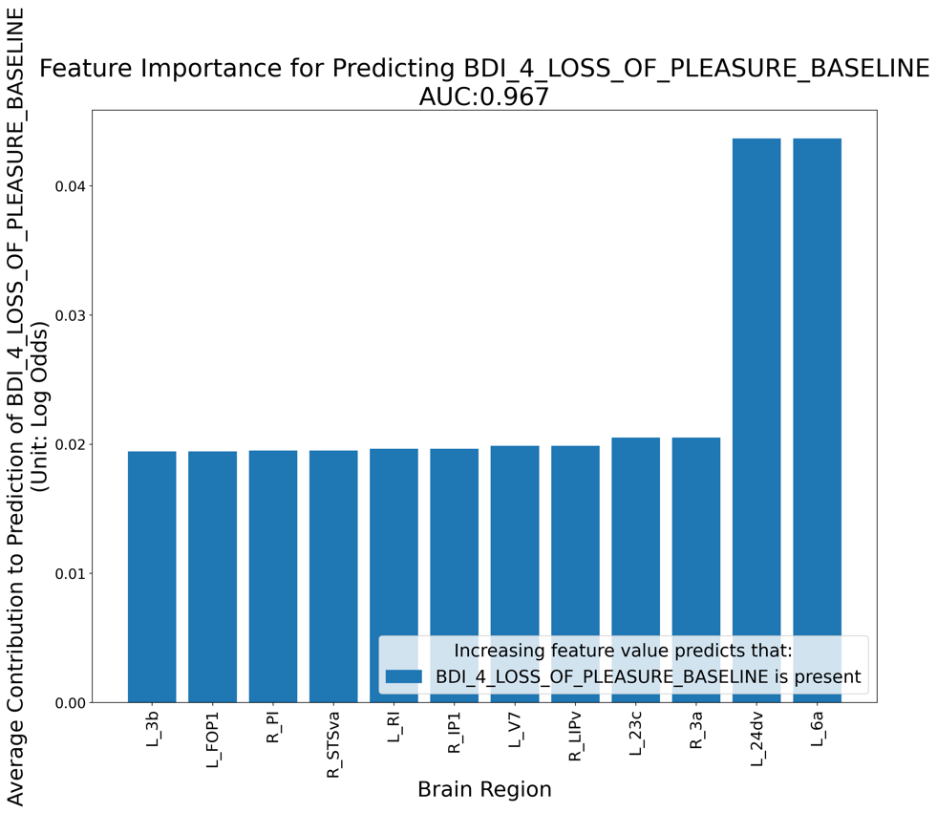

Supplementary Figure 4 Predictors of a) BDI 4 – Loss of Pleasure at Baseline and b) Improvement of BDI 1 – Loss of Pleasure after rTMS treatment to area left 46.

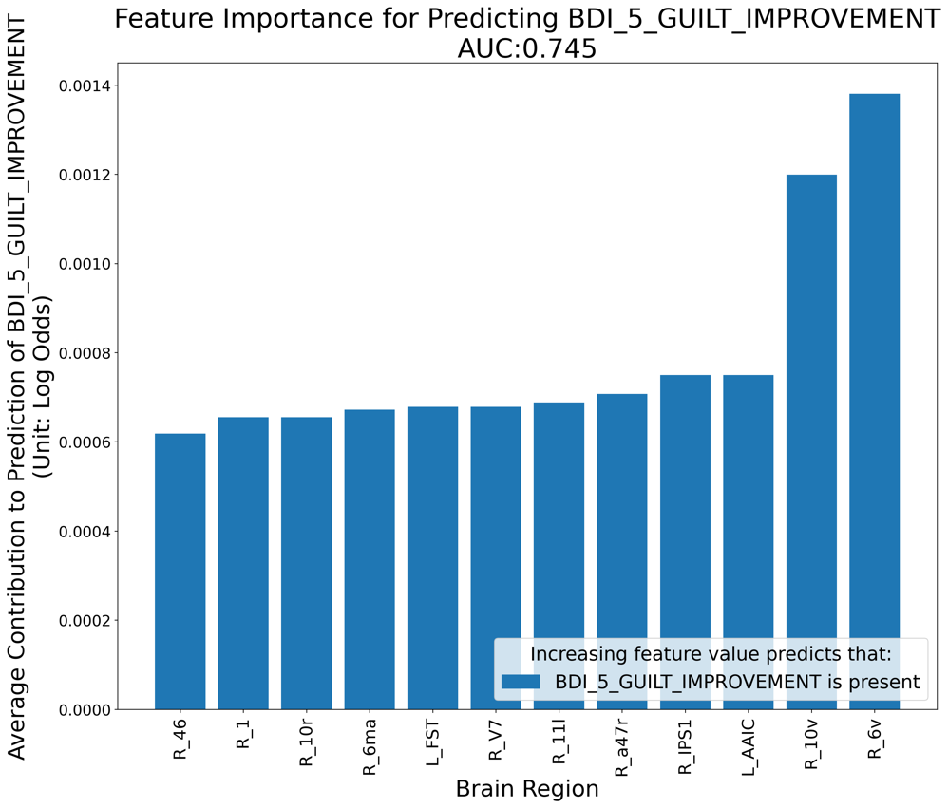

Supplementary Figure 5 Predictors of Improvement of BDI 5 - Guilt after rTMS treatment to area left 46.
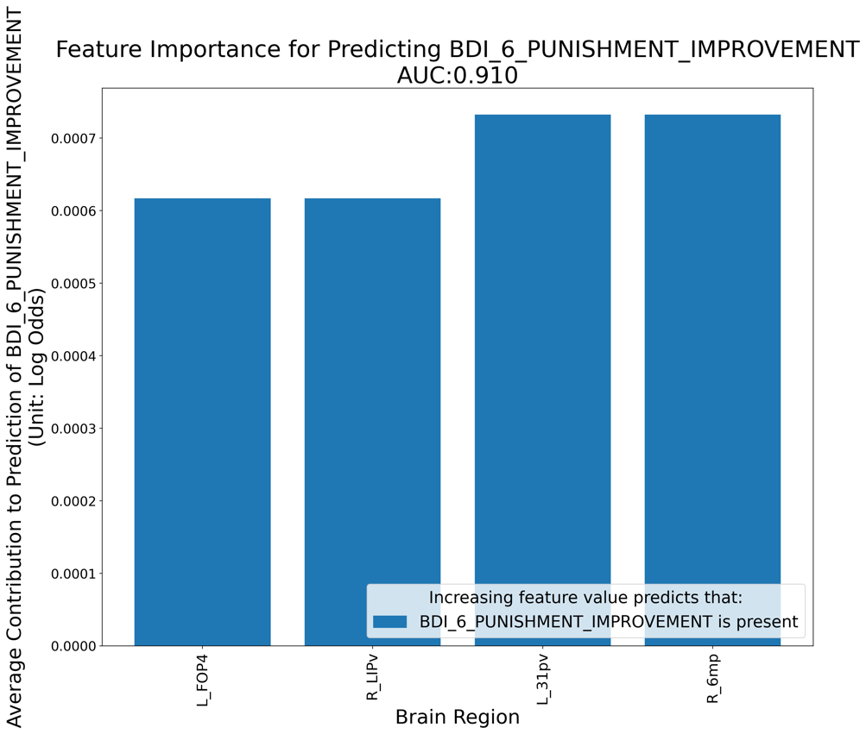
Supplementary Figure 6 Predictors of Improvement of BDI 6 -Punishment after rTMS treatment to area left 46.

a
b
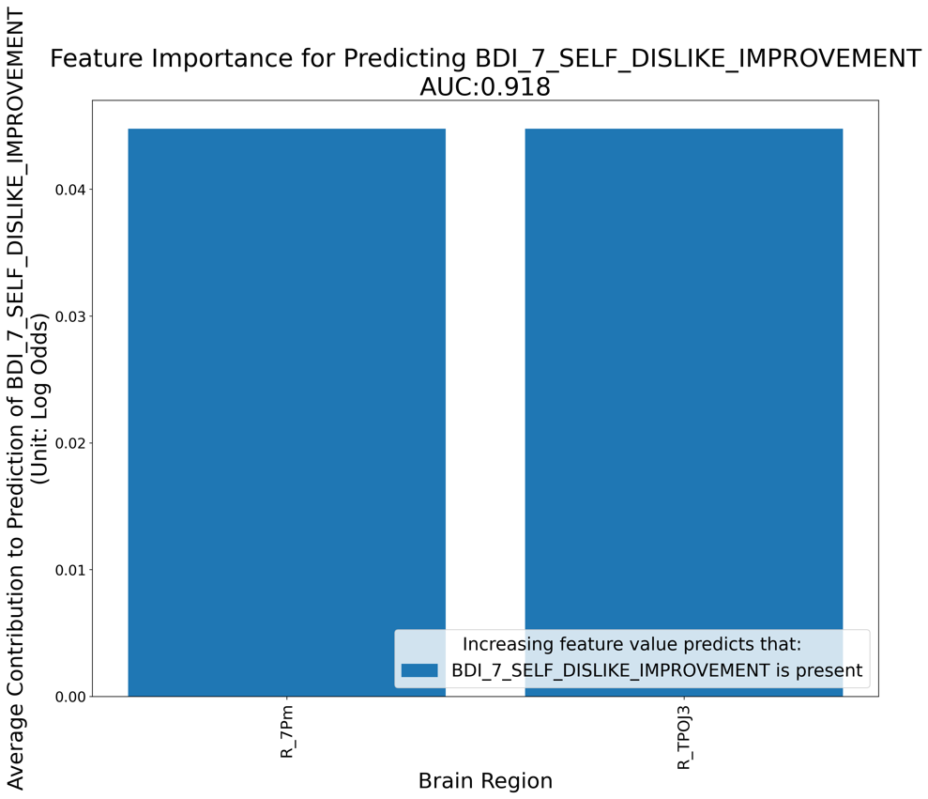
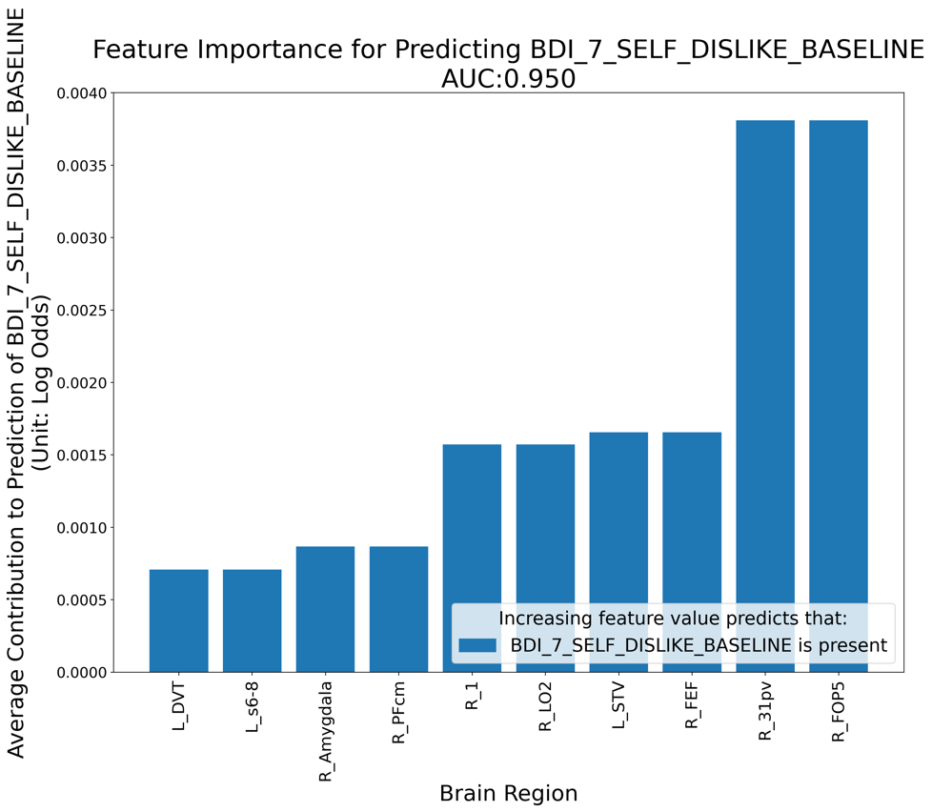

Supplementary Figure 7 Predictors of a) BDI 7 – Self-dislike at Baseline and b) Improvement of BDI 7 -Self-dislike after rTMS treatment to area left 46.

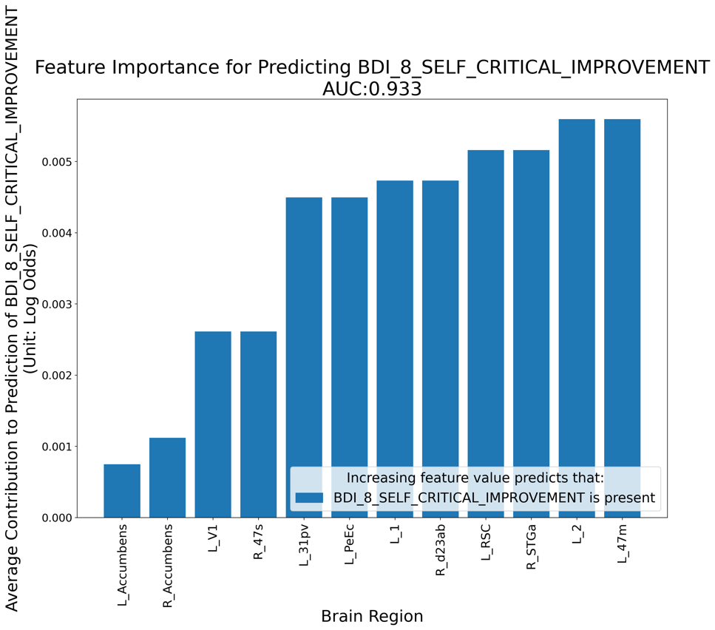
a
b
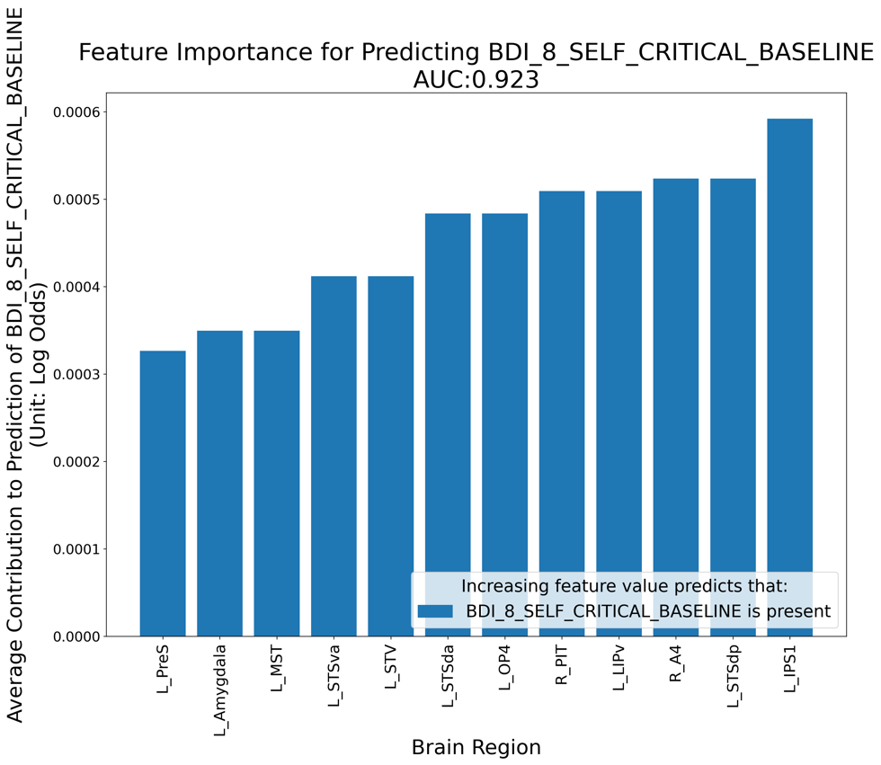

Supplementary Figure 8 Predictors of a) BDI 8 – Self-critical at Baseline and b) Improvement of BDI 8 - Self-critical after rTMS treatment to area left 46.

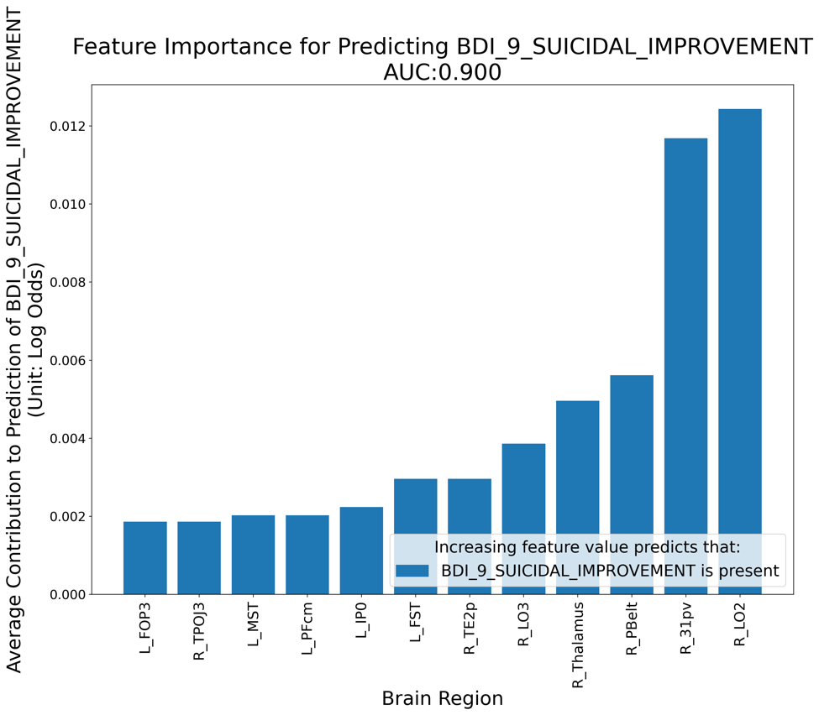
Supplementary Figure 9 Predictors of Improvement of BDI 9 -Suicidality after rTMS treatment to area left 46.

a
b
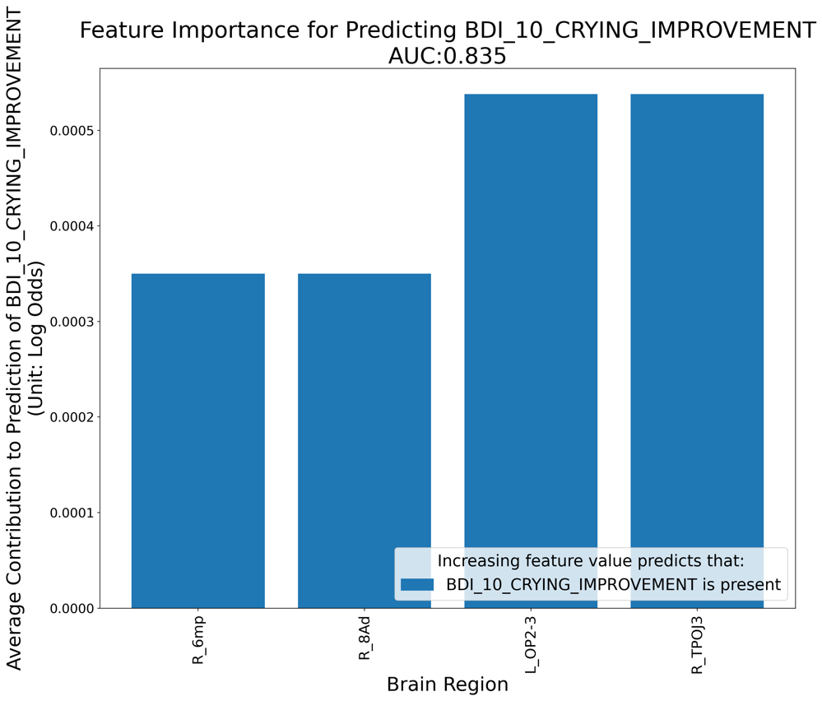
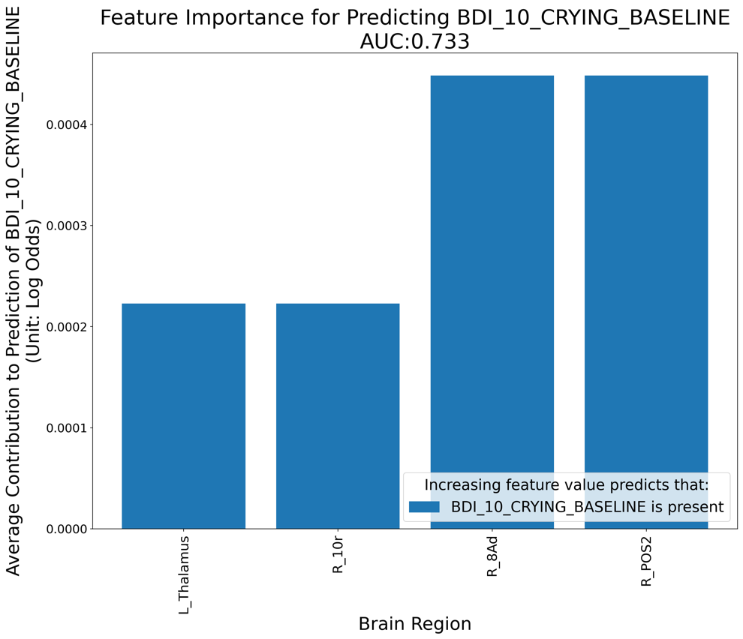

Supplementary Figure 10 Predictors of a) BDI 10 – Crying at Baseline and b) Improvement of BDI 10 -Crying after rTMS treatment to area left 46.

a
b

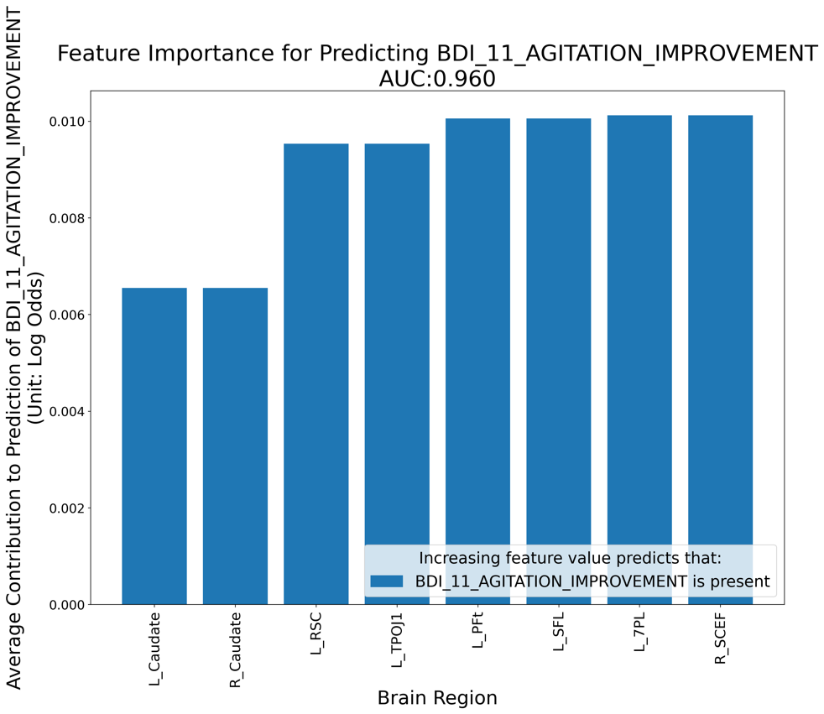
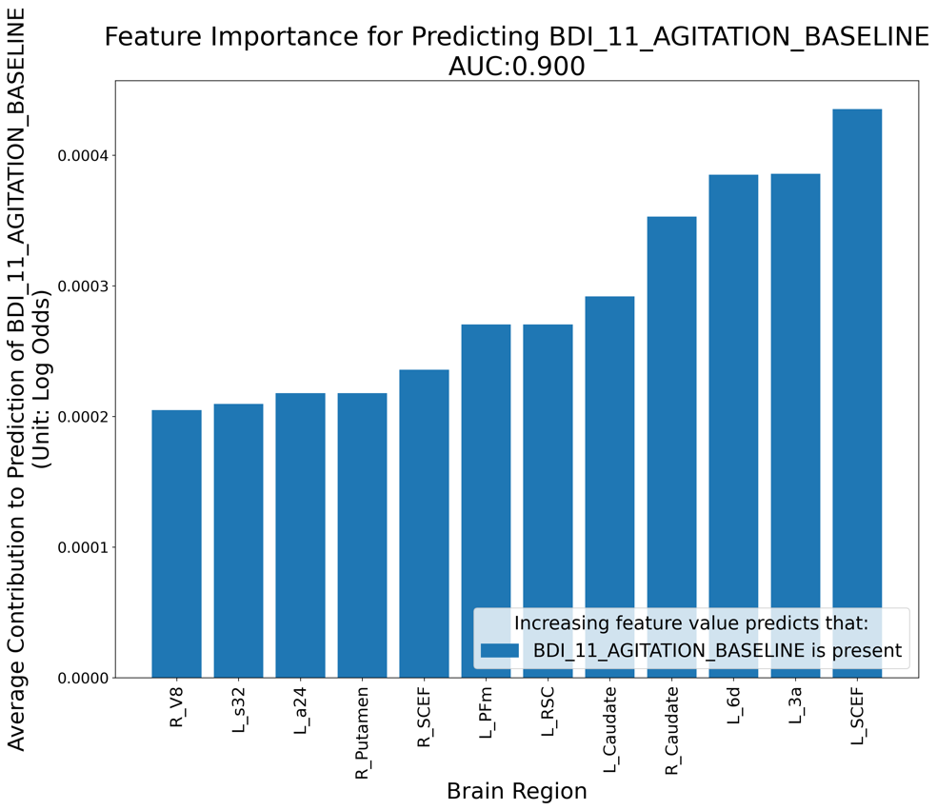

Supplementary Figure 11 Predictors of a) BDI 11 – Agitation at Baseline and b) Improvement of BDI 11 - Agitation after rTMS treatment to area left 46.

a
b
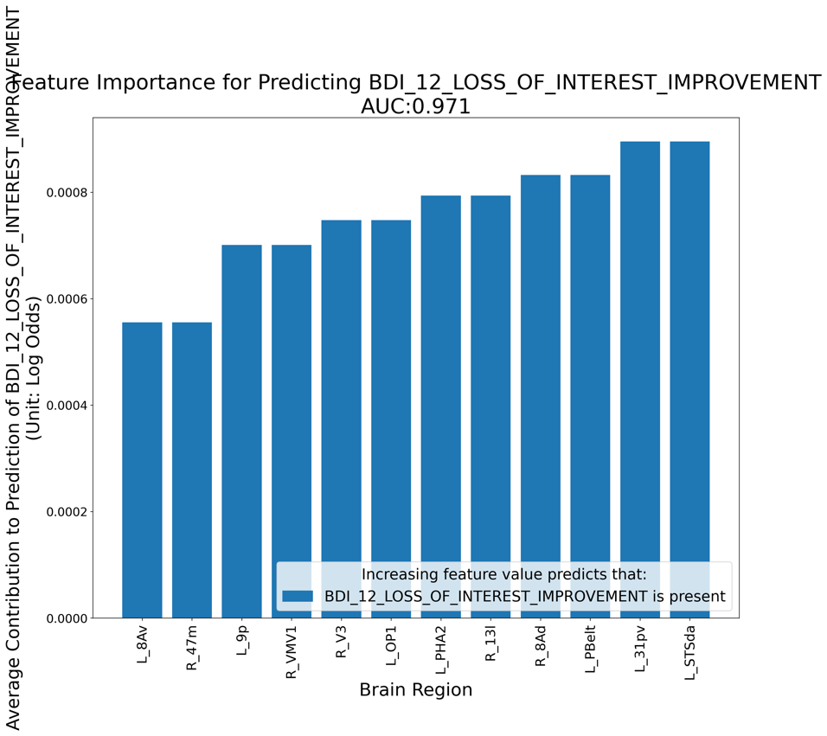
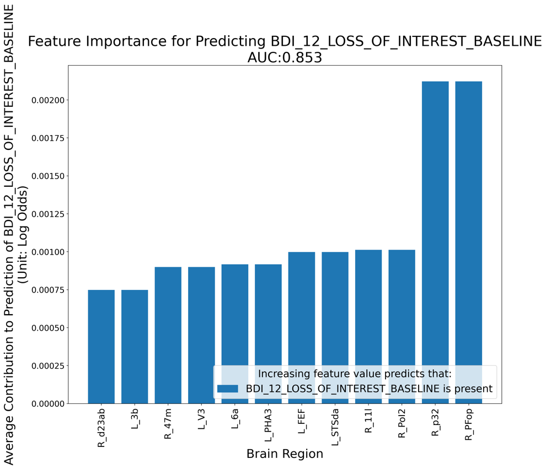

Supplementary Figure 12 Predictors of a) BDI 12 – Loss of interest at Baseline and b) Improvement of BDI 12 -Loss of interest after rTMS treatment to area left 46.

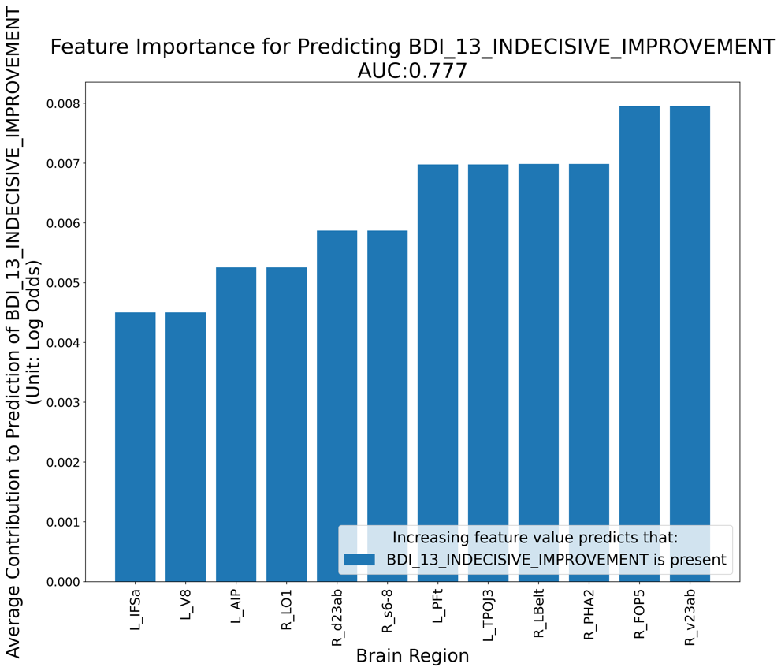

Supplementary Figure 13 Predictors of Improvement of BDI 13 - Indecisiveness after rTMS treatment to area left 46.

a
b
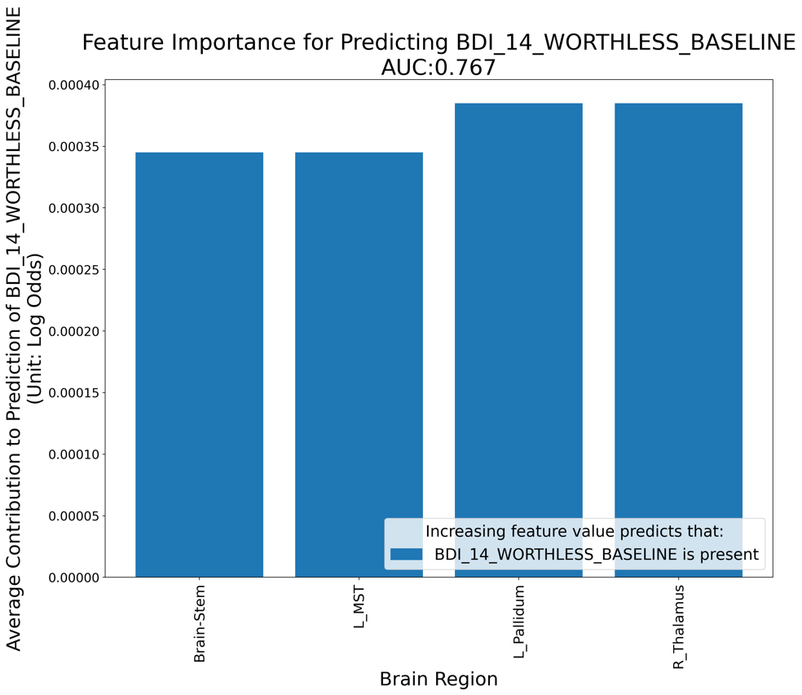
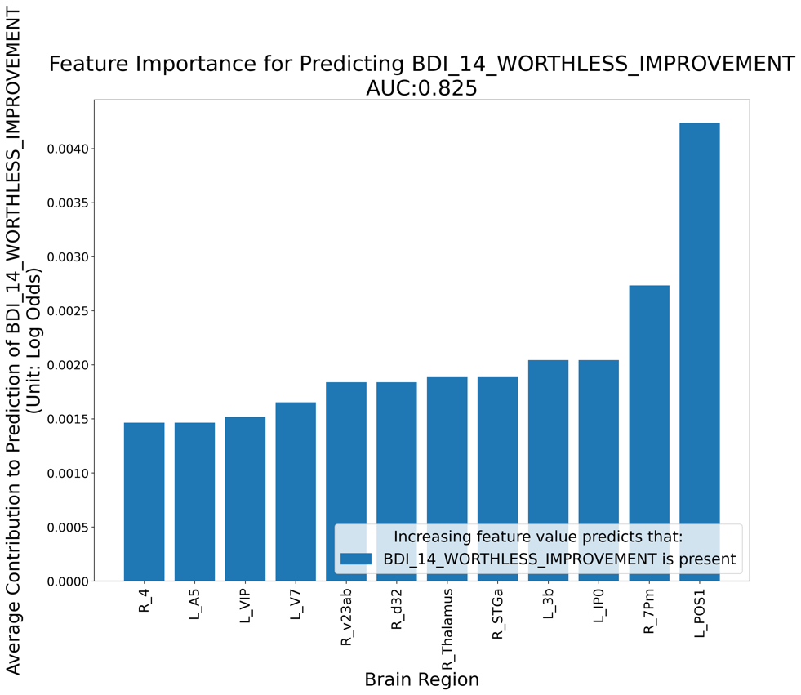

Supplementary Figure 14 Predictors of a) BDI 14 – Worthlessness at Baseline and b) Improvement of BDI 14 -Worthlessness after rTMS treatment to area left 46.

a
b
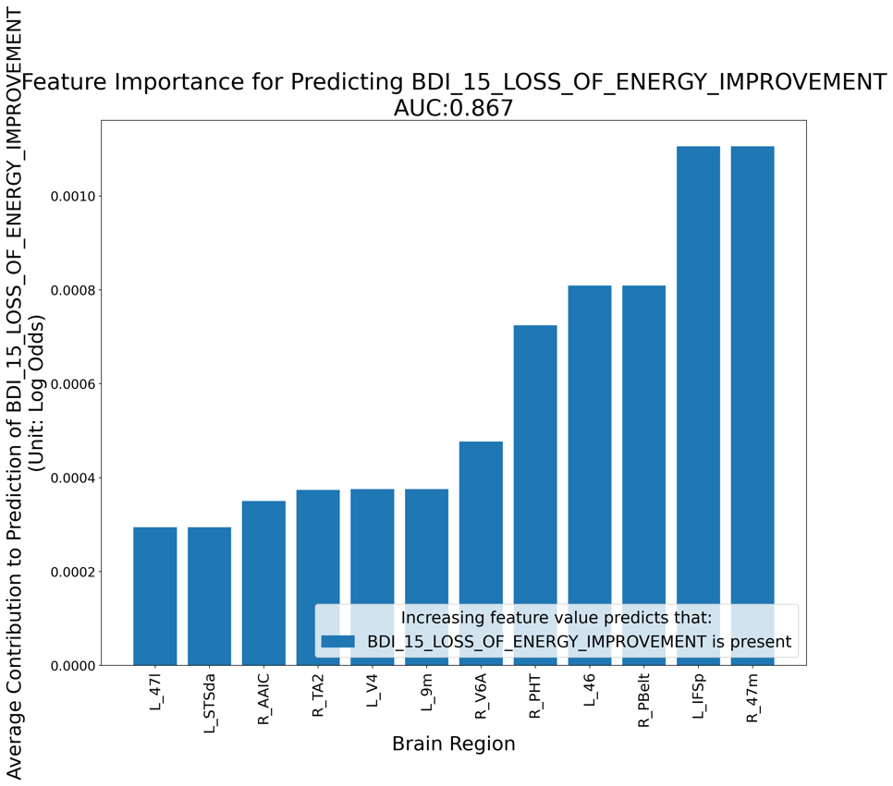
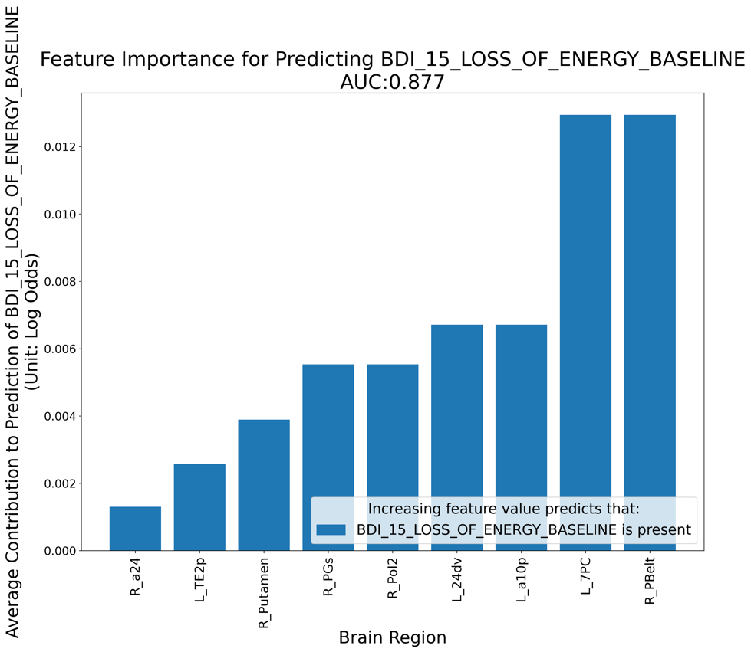

Supplementary Figure 15 Predictors of a) BDI 15 – Loss of energy at Baseline and b) Improvement of BDI 15 -Loss of energy after rTMS treatment to area left 46.

a
b
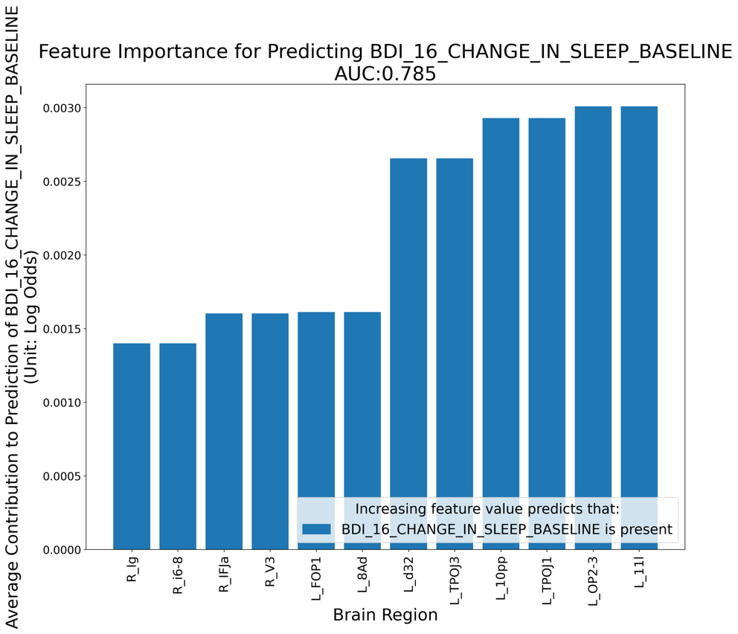
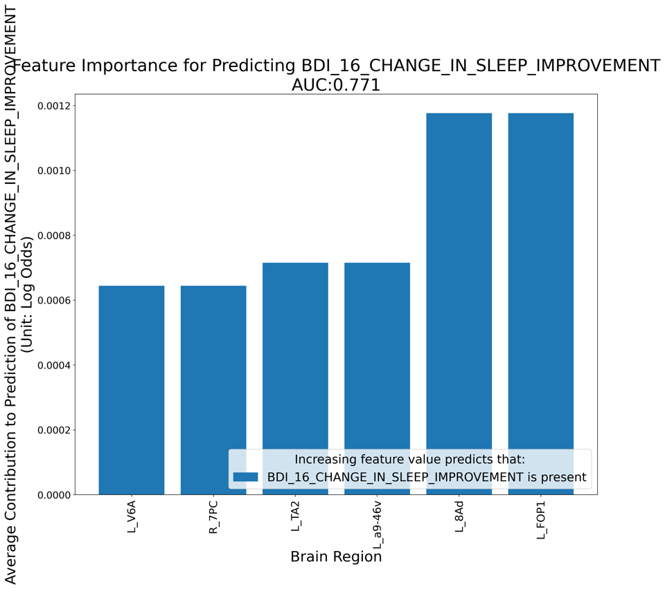

Supplementary Figure 16 Predictors of a) BDI 16 – Change in Sleep at Baseline and b) Improvement of BDI 16 -Change in Sleep after rTMS treatment to area left 46.

a
b
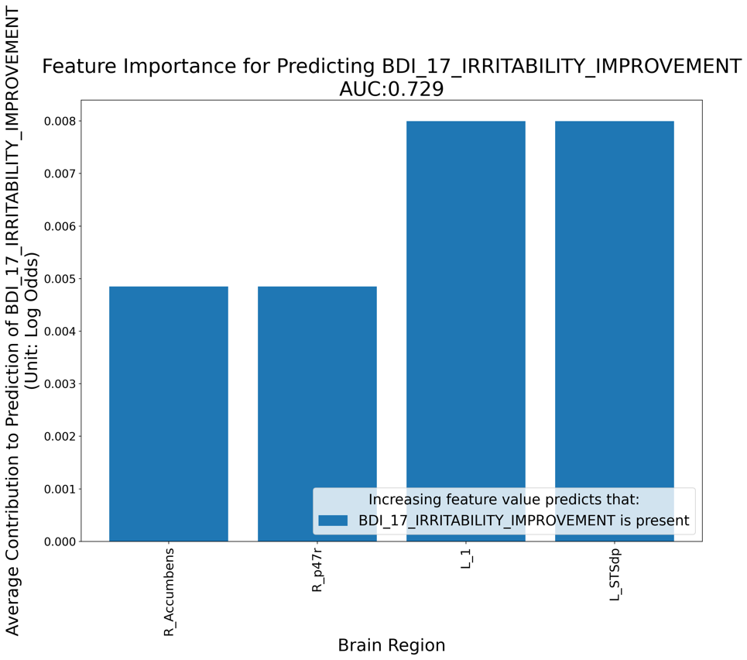
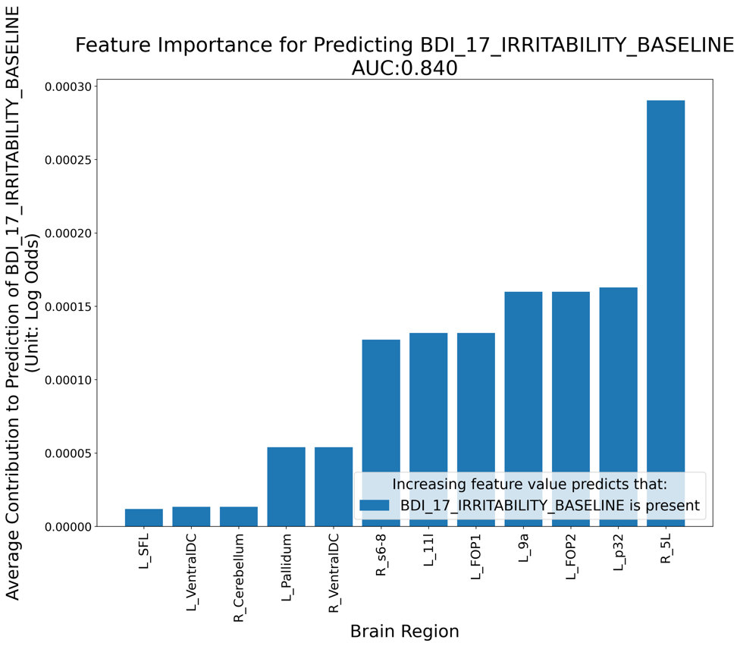

Supplementary Figure 17 Predictors of a) BDI 17 – Irritability at Baseline and b) Improvement of BDI 17 -Irritability after rTMS treatment to area left 46.

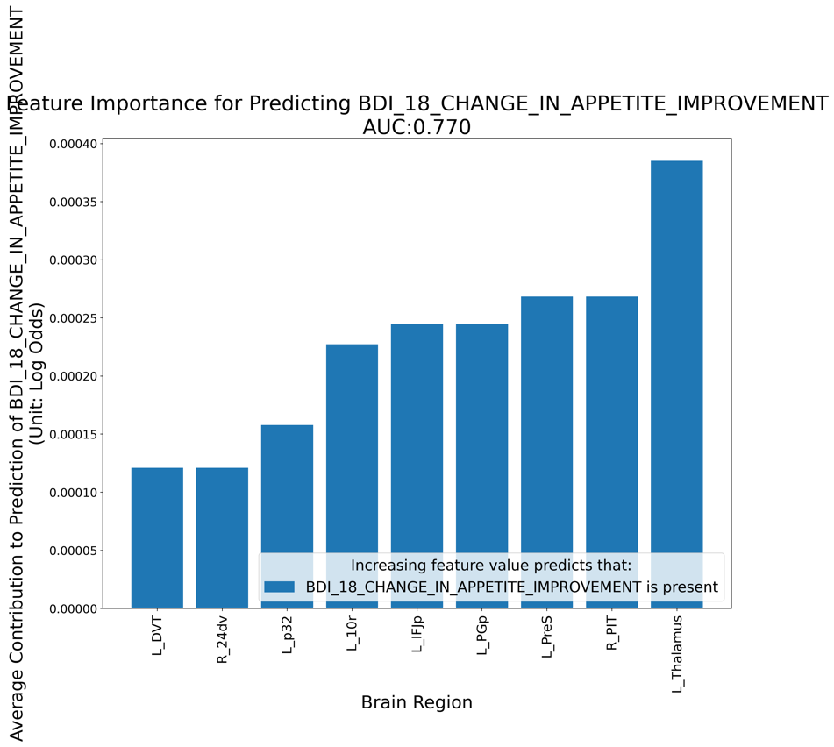

Supplementary Figure 18 Predictors of Improvement of BDI 18 - Change in Appetite after rTMS treatment to area left 46.

a
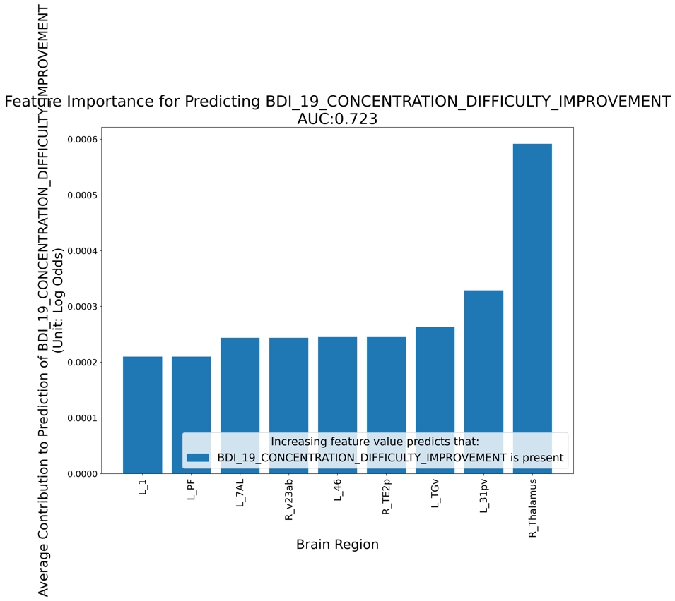
b
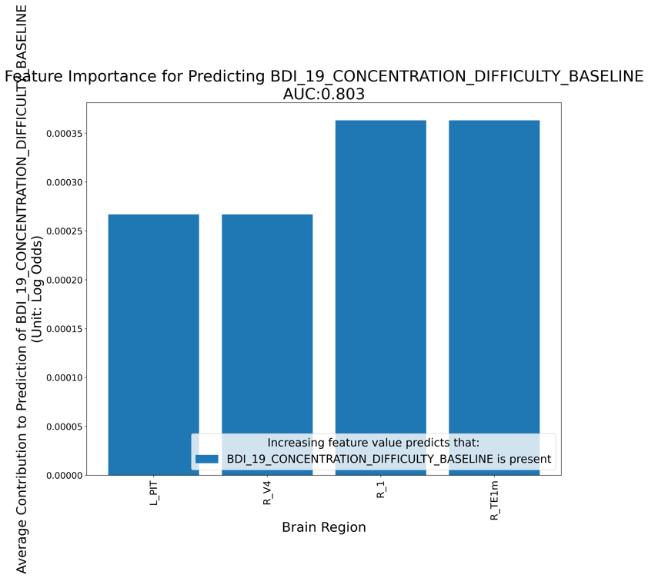

Supplementary Figure 19 Predictors of a) BDI 19 – Concentration difficulty at Baseline and b) Improvement of BDI 19 -Concentration difficulty after rTMS treatment to area left 46.

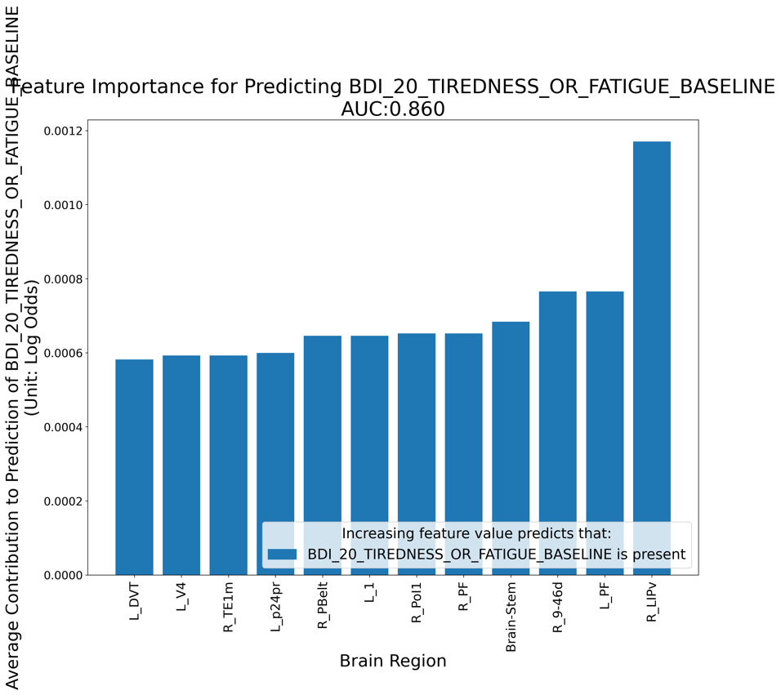

Supplementary Figure 20 Predictors of a) BDI 20 – Tiredness at Baseline

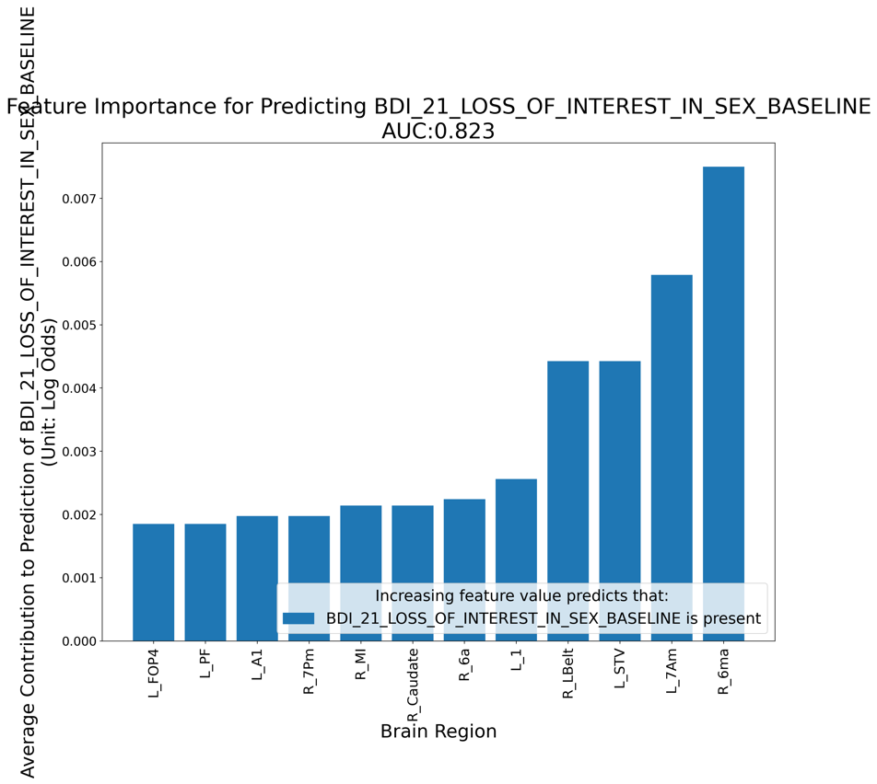
Supplementary Figure 21 Predictors of a) BDI 21 – Loss of interest in sex at Baseline

