SUPPLEMENTAL MATERIALS
Supplemental Table S1. Descriptive details about data sources of iron status and myocardial infarction (MI)
Supplemental Table S2. Associations between genetically instrumented iron status and myocardial infarction using the separately selected single-nucleotide
variations associated with each iron biomarker
Supplemental Figure S1. Forest plots of SNPs associated with iron status and myocardial infarction (MI)
Supplemental Figure S2. Scatter plots of SNPs associated with iron status and myocardial infarction (MI)
Supplemental Figure S3. Funnel plots of SNPs associated with iron status and myocardial infarction (MI)
Supplemental Figure S4. Leave-one-out plots of SNPs associated with iron status and myocardial infarction (MI)

Exposure or outcome | First author (year) | Participants (Sample size) | Web source
Iron status
Iron | Neale lab (2018) | 361,194individuals of European ancestries | UK Biobank(Binary).2018
Ferritin | Benyamin (2018) | 23,986individuals of European ancestries | GIS.2018
Transferrin saturation | Benyamin (2018) | 23,986individuals of European ancestries | GIS.2018
Transferrin | Benyamin (2018) | 23,986individuals of European ancestries | GIS.2018
MI | Neale lab (2018) | 7,018 MI cases and 354,176 controls of European ancestries | UK Biobank(Binary).2018
Supplemental Table S1. Descriptive details about data sources of iron status and MI
Abbreviations: MI: myocardial infarction.

Supplemental Table S2. Associations between genetically instrumented iron status and myocardial infarction using the separately selected single-nucleotide
variations associated with each iron biomarker.
Exposure | MR-Egger |  |  |  |  | Maximum likelihood
Exposure | OR | CI | Q statistic(P) | Intercept (P) |  | OR | CI | P-value
Iron | 0.384 | 0.083-1.771 | 0.691 | 0.419 |  | 1.034 | 0.787-1.358 | 0.807
Ferritin | 0.998 | 0.991-1.006 | 0.968 | 0.966 |  | 0.998 | 0.994-1.001 | 0.363
Transferrin saturation | 0.999 | 0.996-1.002 | 0.307 | 0.737 |  | 0.999 | 0.997-1.000 | 0.454
Transferrin | 1.001 | 0.999-1.004 | 0.072 | 0.107 |  | 1.000 | 0.998-1.001 | 0.390
Abbreviations: MR-Egger: Mendelian randomization-Egger; IVW: Inverse variance weighted, OR: odds ratio.

Supplemental Figure S1. Forest plots of SNPs associated with iron status and myocardial infarction (MI)
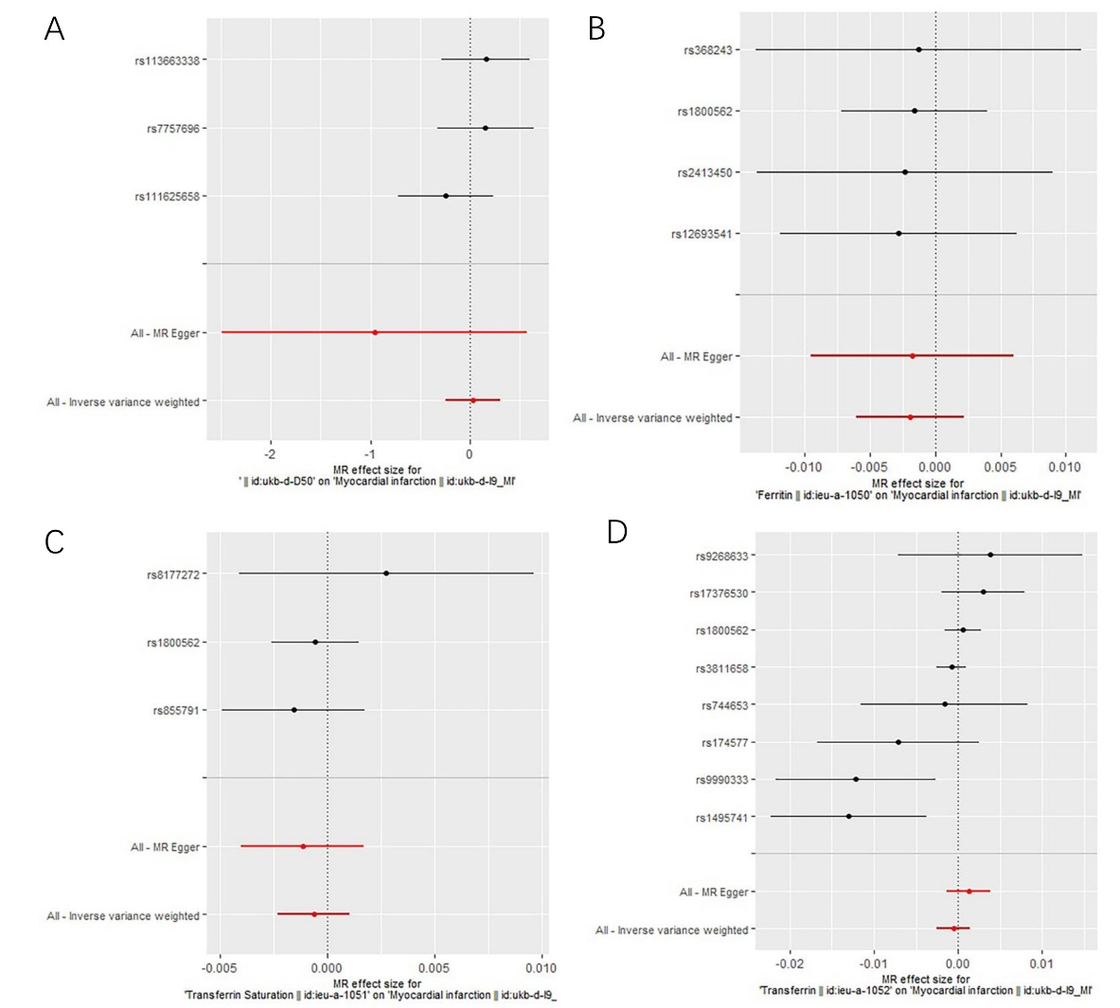
Note: (A) For Iron; (B) For Ferritin; (C) For Transferrin Saturation; (D) For Transferrin; Each row (black lines) represents the result after the removal of the corresponding SNP, and the overall effect is shown at the bottom (red line).
Supplemental Figure S2. Scatter plots of SNPs associated with status and myocardial infarction (MI)
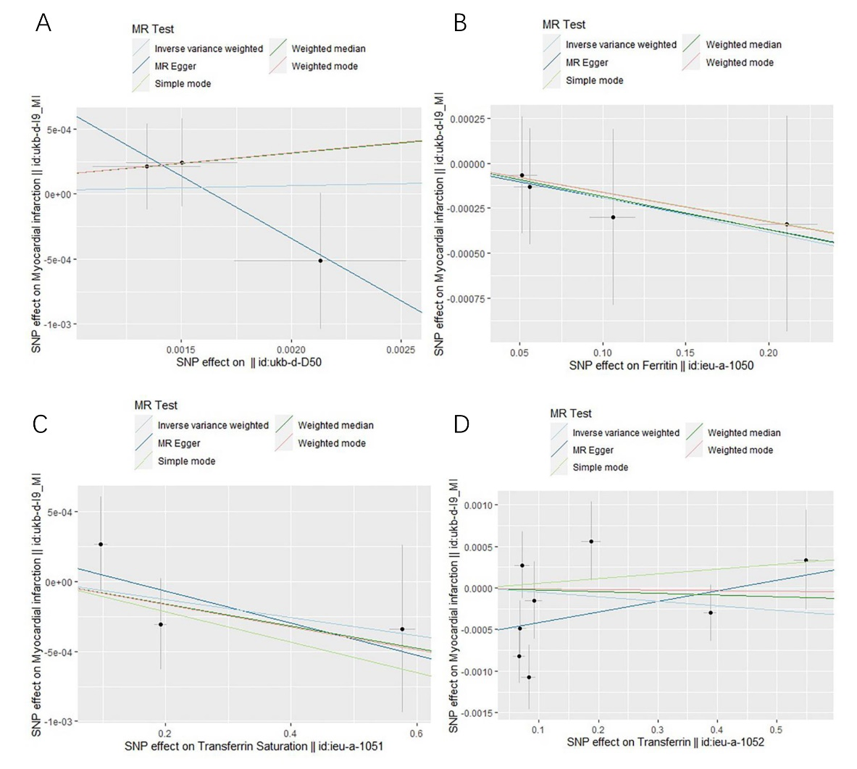
Note: (A) For Iron; (B) For Ferritin; (C) For Transferrin Saturation; (D) For Transferrin; According to the catter plots, the sleep duration was not associated with atherosclerosis(AS).
Supplemental Figure S3. Funnel plots of SNPs associated with status and myocardial infarction (MI)
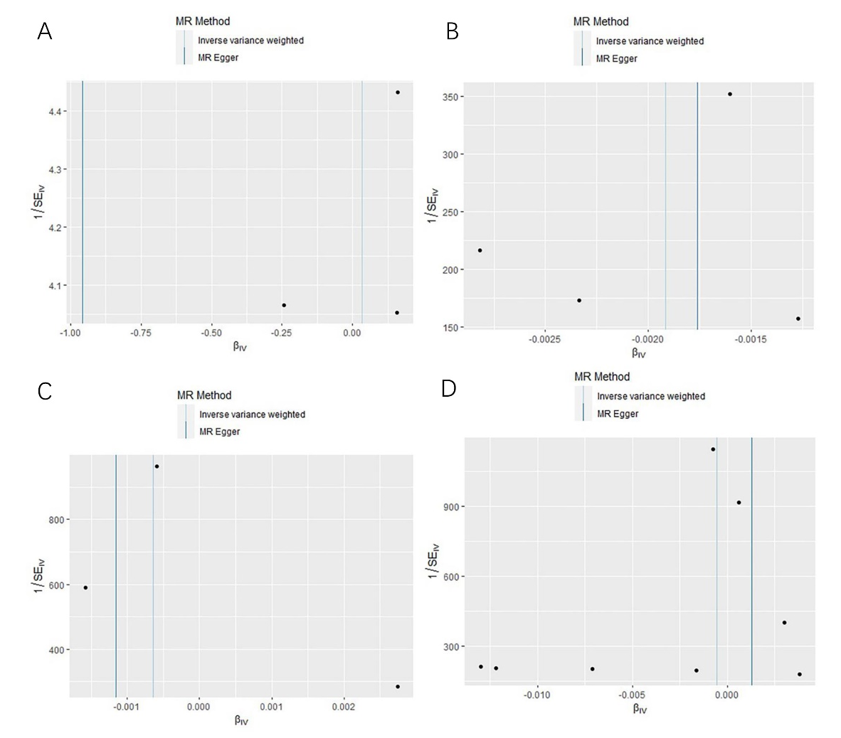
Note: (A) For Iron; (B) For Ferritin; (C) For Transferrin Saturation; (D) For Transferrin; The funnel plot showed that there was not basically symmetry.

Supplemental Figure S4. Leave-one-out plots of SNPs associated with status and myocardial infarction (MI)
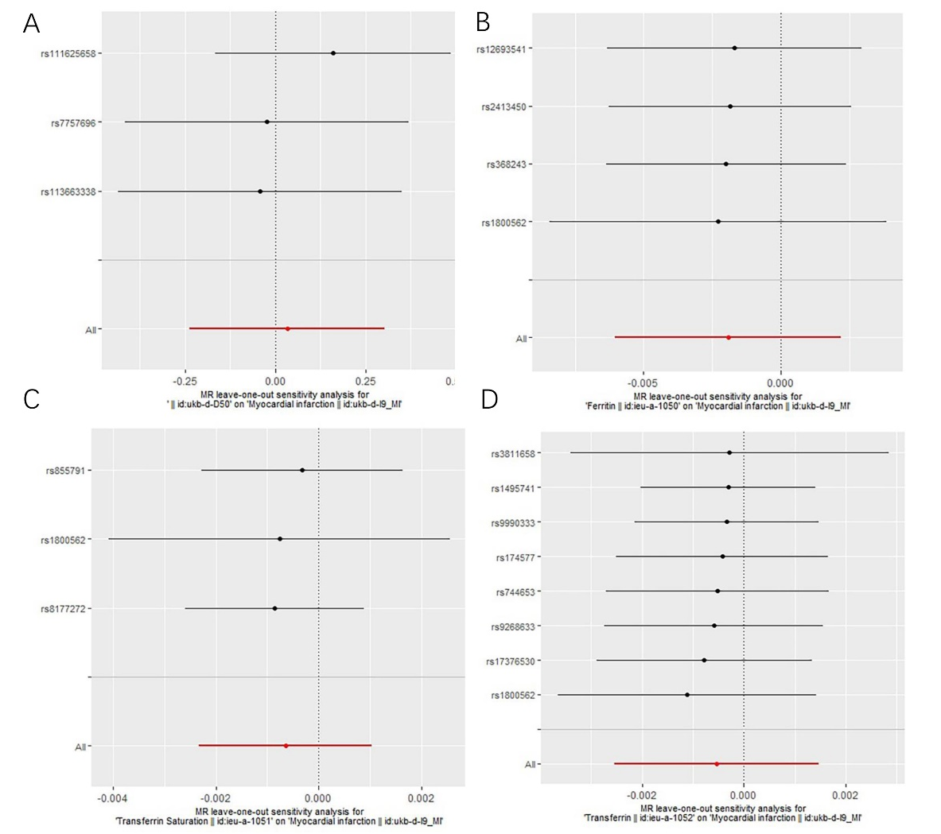
Note: (A) For Iron; (B) For Ferritin; (C) For Transferrin Saturation; (D) For Transferrin; Each row (black lines) represents the result after the removal of the corresponding SNP, and the overall effect is shown at the bottom (red line).
References
1.Palmer TM, Lawlor DA, Harbord RM, Sheehan NA, Tobias JH, Timpson NJ, Davey Smith G, Sterne JA. Using multiple genetic variants as instru-
mental variables for modifiable risk factors. Stat Methods Med Res. 2012; 21:223–242. Doi: 10.1177/0962280210394459

