Supplementary material:
Electron-phonon coupling in amphiboles contributes to the anomalous conductivity in subduction zones
Simone Bernardini, Giancarlo Della Ventura, Jochen Schlüter and Boriana Mihailova

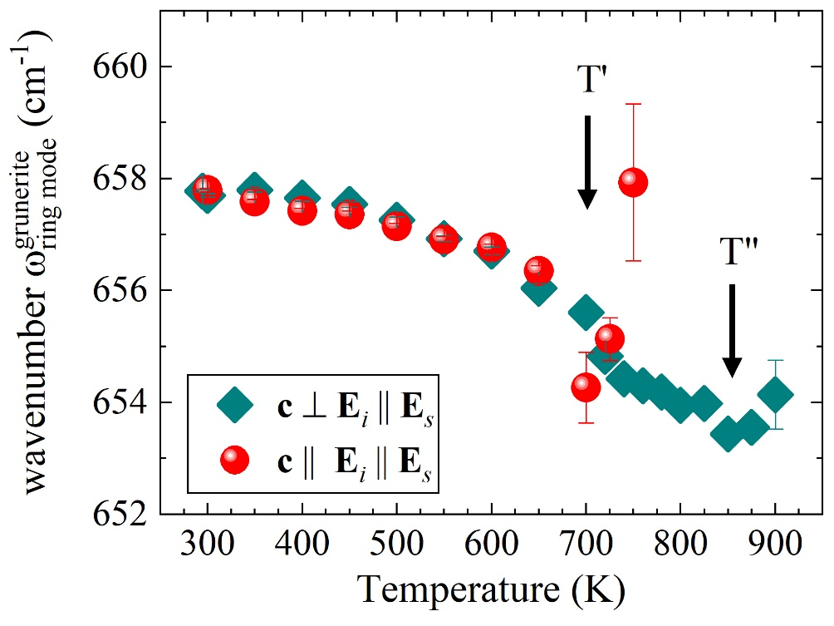
Figure S1. Temperature dependence of the wavenumber of the SiO₄-ring mode for grunerite derived from c || E_{i} || E_{s} (spheres) and c ⊥ E_{i} || E_{s} (rhombuses) spectra. Data from Mihailova et al. (2021)¹².

