Supplementary Information for
Enhanced poly-γ-glutamic acid production by a newly isolated B. tequilensis BL01
Author：Dexin Wang^{1,2}†, Dasen Zhou³†, Jiaqi Gao^{1,2,4}, Wenqin Bai^{1,2*}
Affiliations:
¹ CAS Key Laboratory of Systems Microbial Biotechnology, Tianjin Institute of Industrial Biotechnology, Chinese Academy of Sciences, Tianjin, 300308, China
² National Center of Technology Innovation for Synthetic Biology, Tianjin, 300308, China
³ College of Biotechnology, Tianjin University of Science and Technology, Tianjin, 300457, China
⁴ University of Chinese Academy of Sciences, 19A Yuquan Road, Shijingshan District, Beijing, 100049, China
*Correspondence to: WB (baiwq@tib.cas.cn)
†These authors contributed equally to this work

Figure legends
Fig. S1 The γ-PGA titer normalized to the biomass of the individual cultures. (a) Effect of carbon sources; (b) Effect of nitrogen sources; (c) Effect of temperature. Values represent the mean ± SD, n=3.
Fig. S2 Fed-batch fermentation for γ-PGA production by B. tequilensis BL01. (a) Curve of dissolved oxygen and pH; (b) Time-course profile of meso-2,3-BD, R, R-2,3-BD and total 2,3-BD. Values represent the mean ± SD, n=3.
Fig. S3 The molecular weight distribution of γ-PGA produced by B. tequilensis BL01.
Fig. S4 1H-NMR spectrum of γ-PGA produced by B. tequilensis BL01 recorded in D₂O. The peak at 4.7 ppm corresponds to the D₂O used as a solvent. X-marked peaks indicate impurity peaks, most of which are amino acids residues.

a
b
c
Fig. S1 The γ-PGA titer normalized to the biomass of the individual cultures. (a) Effect of carbon sources; (b) Effect of nitrogen sources; (c) Effect of temperature. Values represent the mean ± SD, n=3.
a
700 rpm
600 rpm
500 rpm
400 rpm
b
Fig. S2 Fed-batch fermentation for γ-PGA production by B. tequilensis BL01. (a) Curve of dissolved oxygen and pH; (b) Time-course profile of meso-2,3-BD, R, R-2,3-BD and total 2,3-BD. Values represent the mean ± SD, n=3.

Fig. S3 The molecular weight distribution of γ-PGA produced by B. tequilensis BL01.
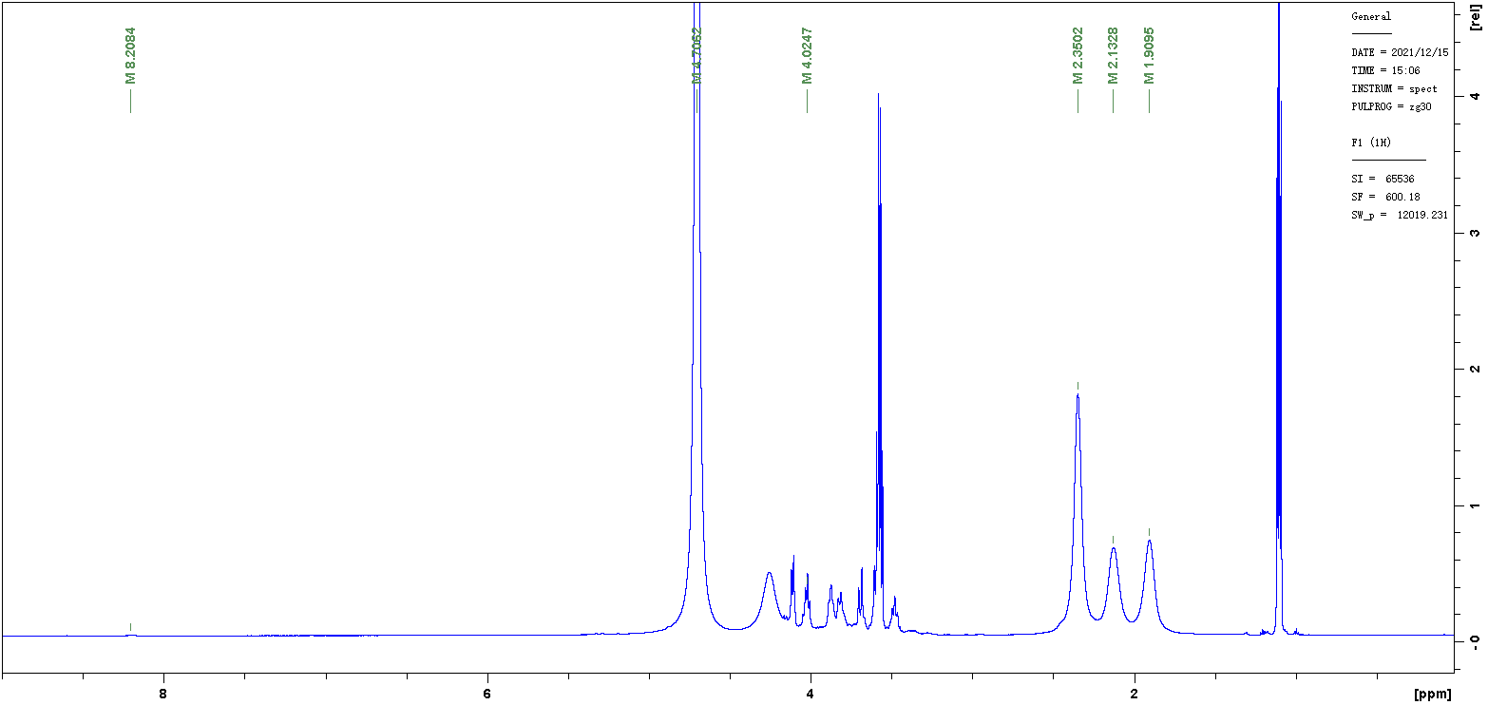
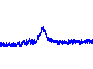
X
β
β
γ
α
D₂O
Fig. S4 1H-NMR spectrum of γ-PGA produced by B. tequilensis BL01 recorded in D₂O. The peak at 4.7 ppm corresponds to the D₂O used as a solvent. X-marked peaks indicate impurity peaks, most of which are amino acids residues.

Table S1 γ-PGA production by the isolated strains
Strains | 12 h |  | 18 h |  | 24 h |  | γ-PGA/Biomass  (g/g) | species
Strains | Biomass (g/L) | γ-PGA (g/L) | Biomass (g/L) | γ-PGA (g/L) | Biomass (g/L) | γ-PGA (g/L) | γ-PGA/Biomass  (g/g) | species
BL01 | 1.7 ± 0.1 | 4.4 ± 0.3 | 2.7 ± 0.2 | 6.0 ± 0.2 | 4.5 ± 0.2 | 8.6 ± 0.3 | 1.91 ± 0.16 | B. tequilensis
F29 | 1.7 ± 0.2 | 5.6 ± 0.2 | 2.9 ± 0.2 | 7.2 ± 0.3 | 4.7 ± 0.3 | 8.3± 0.3 | 1.76 ± 0.19 | B. halotolerans
L29 | 1.6 ± 0.1 | 3.6 ± 0.1 | 2.5 ± 0.2 | 7.5 ± 0.2 | 5.1 ± 0.3 | 7.9 ± 0.3 | 1.55 ± 0.16 | B. zanthoxyli
L45 | 1.6 ± 0.2 | 4.0 ± 0.1 | 2.7± 0.1 | 7.3 ± 0.3 | 4.8 ± 0.2 | 7.4 ± 0.3 | 1.54 ± 0.13 | B. licheniformis
W1 | 2.2 ± 0.1 | 2.4 ± 0.1 | 3.4 ± 0.1 | 4.2 ± 0.2 | 6.1 ± 0.3 | 5.1 ± 0.2 | 0.84 ± 0.07 | B. subtilis
Note: The biomass and γ-PGA titer was measured at 12, 18, and 24 h; The γ-PGA titer/Biomass was tested at 24 h. Values represent the mean ± SD, n=3.

