Supplementary Information
Van der Waals interactions regulating the hydration of 2-methacryloyloxyethyl phosphorylcholine, the constructing monomer of biocompatible polymers
Masae Takahashi, Sifan Chen, Hiroshi Matsui, Nobuyuki Morimoto and Yuka Ikemoto

Contents
Table S1. Relative energies of 48 MPC conformers (in kcal/mol) calculated with different dielectric constant (ε)
Fig. S1. Number representing the 81 conformations, ABCD, of MPC.
Fig. S2. FIR spectra of conformers 1−6 in Fig.7 of the main text, calculated in a solvent with a dielectric constant ε = 15.20 at the b3LYP/6-311++G(d,p) level with dispersion correction. The FWHM of the calculated spectra is set to the same value as that of the well-separated sharp peak observed at 423 cm⁻¹ at 4 K in Fig. 2a of the main text (FWHM = 4.4 cm⁻¹).

Table S1. Relative energies of 48 MPC conformers (in kcal/mol) calculated with different dielectric constant (ε)ª
conformers^{b} | Solvent-free | ε = 8.33 | ε = 15.20
131Y (1) | 0.00 | 0.00 | 0.00
3112 (6) | 2.45 | 0.92 | 0.91
133X | 2.56 | 1.13 | −
1332 (5) | 3.26 | 0.99 | 0.85
3X33 (4) | 3.62 | 0.96 | 0.73
1Y11 (2) | 4.26 | 0.99 | 0.64
1311 | 4.57 | 3.59 | 3.33
3311 | 4.60 | 2.78 | 2.49
3121 | 4.88 | 3.82 | 3.72
3131 (3) | 5.35 | 1.30 | 0.65
2311 | 5.37 | 4.20 | −
1133 | 5.44 | 3.88 | 3.59
3323 | 5.71 | 4.30 | 4.23
1X32 | 6.35 | 4.32 | 4.14
1333 | 6.62 | 2.61 | 2.35
1212 | 6.65 | 3.47 | 3.17
1111 | 6.73 | 4.41 | 4.23
3313 | 6.73 | 4.14 | 3.54
3X32 | 6.74 | 2.77 | 2.31
2132 | 6.77 | 4.32 | −
113X | 6.80 | 3.78 | 3.23
2312^{c} | 6.98 | 5.00 | 4.24^{d}
3133 | 7.08 | − | 5.68
Y111 | 7.11 | 3.87 | 3.57
2X32 | 7.23 | 4.71 | 4.51
1323 | 7.44 | 4.62 | 4.47
1112 | 7.49 | 4.62 | 4.33
2312^{c} | 7.56 | − | 4.24^{d}
1131 | 7.56 | 5.12 | 4.61
2313 | 7.60 | 5.53 | −
1322 | 7.66 | 5.16 | 5.05
1123 | 7.75 | 5.58 | 5.46
2333 | 7.83 | − | −
1321 | 8.10 | 5.61 | 5.37
1121 | 8.12 | 5.84 | 3.59
3333 | 8.15 | 4.93 | 4.55
1122 | 8.26 | 5.76 | 5.54
1223 | 8.46 | − | 5.53
3332 | 8.59 | 5.04 | 4.56
1222 | 8.70 | − | −
3321 | 9.03 | 5.96 | 5.65
3123 | 9.04 | − | −
3232 | 9.06 | − | −
1221 | 9.18 | 6.14 | 5.82
3322 | 9.24 | 6.08 | 5.69
3221 | 9.41 | 3.76 | −
3222 | 9.80 | 6.16 | 5.72
3223 | 9.90 | 6.25 | 5.78
ªResults at the B3KYP/6-311++G(d,p) level with dispersion correction. ^{b}See Fig. S1 for conformational numbering. X and Y mean between 1 and 2, 2 and 3, respectively. The numbers in bold in parentheses are the molecule numbers in Fig. 7 of the main text. ^{c}Two 2312 conformations with slight differences in the C(=O)C(CH₂)CH₃ moiety. ^{d}Conformation is 3X12.

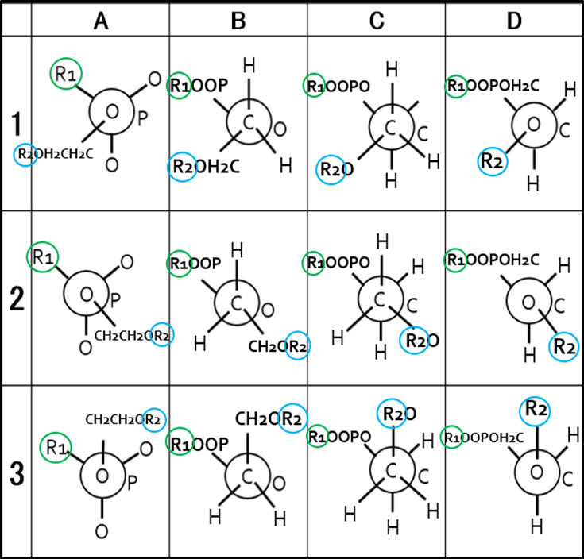
R₁ = OCH₂CH₂N⁺(CH₃)₃, R₂ = C(=O)C(CH₂)CH₃
Fig S1. Number representing the 81 conformations, ABCD, of MPC.

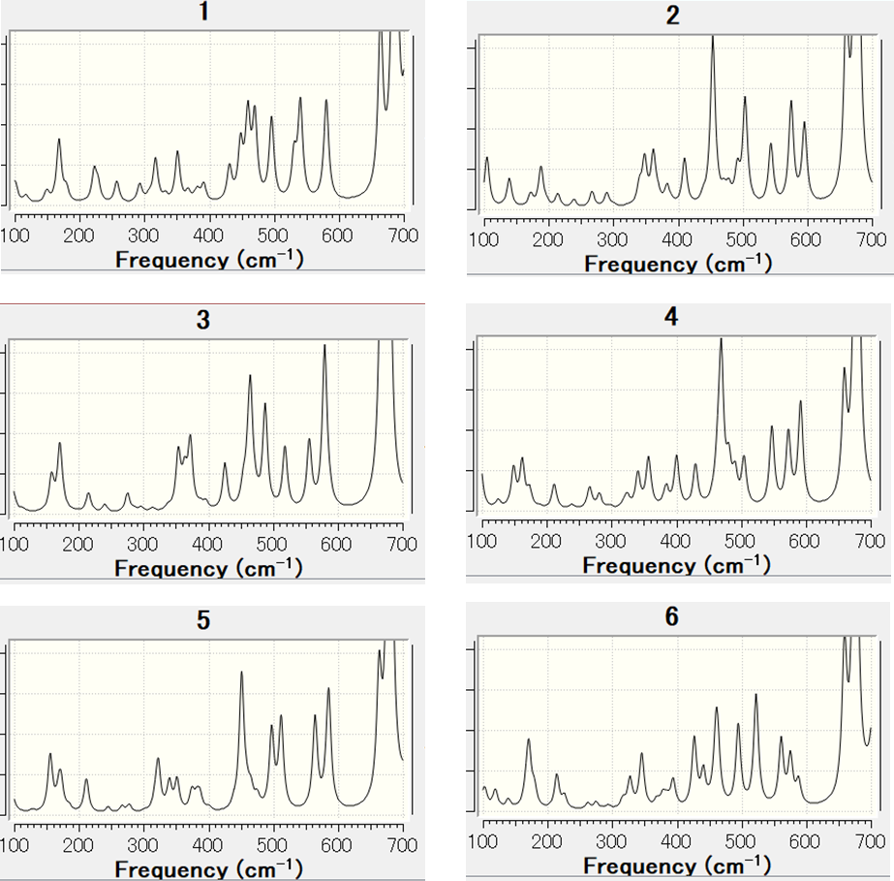
Fig. S2. FIR spectra of conformers 1−6 in Fig.7 of the main text, calculated in a solvent with a dielectric constant ε = 15.20 at the b3LYP/6-311++G(d,p) level with dispersion correction. The FWHM of the calculated spectra is set to the same value as that of the well-separated sharp peak observed at 423 cm⁻¹ at 4 K in Fig. 2a of the main text (FWHM = 4.4 cm⁻¹).

