Supporting Information
Degradation of cyanobacterial neurotoxin β-N-methylamino-L-alanine (BMAA) using ozone process: influencing factors and mechanism

Boyin Yan¹, Chunyu Han¹, Zhiquan Liu², Guizhi Wu¹, Songxue Wang^{1*}, Jincheng Li¹, Wenxiang Xia¹ and Fuyicui³

¹ School of Environmental and Municipal Engineering, Qingdao University of Technology, Qingdao 266033, China.
² Institute of Environmental Research at Greater Bay, Key Laboratory for Water Quality and Conservation of the Pearl River Delta, Ministry of Education, Guangzhou University, Guangzhou 510006, China.
³ School of Environment and Ecology, Chongqing University, Chongqing, 400044, China.

*Corresponding authors.
E-mail address:
Songxue Wang, songxue.wang@outlook.com
List of Supporting Information:

Fig. S1 Schematic figure of reaction device
Fig. S2 Structure of BMAA
Fig. S3 Mass spectrum of by-proudct (m/z = 105)
Fig. S4 Mass spectrum of by-proudct (m/z = 90)
Fig. S5 Mass spectrum of by-proudct (m/z = 88)

Fig. S1 Schematic figure of reaction device. ① Ozone reaction vessel, ② aeration head, ③ magnetic rotor, ④ ozone generator, ⑤ magnetic stirrer, ⑥ constant temperature water tank, ⑦ exhaust gas treatment device, ⑧ constant temperature water circulator and ⑨ sampling port.
Fig. S2 Structure of BMAA (A), BMAA²⁺ (B), BMAA⁺ (C, D and E), BMAA⁰ (F and G) and BMAA⁻ (H)
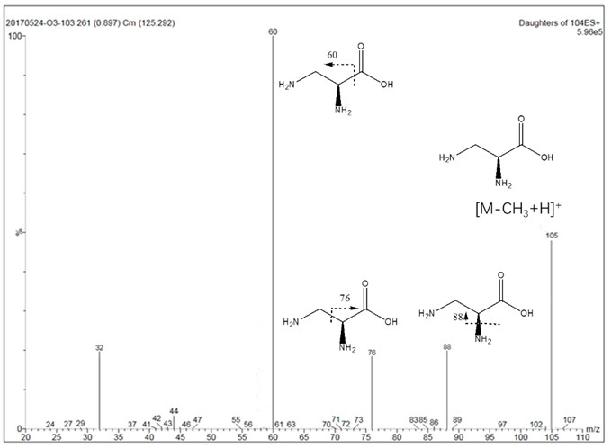
Fig. S3 Mass spectrum of by-proudct (m/z = 105)

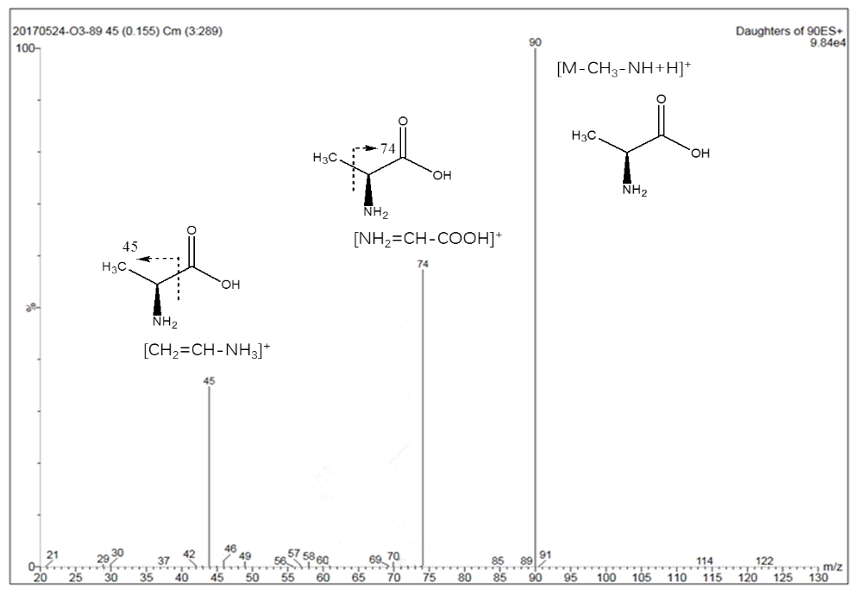
Fig. S4 Mass spectrum of by-proudct (m/z = 90)
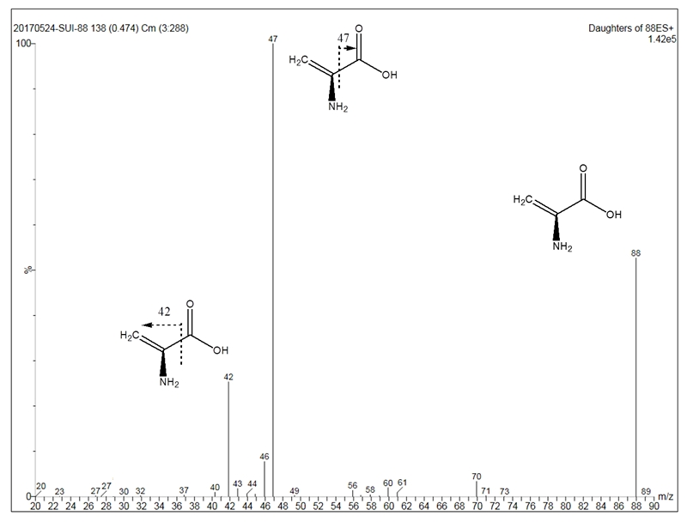
Fig. S5 Mass spectrum of by-proudct (m/z = 88)

